Investigating gender inequality with education and governance: A longitudinal cluster analysis on countries in Africa

Malcolm J. Beynon*

and

Alpa Dhanani

Cardiff Business School
Cardiff University
Cardiff
CF10 3EU

* Email: beynonmj@cardiff.ac.uk

Track – African Studies

Investigating gender inequality with education and governance: A longitudinal cluster analysis on countries in Africa

Abstract
In the continent of Africa, as with other parts of the world, there remains a noticeable presence of gender inequality in education across many of its constituent countries. This exploratory longitudinal study considers how general measures of the equality of women in a country confers itself to gender parity in education as well as overall governance (the latter a benchmark elucidation). The countries of Africa form the basis for the study, using data from the Ibrahim Index of African Governance, over the years 2012 through to 2021. The country based measures of, Political Power & Representation, Equal Rights & Civil Liberties, Socioeconomic Opportunity, Equal Access to Public Services and Laws on Violence against Women, are used to cluster the African country-year observations considered. The established clusters, using fuzzy c-means clustering, are defined and subsequently tested for validity against two further measures (at country level), gender parity in education and overall governance. Investigating these two ‘different’ measures also illustrates the separation of education gender parity and governance across Africa over the considered years. Results offer practical evidence of the way gender parity in education and overall governance can be described against general typologies (clusters) of women’s equality issues across the countries and years considered.

- Introduction
It remains the reality that gender inequality is present across a large swathe of countries in the world (see for example Ridge et al., 2019; Carlsen, 2020). Its continued presence in the world is an acknowledgement that cultural and political values have an adverse effect on the ability to establish parity in education terms across genders (Moore and Shackman, 1996). While efforts have been made to mitigate this inequality, success has been varied, and there are noticeable variations in the levels of gender inequality across countries, and even continents (Jain-Chandra et al., 2017). Where there remains noticeable inequality is in the continent of Africa (Ridge et al., 2019).
The issue of gender inequality in Africa has received previous research focus (see Doss et al., 2015; Bassey and Bubu, 2019), including specifically in education (see Evans et al., 2020; Baten et al., 2021). The frame of reference in this study is a large sample of countries in Africa. Data from the Ibrahim Index of African Governance (IIAG – IIAG, 2023), is employed in the analysis in this exploratory study. The intention of the IIAG is to provides a framework for any interested audience to assess the delivery of public goods and services and public policy outcomes in African countries (IIAG, 2023). The relevance of IIAG itself has previously been discussed in Mitra (2013) and Tarabusi and Gurarini (2013). A longitudinal perspective is also included in this study, with the considered IIAG data covering the years 2012 through to 2021, with cases considered being country-year observations. To date, the authors believe this to be the first ‘longitudinal’ cluster investigation of gender inequality in education, in this case across African countries.
The main technique employed in this study is a clustering approach (see Crum et al., 2022; Ikotun et al., 2023), whereby cases (here country-year observations) are grouped in such a way that cases in the same group are more similar to each other than to those in other groups. As a technique, it offers an unsupervised format, allowing researchers to explore, learn, and summarize large amounts of data in an efficient way (Waggoner, 2020). Indeed, this fits well with gender inequality research problem considered here, with Ridge et al. (2019) suggesting a “one-size-fits-all” approach does not work in this context – instead more holistic approach adopted. In the area of region/country level analysis, clustering has been used previously, including, Gocer et al. (2016), Beugelsdijk et al. (2017) and Kigerl (2016). It is noted in Crum et al. (2022), in a recent survey of clustering in entrepreneurship, advocate its pertinent role in exploratory studies, as the case here. The nascent fuzzy c-means (FCM) clustering approach is employed (see Bezdek, 1980, 2013; Andrews et al., 2017; 2023).
Here, the African country-year observations are attempted to be clustered based on dimensions of general equality representativeness of (termed in this study measures/clustering variables), namely; Political Power & Representation, Equal Rights & Civil Liberties, Socioeconomic Opportunity, Equal Access to Public Services and Laws on Violence against Women. These measures have themselves been included in previous research, see for example, Ferreira (2024), Paile (2023) and Ndonga et al. (2021). Seven clusters are established based on these measures (depicting typologies of women’s equality), which exhibit statistically significant differences across the clustering variables. It follows, they offer an exploratory typology of women’s equality across the countries of Africa (over the years 2012 through to 2021). Indeed, graphical heat maps shown elucidate the volatility of changes in the cluster membership of the African countries over the considered years based on these clustering variables.
The established clusters (country oriented African women inequality typologies) are further considered against two external variables, gender parity in education and overall governance. The inclusion of these two ‘contrasting’ external variables is to sense check how gender parity in education may compare to the most general governance notion of the country (in a specific year), through the lens of women’s inequality issues. Statistically significant differences in the values of these external variables across the established clusters of country-year observations demonstrate these ‘difference’ relationships between clustering and external variables. Indeed, Ketchen and Shook (1996) see this external variable consideration as a validation attempt of the clustering approach undertaken previously. Further, hierarchical regression analyses presented drill down further into the significances of the considered clustering variables, and year, to the education and governance external variables.
With an emphasis on the visualisation of many of the results, this study offers a novel perspective into both the inter-relationships between gender inequality measures of across African countries, as well as the potential for a clustering approach in this area.
The structure of the rest of the study is as follows: In section 2, a discussion on gender and inequality in Africa is given. Section 3 introduces the data as well as visualisation on its between year and between country variations. In section 4, the initial FCM clustering of the African country-year observations is undertaken and interpreted. Section 5 considers the established clusters against the external variables describing gender inequality in education and overall governance, and year variations, in cluster membership. In section 6 conclusions are given as well as directions for future research.

- Women, equality and Africa
The importance of gender inequality in education is highlighted in Chankseliani and McCowan (2021), who note its inclusion amongst the 17 UN Sustainable Development Goals (SDGs) (specifically SDG4). While acknowledging that women are more educated now than at any point in history, they further note that many countries remain far from achieving gender equality in the classroom.
Ridge et al. (2019) notes how gender inequality statistics vary across regions and countries, noting sub-Saharan Africa and southern Asia experiencing large inequalities. Importantly, the same study offers a flag not to think gender inequality is specific to these regions, with a view of first “look in the mirror”, they (Ridge et al., 2019) suggests G20 countries should begin by investigating their own gender equality in education.
Focussing on the cultural values effecting gender inequality in education, Bassey and Bubu (2019) acknowledge the impact of African societies being patriarchal (they do go on to query the notion of what the term gender encompasses), see also Olatunji (2013).

- Discussion of data and visualisations
The data considered in this study comes from the Ibrahim Index of African Governance (IIAG), a tool that measures and monitors governance performance in African countries (IIAG, 2023). Their reflection on governance, in general, is described by;

“.. the provision of political, social, economic and environmental public goods and services that every citizen has the right to expect from their government, and that a government has the responsibility to deliver to its citizens.”

The IIAG data has been included in a range of academic studies, including effects of good governance on financial reports quality (Masnila et al., 2021), comparing with other governance measures (Mitra, 2013) and measuring political accountability in Africa (Ohamadike, 2022). Idris (2013) note, even over 10 years ago, that the IIAG was a reputable non-government body, with up to date and reliable indexes of Africa governance. Further, the reliability views on the IIAG data in these studies suggest, IIAG has become a reference point for governments and NGOs (Mitra, 2013), as well as other international institutions and foreign investors (Tarabin and Gurarin, 2013).
Here we consider a series of variables (indicators) included in the IIAG, predominantly associated with women/gender issues. Moreover, a whole section of the IIAG database covers the higher order topic of ‘Participation, Rights and Inclusion’, and within this sub-topic variables relating to ‘Women’s Equality’. Elsewhere, in the higher order topic ‘Human Development’, and ‘Education’ sub-topic, there are gender parity in education measures, and above all this an overall governance measure.
Details on the specific variables (indicators) considered in this study are given in Table 1.

Table 1. Description of the data, clustering and external variables (indicators)

Clustering Variable | Long name | Description
PolPowRepWom | Political Power & Representation of Women | This indicator assesses the extent to which political power is distributed by gender and measures the proportion of women in the executive, in the legislature and in the highest branch of the judiciary.
EqCivLibWom | Equal Rights & Civil Liberties for Women | This sub-indicator assesses the extent to which women enjoy the same level of civil liberties as men. Here, civil liberties are understood to include access to justice, private property rights, freedom of movement, and freedom from forced labour.
SocioEconOppWom | Socioeconomic Opportunity for Women | This indicator assesses the extent to which state jobs and business opportunities are equally open regardless of gender and the extent to which women receive equal pay, benefits and treatment as men in the workplace.
AccPubServWomVDEM | Equal Access to Public Services for Women | This indicator assesses the extent to which access to basic public services, such as order and security, primary education, clean water, and healthcare, are distributed equally according to gender. This sub-indicator assesses if gender is an important cleavage in society for the distribution of public services.
LawsViolenceWomWB | Laws on Violence against Women | This indicator assesses the extent to which there are laws and regulations against domestic violence and sexual harassment by assessing whether there is legislation specifically addressing domestic violence, there is legislation on sexual harassment in employment, there are criminal penalties or civil remedies for sexual harassment in employment, whether the legislation establishes clear criminal penalties for domestic violence, and whether there is a specialised court or procedure for cases of domestic violence.
External Variable | Long name | Description
GendParEduc | Gender Parity in Education | This sub-indicator measures the ratio of female gross enrolment to male gross enrolment in primary and lower secondary education.
OvrllGvnnc | Overall Governance | A composite index which gives a statistical measure of overall governance performance

In Table 1, the data presented includes aspects of gender inequality and governance, described in the literature review available in IIAG. The IIAG database includes data over the year range, 2012 through to 2021, hence a case here is a country-year observation. Based on the variables considered (including the need for complete data at the country-year observation level), 48 countries in Africa are included in this study, see Figure 1.

Figure 1. Graphical depiction of included countries in this study

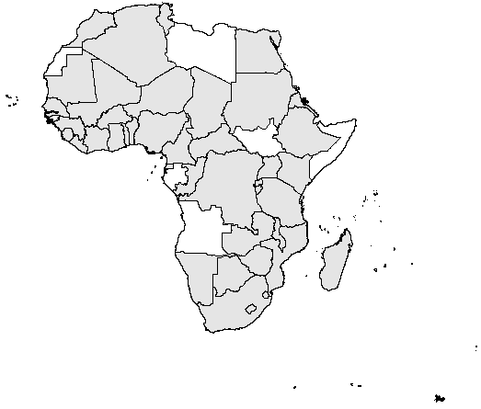

The map in Figure 1 shows the 48 countries included in the analysis as grey shaded. With each country present for each of the considered 10 years of data, a total of 480 country-year observations make up the analysed Africa gender-inequality data set.
A further elucidation is given on the country-year observations, to inspect whether there is dramatic year variation across the considered variables (clustering and external), see Figure 2.

Figure 2. Boxplot based elucidation of clustering and external variable values over the considered years

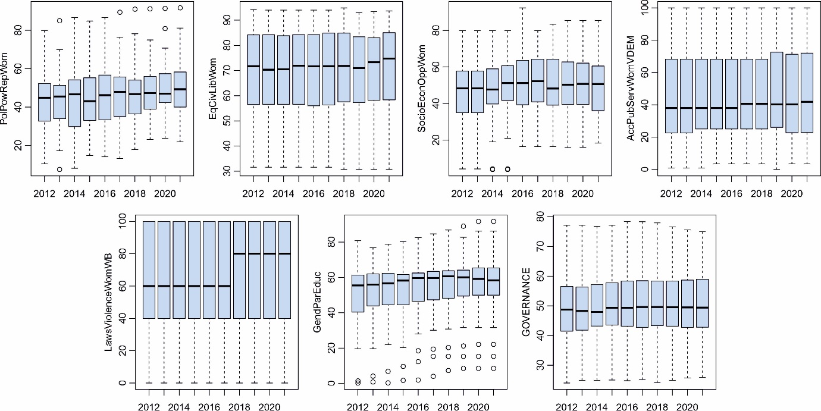

The results presented in each graph in Figure 2, includes the boxplot representation spread of the respective clustering and external variables on a specific year, hence 10 boxplots in each graph covering the years 2012 through to 2021. ANOVA tests can be made to check if there are between year differences over a variable in the valyes, next given; PolPowRepWom (F(1, 478) = 1641, p = 0.008), EqCivLibWom (F(1, 478) = 107, p = 0.55), SocioEconOppWom (F(1, 478) = 3.15, p = 0.078), AccPubServWomVDEM (F(1, 478) = 0.8, p = 0.37), LawsViolenceWomWB (F(1, 478) = 6.34, p = 0.012), GendParEduc (F(1, 478) = 6.26, p = 0.013) and OvrllGvnnce (F(1, 478) = 0.74, p = 0.39).
The inferences of the ANOVA results indicate, at 5% significance level, two of the five clustering variable suggest year-on-year differences, and one of the two external variables is also exhibiting year-on-year difference (inequality in education). Whilst this is noted, inspection of the graphs suggests the variations are not dramatic as you go from 2012 through to 2021.
A similar form of data elucidation can be undertaken based on individual countries (48 in number), and the sets of country-year observations values describing them (10 in number), see Figure 3.

Figure 3. Boxplot based elucidation of clustering and external variable values over the considered countries

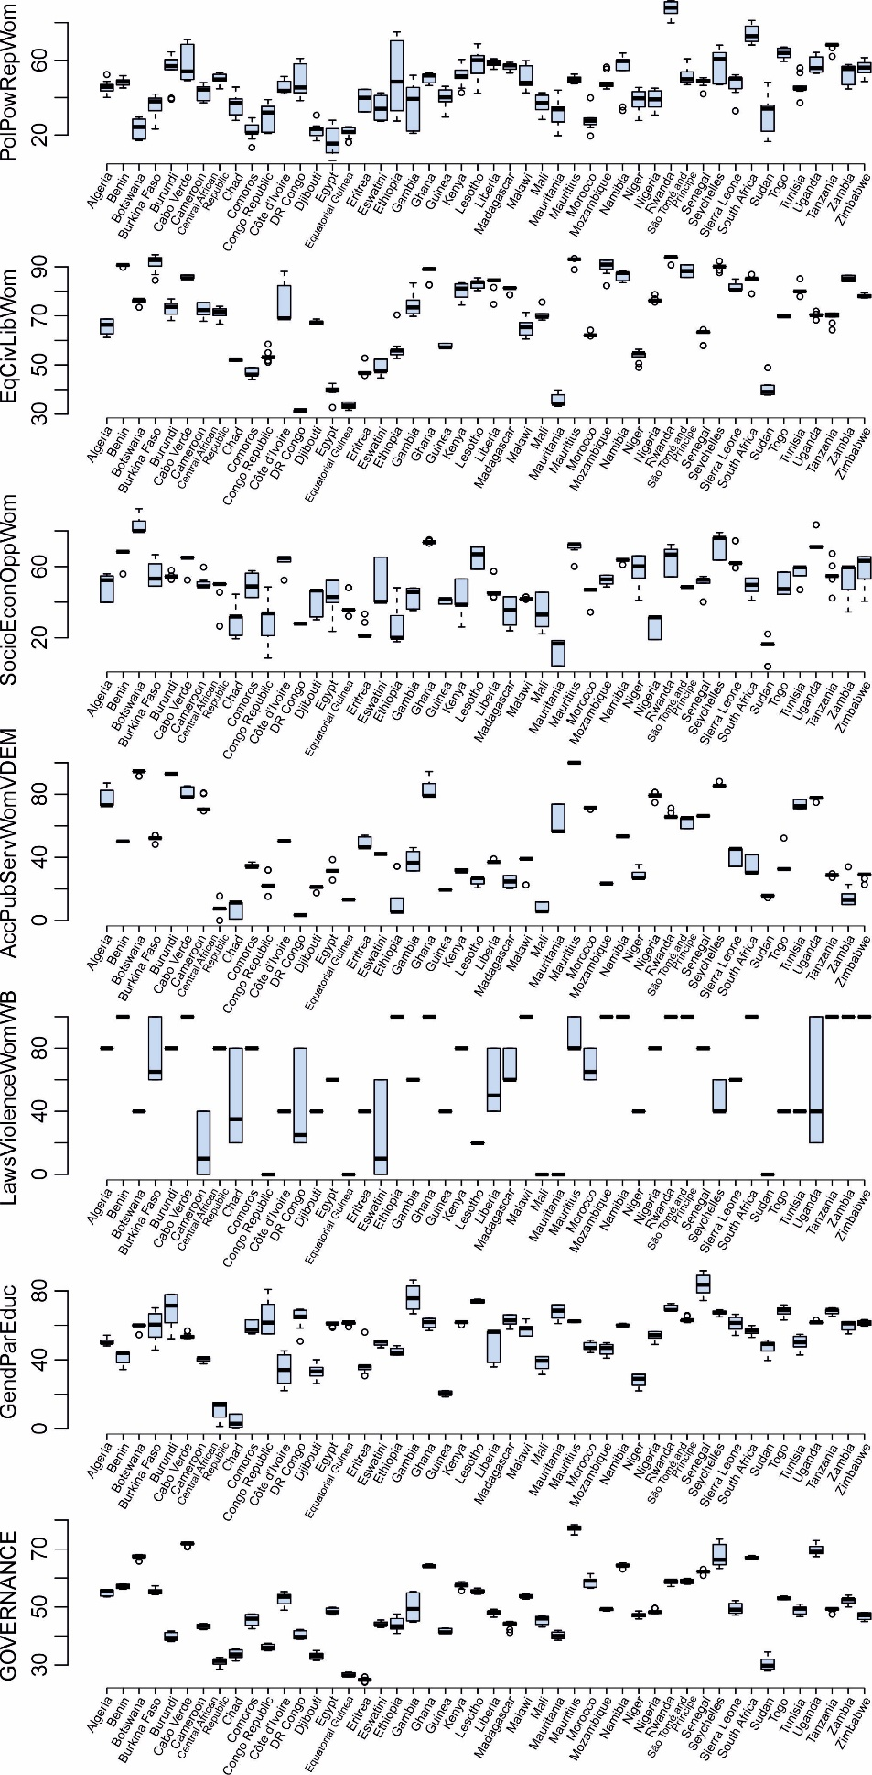

In each graph shown in Figure 3, the 48 country based boxplots describe the spread of the individual clustering and external variable values for a single country (over the considered 10 years). Inspection of these graphs (ANOVA results not considered here since variations across countries could be expected), indicate the noticeable range of variable values across the respective African countries are associated with them, across both clustering and external variables. Further ‘early’ elucidation is given in regard to the relationship between each clustering variable and the external variables, GenParEduc and OvrllGvrnnce, see Figures A1 and A2 in Appendix A. The details in Appendix A are an attempt to contribute to the reader the fullest understanding to the country-year observations level data set considered here.
The last data elucidation given in this section is on the relationship between the two external variables gender parity in education and overall governance, see Figure 4 (using standardised values). We remind the reader that while the specific interest of this study is the relationship between general gender inequality and gender parity in education in African countries, the inclusion of the overall governance external variable is to offer a benchmark on whether gender inequality variations are systematic of general governance issues in African countries.

Figure 4. Scatterplot elucidations of relationship between external variables GendParEduc and OvrllGvrnnce.

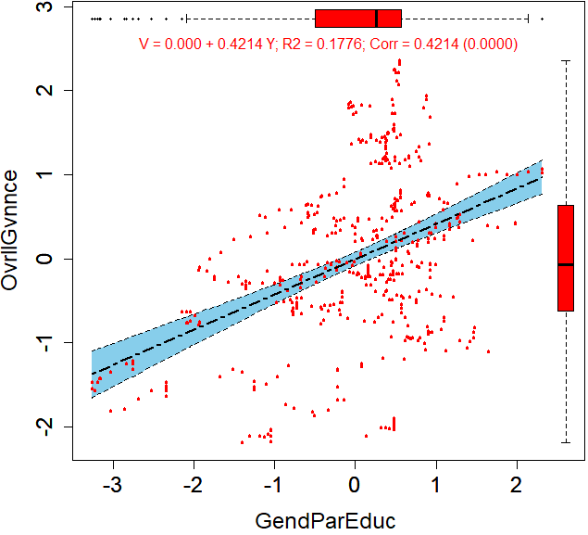

In Figure 4, each point in the scatterplot shows represents a country-year observation (480 in total). A regression line is also drawn, and a concomitant 95% confidence interval shaded regions (Individual year scatter plot graphs are shown in Figures A1 and A2 in Appendix A). The level of relationship (correlation) between the two external variables is limited (when considering both the statistical and graphical evidence presented). This is itself is interesting since it demonstrates that the two ‘external variable’ issues of GenParEduc and OvrllGvrnnce, do not necessarily infer each other. Hence, how the later undertaken clustering of gender inequality variables relates to these different external variables will be of noticeable interest.

- Cluster analysis
This section undertakes a cluster analysis of the Africa gender-inequality data set. Here fuzzy c-means (FCM) clustering is employed (Bezdek 1980; 2013), which is a non-hierarchical clustering approach, where there is allowance for levels of membership to more than one cluster (see its recent application in Andrews et al., 2017; 2023; Haddoud et al., 2018). Here, the clustering process is broken down into several stages.

  - Number of clusters
With FCM being a non-hierarchical clustering technique, there is a requirement to consider the number of clusters to establish (see for example Kodinariya and Makwana, 2013). In recent years there has been increased developments on the topic of the approximate number of clusters to establish. This has been very much numerical measure based, including Masud et al. (2018). Against this, studies including Ketchen and Shook (1996), acknowledge that theoretical appropriateness is an important feature of the numbers of clusters to establish.
Here, while numerical based ‘number of cluster’ algorithms suggested over 10 clusters, this meant the existence of low frequency of country-year observations in some clusters. Following Ketchen and Shook (1996), see also Andrews et al. (2017; 2023), number of clusters less than 10 were investigated, with seven clusters considered appropriate for this exploratory study.

  - Cluster analysis
Following the findings in the previous subsection, here the clustering of the 480 African country-year observations is exposited, with a seven cluster solution established. Using FCM, the clustering process was undertaken using the ‘clust’ package through the R programming language. The final cluster solution offers associated sets of fuzzy membership scores to each country-year observation, defining its level of membership to what each cluster represents.
Based on these fuzzy membership score results, useable details on clusters of country-year observations can be evidenced based on majority association to a single cluster, see Figure 5 (following the visual approach in Andrews et al., 2017; 2023).

Figure 5. Boxplot and mean cluster variable values details

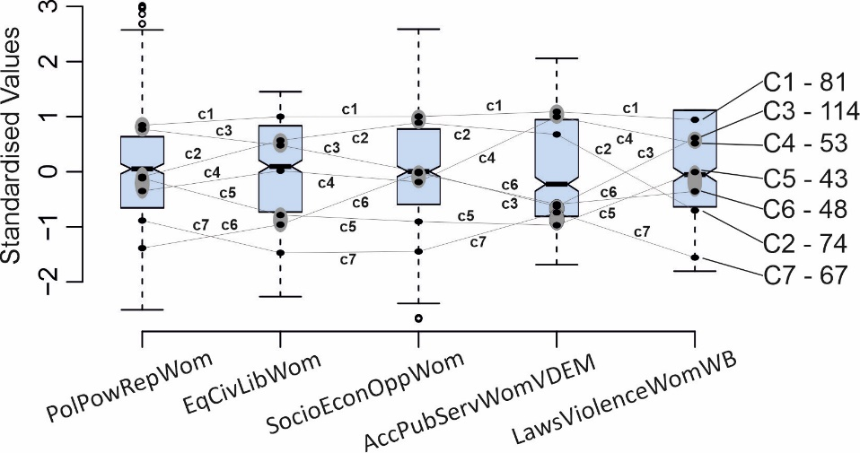

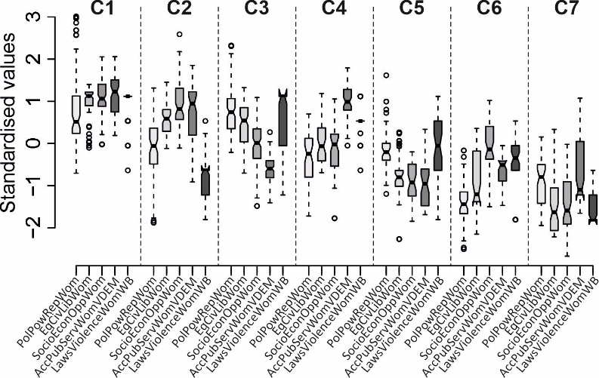

In Figure 5a, the five boxplots shown exposit the spread of each of the considered cluster variables (using variable abbreviation terms as introduced in Table 1), PolPowRepWom, EqCivLibWom, SocioEconOppWom, AccPubServWomVDEM and LawsViolenceWomWB, across the 480 country-year observations. Each point represents a mean cluster variable value of country-year observations majority associated to a single cluster, with the lines joining sets of points connecting the mean cluster variable details for a single cluster. Also shown to the right are the initial given cluster names (C1, C2, .., C7) and the number of country-year observations majority associated to them. In Figure 5b, the seven clusters are again shown, each described by five boxplots showing the spread of the values of the respective clusters (of country-year observations) across each of the cluster variables.
ANOVA tests are produced to investigate the differences of the different clusters of country-year observations across each cluster variable; PolPowRepWom (F(1, 478) = 300, p = 0.000), EqCivLibWom (F(1, 478) = 1126, p = 0.000), SocioEconOppWom (F(1, 478) = 570, p = 0.000), AccPubServWomVDEM (F(1, 478) = 222, p = 0.000) and LawsViolenceWomWB (F(1, 478) = 225, p = 0.000). The ANOVA results report that there is statistically significant difference across the different clusters on each clustering variable. This allows further consideration of between pairs of clusters, using Bonferroni post-hoc measures (see Andrews et al., 2017; 2023). In Figure 5a, where there is not 5% post-hoc difference between pairs of clusters, their respective mean values are enclosed by dark grey shaded ovals (signifying no difference between them). For example, in the case of clustering variable AccPubServWomVDEM, the two ovals shown infer there are two groups of clusters in statistical difference terms, here termed High and Low.
With the clusters described in general terms, we are next in a position to further describe the cluster in qualitative terms;

C1 (81) – “High equality in general” – High PolPowRepWom, High EqCivLibWom, High SocioEconOppWom, High AccPubServWomVDEM and High LawsViolenceWomWB
C2 (74) – “High equality but law lacking” – Medium PolPowRepWom, Medium-High EqCivLibWom, High SocioEconOppWom, Medium-High AccPubServWomVDEM and Medium-Low LawsViolenceWomWB
C3 (114) – “High-Medium equality but low accessing public services” – High PolPowRepWom, Medium-High EqCivLibWom, Medium SocioEconOppWom, Low AccPubServWomVDEM and Medium-High LawsViolenceWomWB
C4 (53) – “Medium equality but high accessing public services” – Medium PolPowRepWom, Medium-High EqCivLibWom, Medium SocioEconOppWom, High AccPubServWomVDEM and Medium-High LawsViolenceWomWB
C5 (43) – “Medium-Low equality” – Medium PolPowRepWom, Medium-Low EqCivLibWom, Medium-Low SocioEconOppWom, Low AccPubServWomVDEM and Medium LawsViolenceWomWB
C6 (48) – “Low equality” – Low PolPowRepWom, Medium-Low EqCivLibWom, Medium SocioEconOppWom, Low AccPubServWomVDEM and Medium-Low LawsViolenceWomWB
C7 (67) – “Very low equality” – Medium-Low PolPowRepWom, Low EqCivLibWom, Low SocioEconOppWom, Low AccPubServWomVDEM and Low LawsViolenceWomWB

- External variable analysis and hierarchical regression
This section extends the analysis in this study to further consider the established gender equality clusters found previously (see Figure 5), in regard to further variables associated with the focus of the study, but not considered in the clustering process (external variables). Moreover, the notions of country level gender parity in education and overall governance are considered.

  - External Variable
In this section a breakdown of the variability in the GenParEduc and OvrllGvrnnce values across the country-year observations majority associated with the respective clusters are considered, see Figure 6

Figure 6. Boxplot and mean external variable values details

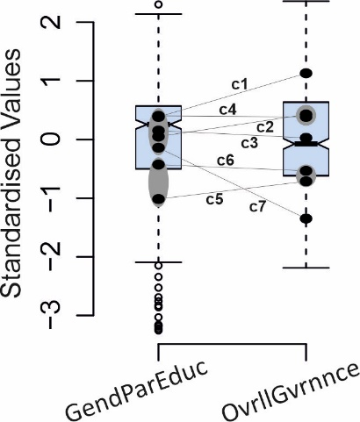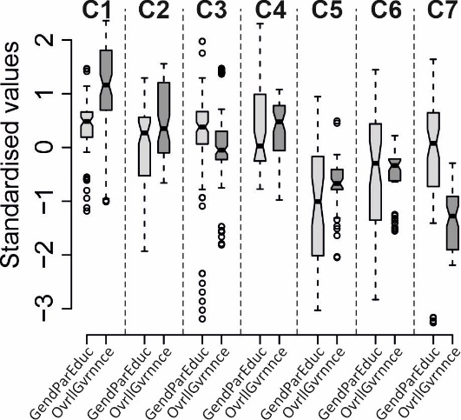

In Figure 6a, like that presented for the clustering variables in Figure 5a, the boxplots show the spread of the GenParEduc and OvrllGvrnnce values for the 480 country year observations considered. For each cluster, their respective cluster mean values for GenParEduc and OvrllGvrnnce are shown, joined by a line. In Figure 6b, the respective pairs of boxplots show the spread of the GenParEduc and OvrllGvrnnce values for the cluster specific country year observations (like those presented in Figure 5b).
The associated ANOVA results across both GenParEduc and OvrllGvrnnce, are; GenParEduc (F(1, 478) = 29.5, p = 0.000) and OvrllGvrnnce (F(1, 478) = 525, p = 0.000). These ANOVA results indicate statistical significance in the gender inequality cluster mean values shown, in terms of their associated GenParEduc and OvrllGvrnnce values. This allows post hoc results to be considered across both GenParEduc and OvrllGvrnnce, with dark grey shaded ovals shown in Figure 6a (the presence of dark ovals show non-statistical different mean values).
Inspection of these results, following the statistical significance understanding, is premised on the level of ‘non-ladder shape’ results shown in Figure 6a, that is, if there was perfect relatively similar cluster associated values across GenParEduc and OvrllGvrnnce, there would be a series of horizontal lines going up the plot (like rungs on a ladder). This is not the case in Figure 6a, and confirms that there is inherent differences between the two external variables and the established clusters as also exposited in the scatterplot in Figure 4 (the important factor the external variable values are statistically different across the different established clusters).
There appears to be two groupings of clusters, for which their values do not overlap, towards the bottom C5 and C6, and near top C1, C2, C3, C4 and C7. Further variations include; i) it is interesting that the C7 cluster, which in the middle of the clusters for GenParEduc is at the bottom of the OvrllGvrnnce clusters and ii) to a lesser extent to i), amongst the top four valued clusters in Figure 6a, two (C4 and C3) have relatively horizontal lines, while the two (C1 and C2) increase their values and cross one of each of C4 and C3.
Since each country is represented by a set of 10 country-year observations, a consideration at the country level in their country to cluster associations across the years 2012 through to 2021, is next given in the heatmaps shown in Figures 7 and 8 (separate heatmaps are shown against GenParEduc and OvrllGvrnnce values).

Figure 7. Graphical elucidation of country-year cluster membership and country mean GenParEduc values

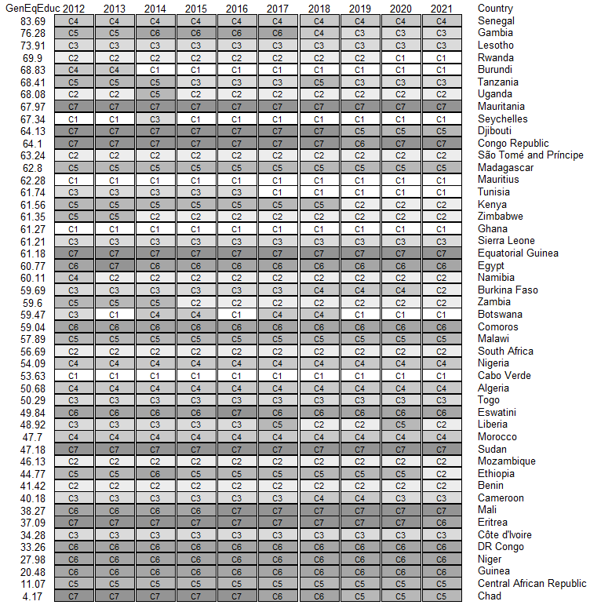

Figure 8. Graphical elucidation of country-year cluster membership and country mean OvrllGvrnc values

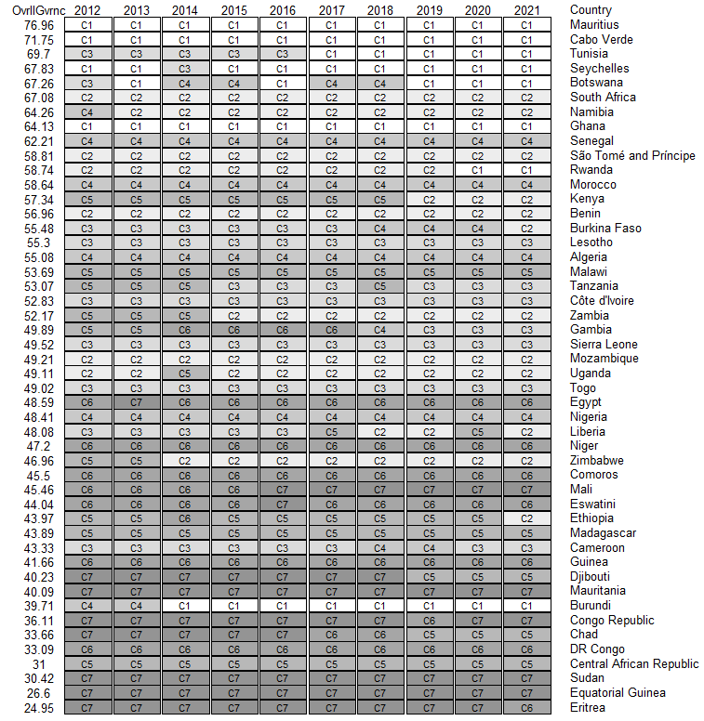

In Figures 7 and 8, the cluster membership details of each country-year observation are represented as a cell in a large matrix of cells (for brevity we return to using their C1 to C7 labels). Each country (row) is represented by 10 such cells, one for each year (column) of consideration (acknowledging that each country was present for each considered year). The ordering of the countries is top to bottom based on largest to smallest mean GenParEduc (Figure 7) and OvrllGvrnc (Figure 8) external variable values (for each country). The cluster cells are shaded light grey to dark grey from (their original establishment, cluster “High equality” (C1) down to cluster “Very low equality” (C7) (noting in the Figure 5b the clusters were ordered based on overall mean cluster variable values – see footnote 6).
In terms of interpretation of the heatmaps there are two directions of understanding, i) Left to right across the columns will for a single country show the possible change in cluster memebrship of a country over the different years, and ii) top to bottom across the rows how the cluster associations change by country, ranked top to bottom on the avrage index scores for GenParEduc (Figure 7) and OvrllGvrnc (Figure 8).
In Figure 7, for the GenParEduc exteral variable, the countries are ranked from top Senegal (83.69) to bottom Chad (4.17). The shading of the cells for the different clusters (explained previously) enable clear elucidation on where there is changes to cluster membership for a country over the years 2012 to 2021. In general terms, there appears no gradual shading difference in rows of cells in Figure 7 as you move down the country rank ordering (based on GenParEduc)
In Figure 8, for the OvrllGvrnc exteral variable, the countries are ranked from top Mauritius (76.96) to bottom Eritrea (24.95). The shading of the cells for the different clusters (explained previously) enable clear elucidation on where there is changes to cluster membership for a country over the years 2012 to 2021. In general terms there appears to show, but unevenly, darkening og of the cells as you move down the rows in Figure 8 (two noticeable exceptions are in regard to Zimbabwe and Burundi). This shows as OvrllGvrnc decreases (mean measure), it appears the cluster membership moves through C1 to C7 (not exactly).

  - Hierarchical regression
A further level of analysis can be undertaken in regard to the established clusters and external variables. This is in the form of hierarchical regressions, in the context of clustering, as undertaken in Janssens et al. (2003) and Andrews et al. (2017; 2023). Here, two sets of hierarchical regressions are undertaken, see Table 2 (GenParEduc - gender parity in education) and Table 3 (OvrllGvrnc - overall governance). In the presented regressions, the year is also included.

Table 2. GenParEduc hierarchical regression results

Sanitation | ¬C1 | ¬C2 | ¬C3 | ¬C4 | ¬C5 | ¬C6 | ¬C7
Intercept | -79.448** | -79.804** | -79.631** | -79.382** | -81.024** | -80.204** | -79.837**
C1 | - | 0.356* | 0.183 | -0.066 | 1.576*** | 0.756*** | 0.389*
C2 | -0.356* | - | -0.173 | -0.422* | 1.220*** | 0.400* | 0.033
C3 | -0.183 | 0.173 | - | -0.249 | 1.393*** | 0.573*** | 0.206
C4 | 0.066 | 0.422* | 0.249 | - | 1.642*** | 0.822*** | 0.456*
C5 | -1.576*** | -1.220*** | -1.393*** | -1.642*** | - | -0.820*** | -1.187***
C6 | -0.756*** | -0.400* | -0.573*** | -0.822*** | 0.820*** | - | -0.367^
C7 | -0.389* | -0.033 | -0.206 | -0.456* | 1.187*** | 0.367^ | -
Year | 0.040** | 0.040** | 0.040** | 0.040** | 0.040** | 0.040** | 0.040**
Adj. R2 | 0.178 | 0.178 | 0.178 | 0.178 | 0.178 | 0.178 | 0.178
F (7, 472) | 15.8*** | 15.8*** | 15.8*** | 15.8*** | 15.8*** | 15.8*** | 15.8***
Signif. codes: 0 ‘***’ 0.001 ‘**’ 0.01 ‘*’ 0.05 ‘^’ 0.1 ‘ ’ 1

Table 3. OvrllGvrnc hierarchical regression results

Sanitation | ¬C1 | ¬C2 | ¬C3 | ¬C4 | ¬C5 | ¬C6 | ¬C7
Intercept | 6.533 | 5.721 | 5.347 | 5.637 | 4.524 | 4.787 | 3.943
C1 | - | 0.812*** | 1.186*** | 0.896*** | 2.009*** | 1.746*** | 2.590***
C2 | -0.812*** | - | 0.373*** | 0.084 | 1.196*** | 0.934*** | 1.778***
C3 | -1.186*** | -0.373*** | - | -0.289* | 0.823*** | 0.561*** | 1.404***
C4 | -0.896*** | -0.084 | 0.289* | - | 1.113*** | 0.850*** | 1.694***
C5 | -2.009*** | -1.196*** | -0.823*** | -1.113*** | - | -0.263^ | 0.581***
C6 | -1.746*** | -0.934*** | -0.561*** | -0.850*** | 0.263^ | - | 0.844***
C7 | -2.590*** | -1.778*** | -1.404*** | -1.694*** | -0.581*** | -0.844*** | -
Year | -0.003 | -0.003*** | -0.003 | -0.003 | -0.003 | -0.003 | -0.003
Adj. R2 | 0.594 | 0.594 | 0.594 | 0.594 | 0.594 | 0.594 | 0.594
F (7, 472) | 101*** | 101*** | 101*** | 101*** | 101*** | 101*** | 101***
Signif. codes: 0 ‘***’ 0.001 ‘**’ 0.01 ‘*’ 0.05 ‘^’ 0.1 ‘ ’ 1

In Tables 2 and 3, coefficient values are given along with their levels of significance. At the bottom of each model, regression measures are given, including Adj. R2 and F.

- Conclusions
This study has considered a novel, but exploratory, investigation of the context of gender inequality (and governance) across a large sample of countries in Africa. Using data from the IIAG, with a 10-year longitudinal dimension to the analysis is also given. It is a multi-stage analysis, with initial considerations of gender inequality measures across 48 African countries, and a concomitant 480 country-year observations.
The central technical focus throughout this analysis has been through a cluster based approach to the typology (cluster) setting of country-year observations, based on a range of gender inequality clustering variables. The established typologies of country-year observations based premised not on ‘correlated’ sets of gender inequality measures, instead noticeable, low, medium and high descriptors describe them.
Subsequent consideration of the established gender inequality oriented clusters against the external variables gender parity in education and overall governance. Statistically significant differences are found across the clusters of country-year observations and these external variables.
With an emphasis on the visualisation of results, the presented heatmaps give clear elucidation of the changes in an African country’s stability or instability in cluster membership over the considered years. The authors believe, tis exploratory study offers a practical elucidation on the embeddedness of gender inequality across a large sample of countries in Africa, and how this relates to education and governance issues.

References
Andrews, R., Beynon, M. J., & Baafi, F. (2023). Access to basic infrastructure services in Ghanaian local government: a contextual approach. Local Government Studies, 1-24.
Andrews, R., Beynon, M. J., & Genc, E. (2017). Strategy implementation style and public service effectiveness, efficiency, and equity. Administrative Sciences, 7(1), 4.
Bassey, S. A., & Bubu, N. G. (2019). Gender inequality in Africa: a re-examination of cultural values. Cogito, 11(3), 21-36.
Baten, J., De Haas, M., Kempter, E., & Meier zu Selhausen, F. (2021). Educational gender inequality in Sub‐Saharan Africa: a long‐term perspective. Population and Development Review, 47(3), 813-849.
Beugelsdijk, S., Kostova, T., & Roth, K. (2017). An overview of Hofstede-inspired country-level culture research in international business since 2006. Journal of International business studies, 48, 30-47.
Bezdek, J. C. 1980. “A convergence theorem for the fuzzy ISODATA clustering algorithms.” IEEE transactions on pattern analysis and machine intelligence (1): 1-8.
Bezdek, J. C. 2013. “Pattern recognition with fuzzy objective function algorithms.” Springer Science & Business Media.
Carlsen, L. (2020). Gender inequality and development. Sustainability Science, 15(3), 759-780.
Chankseliani, M., & McCowan, T. (2021). Higher education and the sustainable development goals. Higher Education, 81(1), 1-8.
Crum, M., Nelson, T., de Borst, J., & Byrnes, P. (2022). The use of cluster analysis in entrepreneurship research: Review of past research and future directions. Journal of Small Business Management, 60(4), 961-1000.
Doss, C., Kovarik, C., Peterman, A., Quisumbing, A., & Van Den Bold, M. (2015). Gender inequalities in ownership and control of land in Africa: myth and reality. Agricultural Economics, 46(3), 403-434.
Evans, D. K., Akmal, M., & Jakiela, P. (2020). Gender gaps in education: The long view. IZA Journal of Development and Migration, 12(1).
Ferreira, I. A. (2024). Institutions and governance in Mozambique.
Gocer, I., Akin, T., & Alatas, S. (2016). The effects of saving-investment gap on economic growth in developing countries: A clustering and panel data analysis. Theoretical & Applied Economics, 23(2).
Haddoud, M. Y., Beynon, M. J., Jones, P., & Newbery, R. (2018). SMEs’ export propensity in North Africa: a fuzzy c-means cluster analysis. Journal of Small Business and Enterprise Development, 25(5), 769-790.
Idris, M. (2013). Corruption and insecurity in Nigeria. Public Administration Research, 2(1), 59.
Ikotun, A. M., Ezugwu, A. E., Abualigah, L., Abuhaija, B., & Heming, J. (2023). K-means clustering algorithms: A comprehensive review, variants analysis, and advances in the era of big data. Information Sciences, 622, 178-210.
IIAG (2023) https://iiag.online/about.html. Accessed 06-07-2023.
Jain-Chandra, S., Kochhar, K., Newiak, M., Zeinullayev, T., & Zhuang, L. (2017). Gender inequality around the world. Women, Work, and Economic Growth: Levelling the Playing Field, 13-27.
Janssens, M., Sels, L., & Van den Brande, I. (2003). Multiple types of psychological contracts: A six-cluster solution. Human Relations, 56(11), 1349-1378.
Kodinariya, T. M., & Makwana, P. R. (2013). Review on determining number of Cluster in K-Means Clustering. International Journal, 1(6), 90-95.
Ketchen, D. J. and C. L. Shook. 1996. “The application of cluster analysis in strategic management research: an analysis and critique.” Strategic Management Journal 17(6): 441-458.
Kigerl, A. (2016). Cyber Crime Nation Typologies: K-Means Clustering of Countries Based on Cyber Crime Rates. International Journal of Cyber Criminology, 10(2).
Masnila, N., Mayasari, R., Firmansyah, F., Febriantoko, J., & Said, J. (2021). The Effect of Good Government Governance on the Financial Reports Quality: The Case of Provincial Capital Governments in Indonesia. International Journal of Business, Management and Economics, 2(4), 270-287.
Masud, M. A., Huang, J. Z., Wei, C., Wang, J., Khan, I., & Zhong, M. (2018). I-nice: A new approach for identifying the number of clusters and initial cluster centres. Information Sciences, 466, 129-151.
McDermott, A. M., Heffernan, M., & Beynon, M. J. (2013). When the nature of employment matters in the employment relationship: A cluster analysis of psychological contracts and organizational commitment in the non-profit sector. The International Journal of Human Resource Management, 24(7), 1490-1518.
Mitra, S. (2013). Towards a multidimensional measure of governance. Social Indicators Research, 112, 477-496.
Moore, G., & Shackman, G. (1996). Gender and authority: A cross-national study. Social Science Quarterly, 273-288.
Ndonga, D., Chihaka, S., & Fielder, A. (2021). Integration of gender practices and promotion of diversity in customs and trade: the case of East and Southern Africa. World Customs Journal, 15(1).
Olatunji, C. M. P. (2013). An argument for gender equality in Africa. CLCWeb: Comparative Literature and Culture, 15(1), 9.
Ohamadike, N. (2022). Measuring political accountability in Africa using a multi-item index. The Africa Governance Papers, 2(1), 32-47.
Paile, M. (2023). A Cautious View of the Human Capital Discourse and the Possibility of a Lifelong and Life-Wide Learning Public Service. Journal of Public Administration, 58(1), 149-167.
Ridge, N., Kippels, S., Cardini, A., & Yimbesalu, J. P. (2019). Developing National Agendas in Order to Achieve Gender Equality in Education (SDG 4). Policy Brief 2030 AGENDA FOR SUSTAINABLE DEVELOPMENT, (4), 1-16.
Casadio Tarabusi, E., & Guarini, G. (2013). An unbalance adjustment method for development indicators. Social indicators research, 112, 19-45.
Waggoner, P. D. (2020). Unsupervised machine learning for clustering in political and social research. Cambridge University Press.

Appendix
In this appendix a series of graphical evidence are produced to accompany the findings in the main text. These include consideration of the clustering variables against each of the eternal variables, i) gender inequality in education (see Figure A1), ii) overall governance (see Figure A2).

Figure A1. Scatterplot elucidations of relationships between individual clustering variable and external variable GendParEduc.

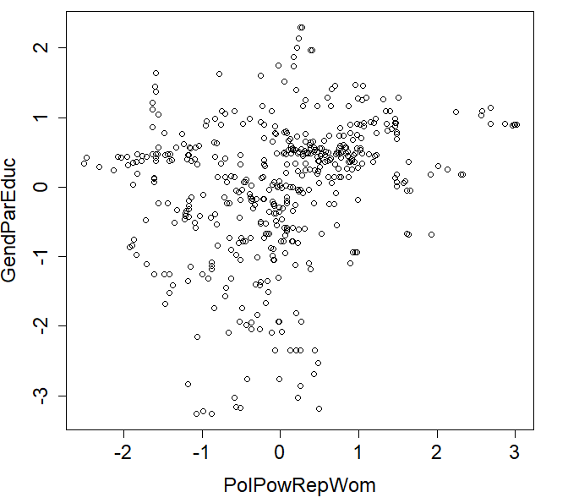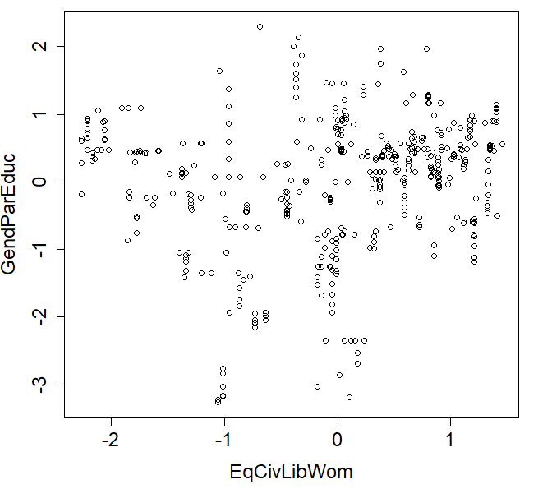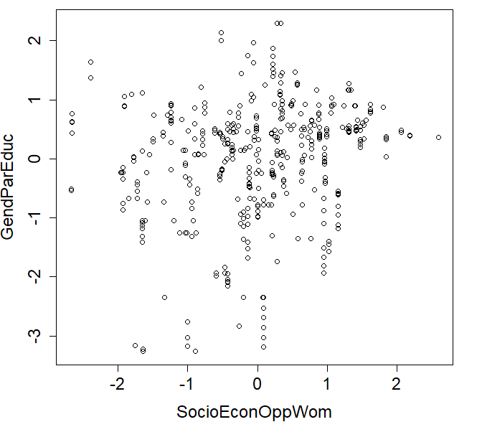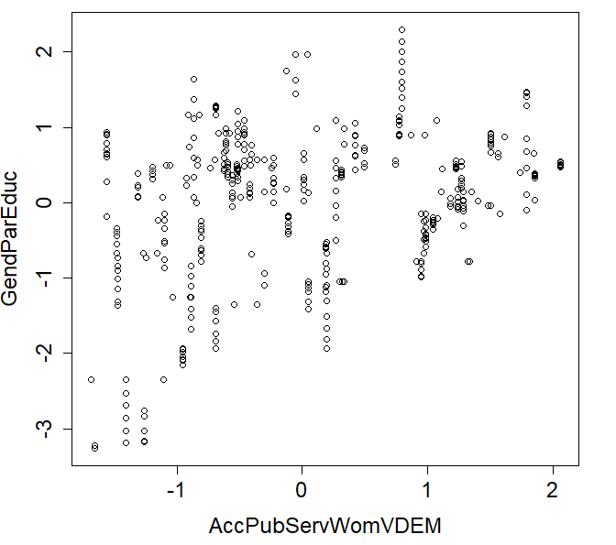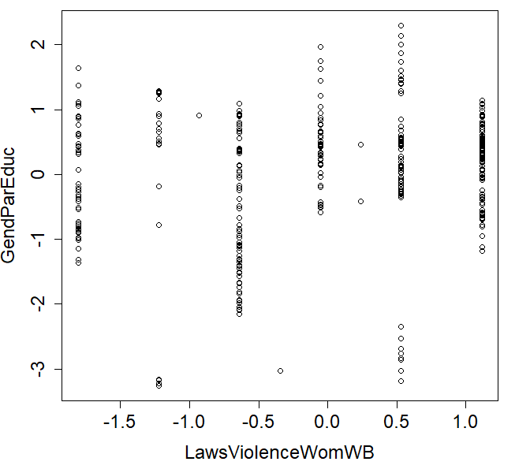

Figure A2. Scatterplot elucidations of relationships between individual clustering variable and external variable Governance.

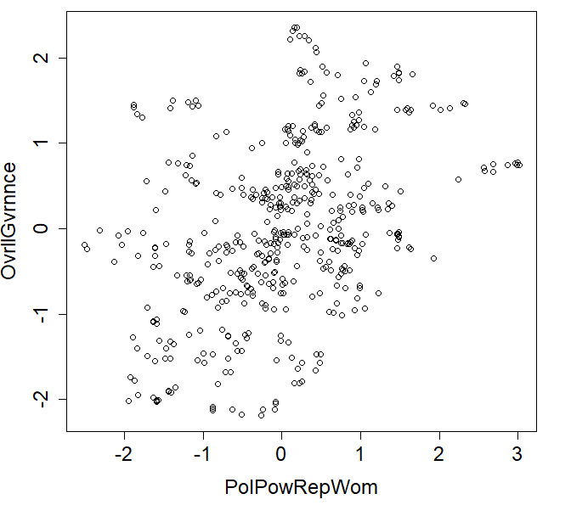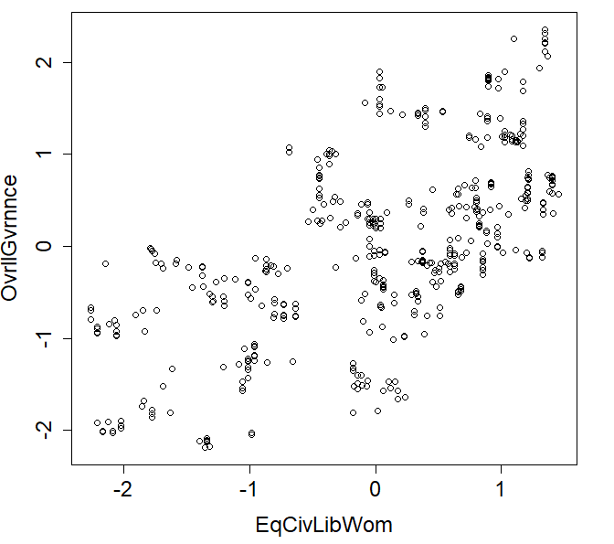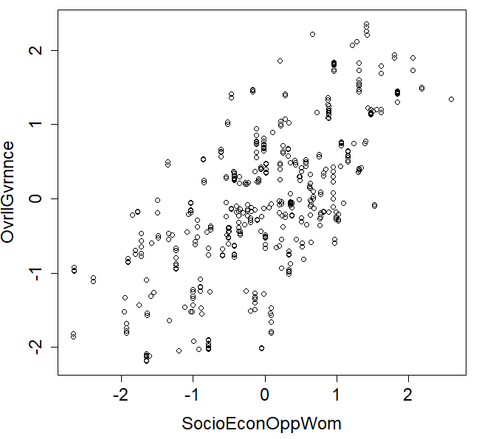
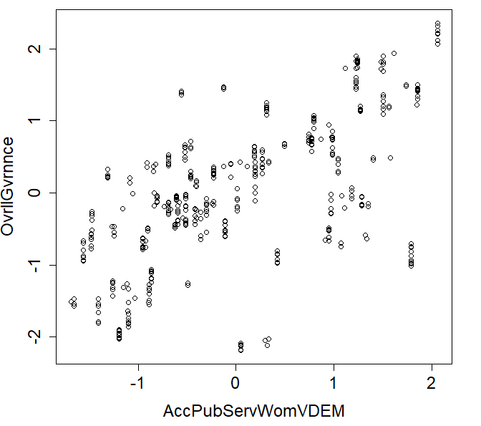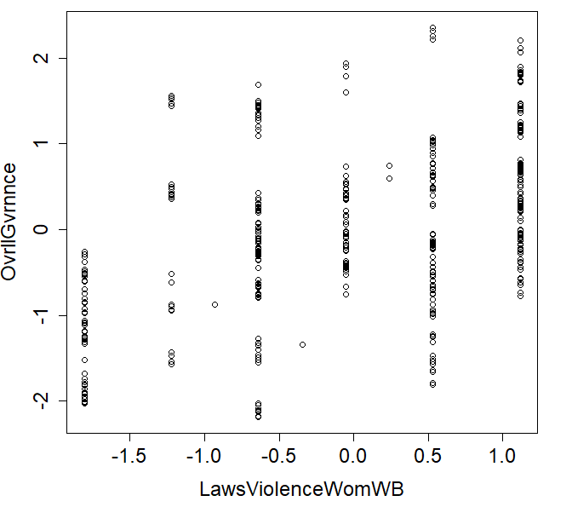

The notion of an external variable is that it is a variable which is external to the clustering process (was not used to cluster country-year observations), as described in Ketchen and Shook (1996).
As described in IIAG (2023), raw data come on different scales from source. To be compared and combined, data are normalised to a range of 0.0-100.0, where 100.0 is the best possible score. Best score noting the direction of good governance etc. on particular variables (indicators).
The countries not included are; Angola, French Southern Territories, Western Sahara, Gabon, Guinea-Bissau, Libya, Mayotte, Reunion, Somalia and South Sudan.
Majority association is simply picking the cluster for which a country-year observation has the largest fuzzy membership function association to (see Andrews et al., 2017; 2023).
We note following McDermott et al. (2013), the FCM may facilitate a fair spread of cases across established clusters, something apparent here.
The ordering of the clusters in Figure 5b is, without loss of generality, based on the overall average mean value of country-year observations across all cluster variables, from highest (C1) down to lowest (C7). While this is notional ordering, with all variables measured over the same domain (positivity of governance in that area), it does offer a suggestion of depth of average positivity.
Clearly, in the case of GenParEduc, through IIAG the considered clustering variables may contribute to this score. However, how representative are the clusters in relation to OvrllGvrnnce is worthy of inspection.
Looking to the future, it would be beneficial to include other profiling variable in these regression analyses, see Andrews et al. (2017; 2023), as discussed in the conclusions.

