Uncertainty based ranking of ‘Accounting’ courses in UK universities based on their National Student Survey theme scores using Classification and Ranking Belief Simplex

Malcolm J. Beynon

Cardiff Business School
Cardiff University
Cardiff
CF10 3EU

Email: beynonmj@cardiff.ac.uk

Uncertainty based ranking of ‘Accounting’ courses in UK universities based on their National Student Survey theme scores using Classification and Ranking Belief Simplex
Abstract
In the UK, the annual National Student Survey (NSS) has embedded itself in the country’s higher education sector as a reality check to the state of the concomitant undergraduate student learning experience (SLE). Its impact grows year on year, with universities comparing themselves against each other on their respective NSS scores (based positivity scores), as well as prospective students using these results to evidence their potential university decision-making. The SLE themes included in the NSS are; teaching on my course, learning opportunities, assessment and feedback, academic support, operations and management and learning resource. This study offers a novel set of ranking analyses of ‘Accounting’ courses in UK universities based on their NSS theme positivity scores, using the Classification and Ranking Belief Simplex (CaRBS) technique, demonstrating an uncertain reasoning approach in this case (along with SMARTER based benchmark ranking results). The CaRBS analyses use slightly different versions of the data, firstly a direct ranking of the courses based on theme positivity scores, and secondly a ranking which includes also the impact of the level of non-participation of students on the individual courses to the NSS survey themes. This non-participation brings levels of uncertainty in the ranking positions of the considered ‘Accounting’ courses, premised on separate levels of belief and plausibility in possible rank positions. With emphasis on the visualisation of results, the findings clearly demonstrate how uncertainty/ignorance (here levels of non-participation) in NSS evidence may have an impact on the perceived ranking results and these should certainly not be considered an irrelevance in any subsequent prospective student decision making.

- Introduction
The National Student Survey (NSS) is an annual survey in the UK higher education sector, enabling final year undergraduate students to offer opinions on their student learning experience (SLE - see Arthur, 2020). Since its introduction in 2005, at the behest of the UK Government (Sabri, 2013), it (NSS) has established itself as an impacting source of evidence to both university managers and prospective students alike (Tauringana et al., 2019; Dean et al., 2020).
A noticeable particular form of the elucidation of the NSS data is through their inclusion in league tables (Gibbons et al., 2015), with a subsequent prospective ranking of universities, and courses, exposited. Different levels of NSS data are available, including university level and course level (see Cheng and Marsh, 2010; Pollet and Shepherd, 2022, and in terms of world rankings in general, Romanova et al., 2019). With the existence of league tables of NSS data, the issue becomes that of the rank positions of university and/or courses (Thiel, 2019), and i) subsequently for university managers the potential for ‘case’ rank strategic marketing and ii) prospective student decision making on university choice.
One under considered feature of the NSS data is the level of participation/non-participation of the students on a course in terms of them responding to the call to undertake NSS (and undertaking the required NSS responses). ?? and ?? both acknowledge the potential for significant non-participation of students with the NSS. The direct effect of such participation consideration is to avail a notion of certainty/uncertainty in the inference of the concomitant rankings in league tables (e.g. less participation – less certainty etc.). Hence whether decision making by universities or prospective students, whether they should take into consideration the ‘uncertainty’ associated with participation levels of students with NSS.
To date, there has been very little research on NSS which has included reference to the levels of participation of the students with the NSS. One exception is Bell and Brooks (2019), which included participating rates as a variable in analysis, noting as a key finding, that the participation rate is highly significantly and positively related to student satisfaction. This dearth of consideration is very surprising, given the ways and means university managers (and their subordinates) may expend energies and strategies on motivating their concomitant students to positively participate in the NSS (see Thiel, 2019). Indeed, the overseers of the NSS themselves are clear about to what level a university (course) may strategically ‘motivate’ their students to participate in the NSS (see NSS, 2023).
Central to the employed ranking approaches in this study is the technique called Classification and Ranking Belief Simplex (CaRBS – Beynon 2005), which infers a form of uncertain reasoning underlying the analysis undertaken (ibid.). Moreover, with its rudiments based on the Dempster-Shafer theory of evidence (DST – Dempster, 1967; Shafer, 1976), it is (Du and Zhong, 2021, p. 1201);

“….a flexible and useful mathematical tool for expressing and combining information under ignorance. … Combining DST with decision theory, … was introduced to analyze multiple-criteria decision-making (MCDM) issues in uncertain environments.”

A feature of the DST based CaRBS approach is its emphasis on the graphical elucidation of the ‘workings’ of analysis, an important feature when trying to elucidate results to both technical and non-technical stakeholders (see Beynon, 2005), a potential feature of the stakeholders interested in NSS based ranking results. It follows, this study also offers the opportunity to view how DST based ignorance/uncertainty may operate (in contrast to say more probabilistic forms).
As the CaRBS name shows, the technique offers both a ranking and classification approach to analysis. Here, the ranking perspective is employed (see Beynon, 2005), but acknowledging ‘classification’ based studies employing CaRBS include, medical (Whatling et al., 2015) and entrepreneurship and innovation (Beynon et al., 2020). We note Beynon and Kitchener (2005, p. 158) employed the ranking form of CaRBS in a healthcare setting, suggesting, i) the method ranks using either of two confidence measures (DST-related belief and plausibility values), ii) presents a systematic approach to managing missing data (not required here), iii) it produces stable rankings, and iv) utilizes the simplex plot method of data representation.
This study offers a novel benchmark on the potential for uncertain/ignorance reasoning type analyses of NSS data in the ranking context. Moreover, the levels of uncertainty/ignorance each NSS theme positivity score includes to the ranking of a course premised on the level of participation of the students on the courses with the NSS. The results presented offer a first ‘direct-effect’ elucidation on the associated participation levels of students to the NSS at the individual theme positivity score level. The presented ‘overlapping’ DST based Belief to Plausibility numerical intervals of ranking scores for courses demonstrates how ‘fragile’ such ranking based inferences may be. Where Belief and Plausibility measures do not and do take into account the ‘uncertainty/ignorance’ based numerical evidence in the NSS theme data, respectively.
The rest of the study is as follows. In section 2, a description of NSS, ranking and non-participation is discussed. Section 3 describes the considered NSS data and initial SMARTER based results presented. In section 4, uncertainty modelling of the NSS data is described as well as the required elements of the CaRBS technique introduced. Section 5 produces CaRBS and final ranking results. In section 6, conclusions are given as well as directions for future research.

- NSS and university rankings
In this section a discussion of NSS is given, with particular emphasis on the role it plays in ranking techniques. Even near the introduction of the annual NSS, Thiel (2019) projects roughly half a million students able to participate, making it a ‘high-profile’ census on SLE. As a tool for the learning about the SLE in UK institutions, the NSS is comparative with similar undertaken surveys in other countries, see details in Bennet and Kane (2014).
A natural consequence of the presence of NSS data in rankings of universities (e.g. in league tables), is the intention of institutions to react to such rankings. Tauringana et al. (2019) offer a description of the NSS improvement initiatives, noting examples relative to specific themes making up the NSS exercise. These initiatives may be targeted directly at the student environment, as well as more indirect restructuring ventures. Behind these initiatives may be the intention of competitive advantage, a factor which makes learning about initiative more difficult. Included in their study, pertinent to the analysis here, is example of the level of change in NSS theme scores, e.g. 53-percent fall, which also offers a scale of how the NSS results may vary year on year.
The focus of the existence of the NSS is to acquire the student perception of their SLE. Bennett and Kane (2014) advocate the variations in how students may interpret the meanings of the questions making up the NSS, going onto describe the factors behind the questions themselves.
Within the UK, the NSS took on further importance, when in 2016, aspects of it were incorporated into the UK Teaching Excellence Framework (TEF), which impacts include the ability for institutions to change their tuition fees (see also Sutherland et al., 2018).
Pollet and Shephard (2022), during the existence of the NSS, have flagged its reliability and regular development.
With ‘Accounting’ courses being the cases of reference in this study, we note Sutherland et al. (2018) considered NSS in the context of Business School explicitly (which will often include management of ‘Accounting’ courses). They go into details of how the NSS themes are perceived in Business Schools. Not a considered feature in this study, but the Business School perspective does get considered as an even more relevant environment where the students are considered consumers in the university sector.

- NSS data and SMARTER analysis
In this section, the considered NSS data is described, along with a ‘simple’ benchmark set of ranking results (using SMARTER, Edwards and Barron, 1994).
A feature of the NSS is that it offers data on student responses at a number of different levels, including university and course level details (see Thiel, 2019). In this study, to offer a level of ‘inherent’ homogeneity in the intended ranking results, a course level analysis is undertaken. Moreover a specific course was considered, which had a presence across a wide range of UK universities, in this case the course termed ‘Accounting’ was considered. Using the most recent 2023 NSS data available, a total of 105 Accounting courses are identified (across the UK) to be compared. One feature of considering course level perspective is that it does facilitate both university managers and prospective students ‘viewpoints’.
Moreover, ‘Accounting’ course ranking results would be of interest to university managers, and also be a model to how prospective students may attempt to rank comparable ‘Accounting’ courses. At the course (and university) level, there is different participation data to consider, with each student able to answer over 20+ questions which the NSS partitions into a number of themes. These themes are ‘teaching on my course’, ‘learning opportunities’, ‘assessment and feedback’, ‘academic support’, ‘operations and management’, ‘learning resource’ and ‘student voice’, and are the considered level of data in this study, see Table 1.

Table 1. Description of criteria themes considered in this study

Theme | Description | Statistics - [min, max], mean, Sd
Teaching on my course (ToMC) | 1. How good are teaching staff at explaining things? 2. How often do teaching staff make the subject engaging? 3. How often is the course intellectually stimulating? 4. How often does your course challenge you to achieve your best work? | [52.8, 98.7]  84.296, 7.427
Learning opportunities (LO) | 5. To what extent have you had the chance to explore ideas and concepts in depth? 6. How well does your course introduce subjects and skills in a way that builds on what you have already? 7. To what extent have you had the chance to bring together information and ideas from different topics? 8. To what extent does your course have the right balance of directed and independent study? 9. How well has your course developed your knowledge and skills that you think you will need for your future? | [48.6, 100.0]  82.877, 6.630
Assessment and feedback (AaF) | 10. How clear were the marking criteria used to assess your work’? 11. How fair has the marking and assessment been on your course? 12. How well have assessments allowed you to demonstrate what you have learned? 13. How often have you received assessment feedback on time? 14. How often does feedback help you to improve your work? | [52.0, 98.2]  79.512, 8.694
Academic support (AS) | 15. How easy was it to contact teaching staff when you needed to? 16. How well have teaching staff supported your learning? | [61.1, 100.0]  85.580, 7.771
Organisation and management (OaM) | 17. How well organised is your course? 18. How well were any changes to teaching on your course communicated? | [33.3, 100.00]  83.066, 9.972
Learning resources (LR) | 19. How well have the IT resources and facilities supported your learning? 20. How well have the library resources (e.g., books, online services and learning spaces) supported your  learning? 21. How easy is it to access subject specific resources (e.g., equipment, facilities, software) when you need them? | [70.0, 100.0]  88.110, 5.352
Student voice (SV) | 22. To what extent do you get the right opportunities to give feedback on your course? 23. To what extent are students' opinions about the course valued by staff? | [51.9, 100.0]  76.906, 8.898

In Table 1, the details of the seven NSS themes are exposited, including the subsets of questions associated with each theme for which a student can offer a response to (see footnote ?). Also shown are descriptive statistics of the reported positivity score for each theme. Where positivity is in terms of the proportions of participating students replying positively to the NSS questions (see NSS, 2023 for further technical details).
Further exposition of the theme level data is given in Figure 1, to evidence the levels of variation in the positivity scores of themes across the different ‘Accounting’ courses, as well as the levels of participation with NSS of students associated with each ‘Accounting’ course.

Figure 1. Boxplot based elucidation of theme scores (1a) and participation levels (1b)

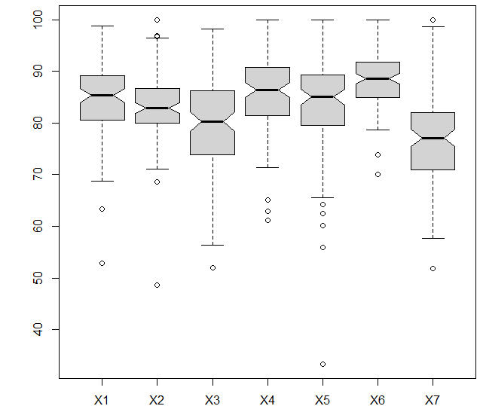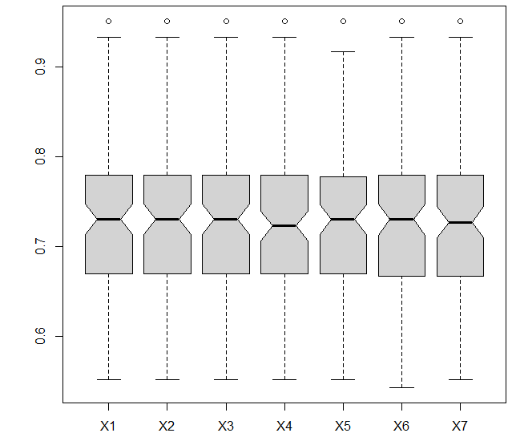

In Figure 1a, each boxplot describes the spread of the respective theme positivity score values for the included 105 considered ‘Accounting’ courses. Their visual variation is a reminder that while in the NSS data a theme positivity score has the theoretical range of 0 – 100, each theme has their own actual sub-range of this. This is interesting in itself, since it elucidates the underlying ‘score’ based feelings the different themes may engender on the students (participating in NSS).
Acknowledging that the later CaRBS analyses will include consideration of the level of participation of students to the NSS theme questions on each ‘Accounting’ course, Figure 1b reports the boxplot based elucidation of the participation levels of students across all themes from the 105 ‘Accounting’ course. The boxplots appear relatively similar which is understandable, since any student participating in the NSS will probably respond to all (the majority) the questions (see also footnote 1). The participation level similarity across the themes suggests this is the case, but the subtle variations show some inconsistent student sets of respondents is evident. Looking across all themes (in boxplot terms) there is a rough median of 73% participation of students amongst the considered universities (‘Accounting’ courses), with rough minimum and maximum participation levels of 55% and 95% evident.
To offer a benchmark set of ranking results to compare against the later CaRBS based results against, here SMARTER based analysis is undertaken. SMARTER (Simple Multi-Attribute Rating Technique Exploiting Ranks – see Edwards and Barron, 1994), is considered a relatively simple preference ranking process based on multi-attribute utility theory (MAUT). As described in Beynon and Kitchener (2005), it is an additive approach for the evaluation of a preference value for each alternative.
In technical terms, for the j^{th} alternative (‘Accounting’ course) then its preference value (PV_{j}) is given by PV_{j} = $\sum_{i=1}^{n}{w_{i}v_{j,i}}$, where $v_{j,i}$ is a standardised theme value and w_{i} is the weight of importance of that theme. Here, without loss of generality to the consideration of other combinations of different weights, equal weighting of the NSS themes is assumed, so w_{i} = 1/n_{T}, i = 1, .. n_{T} (n_{T} - number of Themes). In the context of the constructed NSS problem, the PV_{j} values relate directly to the level of ‘good-SLE’ exhibited by an ‘Accounting’ course. With the notion of good-SLE based on the ‘positive’ direction of each positivity score associated with a theme (the higher the score the more positive opinion to a theme).
The resultant PV_{j} values for the considered 105 ‘Accounting’ courses are presented in graphical form in Figure 2.

Figure 2. Ranking results of alternatives using SMARTER

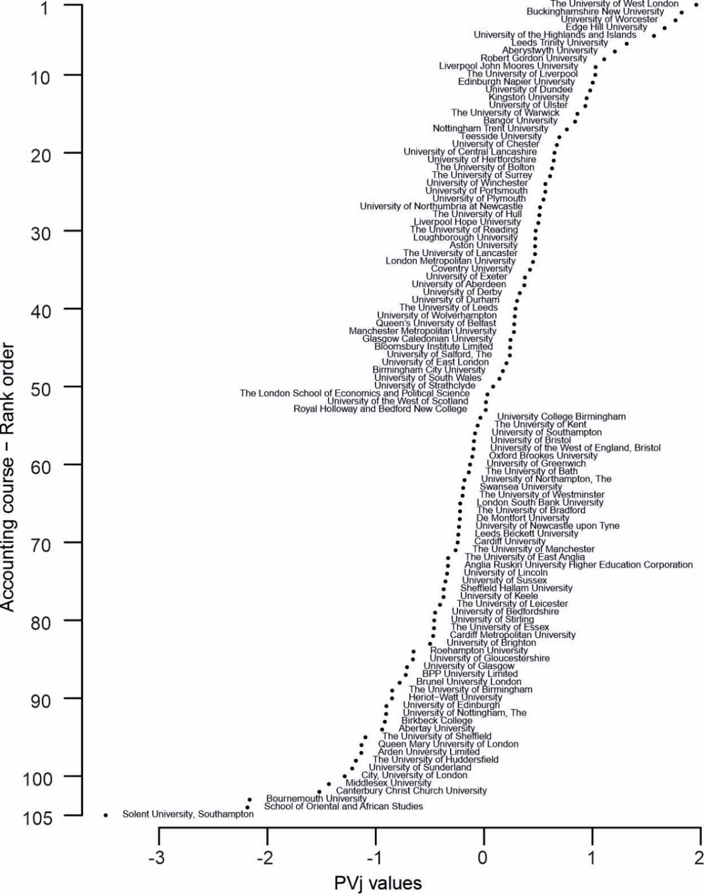

In Figure 2, the considered 105 ‘Accounting’ courses are shown, each represented by their respective ‘good-SLE’ PV_{j} values in PV_{j} rank order, lowest (bottom) to highest (top) scored (ranked). A general observation of the PV_{j} results suggest a smooth incremental set of changes through the main body of PV_{j} values shown, with increased changes at either ends of the PV_{j} range (a boxplot is shown at the top of the plot to evidence the range of PV_{j} values). This set of NSS based ‘good-SLE’ ranking results will form a ‘simple’ benchmark for the next presented CaRBS based analyses.

- CaRBS based rankings of NSS data – two approaches
In this section, two sets of CaRBS based ranking analyses are undertaken on the considered 105 ‘Accounting’ courses and their associated NSS data. The difference in the two sets of analyses is in terms of the way the levels of participation of students on each course are considered. Moreover, the first analyses (CaRBS1), does not take account of the varying levels of student participation on a course with NSS (so similar in context to the SMARTER analysis undertaken), and secondly when the individual courses levels of student participation are taken into account (CaRBS2) (see Figure 1b for evidence on such theme level participation rates of students. As in the SMARTER analysis, in this section, each NSS theme is given equal weighting in terms of the importance of their contribution to overall ‘good-SLE’ ranking of the courses.
The general technical details of the CaRBS ranking approach are given in Appendix A (see also Beynon, 2005; Beynon and Kitchener, 2005). It follows, in each of the CaRBS based ranking analyses undertaken, there is the requirement to assign values to the individual Course (C_{j}) and Theme (T_{i}), the sets of parameters k_{j,i}, θ_{j,i}, A_{j,i} and B_{j,i} (see Appendix A). In contrast to previous use of CaRBS in a ranking context, here the parameters’ details are not at the criteria (theme) level but instead are at the course level only, because it is at the course level that there are different levels of participation uncertainty/ignorance in the second employment of CaRBS here (CaRBS2).

Course ranking without theme based student participation levels (CaRBS1)
In this section there is no consideration of the varying participation levels of students on each ‘Accounting’ course to the NSS. It follows, with equal weighting of importance of the themes, the CaRBS parameters (k_{j,i}, θ_{j,i}, A_{j,i} and B_{j,i}) for each theme and course are first established.
Here, the parameter values k_{j,i} and θ_{j,i} were the respective k_{j,i} = 1/(4σ_{j,i}) and θ_{j,i} = $\overline{v_{i}}$ (as described in Appendix A – but noting here we include a 4 in the denominator for k_{j,i} to reduce the non-linearity in the associated confidence value function). For each A_{j,i} and B_{j,i}, they are identified by the levels of ignorance to be considered in the theme level evidence, noting as in Beynon (2005), a single theme on its own is considered a low level measurement, which on its own cannot explain overall ‘good-SLE’, hence the argued inclusion of ignorance with an individual theme’s evidence. Here, a general interval of ignorance employed is [Θ_{L,j,i}, Θ_{U,j,i}] = [0.5, 0.5], which from Appendix A means, B_{j,i} = 0.5 and A_{j,i} = $\frac{0.5-0.5}{1+0.5-2*0.5}=0.0$.
Using the defined CaRBS parameters, two example sets of constructed theme BOEs and final BOEs are shown for two sample ‘Accounting’ courses, see Table 2.

Table 2. Example theme and final course-SLE BOEs using CaRBS1 analysis for two Accounting courses

BOE | ToMC | LO | AaF | AS | OaM | LR | SV | Final BOE  m_{j}($∙$)
scores | 76.3 | 79 | 82.5 | 82.5 | 85 | 80.7 | 71.7
m_{4,i}({x}) | 0.217 | 0.232 | 0.261 | 0.238 | 0.256 | 0.207 | 0.232 | 0.415
m_{4,i}({¬x}) | 0.283 | 0.268 | 0.239 | 0.262 | 0.244 | 0.293 | 0.268 | 0.540
m_{4,i}({x, ¬x}) | 0.500 | 0.500 | 0.500 | 0.500 | 0.500 | 0.500 | 0.500 | 0.045
scores | 98.7 | 93.7 | 87.4 | 97.4 | 86.8 | 94.7 | 91.2
m_{15,i}({x}) | 0.309 | 0.300 | 0.278 | 0.297 | 0.262 | 0.288 | 0.300 | 0.637
m_{15,i}({¬x}) | 0.191 | 0.200 | 0.222 | 0.203 | 0.238 | 0.212 | 0.200 | 0.319
m_{15,i}({x, ¬x}) | 0.500 | 0.500 | 0.500 | 0.500 | 0.500 | 0.500 | 0.500 | 0.044

In Table 2, each of the first seven columns reports a theme BOE (Body of Evidence – see Appendix A), describing the levels of exact belief in theme evidence to {x} (good-SLE) and {¬x} (not-good-SLE) and {x, ¬x} (ignorance). Inspection shows noticeable levels of ignorance (m_{j,i}({x, ¬x})) with each theme (each considered a low level piece of evidence on their own). The far right column gives the final course-SLE BOE for the reference ‘Accounting’ course, found from the combination of the respective theme BOEs (using combination rule as described in Appendix A). Inspection shows much less ignorance (m_{j}({x, ¬x})) associated within the final course-SLE BOE compared with the individual theme BOEs, a demonstration of how the combination of ‘low level’ theme evidence combines into a less ignorant piece of evidence (here in terms of final course-SLE BOE).
For each ‘Accounting’ course, the final course-SLE BOEs can be represented as simplex coordinates in a simplex plot (see Appendix A), see Figure 3, for the considered 105 ‘Accounting’ courses.

Figure 3. Simplex plot representations of final course-SLE BOEs (using CaRBS1)

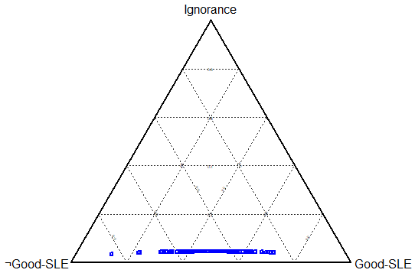

In the simplex plot in Figure 3, each point (simplex coordinate) represents a final course-SLE BOE. With the almost same ignorance attributed to each theme on a course (distance away from base line of simplex plot), the very ‘limited’ difference in heights of the simplex coordinates is through levels of conflict in the theme level pieces of evidence (identified when combining theme BOEs to achieve a final course-SLE BOE).
With the final course-SLE BOEs (m_{j}($∙$)) also made up of the mass values m_{j}({x}), m_{j}({¬x}) and m_{j}({x, ¬x}), two final forms of ‘ranking’ evidence can be constructed, termed Belief and Plausibility. These Belief (Bel_{j}({x})) and Plausibility (Pls_{j}({x})) measures exclude and include the concomitant ignorance (m_{j}({x, ¬x}) respectively, and are at the ends of the evidence spectrum in a BOE. The respective Belief (Bel_{j}({x}) = m_{j}({x})) and Plausibility (Pls_{j}({x}) = m_{j}({x}) + m_{j}({x, ¬x})) results for this set of final course-SLE BOEs are shown in Figure 4.

Figure 4. Ranking results of ‘Accounting’ courses using CaRBS1, based on Belief (circles - left) and Plausibility (crosses - right)

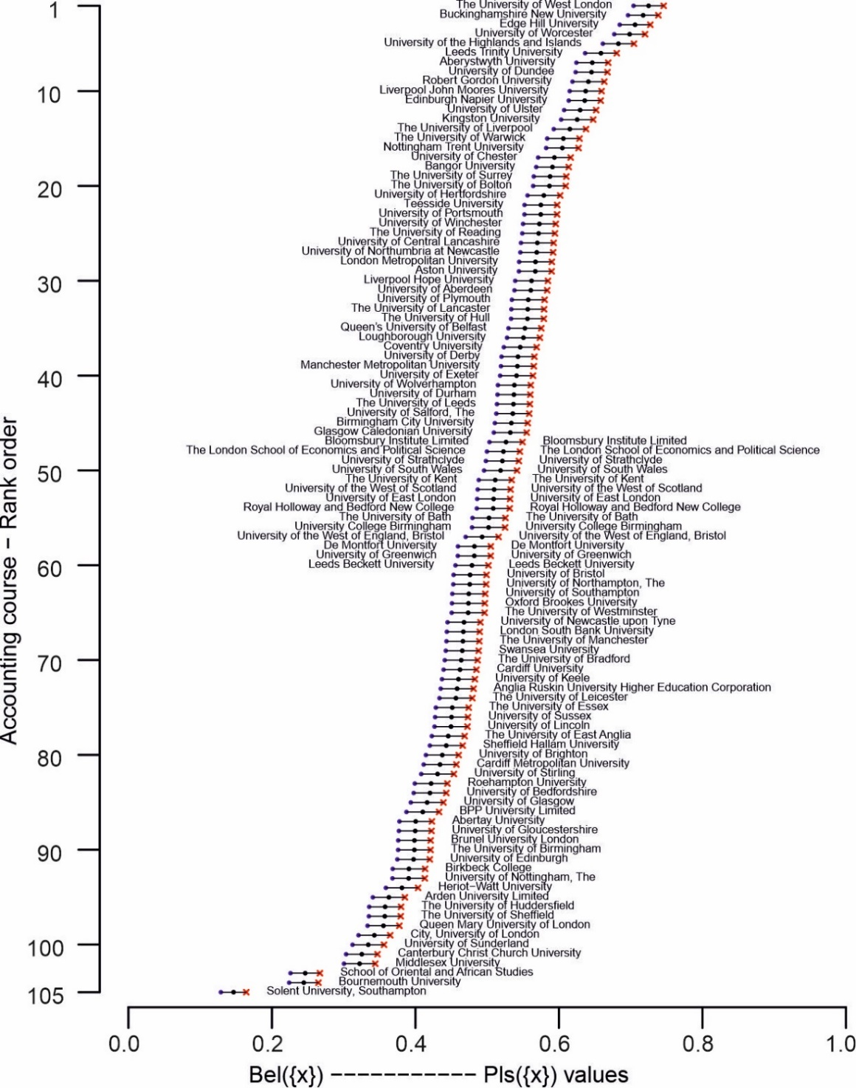

In Figure 4, two separate rankings of the 105 Accounting courses are given, for each ‘Accounting’ course, the left set of circles are Belief (Bel_{j}({x})) values, and right set of crosses are respective Plausibility (Pls_{j}({x})) values. In between each circle and cross for a course is a further circle which is midway (in horizontal distance) between respective Bel_{j}({x}) and Pls_{j}({x}) (in technical terms value has 0.5(Bel_{j}({x}) + Pls_{j}({x}))). Thin lines join respective ‘Accounting’ course Belief and Plausibility values, for which there are two points of interest;

- The horizontal distance between a course belief and plausibility points (circle and crosses joined by lines) rank position is the associated ignorance (m_{j}({x, ¬x})).
- The vertical distance (in terms of rank positions difference) shows the volatility of a course’s rank position in the course-SLE BOE, based on the impact of the difference in level of ignorance associated with each final course-SLE BOE (in Figure 4 there is no volatility in rank positions shown – but see later).

Inspection of the Belief-Plausibility sets of points shows limited (actually no) difference in the respective sets of Belief and plausibility ranks of points. This is due to the theme positivity score only being used, without inclusion of the levels of participation of the student on each course with the NSS.

Course ranking with student theme based participation levels (CaRBS2)
The next utilisation of the CaRBS technique is the potential to rank ‘Accounting’ courses, but taking into consideration the levels of participation of the students to the NSS survey on each considered course. A feature of the NSS data sent out to universities is that it includes the level (numbers) of participating and non-participating students on each course and specifically at theme level (see Figure 1b).
In this sub-section, the CaRBS parameter k_{j,i} and θ_{j,i} are the same as in the previous sub-section. The A_{j,i} and B_{j,i} parameters, being associated with concomitant ignorance in evidence, are different and next explained. Here, general interval of ignorance of [0.5, 0.9] is considered, with the 0.9 (changed from 0.5 in previous sub-section), an acknowledgement that with the potential for upto 50% non-participation of students on a considered ‘Accounting’ course there may be different levels of ignorance in the theme based evidence included for different courses. These are general bounds, with course specific [Θ_{L,j,i}, Θ_{U,j,i}] ignorance intervals next identified.
For a Course C_{j} and Theme T_{i}, the level of student participation is given by r_{j,i} = Number of respondents / Number of population (noting r_{j,i} > 0.5 to be included as per NSS rules). It follows, as r_{j,i} gets larger there is larger student participation with NSS on the course so more certainty in the evidence in a respective theme BOE, so a lower Θ_{U,j,i} should be employed (noting Θ_{L,j,i} remains for all course as in the previous sub-section). Therefore, here for a course with r_{j,i} level of participation, then Θ_{U,j,i} = 1.3 – 0.8r_{j,i} (since when r_{j,i} = 0.5 then Θ_{U,j,i} = 1.3 – 0.8*0.5 = 0.9 and r_{j,i} = 1.0 then Θ_{U,j,i} = 1.3 – 0.8*1.0 = 0.5).
Using the same example ‘Accounting’ courses as in CaRBS1 analysis (see Table 2), Table 3 shows the respective theme and final BOEs.

Table 3. Example theme and final course-SLE BOEs using CaRBS2 analysis for two ‘Accounting’ courses

BOE | ToMC | LO | AaF | AS | OaM | LR | SV | Final BOE  m_{j}($∙$)
scores | 76.3 | 79 | 82.5 | 82.5 | 85 | 80.7 | 71.7
m_{4,i}({x}) | 0.037 | 0.081 | 0.163 | 0.097 | 0.150 | 0.000 | 0.081 | 0.212
m_{4,i}({¬x}) | 0.227 | 0.184 | 0.102 | 0.168 | 0.115 | 0.245 | 0.184 | 0.564
m_{4,i}({x, ¬x}) | 0.735 | 0.735 | 0.735 | 0.735 | 0.735 | 0.755 | 0.735 | 0.224
scores | 98.7 | 93.7 | 87.4 | 97.4 | 86.8 | 94.7 | 91.2
m_{15,i}({x}) | 0.323 | 0.311 | 0.282 | 0.307 | 0.260 | 0.295 | 0.310 | 0.681
m_{15,i}({¬x}) | 0.166 | 0.178 | 0.207 | 0.182 | 0.229 | 0.194 | 0.179 | 0.272
m_{15,i}({x, ¬x}) | 0.511 | 0.511 | 0.511 | 0.511 | 0.511 | 0.511 | 0.511 | 0.047

In Table 3, the individual theme BOEs and final BOEs are shown for two ‘Accounting’ courses. Comparisons of the levels of ignorance (m_{j}({x, ¬x})) across the sets of theme BOEs are different between the two courses (and those in Table 2 when employing CaRBS1). It is known the two ‘Accounting’ courses have respective participation rates of r_{4,i} = 0.571 (and 0.543 for OaM) and r_{15,i} = 0.906, hence the higher levels of ignorance in theme BOEs associated with m_{4,i}({x, ¬x}) = 0.735 compared to m_{15,i}({x, ¬x}) = 0.511, a direct consequence of the respective levels of student participation for students on the two sample ‘Accounting’ courses (shown in Table 3). Similar variations in ignorance are subsequently exhibited in the respective final course-SLE BOEs shown (m₄({x, ¬x}) = 0.224, to m₁₅({x, ¬x}) = 0.047).
The resultant simplex coordinates of final course-SLE BOEs for the considered ‘Accounting’ courses are shown in a simplex plot, see Figure 5.

Figure 5. Simplex plot representations of final course-SLE BOEs (using CaRBS2)

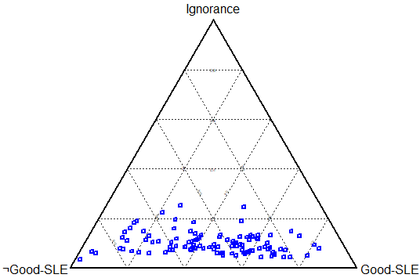

In Figure 5, each point represents a final course-SLE BOE, established from the combination of the respective course theme BOEs. Compared to the previous results with CaRBS1 (see Figure 3) there is much more variation in heights of final course-SLE BOE simplex coordinates. In this case, the height of the simplex coordinates (towards the ignorance vertex) is associated with levels of participation/non-participation of the respective students on each considered course to NSS.
The subsequent ranking graphs (Belief ---------- Plausibility) for this set of final course-SLE BOEs are presented in Figures 6 and 7.

Figure 6. Ranking results of ‘Accounting’ courses using CaRBS2, with non-ranked Belief (circles - left) and Plausibility (crosses - right)
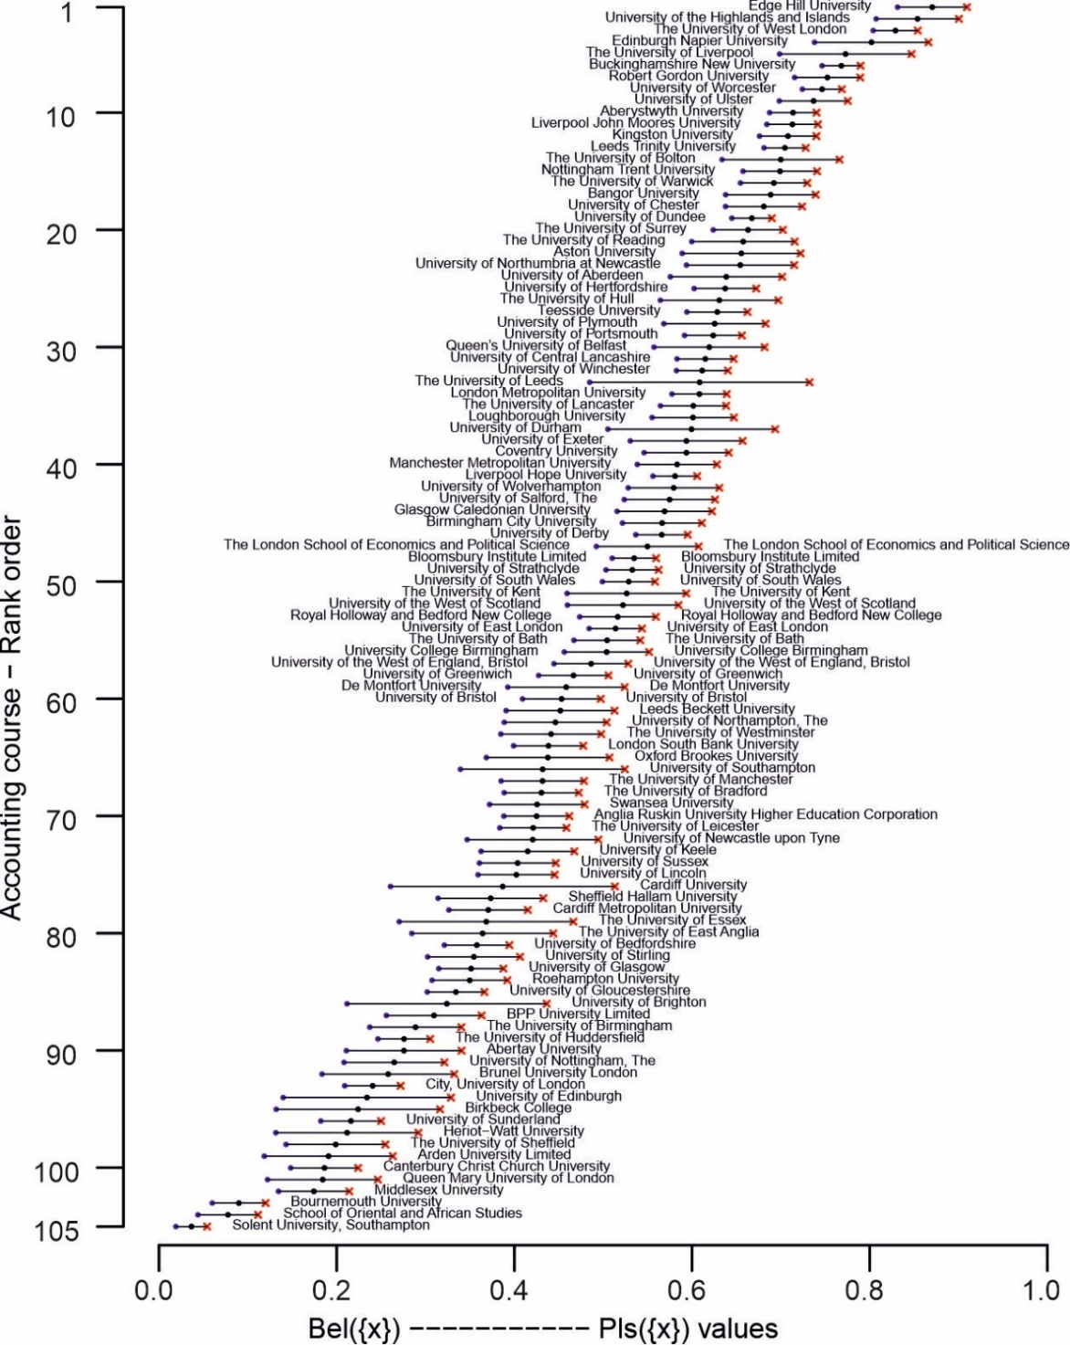

In Figure 6, as in Figure 4, the 105 ‘Accounting’ courses are ranked on the middle 0.5(Bel_{j}({x}) + Pls_{j}({x})) value (centre circles), with lines reaching out left and right to their respective Belief and Plausibility values. As evidenced in Table 3, there is noticeable variety in the widths between associated pairs of Belief (circles) and Plausibility (crosses), either side of central circle, a direct consequence of the differing levels of ignorance present in evaluated final course-SLE BOEs, itself directly related to the levels of student participation with NSS on the individual ‘Accounting’ courses.
These variations in associated Belief and Plausibility do suggest that depending on the consideration of the ignorance, if next ranking on the ‘spectrum’ extremes of Belief and Plausibility would change the rank ordering (or any points within the spectrum). With this in mind, a similar CaRBS2 based ranking graph is given in Figure 7, but now respective Bel and Plausibility values are also ranked.

Figure 7. Ranking results of ‘Accounting’ courses using CaRBS2, with ranked Belief (circles - left) and Plausibility (crosses - right)

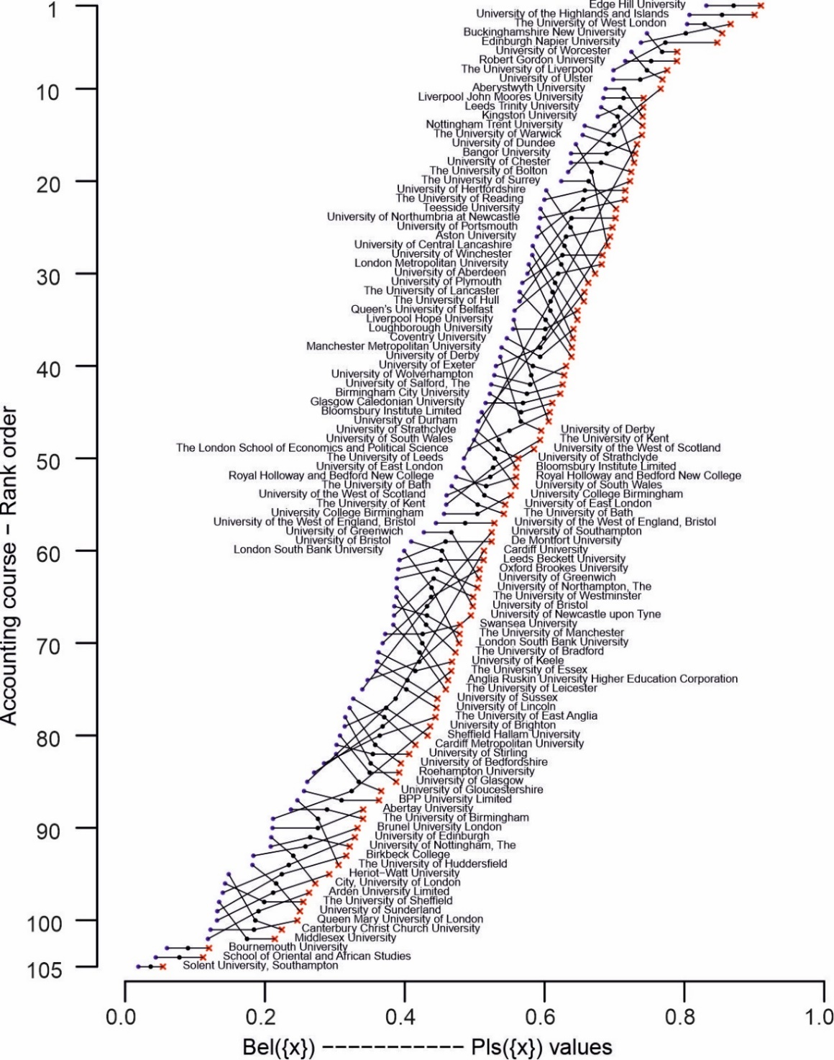

In Figure 7, for an individual ‘Accounting’ course it is ranked again on the 0.5(Bel_{j}({x}) + Pls_{j}({x})) (central circle), as in Figure 6. Then thin lines extend from this point to their respective Belief and Plausibility values, now themselves separately rank ordered.
It follows, for different ‘Accounting’ courses, their respective Belief and Plausibility rank positions will either be ‘above and below’, or ‘below and above’, relative to their central circle. The variation in the levels of rank difference exhibited when considering Belief and Plausibility rank positions demonstrates ‘effectively’ how, if considering student participation levels on courses with NSS, the level of rank uncertainty could be dramatically different. There is an important point here, those students not participating with NSS, if they were to, could offer positive or not-positive opinions, something then subsequently reflected in the Belief and Plausibility values (both in terms of their opinion and that they participated in giving their opinion).
To bring together the results from the SMARTER, CaRBS1 and CaRBS2 analyses, we next briefly elucidate a comparison between the respective values, see Figure 8.

Figure 8. Comparison of ‘good-SLE’ results between SMARTER, CaRBS1 and CaRBS2

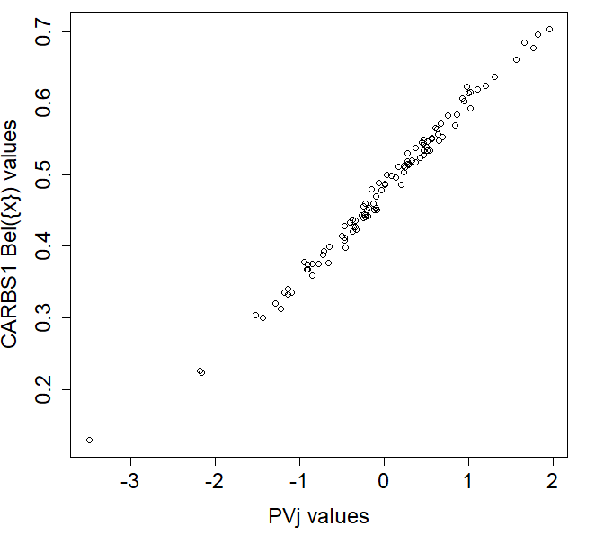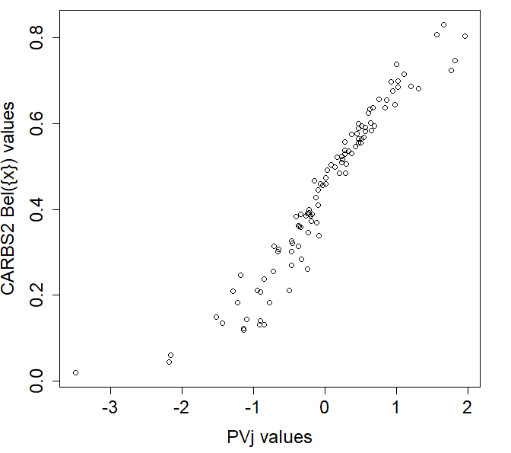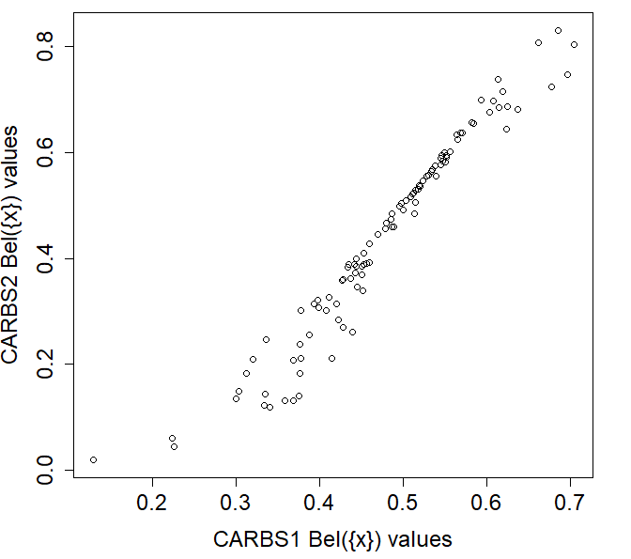
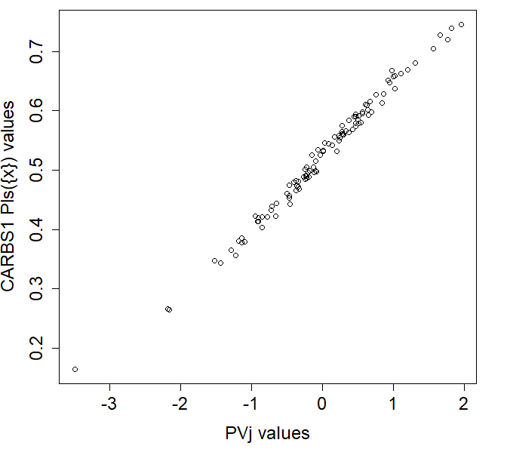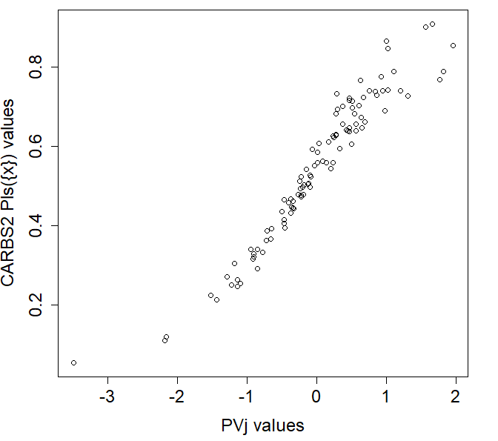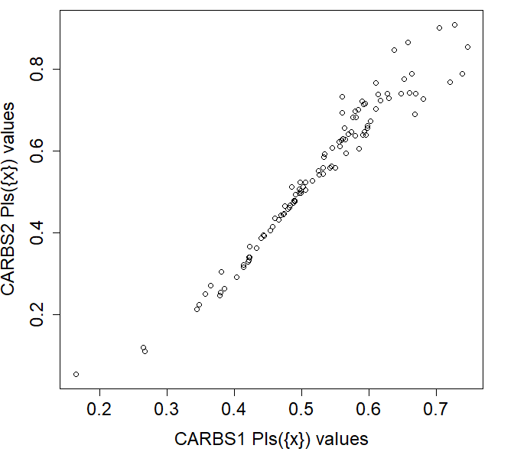

In Figure 8, each scatterplot shows the comparisons between pairs of ‘good-SLE’ scores from the different analyses undertaken. Each row, top and bottom, undertakes comparisons between Bel({x}) and Pls({x}) sets of values, respectively, including against the previously found PV_{j} values.

5. Conclusions
This study has elucidated a novel approach to the ranking of courses across UK universities in respect to their NSS theme based scores. Its novelty has been through the inclusion the considerations of the level of non-participation students to the NSS on the individual included courses. As such, it offers a benchmark on the potential impact of ‘non-participation’ uncertainty in the NSS inferences. With increasing effect/impact associated with NSS results, and subsequent reactions entered into, this study is very much a demonstration of decision-making under uncertainty.
The CaRBS technique, using the Dempster-Shafer theory of evidence, is shown to be a versatile approach where ‘non-participation’ based ignorance is able to be realistically modelled. The Belief and Plausibility ‘good-SLE’ results are a clear demonstration of how ignorance can be ‘differently’ considered in the context of ranking of courses based on NSS theme scores. Looking to the future, it would be interesting to see how different ‘importance’ weightings of themes may impact on ranking results.
In terms of practical considerations for university managers and/or prospective students, the analysis in this study is very much a demonstration with hoe ‘uncertainty’ may be associated with rank positions, and therefore how this may impact on pertinent decision-making.

Appendix A
This appendix briefly describes the CaRBS technique, including its use to rank alternatives. For full technical details in the ranking context, see Beynon (2005) and Beynon and Kitchener (2005).
In the context of CaRBS, using the rudiments of DST, we consider a set of two hypotheses Θ = {x, ¬x}, a mass function m: 2^{Θ} → [0, 1], such that m(φ) = 0 (φ - empty set), for any $s⊏2^{Θ}$ (2^{Θ} - power set of Θ), for which m(s) is non-zero, it is called a focal element and the m(s) value represents the exact belief ‘evidence’ in the proposition. The collection of mass values (and focal elements) associated with a single piece of evidence is called a body of evidence (BOE). With Θ = {x, ¬x}, a BoE is made up of three focal elements {x}, {¬x} and {x, ¬x} depicting, with accompanying mass values m({x}), m({¬x}) and m({x, ¬x}), which sum to one (m({x}) + m({¬x}) + m({x, ¬x}) = 1).
Based on these details, focal elements and mass values, the rudiments of the CaRBS technique are shown in Figure A1 (with description given in context of NSS based study).

Figure A1. Graphical elucidation of the CaRBS technique

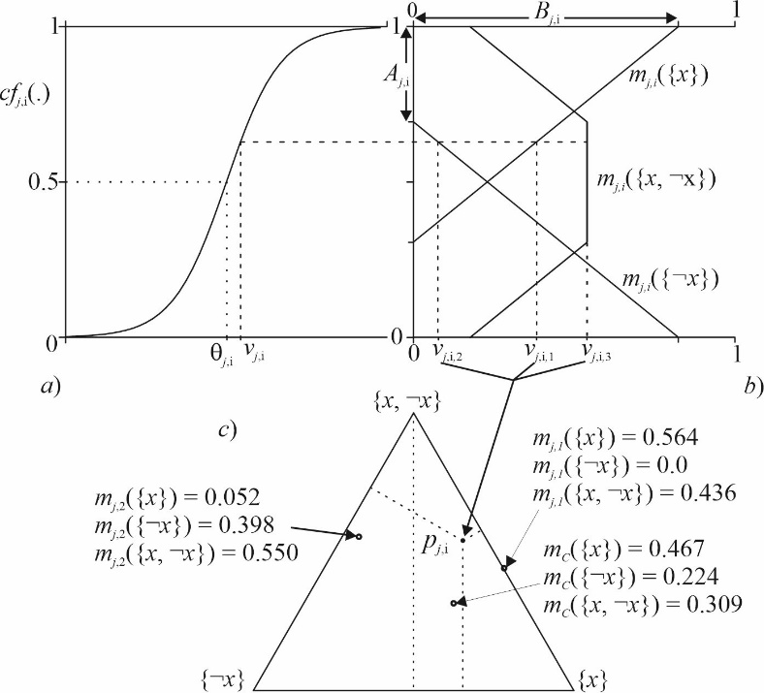

For a positivity score v_{j,i} (for Course C_{j} and Theme T_{i}) in the NSS data set, it is first transformed into a confidence value over a 0 – 1 domain using a sigmoid function (see Beynon, 2005), with control parameters k_{j,i} and θ_{j,i} (see Figure A1a). The resultant value is partitioned into a Theme BOE m_{j,i}({x}) with mass values and focal elements, m_{j,i}({x}), m_{j,i}({¬x}) and m_{j,i}({x, ¬x}), as shown in Figure A1b, with parameters A_{j,i} and B_{j,i}, using the functions;

m_{j,i}({x}) = $max (0, \frac{B_{i}}{1-A_{i}}{cf}_{i}$(v_{j,i})$-\frac{{A_{i}B}_{i}}{1-A_{i}})$, m_{j,i}({¬x}) = $max (0, \frac{{-B}_{i}}{1-A_{i}}{cf}_{i}\left(v\right)+B_{i})$
and m_{j,i}({x, ¬x}) = 1 – m_{j,i}({x}) – m_{j,i}({¬x}),

where ${cf}_{j,i}\left(vj,i\right)= 1/{(1+exp⁡(-k_{j,i}(vj,i-θ_{j,i}})))$ and m_{j,i}({x}) + m_{j,i}({¬x}) + m_{j,i}({x, ¬x}) = 1. These three mass values can be depicted as a point p_{j,i} = (x_{j,i}, y_{j,i}) in a simplex plot (see Figure A1c), with values x_{j,i} = m_{j,i}({x}) + 0.5m_{j,i}({x, ¬x}) and y_{j,i} = 0.5$\sqrt{3}$m_{j,i}({x, ¬x}).
Also shown in Figure A1c are two example simplex coordinates (points) with known BOEs m_{j,1}($∙$) and m_{j,2}($∙$). The combination of these two pieces of evidence is shown as a simplex coordinate (point) and associated BOE m_{j}($∙$), using the combination rule (given in specific terms [m_{j,j} $⊕$m_{j,k}]($∙$), with details;
[m_{j,i} $⊕$m_{j,k}]($\{x\}$) = $\frac{m_{j,i }\left(\left\{x\right\}\right)m_{j,i }\left(\left\{x\right\}\right)+ m_{j,i }\left(\left\{x\right\}\right)m_{j,i }\left(\left\{x, ¬x\right\}\right)+m_{j,i }(\left\{x, ¬x\right\})m_{j,i }(\left\{x\right\})}{1-{(m}_{j,i }\left(\left\{¬x\right\}\right)m_{j,i }\left(\left\{x\right\}\right)+m_{j,i }(\left\{x\right\})m_{j,i }(\left\{¬x\right\}))}$
[m_{j,i} $⊕$m_{j,k}]($\{¬x\}$) = $\frac{m_{j,i }\left(\left\{¬x\right\}\right)m_{j,i }\left(\left\{¬x\right\}\right)+ m_{j,i }\left(\left\{¬x\right\}\right)m_{j,i }\left(\left\{x, ¬x\right\}\right)+m_{j,i }(\left\{x, ¬x\right\})m_{j,i }(\left\{¬x\right\})}{1-{(m}_{j,i }\left(\left\{¬x\right\}\right)m_{j,i }\left(\left\{x\right\}\right)+m_{j,i }(\left\{x\right\})m_{j,i }(\left\{¬x\right\}))}$
[m_{j,i} $⊕$m_{j,k}]($\{x, ¬x\}$) = 1 – ([m_{j,i} $⊕$m_{j,k}]($\{x\}$) + [m_{j,i} $⊕$m_{j,k}]($\{¬x\}$)).
which can be applied to multiple pieces of evidence (not just two pieces of evidence). The resultant combined evidence is itself made up of three mass values m_{j}({x}), m_{j}({¬x}) and m_{j}({x, ¬x}). For a particular Course C_{j}, the m_{j}($∙$) is the final course-SLE BOE based upon which its place in a ranking of courses can be found.
For each Course C_{j} and Theme T_{i}, the set of parameter values k_{j,i}, θ_{j,i}, A_{j,i} and B_{j,i}, are required to be assigned values. Following Beynon (2005) and Beynon and Kitchener (2005) the parameters are found by k_{j,i} = 1/σ_{j,i} (where σ _{j,i} = $\sqrt{\frac{1}{n}\sum_{j=1}^{n}{{\left(\overline{v_{i}}-v_{j,i}\right)}^{2}}}$ is respective standard deviation of value for that attribute – also note +1 is used consistently since there is an understood positive relationship of each theme to overall ranking), θ_{j,i} = $\overline{v_{i}}$ (where $\overline{v_{i}}$ = $\frac{1}{n}\sum_{j=1}^{n}{v_{j,i}}$ is the respective mean value). For A_{j,i} and B_{j,i}, following Beynon and Kitchener (2005), these are based on an allowed ignorance value, here [Θ_{L,j,i}, Θ_{U,j,i}]. Following Beynon (2005), setting B_{j,i} = Θ_{U,j,i}, then A_{j,i} = $\frac{Θ_{U,j,i}-Θ_{L,j,i}}{1+Θ_{U,j,i}-2Θ_{L,j,i}}$.

References
Arthur, L. (2020). Evaluating student satisfaction-restricting lecturer professionalism: outcomes of using the UK national student survey questionnaire for internal student evaluation of teaching. Assessment & Evaluation in Higher Education, 45(3), 331-344.
Bell, A. R., & Brooks, C. (2019). Is there a ‘magic link’ between research activity, professional teaching qualifications and student satisfaction?. Higher Education Policy, 32, 227-248.
Bennett, R., & Kane, S. (2014). Students’ interpretations of the meanings of questionnaire items in the National Student Survey. Quality in Higher Education, 20(2), 129-164.
Beynon, M., Jones, P. and Pickernell, D. (2020). SME development strategy and product/service innovation intention: a NCaRBS analysis of the role of uncertainty. International Journal of Entrepreneurship and Innovation, 21(1), 3-16.
Beynon, M. J. (2005). A novel technique of object ranking and classification under ignorance: An application to the corporate failure risk problem. European Journal of Operational Research, 167(2), 493-517.
Beynon, M., & Kitchener, M. (2005). Ranking the ‘balance’ of state long-term care systems: a comparative exposition of the SMARTER and CaRBS techniques. Health Care Management Science, 8, 157-166.
Brown, S. (2011). Bringing about positive change in the higher education student experience: a case study. Quality Assurance in Education, 19(3), 195-207.
Cheng, J. H., & Marsh, H. W. (2010). National Student Survey: are differences between universities and courses reliable and meaningful?. Oxford Review of Education, 36(6), 693-712.
Dean, A., Shubita, M., & Claxton, J. (2020). What type of learning journey do students value most? Understanding enduring factors from the NSS leading to responsible decision-making. Journal of Global Responsibility, 11(4), 347-362.
Dempster A.P. (1967) Upper and lower probabilities induced by a multivalued mapping. Ann. Math. Stat., 38, 325-339
Du, Y. W., & Zhong, J. J. (2021). Generalized combination rule for evidential reasoning approach and Dempster–Shafer theory of evidence. Information Sciences, 547, 1201-1232.
Edwards, W., & Barron, F. H. (1994). SMARTS and SMARTER: Improved simple methods for multiattribute utility measurement. Organizational Behavior and Human Decision Processes, 60(3), 306-325.
Gibbons, S., Neumayer, E., & Perkins, R. (2015). Student satisfaction, league tables and university applications: Evidence from Britain. Economics of Education Review, 48, 148-164.
Pollet, T. V., & Shepherd, L. (2022). Subscales in the National Student Survey (NSS): Some considerations on their structure. Journal of Further and Higher Education, 46(9), 1195-1211.
Romanova, E., Kireeva, O., & Podzorova, M. (2019, October). World university rankings and leadership: global analysis and methods for improvement. In 4th International Conference on Social, Business, and Academic Leadership (ICSBAL 2019) (pp. 209-215). Atlantis Press.
Sabri, D. (2013). Student evaluations of teaching as ‘fact-totems’: The case of the UK national student survey. Sociological Research Online, 18(4), 148-157.
Shafer, G., (1976). A Mathematical Theory of Evidence. Princeton University Press, Princeton, NJ.
Sutherland, D., Warwick, P., Anderson, J., & Learmonth, M. (2018). How do quality of teaching, assessment, and feedback drive undergraduate course satisfaction in UK business schools? A comparative analysis with nonbusiness school courses using the UK national student survey. Journal of Management Education, 42(5), 618-649.
Tauringana, V., Mbah, M., & Alexander, P. (2019). Interrogating the importance and awareness of NSS improvement initiatives: a case study of final-year undergraduate students. Journal of Further and Higher Education, 43(1), 58-78.
Thiel, J. (2019). The UK National Student Survey: An amalgam of discipline and neo‐liberal governmentality. British Educational Research Journal, 45(3), 538-553.
Whatling, G. M., Holt, C. A. and Beynon, M. J. 2015. The application of NCaRBS to the Trendelenburg test and total hip arthroplasty outcome. Annals of Biomedical Engineering 43(2), pp. 363-375.

We note in NSS (2023) they give a breakdown of the positivity measure at the theme level, noting (summarised); i) It is not simply an average of the related questions, ii) Each NSS respondent has value calculated for each theme, and iii) Each theme positivity measure is mean student value.
For the NSS data on a course to be made available there is the requirement for at least 50% participation to have been achieved, and at least 10 respondents (see NSS 2023 – for further details).
Standard theme values are used with SMARTER, which are transformed so have zero mean and unity standard deviation.
Here, this conflict is an acknowledgement of that extreme difference in positivity score across themes (for a single Accounting course) is ore conflicting than if similar positivity scores exist – think in terms of the differences between 2 + 2 = 4 and 1 + 3 = 4, the evidence combination is different).

