Smart Growth - Team Learning for SMEs Success

Authors
Anna Zherdeva
https://orcid.org/0000-0001-8635-2362
Deirdre McQuillan
https://orcid.org/0000-0003-1585-2372
Lucía Morales
https://orcid.org/0000-0002-9111-813X

Institution: Technological University Dublin, Ireland

Smart Growth - Team Learning for SMEs Success

Abstract

The European economy recognises SMEs as the backbone of the European economic model, representing 99.8% of all European businesses. SMEs, to achieve successful development, need to focus on their human talents through the implementation of strategic learning and ongoing support of cohesive teamwork as a critical element in SME navigation to the needs and demands of Industry 4.0 and the transition towards Industry 5.0 compounded by the challenges posed by the need for sustainable economic growth and development. We argue that team learning can help SMEs foster their productivity as we consider enabling smart growth. Additionally, team learning can help a company develop mindsets of how a business can find a compromise between profits, society and environmental needs. This research paper presents a structured literature review (SLR) to identify the drivers of management and entrepreneurial team development to promote sustainable growth based on SME progress and social stability and in alignment with the United Nations 2030 Agenda for Sustainable Development.

Keywords: Team Learning, Smart Growth, Entrepreneurship, SMEs
Track Entrepreneurship Education
Word count 7079

- Introduction
Small companies play a crucial role in the European economy, representing the basis of their business activity (European Commission, 2022; OECD, 2023; Gennari, 2023). As we explore businesses’ role in transitioning towards sustainable economic growth and development, we identify SMEs as critical players that can contribute towards a business paradigm shift and the green transition in alignment with the United Nations 2030 Agenda and SDG 13 focused on Climate Action (UN, 2015). Due to the effect of “smallness,” SMEs require additional support to equip them with the necessary skills and knowledge to participate adequately in the transition to a sustainable way of doing business and behaving responsibly in alignment with Corporate Social Responsibility (CSR) and the Environment, Social and Governance (ESG) framework linked to the three pillars of sustainability: economic, social and environmental (Jenkins, 2004; Matten and Moon, 2004; Ormazabal et al., 2018). Enabling working frameworks that facilitate small companies’ transition to green economic models is heavily constrained by facilitating access to financial resources to business owners. Most support offered to small companies by the European governments focuses on facilitating access to funding, export development, and application of current legislation. However, access to funds is constrained as small businesses are characterised by their vulnerability to economic shocks and higher risks associated with their size and functioning structures. Furthermore, small businesses face significant limitations in enabling learning and providing appropriate training and support to their employees’ development. Thus, learning in small companies is foregrounded (Decuyper et al., 2010; McKeown, 2012; Guchait & Hamilton, 2013; Matić, 2022), and a change in the perception and entrepreneurial mindset is required.
The importance of building a culture of team learning is essential for SMEs, as it is quite common that only a small number of people will own the relevant knowledge and information required for successful performance, which represents a challenge for the firm’s survival in the case that the holder of strategic knowledge, skills and capabilities decides to leave the organisation (O’Donnell, 2014; Leick and Gretzinger, 2020; Durst et al., 2023). Thus, team collaboration, learning, and knowledge sharing could determine companies’ sustainable growth, success, efficacy, and survival. As such, managers might need to consider their focus on developing and supporting employees’ knowledge and skills and provide a working context that facilitates the design of learning environments based on mutual trust, goal achievements, and rewards (Lazarević & Lukić, 2018). Team learning progression relies on knowledge combining, experimentation, reflection on actions, open discussion and aligning different opinions (Kozlowski & Ilgen 2006). Additionally, the ability of organisational teams to learn, collaborate and share know-how will provide them with the necessary background to operate in uncertain and dynamic environments (Ashauer & Macan, 2013). However, the main challenge for team learning is members’ unwillingness to participate actively and collaborate, provided support by executives and understanding how to act as a team as it represents a priority for further effective performance and the company’s strategic development (Decuyper et al., 2010; McKeown, 2012; Guchait & Hamilton, 2013; Matić, 2022).
Team learning has become a subject of significant exploration since the beginning of the 21st century (Van der Haar et al., 2013; Guchait & Hamilton, 2013; Hedlund & Österberg, 2013). However, it remains a relatively new field in the research context of SMEs and demands further reflection on its implementation and development. Compared with large enterprises, SMEs have more flexibility in building a learning strategy, but at the same time, they face significant constraints as they have fewer resources (Matić, 2022). Unlike MNCs, SMEs can rarely afford to create a training and development department, which holds the whole learning process for the organisation, from assessing training needs to proposing future learning requests and providing adequate opportunities. In most cases, learning in SMEs lies on the owner or executive shoulders, thus perceiving learning as a load rather than a strategic priority (Ates et al., 2013; Jansson et al., 2017; Bratianu et al., 2020; Matić, 2022).
The importance of learning environments and how they can be integrated as part of SMEs training activities and the role to be played by leadership structures emerges as critical. Executives have a significant impact on the company’s functioning and structuring. Therefore, creating effective and proactive learning environments should be considered part of the organisation’s basic operative systems (Asher & Popper, 2021). Additional research is needed to determine the necessary competencies for designing and developing learning environments that facilitate and support teamwork, collaboration, critical thinking, creativity and innovation (McAdam et al.,2007; Grandinetti, 2014; Asher and Popper, 2019). According to Bratianu et al. (2020), SMEs have more chances to succeed in building a learning organisation as they meet less inertial forces and are more flexible, having less bureaucracy through the decision-making process.
At the beginning of learning strategy planning, for example, managers may not understand the necessity of learning and its impact on the company’s performance. Therefore, the development of management teams emphasising their ability to learn and their role in the learning process is identified as critical. However, the learning environment is a big concern in SMEs as they require a shift in mindset to knowledge as a strategic resource and the impact of organisational learning on the company’s performance (Mahmud & Hilmi, 2014; Bratianu et al., 2020; Matić, 2022). Learning also lies in the concept of smart growth for SMEs, looking for a balance between making profits, making people’s lives and our world better, and understanding how to manage their people and processes smarter (Fitzgerald et al., 2014; Khin and Ho, 2019; Caputo et al., 2021; Islam et al., 2022). The concept of smart growth is widely used within the concept of new urbanism and compact city development, usually environmentally friendly, effective, and sustainable (Al-Mubaraki & Busler, 2017). Due to the current focus on innovation and industry digitalisation, the European economy is moving to an entrepreneurial economy to develop SMEs (Erjavec et al., 2023). Therefore, smart growth in the framework of SMEs has become critical as businesses need to balance profits, society, and the environment, trying to address most economic and climate challenges. In most cases, business owners, being required to balance profitability and sustainability demands, will choose profitability if they contradict each other (Haessler, 2020), while if sustainability leads to financial benefits, the needed implementation will not be questioned. To explain these issues, the paper aims to answer the following question: 'Is team learning an instrument that can drive SMEs' smart growth?'
The chosen methodology to address the outlined question is based on a structured literature review. The choice of SLR was based on its applicability for business and management research, clear guidelines, advantageous ability to assess the body of knowledge, its transparency, rigour and replicability (Tranfield et al., 2003; Mazumdar, Raj, & Sinha, 2005; Snyder et al., 2019). The core research findings highlight that a total of 3,557 research papers considering five areas: “team learning”, “team development”, “management team development”, and “entrepreneurial team development” with a combination of “SMEs” were identified after a preliminary database search. The inclusion criteria were based on the following aspects: full-text, peer-reviewed, open-access papers in English published between 2017 and 2024, resulting in 37 highly cited papers addressing the search conditions fully. The main findings suggest that SME owners should consider embedding learning in their strategic planning and building a culture of constant learning, collaboration and knowledge sharing to prevent a crisis in the company if one of the critical knowledge stakeholders decides to leave. The importance of team learning as part of a businesses’ growth strategy is examined in the following sections, as team learning is considered a development organisational factor.

Team Learning as a Development Factor

In small companies, management teams play a significant role in the learning process and are the main drivers and beneficiaries of team learning (McKeown, 2012). Building a culture of learning in teams is essential for SMEs, as only a few people own the relevant knowledge and information required for successful performance in the company (Durst et al., 2023). The company knowledge owners also represent a challenge for the firm’s survival if, for any reason, they decide to leave the organisation (O’Donnell, 2014; Leick and Gretzinger, 2020). SMEs should embed knowledge management into their strategic plans to mitigate the risks of losing key employees (Wiese & Shawn Burke, 2019). This approach is uncommon in the SME sector because executives do not see team learning plans as a requirement to retain knowledge in the company (McAdam and Reid, 2001; Durst and Edvardsson, 2012; Massaro et al., 2016). According to Senge (1990), teams are a fundamental learning block in organisations, simultaneously being working groups within the organisational context. Additionally, as team members constantly perform activities, such states as unity, trust and agreement should emerge within the teams to support the processes of information sharing and the results of the retention processes (Carton & Cummings, 2012; Salas, Cooke, & Rosen, 2008; Sundstrom, De Meuse, & Futrell, 1990).
Team learning goes far beyond a single definition; it is more likely an “umbrella definition” encompassing different related theories and frameworks (McKeown, 2012). Existing consensus among researchers states that team learning is a critical driver for individual learning (Slavin, 1996; Sweet & Michaelsen, 2007), team effectiveness (Crossan, Lane, White, & Djurfeldt, 1995; West, 1999; Van den Bossche, Gijselaers, Segers, & Kirschner, 2006) and organisational learning and innovation (Crossan, Lane & White, 1999; Decuyper, 2010). Definitions of team learning can significantly vary. The conceptualisation of the team learning definition is still ongoing. However, most scholars agree that the critical points for team learning in SMEs are acquiring, implementing, storing, and running the knowledge (Jones et al., 2010; Decuyper, 2010; McKeown, 2012). Knowledge owned by employees is tacit knowledge, which consists of employees’ experience, expertise, and skills, and it can be represented in ideas, insights, and values that are quite challenging to share as they belong to the individual (Nonaka & Takeuchi, 1995). When tacit knowledge is recorded appropriately and readily available to all company members, it can become explicit knowledge that becomes part of the company’s know-how and its knowledge legacy. As all organisational knowledge is becoming a competitive advantage and contributes to the company’s development, it is necessary to manage tacit knowledge effectively, transforming it into an explicit and available form (Adesina et al., 2024). Although tacit knowledge is an excellent organisational value, it can be easily lost. SMEs are highly affected by the loss of tacit knowledge due to the high turnover of employees, which means that the resignation of the core employees leads to disruption in the firm’s knowledge system (Adesina et al., 2024; Cerchione, Esposito & Spadaro, 2015). Owners should consider that team learning differs from individual learning, and teams are not simply the sum of their members (Hayes and Allinson, 1998; Weick, 1995). In the case of small companies, it is critical to consider how they can manage to transform all received knowledge into organisational memory (Jones and Macpherson, 2006), as the end goal would be to ensure that knowledge will be shared between the team members and will not be lost.
Early research by Dechant, Marsick and Kasl (1993) considered the team development model, starting on the individual level, where each team member builds a unique mental model. If the first stage was passed successfully, the team could enter the joint learning stage, where the small learning teams and subgroups appear. During the second stage, team members start sharing knowledge and interests and engage in the small group formation process (Dechant, Marsick and Kasl, 1993). Next is the synergetic learning stage, when the team starts sharing knowledge between the group members based on their knowledge to transform it into shared team knowledge. Learning for the team becomes a normal process in the final stage, or what is considered the continuous learning stage (Dechant, Marsick and Kasl, 1993). Thus, SME owners aim to develop their teams to the level of joint learning to achieve learning outcomes and the company’s goals. According to the purpose of learning, its relationship to learning goals, and the approach the team is learning, team learning typology is situated on the determination of who is learning. As companies look for constant improvements in their performance and outcomes, learning results might be aligned with this goal, representing primary – changes or improvements in the team and secondary effects, which emerge unexpectedly during group activities. How teams learn can lead to adaptation to the environment, generating new knowledge, or applying new ideas. Learning can also benefit the formation of individual, team, company, and societal knowledge (Michaelsen & Richards, 2005; Rupert & Jehn, 2006; Edmondson, 2007; Sweet & Michaelsen, 2007; Arrow & Cook, 2008; Sessa & London, 2008b).
As the team learning phenomenon occurs over time, another essential aspect is understanding how teams learn from a time perspective (Cronin et al., 2011). Thus, team learning is a shift in knowledge state that starts at one point and ends at another (Wiese & Shawn Burke, 2019). Learning outcomes are identified when knowledge is transformed from individual to collective as information about the team and surrounding systems (Wiese & Shawn Burke, 2019). As a result of team learning, collective knowledge can be achieved successfully only when the team is a united entity that holds knowledge. Even if a team member leaves the team at any time, collective knowledge should remain sustained (Wilson et al., 2007). Measuring collective knowledge is not a straightforward task and requires the determination of learning indicators, which support recognising that learning was successful. For instance, an increase in performance level can show success in team learning (Ellis et al., 2008). Among the most common metrics of learning outcomes are decreases in time competition (Pisano et al., 2001; Edmondson et al., 2003; Reagans et al., 2005) or reduced costs (Adler, 1990; Darr et al., 1995). All these metrics allow business owners to determine the team’s learning effectiveness and describe it in clear metrics for future monitoring.
According to Wheelan (2005), groups develop similarly to companies, passing the same four stages: dependency and inclusion, counter-dependency and fight, trust, structure and work, and termination. The primary aim of every team is to reach the maturity stage and operate in a practical, effective, trustworthy, and successful way (Bennis & Shepard, 1956; Hill & Gruner, 1973; Kaplan & Roman, 1963; Tuckman, 1965; Tuckman & Jensen, 1977). Forming a team aims to reach the productive stage of its members through collaboration and achievement of the company goals (e.g., Gersick, 1991; McGrath, 1991). Despite the broad criticism of this model (Homans et al., 2001), it allows us to consider the unpredictability and complexity of the team development process.
For the business context of small and medium-sized companies, forming learning in teams is crucial due to the increase of adaptability to the environment and effectiveness; improved team performance allows companies to remain competitive while developing and consolidating their growth. Additionally, the start-up stage is the most vulnerable for newly established companies, characterised by the high level of fail rate, according to the “liability of newness” theory (Stinchcombe, 1965; Yang & Aldrich, 2017). To increase chances for survival company needs to consider the funding possibilities and the owner's previous work experience in the relevant business sector (Hannan,1998; Stuart and Sorenson, 2003; Beckman et al., 2007), while previous general managerial experience acquired in well-established companies can appear ineffective in SMEs as they try to occupy pre-determined roles and follow rules inapplicable to emerged ventures (Begley and Boyd, 1987; Stewart et al., 1998). Learning in teams will provide entrepreneurial teams with necessary skills to mitigate considerable risk of venture failure, as among the most applicable learning outcomes are task and process learning to enhance understanding, reduce time for every task, and increase the effectiveness of the work routine and procedures. The team learning process and learning outcomes, which are systemic, cyclical, and integrative, are essential for the company’s performance and the development of teams. Learning provides a systemic process of team members’ knowledge sharing and helps mitigate potential adverse effects when a member withdraws from the company (Decuyper et al., 2010). The reviewed literature offers evidence on the significance of developing teams, which is essential for organisational growth and development. Therefore, understanding how to effectively manage and extract a company’s knowledge from the individual learning stage to the collaborative and participatory element will allow business owners to reach the necessary level of company development and success. However, the question of how business owners perceive learning and do they implement it as their strategic goal remains open. Thus, raising awareness about the possibilities and techniques to transform employees’ knowledge into a company’s organisation for firms’ smart growth and achieve balance between profits and demands from society and the environment remains crucial for SMEs. The structured literature review framework helped dive into the current body of knowledge and identify connections between smart growth and team learning in SMEs, as outlined in section two below.

- Methodological Framework – Structured Literature Review

The methodological framework considered the importance of identifying core research studies that critically evaluate current research in the context of team learning and development for small companies’ smart growth. As such, the structured literature review was carefully assessed as a research method that will help to address the study research question (Page et al., 2021). SLR has become a choice for this study due to its applicability for business and management research, its clear guidelines, its advantageous ability to assess the body of knowledge, transparency, rigour, and replicability (Tranfield et al., 2003; Mazumdar, Raj, & Sinha, 2005; Snyder et al., 2019). Additionally, SLR allows the identification of all empirical studies which satisfy the inclusion criteria to answer the research question. While a semi-systematic review can be helpful in detecting the themes and theoretical perspectives (Ward, House, & Hamer, 2009), it is essential to clarify that mapping the research field goes beyond this study’s scope. As part of the selection of the research method, the integrative review was also considered, but it was not selected, as the latter seeks to cover mature and well-established topics (e.g., Gross, 1998; Covington, 2000; Mazumdar, Raj, & Sinha, 2005), which relates more to team learning in corporations, rather than in SMEs.
To conduct the SLR in the framework of searching for the answer about team learning as an approach to success in SMEs in conditions of smart balance between profits, employees’ satisfaction and benefits to society, this research paper generally considers teams in small companies as entrepreneurial and management. Thus, the keywords search strategy includes five areas: “team learning”, “team development”, “management team development”, and “entrepreneurial team development” with a combination of “SMEs”. The keywords were used in a combined search string using Boolean operators OR and AND. After identifying the keywords to support the search process, the next step was to decide on databases and inclusion and exclusion criteria that would apply to the search (Tranfield et al., 2003).
Google Scholar has become a starting point for driving a search; after the search ran, the returned results showed 216,000 papers. The scope of Google Scholar search covers a broad research perspective; however, it causes difficulties when trying to access the papers as not all have open access, and in the case of expanding knowledge to small companies, accessibility can play a crucial role. Therefore, an alternative search was conducted using OpenALex, as it allows the search with open access parameters and relevance to the business and management field and ensures that peer-reviewed papers were identified (Hanelt, Bohnsack, Marz, & Antunes, Marante, 2021). The exact search in OpenALex returned 6,046 papers, and only 2,264 are in open access, which equals 37.4% of the sample. To expand the search further, the keywords “smart growth” were added, which resulted in 322 open-access journal papers. Having analysed the interest in this topic according to the number of papers each year from 2000 to 2023 and country of institution origin, European institutions mostly represented 56% of the cases, as illustrated in Figure 1. Most papers were published between 2017 and 2023.

Figure 1. Peer-Reviewed Publications between 2000 and 2023 According to Country of Origin
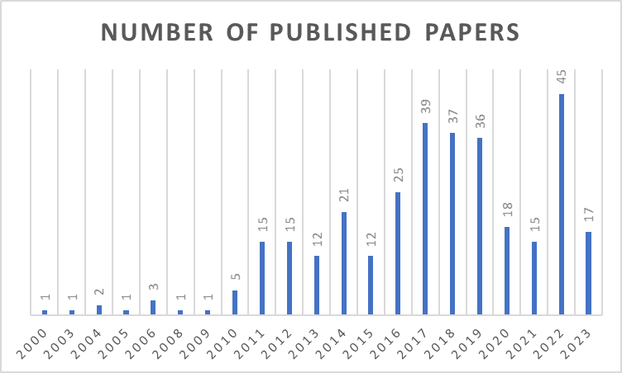
Source: Authors Elaboration (2024)

The next step of the search strategy included peer-reviewed, full-text articles published in English in academic journals found through the databases Business Source Complete, Scopus, and Web of Science, as they represent well-established and relevant datasets in the business and management field (Hanelt, Bohnsack, Marz, & Antunes, Marante, 2021). The search was performed through each database’s titles, keywords, and abstracts. The time frame was chosen between 2017 and 2024, representing the highest activity in the topic research. The initial search resulted in 3,557 articles, which, after the check for open access and excluding duplicates in the timeframe 2017 – 2024, resulted in 83 papers. All resulting journals were checked through the Academic Journal Guide (AJG), 2021 to ensure the quality of the studies (Siachou, Trichina, Papasolomou, & Sakka, 2021). After this step, 22 papers not listed in the AJG ranking were excluded from the dataset, resulting in 61 left.
Additionally, the quality and relevance of studies were assessed through the number of citations representing the interest and relevance to the field (Siachou, Trichina, Papasolomou, & Sakka, 2021). Thus, articles with a citation score higher than 20 were included, which resulted in 37 final papers. Titles and abstracts were screened to ensure the coverage of team development in small and medium-sized companies’ topics. Thus, the selection of the final articles includes 37 articles.
Figure 2 illustrates the paper selection process, adapted from the PRISMA framework widely used for reporting systematic reviews (Page et al., 2021).

Figure 2. Prisma Flow Diagram
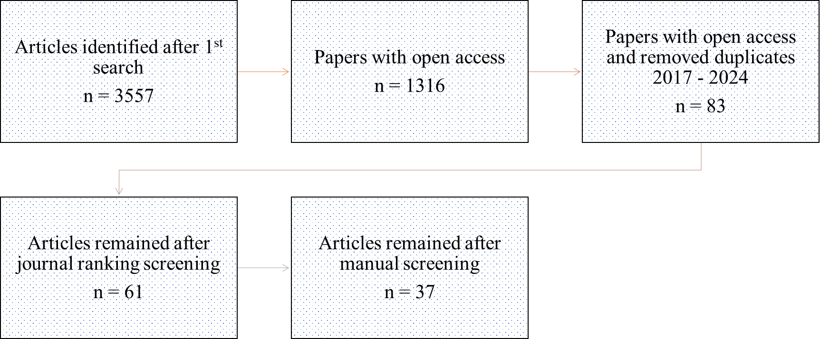
Source: Author’s own work (2024)

The studies included in the review were published between 2017 and 2020 with a breakdown as follows: 10 articles published in 2017, 9 – in 2018, 15 – in 2019, and 3 – in 2020. The search results represent 29 journals, forming the final list in Table 1, contributing 1 to 3 papers in each. The research findings suggest that researchers’ interest has shifted from this topic over the recent three years, highlighting a worryingly decreasing trend when considering the importance of developing research studies in the context of the European economic model, which is heavily dependent on SMEs.

Table 1. List of Journals and Number of Research Papers
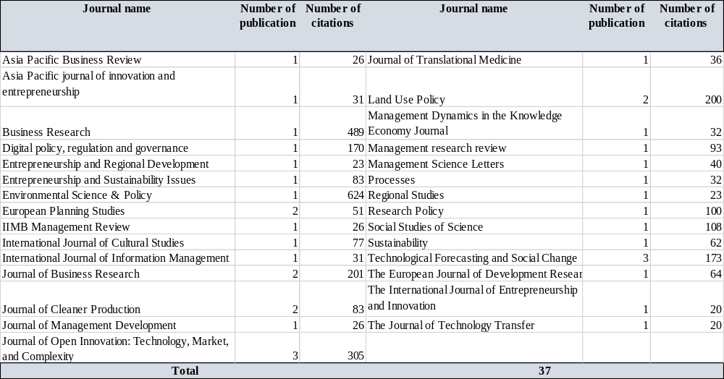
Source: Authors’ Elaboration (2024)
The research process progressed with a careful review of the selected 37 research papers, with the main research findings presented and discussed in the next section, where the role of management in learning organisation forming, challenges which experience managers, usage of training for SME success, and contribution to business, environment, and the economy after embedding team learning in the SMEs were identified as critical aspects. Concepts of smart growth regarding sustainability challenges were identified in the sampled studies, supporting the choice of structured literature review, which allows research to find the current state of the research field and future directions and possibilities (Tranfield et al., 2003).
- Research Findings

The assessment of the research outcomes started with an examination of the geographical context. The main interest in team learning in SMEs for smart growth was found in Europe, with 68%. The rest of the percentage was divided between Asia – 16%, Australia – 11%, and North America – 5%, as presented in Figure 3.

Figure 3. Classification of Studies by Geography
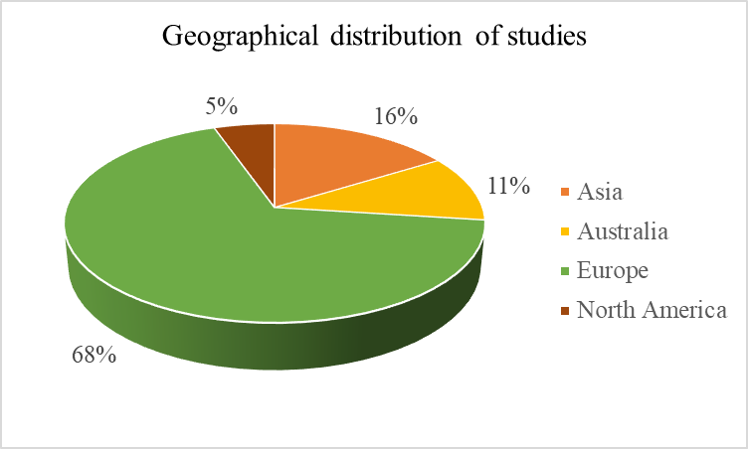
Source: Authors’ Elaboration (2024)

Studies integrated with the research sample have mainly originated from social sciences with an approximate representation of 84% of cases, highlighting the most interest in their primary topics’ investigation of entrepreneurship and business innovation in 6 papers out of 37, followed by frugal innovation in emerging markets and regional development in European Markets, thus, explaining the prevalence of studies from European institutions. These findings are supported by the concepts laid in the foundation of the studies, including knowledge management, entrepreneurship, and sustainability, presented in Figure 4 below.

Figure 4. Dominant Research Concepts
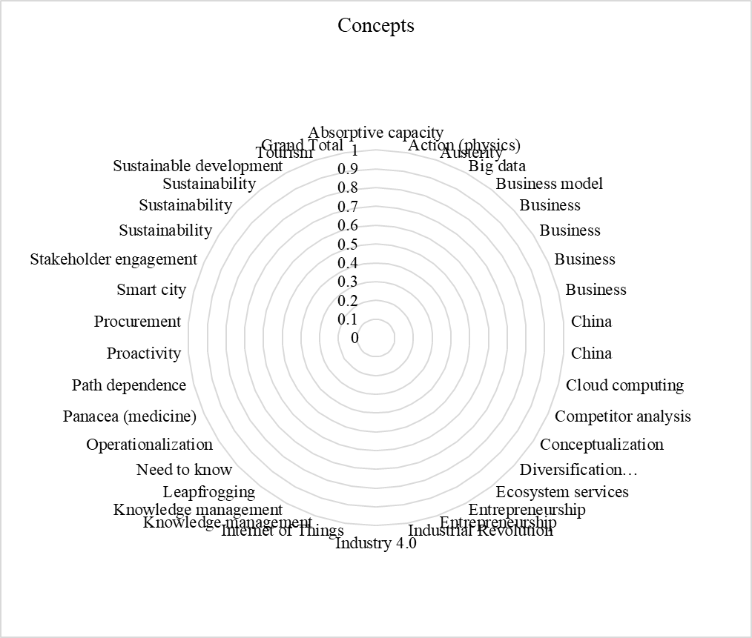
Source: Authors’ Ellaboration (2024)

The research findings suggest that the management team plays a critical role in forming a learning organisation. The primary challenge managers face is the willingness to devote time to training. Also, they should keep in mind that undefined roles of team members will lead to the achievement of inadequate knowledge and result in insufficient reward distribution (Ferreira et al., 2022; Hoang et al., 2021; Lazarević & Lukić, 2018), training as a strategy for smart development, and the firms’ contribution to business, environment, and society are critical for the business success.

  - The vital role of the management team in forming a learning organisation

If the team can work collaboratively and reach a synergetic effect by combining its individuals’ experiences, backgrounds and expertise, the company’s outcomes would grow significantly (Tihula et al., 2009), as a team is a limited number of people with complementary skills that has a goal and interact directly (Katzenbach and Smith, 1993a). Additionally, the ability to facilitate collaboration in teams will mitigate the risks of the company’s failure in the early stage of the lifespan. Cohen and Bailey (1997) identified four team types, which are: 1) work teams, 2) parallel teams, 3) project teams, and 4) management teams. Teamwork benefits work and company performance (Hunsaker, 2001; Eisenstat & Cohen, 1990). Management teams are formed in the stages of growth and maturity, as in the very early start-up stages, only the founder or founders team operates. Despite various and overlapping definitions, management teams include groups of managers responsible for defining general development direction, critical decisions in the company, and overall running a business (Huovinen & Pasanen, 2010). Most managers in management teams are at the same organisational level, report to the CEO or owner, and hold the leadership positions driving their own and staff’s effective performance (McIntyre, 1998: 2-3, 5-6; Longenecker et al., 1994: 215; Van Egeren, 1994: 18; Keck, 1998, Finkelstein, 1992, Keck & Tushman, 1993). Management teams can consist of owners and hired managers, mostly a feature of large and multi-national corporations.
The research findings reveal a significant interest in the exploration of management teams as teams emerged as a result of two theoretical developments in organisational studies, which include the shift in analysis from individual to entire team coalition (Cyert & March 1963) and deep analysis of the link between the demographic characteristics and the outcomes (Hambrick & Mason, 1984). The elaboration of the management team concept led to the recognition of the management team as the most influential member in decision-making and the operational aspects of running businesses. At the same time, they can behave not like a real team (Finkelstein & Hambrick, 1996). Among those scholars who explored SMEs, an agreement exists that the management team is essential for a company’s successful performance (Eisenhardt & Schnoonhoven, 1990; Storey, 1994). The explanation lies in the entrepreneur’s perception limitation; thus, the management team can improve performance and allow the company to succeed (Huovinen & Pasanen, 2010). In addition, managers can promote learning in their organisations, expanding the understanding of the necessity of this process and building a learning culture in the company. The continued boom of research on the management team topic supports the previous conclusions about the impact and effectiveness of designing and using management teams for the firm’s stable growth, effectiveness and success (Ghosh et al., 2001; Lester et al., 2002; Huovinen & Pasanen, 2010). Management teams are common for large corporations; for small firms, as two-thirds of SMEs have management teams (Cooney et al., 2005).
The creation of management teams aims to positively contribute to the organisations’ performance (Bang & Midelfart, 2017). Despite a number of research studies on team effectiveness in general, a lack of comprehensive analysis of management team effectiveness exists (Wageman et al., 2008; Overfield et al., 2016). According to Harvard professor J. R. Hackman’s categorisation, management teams are effective if they can achieve satisfying results in task performance, individual growth, and team viability. Thus, to be effective, management teams need to be able to learn, as researchers found that the ability to learn may be essential for companies to compete in an unpredictable and unstable environment (Fyhn et al., 2023; Cannon &Edmondson, 2001; Naot, Lipshitz, & Popper, 2004). According to Bell (2012) and Edmondson (2007), there is a strong connection between management team learning and effectiveness. If the leader demonstrates the readiness to invest time into learning and development, the whole team will be encouraged to build a culture of learning company (Schein, 2010; Shteynberg, Hirsh, Galinsky, & Knight, 2014).

  - The main challenges for managers in effective team learning design

The research findings point out the critical importance of team learning in SMEs. Recent studies promote the direct correlation between team learning and firm performance and effectiveness (Hemshorn de Sanchez et al., 2022; Veli Korkmaz et al., 2022; Mohamed, 2019), regardless of the company size. The role of SME managers is crucial in all aspects of company performance. The owner should clearly understand that executives in SMEs are critical elements in the decision-making process and for the whole company’s performance; however, they might simultaneously become a barrier to building the learning environment (Tam & Gray, 2021). According to Jones and Macpherson et al. (2006), the reason for such ambivalent behaviour might determine learning in SMEs only as a reaction to crisis rather than implementing a planning learning strategy. Thus, generating and implementing a learning strategy for the company is paramount.
Considering that building an effective team learning environment is not a straightforward process and different factors could easily affect it (Edmondson, 1999), the literature identified a range of various factors impacting team learning, among them shared mental models (Kozlowski & Bell, 2008), team psychological safety (Edmondson, 1999), group potency (Mathieu et al., 2008) and team efficacy, team development, team leadership, which can affect team learning dynamics (Arrow & Cook, 2008; Arrow et al., 2000; Sweet & Michaelsen, 2007).
An important aspect to be considered relates to our understanding of team leadership, which, according to Ciulla (2002), means how one person gets others to do something. In the context of learning, any programmes need to be compulsorily supported by senior management; otherwise, they cannot be successful (Bain, 1998). Conversely, suppose executives can implement their learning experience. In that case, the team’s learning outcomes will rise significantly and build a foundation for growing the company’s competitiveness, as illustrated in the SWOT analysis presented in Figure 5.

Figure 5. SWOT Diagram for Organisational Team Learning
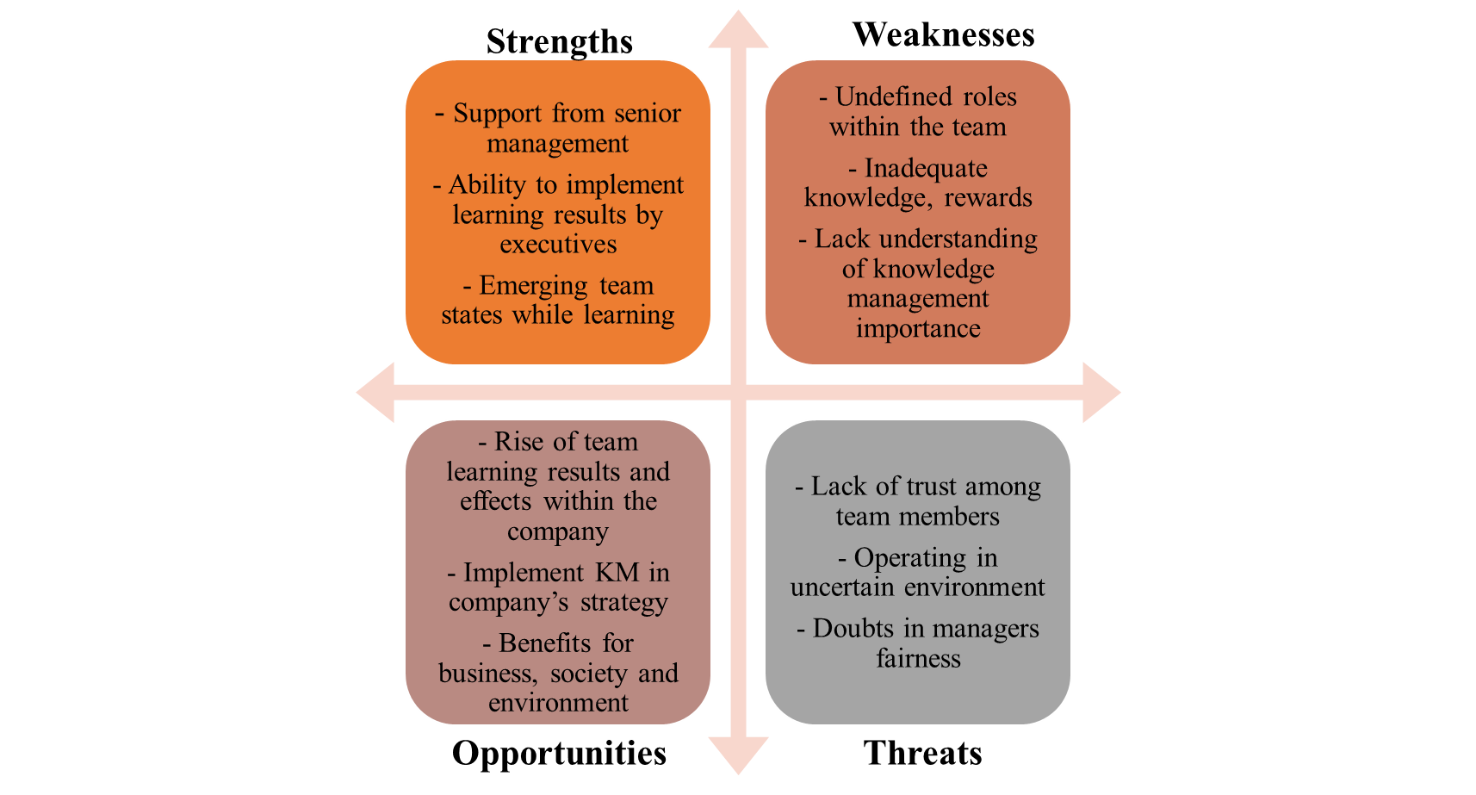
Source: Authors’ Ellaboration (2024)

However, among the possible weaknesses might be the time and effort management teams are willing to devote to training. Also, they should keep in mind that undefined roles of team members will lead to the achievement of inadequate knowledge and result in insufficient reward distribution. If team members start to hesitate about the management practices and fairness of their executives, it will affect trust among team members, provoking further possible problems in performing their everyday duties (Ferreira et al., 2022; Hoang et al., 2021; Lazarević & Lukić, 2018).
The outlined problems rely on the theoretical background in the knowledge management literature (Ferreira et al., 2022; Hoang et al., 2021; Tam & Gray, 2021; Lazarević & Lukić, 2018; Kozlowski & Bell, 2008; Zellmer-Bruhn & Gibson, 2006), all team members know that learning is paramount (Lazarević & Lukić, 2018), and the team could not define the company’s objectives without it. Besides, the learning process would not wholly stop after the problem’s appearance (Lazarević & Lukić, 2018); however, the negative influence on the employees’ motivation to bring new practices into everyday work will continue.
In learning strategy implementation in SMEs, the guide for senior managers is understanding business scenarios (Tam & Gray, 2021). Company learning strategy needs to be independent of learner preferences, totally transparent, and cover the gap between “employees’ and executives’ learning” (Tam & Gray, 2021). Learning strategy can determine a company’s sustained growth and improvements, impacting management practices, social stability, and economic resilience (Islam et al., 2022). However, to reach sustainable growth for SMEs, long-lasting investments in digitalisation and learning as a background are needed to reshape the approach of SMEs to business and shift the priorities in owners’ perception (Salojärvi et al., 2005; Dobbs and Hamilton, 2007; Knudsen et al., 2021).
For the SME sector, practical learning approaches and techniques are those connected with work-based tasks and practice (Tam & Gray, 2021). Since SME owners are mostly time-poor, the primary learning strategies include action learning, on-the-job training, coaching and mentoring, and online learning.

  - Training and Team Learning – A Strategy for Smart Development

Entrepreneurs experience significant business operations changes due to the European market’s high competitiveness and continued innovative and technological development (Petković & Lukić, 2014). Small and medium-sized companies have an advantage from one point as they can react faster to all challenges due to their decentralised decision-making approach, developed collaborative networking, and comprehensive employee knowledge generation and development (Lazarević & Lukić, 2018). Simultaneously, SMEs depend on one or a small team of decision-makers. Thus, lacking expertise or experience in acting in new situations might cause challenges and constraints (Tannenbaum et al., 2012; Mcnamara & Emn, 2020; Kearney & Lichtenstein, 2022). Team training focused on a deep understanding of the team learning phenomenon and its connection to team development can help them in a timely and comprehensive way. Teams have higher expertise, experience, skills, and knowledge (Tannenbaum et al. 2012) than individual solutions, as they combine individuals acting together. When individuals can work collaboratively as a team, all members have an opportunity to learn together and from one another (Woerkom & Croon, 2009). This principle is widely used in team training, allowing members to collaborate, share experiences, and discuss and reflect on achieved ideas.
From other perspectives, the crucial lack of funding and resources might prevent SME teams from implementing training widely. To support small companies in their learning intention, the governments recognise that developing management skills among business owners and companies’ senior management is critical for success. This vision is also supported by the lack of qualified entrepreneurs and executives, who must be trained and supported (OECD, 2022).
Team learning is essential in the very early stages of a company’s existence, aiming to equip the owners with the necessary skills of company development to move from the start-up stage to growing one, as they have to operate in an environment with a high level of uncertainty and risk (Bennis & Shepard, 1956; Hill & Gruner, 1973; Kaplan & Roman, 1963; Tuckman, 1965; Tuckman & Jensen, 1977). Aiming to succeed, entrepreneurs need to manage growth effectively and adequately react to market trends and threats from competitors while balancing profitability without sacrificing sustainability (Joel & Oguanobi, 2024). Additionally, advances in technologies in the implementation of complex digital solutions can give a competitive advantage to start-ups, making business models even more effective. Business owner faces a significant demand for the required knowledge, expertise and skills to navigate the company to success. Bringing a culture of team learning into the organisation, entrepreneurs will contribute significantly from joint expertise, knowledge sharing and mitigating different types of risk, including the risk of company failure (Adeoye et al., 2024).
Entrepreneurial training became a critical part of the educational strategy due to its possibility to address challenges, summarised as possibilities, uncertainties, learning, innovation, and change (Kearney & Lichtenstein, 2022). As the labour market feels an acute deficiency of qualified entrepreneurs, the government bodies have implemented various programs and supported management training and development in team designing and leadership skills (Mcnamara & Emn, 2020). All these initiatives will create an entrepreneurial-friendly environment that nurtures SMEs to a stable position in the highly competitive European economy. For sustainable business operations and fast adaptation to changing environments, entrepreneurs should be able to develop their team-building skills during the training (Teruel-Sánchez et al., 2021).

  - The contribution of team development to business, environment, and society

Learning in organisations is becoming critical due to the environment’s complexity and constantly evolving processes derived from the needs and demands of the knowledge and digital economy (Osland et al., 2015; Gümüsay & Bohné, 2018; Ferreira et al., 2022). The intensity of knowledge usage in different companies may vary significantly, but the ability to work with knowledge has become a vital competency for company owners (Ferreira et al., 2022). Thus, designing a learning organisation benefits the company and employees’ professional development, with positive spillover effects towards society, the environment, and the economy. Additionally, most studies identified smart growth in connection with and addressing sustainable development goals promoted by the United Nations as a pathway to sustainable development. Among the most recognisable goals are decent work and economic growth through partnerships with industry, innovation, and infrastructure. Figure 6 provides insight into the learning organisation and its different dynamics, according to Ferreira (2022).

Figure 6. Effects of learning organisation.

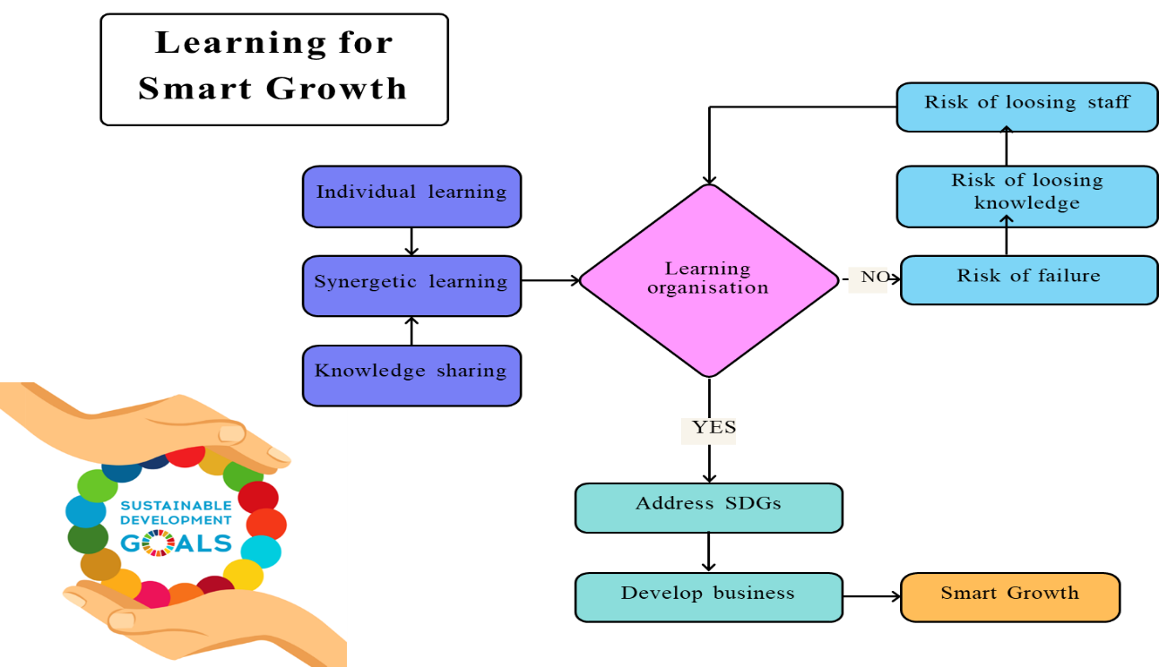
Source: Adapted from Ferreira (2022)

Individual or professional development covers the necessary skills and competencies required to achieve a company’s goals through the indicators of productivity and organisational performance (Smith and Kritsonis, 2006). The level of these competencies can be characterised as a result of employee’s efforts, influenced by experience, education, and the social environment (Gümüsay & Bohné, 2018). When forming a team, an entrepreneur needs to consider how to design the harmonic team equipped with the necessary skills and define the roles within the team accordingly. In turn, the professional development of each team member can benefit the organisational development as a process of diagnosis, planning, and intervention of the whole organisational system (Osland et al., 2015). The process of team forming and sharing knowledge will lead to synergetic learning, perceived by all members as a normal learning continuum to achieve the company’s goals (Michaelsen & Richards, 2005; Edmondson, 2007; Joel & Oguanobi, 2024).
The ability to learn within the organisation and create sufficient knowledge will determine the company’s economic and organisational sustainability, with the condition of multidisciplinary focused teams (Scurtu & Neamtu, 2015). Economic development can contribute to learning in organisation as a process of making people more capable and competent instead of focusing exclusively on the processes of manufacturing, services, or logistics (Wicaksono et al., 2019). Acquiring knowledge in companies also benefits the environment, making the firm’s operational performance more responsible, aiming to protect the Earth and mitigate the challenges that the population faces today (Sauvé et al., 2016). Social development is usually associated with the quality of life, in the prism of team learning in companies, covering the development of human capital and more efficient use. This strategy will help boost productivity growth, innovation, and competitiveness in the company to create new jobs (Bud & Nistor, 2015). Technological development, in turn, can transform economies, societies, organisational structures and strategies; however, it demands extensive training and knowledge application (Gölpek, 2015). Thus, learning in organisations lies at the heart of the company’s activity and employees’ development. Learning helps staff to transfer their own tacit knowledge into explicit company knowledge, determine whether it will be successful in operational activity and performance, and lead to smart growth, expressed in the creation and delivery of environmental and social values to all stakeholders (Ghisellini et al., 2024).

Conclusion

Human capital is the biggest company’s value regardless of size (Hillberg, 2024). In small companies, entrepreneurs represent the human resources responsible for the configuration and running of businesses (Costin et al., 2021). Entrepreneurs starting the business rarely engage in “traditional education”. In most cases, they are self-made professionals. They can run their business successfully to some extent. However, when a firm starts growing, a lack of competencies may affect this process. Thus, in a knowledge-intensive economy, such as the one defining the European model, skills in working with knowledge are becoming crucial, as they can help to decrease economic pressure and the changing environment. Studies identified during the research support this opinion and show a high interest in knowledge management in SMEs for smart growth, highlighted through decent work and economic growth with the help of partnerships with industry, innovation, and infrastructure.
Team learning can become a driver of a company’s intention to grow concerning business indicators, society and the environment. The company’s progress to the learning organisation stage will provide it with instruments and techniques to develop sustainably in an uncertain environment (Asher & Popper, 2021). Building a learning organisation is a lengthy process that requires improving managerial and leadership competencies from the owner and senior managers and understanding how to convert tacit employees’ knowledge into explicit companies. SMEs are identified as having more flexibility, agility, and openness to new ideas (Matić, 2022) than large enterprises; however, the concentration of most decision-making possibilities on one hand can result in severe repercussions for the company. Thus, embedding learning in the company’s strategic planning and building a culture of constant learning, collaboration, and knowledge sharing can become a pillar in the prevention of crisis in the company in case critical employees leave. Therefore, developing a senior team through team learning becomes essential to success. Additionally, organisational learning is becoming critical due to the environment’s complexity and constant economic move to the knowledge economy. The intensity of knowledge usage in different companies may vary significantly, but the ability to work with knowledge has become a vital competency for company owners (Ferreira et al., 2022). Thus, designing a learning organisation and learning in teams benefits not exclusively the company and employees’ professional development but also society, the environment, the economy, and technology, providing a balance between profit generation and creating values for society and the environment.
Policymakers should consider initiatives to create an entrepreneurial-friendly environment that nurtures SMEs to a stable position in the highly competitive European economy. For sustainable businesses operations and fast adaptation to changing environments, entrepreneurs should be able to develop their team-building skills during the training (Teruel-Sánchez et al., 2021), and learning online can boost the possibilities for expanding their knowledge. Embedding various entrepreneurial trainings in the offer to support businesses will help address challenges, uncertainties, and challenges faced by organisations (Kearney & Lichtenstein, 2022). To cope with an acute deficit of qualified entrepreneurs, government bodies could design and implement various programs and support management training in knowledge management and sustainable practices to support the labour market (McNamara & Emn, 2020).
Future lines of research might consider exploring the directions of team learning development for SMEs’ smart growth and undertaking an empirical study with business owners and entrepreneurs. Online learning as a part of digital strategy might become a solution to make learning in a company accessible and cost-efficient (Leyer et al., 2023), as it allows to work with different sources of information simultaneously and raises efficiency in team performance (Kirschner, Sweller, & Clark, 2006).

References

Adesina, A. O., Ocholla, D. N., & Adesina, A. (2024). South African Journal of Information Management. https://doi.org/10.4102/sajim
Adeoye, O. B., Addy, W. A., Odeyemi, O., Okoye, C. C., Ofodile, O. C., Oyewole, A. T., & Ololade, Y. J. (2024). Fintech, taxation, and regulatory compliance: navigating the new financial landscape. Finance and Accounting Research Journal, 6(3), pp. 320-330.
Al-Mubaraki, H. M., & Busler, M. (2017). Challenges and opportunities of innovation and incubators as a tool for knowledge-based economy. Journal of Innovation and Entrepreneurship, 6(1). https://doi.org/10.1186/s13731-017-0075-y
Ashauer, S. A., and Macan, T. (2013). ′How can leaders foster team learning? Effects of leader-assigned mastery and performance goals and psychological safety′. Journal of Psychology: Interdisciplinary and Applied, 147(6), pp. 541–561. https://doi.org/10.1080/00223980.2012.719940
Asher, D. and Popper, M. (2019), “Tacit knowledge as a multilayer phenomenon: the ‘onion’ model”, The Learning Organization, 26(3), pp. 276-288
Asher, D., & Popper, M. (2021). ′Eliciting tacit knowledge in professions based on interpersonal interactions′. Learning Organization, 28(6), pp. 523–537. https://doi.org/10.1108/TLO-03-2021-0035
Ates, A., Garengo, P., Cocca, P., & Bititci, U. (2013). The development of SME managerial practice for effective performance management. Journal of Small Business and Enterprise Development, 20(1), 28-54
Bank of Ireland, C. (2021). No.2 SME liquidity needs during the COVID-19 shock (McGeever, McQuinn and Myers). https://ec.europa.eu/growth/smes/business-friendly-environment/sme-definition_en
Beckman, C. M., Burton, M. D., & O’Reilly, C. (2007). Early teams: The impact of team demography on VC financing and going public. Journal of Business Venturing, 22(2), 147–173. https://doi.org/10.1016/j.jbusvent.2006.02.001
Begley, T.M., Boyd, D. P. (1987). A comparison of entrepreneurs and managers of small business ﬁrms. Journal of Management, 14, pp. 99-108.
Bell, R., & Bell, H. (2020). ′Applying educational theory to develop a framework to support the delivery of experiential entrepreneurship education′. Journal of Small Business and Enterprise Development, 27(6), pp. 987–1004. https://doi.org/10.1108/JSBED-01-2020-0012
Bennis, W. G., & Shepard, H. A. (1956). ′A theory of group development′. Human Relations, 9, pp. 415–437
Bratianu, C., Prelipcean, G., & Bejinaru, R. (2020). ′Exploring the latent variables which support SMEs to become learning organisations ′. Management & Marketing. Challenges for the Knowledge Society, 15(2), pp. 154-171. https://doi.org/10.2478/mmcks-2020-0010
Bud, A., & Nistor, R. (2015). ′A qualitative evaluation on SOP HRD 2007–2013 in Romania – Focus group study′. Economic Science Series, 24(1), pp. 1044–1053. https:// ideas.repec.org/a/ora/journl/v1y20 15i1p 1044- 1053. Html
Cannon, M. D., & Edmondson, A. C. (2001). ′Confronting failure: Antecedents and consequences of shared beliefs about failure in organisational work groups′. Journal of Organizational Behaviour, 22, pp.161–177.http://dx.doi.org/10.1002/job.85
Caputo, A., Pizzi, S., Pellegrini, M.M. and Dabić, M. (2021): Digitalisation and business models: Where are we going? A science map of the field. Journal of Business Research, 123(Feb), pp.489-501
Carton, A. M., & Cummings, J. N. (2012). A theory of subgroups in work teams. Academy of Management Review, 37(3), pp. 441–470.
Cerchione, R., Esposito, E. & Spadaro, M.R., 2015, ‘The spread of knowledge management in SMEs: A scenario in evolution’, Sustainability. 7(8), pp. 10210–10232. https://doi.org/10.3390/su70810210
Ciulla, J. B. (2002). ′Trust and the Future of Leadership′. The Blackwell Guide to Business Ethics. Blackwell. pp. 334—351.
Cohen, S. G. & Bailey, D. E. (1997). ′What makes teams work: group effectiveness research from the shop floor to the executive suite′. Journal of Management,23(3), pp. 239-290
Costin, Y., Igoe, J., Flynn, A., Birdthistle, N., & Hynes, B. (2021). ′Human capabilities and firm growth; an investigation of women-owned established micro and small firms in Ireland′. Small Enterprise Research, 28(2), pp. 134–152. https://doi.org/10.1080/13215906.2021.1944902
Covington, M. V. (2000). Goal theory, motivation, and school achievement: An in-tegrative review.Annual Review of Psychology, 51, pp. 171–200.https://doi.org/10.1146/annurev.psych.51.1.171
Crossan, M. M., Lane, H. W., & White, R. E. (1999). ′An organisational learning framework: from intuition to institution′. Academy of Management Review, 24(3), pp. 522–537
Crossan, M. M., Lane, H. W., White, R. E., & Djurfeldt, L. (1995). ′ Organisational learning: Dimensions for a theory′. The International Journal of Organizational Analysis,3(4), pp.337–360
Darr, E. D., Argote, L., and Epple, D. (1995). ′The acquisition, transfer, and depreciation of knowledge in service organisations: productivity in franchises′. Management Science,41, pp. 1750–1762. doi: 10.1287/mnsc.41.11.1750
Dechant, K., Marsick, V. J., & Kasl, E. (1993). ′Towards a model of team learning′. Studies in Continuing Education, 15(1), pp. 1–14
Decuyper, S., Dochy, F. and Van den Bossche, P. (2010), ′Grasping the dynamic complexity of team learning: an integrative model for effective team learning in organisations ′, Educational Research Review, 5(2), pp. 111-133, doi: 10.1016/j.edurev.2010.02.002
Dobbs, M. and Hamilton, R.T. (2007): Small business growth: recent evidence and new directions. International Journal of Entrepreneurial Behavior & Research, 13(5), pp.296-322
Durst, S. and Edvardsson, I.R. (2012), “Knowledge management in SMEs: a literature review”, Journal of Knowledge Management, 16(6), pp. 879-903.
Durst, S., Edvardsson, I. R., & Foli, S. (2023). Knowledge management in SMEs: a follow-up literature review. In Journal of Knowledge Management, 27(11), pp. 25–58. Emerald Publishing. https://doi.org/10.1108/JKM-04-2022-0325
Edmondson, A. (1999). ′Psychological safety and learning behaviour in work teams′. Administrative Science Quarterly, 44 (2), pp. 350–383
Eisenstat, R. and Cohen, S. (1990), ′Top management groups′, in Hackman, J.R. (Ed.), Groups that Work (and Those That Don’t): Creating Conditions for Effective Teamwork, Jossey-Bass Publications, San Francisco, CA, pp. 78-86
Ellis, A.P.J., Hollenbeck, J.R., Ilgen, D.R., Porter, L.H., West, B.J. and Moon, H. (2003), ′Team learning: collectively connecting the dots′, Journal of Applied Psychology, 88(5), pp. 821-835, doi:10.1037/0021-9010.88.5.821
Erjavec, E., Redek, T., & Kostevc, Č. (2023). SMEs “Growing Smart”: The Complementarity of Intangible and Digital Investment in Small Firms and Their Contribution to Firm Performance. Economic and Business Review, 25(4), 216–232. https://doi.org/10.15458/2335-4216.1328
Ferreira, B., Curado, C., & Oliveira, M. (2022). ′The Contribution of Knowledge Management to Human Resource Development: a Systematic and Integrative Literature Review′. Journal of the Knowledge Economy, 13(3), pp. 2319–2347. https://doi.org/10.1007/s13132-021-00815-9
Finkelstein S, Hambrick DC (1990). ′Top-management-team tenure and organisational outcomes: the moderating role of managerial discretion′. Administrative Science Quarterly, 35(3): pp. 484–503
Fitzgerald, M., Kruschwitz, N., Bonnet, D. and Welch, M. (2014): Embracing digital technology: A new strategic imperative. MIT Sloan Management Review, 55(2), p.1-16.
Fyhn, B., Schei, V., & Sverdrup, T. E. (2023). ′Taking the emergent in team emergent states seriously: A review and preview′. Human Resource Management Review, 33(1). https://doi.org/10.1016/j.hrmr.2022.100928
Gennari, F. (2023). ′The transition towards a circular economy. A framework for SMEs′. Journal of Management and Governance, 27(4), pp.1423–1457. https://doi.org/10.1007/s10997-022-09653-6
Gersick, C. J. (1991). ′Revolutionary change theories: A multi-level exploration of the punctuated equilibrium paradigm′. Academy of Management Review, 16(1), pp. 10–36
Ghisellini, P., Quinto, I., Passaro, R., & Ulgiati, S. (2024). Exploring environmental and social performances of circular start-ups: An orientation and certification assessment. Business Strategy and the Environment, 33(4), pp. 3222–3241. https://doi.org/10.1002/bse.3620
Ghosh, B. C., Liang, T. W., Meng, T. T. & Chen, B. (2001). ′The key success factors, distinctive capabilities, and strategic thrusts of top SMEs in Singapore′. Journal of Business Research,51, pp. 209-221
Gölpek, F. (2015). ′Service sector and technological developments′. Procedia - Social and Behavioral Sciences, 181, pp. 125–130. https:// doi. org/ 10. 1016/j. sbspro. 2015. 04. 873
Gopinath, C., & Saleem, F. (2020). ′ effect of structuring on team behaviour and learning′. Journal of Education for Business, 95(6), pp. 359–366. https://doi.org/10.1080/08832323.2019.1664373
Grandinetti, R. (2014), “The explicit dimension: what we could not learn from polanyi”, The Learning Organization, 21(5), pp. 333-346
Gross, J. J. (1998). The emergingfield of emotion regulation: An integrative review.Review of General Psychology, 2, pp. 271–299.https://doi.org/10.1037/1089-2680.2.3.271
Guchait, P. & Hamilton, K. (2013). ′The temporal priority of team learning behaviours vs. shared mental models, in service management teams′. International Journal of Hospitality Management, 33, pp. 19-28
Gümüsay, A., & Bohné, T. (2018). ′Individual and organisational inhibitors to the development of entrepreneurial competencies in universities′. Research Policy, 47(2), pp. 363–378. https:// doi. org/ 10. 1016/j.respol. 2017. 11. 008
Haessler, P. (2020) 'Strategic Decisions between Short-Term Profit and Sustainability,' Administrative Sciences, 10(3), pp. 63. https://doi.org/10.3390/admsci10030063.
Hambrick DC, Mason P (1984). ′Upper echelons: the organisation as a reflection of its top managers′. Academy of Management Review, 9(2): pp.193–206
Hanelt, A., Bohnsack, R., Marz, D., & Antunes Marante, C. (2021). A systematic review of the literature on digital transformation: Insights and implications for strategy and organisational change. Journal ofManagement Studies, 58(5), pp. 1159–1197
Hannan, M. (1998). 'Rethinking age dependence in organizational mortality: logical formalizations'. American Journal of Sociology. 104(1), pp. 126.
Harris, M., & Wood, G. (2020). Ambidextrous working in health and social care services: A conﬁgurational view. Long Range Planning, 53(6), 102051
Hayes, J., and Allinson, C.W. (1998), ′Cognitive style and the theory and practice of individual and collective learning in organisations′, Human Relations, 51, pp 847–872
Hedlund, E. & Österberg, J. (2013). ′Team Training, Team Learning, Leadership and Psychology Safety: A Study of Team Training and Team Learning Behavior during a Swedish Military Staff Exercise′. Sociology Mind, 3(1), pp. 89-98
Hemshorn de Sanchez, C. S., Gerpott, F. H., & Lehmann-Willenbrock, N. (2022). ′A review and future agenda for behavioral research on leader–follower interactions at different temporal scopes′. Journal of Organizational Behavior, 43(2), pp. 342–368. https://doi.org/10.1002/job.2583
Hill, W. F., & Gruner, L. (1973). ′A study of development in open and closed groups′. Small Group Research, 4(3), pp. 355–381. doi: 10.1177/104649647300400303
Hillberg Jarl, F. (2024). The impact of leadership on the workplace learning of individuals and teams: a literature review and synthesis. In Learning Organization. Emerald Publishing. https://doi.org/10.1108/TLO-11-2022-0144
Hoang, G., Wilson-Evered, E., & Lockstone-Binney, L. (2021). ′Leaders influencing innovation: A qualitative study exploring the role of leadership and organisational climate in Vietnamese tourism SMEs′. Employee Relations, 43(2), pp. 416–437. https://doi.org/10.1108/ER-07-2019-0279
Homans, T. (2001). ′Team learning: Theory and facilitation′. Schoonhoven, Netherlands: Academic
Hunsaker, P.L. (2001), ′Training in Management Skills′, Prentice-Hall: Englewood Cliffs, NJ
Huovinen, S., & Pasanen, M. (2010). ′Entrepreneurial and management teams: What makes the difference′? Journal of Management and Organization, 16(3), pp.436–453. https://doi.org/10.5172/jmo.16.3.436
Islam, A., Wahab, S. A., & Latiff, A. S. A. (2022). Annexing a Smart Sustainable Business Growth Model for Small and Medium Enterprises (SMEs). World Journal of Entrepreneurship, Management and Sustainable Development, 18(2), pp. 185–209. https://doi.org/10.47556/J.WJEMSD.18.2.2022.2
Jansson, J., Nilsson, J., Modig, F., & Hed Vall, G. (2017). Commitment to sustainability in small and medium‐sized enterprises: the influence of strategic orientations and management values. Business Strategy and the Environment, 26(1), 69-83. https://doi.org/ 10.1002/bse.1901
Jenkins, H. M. (2004). ′A critique of conventional CSR theory: An SME perspective′. Journal of General Management, 29(4), pp. 37–57. https:// doi. org/ 10. 1177/ 03063 07004 02900 403
Joel, N. O. T., & Oguanobi, N. V. U. (2024). Entrepreneurial leadership in start-ups and SMEs: Critical lessons from building and sustaining growth. International Journal of Management & Entrepreneurship Research, 6(5), pp. 1441–1456. https://doi.org/10.51594/ijmer.v6i5.1093
Jones, O., Macpherson, A., and Thorpe, R. (2010), ′Learning in owner-managed small firms: mediating artefacts and strategic space′, Entrepreneurship and Regional Development, 22, pp 649–673
Kaplan, C. A. S, & Roman, M. (1963). ′Phases of development in an adult therapy group′. International Journal of Group Psychotherapy, 13, 10–26
Katzenbach, J. & Smith, D. (1993b). ′The wisdom of teams: creating the high-performance organisation′. McGraw-Hill, New York
Kearney, C., & Lichtenstein, B. (2022). ′Generative Emergence: Exploring the Dynamics of Innovation and Change in High-Potential Start-Up Ventures′. British Journal of Management. https://doi.org/10.1111/1467-8551.12604
Keck, S.L. and Tushman, M. (1993), ‘′Environmental and organisational context and executive team structure′, Academy of Management Journal, 36(6), pp. 1314-44
Khin, S. and Ho, T.C. (2019): Digital technology, digital capability and organisational performance. International Journal of Innovation Science, 11(2), pp.177-195
Kirschner, P. A., Sweller, J., & Clark, R. E. (2006). ′Why minimal guidance during instruction does not work: An analysis of the failure of constructivist, discovery, problem-based, experiential, and inquiry-based teaching′. Educational Psychologist, 41(2), pp. 75–86. https://doi.org/10.1207/s15326985ep4102_1
Knudsen, E.S., Lien, L.B., Timmermans, B., Belik, I. and Pandey, S. (2021): Stability in turbulent times? The effect of digitalisation on the sustainability of competitive advantage. Journal of Business Research, 128, (05/2021), pp.360-369
Kozlowski, S. W. J., & Ilgen, D. R. (2006). ′Enhancing the effectiveness of work groups and teams′. Psychological Science in the Public Interest,73, pp. 77–124. doi: 10.1111/j.1529-1006.2006. 00030.x
Lazarević, S., & Lukić, J. (2018). ′Team learning processes and activities in organisation: a case study′, Economic Themes, 56(3). http://www.economic-themes.com/
Leick, B. andGretzinger, S. (2020), “Business networking in organisationally thin regions: a case study on network brokers, SMEs and knowledge-sharing”, Journal of Small Business and Enterprise Development, 27(5), pp. 839-861.
Leyer, M., Yuan, B., Wang, M., & Moormann, J. (2023). ′Classroom or online learning? Impact of experiential learning in business process management education′. Knowledge Management and E-Learning, 15(2), pp. 214–234. https://doi.org/10.34105/j.kmel.2023.15.012
Mahmud, N., & Hilmi, M. F. (2014). TQM and Malaysian SMEs performance: the mediating roles of organisation learning. Procedia-Social and Behavioural Sciences, 130, 216-225. https://doi.org/10.1016/j.sbspro.2014.04.026
Massaro, M., Handley, K., Bagnoli, C. and Dumay, J. (2016), “Knowledge management in small and medium enterprises: a structured literature review”, Journal of Knowledge Management, 20(2), pp. 258-291.
Matić, I. (2022). ′Managerial Interpersonal Competencies-Benefiting from Learning Organization Characteristics in SMEs′. Management Dynamics in the Knowledge Economy, 1, https://doi.org/10.2478/mdke
Matten, D., & Moon, J. (2004). ′A conceptual framework for understanding CSR′. pp. 335–356. Springer.
Mazumdar, T., Raj, S. P., & Sinha, I. (2005). Reference price research: Review and pro-positions. Journal of Marketing, 69, pp. 84–102.https://doi.org/10.1509/jmkg.2005.69.4.84
McAdam, R. and Reid, R. (2001), “SME and large organisation perceptions of knowledge management: comparisons and contrasts”, Journal of Knowledge Management, 5(3), pp. 231-241.
McAdam, R., Mason, B. and McCrory, J. (2007), “Exploring the dichotomies within the tacit knowledge literature: towards a process of tacit knowing in organisations”, Journal of Knowledge Management, 11(2), pp. 43-59
McEwan, D., & Beauchamp, M. R. (2014). ′ teamwork in sport: a theoretical and integrative review′. International Review of Sport and Exercise Psychology, 7(1). https://doi.org/10.1080/1750984X.2014.932423
McIntyre, M.G. (1998), ′The Management Team Handbook. Five Key Strategies for Maximizing Group Performance′, Jossey-Bass Publishing, SF
McKeown, I. (2012). ′Team Learning in SMEs: Learning the Lessons′. Industry and Higher Education, 26(6), pp. 491–503. https://doi.org/10.5367/ihe.2012.0123
McNamara, F., & Emn, E. Q. (2020). ′Migratory Pathways to Ireland for Start-Ups and Innovative Entrepreneurs′. https://doi.org/10.26504/rs102.pdf
Mohamed, N. A., & Sheikh Ali, A. Y. (2021). ′Entrepreneurship education: systematic literature review and future research directions′. World Journal of Entrepreneurship, Management and Sustainable Development, 17(4), pp. 644–661. https://doi.org/10.1108/WJEMSD-07-2020-0084
Nachmias, S., & Hubschmid-Vierheilig, E. (2021). ′We need to learn how to love digital learning ‘again’: European SMEs response to COVID-19 digital learning needs′. Human Resource Development International, 24(2), pp. 123–132). Routledge. https://doi.org/10.1080/13678868.2021.1893503
Naot, Y. B-H., Lipshitz, R., & Popper, M. (2004). ′Discerning the quality of organisational learning′. Management Learning, 35, pp. 451–472.http://dx.doi.org/10.1177/1350507604048273
Nonaka, I. & Takeuchi, H., 1995, The knowledge-creating company: How Japanese companies create the dynamics of innovation, Oxford University Press, United Kingdom.
O’Donnell, A. (2014), “The contribution of networking to small firm marketing”, Journal of Small Business Management, 52, pp. 164-187.
OECD. (2022). OECD Recommendation on SME and Entrepreneurship Policy. https://www.oecd.org/cfe/smes/oecdrecommendationonsmeandentrepreneurshippolicy
Ormazabal, M., Prieto Sandoval, V., Puga-Leal, R., & Jaca, C. (2018). ′Circular economy in Spanish SMEs: Challenges and opportunities′. Journal of Cleaner Production, 185, pp. 157–167. https:// doi.org/ 10. 1016/j. jclep ro. 2018. 03. 031
Osland, J., Devine, K., & Turner, M. (2015). ′Organizational behavior′. Wiley Encyclopedia of Management. https:// doi. org/ 10. 1002/ 97811 18785 317. weom0 60151
Overfield, D. V. (2016). ′A comprehensive and integrated framework for developing leadership teams′. Consulting Psychology Journal: Practice and Research, 68, pp. 1–20. http://dx.doi.org/10.1037/cpb0000053
Page, M. J., McKenzie, J. E., Bossuyt, P. M., Boutron, I., Hoffmann, T. C., Mulrow, C. D., Shamseer, L., Tetzlaff, J. M., Akl, E. A., Brennan, S. E., Chou, R., Glanville, J., Grimshaw, J. M., Hróbjartsson, A., Lalu, M. M., Li, T., Loder, E. W., Mayo-Wilson, E., McDonald, S., … Moher, D. (2021). ′The PRISMA 2020 statement: An updated guideline for reporting systematic reviews′. International Journal of Surgery, 88. https://doi.org/10.1016/j.ijsu.2021.105906
Petković, M. & Lukić, J. (2014). ′New organisational forms supported by the information and communication technology: the case of Serbian ICT industry′. Facta Universitatis: Economics and Organization, 11(2), pp. 101-115
Pisano, G. P., Bohmer, R. M., and Edmondson, A. C. (2001). ′ Organisational differences in rates of learning: evidence from the adoption of minimally invasive cardiac surgery′. Management Science, 47, pp. 752–768. doi: 10.1287/mnsc.47.6.752.9811
Reagans, R., Argote, L., and Brooks, D. (2005). ′Individual experience and experience working together: predicting learning rates from knowing who knows what and knowing how to work together′. Management Science, 51, pp. 869–881.doi: 10.1287/mnsc.1050.0366
Salas, E., Cooke, N. J., & Rosen, M. A. (2008). On teams, teamwork, and team performance: Discoveries and developments. Human Factors: The Journal of the Human Factors and Ergonomics Society, 50(3), pp. 540–547.
Salojärvi, S., Furu, P. and Sveiby, K.E. (2005): Knowledge management and growth in Finnish SMEs. Journal of Knowledge Management, 9(2), pp.103-122
Schein, E. H. (2010). ′Organizational culture and leadership′ (4th ed.). San Francisco, CA: Wiley
Scurtu, L., & Neamtu, D. (2015). ′The need of using knowledge management strategy in modern business organisations ′. The USV Annals of Economics and Public Administration, 15(2), pp. 157–167. Available online at https:// annals. seap. usv. ro
Senge, M. (1990), ′The Fifth Discipline: The Art and Practice of the Learning Organization′, Doubleday, New York.
Shteynberg, G., Hirsh, J. B., Galinsky, A. D., & Knight, A. P. (2014). ′Shared attention increases mood infusion′. Journal of Experimental Psychology: General, 143, pp.123–130.http://dx.doi.org/10.1037/a0031549
Siachou, E., Trichina, E., Papasolomou, I., & Sakka, G. (2021). Why do employees hide their knowledge and what are the consequences? A systematic literature review. Journal of Business Research, 135, pp. 195–213
Slavin, R. E. (1996). ′ research on cooperative learning and achievement: What we know, what we need to know′. Contemporary Educational Psychology,21(1), pp.43–69
Smith, Y., & Kritsonis, W. (2006). ′The differences in professional development with corporate companies and public education′. National Journal for Publishing and Mentoring Doctoral Student Research, 3(1), pp. 1–6. Available online at https:// files.eric.ed.gov
Snyder, H. (2019) ‘Literature review as a research methodology: An overview and guidelines,’ Journal of Business Research, 104, pp. 333–339. https://doi.org/10.1016/j.jbusres.2019.07.039
Stewart, W.H., Watson, W.C., Carland, J.C., James W. (1998). A comparison of entrepreneurs, small business owners, and corporate managers. Journal of Business Venture, 14, pp. 189-214.
Stinchcombe, Arthur L. (1965). ′Social structure and organizations′. In: March, J.G. (Ed.), Handbook of Organizations. Rand McNally, Chicago, IL, pp. 142e193.
Stuart, T., Sorenson, O. (2003). Liquidity events and the geographic distribution of entrepreneurial activity. Administrative Science Quarterly, 48(2), pp. 175-201.
Sundstrom, E., De Meuse, K. P., & Futrell, D. (1990). Work teams: Applications and effectiveness. American Psychologist, 45(2), 120.
Sweet, M., & Michaelsen, L. (2007). ′How group dynamics research can inform the theory and practice of postsecondary small group learning′. Educational Psychology Review,19(1), pp.31–47
Tannenbaum, S. I., Mathieu, J. E., Salas, E. & Cohen, D. (2012). ′Teams Are Changing: Are Research and Practice Evolving Fast Enough′? Industrial and Organizational Psychology, 5, pp. 2-24
Teruel-Sánchez, R., Briones-Peñalver, A. J., Bernal-Conesa, J. A., & de Nieves-Nieto, C. (2021). ′ influence of the entrepreneur’s capacity in business performance′. Business Strategy and the Environment, 30(5), pp. 2453–2467. https://doi.org/10.1002/bse.2757
Tihula, S., Huovinen, J., & Fink, M. (2009). ′Entrepreneurial team’s vs management teams: Reasons for team formation in small firms′. Management Research News, 32(6), pp. 555–566. https://doi.org/10.1108/01409170910962984
Tranfield, D., Denyer, D., & Smart, P. (2003). Towards a Methodology for Developing Evidence-Informed Management Knowledge by Means of Systematic Review. British Journal of Management. 14(3), pp. 207–222). https://doi.org/10.1111/1467-8551.00375
Tuckman, B. W. (1965). ′Developmental sequence in small groups′. Psychological Bulletin, 63(6), 384–399.
Tuckman, B. W., & Jensen, M. A. (1977). ′Stages of small-group development revisited′. Group & Organization Management, 2(4), pp. 419–427. doi: 10.1177/105960117700200404
Van den Bossche, P., Gijselaers, W., Segers, M., &Kirschner, P.A. (2006). ′Social and cognitive factors driving teamwork in collaborative learning environments. Team learning beliefs & behaviours′. Small Group Research, 37(5), pp. 490–521
Van der Haar, S., Segers, M. & Jehn, K. A. (2013). ′Towards a contextualised model of team learning processes and outcomes′. Educational Research Review, 10, pp. 1-12
Veli Korkmaz, A., van Engen, M. L., Knappert, L., & Schalk, R. (2022). ′About and beyond leading uniqueness and belongingness: A systematic review of inclusive leadership research′. Human Resource Management Review, 32(4). https://doi.org/10.1016/j.hrmr.2022.100894
Verzat, C., O’Shea, N., & Jore, M. (2017). ′Teaching proactivity in the entrepreneurial classroom′. Entrepreneurship and Regional Development, 29 (9–10), pp. 975–1013. https://doi.org/10.1080/08985626.2017.1376515
Wageman, R., Nunes, D. A., Burruss, J. A., & Hackman, J. R. (2008). ′Senior leadership teams: What it takes to make them great′. Boston, MA: Harvard Business School Press
Ward, V., House, A., & Hamer, S. (2009). Developing a framework for transferringknowledge into action: A thematic analysis of the literature.Journal of Health Services Research and Policy, 14, pp. 156–164.https://doi.org/10.1258/jhsrp.2009.008120.
Weick, K. (1995), ′Sensemaking in Organisations′, Sage, Thousand Oaks, CA
West, M. (1999). ′Communication and teamworking in healthcare′. Nursing Times Research, 4(1), pp. 8–17
Wicaksono, P., Hardini, N., & Bakhtiar, T. (2019). ′Economic and social development in global production networks: Lessons from the Indonesian footwear industry′. International Journal of Business and Society, 20 (S1), pp.127–144. https:// scholar.ui.ac.
Wilson, J.M., Goodman, P.S. and Cronin, M.A. (2007), ′Group learning′, Academy of Management Review, 32(4), pp. 1041-1059, doi:10.2307/20159355
Woerkom, M. & Croon, M. (2009). ′The relationships between team learning activities and team performance′. Personnel Review, 38(5), pp. 560-577
Yang, T., & Aldrich, H. E. (2017). ′The liability of newness” revisited: Theoretical restatement and empirical testing in emergent organizations′. Social Science Research, 63, pp. 36–53. https://doi.org/10.1016/j.ssresearch.2016.09.006

Corresponding Author email: anna.zherdeva@tudublin.ie

