Enhancing Sustainability Across the Lifecycle of Public-Private Partnership Projects: Systematic Review Insights and the Inclusive Sustainable Value Response Framework

- Introduction
Public-Private Partnerships (PPPs) are widely considered as a powerful policy tool for implementing the United Nations’ 2030 Agenda for Sustainable Development, as they can mobilize private sector resources and competencies to deliver public services and infrastructure aligned with the Sustainable Development Goals (SDGs). However, there has been growing concern among governments, civil society organizations, and public sector unions regarding sustainability challenges associated with many PPPs, as PPP projects are typically long-term, complex, and involve a wide range of actors (Ks et al. 2016). In response to these concerns, the United Nations Economic Commission for Europe (UNECE) announced in February 2024 its intention to develop a guide promoting the integration of sustainability considerations throughout the PPP procurement and implementation process, aiming to explore the full potential of PPPs in achieving the SDGs (UNECE, 2024).
In the academic realm, while the sustainability challenges PPP projects face across various sectors have been extensively documented, studies often emphasize financial and operational risks (e.g. Effah Ameyaw and Chan 2013; Akomea-Frimpong et al. 2021; Bao et al. 2022). Little attention has been paid to the broader environmental and social dimensions crucial for comprehensive sustainability in PPPs. Moreover, discussions in the literature on managing challenges tend to be fragmented and typically reactive, often focusing on specific project stages, such as procurement (Patil and Laishram 2016; Agarchand and Laishram 2017; Patil et al. 2021) and implementation (Cheng et al. 2021; Babatunde et al. 2022; Liu et al. 2024). These discussions also typically concentrate on particular strategies or approaches—such as governance (e.g. Ruiz Rivadeneira and Schuknecht 2019; Dewulf and Garvin 2020), risk management (e.g. Fischer et al. 2010; Akomea-Frimpong et al. 2021), performance management(e.g. Mohamad et al. 2018; Liang and Wang 2019; Ghorbany et al. 2024), and stakeholder management (Mwesigwa et al. 2019; Eyiah-Botwe et al. 2020; Wuni and Shen 2020). Despite the increasing research attention to sustainable project lifecycle management (Wang et al. 2020; Ismail et al. 2022), there still seems to lack approaches integrating different perspectives to tackle sustainability challenges in a systematic and comprehensive way.
Meanwhile, insights from theories relevant to sustainable development, such as rresponsible innovation (Owen et al. 2013; Stilgoe et al. 2020) and vvalue ssensitive design have been observed in the PPP literature, highlighting the incorporation of ethical and social considerations in sustainable PPP projects (Henjewele et al. 2013a; Caldwell et al. 2017; Kang et al. 2022). Additionally, the principle of inclusive stakeholder engagement to promote sustainable value co-creation has been effectively leveraged that underscore its importance in promoting sustainability outcomes (Reypens et al. 2016; Villani et al. 2017; Best et al. 2019), while the need for strategic agility in PPP project management has been acknowledged (Dewulf and Garvin 2020b; Rane et al. 2020). However, the explicit application of these principles in examining sustainability issues in PPP projects remains notably limited. In particular, despite their potential to provide profound insights into addressing such challenges, there is a noticeable absence of studies that have systematically and comprehensively combined these theoretical insights with strategic practices across all project phases to tackle sustainability challenges in PPP projects. Insights from theories relevant to sustainable development, such as Responsible Innovation and Value Sensitive Design, while reflected in the PPP literature, have not been fully explored for their potential in a holistic approach across the project lifecycle. This represents a significant gap in the current body of knowledge, underlining the opportunity for their comprehensive application to enhance PPP project sustainability. Moreover, principles found in theories, such as responsiveness, inclusion, collaboration, and adaptiveness, are crucial in guiding decision-making to align with evolving interests, values, and dynamic sustainability challenges in PPP projects. Thus, the explicit application of these insights is invaluable for enhancing the effectiveness of practical strategies throughout the project lifecycle. This approach not only bridges the gap between theory and practice but also facilitates the development of PPP projects that contribute to broader sustainability goals in a holistic, inclusive, and proactive manner.
Addressing these gaps, this study systematically reviews 116 articles to explore: How can a holistic approach, emphasizing sustainable value integration, inclusive stakeholder engagement, and strategic agility, proactively enhance sustainability throughout the entire lifecycle of PPP projects? Specifically, the study aims to:
- Identify the spectrum of sustainability challenges within PPP projects across different sectors in the literature.
- Evaluate current methodologies and strategies discussed in the literature, pinpointing the underlying principles.
- Establish a framework that enhances existing practices by embedding sustainable value integration, inclusive stakeholder engagement and strategic agility through proactive risk management across the lifecycle of PPP projects.
This leads to the development of the Inclusive Sustainable Value Response (ISVR) framework, synthesizing systematic review findings with theoretical insights. The ISVR framework is built on four foundational pillars: 1) Sustainable Value Integration, 2) Inclusive Stakeholder Engagement, 3) Strategic Agility through Proactive Risk Management, and 4) Holistic Integration across the Lifecycle. These pillars collectively ensure that PPP projects are not only designed and managed with sustainability as the forefront consideration but are also equipped to navigate the complexities of sustainable development dynamically and inclusively. As such, the study contributes to the theoretical expansion of sustainability in PPP projects, demonstrates practical application models, and informs policy implications for sustainable public and private collaborations. These contributions underscore the study's impact on both academic literature and practical, policy-driven sustainable development in PPPs.
The remainder of the paper is organized as follows: Section 2 establishes the conceptual context of the study; Section 3 introduces our review methodology; Section 4 presents the results of the literature review; Section 5 proposes the ISVR framework aimed at addressing sustainability challenges proactively and systematically; Section 6 concludes the study and offers suggestions for future research.
- Conceptual Foundations for Holistic Sustainability in PPP Projects
According to the Brundtland Report, sustainability is defined as development "meeting the needs of the present without compromising the ability of future generations to meet their own needs"(Brundtland 1987, p34). This definition underlines the importance of an integrated approach to environmental, social, and economic development concerns (Bali Swain and Yang-Wallentin 2020). While Public-Private Partnerships (PPPs) are widely recognized as an effective mechanism to achieve the SDGs, the inherent complexity and dynamic nature of PPP projects necessitate a holistic approach to proactively tackle sustainability challenges (Hueskes et al. 2017). This section aims to lay the conceptual foundations for integrating insights from key theories—responsible innovation, value sensitive design, inclusive stakeholder engagement, and strategic agility—into the study of enhancing sustainability in PPP project lifecycle proactively.
The pursuit of sustainability within PPP projects requires a deep integration of ethical, environmental, and social considerations throughout the project lifecycle. The responsible innovation framework and value sensitive design can potentially serve as a pivotal theoretical foundation for this purpose. The responsible innovation framework, with its focus on anticipation, reflexivity, inclusion, and responsiveness, offers a structured approach to “taking care of the future through collective stewardship of science and innovation in the present”(Owen et al., 2013, p1570). It represents a collaborative, holistic approach to sustainable development, emphasizing the integration of sustainable considerations across different stages of the innovation process (Blok et al. 2015). Similarly, value sensitive design addresses the integration of human values into technology design through a systematic process (Henjewele et al. 2013; Caldwell et al. 2017; Kang et al. 2022). Both frameworks provide a foundation for embedding sustainability and ethical considerations at every stage of the PPP project lifecycle, ensuring that projects are not only designed and operated with but for society, prioritizing long-term sustainability and ethical integrity (Lubberink et al. 2017; Stilgoe et al. 2020).
Despite extensive discussions on stakeholder engagement, the PPP literature often focuses on basic levels of engagement such as informing, consulting, and involving stakeholders, without fully exploring their potential for sustainable value co-creation. Inclusive stakeholder engagement, aiming to proactively include potentially marginalized individuals and groups, can fill the gap for its strategic and ethical advantages in sustainable project management. It promotes knowledge sharing, innovation, and a sense of ownership, alongside fostering equity, inclusive decision-making, and social capital building, thereby creating a conducive environment for shared visions and long-term sustainability (Mathur, Price and Austin, 2008; Quick and Feldman, 2011; Eskerod, Huemann and Ringhofer, 2015; Mease, Erickson and Hicks, 2018; Nederhand and Klijn, 2019a; Zhang and Liu, 2022). The distinction between mere participation and true inclusion in stakeholder engagement is crucial, as the latter fosters a continuous community effort toward addressing a wide array of issues (Quick & Feldman, 2011). This goes beyond simple involvement, aligning closely with sustainable value co-creation through deeper, collaborative engagement. Sustainable value co-creation transforms stakeholders from mere contributors to active partners in both design and execution, aligning project goals with benefits for all parties involved (Mathur, Price and Austin, 2008; Quick and Feldman, 2011; Liu and Yang, 2023). It can thus leverage the full potential of stakeholder engagement in driving sustainable PPP projects.
Strategic agility can be seen as paramount for the success of PPP projects, enabling them to dynamically adapt and strategically revise in response to external environmental changes. Defined by Doz and Kosonen (2008) and Weber and Tarba (2014), this capacity rests on continuous opportunity sensing, adaptability, and proactive market navigation, as supported by Teece, Peteraf and Leih, (2016). Though "strategic agility" might not be widely referenced within PPP literature, its core principles—adaptability and responsiveness—are indispensable in PPP research, as exemplified by the focus on flexible contracting mechanisms (Roumboutsos and Saussier 2014; Klijn and Koppenjan 2016a) and the necessity of adaptive governance structures to meet public needs and improve service delivery (Koppenjan et al. 2022). In particular, risk management research in the PPP context underscores the necessity for a proactive, integrated, and systematic approach throughout the project lifecycle. This is critical given the heightened risk profile of PPP projects, attributed to their complex stakeholder environments (Bao et al., 2022; Fischer et al.,2010; Zou, Wang and Fang, 2008). However, there is a lack of effective approaches in the anticipation of broader social and environmental risks alongside financial and operational ones in the PPP literature (Rybnicek, Plakolm and Baumgartner, 2020). A more comprehensive risk management approach based on strategic agility principles, can ensure the project's resilience and success from start to finish, highlighting the critical importance of anticipating and mitigating broader impacts beyond the traditional scope.
Overall, PPP projects are characterized by their intricate web of interconnected challenges across environmental, social, and economic domains. These challenges necessitate a holistic approach to sustainability, moving beyond traditional siloed practices. Adopting a lifecycle perspective, as advocated by Labuschagne, Brent and Claasen 2005), and Zou, Wang and Fang (2008) is thus critical. It highlights the need to weave sustainability considerations throughout every project phase, ensuring these principles are central to the project's execution and not just peripheral concerns. The responsible innovation framework and value sensitive design together forge a structured approach for embedding sustainability across the PPP project lifecycle. It emphasizes anticipation, reflexivity, inclusion, and responsiveness to navigate project challenges proactively, while ensuring that human values are integral, addressed in a principled and comprehensive manner (Lubberink et al. 2017; Stilgoe et al. 2020). This synergistic application also provides practical guidelines and tools for sustainable value co-creation through inclusive stakeholder engagement and building strategic agility through proactive risk management, aiming for sustained comprehensive sustainability. In a short, this section underlines the importance of grounding PPP projects in the principles of responsible innovation framework and value sensitive design to not only meet immediate goals but also to contribute to societal and environmental well-being over the long term. Emphasizing sustainable value integration, inclusive stakeholder engagement, and strategic agility allows PPP projects to break conventional limits, leading towards a sustainable development path that is both inclusive and ethically robust.
- Research Methodology
Research on the sustainability of PPP projects spans many fields such as social science, environmental science, engineering, construction, business, management, and accounting. An overwhelming volume of literature brings challenges to generate deep insights into the topic. Following latest systematic reviews in the field of policy and innovation (e.g. Hurmelinna-Laukkanen & Yang, 2022; Stornelli et al., 2021), we address this challenge through a systematic review methodology based on the guidelines of the PRISMA approach(Moher et al. 2009; Page et al. 2021)
We also adopt the research strategy of Kanger et al. (2020), addressing Taagepera’s concern (2018, p152) that social science often prioritizes empirical observations (“How things are?”) over the logical possibilities (“How things should be, on logical grounds?”), although scientific research should be based on both logical prediction and empirical findings to produce concrete scientific value. In the context of the systematic review in our study, it means that although the methodology allows the emergence of existing findings about these sustainability challenges in PPP projects and related strategies to tackle these challenges, these findings are not sufficient because they simply reinforce what has been done in the past instead of what should be done in the future. Therefore, before conducting the systematic review, we conceptualize these logically possible approaches in addressing our research problems based on our study of theories concerning sustainability, policy, and innovation (as seen in Section 2). The process allows us to identify theoretical insights that could guide the development of strategies to enhance sustainability in PPP projects. These include the theories of responsible innovation, value sensitive design, inclusive stakeholder engagement, and strategic agility. The findings provide us with conceptual foundations and guidelines for the systematic review of the literature.
3.1 Research questions, Databases and Search strings
In our systematic review, we focus on two research questions: 1) Which specific sustainability challenges are discussed in the literature for PPP projects across various sectors? 2) What are the dominant (or emergent) strategies or approaches employed in PPP projects to tackle diverse sustainability challenges, and what principles underpin them? Following other reviews, we conducted literature search in Scopus and Web of Science (Thune and Mina 2016; Stornelli et al. 2021). We first conducted a general search with the following key words: (“sustainable challenges” OR sustainability) AND (“public-private partnership” OR PPP). The process allowed us to identify similar terms in the literature to set up our search strings. After screening the search results, we formulated two sets of search strings, employing wildcards and Boolean operators for use in the databases, as presented in Table 1. These search string sets were designed to ensure a thorough coverage of the literature across various facets of the research topic. Furthermore, we tailored these search strings to align with the unique features of each database, thereby enhancing the efficiency and effectiveness of our literature search.
Table 1 Search Strings to Identify Articles on Sustainability of PPP Projects
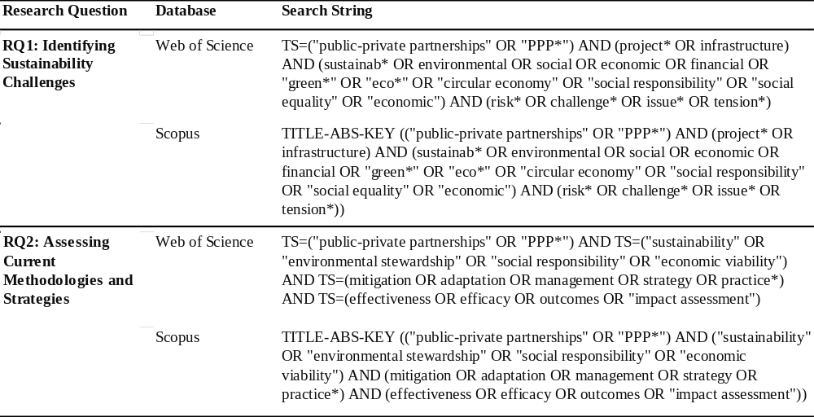
The scanning of the results also informed the development of precise inclusion and exclusion criteria, as shown in Table 2. These criteria serve as a systematic guide to refine the literature collection, ensuring that the studies selected for review are both relevant and contribute substantively to the research objectives, especially those addressing recent developments concerning sustainability issues in PPP projects. This tailored approach ensures the review focuses on high-quality, empirical research within specific subject areas, guaranteeing both relevance to the research objectives and manageability of the literature collection.
Table 2. Selection Criteria for Literature Identification
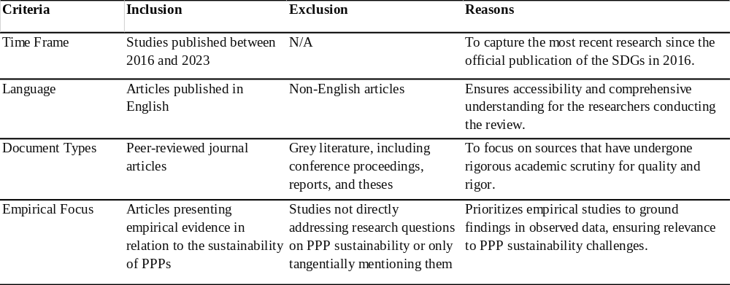
3.2 Search Process, Article Screening, and Identification
Adhering to the principles of PRISMA (see Figure 1), our preliminary literature search yielded a total of 4137 records using the first set of search strings and 531 records with the second set. Upon applying inclusion criteria—time frame, language, and document type—the number of records for screening was reduced to 1872 for the first group and 279 for the second group, as detailed in Table 3. After removing duplicates, we obtained 1149 records for the first group and 209 for the second.
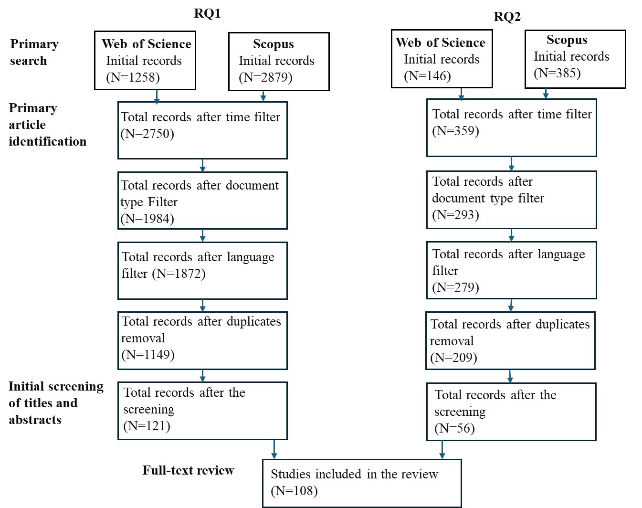
Figure 1 PRISMA flowchart
All these records underwent an initial screening of titles and abstracts, followed by a full-text review to ascertain the articles' eligibility. The decision to include or exclude was based on the redefined criteria during the process of primary paper identification. Articles must present empirical evidence mainly relevant to one or both of the following criteria: 1) sustainability-related challenges in PPP projects; 2) strategies, approaches, methods, or frameworks addressing sustainability challenges in PPP projects. For example, during the initial screening of abstracts, some empirical studies with abstracts that focused on the development of governance strategies or financial management strategies of PPP projects were excluded as they did not focus on strategies for tackling sustainability challenges. Subsequently, during the stage of full-text review, papers that discussed sustainability-related challenges or strategies to address the challenges in PPP projects as a side topic instead of the main areas of focus in the studies were excluded. Papers solely focused on PPP projects for sustainability instead of the sustainability of PPP projects themselves were also excluded. However, papers that discussed sustainability-related challenges facing projects aimed at promoting sustainable development, such as those aiming to promote energy transition or address social issues, were included. In this case, the articles are particularly valuable as they show that even though PPP has been considered an effective tool for achieving SDGs, issues concerning the sustainability of the projects could hinder the exploration of the full potential of these policy instruments.
Table 3. Application of Inclusion Criteria for Primary Paper Identification
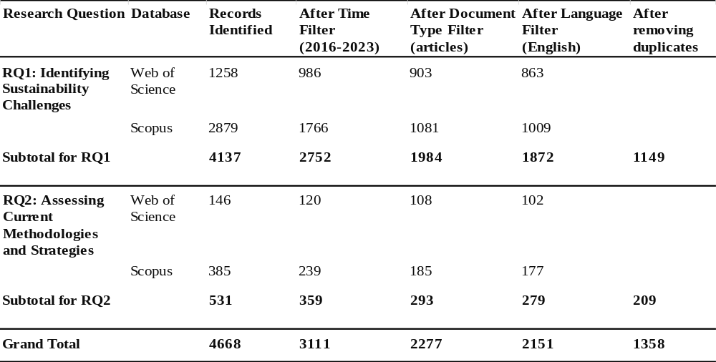
Upon the completion of the screening process, 108 papers were identified. We then adopted a snowballing strategy (Wohlin 2014; Hurmelinna-Laukkanen and Yang 2022), using the reference lists of some key articles to identify additional studies. Through this procedure, we identified another 8 articles. In total, 116 articles were selected for the purpose of this study.
3.3 Data analysis
In the subsequent stage of our study, the identified articles were imported into Nvivo 14, a tool for Qualitative Data Analysis. Our analysis commenced with a thematic coding approach, deeply informed by the theoretical insights discussed in Section 2, which provided theoretical foundations for examining the articles in relation to our two primary research questions. For the first question, we coded the data to reflect the three pillars of sustainable development-economic, environmental, and social challenges-to thoroughly explore the specific sustainability challenges encountered in PPP projects. In addressing the second question, we delineated our analysis into three broader thematic categories reflecting the core areas of investigation informed by our conceptual study: sustainable value creation, the intricacies of stakeholder engagement, and mechanisms of strategic agility within the PPP context. This methodological approach allowed us to meticulously organize and analyze the collected data, facilitating a rich, theory-informed synthesis of findings. This synthesis aimed to offer a comprehensive overview of the existing research landscape regarding sustainability in PPP projects, drawing on a strategy that aligns with practices commonly observed in systematic reviews (e.g. Hurmelinna-Laukkanen & Yang, 2022; Kanger et al., 2020; Perkmann et al., 2021; Rotolo et al., 2022; Stornelli et al., 2021) .
- Results
This section presents the findings from a systematic review of 116 papers, selected from a pool of 1,358 articles gathered from Web of Science and Scopus, aimed at addressing two research questions set up according to the research objectives:
- Which specific sustainability challenges are discussed in the literature for PPP projects across various sectors?
- What are the dominant (or emergent) strategies or approaches employed in PPP projects to tackle diverse sustainability challenges, and what principles underpin them?
4.1 Sustainability Challenges
A thorough synthesis of the collected data from the systematic review has revealed these key areas addressed in the existing literature concerning sustainability challenges facing PPP projects across major sectors ranging from transportation, energy, environmental services, healthcare, as well as public & social Services. Table 4 provides a summarized overview of the types of challenges identified.

Table 4 A Summary of Sustaibale Challenges Facing PPP projects
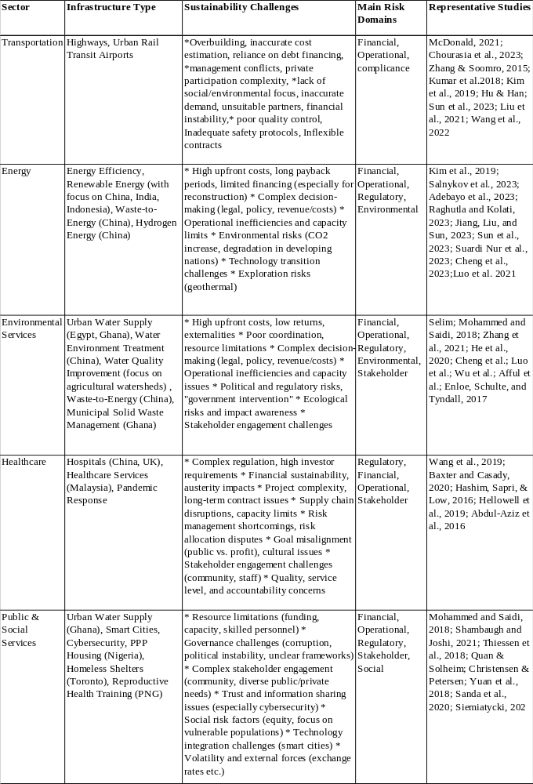
- Heavy Emphasis on Financial and Operational Risks
The analysis reveals a consistent emphasis on addressing financial and operational risks across various PPP project sectors in general, as shown in Table 4. Studies frequently address financial concerns such as cost overruns, project delays, and funding limitations in different sectors (Zhang and Soomro 2015a; Kumar et al. 2018; Baxter and Casady 2020; Mcdonald et al. 2021). For example, Kumar et al (2021) investigate financial risk associated with highway infrastructure projects in India, such as uncertain traffic revenue and escalation of project cost caused by delays in land acquisition. Operational risks related to regluations, government interface and corruption are also often studied (e.g. Sachs et al. 2007; Effah Ameyaw and Chan 2013; Iossa and Martimort 2016) ).This focus is understandable, as financial viability and operational efficiency are essential for the immediate success and stability of any PPP project. Without these foundations, the ability to deliver broader social and environmental benefits is fundamentally compromised.
However, while crucial, an overemphasis on these immediate risks can inadvertently overshadow the proactive management of environmental and social impacts that might threaten the project's long-term sustainability. A project that appears financially successful in the short-term might still unintentionally contribute to environmental degradation or social inequities that undermine its value over time. Unforeseen environmental costs, community tensions, or shifts in resource availability could threaten the PPP's ability to deliver on its intendead purpose and generate sustained benefits.
- Varying Environmental Risk Awareness
The analysis demonstrates an inconsistent emphasis on environmental risks across different PPP project sectors. While the energy and environmental services sectors predictably address environmental concerns (Wu et al. 2017; Kim et al. 2021; Afful et al. 2023; Jiang et al. 2023a), the focus is primarily on direct risks associated with the operation of these project themselves. Examples include pollution risks from energy generation and challenges in waste-to-energy projects (Luo et al. 2021; Cheng et al. 2023). In other sectors, such as transportation, environmental considerations are occasionally mentioned, but primarily in the context of how projects might strain existing resources(Mcdonald et al. 2021). There is less systematic analysis of how PPP projects could exacerbate wider environmental risks such as climate change impacts, or how they might contribute to unsustainable resource depletion in the long term.
- Inconsistent Emphasis on Social Risks
Social risks receive sporadic attention across the analyzed sectors. Papers highlight concerns such as stakeholder conflicts(Chourasia et al. 2023), equity challenges in healthcare access(Hellowell et al. 2019), and the impact of corruption on resource distribution(Mohammed and Saidi 2018). However, these discussions often lack the same depth and rigor applied to the analysis of financial risks. There is also notable gap in proactive identification of vulnerable groups, systematic assessment of social impact, and the development of strategies to ensure PPPs contribute to equitable social outcomes. Furthermore, current practices in PPP often prioritize the voices of powerful stakeholders or those with immediate economic interests in the project. This overlooks the potential concerns and perspectives of communities directly impacted by the project, hindering the development of robust social safeguards and equitable solutions(Klijn and Koppenjan 2016b).
- Limited Explicit Focus on Long-Term Risks
Many of the identified risks or challenges in the literature, across all three sustainability dimensions, have the potential to snowball over time. Examples include inaccurate demand forecasting (Zhang and Soomro 2015), escalating Financial Costs (Welde and Odeck 2017),technology obsolescence(Mukuvari and Khatleli 2020), exacerbated environmental Impacts (Li et al. 2019) and evolving and social needs(Huang et al. 2022). However, existing studies look at immediate sustainability challenges and lack an emphasis on these risks that can manifest over the entire lifecycle of the PPP, compromising long-term economic, social, and environmental sustainability. This short-sightedness leaves PPP projects vulnerable to project failures, due to issues such as financial losses, missed contractual obligations, public backlash, loss of legitimacy, and long-term degradation of environmental assets.
The results consistently show a focus on financial and operational risks in PPP projects, yet often overlook the broader social and environmental impacts that could jeopardize long-term sustainability. Furthermore, there is a notable lack of attention to long-term sustainability challenges. Overall, the literature review on sustainability challenges in PPP projects underscores the necessity for a more comprehensive and holistic examination of risks and challenges across the economic, social, and environmental dimensions of sustainable development throughout the project's lifecycle.
4.2 Strategies for mitigating sustainability risks
This section explores the comprehensive range of strategies or approaches that have been adopted to promote sustainability of PPP projects, as derived from a synthesis of current literature. As illustrated in Table 5 below, five key strategic themes are identified in the literature including governance, risk management, environmental integration, performance evaluation, project planning, and stakeholder engagement. Each theme is dissected to reveal its strategic focus, the underlying principles that guide it, and the specific sustainability challenges it addresses. Through this examination, we aim to elucidate the multifaceted approaches that are shaping the sustainability discourse within PPP field, offering insights into the principles that underpin successful sustainable practices in this domain.

Table 5 Strategic Themes for Sustainable Risk Mitigation in PPP Projects
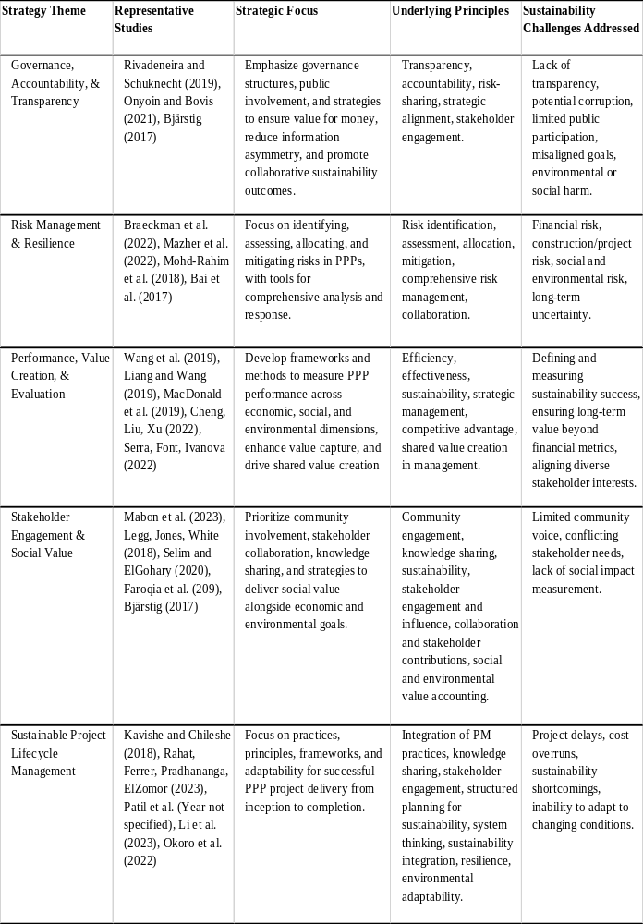
- Governance, accountability, and transparency
In PPP research domain, effective governance is considered fundamental for driving sustainable outcomes. Several studies have focused on the importance of establishing robust governance structures based on these underlying principles of transparency and accountability. The research emphasizes public involvement and deploy strategies that aim to ensure value for money, reduce information asymmetry, and enhance collaborative sustainability outcomes. The underlying principles are central, encouraging risk-sharing, strategic alignment, and active stakeholder engagement. By addressing challenges such as potential corruption and environmental or social harm, the principles of transparency and accountability are vital in steering PPPs towards more ethical and sustainable horizons (Bjärstig 2017; Ruiz Rivadeneira and Schuknecht 2019; Onyoin and Bovis 2022). There is also research that addresses the necessity for responsiveness and complementarity of contractual and relational mechanisms in PPPs(Dewulf and Garvin 2020a). Given the uncertainty of PPP projects, there is also research that explores how governance strategies can respond to risks in PPP projects proactively by addressing the necessity for responsiveness and complementarity of contractual and relational mechanisms in PPPs(Dewulf and Garvin 2020a).
However, despite addressing effective and responsive governance in promoting sustainability of PPP projects, such discussions tend to focus on these governance practices in tackling sustainability challenges in procurement and operations of PPP projects with the involvement of main stakeholders, especially actors in the government. As a result, many governance strategies often focus on short term financial related issues while failing to address the long-term sustainability of PPP projects.
- Risk Management and Resilience
The management of risk and fostering of resilience are seen as indispensable components in sustaining PPP initiatives in the literature, where various risk management strategies are discussed. For example, Braeckman et al. (2022), Mazher et al. (2022) and Mohd-Rahim et al. (2018) provide methodologies for a thorough risk assessment, allocation, and mitigation within PPPs. The studies demonstrate how to adherence to principles such as comprehensive risk management and collaboration addressing resilience to ensure the success of PPP projects. Some studies have also looked at methods at a particular stage or dimension of risk management such as risk factor allocation (Jin et al. 2019), risk assessment (Li and Wang 2019), or knowledge sharing (Jiang et al. 2023).
While the PPP risk management literature offers comprehensive strategies for tackling sustainablity risks, the primary focus is on financial risks and operatoinal risk, addressing economic sustainabliy of PPP projects. Few studies emphaise on how to manage broader social and environmental risks alongside financial and operational ones. In addition, the literature often presents these strategies as a linear process of identification, assessment, measurement, and mitigation. This conventional perspective overlooks the evolving nature of risks throughout PPP projects, potentially leaving projects vulnerable to unaddressed risks. Advocating for a cyclical, iterative risk management process is crucial, where risk management activities are continuously revisited and adapted throughout the entire lifecycle of PPP projects. Integrating such an approach throughout all stages of a PPP project enables ongoing adjustments to strategies in response to new and changing risks, thereby significantly enhancing the project's resilience to uncertainties and improving sustainability outcomes through the maintenance of relevant and dynamic practices.
- Performance Management and Value Creation
Efficient performance management of PPP projects to maximize value creation is a well-explored theme in PPP literature. This area actively investigates various tools and models for setting performance targets and indicators, monitoring performance, and evaluating outcomes. It examines the core principles of efficiency, effectiveness, and competitive advantage, showing how performance management strategies contribute to shared value creation and sustainable outcomes. Key contributions in this field include research by Hashim et al.(2016); Liu et al. (2018); Lop and Ismail 2023; Verweij and van Meerkerk (2022), and Ghorbany et al. (2023), mainly focusing on economic value creation.
Although a significant body of research, including Shen et al. (2016); Liang and Wang (2019); Wang et al. (2020); Xu et al. (2020); Hu et al. (2021); and Wang et al. (2023a and 2023b), proposes frameworks for evaluating PPPs across economic, social, and environmental dimensions with a focus on enhancing economic value alongside improvements in social and environmental performance, these discussions often prioritize the perspectives of key stakeholders with immediate financial and administrative stakes. This internally centered approach tends to overlook the broader spectrum of stakeholders, especially those impacted by or concerned with the PPP projects’ broader social and environmental effects. The literature reveals a noticeable gap in performance management strategies that comprehensively account for the wider range of stakeholder interests and concerns, moving beyond a narrow focus on financial and administrative priorities. It highlights the need for innovative performance management strategies that prioritize inclusivity and measure the long-term social and environmental value creation of PPP projects.
- Stakeholder Engagement and Inclusion
Stakeholder engagement is recognized as crucial for the sustainability of PPP projects, which inherently involve a diverse array of stakeholders with conflicting objectives. Numerous studies have showcased various strategies and methods for stakeholder engagement, focusing on the principles of transparency and openness as key to addressing sustainability challenges in PPP projects (e.g. Henjewele et al. 2013; Amadi et al. 2018; Amadi et al. 2019; Eyiah-Botwe et al. 2020; Jayasuriya et al. 2020; Srinivasan and Dhivya 2020;Wuni and Shen, 2020; Uddin et al. 2023). For instance, Wuni and Shen (2020) highlight that stakeholder analysis and early involvement, along with effective communication, information sharing, and the integration and management of stakeholder interests and conflicts, are essential for effectively engaging stakeholders in mitigating PPP project challenges. Amadi et al. (2019) describe a dynamic stakeholder engagement strategy involving the dynamic identification of stakeholders, their interests, and their management at each project phase with an emphasis on transparency. Collectively, these studies underscore the necessity of effective stakeholder management strategies to overcome sustainability challenges in PPP projects.
Despite the wealth of knowledge, there remains a gap in understanding how to engage a wider range of stakeholders, especially communities and groups concerned with environmental and social sustainability. Among the limited studies addressing this gap, Wuni and Shen (2020) and Mabon et al. (2023) are noteworthy for emphasizing community engagement as a cornerstone of sustainable PPP projects. They argue that involving communities through collaborative knowledge sharing and aligning with sustainability principles not only fosters economic and environmental value but also ensures the integration and recognition of social contributions. This highlights a critical research gap in developing comprehensive strategies that engage a broader spectrum of stakeholders, particularly those focused on environmental and social sustainability, in the PPP project lifecycle.
- Sustainable Project Lifecycle Management, Proactiveness and Adaptiveness
There has been growing attention to the integration of sustainability principles into every phase of the project lifecycle in the PPP literature. Research emphasizes the importance of incorporating sustainability considerations from project planning and design to procurement, operation, and transfer phases (Dolla and Laishram 2020). Specifically, studies have identified various critical factors and strategies that can enhance sustainability across the lifecycle of PPP projects. Such discussions covers a broad range of topics, from governance and efficiency (Hueskes et al. 2017; Wang et al. 2020b) to life cyle risk management (Mohd-Rahim et al. 2018b; Bakhtawar et al. 2022; Koc et al. 2023), the use of technology (Hoeft et al. 2021), life cyle performance measurements (Liu et al. 2018b; Kim and Thuc 2021; Ismail et al. 2022) and stakeholder management (Lenferink et al. 2013; He et al. 2020).
Collectively, the cited studies underscore the essential nature of proactiveness, adaptiveness, and agility within sustainable project lifecycle management. Proactiveness in SPLM involves anticipating sustainability challenges and opportunities early in the project lifecycle to integrate preventive measures and sustainability-driven innovations (Dolla and Laishram 2020; Mohd-Rahim et al. 2018). This anticipatory approach ensures that projects are not only compliant with current sustainability standards but are also poised to adapt to future sustainability trends and regulations. Adaptiveness, on the other hand, highlights the ability of PPP projects to respond to unforeseen sustainability challenges and stakeholder needs as they arise throughout the project lifecycle. This adaptiveness is crucial for maintaining project alignment with sustainability goals despite changing environmental, social, and economic contexts (Hueskes et al. 2017; Bakhtawar et al. 2022). Lastly, agility in SPLM refers to the flexibility of project management processes to rapidly integrate new sustainability practices and technologies, enabling projects to benefit from innovations that enhance environmental, social, and economic value creation (Hoeft et al. 2021; Kim and Thuc 2021). Together, these principles ensure that PPP projects are not only designed and executed with a foundational commitment to sustainability but are also capable of evolving in response to new sustainability insights and imperatives, thereby contributing to a more sustainable and resilient built environment.
Despite the increasing attention to sustainable project lifecycle management, research in this area remains fragmented. While there is a recognized need for a lifecycle perspective in PPP project management to ensure the sustainability of projects, studies integrating different perspectives to tackle sustainability challenges in a systematic and comprehensive way are scarce. This gap indicates the need for future research to embrace a more integrated and cohesive approach, merging strategies like governance, risk management, performance management, and stakeholder engagement into a unified model that comprehensively addresses the economic, environmental, and social dimensions of sustainability. This would not only enrich the theoretical underpinnings of sustainable project lifecycle management in PPPs but also offer practical insights for achieving more sustainable and resilient project outcomes.

- Developing the Inclusive Sustainable Value Response Framework for PPP Project Sustainability
The systematic review of the literature reveals an imbalanced focus on sustainability challenges in PPP projects across different sectors - discussions often prioritize financial risk management, leaving other dimensions of sustainability that includes environmental stewardship and social equity, less explored. Existing research on strategies to address sustainability challenges highlights the significant roles of various strategies such as governance, risk management, performance management, and stakeholder engagement, along with sustainable lifecycle project management. However, these discussions are often fragmented, pointing to a gap in the literature: the need for a more systematic and comprehensive strategy that integrates sustainability across the entire lifecycle of PPP projects.
Drawing upon the rich theoretical foundations laid out in Section 2, including Responsible Innovation, Value Sensitive Design, Inclusive Stakeholder Engagement, and Strategic Agility, the ISVR framework, as illustrated in Figure 2 below, is designed to fill this gap. It advocates for a holistic approach, ensuring sustainability consideration is integrated into every stage of PPP projects from initiation through to operation. The ISVR Framework represents a paradigm shift in PPP project management, emphasizing sustainability as a core value rather than an add-on. It is guided by the principles derived from four pivotal theories, including anticipation, inclusion, adaptability, and responsiveness, ensuring PPP projects are not only environmentally viable but also socially equitable and economically beneficial. Thus, the ISVR Framework champions value integration and responsive adaptability across the PPP project lifecycle. It is structured around four foundational pillars, each playing a crucial role in enhancing the project's sustainability across different stages of the lifecycle. These pillars are:
- Sustainable Value Integration - Embedding environmental, social, and economic considerations into every decision and action.
- Inclusive Stakeholder Engagement - Ensuring that all stakeholders, especially those traditionally marginalized, have a voice in the project.
- Strategic Agility through Proactive Risk Management - Enabling projects to anticipate and adapt to risks and changes in a timely manner.
- Holistic Integration across the Project Lifecycle - Seamlessly incorporating these pillars to achieve comprehensive sustainability.
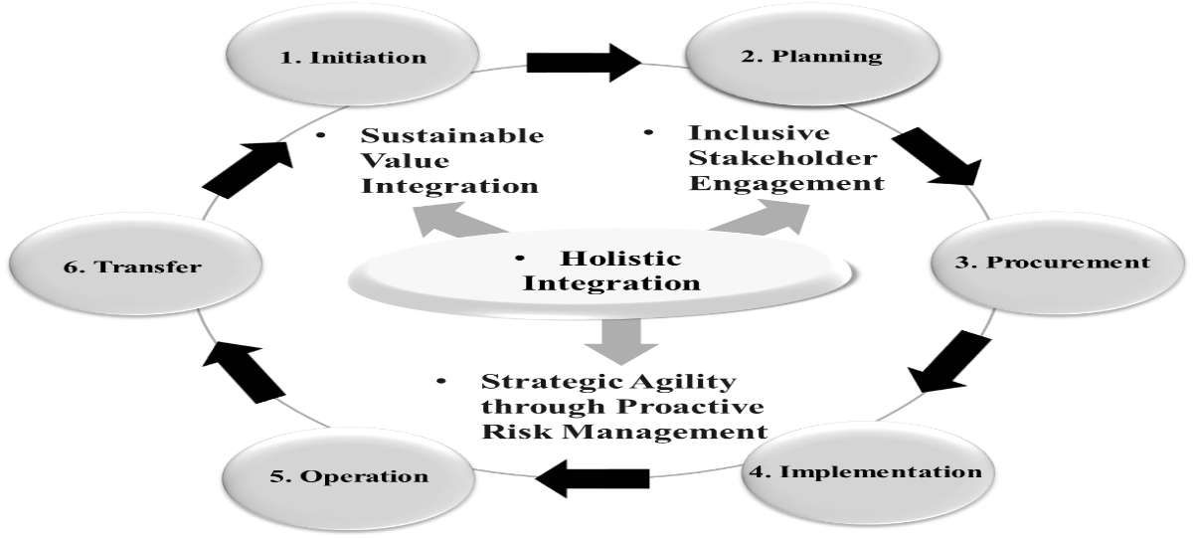
Figure 2 The Inclusive Sustainable Value Response Framework
The subsequent sections will explore each pillar in detail, demonstrating their significance, implementation strategies, and impact on the sustainability of PPP projects. This exploration is followed by a hypothetical case study.
5.1 Sustainable Value Integration
Sustainable Value Integration, the cornerstone of the ISVR framework, ensures environmental stewardship, social equity, and economic viability are core considerations in every decision and action taken throughout the PPP project lifecycle. It ensures that sustainability consideration is not addressed as an afterthought but is weaved into the project's processes, from initiation, planning through to implementation and beyond. This pillar is critical for several reasons. Firstly, it ensures that sustainability is a driving force behind strategic choices, guiding projects towards outcomes that benefit not only the current generation but also future ones. This approach hence directly responds to the UN call of addressing the SDGs in all human activities, reflecting a commitment to global sustainability standards (Brundtland, 1987; Bali Swain & Yang-Wallentin, 2020). Secondly, focusing on sustainability in decision-making helps to balance the often-competing interests of environmental protection, social responsibility, and economic growth and address the issues in conventional risk management and performance management that tend to have a narrow focus on financial and operational issues (e.g. Braeckman et al., 2022, Mazher et al., 2022; Verweij and van Meerkerk, 2022, and Ghorbany et al., 2023). Thirdly, by embedding these values into project actions, it encourages a comprehensive risk management strategy that proactively identifies and mitigates potential sustainability challenges, thereby enhancing project resilience (Hueskes et al., 2017). Lastly, it promotes inclusivity in stakeholder engagement and transparency in project governance by fostering shared visions and missions guiding the project's development towards more ethical and sustainable horizons (Bjärstig 2017; Onyoin and Bovis 2022).
Operationalizing sustainable value integration within the ISVR framework mandates the embedding of sustainability assessments and criteria right from a project's initiation, blending these considerations seamlessly into other stages till the end. This comprehensive approach ensures sustainability outcomes are specified in all contracts and rigorously monitored throughout the project's lifecycle. The integration is underpinned by the theoretical frameworks of responsible innovation and value sensitive design, which champion principles of anticipation, reflexivity, inclusion, and responsiveness based on human values. These principles are critical for navigating the sustainability landscape effectively, ensuring that decisions and actions at every phase align with broader economic, environmental, and social goals (Owen et al., 2013; Stilgoe et al., 2020). Imagine a PPP infrastructure project where, beyond the standard financial risk assessments, sustainability risk assessments are conducted at every stage—from planning and design to construction and operation. In the planning stage, potential environmental impacts are anticipated and strategies for minimizing carbon footprint are integrated. During procurement, criteria for selecting contractors include not only cost and efficiency but also adherence to sustainable practices, such as waste reduction and community engagement. Performance management systems, traditionally focused on financial and operational metrics, now include sustainability indicators, monitoring environmental impact, social equity, and economic benefits. This shift encourages a proactive approach to risk management, where risks to sustainability are identified and addressed alongside financial risks, enhancing the project's resilience and contribution to a sustainable and equitable world. Through this lens, the project not only achieves its infrastructural goals but also becomes a model for sustainable development, illustrating the practical application of Sustainable Value Integration across the PPP project lifecycle.
By prioritizing sustainable values in decision-making and actions across all phases, PPP projects can achieve a harmony of economic, environmental, and social goals, ensuring not only the project's success but also its contribution to a more sustainable and equitable world.
5.2 Inclusive Stakeholder Engagement
Distinctive in its approach, the ISVR framework emphasizes inclusivity and value co-creation, engaging a diverse group of stakeholders throughout the project lifecycle, from planning and design to implementation and evaluation. This approach acknowledges that stakeholders have unique insights, values, and expectations that can significantly contribute to the project’s success. It goes beyond mere consultation to ensure that all voices, especially those from marginalized or underrepresented groups, actively influence project decisions and outcomes. This method promotes social equity by fairly distributing the benefits and burdens of PPP projects among all stakeholders. Active involvement of community members and other stakeholders in decision-making processes enables projects to more effectively address local needs and mitigate adverse impacts, thereby fostering social cohesion and trust (Reypens et al., 2016; Villani et al., 2017). Such inclusive engagement permits the co-creation of value, where diverse perspectives inspire innovative solutions aligned with sustainability goals. This collaborative approach not only enhances project outcomes but also integrates sustainability considerations into every project aspect, leading to environmentally viable, socially equitable, and economically beneficial results (Quick and Feldman, 2011; Eskerod, Huemann, and Ringhofer, 2015). Stakeholder insights aid in anticipating risks, identifying emerging challenges, and adapting strategies, thus bolstering the project's capacity to sustain its value over time and contribute to long-term sustainability (Mease, Erickson, and Hicks, 2018; Zhang and Liu, 2022).
Marking a transformative departure from traditional stakeholder consultation methods (McErlane et al. 2016; Zhang and Liu 2022), the ISVR framework advocates for genuine participatory engagement. In an imagined urban mobility project scenario, stakeholders, including community members, environmental groups, and local businesses, are deeply involved in workshops and online forums with specific tasks, not just for feedback but for co-creating the project's sustainability goals. This collaborative process might lead to drafting contracts with embedded sustainability outcomes, establishing comprehensive risk assessment criteria beyond financial aspects to include environmental and social dimensions, and developing tailored performance monitoring systems. Such efforts could result in the integration of green corridors alongside transit routes, enhancing environmental stewardship and community well-being. This model leverages diverse stakeholder insights for tangible sustainable value co-creation, embedding these contributions throughout the project lifecycle and demonstrating a commitment to comprehensive sustainability and SDG alignment.
The inclusive and participatory stakeholder engagement model, a cornerstone of the ISVR framework, promotes PPP projects toward a holistic sustainability approach. Moving past traditional methods to embrace genuine collaboration ensures diverse perspectives directly shape project planning, execution, and evaluation (Mathur, Price, and Austin, 2008; Quick and Feldman, 2011). The co-creation of sustainable solutions not only achieves short-term project goals but also aligns with broader, long-term sustainability objectives, reflecting the SDGs' principles. Ultimately, this approach cultivates a project environment where sustainability is a shared, co-created value, significantly contributing to the enduring success and sustainability of PPP projects (Liu and Yang, 2023).
5.3 Strategic Agility through Proactive Risk Management
Strategic agility through proactive risk management is integral to PPP projects, enhancing their adaptability and responsiveness through the anticipation and mitigation of potential risks. This approach, grounded in strategic agility theories (Doz and Kosonen, 2008; Weber and Tarba, 2014) and responsible innovation principles of anticipation, reflexivity, inclusion, and responsiveness (Owen et al., 2013), encourages a dynamic, continuous risk management process. It is designed not just for risk identification but for the active preparation for future challenges that could impact a project's sustainability goals, allowing PPP projects to effectively navigate the shifting terrains of environmental, social, and economic contexts (Zou, Wang, and Fang, 2008; Owen et al., 2013).
The implementation of this approach emphasizes effective responsiveness through feedback loops, embedding continuous risk management activities across the project lifecycle. These feedback loops represent a departure from conventional risk management strategies that tend to follow a linear process concentrating on specific project stages or singular risk management dimensions (e.g., Braeckman et al. 2022, Jin et al. 2019, Li and Wang 2019). Imagine a PPP in an infrastructure project where economic volatility, new environmental regulations, and community opposition emerge as potential risks. In this scenario, proactive risk management entails the establishment of mechanisms for ongoing dialogue with stakeholders, environmental monitoring, and economic analysis, creating a responsive framework that adapts to these challenges in real-time. For instance, economic downturns might prompt the exploration of alternative financing models or cost-saving measures, while environmental regulation changes could lead to the adoption of greener technologies. Community opposition, identified early through stakeholder engagement, allows for timely negotiations and modifications to project plans, ensuring social concerns are addressed and mitigated. Such a proactive and adaptive approach underscores the importance of feedback loops, where risks are continuously reassessed and strategies updated, thereby enhancing the project's resilience and alignment with sustainability goals.
To sum up, integrating strategic agility through proactive risk management equips PPP projects with a comprehensive mechanism to anticipate, adapt to, and effectively manage sustainability challenges. The implementation of dynamic risk management strategies, characterized by feedback loops of continuous risk management activities, enables projects to evolve strategies based on real-time insights and emerging trends. This ensures projects maintain alignment with sustainability objectives, enhancing their capacity to navigate current complexities and future uncertainties. Such a paradigm shift fosters a forward-looking project management culture, transforming PPP projects into living ecosystems that continuously evolve. Driven by a deep commitment to sustainability, this approach positions projects for success amidst the changing landscape of sustainable development, significantly contributing to its overarching goals.
5.4 Holistic Integration across the Project Lifecycle
The ISVR framework’s unique value lies in its emphasis on a holistic integration of sustainable value principles, inclusive stakeholder engagement and risk management across at every stage of a PPP project life cycle. This integration ensures that these underlying principles, strategic actions or tools/methods supporting sustainability is not compartmentalized into a single phase but is a continuous thread woven through every stage, from initiation, planning and procurement to implementation, operation and transfer. Such integration allows for a seamless transition between project phases, maintaining sustainability momentum and ensuring that each stage builds upon the progress of the previous one addressing sustaiblity challenges, thereby addressing the project's environmental, social, and economic aspects in a unified manner. The holistic integration counters the fragmented approaches often observed in PPP projects, where sustainability efforts are isolated to specific project stages or domains. By integrating sustainability comprehensively, the ISVR framework ensures a coordinated effort across all project phases, effectively addressing the gaps identified in both the theoretical foundations and the practical challenges observed according to the review of the literature (Hueskes et al., 2017).
Specifically, through the integration of these three pillars, the approach promotes sustainable value co-creation by engaging all stakeholders in the sustainability process. It acknowledges and utilizes the diverse perspectives and expertise of stakeholders, thereby enriching the project's sustainability initiatives and outcomes (Reypens et al., 2016; Villani et al., 2017). Strategic agility through proactive risk management, when integrated holistically across the lifecycle, ensures that risks related to sustainability are identified, assessed, and mitigated in a timely and effective manner. This comprehensive view of risk management supports the project's long-term viability and success by preemptively addressing potential sustainability challenges (Zou, Wang, and Fang, 2008; Rybnicek and Königsgruber, 2019). It also enables PPP projects to be more adaptable and responsive to evolving sustainability challenges and stakeholder needs. This integration fosters a project environment that is proactive rather than reactive, ensuring that sustainability considerations are agile and reflective of current and future sustainability trends (Owen et al., 2013; Stilgoe et al., 2020). Finally, the integrated and cohesive approach enrichs existing sustaiable project life cycle research (e.g. Dolla and Laishram 2020; Hueskes et al. 2017a; Mohd-Rahim et al. 2018b; Bakhtawar et al. 2022; Koc et al. 2023) by merging different strategies and approaches for tackling sustainability issues into a unified model that appreciates the interconnectedness of various sustainability factors (Bali Swain & Yang-Wallentin, 2020).
- Conclusion and research limitations
Based on our systematic review of 116 articles, this study has aimed to identify these sustainability challenges within PPP projects and evaluate current strategies addressing these challenges. Ultimately, it leads to the development of the ISVR framework, which represents a paradigm shift in the management of PPP projects.
The ISVR framework emphasizes the critical importance of integrating sustainable value, inclusive stakeholder engagement, and strategic agility through proactive risk management across all project stages. This approach ensures that PPP projects are not merely sustainable in their intentions but also in their practical execution, turning potential sustainability challenges into opportunities for innovation and enhanced project resilience. By fostering a holistic and adaptable approach, the framework aligns project outcomes closely with environmental, social, and economic sustainability goals, surpassing traditional project management methodologies that primarily focus on financial metrics and operational efficiencies.

Future research could explore:
- The application of the ISVR framework across different sectors and geographical contexts to assess its adaptability and impact on diverse PPP projects.
- The development of quantitative metrics for evaluating the success of projects managed under the ISVR framework, particularly in terms of sustainability outcomes.
- The exploration of technological innovations that can support the principles of the ISVR framework, enhancing stakeholder engagement and risk management processes.
- An in-depth analysis of the challenges and barriers to implementing the ISVR framework in existing PPP project management practices, identifying strategies for overcoming these obstacles.
These research avenues promise to further explore the framework’s full potential, providing valuable insights for practitioners and policymakers committed to advancing sustainable development through PPP projects. The framework can ensure that PPP projects are not only designed and managed with sustainability at the forefront but are also equipped to navigate the complexities of sustainable development dynamically and inclusively. This study contributes to the theoretical expansion of sustainability in PPP projects, demonstrates practical application models, and informs policy implications for sustainable public and private collaborations. These contributions underscore the study's impact on both academic literature and practical, policy-driven sustainable development in PPPs.
It is worth mentioning the limitations of our research strategy. Firstly, by focusing exclusively on journal articles that present empirical evidence, we may overlook significant insights from other types of studies, such as theoretical papers or grey literature, which could offer valuable perspectives or solutions. Secondly, our reliance on thematic coding, grounded in predefined theoretical concepts, might constrain our ability to discover new findings that fall outside these established frameworks. This approach, while systematic, introduces the risk of confirmation bias, potentially steering us towards a singular interpretation and inadvertently omitting alternative methodologies or innovative solutions that do not align with our initial theoretical assumptions.
In conclusion, while this study offers a comprehensive framework for enhancing sustainability in PPP projects, acknowledging these limitations highlights the need for further research incorporating diverse sources and methodologies. This broader approach will enrich the understanding and application of the ISVR framework, ultimately driving more robust and innovative solutions in the realm of sustainable PPP project management.

Reference
Afful, B.E.B., Addaney, M., Anaafo, D., Akudugu, J.A., Borkor, F.K., Yeboah, E.O. and Sampana, J. 2023. Public-private partnership in municipal solid waste management in the Sunyani municipality of Ghana. Journal of Property, Planning and Environmental Law ahead-of-print(ahead-of-print). doi: 10.1108/JPPEL-04-2023-0012/FULL/XML.
Agarchand, N. and Laishram, B. 2017. Sustainable infrastructure development challenges through PPP procurement process: Indian perspective. International Journal of Managing Projects in Business 10(3), pp. 642–662. doi: 10.1108/IJMPB-10-2016-0078/FULL/PDF.
Akomea-Frimpong, I., Jin, X. and Osei-Kyei, R. 2021. Managing financial risks to improve financial success of public—private partnership projects: a theoretical framework. Journal of Facilities Management 20(5), pp. 629–651. doi: 10.1108/JFM-03-2021-0036/FULL/PDF.
Amadi, C., Carrillo, P. and Tuuli, M. 2018. Stakeholder management in PPP projects: external stakeholders’ perspective. Built Environment Project and Asset Management 8(4), pp. 403–414. doi: 10.1108/BEPAM-02-2018-0048/FULL/XML.
Amadi, C., Carrillo, P. and Tuuli, M. 2019. PPP projects: improvements in stakeholder management. Engineering Construction and Architectural Management 27(2), pp. 544–560. doi: 10.1108/ECAM-07-2018-0289.
Anderson, B.B. and Ratiu, C. 2019. Stakeholder considerations in public-private partnerships. World Journal of Entrepreneurship, Management and Sustainable Development 15(3), pp. 212–221. doi: 10.1108/WJEMSD-04-2018-0046/FULL/PDF.
Babatunde, S.O., Ekundayo, D., Udeaja, C. and Abubakar, U.O. 2022. An investigation into the sustainability practices in PPP infrastructure projects: a case of Nigeria. Smart and Sustainable Built Environment 11(1), pp. 110–125. doi: 10.1108/SASBE-04-2020-0048/FULL/XML.
Bakhtawar, B., Thaheem, M.J., Arshad, H., Tariq, S., Mazher, K.M., Zayed, T. and Akhtar, N. 2022. A sustainability-based risk assessment for p3 projects using a simulation approach. Sustainability (Switzerland) 14(1), p. 344. Available at: https://www.mdpi.com/2071-1050/14/1/344/htm [Accessed: 9 March 2024].
Bali Swain, R. and Yang-Wallentin, F. 2020. Achieving sustainable development goals: predicaments and strategies. International Journal of Sustainable Development & World Ecology 27(2), pp. 96–106. Available at: https://www-tandfonline-com.proxy.uwasa.fi/doi/abs/10.1080/13504509.2019.1692316 [Accessed: 10 March 2024].
Bao, F., Martek, I., Chen, C., Wu, Q. and Chan, A.P.C. 2022. Critical Risks Inherent to the Transfer Phase of Public–Private Partnership Water Projects in China. Journal of Management in Engineering 38(3), p. 04022006. Available at: https://ascelibrary.org/doi/abs/10.1061/%28ASCE%29ME.1943-5479.0001024 [Accessed: 2 March 2024].
Baxter, D. and Casady, C.B. 2020. A Coronavirus (COVID-19) Triage Framework for (Sub)National Public–Private Partnership (PPP) Programs. Sustainability 2020, Vol. 12, Page 5253 12(13), p. 5253. Available at: https://www.mdpi.com/2071-1050/12/13/5253/htm [Accessed: 5 March 2024].
Best, B., Moffett, S. and McAdam, R. 2019. Stakeholder salience in public sector value co-creation. Public Management Review 21(11), pp. 1707–1732. Available at: https://www-tandfonline-com.proxy.uwasa.fi/doi/abs/10.1080/14719037.2019.1619809 [Accessed: 10 March 2024].
Bjärstig, T. 2017. Does Collaboration Lead to Sustainability? A Study of Public–Private Partnerships in the Swedish Mountains. Sustainability 2017, Vol. 9, Page 1685 9(10), p. 1685. Available at: https://www.mdpi.com/2071-1050/9/10/1685/htm [Accessed: 6 March 2024].
Blok, V., Lemmens, P., Blok, V. and Lemmens, P. 2015. The Emerging Concept of Responsible Innovation. Three Reasons Why It Is Questionable and Calls for a Radical Transformation of the Concept of Innovation. doi: 10.1007/978-3-319-17308-5_2.
Braeckman, J., Markkanen, S. and Seega, N. 2022. Financiers’ perceptions of risk in relation to large hydropower projects. Environmental Research: Infrastructure and Sustainability 2(1), p. 015006. Available at: https://iopscience.iop.org/article/10.1088/2634-4505/ac4e70 [Accessed: 8 March 2024].
Brundtland, G. 1987. Report of the World Commission on Environment and Development: Our Common Future. United Nations General Assembly document A/42/427.
Caldwell, N.D., Roehrich, J.K. and George, G. 2017. Social Value Creation and Relational Coordination in Public-Private Collaborations. Journal of Management Studies 54(6), pp. 906–928. Available at: https://onlinelibrary.wiley.com/doi/full/10.1111/joms.12268 [Accessed: 10 March 2024].
Cheng, M., Liu, L., Cheng, X. and Tao, L. 2023. Risk analysis of public-private partnership waste-to-energy incineration projects in China: a hybrid fuzzy DEMATEL-ISM approach. Engineering, Construction and Architectural Management ahead-of-print(ahead-of-print). doi: 10.1108/ECAM-06-2022-0546/FULL/XML.
Cheng, Z., Wang, H., Xiong, W., Zhu, D. and Cheng, L. 2021. Public–private partnership as a driver of sustainable development: toward a conceptual framework of sustainability-oriented PPP. Environment, Development and Sustainability 23(1), pp. 1043–1063. Available at: https://link.springer.com/article/10.1007/s10668-019-00576-1 [Accessed: 10 March 2024].
Chourasia, A.S., Dalei, N.N. and Jha, K. 2023. Evaluating public–private partnership role on the sustainability of airports in India. Sustainable Development 31(5), pp. 3595–3608. Available at: https://onlinelibrary-wiley-com.proxy.uwasa.fi/doi/full/10.1002/sd.2613 [Accessed: 6 March 2024].
Cinar, E., Demircioglu, M.A., Acik, A.C. and Simms, C. 2024. Public sector innovation in a city state: exploring innovation types and national context in Singapore: Public sector innovation in Singapore. Research Policy 53(2). doi: 10.1016/j.respol.2023.104915.
Demirag, I., Khadaroo, I., Stapleton, P. and Stevenson, C. 2011a. Risks and the financing of PPP: Perspectives from the financiers. The British Accounting Review 43(4), pp. 294–310. doi: 10.1016/J.BAR.2011.08.006.
Demirag, I., Khadaroo, I., Stapleton, P. and Stevenson, C. 2011b. Risks and the financing of PPP: Perspectives from the financiers. The British Accounting Review 43(4), pp. 294–310. doi: 10.1016/J.BAR.2011.08.006.
Dewulf, G. and Garvin, M.J. 2020a. Responsive governance in PPP projects to manage uncertainty. Construction Management and Economics 38(4), pp. 383–397. Available at: https://www-tandfonline-com.proxy.uwasa.fi/doi/abs/10.1080/01446193.2019.1618478 [Accessed: 7 March 2024].
Dewulf, G. and Garvin, M.J. 2020b. Responsive governance in PPP projects to manage uncertainty. Construction Management and Economics 38(4), pp. 383–397. Available at: https://www-tandfonline-com.proxy.uwasa.fi/doi/abs/10.1080/01446193.2019.1618478 [Accessed: 10 March 2024].
Dolla, T. and Laishram, B. 2020. Enhancing Sustainability in Public-Private Partnership Projects through Bid Selection Model. Transportation Research Procedia 48, pp. 3896–3907. doi: 10.1016/J.TRPRO.2020.08.031.
Doz, Y. and Kosonen, M. 2008. The dynamics of strategic agility: Nokia’s rollercoaster experience. California Management Review 50(3), pp. 95–118. Available at: https://journals-sagepub-com.proxy.uwasa.fi/doi/abs/10.2307/41166447 [Accessed: 1 March 2024].
Eadie, R., Millar, P. and Toner, L. 2013. Public private partnerships, reevaluating value for money. International Journal of Procurement Management 6(2), pp. 152–169. doi: 10.1504/IJPM.2013.052467.
Effah Ameyaw, E. and Chan, A.P.C. 2013. Identifying public-private partnership (PPP) risks in managing water supply projects in Ghana. Journal of Facilities Management 11(2), pp. 152–182. doi: 10.1108/14725961311314651/FULL/XML.
Eskerod, P., Huemann, M. and Ringhofer, C. 2015. Stakeholder Inclusiveness: Enriching Project Management with General Stakeholder Theory1. https://doi-org.proxy.uwasa.fi/10.1002/pmj.21546 46(6), pp. 42–53. Available at: https://journals-sagepub-com.proxy.uwasa.fi/doi/abs/10.1002/pmj.21546 [Accessed: 29 February 2024].
Eyiah-Botwe, E., Aigbavboa, C.O. and Thwala, W.D. 2020. Curbing PPP construction projects’ failure using enhanced stakeholder management success in developing countries. Built Environment Project and Asset Management 10(1), pp. 50–63. doi: 10.1108/BEPAM-01-2018-0035/FULL/XML.
Fischer, K., Leidel, K., Riemann, A. and Alfen, H.W. 2010. An integrated risk management system (IRMS) for PPP projects. Journal of Financial Management of Property and Construction 15(3), pp. 260–282. doi: 10.1108/13664381011087515/FULL/PDF.
Ghorbany, S., Noorzai, E. and Yousefi, S. 2023. BIM-based solution to enhance the performance of public-private partnership construction projects using copula bayesian network. Expert Systems with Applications 216, p. 119501. doi: 10.1016/J.ESWA.2023.119501.
Ghorbany, S., Yousefi, S. and Noorzai, E. 2024a. Evaluating and optimizing performance of public–private partnership projects using copula Bayesian network. Engineering, Construction and Architectural Management 31(1), pp. 290–323. doi: 10.1108/ECAM-05-2022-0492/FULL/XML.
Ghorbany, S., Yousefi, S. and Noorzai, E. 2024b. Evaluating and optimizing performance of public–private partnership projects using copula Bayesian network. Engineering, Construction and Architectural Management 31(1), pp. 290–323. doi: 10.1108/ECAM-05-2022-0492/FULL/PDF.
Hashim, H., Che-Ani, A.I., Hashim, H. and Che-ani, A.I. 2016. A Polemic On Defects Liability In Public Private Partnership (PPP) Project. Journal of Engineering Science and Technology Special Issue on ISSC, pp. 219–227. Available at: https://www.researchgate.net/publication/319016617 [Accessed: 8 March 2024].
He, N., Li, Y., Li, H., Liu, Z. and Zhang, C. 2020. Critical factors to achieve sustainability of public-private partnership projects in the water sector: A stakeholder-oriented network perspective. Complexity 2020. doi: 10.1155/2020/8895980.
Hellowell, M., Stafford, A. and Stapleton, P. 2019. Austerity and Hospitals in Deficit: Is PPP Termination the Answer? Abacus 55(3), pp. 535–556. Available at: https://onlinelibrary-wiley-com.proxy.uwasa.fi/doi/full/10.1111/abac.12163 [Accessed: 6 March 2024].
Henjewele, C., Fewings, P. and Pantaleo, D.R. 2013a. De-marginalising the public in PPP projects through multi-stakeholders management. Journal of Financial Management of Property and Construction 18(3), pp. 210–231. doi: 10.1108/JFMPC-05-2013-0021/FULL/XML.
Henjewele, C., Fewings, P. and Pantaleo, D.R. 2013b. De-marginalising the public in PPP projects through multi-stakeholders management. Journal of Financial Management of Property and Construction 18(3), pp. 210–231. doi: 10.1108/JFMPC-05-2013-0021/FULL/HTML.
Hoeft, M., Pieper, M., Eriksson, K. and Bargstädt, H.J. 2021. Toward Life Cycle Sustainability in Infrastructure: The Role of Automation and Robotics in PPP Projects. Sustainability 2021, Vol. 13, Page 3779 13(7), p. 3779. Available at: https://www.mdpi.com/2071-1050/13/7/3779/htm [Accessed: 9 March 2024].
Hu, Z., Li, Q., Liu, T., Wang, L. and Cheng, Z. 2021. Government equity investment, effective communication and public private partnership (PPP) performance: evidence from China. Engineering, Construction and Architectural Management 28(9), pp. 2811–2827. doi: 10.1108/ECAM-02-2020-0138/FULL/XML.
Huang, X., Lin, Y., Lim, M.K., Zhou, F., Ding, R. and Zhang, Z. 2022. Evolutionary dynamics of promoting electric vehicle-charging infrastructure based on public–private partnership cooperation. Energy 239, p. 122281. doi: 10.1016/J.ENERGY.2021.122281.
Hueskes, M., Verhoest, K. and Block, T. 2017. Governing public–private partnerships for sustainability: An analysis of procurement and governance practices of PPP infrastructure projects. International Journal of Project Management 35(6), pp. 1184–1195. doi: 10.1016/J.IJPROMAN.2017.02.020.
Hurmelinna-Laukkanen, P. and Yang, J. 2022. Distinguishing between appropriability and appropriation: A systematic review and a renewed conceptual framing. Research Policy 51(1). doi: 10.1016/j.respol.2021.104417.
Iossa, E. and Martimort, D. 2016. Corruption in PPPs, incentives and contract incompleteness. International Journal of Industrial Organization 44, pp. 85–100. doi: 10.1016/J.IJINDORG.2015.10.007.
Ismail, S., Mohamad, R. and Mohd Said, J. 2022. Performance indicators for lifecycle process of public private partnership (PPP) projects in Malaysia. Built Environment Project and Asset Management 12(5), pp. 704–718. doi: 10.1108/BEPAM-02-2021-0030/FULL/PDF.
Iyer, K.C. and Balamurugan, R. 2006. Evaluation of private sector participation models in highway infrastructure in India – a system dynamics approach. Journal of Advances in Management Research 3(1), pp. 44–58. doi: 10.1108/97279810680001238/FULL/XML.
Jayasuriya, S., Zhang, G. and Yang, R.J. 2020. Exploring the impact of stakeholder management strategies on managing issues in PPP projects. International Journal of Construction Management 20(6), pp. 666–678. Available at: https://www.tandfonline.com/doi/abs/10.1080/15623599.2020.1753143 [Accessed: 8 March 2024].
Jiang, W., Liu, C. and Sun, Z. 2023a. Promoting developments of hydrogen production from renewable energy and hydrogen energy vehicles in China analyzing a public-private partnership cooperation scheme based on evolutionary game theory. Energy 278, p. 127654. doi: 10.1016/J.ENERGY.2023.127654.
Jiang, X., Wang, S., Liu, Y., Xia, B., Skitmore, M., Nepal, M. and Ghanbaripour, A.N. 2023b. A method for the ontology-based risk management of PPP construction projects. Construction Innovation 23(5), pp. 1095–1129. doi: 10.1108/CI-02-2022-0029/FULL/PDF.
Jin, H., Liu, S., Liu, C. and Udawatta, N. 2019. Optimizing the concession period of PPP projects for fair allocation of financial risk. Engineering, Construction and Architectural Management 26(10), pp. 2347–2363. doi: 10.1108/ECAM-05-2018-0201/FULL/PDF.
Kang, J., Tong, C. and Dantong, T. 2022. The Theory, Practice and Improvement in Providing “Rights – Ethical Public Goods” with PPP. International Research Journal of Economics and Management Studies IRJEMS 2(1), pp. 32–39. doi: 10.56472/25835238/IRJEMS-V2I1P105.
Kanger, L., Sovacool, B.K. and Noorkõiv, M. 2020. Six policy intervention points for sustainability transitions: A conceptual framework and a systematic literature review. Research Policy 49(7). doi: 10.1016/j.respol.2020.104072.
Kim, K., Kim, J. and Yook, D. 2021. Analysis of Features Affecting Contracted Rate of Return of Korean PPP Projects. Sustainability 2021, Vol. 13, Page 3311 13(6), p. 3311. Available at: https://www.mdpi.com/2071-1050/13/6/3311/htm [Accessed: 5 March 2024].
Kim, S.Y. and Thuc, L.D. 2021. Life Cycle Performance Measurement in Public–Private Partnership Infrastructure Projects. Journal of Infrastructure Systems 27(4), p. 06021001. Available at: https://ascelibrary.org/doi/abs/10.1061/%28ASCE%29IS.1943-555X.0000639 [Accessed: 9 March 2024].
Klijn, E.H. and Koppenjan, J. 2016a. The impact of contract characteristics on the performance of public–private partnerships (PPPs). Public Money & Management 36(6), pp. 455–462. Available at: https://www-tandfonline-com.proxy.uwasa.fi/doi/abs/10.1080/09540962.2016.1206756 [Accessed: 2 March 2024].
Klijn, E.H. and Koppenjan, J. 2016b. The impact of contract characteristics on the performance of public–private partnerships (PPPs). Public Money & Management 36(6), pp. 455–462. Available at: https://www-tandfonline-com.proxy.uwasa.fi/doi/abs/10.1080/09540962.2016.1206756 [Accessed: 6 March 2024].
Koc, K., Kunkcu, H. and Gurgun, A.P. 2023. A Life Cycle Risk Management Framework for Green Building Project Stakeholders. Journal of Management in Engineering 39(4), p. 04023022. Available at: https://ascelibrary.org/doi/abs/10.1061/JMENEA.MEENG-5361 [Accessed: 9 March 2024].
Koppenjan, J., Klijn, E.H., Verweij, S., Duijn, M., van Meerkerk, I., Metselaar, S. and Warsen, R. 2022. The Performance of Public–Private Partnerships: An Evaluation of 15 Years DBFM in Dutch Infrastructure Governance. Public Performance & Management Review 45(5), pp. 998–1028. Available at: https://www-tandfonline-com.proxy.uwasa.fi/doi/abs/10.1080/15309576.2022.2062399 [Accessed: 2 March 2024].
Ks, J., Chowdhury, A., Sharma, K. and Platz, D. 2016. Public-Private Partnerships and the 2030 Agenda for Sustainable Development: Fit for purpose? Available at: http://www.un.org/en/development/ [Accessed: 10 March 2024].
Kumar, L., Jindal, A. and Velaga, N.R. 2018. Financial risk assessment and modelling of PPP based Indian highway infrastructure projects. Transport Policy 62, pp. 2–11. doi: 10.1016/J.TRANPOL.2017.03.010.
Labuschagne, C., Brent, A.C. and Claasen, S.J. 2005. Environmental and social impact considerations for sustainable project life cycle management in the process industry. Corporate Social Responsibility and Environmental Management 12(1), pp. 38–54. Available at: https://onlinelibrary-wiley-com.proxy.uwasa.fi/doi/full/10.1002/csr.76 [Accessed: 29 February 2024].
Lenferink, S., Tillema, T. and Arts, J. 2013. Towards sustainable infrastructure development through integrated contracts: Experiences with inclusiveness in Dutch infrastructure projects. International Journal of Project Management 31(4), pp. 615–627. doi: 10.1016/J.IJPROMAN.2012.09.014.
Li, H., Xia, Q., Wen, S., Wang, L. and Lv, L. 2019. Identifying Factors Affecting the Sustainability of Water Environment Treatment Public-Private Partnership Projects. Advances in Civil Engineering 2019. doi: 10.1155/2019/7907234.
Li, Y. and Wang, X. 2019. Using fuzzy analytic network process and ISM methods for risk assessment of public-private partnership: a China perspective. Journal of Civil Engineering and Management 25(2), pp. 168–183. Available at: https://jest.vgtu.lt/index.php/JCEM/article/view/8655 [Accessed: 8 March 2024].
Liang, Y. and Wang, H. 2019. Sustainable Performance Measurements for Public–Private Partnership Projects: Empirical Evidence from China. Sustainability 2019, Vol. 11, Page 3653 11(13), p. 3653. Available at: https://www.mdpi.com/2071-1050/11/13/3653/htm [Accessed: 8 March 2024].
Liu, B., Li, J., Wang, D., Liu, H., Wu, G. and Yuan, J. 2024. Public–private partnerships: a collaborative framework for ensuring project sustainable operations. Engineering, Construction and Architectural Management 31(1), pp. 264–289. doi: 10.1108/ECAM-12-2021-1124/FULL/XML.
Liu, H.J., Love, P.E.D., Smith, J., Irani, Z., Hajli, N. and Sing, M.C.P. 2018a. From design to operations: a process management life-cycle performance measurement system for Public-Private Partnerships. Production Planning & Control 29(1), pp. 68–83. doi: 10.1080/09537287.2017.1382740.
Liu, H.J., Love, P.E.D., Smith, J., Sing, M.C.P. and Matthews, J. 2018b. Evaluation of public–private partnerships: A life-cycle Performance Prism for ensuring value for money. Environment and Planning C: Politics and Space 36(6), pp. 1133–1153. Available at: https://journals-sagepub-com.proxy.uwasa.fi/doi/full/10.1177/2399654417750879 [Accessed: 9 March 2024].
Liu, J., Love, P.E.D., Smith, J., Matthews, J. and Sing, C.-P. 2016. Praxis of Performance Measurement in Public-Private Partnerships: Moving beyond the Iron Triangle. Journal of Management in Engineering 32(4). doi: 10.1061/(ASCE)ME.1943-5479.0000433.
Liu, Q. and Yang, M. 2023. Sustainable Value Co-creation in the Circular Economy through Digitalization. https://doi.org/10.5465/AMPROC.2023.19075abstract 2023(1). Available at: https://journals.aom.org/doi/abs/10.5465/AMPROC.2023.19075abstract [Accessed: 1 March 2024].
Lop, N.S. and Ismail, K. 2023. Criteria in Selecting Key Performance Indicators for Public Private Partnership (PPP) Projects. International Journal of Sustainable Construction Engineering and Technology 14(3), pp. 299–308. Available at: https://publisher.uthm.edu.my/ojs/index.php/IJSCET/article/view/15029 [Accessed: 8 March 2024].
Lubberink, R., Blok, V., van Ophem, J. and Omta, O. 2017. A framework for responsible innovation in the business context: Lessons from responsible-, social- and sustainable innovation. Responsible Innovation 3: A European Agenda?, pp. 181–207. Available at: https://link-springer-com.proxy.uwasa.fi/chapter/10.1007/978-3-319-64834-7_11 [Accessed: 29 February 2024].
Luo, C., Ju, Y., Dong, P., Gonzalez, E.D.R.S. and Wang, A. 2021. Risk assessment for PPP waste-to-energy incineration plant projects in china based on hybrid weight methods and weighted multigranulation fuzzy rough sets. Sustainable Cities and Society 74, p. 103120. doi: 10.1016/J.SCS.2021.103120.
Mabon, L., Shih, W.Y. and Jou, S.C. 2023. Integration of knowledge systems in urban farming initiatives: insight from Taipei Garden City. Sustainability Science 18(2), pp. 857–875. Available at: https://link-springer-com.proxy.uwasa.fi/article/10.1007/s11625-022-01196-x [Accessed: 8 March 2024].
Mathur, V.N., Price, A.D.F. and Austin, S. 2008a. Conceptualizing stakeholder engagement in the context of sustainability and its assessment. Construction Management and Economics 26(6), pp. 601–609. Available at: https://doi.org/10.1080/01446190802061233 [Accessed: 29 February 2024].
Mathur, V.N., Price, A.D.F. and Austin, S. 2008b. Conceptualizing stakeholder engagement in the context of sustainability and its assessment. Construction Management and Economics 26(6), pp. 601–609. Available at: https://www-tandfonline-com.proxy.uwasa.fi/doi/abs/10.1080/01446190802061233 [Accessed: 29 February 2024].
Mazher, K.M. et al. 2022. Identifying Measures of Effective Risk Management for Public–Private Partnership Infrastructure Projects in Developing Countries. Sustainability 2022, Vol. 14, Page 14149 14(21), p. 14149. Available at: https://www.mdpi.com/2071-1050/14/21/14149/htm [Accessed: 8 March 2024].
Mcdonald, D.A., Marois, T. and Spronk, S. 2021. Public Banks + Public Water = SDG 6? Water Alternatives 14(1), pp. 117–134. Available at: www.water-alternatives.org [Accessed: 5 March 2024].
Mease, L.A., Erickson, A. and Hicks, C. 2018. Engagement takes a (fishing) village to manage a resource: Principles and practice of effective stakeholder engagement. Journal of Environmental Management 212, pp. 248–257. doi: 10.1016/J.JENVMAN.2018.02.015.
Mihailova, D., Schubert, I., Burger, P. and Fritz, M.M.C. 2022. Exploring modes of sustainable value co-creation in renewable energy communities. Journal of Cleaner Production 330, p. 129917. doi: 10.1016/J.JCLEPRO.2021.129917.
Mohamad, R., Ismail, S. and Mohd Said, J. 2018. Performance indicators for public private partnership (PPP) projects in Malaysia. Journal of economic and administrative sciences 34(2), pp. 137–152. doi: 10.1108/JEAS-04-2017-0018.
Mohammed, A.A. and Saidi, A.M. 2018. Public-Private Partnership: Ghanaian Perspective of Urban Water Supply. International Journal of Engineering & Technology 7(3), pp. 49–52. Available at: www.sciencepubco.com/index.php/IJET [Accessed: 6 March 2024].
Mohd-Rahim, F.A., Abd-Rahim, M.S., Zainon, N., Chuing, L.S. and Abd-Samad, Z. 2018a. Project Life Cycle Risk of Public-Private Partnership (PPP) Projects for Construction Sustainability. Journal of Design and Built Environment 2018(Spoecialissue), pp. 39–53. Available at: https://vmis.um.edu.my/index.php/jdbe/article/view/12158 [Accessed: 8 March 2024].
Mohd-Rahim, F.A., Abd-Rahim, M.S., Zainon, N., Chuing, L.S. and Abd-Samad, Z. 2018b. Project Life Cycle Risk of Public-Private Partnership (PPP) Projects for Construction Sustainability. Journal of Design and Built Environment 2018(Spoecialissue), pp. 39–53. Available at: https://jupidi.um.edu.my/index.php/jdbe/article/view/12158 [Accessed: 9 March 2024].
Moher, D. et al. 2009. Preferred reporting items for systematic reviews and meta-analyses: the PRISMA statement. PLoS medicine 6(7). Available at: https://pubmed.ncbi.nlm.nih.gov/19621072/ [Accessed: 13 March 2024].
Mukuvari, B. and Khatleli, N. 2020. The impact of obsolescence on public-private partnership projects in South Africa. Supporting Inclusive Growth and Sustainable Development in Africa - Volume II: Transforming Infrastructure Development, pp. 37–48. Available at: https://link-springer-com.proxy.uwasa.fi/chapter/10.1007/978-3-030-41983-7_4 [Accessed: 6 March 2024].
Mwesigwa, R., Bagire, V., Ntayi, J.M. and Munene, J.C. 2019. Antecedents of stakeholder management in public private partnership projects in Uganda. World Journal of Entrepreneurship, Management and Sustainable Development 15(2), pp. 169–181. doi: 10.1108/WJEMSD-03-2018-0034.
Nederhand, J. and Klijn, E.H. 2019. Stakeholder Involvement in Public–Private Partnerships: Its Influence on the Innovative Character of Projects and on Project Performance. Administration and Society 51(8), pp. 1200–1226. Available at: https://journals.sagepub.com/doi/full/10.1177/0095399716684887 [Accessed: 29 February 2024].
Onyoin, M. and Bovis, C.H. 2022. Sustaining Public–Private Partnerships for Public Service Provision Through Democratically Accountable Practices. Administration and Society 54(3), pp. 395–423. Available at: https://journals-sagepub-com.proxy.uwasa.fi/doi/full/10.1177/00953997211030516 [Accessed: 6 March 2024].
Owen, R., Stilgoe, J., Macnaghten, P., Gorman, M., Fisher, E. and Guston, D. 2013. A Framework for Responsible Innovation. Responsible Innovation: Managing the Responsible Emergence of Science and Innovation in Society, pp. 27–50. Available at: https://onlinelibrary-wiley-com.proxy.uwasa.fi/doi/full/10.1002/9781118551424.ch2 [Accessed: 29 February 2024].
Page, M.J. et al. 2021. PRISMA 2020 explanation and elaboration: updated guidance and exemplars for reporting systematic reviews. The BMJ 372. Available at: /pmc/articles/PMC8005925/ [Accessed: 13 March 2024].
Patil, N.A. and Laishram, B.S. 2016. Sustainability of Indian PPP procurement process: Development of strategies for enhancement. Built Environment Project and Asset Management 6(5), pp. 491–507. doi: 10.1108/BEPAM-09-2015-0043/FULL/PDF.
Patil, N.A., Thounaojam, N. and Laishram, B. 2021. Enhancing sustainability of Indian PPP procurement process using system dynamics model. Journal of Public Procurement 21(4), pp. 345–369. doi: 10.1108/JOPP-01-2019-0002/FULL/XML.
Perkmann, M., Salandra, R., Tartari, V., McKelvey, M. and Hughes, A. 2021. Academic engagement: A review of the literature 2011-2019. Research Policy 50(1). doi: 10.1016/j.respol.2020.104114.
Quick, K.S. and Feldman, M.S. 2011. Distinguishing participation and inclusion. Journal of Planning Education and Research 31(3), pp. 272–290. Available at: https://journals-sagepub-com.proxy.uwasa.fi/doi/10.1177/0739456X11410979 [Accessed: 29 February 2024].
Rane, S.B., Narvel, Y.A.M. and Bhandarkar, B.M. 2020. Developing strategies to improve agility in the project procurement management (PPM) process: Perspective of business intelligence (BI). Business Process Management Journal 26(1), pp. 257–286. doi: 10.1108/BPMJ-07-2017-0196/FULL/PDF.
Reypens, C., Lievens, A. and Blazevic, V. 2016. Leveraging value in multi-stakeholder innovation networks: A process framework for value co-creation and capture. Industrial Marketing Management 56, pp. 40–50. doi: 10.1016/J.INDMARMAN.2016.03.005.
Rotolo, D., Camerani, R., Grassano, N. and Martin, B.R. 2022. Why do firms publish? A systematic literature review and a conceptual framework. Research Policy 51(10). doi: 10.1016/j.respol.2022.104606.
Roumboutsos, A. and Saussier, S. 2014. Public-private partnerships and investments in innovation: the influence of the contractual arrangement. Construction Management and Economics 32(4), pp. 349–361. Available at: https://www-tandfonline-com.proxy.uwasa.fi/doi/abs/10.1080/01446193.2014.895849 [Accessed: 2 March 2024].
Ruiz Rivadeneira, A.M. and Schuknecht, L. 2019. Ensuring effective governance of Public-Private Partnerships. Journal of Infrastructure, Policy and Development 3(2), pp. 177–195. Available at: https://systems.enpress-publisher.com/index.php/jipd/article/view/1148 [Accessed: 6 March 2024].
Rybnicek, R., Plakolm, J. and Baumgartner, L. 2020. Risks in Public–Private Partnerships: A Systematic Literature Review of Risk Factors, Their Impact and Risk Mitigation Strategies. Public Performance & Management Review 43(5), pp. 1174–1208. Available at: https://www-tandfonline-com.proxy.uwasa.fi/doi/abs/10.1080/15309576.2020.1741406 [Accessed: 1 March 2024].
Sachs, T., Tiong, R. and Qing Wang, S. 2007. Analysis of political risks and opportunities in public private partnerships (PPP) in China and selected Asian countries: Survey results. Chinese Management Studies 1(2), pp. 126–148. doi: 10.1108/17506140710758026/FULL/XML.
Shen, L., Tam, V.W.Y., Gan, L., Ye, K. and Zhao, Z. 2016. Improving sustainability performance for public-private-partnership (PPP) projects. Sustainability 8(3). doi: 10.3390/SU8030289.
Srinivasan, N.P. and Dhivya, S. 2020. An empirical study on stakeholder management in construction projects. Materials Today: Proceedings 21, pp. 60–62. doi: 10.1016/J.MATPR.2019.05.361.
Stilgoe, J., Owen, R. and Macnaghten, P. 2020. Developing a framework for responsible innovation*. The Ethics of Nanotechnology, Geoengineering and Clean Energy, pp. 347–359. Available at: https://www.taylorfrancis.com/chapters/edit/10.4324/9781003075028-22/developing-framework-responsible-innovation-jack-stilgoe-richard-owen-phil-macnaghten [Accessed: 29 February 2024].
Stornelli, A., Ozcan, S. and Simms, C. 2021. Advanced manufacturing technology adoption and innovation: A systematic literature review on barriers, enablers, and innovation types. Research Policy 50(6). doi: 10.1016/j.respol.2021.104229.
Taagepera, R. 2008. Making Social Sciences More Scientific: The Need for Predictive Models. Making Social Sciences More Scientific: The Need for Predictive Models, pp. 1–272. Available at: https://academic.oup.com/book/5413 [Accessed: 13 March 2024].
Taagepera, R. 2018. Science walks on two legs, but social sciences try to hop on one. International Political Science Review 39(1), pp. 145–159. Available at: https://journals-sagepub-com.proxy.uwasa.fi/doi/full/10.1177/0192512116682185 [Accessed: 13 March 2024].
Teece, D., Peteraf, M. and Leih, S. 2016. Dynamic Capabilities and Organizational Agility: Risk, Uncertainty, and Strategy in the Innovation Economy. http://dx.doi.org.proxy.uwasa.fi/10.1525/cmr.2016.58.4.13 58(4), pp. 13–35. Available at: https://journals-sagepub-com.proxy.uwasa.fi/doi/abs/10.1525/cmr.2016.58.4.13 [Accessed: 1 March 2024].
Thune, T. and Mina, A. 2016. Hospitals as innovators in the health-care system: A literature review and research agenda. Research Policy 45(8), pp. 1545–1557. doi: 10.1016/J.RESPOL.2016.03.010.
Uddin, S., Ong, S. and Matous, P. 2023. Stakeholder engagement variability across public, private and public-private partnership projects: A data-driven network-based analysis. PLOS ONE 18(1), p. e0279916. Available at: https://journals.plos.org/plosone/article?id=10.1371/journal.pone.0279916 [Accessed: 8 March 2024].
UNECE. 2024. UNECE to develop a guide promoting green and sustainable PPP procurement for the SDGs | UNECE. Available at: https://unece.org/economic-cooperation-and-integration/news/unece-develop-guide-promoting-green-and-sustainable-ppp [Accessed: 10 February 2024].
Verweij, S. and van Meerkerk, I. 2021. Do public–private partnerships achieve better time and cost performance than regular contracts? Public Money & Management 41(4), pp. 286–295. Available at: https://www.tandfonline.com/doi/abs/10.1080/09540962.2020.1752011 [Accessed: 8 March 2024].
Villani, E., Greco, L. and Phillips, N. 2017. Understanding Value Creation in Public-Private Partnerships: A Comparative Case Study. Journal of Management Studies 54(6), pp. 876–905. Available at: https://onlinelibrary-wiley-com.proxy.uwasa.fi/doi/full/10.1111/joms.12270 [Accessed: 10 March 2024].
Wang, D., Wang, X., Liu, M., Liu, H. and Liu, B. 2020a. Managing public–private partnerships: a transmission pattern of underlying dynamics determining project performance. Engineering, Construction and Architectural Management 28(4), pp. 1038–1059. doi: 10.1108/ECAM-01-2020-0034/FULL/XML.
Wang, D., Wang, X., Wang, L., Liu, H.J. and Jia, X. 2023a. A performance measurement system for public–private partnerships: integrating stakeholder influence and process trans-period effect. International Journal of Productivity and Performance Management 72(1), pp. 137–155. doi: 10.1108/IJPPM-08-2020-0408/FULL/XML.
Wang, D., Wang, X., Wang, L., Liu, H.J. and Jia, X. 2023b. A performance measurement system for public–private partnerships: integrating stakeholder influence and process trans-period effect. International Journal of Productivity and Performance Management 72(1), pp. 137–155. doi: 10.1108/IJPPM-08-2020-0408/FULL/XML.
Wang, N., Ma, M. and Liu, Y. 2020b. The Whole Lifecycle Management Efficiency of the Public Sector in PPP Infrastructure Projects. Sustainability 2020, Vol. 12, Page 3049 12(7), p. 3049. Available at: https://www.mdpi.com/2071-1050/12/7/3049/htm [Accessed: 9 March 2024].
Weber, Y. and Tarba, S.Y. 2014. Strategic agility: A state of the art introduction to the special section on strategic agility. California Management Review 56(3), pp. 5–12. Available at: https://journals-sagepub-com.proxy.uwasa.fi/doi/abs/10.1525/cmr.2014.56.3.5 [Accessed: 1 March 2024].
Welde, M. and Odeck, J. 2017. Cost escalations in the front-end of projects – empirical evidence from Norwegian road projects. Transport Reviews 37(5), pp. 612–630. Available at: https://www.tandfonline.com/doi/abs/10.1080/01441647.2016.1278285 [Accessed: 6 March 2024].
Wohlin, C. 2014. Guidelines for Snowballing in Systematic Literature Studies and a Replication in Software Engineering. Available at: http://dx.doi.org/10.1145/2601248.2601268 [Accessed: 13 March 2024].
Wu, Y., Li, L., Xu, R., Chen, K., Hu, Y. and Lin, X. 2017. Risk assessment in straw-based power generation public-private partnership projects in China: A fuzzy synthetic evaluation analysis. Journal of Cleaner Production 161, pp. 977–990. doi: 10.1016/J.JCLEPRO.2017.06.008.
Wuni, I.Y. and Shen, G.Q. 2020. Stakeholder management in prefabricated prefinished volumetric construction projects: benchmarking the key result areas. Built Environment Project and Asset Management 10(3), pp. 407–421. doi: 10.1108/BEPAM-02-2020-0025.
Xu, Z., Wang, X., Xiao, Y. and Yuan, J. 2020. Modeling and performance evaluation of PPP projects utilizing IFC extension and enhanced matter-element method. Engineering, Construction and Architectural Management 27(8), pp. 1763–1794. doi: 10.1108/ECAM-08-2019-0429/FULL/XML.
Zhang, X. and Liu, J. 2022. Incentive Mechanism and Value-Added in PPP Projects Considering Financial Institutions’ Early Intervention. Journal of Construction Engineering and Management 148(4), p. 04022001. Available at: https://ascelibrary.org/doi/abs/10.1061/%28ASCE%29CO.1943-7862.0002248 [Accessed: 29 February 2024].
Zhang, X. and Soomro, M.A. 2015a. Failure Path Analysis with Respect to Private Sector Partners in Transportation Public-Private Partnerships. Article in Journal of Management in Engineering. Available at: https://www.researchgate.net/publication/277885139 [Accessed: 5 March 2024].
Zhang, X. and Soomro, M.A. 2015b. Failure Path Analysis with Respect to Private Sector Partners in Transportation Public-Private Partnerships. Journal of Management in Engineering 32(1), p. 04015031. Available at: https://ascelibrary.org/doi/abs/10.1061/%28ASCE%29ME.1943-5479.0000384 [Accessed: 6 March 2024].
Zou, P.X.W., Wang, S. and Fang, D. 2008. A life-cycle risk management framework for PPP infrastructure projects. Journal of Financial Management of Property and Construction 13(2), pp. 123–142. doi: 10.1108/13664380810898131/FULL/PDF.

