When carbon production meets climate action: co-creating sustainable development for climate change via innovative storytelling

Fabien Littel
University of Southampton

Ai Yu
University of Southampton

Abstract
This paper aims to offer an innovative contribution to organisation and management studies related to climate change, by presenting and analysing experiments of co-creation between actors typically seen as antagonistic: oil and gas industry employees, and climate change advocates, lobbyists, or activists. Based on data collected through storytelling-based online workshops where representatives of these groups share perspectives and engage in co-creating visions of a sustainable future through storytelling, it expands ontological approaches on possible climate solutions by applying a Deleuzian immanent ethics lens, going beyond traditional boundaries and established sets of moral values. Leaning further into Deleuze’s work, it applies a rhizomatic framework to the levels of connection through which dialogical storytelling enables constructive vision-developing for a sustainable future.

Introduction
This paper is based on the findings of an empirical study bringing together current oil and gas employees with former employees now advocating for alternative paths away from fossil fuels via lobbying or climate activism. Through online workshops, they get to engage, using storytelling, in constructive exchange and co-creation of visions for a sustainable future, envisaging the role of the fossil fuel industry within it. This represents an innovative approach to climate change related action, by facilitating acts of co-creation between individuals adopting positions typically studied separately and considered antagonistic. We argue that this antagonistic perspective and assumption that these groups can only operate against, rather than with, one another, constitutes a missed opportunity to creatively envisage new paths towards a sustainable future. Through bringing these differing views together constructively, this paper embraces a Deleuzian immanent ethics theoretical framework, offering a shift in the current climate change debate involving the oil and gas industry. Our empirical study explores the potential for storytelling-based co-creation to challenge existing moral systems, and in doing so offers new possibilities in the context of a grand societal challenge such as climate change.
The oil and gas industry and climate change
Research literature has, over the past few years, highlighted ways in which the oil and gas industry has not only contributed to climate change (Grasso, 2019), been slow to act (Boon, 2019), but also actively managed its image and public perception against criticism towards its activities (Kassinis and Panayiotou, 2018), as well as its lack of radical transformation (Ferns and Amaeshi, 2021; Wright et al., 2021). While some research has sought to give voice and share perspectives from the people at the heart of the oil and gas industry, i.e., its employees, it has either focused on employees whose role related directly to sustainability (Halttunen et al., 2022), those considered as “experts” in hydrocarbons (Field, 2021), or a single-company case study (Demers and Gond, 2020). The findings from this burgeoning literature may indicate possibilities for positions of resistance from within, most of it situates these actors in a position of justification or defensiveness. Where oil and gas employees were observed as taking pro-active steps in support of the environment outside of the control of their organisation, it remained action on a day to day level related to the life of their office, rather than anything more radical (Skoglund and Böhm, 2020). In this paper, we propose to represent a more varied cross-section of employees, current and past, from various disciplines and bringing differing views on climate change. We consider their perspectives and bias for action in a more radical and holistic way, for themselves, the industry, and the world.
An immanent ethics approach to environmentalism
To envisage possible sustainable futures, this paper adopts an immanent ethics approach for organisational environmentalism (Johnsen, 2021), drawing on the work of Deleuze (1983; 1988) on morality and ethics, and specifically the differences between these two concepts. Deleuze stresses the limitations which come with set systems of moral values, and the potential existing within immanent ethics taking distance from such systems, while refraining from applying judgement (Banville and Torres, 2017). Deleuze and Guatarri’s (1987 [1980]) metaphor of the rhizome as aspiration for connections leading to new collective entities has inspired other collective endeavours (Wyatt et al., 2014), and is seen as appropriate for this study where differing perspectives, from oil and gas employees to climate activists, are encouraged to come together without judgement in an exercise of collective creation. By applying a Deleuzian immanent ethics framework to this study, we position our workshops as a series of experiments on how sustainable futures can come to being.
Co-creating future visions through storytelling
By conducting these co-creation events, this study follows calls for sustainability research to be approached in a more critical and relational manner (Ergene et al., 2021), and focus on discretionary positive moral intent (Snellman, 2023) to enable constructive collaboration beyond individual opinions. Storytelling has been positioned as an effective way of bridging differences in identities and opinions through a dialogical approach (Black, 2008). In the context of climate change, while stories have been shown to support the manipulation of public opinion (Munro, 2017), they have also been used as a way to get people to envisage changes in behaviours regarding the use of energy (Rotmann, 2017) or picture strategies for adaptation (Harcourt et al., 2021). In particular, seeking to visualise stories about possible futures has been shown to help envisage positive outcomes and drive more constructive paths for action (Lê, 2013). This study aims to put in practice the concept of dialogic storytelling to help foster collaboration between people with differing opinions, while focusing on visions of the future, in a way which is described in the next section.
Methodology
In the earlier stages of the project of which this paper forms the third and final part, a total of thirty-six participants were recruited for semi-structured interviews in support of two separate studies. At the time of their recruitment, all participants were advised that co-creation workshops would be organised as a future study and given an opportunity to express their interest. Recruiting participants from an earlier study enabled the research team to ensure various perspectives and experiences were represented in these workshops, based on data collected in earlier interviews.
From the thirty-six initial participants, twelve agreed to take part in these co-creation workshops. They were split across three events which took place between the 13th and 25th March 2024, including four participants each. The small group size was deemed appropriate to ensure all participants could contribute substantially and have time and space to share their perspectives and engage in discussions.
Due to the geographically spread nature of the participants, the co-creation workshops were held online using MS Teams, and scheduled to last two hours. They were structured in five main parts including an introduction, a first activity focusing on individual stories and experiences with oil and gas to date, a discussion looking to identify commonalities and differences, a second activity where the group will collectively develop a story around a sustainable future, and a final discussion to reflect on the process and the outcome which was achieved. See table 1 for the workshop structure.
The workshops were run by a professional facilitator, with the research team present and acting as observers. To support the dialogic storytelling (Black, 2008) ambition of the event, an artist attended each workshop to produce a live visual depiction of the stories being shared and developed. This was intended to serve two purposes: overcome the challenges of getting participants via an online platform to produce drawings or visual representations of their own stories or thoughts, yet still include a visual aid to the storytelling exercises; and produce an artefact which serves as a visual output of each workshop. See figure 1 for an example of board produced by the artist during one of the workshops.
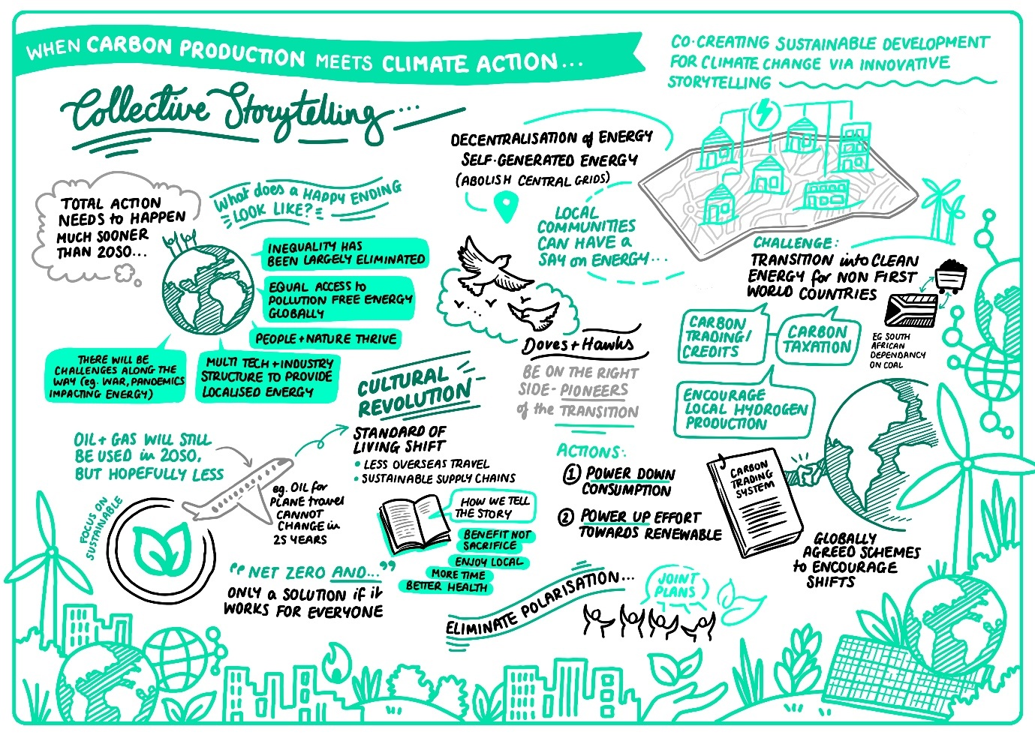
Figure 1 – Board produced by the live artist during the collective storytelling exercise of one of the workshops
The workshops were recorded on MS Teams, and fully transcribed. This allows the qualitative analysis to take place on two levels. First, the stories produced by the participants, either individually or in group, will be analysed using their written and spoken descriptions, as well as the drawings produced by the artist. Secondly, the co-creation process itself will be analysed using a discursive approach based on the transcription of conversations during the workshops, as well as additional reflections the participants will be invited to share in writing with the research team following the events.
Section | Duration | Content
Introduction | 20 minutes | Welcome  Context of the study  Schedule of the session  Ground rules
Activity 1 | 30 minutes | Individually written short stories on the theme “My personal story with the oil and gas industry”  Shared across the group and opened for questions  Live drawing based on individual stories
Discussion | 15 minutes | Compare individual stories  Put greater emphasis on similarities
Break (5 minutes)
Activity 2 | 30 minutes | Group jointly develops a story on the theme “Our collective future with the oil and gas industry”  Start of the story is today, end is 2050  The story should end with a positive outcome  The group should agree on the 3 or 4 defining moments of the story  Live drawing based on the development of the story (to be reviewed throughout the discussion)
Discussion and close | 20 minutes | Reflections from the group on the process and the outcome reached
Table 1 – Co-creation workshop structure
Contribution
We expect this paper to contribute to the existing literature in three main areas. First, from an empirical standpoint, we explore the potential for climate action which may come from within the oil and gas industry via its employees, by using a positive and constructive approach while confronting them with industry detractors, in contrast with justificative, defensive or critical angles presented thus far (Demers and Gond, 2020) and considering topics which go beyond what employees might see as being within their direct scope of control (Halttunen et al., 2022). Second, from a theoretical perspective, we envisage a Deleuzian immanent ethics approach to the collective development of sustainable futures beyond individual positions and moral systems, to expand ontological perspectives used to further the discussion on climate change and action. Third and finally, from a methodological perspective, we present an innovative use of storytelling in the context of climate change (Harcourt et al., 2021), generating data through discussion and live drawing while applying a dialogic approach (Black, 2008) to create new possibilities for the future, thus paving the way for such creative methods to be used in the context of grand challenges, by actors typically viewed as following more traditional strategy and decision-making processes.
References
Banville, M.-S., Torres, J., 2017. On embracing an immanent ethics in urban planning: Pursuing our Body-without-Organs. Planning Theory 16, 255–274. https://doi.org/10.1177/1473095215625707
Black, L.W., 2008. Deliberation, Storytelling, and Dialogic Moments: Deliberation, Storytelling, and Dialogic Moments. Communication Theory 18, 93–116. https://doi.org/10.1111/j.1468-2885.2007.00315.x
Boon, M., 2019. A Climate of Change? The Oil Industry and Decarbonization in Historical Perspective. Bus. Hist. Rev. 93, 101–125. https://doi.org/10.1017/S0007680519000321
Deleuze, G. (1983). Nietzsche and Philosophy. New York: Columbia University Press.
Deleuze, G. (1988). Spinoza: Practical Philosophy. San Francisco: City Lights Books.
Deleuze, G, & Guattari, F. (1987 [1980]) A Thousand Plateaus: Capitalism and Schizophrenia (Trans. Massumi B). Minneapolis, MN: University of Minnesota Press.
Demers, C., Gond, J.-P., 2020. The Moral Microfoundations of Institutional Complexity: Sustainability implementation as compromise-making at an oil sands company. Organization Studies 41, 563–586. https://doi.org/10.1177/0170840619867721
Ergene, S., Banerjee, S.B., Hoffman, A.J., 2021. (Un)Sustainability and Organization Studies: Towards a Radical Engagement. Organization Studies 42, 1319–1335. https://doi.org/10.1177/0170840620937892
Ferns, G., Amaeshi, K., 2021. Fueling Climate (In)Action: How organizations engage in hegemonization to avoid transformational action on climate change. Organization Studies 42, 1005–1029. https://doi.org/10.1177/0170840619855744
Field, S., 2021. Power and precariousness in the expert hierarchies of the US hydrocarbon industry. Critique of Anthropology 41, 303–319. https://doi.org/10.1177/0308275X211038608
Grasso, M., 2019. Oily politics: A critical assessment of the oil and gas industry’s contribution to climate change. Energy Research & Social Science 50, 106–115. https://doi.org/10.1016/j.erss.2018.11.017
Halttunen, K., Slade, R., Staffell, I., 2022. “We don’t want to be the bad guys”: Oil industry’s sensemaking of the sustainability transition paradox. Energy Research & Social Science 92, 102800. https://doi.org/10.1016/j.erss.2022.102800
Harcourt, R., Bruine De Bruin, W., Dessai, S., Taylor, A., 2021. Envisioning Climate Change Adaptation Futures Using Storytelling Workshops. Sustainability 13, 6630. https://doi.org/10.3390/su13126630
Johnsen, C.G., 2021. Sustainability Beyond Instrumentality: Towards an Immanent Ethics of Organizational Environmentalism. J Bus Ethics 172, 1–14. https://doi.org/10.1007/s10551-019-04411-5
Kassinis, G., Panayiotou, A., 2018. Visuality as Greenwashing: The Case of BP and Deepwater Horizon. Organization & Environment 31, 25–47.
Lê, J.K., 2013. How constructions of the future shape organizational responses: climate change and the Canadian oil sands. Organization 20, 722–742.
Munro, K., 2017. Hegemonic stories in environmental advocacy testimonials. Energy Research & Social Science 31, 233–239. https://doi.org/10.1016/j.erss.2017.05.038
Rotmann, S., 2017. “Once upon a time…” Eliciting energy and behaviour change stories using a fairy tale story spine. Energy Research & Social Science 31, 303–310. https://doi.org/10.1016/j.erss.2017.06.033
Skoglund, A., Böhm, S., 2020. Prefigurative Partaking: Employees’ Environmental Activism in an Energy Utility. Organization Studies 41, 1257–1283. https://doi.org/10.1177/0170840619847716
Snellman, K., 2023. The creation of desirable futures: A call for supererogatory management to foster sustainability transitions. Technological Forecasting.
Wright, C., Nyberg, D., Bowden, V., 2021. Beyond the discourse of denial: The reproduction of fossil fuel hegemony in Australia. Energy Research & Social Science 77, 102094. https://doi.org/10.1016/j.erss.2021.102094
Wyatt, J., Gale, K., Gannon, S., Davies, B., Denzin, N.K., St. Pierre, E.A., 2014. Deleuze and Collaborative Writing: Responding to/With “JKSB.” Cultural Studies ↔ Critical Methodologies 14, 407–416. https://doi.org/10.1177/1532708614530313

