Religious consumers' ethical dilemmas for sustainable automobile consumption
Abstract
In urban markets of some developing countries, religious beliefs, rituals, and practices heavily influence consumer choices, including the adoption of eco-friendly technologies. The values religious consumers experience often conflict with one other and with market stimuli. Through qualitative interviews with 29 Pakistani residents, we offer novel insight into how these consumers navigate ethical dilemmas identified with their religious values to purchase and use electric vehicles. Advancing belief-congruence theories, we show how religious consumers navigate the self and non-self-contexts (the social-environment-oriented domains) to achieve self-control which sometimes reduce unsustainable automobile consumption behaviours. Such navigation create intra-value/domain and inter-value/domain cognitive conflicts which shape attitudes and behaviours towards (un)sustainable consumption of emerging technologies. We theorise and illustrate the malleability and temporality of the valuation process of religious beliefs and practices in such a developing country market context.

Keywords: Belief congruence theory, Religious values, Electric Vehicles, Muslim Consumers, Sustainable Consumption
Introduction
In many low-income countries, the incorporation of morally binding values, such as religious values, fundamentally changes consumers decision-making and ethical behaviour (Arli et al., 2019). In particular, religious consumers face ethical dilemmas (i.e. tension between and within conflicting values and practices about the best course of action) to sustainably consume emerging technologies, including fully electric vehicles (EVs) and hybrid electric vehicles (HEVs). This may be due to the dual focus of religious individuals values on achieving self-oriented interests and social-environment-oriented missions. Research in advanced economies highlight ethical dilemmas among some religious groups, like Muslims, regarding Carbon Capture and Storage (CCS) technologies. Their values of stewardship and harmony with nature affect the acceptability of CCS (Hope and Jones, 2014). In developing countries, studies suggest that religious values influence consumers to adopt, emerging technologies, such as information technology products (e.g., Ali et al., 2019). However, what exactly the ethical dilemmas religious consumers experience is ambiguous, and their influence on EV/HEVs adoption remains little known.
Religion continues to exert a significant influence on consumer experiences within urban markets in numerous low-income countries (Arifin et al., 2023; Gbadamosi and Oniku, 2021), providing "a system of beliefs that make consumers more certain about the correctness of their judgement" (Alsaad et al., 2022, p.414). However, many of such cities face the grand challenge of increasing transport-related carbon emissions which are causing severe environmental damage and harm human health (Ahmed, 2023; Emodi et al., 2022). This situation raises questions about the ethical dilemma religious followers experience and how they apply their values to consume transport products sustainably.
Religious ethics or values are recognised as important for achieving sustainability in the fields of conservation psychology and consumer studies (Clayton and Myers, 2015; Minton et al., 2022). Religious values refer to standards of thought, feelings and actions associated with the beliefs and practices of a religious group (e.g., exercising self-control, refraining from hurting others) (DeWall et al., 2014; Minton, 2018). Research examining individuals consumption decisions show that religious values can positively influence followers pro-environmental ethical behaviours (Bhuian et al., 2018; Hwang, 2018). Such behaviours include purchasing and consuming products sustainably (Ali et al., 2019; Arli and Tjiptono, 2018; Singh et al., 2021; Vitell et al., 2009). Sustainable consumption refers to "actions that result in decreases in adverse environmental impacts as well as decreased utilisation of natural resources across the lifecycle of the product, behaviour or service" (White et al., 2019, p.24). Research suggest that individuals religious affiliation (i.e., the religious organisation and texts one follows or, more simply, the substance of one's beliefs) can influence their sustainable consumption behaviours (Mathras et al., 2016; Minton and Kahle, 2014). Compared to Christianity and Islam, some scholars believe that the values and practices of religions like Hinduism and Buddhism are more sustainability-focused (Minton et al., 2015). In contrast, researchers shows that individuals levels of religiosity (i.e., how religious views are lived, either internally or externally) may determines their sustainability, with Buddhists and Hindus less likely to hold pro‐environmental views than Christians (Minton et al., 2016). Against the backdrop of these contradictory assertions of religion impacting sustainable consumption, some studies suggest that religious individuals may be influenced by "dominion" and "dogmatic" ideas which can reduce their eco-friendly behaviours (Preston and Baimel, 2021). Hope and Jones (2014), for instance, showed that due to their beliefs in the afterlife and divine intervention, Muslim and Christian individuals had a relatively low sense of urgency for environmental issues, especially climate change. These contrasting views may point to ethical dilemmas faced by some followers of these religious traditions that affect sustainable consumption choices.
In the urban marketplace, a shifting dynamic unfolds as tensions arise between sacred and secular spheres (Husain et al., 2019; Woods and Kong, 2022). Concurrently, the necessity of embracing innovative transportation technologies like EVs and HEVs to combat environmental challenges becomes increasingly apparent (Khan et al., 2022; Limon et al., 2023), aligning with the ecological stewardship inherent in many religious traditions. However, the urban landscape of low-income countries presents a confluence of factors influencing consumer automobile choices, from variety to price, service and quality (Soron, 2016). Despite the recognised benefits, the uptake of EVs and HEVs in such markets has been steady but slow due to technical, infrastructural, financial, and behavioural issues (Goel et al., 2023; Jajja et al., 2021; Mali et al., 2022), making it unclear into how religious consumers navigate their values to consume automobiles sustainably. For instance, there is a lack of knowledge concerning how and when individuals within religious communities transition from ego-centric mindsets to sacred orientations when facing cognitive conflicts. Hence, religious consumers are confronted with ethical dilemmas of multiple interests, values and practices, and must exercise judgment on the course of action to navigate the dilemmas since failure to do so might impact their religious identities. Driven by recent calls for more qualitative studies offering fresh insights in consumer research (Fischer and Guzer, 2023;Thompson et al., 2023), and acknowledging the theoretical and practical importance of understanding the ethical dilemmas faced by religious consumers in low-income countries when acquiring automobiles, we ask how do Muslim consumers navigate ethical dilemmas identified with their religious values to purchase and use EVs/HEVs?
To explore the research question, we adopted qualitative approaches (Gioia et al., 2013) and examined 29 Pakistani urban Muslims' automobile consumption habits to understand how their ethical dilemmas affects their use of EVs/HEVs technologies. We draw on belief congruence theory to make sense of the data (Rokeach, 1960; Rokeach and Rothman, 1965). This theoretical lens contends that core values of a belief system guide, motivate and shape individuals sustainable consumption experiences (Minton et al.., 2022; Minton and Geiger-Oneto, 2020). Thus, individuals seeks to act in ways that align with their religious values. Drawing on this theoretical lens, we theorise on how the internal diversities of the Islamic belief system shape followers motives, priorities and choices for automobiles. We contribute to consumer research in three ways. First, we provide greater insight into how religious consumers navigate the self and social-environment-oriented domains to achieve self-control that reduces unsustainable automobile consumption behaviours. Second, we expand on recent discussions on why religious consumers' attitudes and behaviours towards sustainable consumption of emerging technologies may differ. We argue that Muslim consumers who align their attitudes and behaviours toward EV/HEV consumption are those who can balance received knowledge on environmental accountability with sustainability information from non-self and market actors/structures. Third, we show how religious values are malleable and how the evolving conditions within such values and low-income countries' urban markets interact to influence religious consumers to change their eco-un/friendly automobile consumption behaviours.
Theoretical Framing
Belief congruence theory and sustainable consumption
This paper draw on belief congruence theories (Rokeach, 1960; Rokeach and Rothman, 1965; Minton et al., 2022) to examine how religious values influence the experiences of Muslim consumers for eco-friendly automobiles. Values may be described as abstract goals guiding individuals while making decisions in various circumstances. Kraatz and Flores (2015, p. 356) define values as collective "beliefs about the things that are worth having, doing, and being". Carrying "normative weight..[-]..people experience values as moral imperatives and use them to judge the world, each other, and themselves" (Kraatz et al., 2020, p.477). Values that prevail in the marketplace—such as care, fairness, reciprocity, loyalty, purity, trust for others, belief about autonomy, personal achievement, innovativeness, restraint, hedonism, comfort with ambiguity, level of environmental concern, and knowledge—are useful for understanding individuals ethical evaluations and sustainable consumption experiences (Minton and Kahle, 2014; Sharma and Jha, 2017; Yan et al., 2023). Therefore, individual fundamental values (including those linked to religious traditions) explain whether or not sustainability, especially sustainable consumption, is considered ethically relevant (Gutsche, 2019; Minton et al., 2022). Hence, values play a key "role in motivating and directing action" (Kraatz et al., 2020, p. 485), binding consumers to market, social, and environmental structures that shape their intentions and choices.
Consumers who identify with Buddhist, Christian, Hindu, and Islamic values feel more connected to these systems and are more likely to align their consumption choices with them (Sharma and Jha, 2017). This view underlies the belief congruence theory, which holds that core beliefs and values guide, motivate and shape individuals experiences (Rokeach, 1960; Rokeach and Rothman, 1965). For instance, religious values shape consumers' worldviews and identities and can influence eco-friendly product purchases and consumption (Leary et al., 2016; Minton et al., 2018). This is because "certain religious values specifically dictate moral guidelines regarding what consumption behaviours are allowed versus forbidden" (Mathras et al., 2016, p.304). Thus, Jewish kosher laws prohibit eating pork, shellfish, and dishes containing both meat and dairy products (Klein, 1979), and Islamic moral code (sharia) distinguishes between halal (permissible) and haram (prohibited) products, including pork, alcohol, and interest-earning banking products (Ahmad et al., 2011; Alserhan, 2010). Therefore, religious values may help people exercise self-control by limiting the burden of choice, controlling egotistical impulses, and reducing impulsivity by focusing on long-term goals (DeWall et al., 2014; Kurt et al., 2018; Minton, 2018).
Compared to other institutions (e.g., social norms), religious values' enduring structures have the greatest impact on consumers' behaviour (Minton and Kahle 2014). According to the belief congruence theory, individuals have a hierarchy of attitudes and values that are stable and difficult to change (Rokeach, 1973). Consumers consider how well market stimuli—such as product type, price, service, quality, and innovation—align with their beliefs when making purchases given that consumer-product congruence affects attitudes towards products (Zhu et al., 2019). This means that although value systems' enduring nature sets the baseline for evaluating specific courses of action (e.g., decisions to buy and consume eco-friendly products), stimuli can activate and transform belief systems, creating mental linkages that lead to cognitive interactions (Alhouti et al., 2015). However, consumer research examining how consumers navigate ethical dilemmas identified with their religious values to consume emerging technologies sustainably are limited.

Religious consumers value conflicts and market stimuli
Consumer research has firmly established the role of religion in shaping sustainable consumption behaviours (Gutsche, 2019; Minton et al., 2015)(for an extensive review see: Orellano et al., 2020). However, our understanding remains limited regarding the tensions arising within and between religious values, and how these tensions affect the translation of attitudes into actions towards eco-friendly technologies. Conflicts within and between religious values can perpetuate unsustainable consumption practises due to values' centrality to cognitive evaluation. For example, in Buddhism and Taoism, a conflict between beliefs like 'understanding the interdependence between nature and living beings' and the highly institutionalised practise of 'burning incense sticks or joss paper to evoke the presence of divinities or deities' may perpetuate environmental pollution among religious consumers. In Islam, rituals and ethics guide followers' environmental protection and care (e.g., conserving, reusing, and recycling resources, planting trees, caring for animals, eliminating noise pollution) (Helfaya et al., 2018). However, followers face value conflict for practises that pollute the environment (e.g., increased meat consumption and feasting during Ramadan, which increase carbon emissions, noise pollution from the call to prayer or adhan). A further demonstration of value conflict emerges within Hinduism, where the emphasis on environmentalism contradicts the pollution generated by traditional cremation rituals. These instances illustrate the cognitive dilemmas that prevail within belief systems, influencing attitudes towards sustainability and consumption experiences. Yet, few studies have examined the processes and timing by which religious values shape gap existing between attitudes and behaviours towards sustainability. We argue and theorise that by engaging temporally with religious values, Muslim consumers recognise internal conflicts, seek balance through responsible consumption, reflect and re-assess how their values could be extend to consume modern technologies sustainably.
From a socio-cognitive perspective, consumers achieve cognitive congruence by evaluating value attributes, value conflicts, and market stimuli (Basil and Herr, 2006). Thus, tensions or imbalances can be resolved by consumers' evaluation of values-related and market stimuli-related information (El-Bassiouny, 2014; Veer and Shankar, 2011). Religious texts and teachings, such as from the Qur'an, provide a guide on how Muslim consumers can maintain a balance. Within this tradition, concepts "improving the well-being (falah) of all mankind" help Muslim consumers achieve "a balance between material and spiritual well-being, and clearly establishes a purpose to human life and a direction as to where human beings are eventually going" (El-Bassiouny 2014, p.44). However, empirical research has largely used correlation-based analysis to understand religious values and their interactions with market stimuli, raising concerns about causality in attitudes, motivations, intentions, and experiences. For instance, it is shown how religious values (measured by religious affiliation and religiosity in belief systems like Buddhism, Christianity, Hinduism, and Islam) interact with cultural values to influence consumers' sustainable consumption and well-being (Minton et al., 2022). Yet, we have insufficient knowledge about how religious consumers' navigate intra and inter-value dilemmas to consume new technologies sustainably. To understand the internal diversity of Islamic religious values and their interactions with market stimuli in Pakistan's urban marketplaces we employ qualitative methodologies necessary to examine such nuances. Next, we present our empirical context for studying religious values and EV/HEV purchase and consumption experiences.

Methodology
To inform theory about how religious values shape gaps between attitudes and behaviours towards sustainable consumption, we adopted a qualitative inductive method (Gioia et al., 2013; Strauss & Corbin, 1998). We used Gioia et al. (2013) to collect and analyse our data, focusing on ethical dilemmas identified with religious values and how they urban influence consumers decisions for EVs/HEVs in developing countries. Our approach respond to recent calls for more qualitative research in consumer research not only to generate new theories, but also to elaborate existing ones (Fischer and Guzel, 2023; Thompson et al., 2023), including those focused on how consumers experience time in personal and inter-personal contexts (Janiszewski and Van Osselaer, 2022).
Research context
Despite the transportation sector's continued reliance on fossil fuels and consumers' significant barriers to adopting green technologies, developing economies gradually increase their demand for EVs/HEVs (Jajja et al., 2021; Mali et al., 2022). Pakistan is an ideal setting to study how religious values influence emerging economy consumers' eco-friendly car purchases and consumption experience. The auto industry contributes 2.8% of Pakistan's GDP and 30 billion rupees in taxes and duties (Khan et al., 2022). It had Asia's highest growth between 2014 and 2018, with sales and output reaching 171% to 172.5% (Khan et al., 2022). To boost transport sector development, Pakistan's second Auto Industry Development and Export Policy (AIDEP 2021-2026) was approved in December 2021. It promotes fuel-efficient technologies, including EVs/HEVs, to reduce transport sector emissions and combat climate change. The target for all vehicles is 90% EV adoption by 2030, with 30% of new four-wheel vehicles and 50% of new two- and three-wheel vehicles expected to be EVs (Khan et al., 2022). Despite its economic importance, Pakistan's transport sector, especially road transport, emits 92% of CO2 (Khan et al., 2020). With research showing a strong relationship between Islam and ecology (Siyavooshi et al., 2019), the transport sector's CO2 emissions raise questions about how religion influences sustainable automobile consumption. Pakistan is the second most populous nation of Islamic believers after Indonesia, with 97% of its population Muslim (Bukhari et al., 2019). Thus, our study shows how Islamic values influence sustainable automobile consumption, examining specifically urban consumers' experiences for purchasing and using EVs/HEVs to reduce CO2 emissions.
Data collection
Our primary data collection spanned nearly two years, including preparation for data collection, interviews, follow-up interviews, secondary data collection (specifically real-time new articles on EV/HEV acquisition and usage in urban Pakistan), reflective diaries, and transcription activities.
Interviews. Consistent with most inductive research (e.g., Gioia et al., 2013), our primary data source was semi-structured interviews. We purposefully sampled 29 interviewees to obtain multiple perspective on how religious values are acquired and transformed over time. This interview protocols allowed "for the free flow of consumer interpretation and storytelling... starting with behaviour and encouraging the consumer to link back to their underlying motivations, values and identities" (Davies and Gutsche, 2016, p.1329). To comply with UK government social distancing rules, the second author conducted all interviews in Urdu using Skype and Microsoft Teams. The first interview questions focused on the participants' religious background, then shifted to the phenomenon of interest: consumers' experiences of religious practises, rituals, and beliefs and how their desires, feelings, and mental evaluation of such beliefs and practises influence their purchase and consumption choices for EV/HEV products. The interviewees were further asked about how they perceived their religious expectations when making purchases for emerging technologies, such as EV/HEVs. Responses to these initial questions led to follow-up questions about how participants' religious beliefs and rituals affected their sustainable consumption experiences for automobiles. Our goal was to identify religious values as the origin of desires and actions that lead to the purchase and consumption of automobile products, identify intra and inter-value conflicts as epiphenomenal consequences, and then understand how the urban religious consumers achieve cognitive congruence to consume such products more sustainably. Following the initial interviews, we conducted multiple rounds of follow-ups with 12 participants, worked closely with them, and received valuable feedback on their subjective interpretations of the interview materials. The study participants read and verified some transcriptions. A neutral party translated interview transcripts into English and back into Roman Urdu to ensure accuracy. Interpretation differences were resolved through negotiation and debate. The suggested changes were minor and focused on recalling and including specific details from the transcript. Finally, a reflective journal helped interpret the material. This provided a complete picture of participants' lived experiences and perceptions.
The interviews ranged from 45 minutes to 2 hours. All the participants were Pakistani nationals and residents who reported as practising Muslims, have purchased at least one sustainability-related product, have at least 12 months of experience owning and using a personal automobile, and at the moment of interview used or planned to acquire an EV/HEV in the following six months. We continued identifying this consumer group to interview until we achieved theoretical saturation. Muslim consumers are ethically bound to adhere to halal principles (Wilson and Liu, 2011). While "halal" is most often used to refer to food, it covers a much wider range of consumer products and services free of Islamic prohibitions. Given the homogeneity of this religious group, we could derive insights into their collective experiences and perceptions. Our study did not pose any physical or psychological risks, and all participants signed consent forms before the interviews. Pseudonyms were used to protect participants' identities. In major cities like Islamabad, Karachi and Lahore, participants work in various fields, including higher education, accounting, marketing, public sector and self-employment (see Table 1).

[INSERT TABLE 1 HERE]

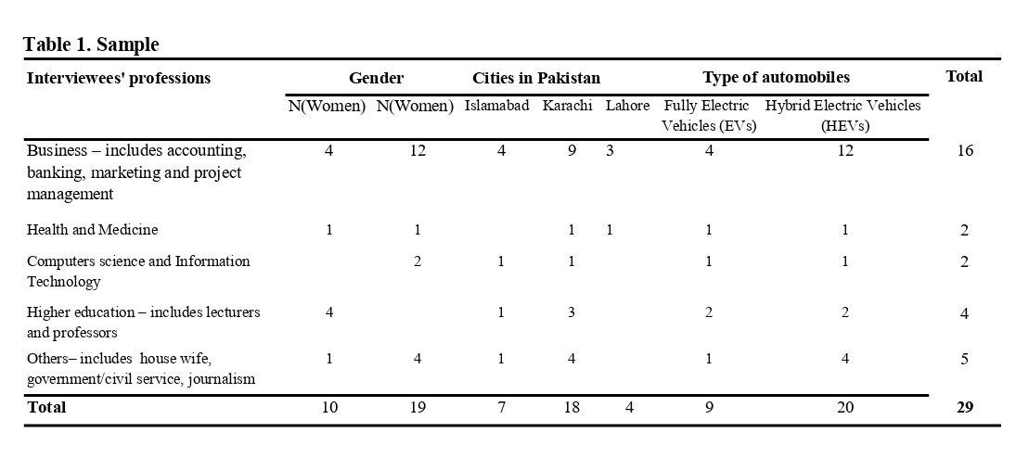
Data analysis
Our analysis was structured in accordance with the methods outlined by Gioia and colleagues (2013), drawing upon established procedures for open-ended, inductive theory-building research (Glaser & Straus,1967; Strauss & Corbin, 1998). After several rounds of data collection, we analysed our gathered materials in four stages. Stage 1 involved the interviews being content analyzed through an inductive process of dictionary building. Line-by-line reading of the English transcripts yielded initial ideas on the complex struggle experienced by Muslim consumers as they navigate the intersection of religious principles and secular influences in their daily decisions regarding automobile consumption. It was possible to identify preliminary concepts that retained an organic connection with the participants while providing enough abstraction to promise future theoretical development. We classified our material as “data driven codes” using common patterns of religious beliefs, rituals and practises to characterise religious values and Islamic consumers' purchasing and consumption habits and choices. Concepts like "do good things", "ensure better society", "engage in selfless acts", and "consider the well-being of others" are examples of beliefs and practices that characterised the religious consumers as a social group. Beliefs and rituals that ensure that a person is "internally clean", "externally clean", "avoid waste", "avoid extravagance" and "use resources in moderation" and "become convenient" all function as religious value codes that shape individuals' sustainable consumption experiences.
To achieve conceptual development and qualitative rigour, establishing the relationship between facts and new ideas is needed (Gioia et al., 2013). Therefore, stage 2 involved grouping the religious value codes into four related but distinct codes: "cleanliness," "beneficence," "frugality," and "comfortable living" and examine using iterative part-to-whole approach (Thompson, 1997) to identify stories of any possible tensions or conflicts that exist within and between these perceived values. We had participants verify our work as it progressed to ensure that our preliminary results accurately reflected their views and experiences. Participant checks are "the single most important way of ruling out the possibility of misinterpreting the meaning of what informants say and so and the perspective they have on what is going on" (Maxwell, 2012, p.11). For instance, we sought clarifications between closely related concepts like "avoid waste", "avoid extravagance/overspending", and "use resource in moderation", which led us to define and relate "avoid waste" and "use resource in moderation" only to non-monetary resources. We then examined how participants use each value in making choices along a spectrum of self and social-environment-oriented domains. Here, we examine how religious values activate cognitive-stimuli processes to influence Muslim consumers' EV/HEV and non-EV/HEV choices over time. Through this analytical process, we were able to see how participants favoured specific religious values over others in given decision situations, how they changed between values (and sub-values) during contextual interactions within the self and social-environment-oriented domains, and circumstances under which identified codes and processes related to individual participants. We classified the conflicts that we identified within and between values as well as domains as our “aggregate themes” (see Figure 1).
Stage 3 involved improving and strengthening our interpretations by triangulating our individual and group-level data points, occasionally consulting the participants' and second author's reflective notes, and across ourselves as authors and theoretical perspectives. For instance, we confronted our identified continuum of shared and conflicting religious values (see Figure 2) with the data in the reflective diaries, going back and forth between our data, model and the consumer research literature. This resulted in our process model of the link between consumers ethical dilemma of religious values and un/sustainable automobile consumption (see Figure 3). In Stage 4 and throughout the research, we considered our positionality in relation to the phenomena under study. The first and second authors, of different religious faiths collaborated closely, comparing and discussing empirically supported emerging themes. The third author provided critical feedback and an outsider's perspective on the development of our theory. The conclusions rely on the participants' own words (themes and codes) to attest to the reliability of their responses (Lincoln and Guba, 2000).
[INSERT FIGURE 1 HERE]
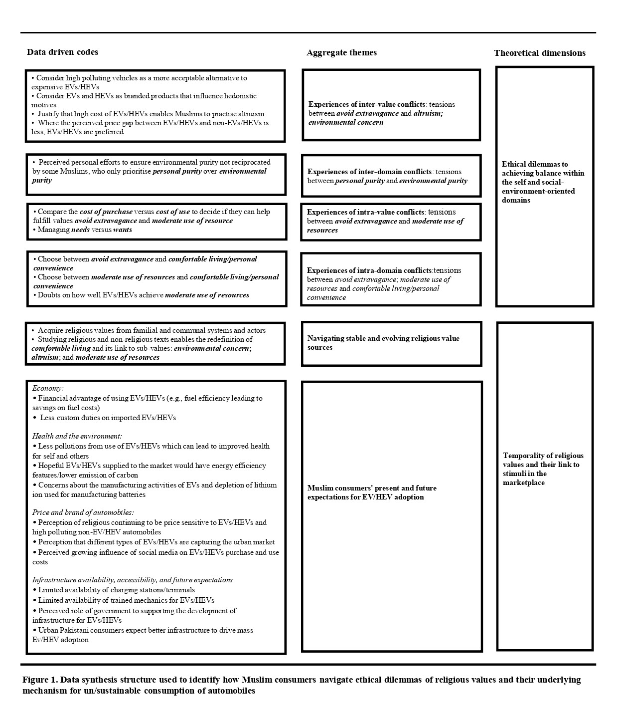
Findings
This section discusses our interview participants' ethical dilemmas and how they use religious values to navigate self and social-environment-oriented domains to choose and consume EV/HEV products. We organised our findings sequentially for clarity, but our interviewees' ethical dilemmas and how they navigated religious values to achieve balance within the self and the social-environment-oriented domains were iterative and temporal. We use two categories to present our findings: "ethical dilemmas in achieving balance within the self and the social-environment domains" and "Temporality of religious values and stimuli in the urban marketplace".

Ethical dilemmas in achieving balance within the self and the social-environment domains
The analysis shows that our participants recognise the need to attain the responsible religious self. Such identity require applying values of cleanliness, beneficence, frugality, and comfortable living ("achieve personal comfort or convenience") which affect how they consume products in general and automobiles sustainably/unsustainably. For these values, cleanliness relates to an individual's religious duty to maintain personal purity ("internally clean"; "clean yourself") and environmental purity ("environmentally clean") for the benefit of society. For instance, there were comments like: "You keep yourself clean. This automatically creates inside you an ability from Allah Almighty to keep your surroundings clean [..] I wanted to get a friendly car, I wanted to get an electric car, it indirectly links my religion that it is going towards cleanliness" (INT#17); "You are supposed to take care of the cleanliness around you where you live. Then, there are other factors of carbon emission, but most importantly keeping the surroundings at least clean" (INT#3). Thus, we identified cleanliness to have sub-forms of "personal purity" and "environmental purity". For beneficence, sub-values of environmental concern ("protect the environment") and altruism ("care for others"; "benefit others") were identified. For example, regarding altruism, there were comments such as: "Islam teaches us to take care of others, like your health. Then people are having health issues..[-]..As our religion says to look after the others, so with buying this electric vehicle, I feel it's my duty to take care of others" (INT#10); "with the use of hybrid vehicle there will be less combustion levels, which will be good for air quality and this will give benefit to the people and pollution will be decreased…[-]..it is on the rise, which is not healthy for the people. So in this perspective, buying a hybrid vehicle does fit in the religion" (INT#26). To reconcile self-needs and social-environment expectations, our participants further used three sub-values of frugality: "avoid waste," "avoid extravagance/overspending," and "use resources in moderation". For instance, an interviewee states: "We are always told to be moderate in our spending so we should follow the centre path. It means that we should neither buy highly expensive things [EV/HEV products] nor very cheap things [non-EV/HEV products], but we should strike a balance" (INT#28). Therefore, the interviewees aim to achieve balance using their religious values that meet the expectations of the self and social-environment-oriented domains. Achieving such a balance is consistent with the view that “the [religious] self does not affect materialism and that the non-self ethical dimensions reduce materialism” (Pace, 2013, p.44). However, many participants faced cognitive conflicts in achieving these dual goals.
Figure 2 shows a continuum of self and social-environment-oriented domains where religious values are activated to influence interviewees EV/HEV and non-EV/HEV product choices. Religious values are more than tools for decision-making for our interviewees; they also show the Muslim consumers' ability to selectively apply certain values to their personal interests and societal expectations. The figure visually depicts the most frequently shared or conflicting values on an x- and y-axis. The model's dimensions were identified using labels from our interviewees. The horizontal dimension shows how much consumers are affected by internal and external stimuli. The vertical dimension shows the extent to which self or social-environment expectations drive consumers' motives. Figure 2 shows how the interviewees collectively make sense of their religious values and form coalitions across and within domains as part of their cognitive evaluation processes. The following section discusses the participants' experiences of inter-values/domains and intra-values/domains conflicts.
[INSERT FIGURE 2 HERE]
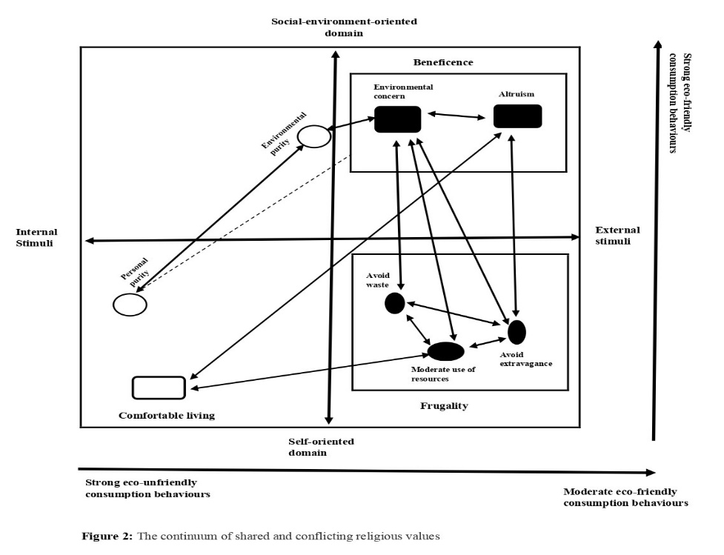
Experiences of inter-values conflicts: avoid extravagance vs. altruism/environmental concern
The interviewees reside in urban areas where poverty is rampant. Normally, purchasing and consuming automobiles do not cause conflict between avoid extravagance (frugality) and altruism (beneficence) associated with the self and social-environment-oriented motives and their internal/external dimensions. This is because many of the interviewees enact avoid extravagance at the cognitive and social levels when they choose to purchase automobiles, preferring low-priced cars to use savings made on purchase to care for others through charity giving (altruism). For example, one interviewee said, "Allah has forbidden us from extravagance ...[-]...With 10,000 rupees I'd fed maybe 10 families. So I would rather do that than spend the whole amount on myself "(INT#4). Therefore, many of the participants prefer low-cost, high-polluting cars to expensive, eco-friendly ones like EVs/HEVs. However, conflict arises against avoid extravagance where consumers consider EVs/HEVs to "help humans, animals and plants to be greener, healthier and better" (INT#14). Similarly, the interviewees sometimes experience a dilemma between avoid extravagance and environmental concern with some justifying EVs/HEVs purchase to achieve environmental concern: "Maybe I can get a diesel engine for a lesser amount. But this will have a very lethal impact towards the environment"(INT#24). Hence, sharing his dilemma, one interviewee states: "If I follow the religion, I cannot buy an electric car because it is very expensive, and I would have to travel in a passenger bus instead"(INT#6). However, where the interviewees perceive price differentials between EVs/HEVs and non-EVs/non-HEVs products as less significant, they argued that EVs/HEVs offer them a better option to fulfil the religious obligation of care for others (altruism) and protect the environment (environmental concern). Nevertheless, the high cost of EVs/HEVs makes many interviewees view such automobiles as luxury products.
Apart from their high price, EVs/HEVs are considered "branded products" with hedonistic motives:
"As you know, people are brand conscious nowadays and go for branded products irrespective of the cost effect. Our religion forbids overspending and tells us to adopt moderation…[-]..Although it is impossible in today's world, and I would not say that I follow exactly what Allah-Taala told me, I try to follow as much as I can"(INT#10).
These findings suggest EVs/HEVs as branded products embody extravagant values and a poor consumption choice that some interviewees view to contradict altruism towards impoverished populations. Thus, the framing of selectively prioritising extravagance (choosing EVs/HEVs products with high purchase prices) to achieve altruism and environmental concern values suggests a way in which egoistic values in the self-domain (e.g., the choice for extravagant products; hedonistic interests) find their way into the social-environment-oriented domain (i.e., justification for vehicle choice to care for others).
Experiences of inter-domain conflicts: personal purity vs. environmental purity
Similar concerns were observed in the self and social-environment-oriented domains that relates personal and environmental purity. Many interviewees reported experiencing a dilemma because their routine religious practices towards society's cleanliness often differ from other adherents. This conflict arises because some religious consumers limit cleanliness to "personal purity or hygiene" and cannot broaden its application to eco-friendly vehicles: "I use euro 5 petrol in my car because it has less carbon emission and is less harmful to the environment [but] our extremist Muslims don't know how much pollution from petrol and diesel cause in the environment"(INT#6). This quote highlights the tensions over the meaning of cleanliness and how it is applied across domains, which leads to un/sustainable consumption. Even where some participants could broaden the application of cleanliness, they chose to buy it for other reasons. For instance, a participant stated: "In cleanliness, there are many other dimensions in which you want to do something, starting from yourself to your surroundings and environment [but] honestly, I bought it [HEV] due to its amazing mileage. I wouldn't say that I bought it for sustainability." (INT#3). Thus, the interviewees' views on why some Muslim consumers prioritise personal purity over environmental purity are due to dilemmas experienced in the self and social-environment-oriented domains. Therefore, many interviewees who value environmental purity as equally important as personal purity often become frustrated by the widespread disregard for transport-related emissions in such a religious context.
Experiences of intra-values conflicts: avoid extravagance vs. moderate use of resources
Similar to the framing of inter-value dilemmas in the self and social-environment-oriented domains, we identify shared perceptions of conflict within values in the domains. Frugality's sub-values of avoid extravagance and moderate use of resources (intra-value conflict within frugality) are the most intense. There are two main sources of conflict. Initially, many interviewees report conflict within avoid extravagance, as "when it comes to buying a hybrid car[HEV], the aspects would be a cost of the car and running cost" (INT#18), with the economic choice identified between the purchase price and cost of use. Hence, "Its [an EV is a] one-time investment, and it gives you lots of saving from your everyday rides than you spend lots of money on your petrol" (INT#20). Therefore, some interviewees who chose EVs/HEVs said, "we prefer high-priced cars that would lead to fuel efficiency and lower fuel costs" (INT#4). In essence, tensions arise over how Muslim consumers' desire to avoid extravagance affects their EV/HEV purchase and use decisions, as:

"when it comes to religion, there's no hard and fast rule, because the rules that were defined by Allah and back when the Shariya were received, they didn't account for a car as an example. This is where my personal thought process starts, which is about how far I'm going to fall [become conflicted] if I'm going to buy a non-EV/ HEV "(INT#18).
The participants narratives further emphasize the tensions they experienced between managing "needs" and "wants”. They articulate that true adherence to Islam entails prioritising needs over wants, living modestly, and rejecting the materialistic pursuits fueled by consumerism. Nonetheless, they reveal the struggles they face against consumerist pressures, portraying consumerism as antithetical to Islamic principles:
"I follow to the extent of my capacity Alhamd o Lillah and as a human being we are not perfect and commit mistakes...[-]..(but) if a person is really a practicing Muslim, he would be following his Prophet (SAW) as a role model and this a benchmark for him...[-]..I mean to say that this is the Muslim’s psychology... if somebody wants to live at this level then he shouldn’t demand too many things.[-]..we have indulged ourselves into an imaginary and fake competition with others and we are standing far from the (religious) reality...[-]..Problem is that we consider all these things mandatory for us. I can live a life with having a normal car. If that necessity has been accomplished with a small car like Mehran so why should I go for luxurious one [EV/HEV]? There are two things, one is the needs and second is the wants. We have fulfilled our needs and satisfied but we are after our wants....[-]...So if we actually follow Islam, it teaches us to stay in our limits and to live a moderate life. But we are running in the race of the world which is not the message of Islam for us...[-]...They want to take away every religious value from us. Consumerism wants us to fulfil our wants but our religion wants us to stick to our needs. So if there is a practicing Muslim, he will counter all these things...[-]..(but) at the moment there is really such a boom in marketing and consumerism that everybody is a victim of it"(INT#25)
Experiences of intra-domain conflicts: avoid extravagance/moderate use of resources vs. comfortable living/personal convenience
Second, there is a conflict within the self-domain between moderate use of resources and comfortable living (see Figure 2). We refer to this as intra-domain value conflict. Some interviewees say balancing moderate use of resources and comfortable living requires personal compromise. EVs/HEVs are known for their "smooth drive": "after knowing about its environmentally friendly features and smooth drive, I changed my mind to buy an electric car" (INT#7). Thus, highlighting the conflict between moderate use of resources and comfortable living and how it affects Muslim consumers' sustainability choices, one participant states: "I would say that my decision-making is based on my own convenience, I am a selfish person"(INT#16). Additionally, some interviewees doubt that EVs/HEVs can help them fulfil their religious obligation of moderate use of resources:
"the thing is its [EVs/HEVs] environment-friendly [feature] is debatable because batteries of these vehicles are made from lithium-ion ..[-]..how sustainable it is to keep on extracting lithium-ion when it is in a very limited resource? ..[-]..Maybe you don't know it has a different carbon footprint from normal fuel cars" (INT#16)
Therefore, in the self-oriented domain, there are conflicts between comfortable living and moderate use of resources. This finding suggests that Muslim consumers who buy EVs/HEVs may do so for personal comfort or convenience rather than to fulfil the religious obligation of moderate use of resources, raising questions about their impact on sustainable consumption. Thus, the conflicts are complex and pluralistic, with interviewees using different combinations of religious values within and across domains to support and oppose their automobile product consumption.
Temporality of religious values and marketplace stimuli
Our analysis of inter and intra-values and domain dilemmas raised questions about how interviewees achieve values congruence to support their sustainable automobile consumption. Our research shows that the interviewees' knowledge and market experiences affect their values of religious beliefs, rituals, and sustainable automobile consumption. This perception of an evolving marketplace (e.g., new information on EV/HEV fuel economy, price, and car brands) influences the values and stimuli of Muslim consumers. Therefore, interviewees temporarily assess the economic, social, and environmental costs and benefits of values and market structures/actors.

Navigating stable and evolving sources of religious values
Many interviewees acquire religious values from family and communal actors (e.g., parents, grandparents, Imams, etc.): "The beliefs and values trickle down from one generation to another, and family have an important role in developing beliefs of their children" (INT#2). However, these values are not static. Our participants report that information-seeking through sources like education (through personal exploration of religious and nonreligious texts), social media, news, and automobile consumption experiences transform their understanding of values and their application over time. These consumers' acceptance of EVs/HEVs in urban Pakistan is affected by such cognitive transformation: "When I learned [through Islamic teachings] the destructive impact of carbon emission on the environment, I started a search on electric vehicles" (INT#3);"As we see that things are being evolved with the passage of time, the same has been taught by our religion in childhood. With the availability of electric cars, we got an opportunity to practice and implement what we have learnt from religion and seen around us, so we are doing that" (INT#7). Thus, the diverse role religious values play in some interviewees' beliefs and practises towards the acquisition and sustainable consumption of automobiles depends on their temporal understanding of how such values can be applied to ethically consume innovative technologies. These Muslim consumers' evolving cognition allows them to respond fluidly to society's emerging issues, as "one should not be rigid in a fundamental approach" (INT#7). However, knowledge affects cognition "in a subtle way because our religion has been shaping us throughout our lives ..[-].. I cannot say that I am buying this car because my religion is particularly saying to do so, but I definitely have a religious perspective back in my mind. Subconsciously, it impacts my decision"(INT#9). According to Hope and Jones (2014), Muslim consumers oppose environmentally harmful technologies due to their environmental consciousness. However, our analysis suggests that environmental consciousness, developed and rooted in more stable segments of religious values, translate into unconscious repetitive behaviours. Transformative sustainability behaviours are only seen in participants who consider relevant new information over time and apply religious values to emerging market situations.
Our analysis also shows that many interviewees initially did not recognise comfortable living as an Islamic value, instead emphasising altruism, frugality, and environmental concern as key to living the "ideal" religious life. Over time, improved religious and nonreligious knowledge of eco-friendly automobiles (EVs/HEVs) influenced these participants to redefine comfortable living as important and link it to the other values. Phrases like "things are changing”, "something I have changed about myself”, and "the market is changing" become part of the cognitive evaluation process and transform how participants link values to market stimuli. Participants' adaptability led to statements that highlighted opportunities for mass consumption of EVs/HEVs and their growing importance for living the ideal religious life:
I would say, 5 years back, 3 years back, or even 2 years back, the options of electrically modified machinery were almost zero [here in Pakistan]. During the last two years in the city, the country and even the world, I believe a tremendous amount of work has been done on electric vehicles. And there are many more opportunities available that you could explore, buy and use. So, this is why I have an option open to me. I just want to go over the options available to me, which is very close to my ideal of [religious]living" (INT#1)
Muslim consumers' present and future expectations for EV/HEV adoption
Many of the interviewees are aware of the market constraints that affect EV/HEV product consumption, including the lack of infrastructure, such as charging facilities/points, after-sales service, spare parts, and competent mechanics. Nonetheless, participants' optimism for the widespread adoption of EVs/HEVs is influenced by their evolving understanding of religious values and market stimuli, which change their preferences for eco-friendly automobiles: " I am sure that with the passage of time as the facilities and infrastructure is being developed, these particular factors will not matter anymore and ultimately people will be moving towards it"(INT#2). Such temporal focus affects the interviewees such that most of them have moved from price consideration (cost of purchase) of EVs/HEVs to the perceived cost of usage over the product's lifespan. Hence, religious values' temporality activates cognitive-stimuli processes that shift choices in urban Pakistan, resulting in repetitive and transformative EV/HEV and non-EV/HEV automobile choices and experiences. Therefore, religious values and market stimuli that affect the sustainable use of automobiles are more of a temporal and mutually dependent process than a "cause and effect" process, as most consumer research suggests.

Discussions
In this study, we aimed to understand how religious consumers navigate ethical dilemmas with the religious self and social-environmental domains to buy and consume EV/HEV products to meet their needs and expectations. Further, we sought to explore how Muslim consumers prioritise some religious values over others and link them to market stimuli. We achieved these through a qualitative inductive study (Gioia et al., 2013) of 29 Muslims in urban Pakistan. Building on insight on belief congruence theory in recent studies (Minton et al., 2022; Minton and Geiger‐Oneto, 2020), we highlight how often taken-for-granted values, such as cleanliness, frugality, beneficence and comfortable living, can perpetuate or transform Muslim consumers' choices for eco-friendly/unfriendly automobiles. However, ethical dilemmas occur not only within and between values but across social-environmental domains (see Figure 2). Looking deeper into the Islamic belief system, we identified its values internal diversities that influence consumers' choices for EV/HEV technologies. Religious consumers are often expected to balance conflicting needs and expectations to attain their religious identities (Rauf et al., 2019). Such expectations include following religious teachings and beliefs regarding consuming eco-friendly technologies (Ali et al., 2019).
[INSERT FIGURE 3]
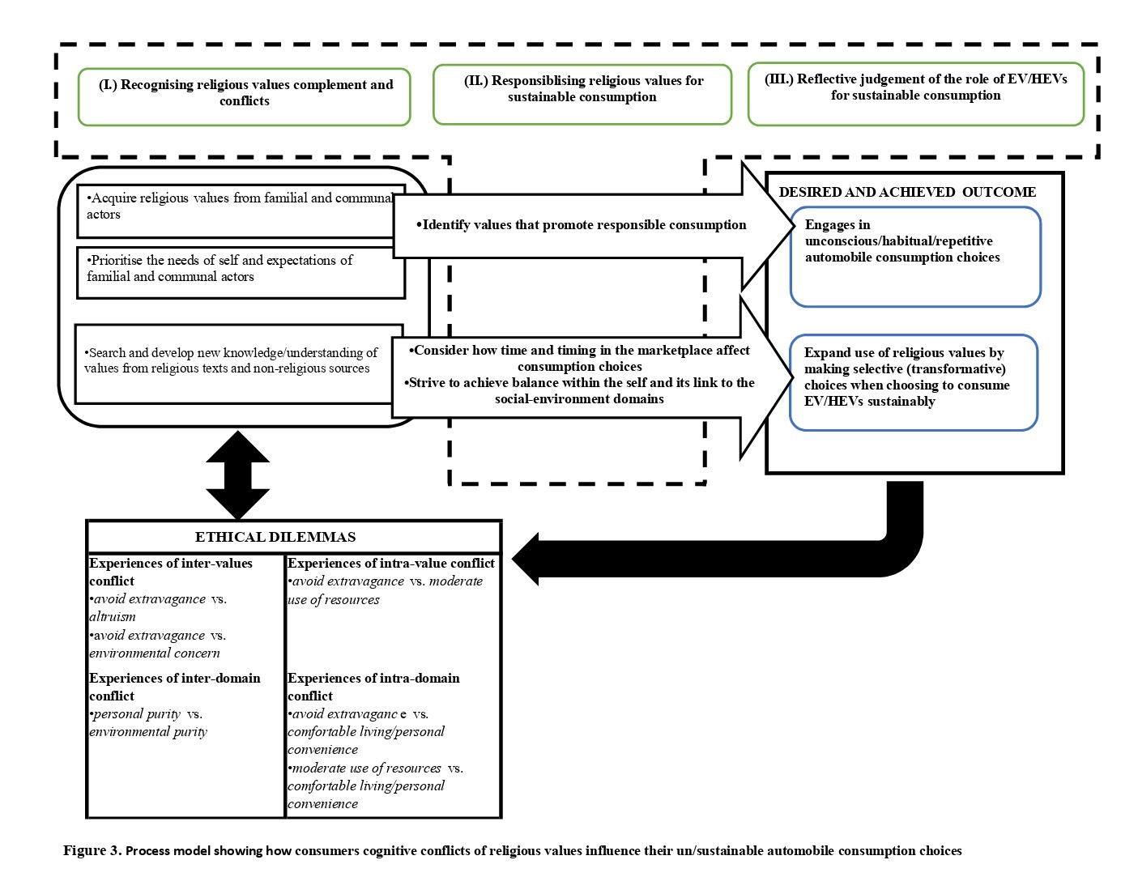
Our findings help us to identify three crucial actions Muslim consumers follow to consume automobiles sustainably/unsustainably: (I)Recognising values complement and conflicts; (II)Responsibilising values for sustainable consumption; (III) Reflective judgement of the role of EV/HEVs for sustainable consumption (see Figure 3). We reveal that socialised practices led the majority of our sample to recognise religious values as crucial for prioritising self-needs and familial and communal expectations. This includes practising values to promote responsible consumption—e.g., avoid wasting food, water, air pollution, recycling (e.g., Siyavooshi et al., 2019). However, many religious consumers who primarily rely on values acquired from their families and communities are unable to apply these values to automobile use. Hence, their reflective judgment to consume automobile products is shaped by unconscious/repetitive choices, which contribute to unsustainable consumption practices in urban Pakistan. Nonetheless, it appears new knowledge gained by some consumers influence them to consider the evolving role of religious values in the marketplace. For such consumers, responsiblising religious values for sustainable consumption involve striving to achieve balance within the self and linking such congruence to the expectations of social-environment domains. Alsaad et al. (2021) shows that individuals religiosity—i.e., how religious views are lived—may have no bearing on their moral obligations, but only on their effectiveness as consumers. However, religious consumers' moral obligations and ethical purchasing choices may be determined by their idealism. We demonstrate that some individuals improved knowledge of religious values enhances their idealisation of such values, allowing them to reflect, deploy and connect the values to make selective/transformative choices to consume EV/HEV products sustainably. Furthermore, we argue that conscious and unconscious choices for EV/HEV products can perpetuate or transform ethical dilemmas. In the following sections, we discuss these findings' theoretical and practical contributions and provide a potential avenue for future research.
Contributions
Implication for consumer research
Our analysis offers three main insights into consumer research.
Self-control and liminality: First, most studies of religious values focus on how they dictate moral guidelines for what consumption behaviours are allowed and forbidden (Mathras et al., 2016). Such values can influence consumers' choices for eco-friendly products (Minton et al., 2018, 2022). We add to the literature on how religious values lead to self-control (e.g., DeWall et al., 2014; Kurt et al., 2018; Minton, 2018) by showing how values like cleanliness, beneficence, frugality, and comfortable living limit unsustainable automobile consumption among Islamic consumers in Pakistan. In such an emerging economy urban marketplace, Muslim consumers' values oscillate within the self and social-environment-oriented domains, with cognitive, social, and environmental experiences influencing EV/HEV consumption behaviours. We demonstrate how such interactions can create dilemmas for Muslim consumers as they select and justify values that are most important to them. Therefore, achieving self-control, limiting the burden of choice, controlling selfish impulses, and reducing impulsivity for eco-unfriendly automobile products may be dependent on how Islamic consumers simultaneously navigate intrinsic and extrinsic forces within cognitive, social, and environment domains.
Past research suggests that people seek congruence between their self-concept—cognitive appraisal of attributes of the self (Abe et al., 1996)—and their actions (Elliot, 1997), or market stimuli like products or brands that can improve or validate their self-image (Sirgy, 1986). Such mental evaluations affect product choices for automobiles (Graeff, 1996; Hong and Zinkhan, 1995). Since ethical consumption choices maybe guided by religious values (Hasan et al., 2023), the degree to which consumers embed these values within the self and social-environment domains can determine their motives for sustainable automobile consumption. Research shows that intrinsically religious people are more likely to evaluate values and stimuli that enhance their spiritual self (Sedikides and Gebauer, 2010). In contrast, those whose motivation for action is driven by expectations of external forces, such as social and environment structures and actors (extrinsically religious), may evaluate values and stimuli with the prospect for social gain more favourably (Arli et al., 2021; Vitell et al., 2009). However, research suggest that individuals choices to seek social benefits with religious actions may lead to unethical consumption choices (Arli et al., 2021).
In this paper, we show how intrinsic and extrinsic ethical forces within the religious self and social-environment domains simultaneously influence Muslim indviduals consumption experiences for automobiles. The idea that Muslim consumers navigate the self and social-environment-oriented domains, relate to Appau et al. (2020, p.167) concept of "permanent liminality" in which some Christian consumers (Pentecostals) engage in "endless movement between the undesired "worldly" in/dividual and the contiguous incorporation into the desired Pentecostal in/dividual and structure". We contribute to consumer studies by showing that religious values, a central ethical construct, can be both personal and driven by social and environmental expectations. Our study reveals the contextual experiences of the typical Muslim consumer within and across religious values that promote sustainability. This insight is crucial to understanding how some Muslim consumers achieve value congruity for sustainable automobile consumption. Hence, our study shows the internal diversities, conflicts, and oscillatory mechanisms within Islamic belief systems and how they affect Muslim consumers' urban automobile purchase and consumption experiences. Therefore, bringing back concepts like religious values in consumer research raises questions about how institutional structures like religion and its internal diversities affect consumers' sustainability behaviours.
Attitude-action gap. Second, our study extends recent discussions on why consumers' attitudes and actions towards sustainable automobile consumption may differ—the so-called 'attitude-action gap' (Adnan et al., 2017; Coffman et al., 2017). Values are learned through socialisation and personal experiences (Rokeach, 1973), but due to social pressures, financial constraints, and other competing priorities, people's stated values and actions often differ (Minton, 2014). Our research indicates that Muslim consumers who actively seek knowledge from both religious and non-religious sources, in addition to information obtained from family and community networks, are more inclined to apply their values in addressing discrepancies between attitudes and actions related to sustainability. Thus, diverse information sources enable Muslim consumers to rectify cognitive dissonance experienced between values and market stimuli (El-Bassiouny, 2014; Veer and Shankar, 2011).
Our material confirms that "the self (of the Muslim consumer sensitive to eco-friendly technologies) does not necessarily serve ego-related desires, but it can play a role within a more complex ethical system that also includes non-self ethical dimensions" (Pace, 2013, p.44). Such non-self ethical systems use media, social networks, and individual resources (information, skills, money) to help religious consumers adopt different positions to embrace sustainable modes of consumption (Koehrsen, 2018). For example, Veer and Shankar (2011) argue that advertisements that suppress materialism are likely to influence Christian consumers to buy luxury goods despite their strong aversion to such practises. This reasoning of religious consumers seeking a balance has been used to understand the paradoxical tensions between consumer desires and the social order, showing that religious adherents use agency to resolve tensions (Rauf et al., 2019). Our study contributes to these studies by showing how Muslim consumers balance values-vs-values and values-vs-stimulis incongruence. We hypothesise that Muslim consumers in the urban marketplace achieve values congruence between attitudes and behaviours towards EV/HEV consumption by balancing received knowledge on religious values that promote environmental accountability with information on sustainability from non-self and market actors/structures.
Temporal navigation of sacred modernities and secular urban markets. Third, and finally, our focus on Muslim consumers' perceptions of time and timing in the urban marketplace, which influence their purchasing and sustainable consumption experiences for EV/HEV products, gives us insight into religious values' malleability and how time perspective can be integrated into consumer sustainability research. Although religious values endure (Minton and Kanle, 2014), such institutional structures evolve overtime (Selznick, 1992). However, consumer studies have not addressed how consumers' perceptions of time and timing affect their engagement with religious beliefs, rituals, and practises, including buying and consuming EV/HEV products in low-income countries. Like other consumer studies (e.g., Hoch and Loewenstein, 1991; Mohsen and Dacko, 2013), we demonstrate the critical role time plays in consumer motivations, actions and experiences as they identify the immediate and future benefits and consequences of EV/HEV products. Temporal cues in the marketplace can transform repetitive actions like transportation, energy, and resource use, which are rooted in religious values that are hard to change. Hoch and Loewenstein (1991) suggest that when consumers are trying to balance psychological forces like desire and willpower to achieve self-control, their temporal understanding of the marketplace influences them to adopt strategies that reduce or overcome desire through willpower. However, we have shown that understanding time allows Muslim consumers in Pakistan to rather transform desires for "luxury" brands (secular products) into those for "convenient" products (sacred products), with EVs/HEVs adoption used to achieve both desires and self-control associated with consuming eco-unfriendly automobiles.
Navigating secular institutional complexities in urban spaces, some religious individuals develop "sacred modernity" identities (Husain et al., 2019; Woods and Kong, 2022) that allow them to embrace malleable evolving religious values and recognise the secular (e.g., high-priced EV/HEVs) as a pathway to the sacred (e.g., frugality, beneficence, comfortable living). Therefore, those who view religious values as enduring and evolving may find them enabling. In this regard, our configuration of temporality and value-stimuli outcomes (sustainable and unsustainable actions) shows how the evolving conditions within belief systems and the low-income country's urban marketplace can influence religious consumers to change their eco-unfriendly automobile consumption habits.
Implication for marketers and policymakers
Our research has practical and policy implications on several fronts. First, from a marketing perspective, there is a need for automobile companies to understand how ethical dilemma associated with religious beliefs influence consumers' choices of product types, price, service, quality and innovation. These market stimulis, when aligned to religious values, can be considered more favourable by the consumers (Minton et al., 2022; Minton and Geiger‐Oneto, 2020). Second, with "no proper marketing of hybrid or electric vehicles in our society with which the people could relate to the religion" (INT#26), manufacturers, advertisers and marketing practitioners can benefit from the knowledge of the emerging sacred identities of some Muslim consumers in the urban marketplace and their preferences for EV/HEVs. They can then design and promote such products to suit their needs, tailoring messages that resonate with such audiences. This includes marketing campaigns (belief-based messaging) that increase the desire of religious consumers to engage in environmentally and socially responsible behaviour.
From a policy perspective, we emphasise that given that the ethical dilemma for EVs/HEVs is gradually transforming in urban contexts of some developing countries, policymakers are urged to implement interventions encouraging religious consumers to break repetitive eco-unfriendly behaviours. It also acknowledges that the internal diversity that characterises religious values in such urban markets implies that government interventions to promote EV/HEV consumption must consider the diverse values positioning of religious consumers, targeting different groups of consumers to deliver sustainable products to these consumers in effective ways.
Limitations and future research
Clearly, our study has some limitations. First, the majority of our participants are educated middle-class urban residents in Pakistan, which may have influenced how they perceive and experience religious values compared to the majority lower-class population, whose automobile consumption is primarily through public transport, and whose experiences are likely to differ. Future research may seek to understand how religious consumers in the lower-income segment of the population interpret religious values and their interactions with market stimuli when utilising eco-un/friendly public transportation. Second, all of the interviewees identified as Muslims, and our study was conducted in an Islamic environment, and as such, some findings might not be entirely transferrable in other religious contexts. Therefore, repeating this research within other world religions such as Hinduism, Buddhism, and Christianity might lead to new insights. Third, and lastly, future research can benefit from utilising ethnographic longitudinal approaches to investigate how this belief congruence mechanism shapes religious attitudes and actions in other geographical spaces, including the perceptions and experiences of religious migrants in high-income countries' marketplaces.
Conclusion
How do religious consumers navigate ethical dilemmas identified with their religious values to purchase and use EVs/HEVs? Research suggests that religious values play a significant role in determining the perception of sustainable consumption as an ethical imperative and influence the responses of adherents to market situations (Minton et al., 2022). Using the transport sector as our case sector, we conjecture that the interactions within and between religious values and their interplay with market stimuli produce religious consumers whose purchases and consumption habits are typical of what scholars call "sacred modernities" (Woods and Kong, 2022). Taking cues from belief congruence perspectives (Minton et al., 2022; Minton and Geiger‐Oneto, 2020), our findings show that appreciating the values of belief systems is essential to understanding and narrowing the gap between attitudes and behaviours towards sustainable consumption. Given that our participants identified religious values as the basis for decisions regarding the sustainable consumption of automobiles, we hope this work will pave the way for future research that can utilise religious belief value congruence theory to address the most pressing and grand challenges facing urban transportation in low-income countries.

References
Abe, S., Bagozzi, R. P., & Sadarangani, P. (1996). An investigation of construct validity and generalizability of the self-concept: self-consciousness in Japan and the United States. Journal of International Consumer Marketing, 8(3-4), 97-123.
Adnan, N., Nordin, S. M., Rahman, I., & Amini, M. H. (2017). A market modeling review study on predicting Malaysian consumer behavior towards widespread adoption of PHEV/EV. Environmental Science and Pollution Research, 24, 17955-17975.
Ahmad, K., Rustam, G. A., & Dent, M. M. (2011). Brand preference in Islamic banking. Journal of Islamic Marketing, 2(1), 74-82.
Ahmed, K. (2023). Carbon footprints across transport infrastructure development and industrial output in Pakistan. Environmental Science and Pollution Research, 30(27), 71296-71321.
Alhouti, S., Musgrove, C. C. F., Butler, T. D., & D’Souza, G. (2015). Consumer reactions to retailer’s religious affiliation: roles of belief congruence, religiosity, and cue strength. Journal of Marketing Theory and Practice, 23(1), 75-93.
Ali, S., Danish, M., Khuwaja, F. M., Sajjad, M. S., & Zahid, H. (2019). The intention to adopt green IT products in Pakistan: Driven by the modified theory of consumption values. Environments, 6(5), 1-19.
Alsaad, A., Elrehail, H., & Saif‐Alyousfi, A. Y. (2022). The interaction among religiosity, moral intensity and moral certainty in predicting ethical consumption: A study of Muslim consumers. International Journal of Consumer Studies, 46(2), 406-418.
Alsaad, A., Saif-Alyousfi, A. Y., & Elrehail, H. (2021). Religiosity, idealism, and ethical consumption: the mediating effect of perceived customer effectiveness and moral obligation. Journal of Social Marketing, 11(1), 25-43.
Alserhan, B. A. (2010). On Islamic branding: brands as good deeds. Journal of Islamic Marketing, 1(2), 101-106.
Appau, S., Ozanne, J. L., & Klein, J. G. (2020). Understanding difficult consumer transitions: the in/dividual consumer in permanent liminality. Journal of Consumer Research, 47(2), 167-191.
Arifin, M. R., Raharja, B. S., & Nugroho, A. (2023). Do young Muslim choose differently? Identifying consumer behavior in Halal industry. Journal of Islamic Marketing, 14(4), 1032-1057.
Arli, D., Septianto, F., & Chowdhury, R. M. (2021). Religious but not ethical: the effects of extrinsic religiosity, ethnocentrism and self-righteousness on consumers’ ethical judgments. Journal of Business Ethics, 171, 295-316.
Arli, D. I., & Tjiptono, F. (2018). Consumer ethics, religiosity, and consumer social responsibility: are they related?. Social Responsibility Journal, 14(2), 302-320.
Arli, D., Tkaczynski, A., & Anandya, D. (2019). Are religious consumers more ethical and less Machiavellian? A segmentation study of Millennials. International Journal of Consumer Studies, 43(3), 263-276.
Basil, D. Z., & Herr, P. M. (2006). Attitudinal balance and cause‐related marketing: An empirical application of balance theory. Journal of Consumer Psychology, 16(4), 391-403.
Bhuian, S. N., Sharma, S. K., Butt, I., & Ahmed, Z. U. (2018). Antecedents and pro-environmental consumer behavior (PECB): the moderating role of religiosity. Journal of Consumer Marketing, 35(3), 287-299.
Bukhari, S. F. H., Woodside, F. M., Hassan, R., Shaikh, A. L., Hussain, S., & Mazhar, W. (2019). Is religiosity an important consideration in Muslim consumer behavior: Exploratory study in the context of western imported food in Pakistan. Journal of Islamic Marketing, 10(4), 1288-1307.
Clayton, S., & Myers, G. (2015). Conservation psychology: Understanding and promoting human care for nature. John Wiley & Sons.
Coffman, M., Bernstein, P., & Wee, S. (2017). Electric vehicles revisited: a review of factors that affect adoption. Transport Reviews, 37(1), 79-93.
Davies, I. A., & Gutsche, S. (2016). Consumer motivations for mainstream “ethical” consumption. European Journal of Marketing, 50(7/8), 1326-1347.
DeWall, C. N., Pond Jr, R. S., Carter, E. C., McCullough, M. E., Lambert, N. M., Fincham, F. D., & Nezlek, J. B. (2014). Explaining the relationship between religiousness and substance use: self-control matters. Journal of Personality and Social Psychology, 107(2), 339–351.
El-Bassiouny, N. (2014). The one-billion-plus marginalization: Toward a scholarly understanding of Islamic consumers. Journal of Business Research, 67(2), 42-49.
Elliott, R. (1997). Existential consumption and irrational desire. European Journal of Marketing, 31(3/4), 285-296.
Emodi, N. V., Inekwe, J. N., & Zakari, A. (2022). Transport infrastructure, CO2 emissions, mortality, and life expectancy in the Global South. Transport Policy, 128, 243-253.
Fischer, E., & Guzel, G. T. (2023). The case for qualitative research. Journal of Consumer Psychology, 33(1), 259-272.
Gbadamosi, A. & Oniku, A.C. (2021), Religion and Consumer Behaviour in Developing Nations. Edward Elgar Publishing.
Gioia, D. A., Corley, K. G., & Hamilton, A. L. (2013). Seeking qualitative rigor in inductive research: Notes on the Gioia methodology. Organizational Research Methods, 16(1), 15-31.
Glaser, B., & Strauss, A. (1967). Discovering grounded theory. Chicago: Aldine.
Goel, P., Kumar, A., Parayitam, S., & Luthra, S. (2023). Understanding transport users' preferences for adopting electric vehicle based mobility for sustainable city: A moderated moderated-mediation model. Journal of Transport Geography, 106, 103520.1-17
Graeff, T. R. (1996). Image congruence effects on product evaluations: The role of self‐monitoring and public/private consumption. Psychology & Marketing, 13(5), 481-499.
Gupta, G., Paruthi, M., & Nijjer, S. (Eds.). (2023). Religion and Consumer Behaviour: Influence of Religiosity and Culture on Consumption. Routledge Studies in Marketing.Taylor & Francis.
Gutsche, G. (2019). Individual and regional Christian religion and the consideration of sustainable criteria in consumption and investment decisions: An exploratory econometric analysis. Journal of Business Ethics, 157, 1155-1182.
Hasan, S., Wooliscroft, B., & Ganglmair-Wooliscroft, A. (2023). Drivers of Ethical Consumption: Insights from a Developing Country. Journal of Macromarketing, 43(2), 175-189.
Helfaya, A., Kotb, A., & Hanafi, R. (2018). Qur’anic ethics for environmental responsibility: Implications for business practice. Journal of Business Ethics, 150, 1105-1128.
Hoch, S. J., & Loewenstein, G. F. (1991). Time-inconsistent preferences and consumer self-control. Journal of consumer research, 17(4), 492-507.
Hong, J. W., & Zinkhan, G. M. (1995). Self‐concept and advertising effectiveness: The influence of congruency, conspicuousness, and response mode. Psychology & Marketing, 12(1), 53-77.
Hope, A. L., & Jones, C. R. (2014). The impact of religious faith on attitudes to environmental issues and Carbon Capture and Storage (CCS) technologies: A mixed methods study. Technology in Society, 38, 48-59.
Husain, S., Molesworth, M., & Grigore, G. (2019). ‘I once wore an angry bird T-shirt and went to read Qur’an’: Asymmetrical institutional complexity and emerging consumption practices in Pakistan. Marketing Theory, 19(3), 367-390.
Hwang, H. (2018). Do religion and religiosity affect consumers’ intentions to adopt pro‐environmental behaviours?. International Journal of Consumer Studies, 42(6), 664-674.
Jajja, M. S. S., Hassan, S. Z., Asif, M., & Searcy, C. (2021). Manufacturing value chain for battery electric vehicles in Pakistan: An assessment of capabilities and transition pathways. Journal of Cleaner Production, 328, 129512. 1-16
Janiszewski, C., & Van Osselaer, S. M. (2022). Abductive theory construction. Journal of Consumer Psychology, 32(1), 175-193.
Khan, F., Ali, Y., & Khan, A. U. (2020). Sustainable hybrid electric vehicle selection in the context of a developing country. Air Quality, Atmosphere & Health, 13, 489-499.
Khan, K., Hameed, I., Hussainy, S. K., & Riaz, K. (2022). Consumers’ sustainable consumption of hybrid cars: an application of goal-framing theory in the Pakistani market. Transportation in Developing Economies, 8(2), 35. 1-14
Klein, I. (1979). A Guide to Jewish religious practice. Jewish Theological Seminary, New York

Koehrsen, J. (2018). Religious agency in sustainability transitions: Between experimentation, upscaling, and regime support. Environmental innovation and societal transitions, 27, 4-15.
Kraatz, M. S. & Flores, R. (2015).Reinfusing values. In Kraatz, M. S. (Ed.), Institutions and ideals: Philip Selznick’s legacy for organizational studies (pp.353-381). Emerald Group Publishing Limited, Bradford, UK
Kraatz, M. S., Flores, R., & Chandler, D. (2020). The value of values for institutional analysis. Academy of Management Annals, 14(2), 474-512.
Kurt, D., Inman, J. J., & Gino, F. (2018). Religious shoppers spend less money. Journal of Experimental Social Psychology, 78, 116-124.
Leary, R. B., Minton, E. A., & Mittelstaedt, J. D. (2016). Thou shall not? The influence of religion on beliefs of stewardship and dominion, sustainable behaviors, and marketing systems. Journal of Macromarketing, 36(4), 457-470.
Limon, M. H., Debnath, B., & Bari, A. M. (2023). Exploration of the drivers influencing the growth of hybrid electric vehicle adoption in the emerging economies: Implications towards sustainability and low-carbon economy. Sustainable Operations and Computers, 4, 76-87.
Lincoln, Y. S., & Guba, E. G. (2000).Paradigmatic controversies, contradictions, and emerging confluences. In Lincoln, Y. S. & Guba, E. G. (Eds.). Handbook of qualitative research (pp. 163–188). Thousand Oaks, CA: Sage.
Mali, B., Shrestha, A., Chapagain, A., Bishwokarma, R., Kumar, P., & Gonzalez-Longatt, F. (2022). Challenges in the penetration of electric vehicles in developing countries with a focus on Nepal. Renewable Energy Focus, 40, 1-12.
Mathras, D., Cohen, A. B., Mandel, N., & Mick, D. G. (2016). The effects of religion on consumer behavior: A conceptual framework and research agenda. Journal of Consumer Psychology, 26(2), 298-311.
Maxwell, J.A. (2012). Qualitative Research Design: An Interactive Approach. Thousand Oaks, CA: Sage, 41
Minton, E. A. (2014). Religion and religiosity’s influence on sustainable consumption behaviors. In L. R. Kahle & E. Gurel-Atay (Eds.), Communicating sustainability for the green economy (pp.73–87). Armonk, NY: M.E. Sharpe
Minton, E. A. (2018). Affective and cognitive religiosity: Influences on consumer reactance and self‐control. Journal of Consumer Behaviour, 17(2), 175-186.
Minton, E. A., & Geiger‐Oneto, S. (2020). Making one's religious self feel better about luxury use: The role of religiosity in choice of disposal option for luxury goods. Journal of Consumer Behaviour, 19(6), 581-593.
Minton, E. A., Jeffrey Xie, H., Gurel‐Atay, E., & Kahle, L. R. (2018). Greening up because of god: The relations among religion, sustainable consumption and subjective well‐being. International Journal of Consumer Studies, 42(6), 655-663.
Minton, E. A. & Kahle, L. R. (2014). Belief systems, religion, and behavioral economics: Marketing in multicultural environments. New York: Business Expert Press

Minton, E. A., Kahle, L. R., Jiuan, T. S., & Tambyah, S. K. (2016). Addressing criticisms of global religion research: A consumption‐based exploration of status and materialism, sustainability, and volunteering behavior. Journal for the Scientific Study of Religion, 55(2), 365-383.
Minton, E. A., Kahle, L. R., & Kim, C. H. (2015). Religion and motives for sustainable behaviors: A cross-cultural comparison and contrast. Journal of Business Research, 68(9), 1937-1944.
Minton, E. A., Tan, S. J., Tambyah, S. K., & Liu, R. L. (2022). Drivers of sustainability and consumer well-being: An ethically-based examination of religious and cultural values. Journal of Business Ethics, 175, 167-190.
Mohsen, M.,G., & Dacko, S. (2013). An extension of the benefit segmentation base for the consumption of organic foods: A time perspective. Journal of Marketing Management, 29(15-16), 1701-1728.
Orellano, A., Valor, C., & Chuvieco, E. (2020). The influence of religion on sustainable consumption: A systematic review and future research agenda. Sustainability, 12(19), 7901.
Pace, S. (2013). Does religion affect the materialism of consumers? An empirical investigation of Buddhist ethics and the resistance of the self. Journal of Business Ethics, 112, 25-46.
Preston, J. L., & Baimel, A. (2021). Towards a psychology of religion and the environment. Current Opinion in Psychology, 40, 145-149.
Rauf, A. A., Prasad, A., & Ahmed, A. (2019). How does religion discipline the consumer subject? Negotiating the paradoxical tension between consumer desire and the social order. Journal of Marketing Management, 35(5-6), 491-513.
Rokeach, M. (1960), The open and closed mind: Investigations into the nature of belief systems and personality systems. New York: Basic Books.
Rokeach, M. (1973). The Nature of Human Values. Free Press, New York.
Rokeach, M., & Rothman, G. (1965). The principle of belief congruence and the congruity principle as models of cognitive interaction. Psychological Review, 72(2), 128–142
Sedikides, C., & Gebauer, J. E. (2010). Religiosity as self-enhancement: A meta-analysis of the relation between socially desirable responding and religiosity. Personality and Social Psychology Review, 14(1), 17-36.
Selznick, P. (1992). The moral commonwealth: social theory and the promise of community. University of California Press, Berkeley
Sharma, R., & Jha, M. (2017). Values influencing sustainable consumption behaviour: Exploring the contextual relationship. Journal of Business Research, 76, 77-88.
Singh, J., Singh, G., Kumar, S., & Mathur, A. N. (2021). Religious influences in unrestrained consumer behaviour. Journal of Retailing and Consumer Services, 58, 102262.1-14
Sirgy, M.J. (1986). Self-Congruity: Toward a Theory of Personality and Cybernetics. Praeger, New York
Siyavooshi, M., Foroozanfar, A., & Sharifi, Y. (2019). Effect of Islamic values on green purchasing behavior. Journal of Islamic Marketing, 10(1), 125-137.
Soron, D. (2016). Driven to drive: Cars and the problem of ‘Compulsory Consumption’, In Conley, J. & McLaren, A. T. (Eds), Car Troubles: Critical Studies of Automobility and Auto-Mobility (pp.181-198). London: Routledge
Strauss, A. & Corbin, J. (1998). Basics of Qualitative Research Techniques. Sage, Thousand Oaks, CA.
Thompson, C. J. (1997). Interpreting consumers: A hermeneutical framework for deriving marketing insights from the texts of consumers’ consumption stories. Journal of marketing Research, 34(4), 438-455.
Thompson, C. J., Mick, D. G., van Osselaer, S. M., & Huber, J. (2023). Commentaries on “The case for qualitative research”. Journal of Consumer Psychology, 33(1), 273-282.
Veer, E., & Shankar, A. (2011). Forgive me, Father, for I did not give full justification for my sins: How religious consumers justify the acquisition of material wealth. Journal of Marketing Management, 27(5-6), 547-560.
Vitell, S. J., Bing, M. N., Davison, H. K., Ammeter, A. P., Garner, B. L., & Novicevic, M. M. (2009). Religiosity and moral identity: The mediating role of self-control. Journal of Business Ethics, 88, 601-613.
White, K., Habib, R., & Hardisty, D. J. (2019). How to SHIFT consumer behaviors to be more sustainable: A literature review and guiding framework. Journal of marketing, 83(3), 22-49.
Wilson, J. A., & Liu, J. (2011). The challenges of Islamic branding: navigating emotions and halal. Journal of Islamic marketing, 2(1), 28-42.
Woods, O., & Kong, L. (2022). Aestheticized temples, rationalized affects: sacred modernities and the micro-regulation of Hinduism in Singapore. Journal of Cultural Geography, 39(2), 182-200.
Yan, L., Keh, H. T., & Murray, K. B. (2024). Feeling the values: How pride and awe differentially enhance consumers’ sustainable behavioral intentions. Journal of the Academy of Marketing Science, 52(1), 75-96.
Zhu, X., Teng, L., Foti, L., & Yuan, Y. (2019). Using self-congruence theory to explain the interaction effects of brand type and celebrity type on consumer attitude formation. Journal of Business Research, 103, 301-309.

