Going Green: Green Transformational Leadership, Green HRM and Green Creativity

Rabia Imran

Department of Management, University of Huddersfield

Email: r.imran@hud.ac.uk

Muhammad Salman Shabbir

York St John University, London Campus

Email: m.shabbir@yorksj.ac.uk

Afsheen Fatima

Dundee Business School, Abertay University

Email: drafsheenfatima@gmail.com

Abstract

In recent years, countries are beginning to recognize the serious threats to the natural environment. Due to constant reliance on electricity and computer emissions, businesses are escalating the already dire situation and doubling global carbon emissions. In order to maintain a competitive edge in the future, companies are now facing severe pressures to adopt environmentally friendly policies and procedures. It has become critical for businesses to protect the environment, and in response of these pressures, they have started using different processes to address environmental concerns. Keeping all the challenges in view, current research aimed at contributing in exploring the role of green transformational leadership (GTL) in enhancing green creativity (GC). Moreover, green human resource management (GHRM) was hypothesized as a mediator in the relationship between green transformational leadership (GTL) and green creativity (GC). The services sector in Oman was the focus of the study by involving 207 participants through questionnaire-based survey method. The study was employed Structural Equation Modeling through (SmartPLS) software to conduct empirical analysis. The results exhibited that green transformational leadership has a positive and significant impact on green creativity. Furthermore, the hypothesized mediation of green HRM was also confirmed in the empirical results. The findings offer useful insights especially for the managers and services-based enterprises which may further helpful for the innovation process. Future research can emphasis on the proposed relationship in other Gulf countries and consider longitudinal settings.
Keywords: Green Transformational leadership (GTL), Green HRM (GHRM), Green Creativity (GC), Oman
Introduction

A growing global consciousness and recent advances in environmental concerns and regulations have made studying environmental quality and its effect on people an increasingly important topic in academic research (Uralovich, Toshmamatovich, Kubayevich, Sapaev, Saylaubaevna, Beknazarova & Khurramov, 2023; Saeed et al., 2019). In addition to regulatory requirements, sustainable environmental practices are now considered critical to develop competitive advantage and shape the reputation of an organization (Chen & Cao, 2023; Paillé, Chen, Boiral & Jin, 2014; Tang el al., 2018). There is a great deal of pressure on the organizations to encourage green behaviors and thus, the organizations are now trying to implement sustainability in almost all processes and practices by being more environment friendly (Ardito & Dangelico, 2018; Saeed, Afsar, Hafeez, Khan, Tahir & Afridi, 2019).
Recently, companies are more focused on promoting green practices and outputs in terms of products and services since governments are seriously taking measures towards environmental issues and legislating accordingly. Green practices are found compatible with current requirements and helpful to improve an organization's image and lower its costs (Chen, Song & Gao, 2023; Nguyen, Onofrei, Yang, Pham, Wiengarten, & Nkhoma, 2023; Leonidou, Leonidou, Fotiadis & Aykol, 2015). As a result, green and environmentally friendly activities have a critical role to play in competitive business environment (Fraj, Matute, & Melero, 2015). Therefore, businesses are increasingly producing environmentally friendly products through green practices in response to the consumers' environmental concerns since they are more aware and more sensitive than ever. New
strategies such as green creativity, therefore, have become the necessity of hour due to increased competition and customer demands (Chen & Chang, 2013; Taha & Abbas, 2023). Scholars have proposed a link between adopting green creativity and gaining a competitive edge which in turn results in high share in the market (Baah, Agyabeng-Mensah, Afum, & Lascano Armas, 2023; Li, Bhutto, Xuhui, Maitlo, Zafar & Bhutto, 2020; Yong, Yusliza, Ramayah & Fawehinmi, 2019).
Any company’s philosophy of environmental management comes from its top management. Environmentally friendly policies are now a necessity for corporations in order to foster green creativity (Zhao & Guo, 2014). When it comes to green products, services, practices and procedures, green creativity refers to new ideas that are deemed novel and useful. (Chen & Chang, 2013). It is through green creativity that products are transformed into long-lasting, environmentally friendly products that ultimately contribute to the organization's green goals (Eide, Saether & Aspelund, 2020). Several studies, to date have examined the antecedents of green creativity at the individual and organizational levels in order to develop better understanding of the phenomenon. According to Mittal & Dhar (2016), green transformational leadership (TFL) promotes green creativity in workers, while Song, Yu & Xu, (2020) argued that managerial concern and green HRM encourages green innovation. Studies have exhibited that green creative behavior can be fostered by a variety of factors, including leadership (Farrukh, Raza & Rafiq, 2023; Jia, Liu, Chin & Hu, 2018; Li, et.al., 2020; Singh, Del Giudice, Chierici & Graziano, 2020). While both Human Resource Management (HRM) and leadership are implicated in the growth of a company's inner capabilities and proficiencies, however, they do so from distinct angles (Leroy, Segers, Van Dierendonck & Den Hartog, 2018). The current research proposed that leadership as a significant factor while emphasizing the understanding, prediction, and control of employees' personal and interpersonal dynamics in the pursuit of common goals (Northouse, 2015). However, HRM practices focus on ways of influencing employees through systems and procedures in a systematic way on a larger scale could also be a notable predictor of green creativity and innovation.

Green Transformational Leadership (GTL) and Green Human Resource Management (GHRM) were considered to be good practices for fostering development of the internal competencies required for green creativity and innovation (Awan, Dunnan, Jamil, & Gul, 2023; Chen and Chang, 2013; Chen, Lai & Wen, 2006; Jia et al., 2018; Renwick, Redman & Maguire, 2013; Zhou, Zhang, Lyu & Zha, 2018). AMO theory and the resource-based view (RBV: Barney, 1991) use green transformational leadership as a strategy to explain how to invite, develop and maintain, green employees who can participate in green creativity (Mittal & Dhar, 2016; Jia, Liu, Chin & Hu, 2018). The current study helps to advance the literature on GTL, GHRM and GC and provides empirical evidence in the Gulf region. Initially, it aimed at contributing the theoretic advancement of both the theories RBV and AMO on the way green transformational leadership along with green HRM practices develop inner capabilities to work on green creativity for addressing environmental concerns. In researchers’ view, the RBV can help to better comprehend, foresee, and dominate organizational human resources by providing a guiding paradigm. Secondly, green transformational leadership directly and indirectly influences on green creativity through the use of green human resource management practices. Finally, it has a contextual validity as it is among the pioneer studies in Oman.

The Context

The Sultanate of Oman is a notable GCC member with a primarily agricultural economy. According to the 2017 estimates of the National Centre for Statistics and Information, 54.30 percent of Oman's population consists of native-born Omani citizens, while 45.70 percent are foreign residents (Imran & Al-Ansi, 2019). In addition, according to the World Bank, in 2019 the GDP of Oman amounted to 76.33 billion US dollars, which is equivalent to 0.07 percent of the global economy (TE, 2021). Oman's growth has been remarkable because it has been so steady, organized, and outstanding. Though historically dependent on oil earnings, recent fluctuations in oil demand and pricing have prompted the country to diversify its economic base in search of more sustainable growth (Alraja et al., 2021; Magd & McCoy, 2014).

Many businesses in the Sultanate of Oman have been severely impacted by the downturn in the country's economy due to Covid-19. However, it is predicted that the Omani economy would rebound quickly (Kamel, 2021). Additionally, the economic pressure was a major element in influencing Omani company interests towards long-term objectives. Research facilities, Sultan Qaboos University, the Innovation and Development Center, business incubators, and the Scientific Research Council are only some of the institutions that have been set up to invest in a green economy that can withstand the test of time. Additionally, in 2004, the Environment Society of Oman was formed with the goal of fostering a greater appreciation for the environment and enhancing the country's ability to respond to environmental challenges (Siyabi & Hakro, 2020). Due to its enormous landmass and relatively small population, the country desperately needs modern infrastructure and innovations to ensure its economy remains cohesive (Alraja et al., 2021). The COVID-19 situation has increased the pressure on Omani enterprises to develop more environmentally friendly methods of doing business; yet, a lack of pertinent research is slowing down the process. This study is among the pioneers to investigate the mechanisms of sustainability through green practices in the service sector and hopes to fill this gap.

Theory and hypotheses

Creativity is beneficial for generating novel ideas that can result in innovative product or process. Creativity is the process of conceiving and producing new ideas, methods, and activities, whereas innovation is the transformation of such ideas into new and valued services, or products (Wyer et al. 2010). In the innovation process creativity is considered as a crucial step because it serves as the stimulus for invention phase in the innovation process (Amabile et al. 1996). A new concept in creativity studies has emerged recently and that is creativity with and environmental concern. Due to environmental issues the competitive concepts in the world have been revised and influenced all facets of a firm’s strategies thus this form of creativity known as green creativity has taken immense importance (Chen and Chang 2013b). In the environmental era, it's important for businesses to combine the idea of sustainability with a creative mindset (Azmat, Lim, Moyeen, Voola & Gupta, 2023; Chen 2010; Chen and Chang 2012b).Green creativity is defined as developing novel, original and useful ideas about green process, product or practice (Chen and Chang 2013). Green creativity that works well can help businesses and society achieve environmental sustainability (Chen and Chang 2013c; Taha & Abbas, 2023). Also, green creativity is an important way for businesses to respond to green trends and gain a competitive edge (Cancela, Coelho & Duarte Neves, 2023; Chang 2011; Chen and Chang. 2012). In the green age, environmental management can not only help companies deal with green problems, but it can also inspire them to be creative about green issues (Chen and Chang 2013; Song, Ma, Fan & Peng, 2023). Green creativity is influenced by number of contextual factors including leadership.
Transformational leadership being an important contextual factor in enhancing creativity is based on trust and commitment and has a positive effect on followers' motivation, identity, and goal-attainment by shaping their confidence, self-efficacy, and self-esteem. This leadership concept is constituted by combining four dimensions named as idealized influence, inspirational motivation, intellectual stimulation, and personalized consideration (Avolio, 1999; Bass & Riggio, 2006). The environmental concern due to global warming and scarcity of resources has pushed the organizations to explore ideas leading to sustainability. The concept of transformational leadership has also been extended to the field of green management and the idea developed recently is called as green transformational leadership (Awan et al., 2023; Cui, Wang & Zhou, 2023; Robertson, 2018). It is defined as motivating subordinates to reach green goals and inspiring them to do attain environmental performance beyond expectation (Chen & Chang, 2013; Jian, Li-Jing, Yuan & Nan, 2019).
When it comes to increasing environmental performance, a key role is played by leaders in increasing creativity in an organization (Awan et al., 2023; Halbesleben, Novicevic, Harvey & Buckley, 2003). Recent studies have shown that green transformational leadership is essential to the success of green creativity (Chen & Chang, 2013; Mittal and Dhar, 2016; Jia et al., 2018; Pham, H. T., Pham, T., Truong Quang, H., & Dang, 2023). The ability of a transformational leader to improve the cognitive abilities of their followers leads to an increase in their ability to come up with new ideas (Gong, Huang & Farh, 2009; Taniya & Widjaja, 2023). A green transformational leader is charismatic and shows their team members the green vision and sets high standards for green creativity. Green transformational leaders use inspirational motivation to build team spirit and give people the motivation they need to be creative in a green way. Individualized consideration helps leaders guide employees by understanding and recognizing their needs and motivations to foster green creativity. Through intellectual stimulation, leaders raise the cognitive ability of staff to think from different paradigms and perspectives for creative solutions to old problems (Maitlo, Wang, Jingdong, Lashari, Faraz, & Hajaro, 2022). The concept is still novel and few researches are available exploring the link (Chen & Chang, 2013; Mittal and Dhar, 2016; Jia et al., 2018) thus the gap creates a need to explore the concept further. Therefore, it is hypothesized that;

H1: Green transformational leadership (GTL) has a positive impact on green creativity (GC)

HRM is a strategic approach to managing employees in an organization so that they can help to gain a competitive advantage. This is a set that is designed and organized to assist employees in maximizing their performance and achieving their strategic goals. Green HRM is a set of HR practices and policies that keep a business running while also attempting to prevent organizations from harming the environment (Yusoff, Nejati, Kee, & Amran, 2020). Green HRM is defined as human resource management (HRM) practices and ideas that are environmentally friendly, resource efficient, and socially responsible (Ren, Tang, & Jackson, 2018). It is concerned with training employees an environmentally friendly work manner while also increasing their environmental awareness, efficiency, involvement, and performance (Pham, Hoang, & Phan, 2019). The green HRM method is thought to be one of the most effective ways to contribute in environmentally friendly program implementation. This is especially true when it comes to preparing employees to evaluate environmental issues in the workplace (Renwick, Redman, & Maguire, 2013).
The process of structuring green HRM of an organization is heavily influenced by the green transformational leadership, which represents the top management's core values and beliefs (Jia, Liu, Chin & Hu, 2018). A green transformational leader by considering employees individual needs designs a green HR system that keeps the followers ambitious and inspired. Thus, there is an important role played by green transformational leader in supporting green HRM practices including recruitment & selection, training & development, performance appraisal and management, and compensation & incentive systems (Awan et al., 2023; Zhu, Chew & Spangler, 2005). Based on the assumption of AMO model we assume that green transformational leadership influence green HRM in a way that develops employees and create opportunities for them to participate in management activities that are environment friendly (Darvishmotevali & Altinay, 2022; Dumont, Shen & Deng, 2017; Wiredu, Yang, Saljoughipour, Olufunke, Sampene, & Brenya, 2023). The research in these lacks empirical evidence and this gap calls for further investigation. Therefore, we propose;

H2: Green transformational leadership (GTL) positively impact green human resource management (GHRM)

According to the firm's resource-based view (RBV), its competitive advantage is dependent on how it makes use of its unique, valuable, and difficult-to-copy strategic resources (e.g., Barney, 1991). A company's long-term success and competitive advantage can be sustained by strategic resources that are difficult or expensive for competitors to imitate with substitute resources that achieve the same job (Amit & Schoemaker, 1993). GHRM's primary goal is to improve, encourage, and provide opportunities for employees to display higher job performances for better outcomes and long-term competitive edge. Many studies have found a link between HRM and creativity, but little research has been done on the individual level (Bos-Nehles, Renkema & Janssen, 2017; Messersmith & Guthrie, 2010). Concrete GHRM measures can be divided into three categories using the AMO framework: those that enhance abilities, those that enhance motivations, and those that enhance opportunities Employees' green creativity is essential to innovation and each of these factors plays an important role in fostering it (Bos-Nehles, Renkema & Janssen, 2017; Jiang, Lepak, Han, Hong, Kim & Winkler, 2012; Liu & Liu, 2023). Therefore, we hypothesize that;

H3: Green human resource management (GHRM) has a positive impact on green creativity (GC)

HRM and creativity are intertwined, and the AMO theories were used in conjunction with the RBV to shed light on this relationship. The AMO theory suggests that how green transformational leadership develop employees' capabilities, motivations, and prospects demonstrate green creativity (Appelbaum, Bailey, Berg, Kalleberg & Bailey, 2000). For the purpose of this study, we used RBV and AMO theory in an unconventional way, focusing on the leadership style and green HRM contribution in developing internal competencies to result in green creativity. We argue, based on the With the AMO theory in mind (Appelbaum et al., 2000), Green Human Resources Management helps companies with a central

planning by providing all green HR practices in order for green human talent to be attracted and for increasing green creativity (Gerhart, 2005). Therefore, it is hypothesized that;
H4: Green human resource management (GHRM) mediates the association between green transformational leadership (GTL) and green creativity (GC)
Moreover, by looking into Scopus database, it was observed that only 212 documents have been produced so far on the topics of Green HRM, Green Transformational Leadership, or Green Creativity. Key search terms of “Green Creativity”, “Green HRM”, and “Green Transformational Leadership” were utilized with “OR” Boolean operator with no time constraint. The resulting 212 research articles published in English language had either of the above three search terms. The results indicate the limited amount of work that has been done on these constructs. After initial analysis it was observed that these variables (Green HRM, GTL, GC) have not been examined collectively, which indicates a gap in the existing scientific literature in this domain. Keeping the existing studies in view, the present study is therefore a pioneer study in this area which tried to address this gap in the literature. Figure 1 shows scientific literature in the areas of green creativity, GTL, and GHRM has been produced from 2010 onwards, and it is a relatively new field of study. Consequently, the existing literature is scattered and lacks the depth in certain areas.
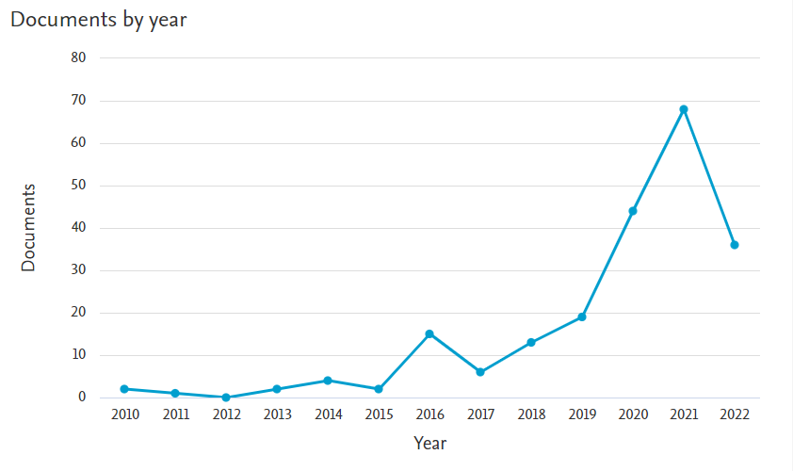
Figure 1: Documents by year on GHRM, GC, and GTL; Source: Scopus database
Further analysis of literature was done via VOSviewer version 1.6.18 software. By looking into the terms map below in Figure 2, the most prominent key terms in the literature of GHRM, GC, and GTL were analyzed. From the analysis it is evident that the concepts of green transformational leadership, green creativity, green behavior, green awareness, green training, green practice, environmental sustainability, and green recruitment are the most prominent with the highest relevance and occurrence rates. These results also support the theoretical framework of the existing study, as the variables under consideration of this study are still evolving and have only been examined separately with other variables in different studies. However, this is the pioneer study that observes the influence of green transformational leadership on the green creativity of employees as well as the mediating role of green HRM on this relationship.
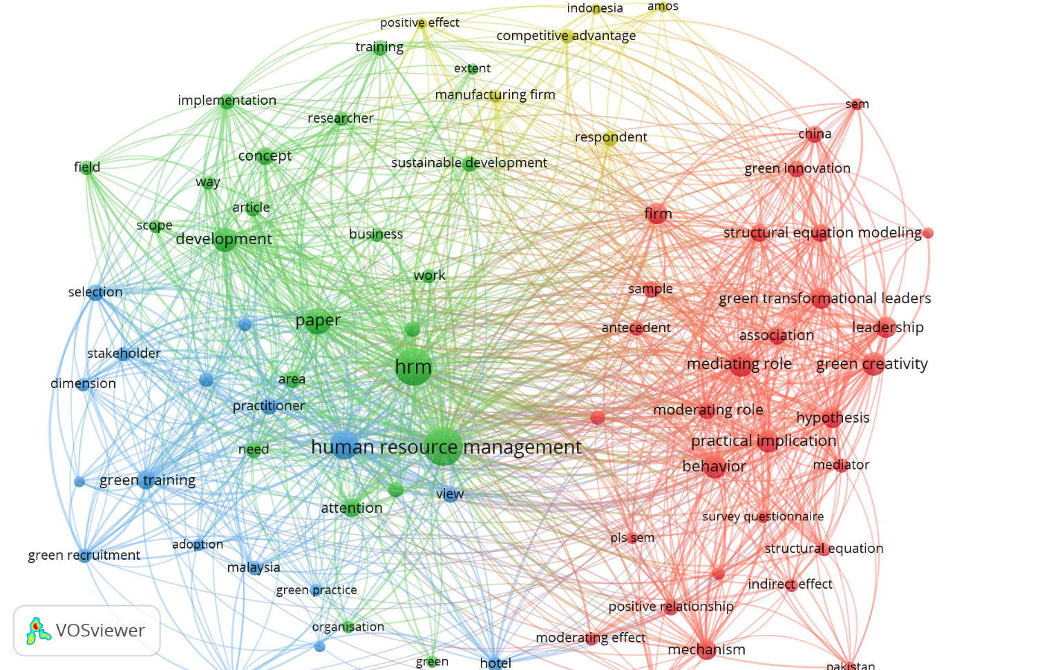
Figure 2: Clusters of GHRM, GC, and GTL literature

Methodology

The current research was conducted on the employees of service sector in Oman. Purposive sampling was used to select 207 employees from Oman's service sector for this study. The participants were approached in their workplaces and given an explanation of the research's purpose and scope. It was made clear to them that the information they collected would remain confidential and the participation was on voluntary basis.
In order to examine the relationship between green transformational leadership, green HRM and green creativity the questionnaire was created by adapting existing research questions and answers into a form. These items were also translated into Arabic, keeping cultural and language constraints in mind. Researchers and practitioners were consulted before survey questionnaires were distributed to ensure they met the criteria for both the validity of the face and the content of the survey. In order to begin the data collection process, 300 questionnaires were distributed and 207 were found to be correct in all aspects exhibiting a response rate of 69%.

Operational Definitions and Measures
The current research adapted already measures of the study variables. All the items in the were anchored on five-point Likert type scale (1 = strongly disagree, 5 = Strongly Agree).

Green Transformational Leadership (GTL)
The term GTL is defined in lines of Bass (1998), Gardner and Avolio (1998). It is described as leader’s behavior who inspire their followers to go above and beyond of what is expected of them in terms of environmental performance. In order to measure the concept a six-item scale developed by Chen and Chang (2013) was adapted. The sample item is “The leader provides a clear environmental vision for the members to follow”.

Green Human Resource Management (GHRM)
The term GHRM is expressed as the human resource management practices that are aimed at the ecofriendly and conservation impact of organizations. Moreover, it is associated with both organization’s environmental strategy and the green behaviors of their employees (Renwick et al., 2013). To measure the concept of GHRM a 13 items scale developed by Sun et al. (2007) and Renwick et al. (2013) and modified by Singh, Del Giudice, Chierici & Graziano, 2020) was adapted. The sample item is “Considerable importance given to green staffing process”.

Green Creativity (GC)
To defined the concept of green creativity, the current research refers to Amabile (1988) who describe the concept as the creation of innovative concepts regarding green products, processes, services or green activities that are seen as being novel, valuable and creative. To measure green creativity a scale developed by Chen and Chang (2013) was adapted. The scale consisted of six-items and the sample item is “The members of the organization promote and champion new green ideas to others”.
Green Human Resource Management

Green Creativity
Green Transformational Leadership

Figure 1: Proposed Research Framework

Data Analysis

The PLS-SEM technique was employed to validate the proposed research model. This method has been previously used in many researches as it gives a vigorous procedure in the examination of primary data (Herath & Rao, 2009; Simkin & McLeod, 2010). PLS-SEM has a requirement of acceptable sample size (Hair et al., 2017). A total data of 207 respondents was collected, which is way above the minimum requirement, and therefore creates a power of 0.99 with medium effect size for proposed PLS model. Thus, the sample size for the model surpassed the minimum requisite. Analysis of model was carried out with the help of Smart PLS (v 3.3.3) and bootstrapping technique was utilized to examine the impact of factor loadings and path coefficients. Moreover, a two-stage method was then employed for data analysis (Anderson and Gerbing, 1988). First of all, measurement model was assessed by way of evaluating the validity and reliability of each of the construct items. This assessment was followed by the assessment of structural model which essentially focuses on the path estimation among the constructs and establishing the significance of the paths.

Assessment of Measurement Model

Measurement model was evaluated for convergent validity which was done with the help of three methods: composite reliability, factor loadings, and average variance extracted (AVE) (Hair et al., 2014; 2017; Ramayah et al., 2018). Composite reliability determines the internal consistency of the constructs, and 0.70 is considered the minimum acceptable value of composite reliability (Herath & Rao, 2009). All the constructs in the model surpassed the minimum value requirement

of the model. Moreover, convergent validity of constructs was assessed by evaluating the AVE and factor loadings. All of the constructs had acceptable values of AVE and CR, and therefore were retained. Likewise, AVE value of greater than 0.5 hints an acceptable value for convergent validity of the model (Hair et al., 2017). All the AVE and factor loading values were greater than the threshold values for the model. Additionally, for factor loading assessment, values in the range of 0.4 to 0.7 are acceptable. It is generally accepted that items with external loadings between this range should be examined, and if the removal of these items increases the AVE and CR values, then the construct items with this range should be removed from the model, or else these items must be retained in the model (Hair et al., 2017). Table below shows the outer loadings, CR, AVE, Rho_A, and Cronbach’s alpha for all the constructs. Figure 2 below shows the measurement model.

Table 1: Convergent Validity of Model

Constructs | Items | Outer  Loadings | Cronbach's  Alpha | Rho_A | CR | AVE
Green Creativity | GC1 | 0.848 | 0.924 | 0.926 | 0.941 | 0.726
Green Creativity | GC2 | 0.853
Green Creativity | GC3 | 0.872
Green Creativity | GC4 | 0.89
Green Creativity | GC5 | 0.812
Green Creativity | GC6 | 0.834
Green HRM | GHRM1 | 0.613 | 0.92 | 0.93 | 0.932 | 0.515
Green HRM | GHRM10 | 0.763
Green HRM | GHRM11 | 0.804

 | GHRM12 | 0.623
 | GHRM13 | 0.703
 | GHRM2 | 0.611
 | GHRM3 | 0.724
 | GHRM4 | 0.734
 | GHRM5 | 0.839
 | GHRM6 | 0.679
 | GHRM7 | 0.82
 | GHRM8 | 0.759
 | GHRM9 | 0.596
Green Transformational Leadership | GTL1 | 0.546 | 0.895 | 0.933 | 0.921 | 0.665
Green Transformational Leadership | GTL2 | 0.868
Green Transformational Leadership | GTL3 | 0.862
Green Transformational Leadership | GTL4 | 0.846
Green Transformational Leadership | GTL5 | 0.874
Green Transformational Leadership | GTL6 | 0.846

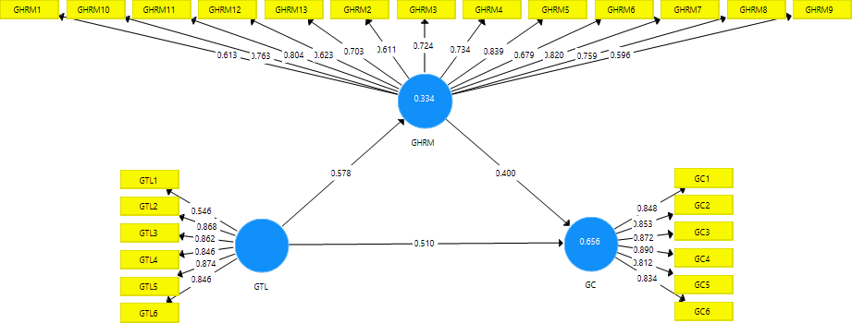

Figure 2: Measurement Model

Evaluation of discriminant validity is done with the help of three benchmarks which includes Fornell-Larcker criterion, cross-loadings, and HTMT (Hair et al., 2017). The acceptable standard for cross-loadings is that, an item’s outer loading value should be higher on its own construct than its values on other constructs (Hair et al., 2017). Table below shows the cross-loadings of each construct.
Table 2: Cross-loadings

 | GC | GHRM | GTL
GC1 | 0.848 | 0.574 | 0.662
GC2 | 0.853 | 0.58 | 0.728
GC3 | 0.872 | 0.689 | 0.561
GC4 | 0.89 | 0.626 | 0.572
GC5 | 0.812 | 0.523 | 0.543
GC6 | 0.834 | 0.555 | 0.702
GHRM1 | 0.435 | 0.613 | 0.285
GHRM10 | 0.455 | 0.763 | 0.418
GHRM11 | 0.631 | 0.804 | 0.553
GHRM12 | 0.366 | 0.623 | 0.341
GHRM13 | 0.577 | 0.703 | 0.381
GHRM2 | 0.387 | 0.611 | 0.315
GHRM3 | 0.441 | 0.724 | 0.551
GHRM4 | 0.578 | 0.734 | 0.386
GHRM5 | 0.525 | 0.839 | 0.476
GHRM6 | 0.389 | 0.679 | 0.288
GHRM7 | 0.655 | 0.82 | 0.49
GHRM8 | 0.461 | 0.759 | 0.446
GHRM9 | 0.453 | 0.596 | 0.335
GTL1 | 0.35 | 0.304 | 0.746
GTL2 | 0.563 | 0.433 | 0.868
GTL3 | 0.655 | 0.475 | 0.862
GTL4 | 0.518 | 0.424 | 0.846
GTL5 | 0.54 | 0.44 | 0.874
GTL6 | 0.734 | 0.543 | 0.846

Fornell and Larcker criteria is another method to examine the discriminant validity. In this method, square root value of AVE for each construct must be greater than values of other constructs. Table below shows that discriminant validity of the model has been achieved through this criteria.

Table 3: Fornell & Larcker Criterion

 | GC | GHRM | GTL
GC | 0.852
GHRM | 0.695 | 0.717
GTL | 0.741 | 0.578 | 0.815

Evaluation of correlation’s HTMT ratio (heterotrait-monotrait) is another way to examine the discriminant validity (Hair et al., 2017). This method shows the estimation of the real correlation between any two constructs. For the analysis, value of 0.90 is threshold for this method. Values that are more than 0.90 suggest the absence of discriminant validity. Table below shows that HTM criteria is achieved for the model.
Table 4: HTMT Ratio

 | GC | GHRM | GTL
GC
GHRM | 0.742
GTL | 0.778 | 0.607

Structural Model

Assessment of structural model was done with the help of R-square which shows the degree of accuracy for the model’s ability to predict. The values in table below reveal that R-square value is
0.65 for green creativity construct and 0.33 for the green HRM construct, which explains the 65% of variance in green creativity and green HRM. The outcomes of the test show that green

transformational leadership coefficient in the model is fairly high. Figure 3 below shows the structural model.
Table 5: R-square

 | R Square | R Square Adjusted
GC | 0.656 | 0.653
GHRM | 0.334 | 0.331

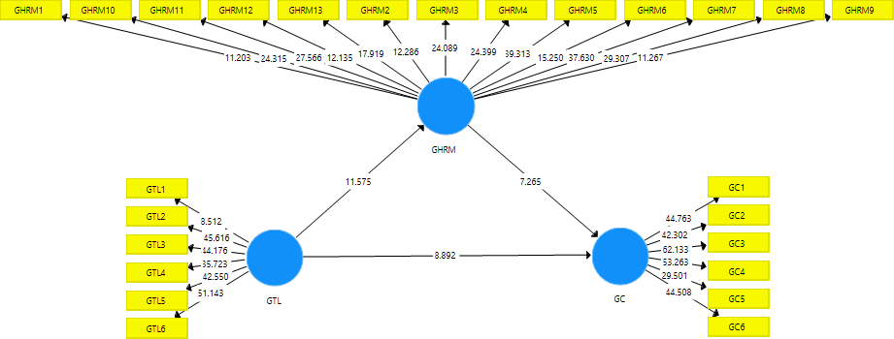

Figure 3: Structural model

Following Table 6 reveals the path coefficient values of the relationships and t-values for hypothesis testing. Based on the outcomes of data analysis, it is established that green transformational leadership has a substantial relationship with green creativity (t-value is 29.61 which is greater than 1.96). Green HRM also has a substantial relationship with green creativity (t-value is 7.26 which is greater than 1.96). Moreover, green transformational leadership also has a substantial relationship with green HRM (t-value is 11.54 which is greater than 1.96). Therefore,

H1, H2, and H3 are supported by results. Additionally, the mediation role of green HRM is also substantial (t-value of 5.23 which is greater than 1.96). Thus, H4 is also positively established by the results.
Table 6: Direct and indirect effects

 | Beta Values | T Statistics | P Values
GHRM -> GC | 0.4 | 7.265 | 0.000
GTL -> GC | 0.741 | 29.613 | 0.000
GTL -> GHRM | 0.578 | 11.549 | 0.000
GTL -> GHRM -> GC | 0.231 | 5.239 | 0.000

Discussion

This research evaluated the relation of GTL and GC, with mediating role of GHRM. Results of hypothesis testing show that green creativity is largely influenced by green transformational leadership, while a high level of GTL is also positively linked with GC. For this study, green transformational leadership has been confirmed for encouraging participation of employees in the creative process by way of promoting green creativity at workplace. Green transformational leadership inspires employees to introduce novel ideas in the workplace (Begum et al., 2021; Huang et al., 2021). The findings of the study show that if leadership has novel ideas, innovative solution to problems, and high spirit, it can inspire employees to have creative approaches at workplace. This research has substantiated the role of GTL on GC and provided empirical evidence of green transformational leadership’s value in improving green creative behavior.

The association between GTL and GC was impacted by employee qualities while majority of the employees who participated in this research were more than 30 years of age, having greater than eight years of experience, and some of them have higher education degrees. With the abovementioned qualities, people have maturity, confidence, and knowledge of creativity’s significance at the workplace. It is also in line with recent studies which confirmed that maturity level of employees promotes creative ideas at workplace (Çop et al., 2021; Mansoor et al., 2021). The adoption of HRM practices that can identify and retain such employees leads to better creativity.
Additionally, green transformational leadership was found positively linked with green HRM, which reflects that high level of green transformational leadership contributes in developing practices related to green HRM. Moreover, GHRM practices adoption at organizational level also contributes in green creativity. Therefore, GHRM plays a mediating role in the association among GTL and GC. Although, green transformational leadership directly influences the green creativity, it also has an indirect effect through green HRM. Therefore, green HRM mediates the relationship between GTL and GC.

Research Limitations and Future Directions

Current study has substantial contributions for the literature and theory, on the other hand, it has some limitations. First of all, the research study used single-dimensional constructs. Although, using multi-dimensional construct for GTL on GC dimensions can further develop understanding. Future research studies can utilize multi-dimensional constructs to get more meaningful findings. Moreover, this research has focused on cross-sectional investigation, while this type of research obliges longitudinal design to assess the effect of GTL on GC. Future research

might emphasis on the proposed relationship in a longitudinal setting. More mediating factors can also be introduced in the future relationships.

References

Al-Alawneh, R., Othman, M., & Zaid, A. A. (2023). Green HRM impact on environmental performance in higher education with mediating roles of management support and green culture. International Journal of Organizational Analysis. Vol. ahead-of-print
Amit, R., & Schoemaker, P. J. (1993). Strategic assets and organizational rent. Strategic management journal, 14(1), 33-46.
Anderson, J. C., & Gerbing, D. W. (1988). Structural equation modeling in practice: A review and recommended two-step approach. Psychological Bulletin, 103(3), 411.
Appelbaum, E., Bailey, T., Berg, P., Kalleberg, A. L., & Bailey, T. A. (2000). Manufacturing advantage: Why high-performance work systems pay off. Cornell University Press.
Ardito, L., & Dangelico, R. M. (2018). Firm environmental performance under scrutiny: The role of strategic and organizational orientations. Corporate Social Responsibility and Environmental Management, 25(4), 426-440.
Avolio, B. J., Bass, B. M., & Jung, D. I. (1999). Re‐examining the components of transformational and transactional leadership using the Multifactor Leadership. Journal of occupational and organizational psychology, 72(4), 441-462.
Avolio, B. J., Bass, B. M., & Jung, D. I. (1999). Re‐examining the components of transformational and transactional leadership using the Multifactor Leadership. Journal of occupational and organizational psychology, 72(4), 441-462.
Azmat, F., Lim, W. M., Moyeen, A., Voola, R., & Gupta, G. (2023). Convergence of business, innovation, and sustainability at the tipping point of the sustainable development goals. Journal of Business Research, 167, 114-170.
Awan, F. H., Dunnan, L., Jamil, K., & Gul, R. F. (2023). Stimulating environmental performance via green human resource management, green transformational leadership, and green innovation: A mediation-moderation model. Environmental Science and Pollution Research, 30(2), 2958-2976.
Baah, C., Agyabeng-Mensah, Y., Afum, E., & Lascano Armas, J. A. (2023). Exploring corporate environmental ethics and green creativity as antecedents of green competitive advantage, sustainable production and financial performance: empirical evidence from manufacturing firms. Benchmarking: An International Journal
Barney, J. (1991). Firm resources and sustained competitive advantage. Journal of management, 17(1), 99-120.
Bass, B. M. (1998). Transformational leadership: Industrial, military, and educational impact.
Mahwah, NJ: Erlbaum.
Bass, B., & Avolio, B. (1995). MLQ multifactor leadership questionnaire. Mind Garden.
Begum, S., Ashfaq, M., Xia, E., & Awan, U. (2021). Does green transformational leadership lead to green innovation? The role of green thinking and creative process engagement. Business Strategy and the Environment, 1– 18. https://doi.org/10.1002/bse.2911
Bos-Nehles, A., Renkema, M., & Janssen, M. (2017). HRM and innovative work behaviour: A systematic literature review. Personnel review.
Boxall, P., & Steeneveld, M. (1999). Human resource strategy and competitive advantage: A longitudinal study of engineering consultancies. Journal of Management studies, 36(4), 443- 463.
Cancela, B. L., Coelho, A., & Duarte Neves, M. E. (2023). Greening the business: How ambidextrous companies succeed in green innovation through to sustainable development. Business Strategy and the Environment, 32(6), 3073-3087.
Carton, A. M., Murphy, C., & Clark, J. R. (2014). A (blurry) vision of the future: How leader rhetoric about ultimate goals influences performance. Academy of Management Journal, 57(6), 1544-1570.
Chen, R., & Cao, L. (2023). How do enterprises achieve sustainable success in green manufacturing era? The impact of organizational environmental identity on green competitive advantage in China. Kybernetes.
Chen, Y. S., & Chang, C. H. (2013). The determinants of green product development performance: Green dynamic capabilities, green transformational leadership, and green creativity. Journal of business ethics, 116(1), 107-119.
Chen, Y. S., & Chang, C. H. (2013). The determinants of green product development performance: Green dynamic capabilities, green transformational leadership, and green creativity. Journal of business ethics, 116(1), 107-119.
Chen, Y. S., Lai, S. B., & Wen, C. T. (2006). The influence of green innovation performance on corporate advantage in Taiwan. Journal of business ethics, 67(4), 331-339.
Chen, S., Song, Y., & Gao, P. (2023). Environmental, social, and governance (ESG) performance and financial outcomes: Analyzing the impact of ESG on financial performance. Journal of Environmental Management, 345, 118829.
Çop, S, Olorunsola, VO, Alola, UV. Achieving environmental sustainability through green transformational leadership policy: Can green team resilience help? Bus Strat Env. 2021; 30: 671– 682. https://doi.org/10.1002/bse.2646
Cui, R., Wang, J., & Zhou, C. (2023). Exploring the linkages of green transformational leadership, organizational green learning, and radical green innovation. Business Strategy and the Environment, 32(1), 185-199.
Dumont, J., Shen, J., & Deng, X. (2017). Effects of green HRM practices on employee workplace green behavior: The role of psychological green climate and employee green values. Human resource management, 56(4), 613-627.
Eide, A. E., Saether, E. A., & Aspelund, A. (2020). An investigation of leaders’ motivation, intellectual leadership, and sustainability strategy in relation to Norwegian manufacturers’ performance. Journal of Cleaner Production, 254, 120053
Farrukh, M., Raza, A., & Rafiq, M. (2023). Environmentally specific authentic leadership and team green creative behavior based on cognitive-affective path systems. International Journal of Contemporary Hospitality Management, 35 (10), 3662-3680.
Fraj, E., Matute, J., & Melero, I. (2015). Environmental strategies and organizational competitiveness in the hotel industry: The role of learning and innovation as determinants of environmental success. Tourism management, 46, 30-42.
Gerhart, B. (2005). Human resources and business performance: Findings, unanswered questions, and an alternative approach. Management revue, 174-185.
Gong, Y., Huang, J. C., & Farh, J. L. (2009). Employee learning orientation, transformational leadership, and employee creativity: The mediating role of employee creative self- efficacy. Academy of management Journal, 52(4), 765-778.
Halbesleben, J. R., Novicevic, M. M., Harvey, M. G., & Buckley, M. R. (2003). Awareness of temporal complexity in leadership of creativity and innovation: A competency-based model. The Leadership Quarterly, 14(4-5), 433-454.
Hair Jr, J. F., Hult, G. T. M., Ringle, C., & Sarstedt, M. (2017). A primer on partial least squares structural equation modeling (PLS-SEM). Sage Publications.
Herath, T., & Rao, H. R. (2009). Encouraging information security behaviors in organizations: Role of penalties, pressures and perceived effectiveness. Decision Support Systems, 47(2), 154-165.
Huang SYB, Ting C-W, Li M-W. The Effects of Green Transformational Leadership on Adoption of Environmentally Proactive Strategies: The Mediating Role of Green Engagement. Sustainability. 2021; 13(6):3366. https://doi.org/10.3390/su13063366
Jia, J., Liu, H., Chin, T., & Hu, D. (2018). The continuous mediating effects of GHRM on employees’ green passion via transformational leadership and green creativity. Sustainability, 10(9), 3237.
Jiang, K., Lepak, D. P., Han, K., Hong, Y., Kim, A., & Winkler, A. L. (2012). Clarifying the construct of human resource systems: Relating human resource management to employee performance. Human resource management review, 22(2), 73-85.
Jung, D. I., Chow, C., & Wu, A. (2003). The role of transformational leadership in enhancing organizational innovation: Hypotheses and some preliminary findings. The leadership quarterly, 14(4-5), 525-544.
Laursen, K., & Foss, N. J. (2003). New human resource management practices, complementarities and the impact on innovation performance. Cambridge Journal of economics, 27(2), 243-263.
Lehman, P. K., & Geller, E. S. (2004). Behavior analysis and environmental protection:
Accomplishments and potential for more. Behavior and social issues, 13(1), 13-33.
Leonidou, L. C., Leonidou, C. N., Fotiadis, T. A., & Aykol, B. (2015). Dynamic capabilities driving an eco-based advantage and performance in global hotel chains: The moderating effect of international strategy. Tourism Management, 50, 268-280.
Leroy, H., Segers, J., Van Dierendonck, D., & Den Hartog, D. (2018). Managing people in organizations: Integrating the study of HRM and leadership. Human Resource Management Review, 28(3), 249-257.
Li, W., Bhutto, T. A., Xuhui, W., Maitlo, Q., Zafar, A. U., & Bhutto, N. A. (2020). Unlocking employees’ green creativity: The effects of green transformational leadership, green intrinsic, and extrinsic motivation. Journal of Cleaner Production, 255, 120229.
Liu, J., & Liu, J. (2023). The greater the incentives, the better the effect? Interactive moderating effects on the relationship between green motivation and green creativity. International Journal of Contemporary Hospitality Management, 35(3), 919-932.
Mansoor A, Farrukh M, Lee J-K, Jahan S. Stimulation of Employees’ Green Creativity through Green Transformational Leadership and Management Initiatives. Sustainability. 2021; 13(14):7844. https://doi.org/10.3390/su13147844
Messersmith, J. G., & Guthrie, J. P. (2010). High performance work systems in emergent organizations: Implications for firm performance. Human Resource Management: Published in Cooperation with the School of Business Administration, The University of Michigan and in alliance with the Society of Human Resources Management, 49(2), 241-264.
Mittal, S., & Dhar, R. L. (2016). Effect of green transformational leadership on green creativity: A study of tourist hotels. Tourism Management, 57, 118-127.
Nguyen, H., Onofrei, G., Yang, Y., Pham, H., Wiengarten, F., & Nkhoma, M. (2023). Handling customer green pressures: The mediating role of process innovation among export‐oriented manufacturing industries. Business Strategy and the Environment, 32(4), 2312-2326.
Northouse, P. G. (2015). Leadership: Theory and Practice (Eighth).
Paillé, P., Chen, Y., Boiral, O., & Jin, J. (2014). The impact of human resource management on environmental performance: An employee-level study. Journal of Business Ethics, 121(3), 451-466.
Park, J., & Kim, H. J. (2014). Environmental proactivity of hotel operations: Antecedents and the moderating effect of ownership type. International Journal of Hospitality Management, 37, 1-10.
Pham, H. T., Pham, T., Truong Quang, H., & Dang, C. N. (2023). Impact of transformational leadership on green learning and green innovation in construction supply chains. Engineering, Construction and Architectural Management, 30(5), 1883-1901.
Ramayah, T., Cheah, J., Chuah, F., Ting, H., Memon, M.A., (2018). Partial Least Squares Structural Equation Modelling (PLS-SEM) using SMARTPLS 3.0: An Updated and Practical Guide to Statistical Analysis (2nd edt). Pearson: Malaysia.
Renwick, D. W., Redman, T., & Maguire, S. (2013). Green human resource management: A review and research agenda. International journal of management reviews, 15(1), 1-14.
Robertson, J. L., & Barling, J. (2013). Greening organizations through leaders' influence on employees' pro‐environmental behaviors. Journal of organizational behavior, 34(2), 176- 194.
Saeed, B. B., Afsar, B., Hafeez, S., Khan, I., Tahir, M., & Afridi, M. A. (2019). Promoting employee's pro-environmental behavior through green human resource management practices. Corporate Social Responsibility and Environmental Management, 26(2), 424-438.
Sarros, J. C., Cooper, B. K., & Santora, J. C. (2008). Building a climate for innovation through transformational leadership and organizational culture. Journal of Leadership & Organizational Studies, 15(2), 145-158.
Simkin, M. G., & McLeod, A. (Solesvik 2010). Why do college students cheat? Journal of Business Ethics, 94(3), 441-453.
Singh, S. K., Del Giudice, M., Chierici, R., & Graziano, D. (2020). Green innovation and environmental performance: The role of green transformational leadership and green human resource management. Technological Forecasting and Social Change, 150, 119762.
Song, W., Yu, H., & Xu, H. (2021). Effects of green human resource management and managerial environmental concern on green innovation. European journal of innovation management, 24(3), 951-967.
Tang, G., Chen, Y., Jiang, Y., Paille, P., & Jia, J. (2018). Green human resource management practices: scale development and validity. Asia Pacific Journal of Human Resources, 56(1), 31-55.
Taha, I. M., & Abbas, A. A. (2023). The Role of Environmental Monitoring in Promoting Green Creativity. Economics and Business, 37(1), 15-36.
Taniya, N., & Widjaja, A. W. (2023). The Effect of Network Capability and Organizational Learning Capability on Transformational Leadership in Forming Innovative Work Behavior Mediated by Critical Thinking Skills at PT Bank Bukopin, Tbk. IDEAS: Journal of Management & Technology, 2(2), 29-48.
Uralovich, K. S., Toshmamatovich, T. U., Kubayevich, K. F., Sapaev, I. B., Saylaubaevna, S. S., Beknazarova, Z. F., & Khurramov, A. (2023). A primary factor in sustainable development and environmental sustainability is environmental education. Caspian Journal of Environmental Sciences, 21(4), 965-975.
Wiredu, J., Yang, Q., Saljoughipour, S., Olufunke, E. C., Sampene, A. K., & Brenya, R. (2023). Stimulating environmental performance through green human resource practice: Does green transformational leadership matter?. Journal of Infrastructure, Policy and Development, 7(1), 2127.
Woodman, R. W., Sawyer, J. E., & Griffin, R. W. (1993). Toward a theory of organizational creativity. Academy of management review, 18(2), 293-321.
Yong, J. Y., Yusliza, M. Y., Ramayah, T., & Fawehinmi, O. (2019). Nexus between green intellectual capital and green human resource management. Journal of cleaner production, 215, 364-374.
Zhao, H., & Guo, S. (2014). Selecting green supplier of thermal power equipment by using a hybrid MCDM method for sustainability. Sustainability, 6(1), 217-235.
Zhou, S., Zhang, D., Lyu, C., & Zhang, H. (2018). Does seeing “mind acts upon mind” affect green psychological climate and green product development performance? The role of matching between green transformational leadership and individual green values. Sustainability, 10(9), 3206.
Zhu, W., Chew, I. K., & Spangler, W. D. (2005). CEO transformational leadership and organizational outcomes: The mediating role of human–capital-enhancing human resource management. The leadership quarterly, 16(1), 39-52.

