Maximizing Business Value through Effective Communication and Collaboration: A Study of Data Science and Stakeholder Engagement at Sky Betting and Gaming
Abstract
This research investigates roles and responsibilities within the Sky Betting and Gaming data science team, emphasising stakeholder engagement and collaboration enhancement. Using a qualitative case study, data from 8 team members and 12 stakeholders were collected through questionnaires and semi-structured interviews. A SWOT analysis was implemented using the stakeholder’s data to investigate the challenges of roles and responsibilities within the team. Findings indicate enhanced collaboration through increased communication, promotion of data science projects, and stakeholder involvement at various project stages. Challenges include conflicting priorities and power dynamics. The study emphasises the vital role of stakeholder engagement in team success, offering practical recommendations through a communication plan and stakeholder strategy. Implications for data science roles are highlighted, with further research recommended to apply these findings in diverse contexts and refine alignment strategies.
Introduction
It is becoming more apparent that organisations can utilise the power of data science to create a competitive advantage and assist in making decisions with data (Medeiros et al., 2020). To maximise the full potential of Data Science, integration with stakeholders is required, to understand business requirements and processes, ensuring data science products are utilised and challenges are overcome (Hosni et al., 2018). One of the main challenges in completion of successful technology projects, including data science projects that are utilised effectively is effective communication and collaboration with stakeholders (Hasnat, et al., 2021), (Zhang et al., 2020). This research is to understand the communication and collaboration challenges faced when implementing data science to maximise business value through effective communication and collaboration with business partners, whilst making recommendations to overcome the challenges.
According to Medeiros et al. (2020) when organisations successfully address specific challenges in implementing data science, such as data quality, data availability and stakeholder collaboration, data becomes a powerful asset. This enables better informed data lead decision making, potentially leading to competitive advantage and potential sustainable growth. Effective data science could enhance customer insights, optimise operations and drive innovation (Wamba et al., 2017).

The Data Science (DS) team was established in 2015, comprising a Head of Department, a Senior Data Scientist, and a Data Scientist. The team faced technical challenges, including a low-quality development environment, difficulties in production of models, and a lack of coding standards. A Principal Data Engineer joined in late 2016 and improved the team's ability to develop and productionise work. The team has grown, with roles like Lead Data Engineer, Lead Data Scientist, four Data Scientists, and seven Data Engineers, along with supporting roles. Despite team growth and technological advancements, the team's ways of working had not been reviewed. Numerous changes, such as team size, resource allocation, and skill sets, have occurred since the team's establishment. The team interacts with stakeholders from various departments, undertaking numerous projects.
However, challenges exist in effective communication and collaboration with stakeholders, the full potential of data science has often been unexploited. The sharing of business requirements and lack of collaboration between teams has led to missed opportunities and data science products not being utilised significantly, reducing value delivered. Challenges also exist in measuring the specific value delivered by models due to inadequate key
performance indicator (KPI) tracking during campaigns. Some models are not utilised due to not meeting stakeholder requirements or changes in business functionality.
Creating a culture of collaboration and communication between teams, ensuring better ways of working is created, should overcome challenges. Our study will consider case study research of Sky Betting and Gaming (SBG) a UK based online gambling business with multiple brands offering entertainment services accessible to millions of users through online platforms and mobile devices. Our present study will investigate way for overcoming the challenges and assisting in the creation of data science products that meet that meet stakeholder’s requirements and delivered in a timely manner, ensuring the best value is delivered to SBG.

Literature review findings reveal gaps in understanding DS team dynamics (Knopp at al. 2016; Jimenaz, 2017; Zahoor, 2021). Smaller organisations often have generalists, while larger ones exhibit diverse roles like scientists, engineers, and architects. The literature points to evolving DS teams with specialised members, creating coordination challenges and a need for clear project alignment (Jimenaz, 2017; Martinez et al. 2021). Communication gaps between DS teams and business stakeholders can lead to projects drifting from requirements, resulting in low value add (Hosni et al., 2018). The literature highlights the importance of effective communication, collaboration, and clear roles when DS teams expand and undergo structural changes. Gaps in research include defining roles and responsibilities in DS teams (Jimenaz, 2017; Zahoor, 2021), effective ways of working with stakeholders (Hosni et al., 2018), and methods for maximising project value through communication and collaboration (Berndtsson's, 2020). The literature also lacks guidance on the best approaches to measure the value of DS projects and identify the responsible role for measuring and reporting outcomes Jarvinen (2016).
The intervention question will be “What are the necessary roles and responsibilities within a DS team, and how can the team effectively collaborate with stakeholders to maximise the business value of the delivered projects for SBG?”
The research aims to explore the essential roles within the SBG DS team, with a focus on effective communication and collaboration with stakeholders. The research aims to provide insights into the specific roles and responsibilities, as well as optimal approaches for stakeholder engagement. This will assist team members in meeting expectations and achieving their goals. Additionally, the research aims to identify effective collaboration methods to enhance project value by understanding stakeholder requirements and perspectives
The outcomes will offer valuable recommendations to senior management for cohesive communication and collaboration strategies, fostering improved outcomes, efficiency, and stakeholder satisfaction. The research informs a broader strategy for future ways of working, ensuring sustained success in delivering value to SBG. Abbreviations used throughout the paper are listed in table 1.

Table 1: Abbreviations of Jobs Roles
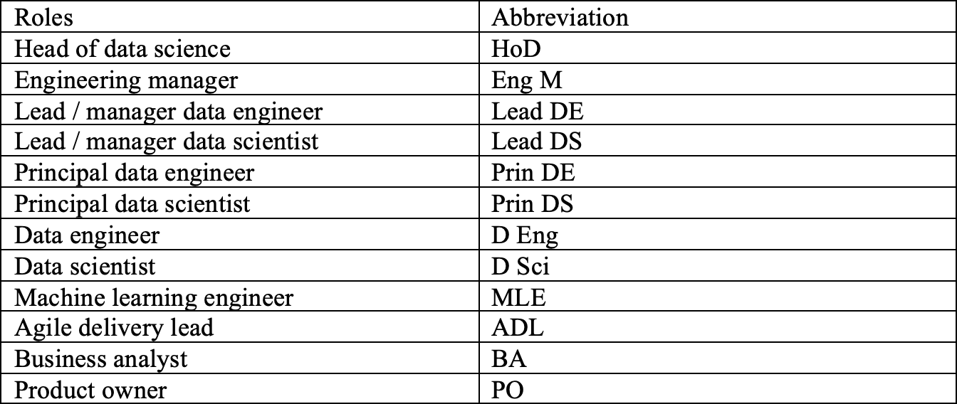
To address the challenges of effective communication and collaboration with data science and stakeholders, it is essential to review the existing literature. By reviewing existing literature, gaps can be identified and best practices that inform the development of strategies for enhancing stakeholder engagement and project success for a functioning data science team. The following literature review will explore these aspects in detail, providing a foundation for the research.
Data Science as a Discipline
According to Bern (2020) DS started with statistics which is embedded in DS. Brodie (2019) expands stating DS uses statistics, programming, and domain knowledge, which relates to machine learning, big data, and data mining. Statistical modelling has been implemented for years, it is only the last two decades that technology has been available to leverage the data (Dean et al., 2004; Dwived et al., 2023). Since then, large businesses have been focusing time and effort on big data technology to leverage the available value (Riggs et al., 2024). According to Bohr et al. (2020) statistical methodology has been available and implemented for numerous years, although more recently new technology and algorithms has become available to leverage stored data. Sarker |(2021) states that combining statistics, programming and domain knowledge, a new discipline named data science has become popular and Ramachandran (2024) states data science has started to grow over the years. According to Medeiros et al. (2020) DS is defined as: DS delivers value to businesses assisting with decision making using data, from applying statistical methods and machine learning, which will be used throughout this research.

Figure 1 shows the three main disciplines relating to data science and the interlinking of the other three key skills to create DS in the centre.

A Figure 1: Venn Diagram of Data Science Concepts

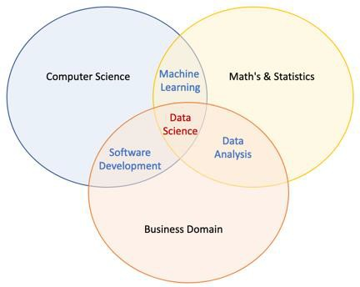
Adapted from Brodie (2019)

Patil (2011) states that when building the LinkedIn DS team, the team was a fully integrated group. Due to the nature of all members having a great understanding of data, the members all had job titles of data scientists, which is also stated at IBM (Wang et al., 2019). Provost et al. (2013) also mentions DS is a confusing discipline and no-one knows exactly what it is, although organisations need to hire data scientists. Patil (2011) defines the role of a data scientist as, someone with curiosity and who are interested in understanding many areas of the business, including the business domain and technology used.

According to Jimenez (2017), a single person that is great in all skills as defined in figure 1 is rare and larger organisations, such as Facebook, Amazon, and Google will have employees that excel in two or three skills, such as machine learning, computer science and statistics (Perifanis et al., 2023). Once the gaps are identified, the organisation can hire people for the gaps, creating a very strong DS team. According to Knopp et al. (2016), smaller organisations without established analytics functions generally rely on a generalist to handle most tasks. In larger organisations with established functions, the data science team can have numerous roles (Zhang et al., 2020).

Data Science Ways of Working Problems
Literature highlights the struggle of data scientists working with other teams, such as engineering and business stakeholders, due to a lack of domain-specific understanding (Saltz 2021). Additionally, the absence of effective sponsorship from upper management slows project delivery and utilisation (Hawsah, 2020).

Proposed Data Science Projects
DS projects in organisations aim to generate value, whether in profit, organisational efficiencies, or compliance (Riggs et al., 2024). Some projects are ad-hoc, requiring extensive data exploration to reduce uncertainty and ensure successful delivery. However, complexities, as noted by Das et al. (2015), make it challenging to establish expectations, define scope, and comprehend business objectives accurately. Misleading objectives, as highlighted by Kuhn et al. (2018), can result in out-of-scope projects, diminishing expected organisational value and leading to stakeholder disengagement. Ransbotham et al. (2015) discusses that technical limitations limits the full potential of DS in businesses, affecting capabilities and hindering access to necessary technology for modelling and productionising models. Data scientists, stated by Hosni et al. (2018), sometimes focus excessively on end goals, building overly complex models that are challenging to explain to stakeholders, potentially making them unusable.

Literature emphasises the challenges in DS project delivery, encompassing issues like mismatched technology, unavailability of required tools, and the tendency to build overly complex models (Hosni et al., 2018). Close collaboration with stakeholders for project definition is highlighted as crucial for maximising project value (Urbinati et al., 2020).

Transforming Data to Value
Prescott (2016) emphasises the growing significance of data as a key driver for business competitiveness, fostering innovation, and delivering value. Bokman et al. (2014) mentions a 23-fold increase in the likelihood of acquiring new customers and 2.6 times boost in ROI for businesses employing data-driven approaches. However, becoming a data-driven business requires both technology and skilled personnel, integrating data decisions into all aspects of the business to cultivate a data-driven culture (Wahyuni, 2024). Berndtsson's (2020) research discusses that less than 25% of businesses have achieved this status, with challenges stemming from cultural aspects, lack of successful data strategies, and insufficient skills for strategy execution.

One significant challenge in DS projects is measuring the projects value, as discussed by Salminen et al. (2017). Jarvinen (2016) notes the importance of refining collected data to derive meaningful insights, emphasising the need for measurable key performance indicators (KPIs) for effective project testing. DS's potential in a data-driven business is immense, but challenges arise in adoption, correct implementation, and accurate measurement of the delivered project's value, involving cultural, strategic, and procedural considerations (Medeiros et al., 2020).

Gaps in Literature
Knopp et al. (2016) highlight that smaller organisations without a dedicated analytics function often rely on generalists, while larger organisations adopt specialised roles in their data science teams (Jimenaz, 2017; Zahoor, 2021). Saltz et al. (2018) states an increasing need for specialised and complex efforts in DS projects, resulting in evolving team structures with Martinez et al. (2021) emphasising the challenges of coordinating larger teams.

However, gaps in the literature emerge as the evolution of team dynamics with team growth is not thoroughly explored. The coordination challenges within a team, especially with roles such as lead data engineers, lead data scientists, data scientists, data engineers, data architects, testers, product owners, and agile delivery leads, remain understudied. Meetings within larger teams are found to be disproportionately focused on engineering or science- related topics, potentially hindering effective communication and participation from all team members.

Issues of confusion and inefficiencies, both internal and external to the team, as highlighted by Saltz (2021), can lead to errors in the absence of a managed process. Kuhn et al. (2018) stresses the importance of collaboration and communication among business stakeholders, emphasising that misalignment can result in products not meeting specifications. Lack of sponsorship from top management, as noted by Saltz et al. (2018), creates a chaotic work environment, impacting team motivation and project delivery time. Challenges in setting expectations, scoping projects, and understanding business objectives are discussed (Das et al., 2015), with misleading objectives leading to out-of-scope projects that fail to deliver value (Kuhn et al., 2018). Hosni et al. (2018) notes that data scientists may prioritise end goals over stakeholders' requirements.

Literature also emphasises gaps in processes for working with stakeholders, indicating uncertainty about the best methods for communication and collaboration to maximise project value (Kuhn et al., 2018). According to Hawsah (2020), the lack of clarity on who is best suited to sponsor data science projects external to the team further contributes to a confusing environment, potentially diminishing project value. Moreover, understanding business objectives for accurate project scoping lacks established processes in the SBG DS team. Once projects leave the team's ownership, there is often no clear ownership within other teams, making it challenging to track project usage and impact.

Measuring the value of DS projects emerges as a significant challenge (Salminen et al., 2017), with Jarvinen (2016) emphasising the need to refine collected data for meaningful insights. The literature reveals gaps in determining the best ways to measure DS project performance through meaningful KPIs, raising questions about who should set and monitor these indicators (Jarvinen, 2016). SBG's DS projects, while frequently used, face challenges in quantifying their impact, hindering confidence in the team's value.

Methodology
The research is following the interpretivist approach, as the approach aligns with the objectives of the research which is to explore the ways of working in DS at SBG. Saunders et al. (2020) state that interpretivism focuses on the details of the research aspect and the accuracy within the details. According to Chowdhury (2014), interpretivism is a philosophy of research that highlights the importance of understanding the subjective perspectives and experiences of people in social contexts. Moreover, the research required an understanding of people’s behaviour and how DS team members interact with stakeholders, which can be observed from stakeholders’ input and understanding details of the situation. According to Bell et al. (2022), the research philosophy should only be chosen based on the nature of the research, due to the nature of the research being exploratory, the interpretivist approach was appropriate.

Due to the nature of the research to understand the ways of working in DS at SBG, the researcher implemented exploratory research design followed by a case-study methodology. The defined approaches assisted the researcher in gaining a clear and in-depth understanding of the research topic. According to Akhtar (2016), exploratory research is exploring something by answering the question in what or how manner. Therefore, the chosen research design was exploratory due to answering the specific questions of what roles and responsibilities should be in a DS team. Exploratory was also chosen to understand what the best ways is of working with stakeholders is, to maximise the impact of DS projects and what is the best way to measure the value. Exploratory design was also chosen as there is little literature available to assist with the research and the nature of the study can serve a basis for future research. Case study methodology was chosen as the research strategy to provide the researcher a clear and deep insight into the problems of the topic in a real-life context. This methodology was chosen as it provides flexibility to the researcher and ensured consistency with limited time to conduct the research. This strategy also means the data can be collected via questionnaires. Saunders et al. (2020) also states that case study methodology develops new models and not supporting existing ones, also answering the ‘why, ‘what’ and ‘how’.

Gilbert (2008) explains that qualitative interviews open the research problem, which was also used in this research as some data was gathered through interviews. Janssen (2010) further explains that qualitative questionnaires aim to capture the diversity within a population of interest rather than creating parameters such as frequencies or means. This research utilised qualitative interviews and questionnaires to gather employees' thoughts and opinions on the defined research objectives. Due to the nature of these methods, the research used a multi-method approach, combining two qualitative data collection methods.

The research implemented an interpretivist approach to explore the DS team's working methods at SBG, focusing on understanding subjective perspectives (Saunders et al., 2020; Chowdhury, 2014). An exploratory design and case study methodology were chosen to gain in-depth insights into DS team roles, stakeholder collaboration, and project value (Akhtar, 2016; Bell et al., 2022). Qualitative interviews and questionnaires were implemented to gather different employee perspectives, implementing a multi-method strategy for comprehensive data collection (Gilbert, 2008; Janssen, 2010).

Data Collection Methods
The primary data collected for the research is based on two different collection methods from two different groups of employees. A questionnaire was sent to 29 DS team members across PPBF, SBG, and TSG brands. The questions asked are outlined in table 2, and all the responses were qualitative data in free-hand text boxes. The questions formed themes around the roles participants felt should be internal within the DS team. According to Dillman et al. (2014), questionnaires should not be left open for over 2-3 weeks as people who are going to respond will have done so, and sending reminders to non-respondents helps increase engagement. Therefore, the questionnaire was open for 2 weeks, with a reminder sent after the first 7 days, and 62% of the population responded.

Interviews were conducted with a sample of the population who volunteered, including four engineers and four scientists from the SBG brand. Guest et al. (2006) recommend that 5-10 participants are suitable for qualitative interviews, considering the research design, research question, and population being studied. The interviews were semi-structured, and the results from the questionnaire were used to create a whiteboard with suggested roles, with each participant having a unique whiteboard, shown in appendix B & C. The researcher discussed with the participants the responsibilities associated with each defined role, communication methods, and stakeholder requirements. The interview also covered ways to better measure the project's value, with notes added to the board and the interview recorded for further reference. The interview questions are listed in Table 3.
Secondly, the researcher collected data from 31 stakeholders within SBG to understand the best ways to work with DS. The interviews were semi-structured, to examine the strengths, weaknesses, opportunities, and threats (SWOT) of ways of working with DS, shown in appendix A. The interviews were flexible and explored new topics during the interview when appropriate. Twelve respondents volunteered to take part after an email was sent twice requesting volunteers. The discussion varied from one stakeholder to another; therefore, the data collected were summarised to assist with the explorative study.

Table 2: Data Science Team Questionnaire
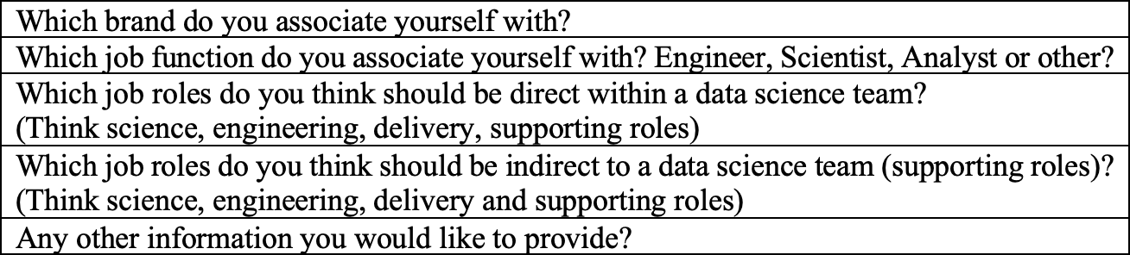
Table 3: Data Science Team Interview Questions
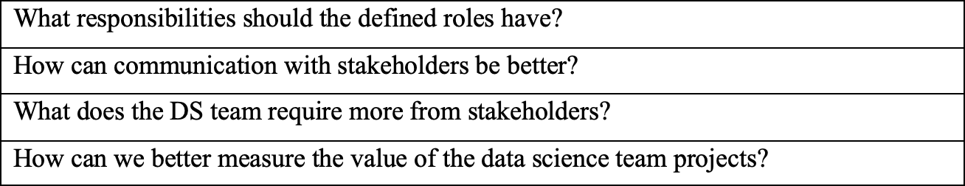

The research undertook a none-probability sampling method of purposive sampling. Purposive sampling is sampling with a purpose in mind and the population is selected because the people have characteristics that are required in the sample (Etikan, 2016). The employees interviewed possessed the characteristics necessary for the research, as determined by the purposive sampling method. To ensure fairness and accuracy, employees from all DS functions and stakeholders were invited to participate. 18 DS team members at PPBF, SBG, and TSG responded to the questionnaire, and 8 SBG DS team members volunteered to be interviewed. The stakeholder participants who agreed to be interviewed included 4 members from CRM, 3 members of BI, 2 members from SG, and 3 members from commercial. Due to the limited number of volunteers, sampling was not conducted on departments or job roles.

Using thematic analysis, repeated patterns in the data sets were identified, enabling the researcher to describe and find themes that supported the research analysis. The data was first familiarised to the researcher to gain an understanding of it, and then labelled with appropriate categories such as communication, collaboration, and strategy. The labelled data facilitated the researcher's ability to draw conclusions from the data.

Semi-structured interviews were chosen as the data collection method for this study because they allowed for discussions and opinions around the subject matter, which could be explored in-depth. The interviews provided participants with a face-to-face anonymous setting, which enabled them to openly express their views. Additionally, the chosen analysis involved a thorough investigation of the collected data to create themes, which helped to ensure valid, accurate, and reliable results. To avoid bias, all DS team members and stakeholders were asked to volunteer for the research, without considering seniority, gender, age, or other demographic factors. The research questions were open-ended and aligned with the research question to encourage participants to freely share their thoughts and opinions, while remaining anonymous to ensure accurate and reliable data and results.

The primary data was collected through questionnaires and semi-structured interviews. Questionnaires were sent to 29 DS team members, with a 62% response rate in two weeks, focusing on DS team roles. Semi-structured interviews with four engineers and four scientists discussed roles, responsibilities, and project value measurement. Additionally, 31 stakeholders were interviewed about effective DS collaboration. Purposive sampling ensured relevant participants. Thematic analysis identified key patterns and themes. These methods provided comprehensive data and ensured unbiased, reliable results.

There are no concerns regarding deception in this research, as the researcher has not collected any personal information. Consent was obtained from employees through a Participation Information Sheet (PIS) and a Participation Consent Form (PCF), before interviews and questionnaires took place. Employees involved in the questionnaire were given information prior to filling it out to ensure a full understanding of their involvement in the project. Before interviews, employees were also given an overview of the project and how the answers would be used. It was ensured that the information provided by the participants is kept fully confidential and only used for the researcher's private use.

Results and Findings
Table 4 summarises roles identified by 18 participants across analyst, engineer, and scientist job roles. The percentage of respondents considering certain roles as internal to the team is displayed, with colours indicating high, low, or neutral responses.
Roles with mentions of 50% or above from any job role are deemed internal to the team. Analysts highlighted HoD, Lead DS, Prin DE, Prin DS, D Sci, MLE, Analyst, and PO. Engineers identified HoD, Lead DE, Lead DS, D Eng, D Sci, MLE, ADL, PO, and Tester. Scientists pointed out HoD, Lead DS, Prin DS, D Sci, MLE, and PO as internal roles within a DS team.

The next section focuses on the primarily responsibilities of the roles that are deemed to be collaborative, communitive, and organised to the team.

Table 4: Roles Internal to Data Science – By Job Role.

Data Science Team Responsibilities
This section presents insights from eight interviews with the SBG DS team, focusing on roles perceived as collaborative, stakeholder-engaging, coordination-oriented, and strategy- focused.

Stakeholder Engagement: The PO received the most mentions (11), with consensus on their role as a liaison between stakeholders and the team. The HoD had 10 mentions, emphasising engagement with senior stakeholders for project optimisation. The Lead DS was mentioned five times, emphasising proactivity and identification of new opportunities.
Coordination: The ADL dominated with 21 mentions, overseeing team ceremonies, capacity planning, and project breakdown. The Lead DS and Lead DE were mentioned for coordinating and planning work, specifically with direct reports.
Internal Team Collaboration: The ADL was highlighted as the key internal collaborator, with mentions of collaboration with Lead DE, Lead DS, scientists, and engineers. Four interviewees stressed the collective responsibility of the entire team for collaboration and project progression.
Strategy: The HoD had seven mentions for providing strategic direction to the DS team. The Prin DS and Prin DE received seven mentions each, with emphasis on forward-thinking, technology initiatives, and team improvements.

Technical Leadership: Prin DS and Prin DE had high mention counts for technical leadership, defined by supporting the team technically and defining patterns for complex projects. S Sci were noted for seeking improvements in technical aspects, while S Eng were advised on the technology direction.

Working with Stakeholders and Measuring the Value of Projects
This section shows the results from the questions asked: How can communication with stakeholders be better? What does the DS team require more from stakeholders? How can we better measure the value of the DS team projects? from the team members interviewed.

Communication with Stakeholders: Communication time was a key concern, with an emphasis on timeliness and updates throughout project stages. Methods of communication, such as a data science monthly information video pack and quarterly roadshows, were suggested for better engagement. The importance of understanding stakeholders' work and cross-learning activities for effective communication was highlighted.

DS Team Requirements from Stakeholders: Faster and more appropriate communication of positive and negative model results was identified as a key requirement. Collaborative efforts for stakeholders to gain a better understanding of DS team activities and delivered projects were emphasised.

Measuring the Value of DS Team Projects: The need to outline project value before modelling, as specified in project documentation, was highlighted. Identifying the best metrics for measuring value and conducting further analysis post-project were suggested. Establishing a feedback loop with stakeholders to understand project impact and revisiting projects for ongoing effectiveness were proposed.

Stakeholders Perception of Data Science
This section provides the results of the SWOT analysis from the 12 stakeholders interviewed. The themes are related to the questions: What are our strengths, weaknesses, opportunities, and threats working effectively together? The main aspects are shown in figure 2 and the whiteboard can be found in appendix A.

Strengths

Great Project Delivery: 83% (10 stakeholders) highlighted DS's excellence in delivering impactful projects, often aligned with their departments. Quick Wins for Business: 75% (9 stakeholders) identified collaboration for quick wins as a key strength, with specific projects mentioned. Strong Technical Skills: 58% (7 stakeholders) acknowledged DS's robust technical skills as a significant strength, emphasising the team's ability to utilise these skills effectively. Subject Matter Expertise: Stakeholders praised DS for subject matter expertise, citing examples of enhancing customer protection and impressive data utilisation.

Weaknesses

Limited Communication: 91% (11 stakeholders) expressed concerns about limited and poor communication regarding work delivery and strategy. Issues include distant communication of roadmap work, lack of understanding about projects in production, and unclear communication when new projects are delivered. Low Collaboration: 83% (10 stakeholders) highlighted low collaboration between DS and stakeholders. Concerns include insufficient collaboration resulting in models not meeting requirements, lack of teamwork between CRM and data science, and low collaboration on statistical expertise. Misalignment with Project Process: 33% (4 stakeholders) mentioned a lack of alignment with the project process. Stakeholders emphasised the importance of understanding complex projects throughout the process for better confidence and team buy-in. Weak Feedback Loop: 33% (4 stakeholders) identified a weak feedback loop on the value brought from projects. Concerns include insufficient feedback on the performance of legacy projects and poor communication from commercial and CRM on the value delivered by DS projects.

Opportunities

Advanced Modelling Capabilities: 91% (11 stakeholders) see an opportunity to collaborate for more advanced modelling, suggesting specific models for products and enhancing analytics to increase ROI. Educating Stakeholders: 75% (9 stakeholders) expressed a need to better understand DS capabilities in their teams. Opportunities include educating stakeholders to increase project involvement and capabilities. Enhanced Collaboration: 66% (8 stakeholders) believe there is an opportunity for increased collaboration. This involves working closely during project development, ensuring early utilisation, and gaining a better understanding of each other's roles. Promoting DS Team's Capabilities: 41% (5 stakeholders) see an opportunity for the DS team to promote its capabilities and delivered projects to wider audiences, enhancing awareness of their impactful work. Sharing Strategy: 33% (4 stakeholders) highlighted the opportunity to share strategies between different areas of the business. This involves understanding team priorities and adopting data-driven approaches, especially in areas like safer gambling and innovation.

Threats

Difficulty in Strategic Progress: 50% (6 stakeholders) highlighted challenges in making strategic progress, with concerns about constraints due to changes in the business and within the tribe. Project Output Not Meeting Requirements: 50% (6 stakeholders) expressed concerns about the threat of being unable to use project outputs because they do not meet requirements. CRM stakeholders particularly emphasised this risk. Quantifying Return on Investment (ROI): 33% (4 stakeholders) mentioned challenges in quantifying the team's ROI, expressing a need to highlight the value of projects and measure their impact. Resource Constraints: 25% (3 stakeholders) identified threats related to low resources for collaboration with different teams. Concerns included difficulty obtaining resources for roadmap.

Figure 2: Stakeholder SWOT Analysis
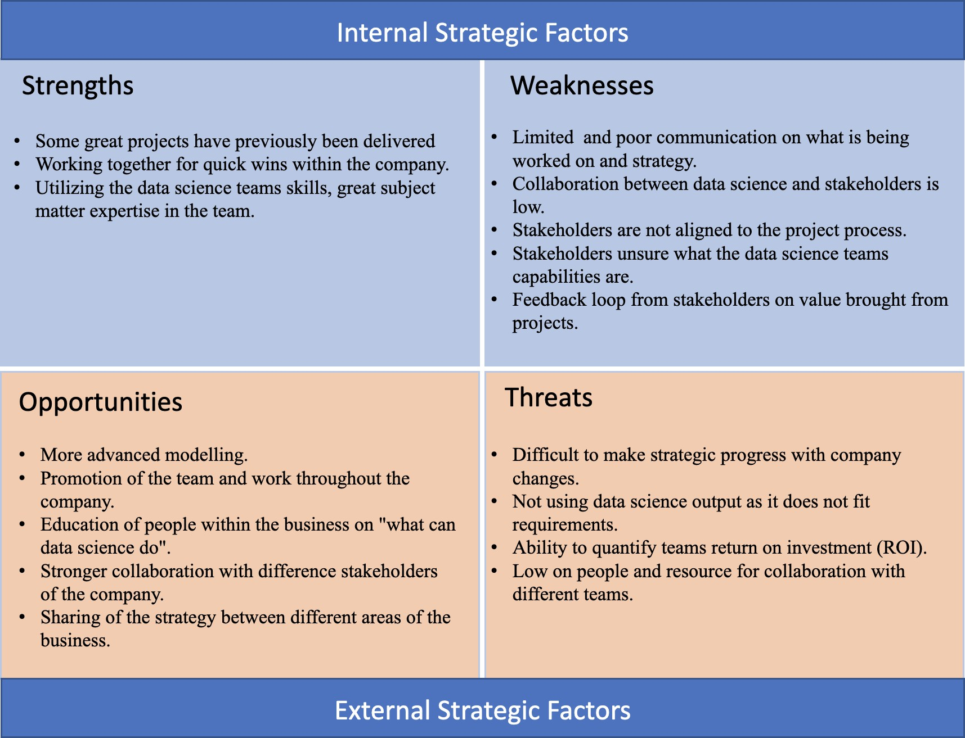

Discussion
The research findings indicate that over 50% of participants in various job roles believe internal roles within a DS team should include HoD, Lead DE, Lead DS, Prin DS, D Eng, D Sci, MLE, ADL, Analyst, PO, and a Tester. This aligns with the view that successful DS teams often consist of well-defined roles, as suggested by Jimenaz (2017) and Zahoor (2021). The study also revealed additional roles, highlighting the complexity of team structures. While the current research addresses the understanding of roles within DS teams, further investigation could explore specific responsibilities within PPBF and TSG teams, potentially through workshops.

Results show engineers, particularly in SBG, emphasise the importance of having an ADL, and all respondents favour having a PO, diverging from the literature's emphasis on technical roles. Emerging research suggests the integration of roles like an ADL due to the combined science and engineering focus, aligning with agile DS delivery (Merelo 2021). Aho et al. (2021) highlight the fundamental role of PO in improving internal processes, aligning with the increasing relevance of these roles in big data projects.
The research reveals that team members should exhibit high levels of stakeholder engagement, coordination, collaboration, and technical leadership. Primarily stakeholders are engaged with the HoD and PO, although scientists and engineers also demonstrating involvement, certainly Lead roles. Scientists emphasise stakeholder engagement for relationship-building throughout projects, contrasting with some literature's more technical focus on scientists. Further research highlights the importance of communication and business engagement for effective data science (Ismail, 2016), reducing issues of project misalignment. ADLs play a crucial role in team coordination and collaboration, managing project delivery, organising ceremonies, and implementing agile methodologies. Collaborative efforts with an ADL can enhance team communication and efficiency, addressing identified issues in DS team collaboration (Saltz, 2021). Leadership roles such as HoD, Prin DE, and Prin DS and Leads emerge with the most mentions for strategy. HoD specifically holds responsibility for setting team strategy, aligning business projects, and collaborating with stakeholders. This contrasts with literature highlighting challenges in data strategy formulation and execution (Jim et al., 2017; Li et al., 2021).

DS success hinges on increased communication and collaboration with stakeholders. Both the DS team and stakeholders acknowledge that enhanced collaboration leads to improved capabilities, project alignment, and stronger relationships, aligning with literature highlighting the benefits of collaboration (Kuhn et al., 2018). Communication improvement areas identified include educating stakeholders, refining communication timing, and adopting new communication methods. Stakeholders emphasise the importance of understanding project intervals for better alignment and value. Aligning communication methods, including engaging videos and roadshows, addresses weaknesses identified by stakeholders, such as unclear roadmaps and project delivery times.

Ownership and sponsorship from stakeholders, along with effective communication of project value, can motivate the team and accelerate project delivery, as indicated in literature (Saltz et al., 2018; Waseem et al., 2020). Implementing new communication methods and cross-team learning activities enhances collaboration and understanding, ultimately contributing to better project outcomes. DS team desires for cross-learning activities align with stakeholders' expressed need for better understanding DS capabilities. Literature

supports the notion that improved understanding enhances domain knowledge and project outcomes (Kuhn et al., 2018; Gontkovicova, 2015). Thus, fostering collaboration, communication, and learning opportunities benefits both teams and enhances overall performance.
In conclusion, the research successfully addresses the question of what is required for DS success from both the DS team and stakeholders. The shared perception emphases a recognised gap in communication and collaboration, suggesting that by improving these aspects, more effective and value-driven projects can be delivered.

The research, based on interviews with scientists and engineers, identifies three key phases to measure the value of DS projects: before modelling, after modelling, and ongoing monitoring. Before modelling, scientists and engineers emphasise understanding the project's value beforehand, defining KPIs, and incorporating financial impact considerations. Post-modelling, scientists suggest additional analysis to measure performance, customer impact, and the use of actionable insights. Both scientists and engineers highlight the importance of a feedback loop, internal monitoring of KPIs, and outlining A/B tests. The responsibilities of a PO are emphasised by scientists and engineers, focusing on ensuring valuable backlog work and maintaining engagement with stakeholders. Analysts are recognised for their domain knowledge, reporting, and dashboarding skills, aligning with literature emphasising their support role for data scientists. Overall, the DS team expresses strong opinions on measuring project performance. The research effectively answers the question regarding team members' perspectives on enhancing project value delivery, providing valuable insights and recommendations.

Limitations and Recommendations
Limitations to the research include time constraints, limited interviews with DS team members, and the use of qualitative data from questionnaires and interviews. Future research could explore DS team responsibilities within other areas of Flutter and different industries to identify differences in team structures and working methods to maximise project value. Future research could also include interviews with additional roles such as ADLS, architects, and POs to gain a better understanding of their thoughts about responsibilities aligning with the team.

The DS team should ideally have a HoD, an analyst, and support from a Prin DS. The HoD should advocate for the DS team and promote a value-driven approach throughout SBG, gaining buy-in and engagement from senior stakeholders. This will help secure sponsorship for DS projects when they are utilised outside of the DS team. A Prin DS should focus on exploring and innovating with technology, implementing state-of-the-art solutions, and enabling the team to learn new skills. This can generate more value for SBG by implementing new DS methodologies. It is also recommended to align an analyst within the DS team to ensure that the models are performing as required and monitor the value by reporting and dashboarding. The analyst should possess excellent domain knowledge and an understanding of the specific KPIs to measure within the context of the project.

It is recommended to educate SBG employees about the capabilities of DS, as well as educate DS team members about the differences in roles, such as ADL, BA, and PO. During the implementation of semi-structured interviews with team members, it became apparent that numerous interviewees were unaware of the differences in responsibilities for some roles

that could be required for a DS team to be fully efficient. Therefore, educating team members about different roles could provide a slightly different response to the questionnaire of roles required in a team. It is also recommended to educate SBG on DS, including its capabilities and what can be achieved when implementing DS within stakeholders’ departments. Many stakeholders are unaware of what DS can do, the value it can bring, and what the team has achieved on previous projects. Educating stakeholders and employees of SBG can increase awareness and buy-in for how effective DS can be in specific departments, potentially leading to the utilisation of DS in more areas of SBG, which can deliver more value throughout the business.

A TOWS analysis was developed shown in figure 3 from the previous SWOT analysis conducted with stakeholders. It is recommended that the strategy outlined in the TOWS matrix should be implemented to enhance and improve how the DS team works with stakeholders. Implementing the proposed strategy should revitalise the ways of working with stakeholders, ensuring alignment, effective communication, and collaboration that maximises the value of DS to SBG. The team's strengths should be leveraged to capture opportunities and minimise threats when working with stakeholders, while addressing weaknesses to take advantage of opportunities and minimise threats. Key aspects of the strategy relate to communication and collaboration, for which a plan is defined in the next section. It is also recommended to develop plans for other strategic areas outlined in the strategy.

Figure 4 shows a communication and collaboration plan for DS and stakeholders to follow. The research highlights the need for improved communication and collaboration between the DS team and stakeholders to work more effectively together. The plan outlines a description of the problem, the recommended frequency and channel for communication and collaboration, and the recommended audience for each aspect. The problems to be solved are all aspects identified from the conducted research. The blue highlights project updates from both DS and stakeholders, yellow strategic updates are from DS to stakeholders, and green highlights communication and collaboration required from stakeholders to DS.

It is recommended that DS and stakeholders work together more closely when projects are being developed to solve specific business problems and align teams fortnightly or more often when the project is in development, as outlined in the blue sections of figure 4. DS should communicate and collaborate about DS aspects to stakeholders and business employees, as outlined in yellow in figure 4. This includes communicating the roadmap, team strategy, team capabilities, and promoting the DS projects. Stakeholders should communicate and collaborate with DS, as outlined in green on figure 4, by showing DS how the project outputs are being used, the stakeholders' team capabilities, and the value derived from the delivered projects.

Implementing the communication and collaboration plan will help the teams work better together, develop projects that meet requirements, are utilised immediately, and deliver more value for SBG.

Figure 3: TOWS Matrix – Working with Stakeholders Strategy.
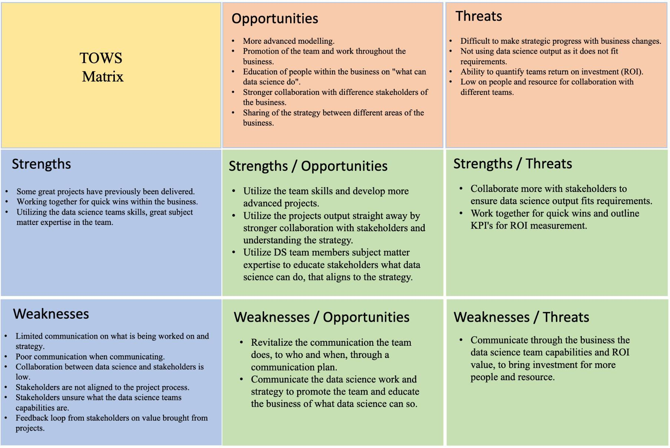

Figure 4: Communication and Collaboration Plan.
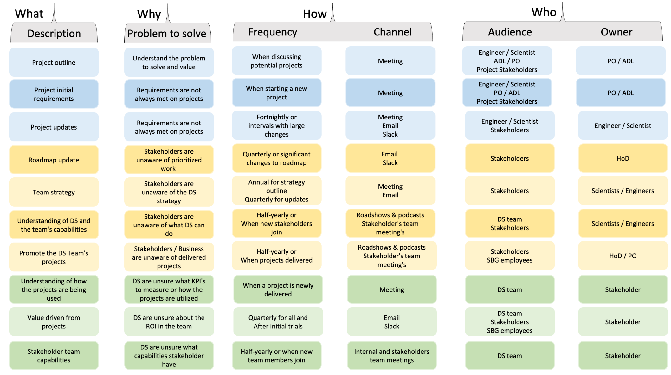

Conclusion and Research Implications
In conclusion, this research has explored the critical roles required within the DS team at SBG to effectively collaborate with stakeholders and maximise the business value of delivered projects. The research questions were aimed at understanding the PPBF, TSG, and SBG DS team members' thoughts about the internal roles, their responsibilities, and the best ways of working with stakeholders. Additionally, the study aimed to understand the stakeholders' perceptions of the DS team and the strengths, weaknesses, opportunities, and threats of working together.

The findings have answered the research questions and provided valuable insights into the critical roles and responsibilities within the DS team. It has been identified the need for clear role definitions, stakeholder buy-in, and senior support for successful project outcomes. A strategy for working more effectively with stakeholders has been developed and a communication and collaboration plan has been implemented. By executing the strategy and communication plan, SBG can deliver more value from DS projects.

This research makes a substantial contribution to the discipline of data science team dynamics and collaboration, particularly within SBG. Through a very detailed examination of roles and responsibilities within the DS team, the research provides a complete guide for other organisations aiming to optimise data science through the collaboration and communication with stakeholders to maximise the value of delivered projects. The incorporation of stakeholder’s perception and a SWOT analysis provides a comprehensive perspective, improving the understanding of both internal and external influences on project outcomes. Importantly, the research goes beyond theoretical frameworks by developing a detailed communication and collaboration strategy, highlighting the requirement for senior sponsor support and stakeholder buy-in. The practical recommendations ensures that the research findings can be applied, providing a roadmap for DS teams to effectively address challenges and raise the success of the delivered projects. Overall, this research does not only contribute to the valuable insights into the DS team structure and roles, but also provides a strategic guide for decision makers, facilitating the development of well-informed strategies. The research contributes to the success of DS initiatives, not only at SBG but in other organisations and industries

References:
Aho, T. Kilamo, T. Lwakatare, L. Mikkonen, T. Sievi-Korte, O. Yaman, S. (2021) – Managing and Composing Teams in Data Science: An Empirical Study. Department of Computing Sciences. Tampere University. Tampere. Finland.

Akhtar, I. (2016) – Research Design. Research in Social Sciences: Interdisciplinary Perspectives. Faculty of Social Sciences. Jamia Millia Islamia University. New Delhi. India.

Bell, E. Harley, B. Bryman, A. (2022) – Business Research Methods. Sixth Edition. Published By: Oxford University Press.
Bern, J. (2020) – Introduction to Data Science. Facility of Computer Science. University of Advent Indonesia. Bandung. Indonesia.

Berndtsson, M. (2020) – 13 Organisations’ Attempts to Become Data-Driven. Department of Computer Science. University of Skovde. Skovde. Sweden.
Bohr, A. Memarzadeh, K. (2020) – The rise of artificial intelligence in healthcare applications. The Department of healthcare. University of Colorado. Boulder. Colorado. United States.

Bokman, A. Fiedler, L. Perrey, J. Pickersgill, A. (2014) – Five Facts: How Customer Analytics Boosts Corporate Performance. Growth. Marketing and Sales. McKinsey & Company. Available at: https://www.mckinsey.com/capabilities/growth-marketing-and- sales/our-insights/five-facts-how-customer-analytics-boosts-corporate-performance (Accessed: 31/10/2022)

Bukhari, D. (2020) – Data Science Curriculum: Current Scenario. Taibah University. Almadinah Almunawarah. Saudi Arabia.

Brodie, M. (2019) – What is Data Science? School of Engineering and Applied Sciences. Harvard University. Cambridge. Massachusetts. United States.

Chowdhury, M. (2014) – Interpretivism in Aiding Our Understanding of the Contemporary Social World. School of Business. North South university, Dhaka. Bangladesh.

Cooper, D. Schindler, P. (2006) – Business Research Methods. 8th Edition. McGraw Hill Publishing. New York. United States.
Das, M. Cui, R. Campbell, D. Agrawal, G. Ramnath, R. (2015) – Towards methods for systematic research on big data. Department of Computer Science and Engineering. The Ohio State University. Columbus. Ohio. United States.

Dean, J. Ghemawat, S. (2004) – MapReduce: Simplified Data Processing on Large Clusters. Google. Mountain View. California. United States.

Dillman, D. Smyth, J. Christian, L. (2014) – Internet, Mail and Mixed-Mode Surveys: The Tailored Design Method. 4th Edition. Wiley Publishing. New York. United States.

Dwived, Y. (2023) – Evolution of Artificial Intelligence Research in Technological Forecasting and Social Change: Research Topics, Trends and Future Directions. Department of Computing. Swansea University. Swansea. United Kingdom.

Etikan, I. (2016) – Comparison of Convenience Sampling and Purposive Sampling. Department of Biostatistics. Near East University. Nicosia. Cyprus.
Gilbert, N. (2008) – Researching Social Life. Third Edition. SAGE Publications Ltd.

Gontkovicova, B. (2015) – The Necessity of Employee Education. Faculty of Business Economics. University of Economics. Bratislava. Slovakia.

Guest, G. Bunce, A. (2006) – How Many Interviews Are Enough? An Experiment with Data Saturation and Variability. FHI 360. Global Health Research. Economic Development and Livelihoods. Durham. United States.

Hasnat, R, Philbin, S. (2021) – Understanding the Communication and Collaboration Challenges Encountered by Technology Managers. Nathu Puri Institute for Engineering and Enterprise, London South Bank University, United Kingdom.

Hawsah, M. (2020) – The Impact of Project Sponsors’ Decisions on the Success of Projects: An Action Research Study. Facility of Humanities and Social Sciences. University of Liverpool. Liverpool. United Kingdom.

Hosni, H. Vulpiani, A. (2018) – Data science and the art of modelling. Department of Philosophy. University of Milan. Milan. Italy.
Ismail, N. (2016) – Data Scientist Skills. Advanced Informatics School. University of Technology Malaysia. Kuala Lumpur.

Jarvinen, J. (2016) – The Use of Digital Analytics for Measuring and Optimising Digital Marketing Performance. School of Business and Economics. Jyvaskyla University. Jyvaskyla. Finland.

Jim, C. Schultz-jones, B. Ledbetter, C. (2017) – The Challenges of Implementing A Data Driven Framework in K-12 Education. Department of Information Science. University of North Texas. Denton. Texas. United States.

Jimenez, L. Solis, A. (2017) – Different roles in data science field. Department of Computer Science. University of Technology Costa Rica. San Carlos. Alajuela. Costa Rica.
Knopp, B. Beaghley, S. Frank, E. Orrie, R. Watson, M. (2016) – Defining the Roles, Responsibilities, and Functions for Data Science Within the Defensive Industry. Department of Political Science. Georgetown University. Washington. United States.

Kuhn, A. Joppen, R. Reinhart, F. (2018) – Analytics Canvas: A Framework for the Design and Specification of Data Analytics Projects. Institute of Electrical Engineering and Information Technology. University of Paderborn. Paderborn. Germany.

Li, Y. Guohui, S. Eppler, M. (2021) – Making Strategy Work: A Literature Review on the Factors Influencing Strategy Implementation. Business School. Central University of Finance and Economics. Beijing. China.

Martinez, I. Viles, E. Olaizola, I. (2021) – Data Science Methodologies: Current Challenges and Future Approaches. School of Engineering. University of Navarra. Donostia-San Sebastian. Spain.

Medeiros, M. Hoppen, N. Macada, A. (2020) – Data Science for business: benefits, challenges, and opportunities. Department of Administration Sciences. Federal University of Rio Grande do Sul. Porto Alegre. Brazil.

Merelo, J. (2021) – Agile Data Science: A Manifesto. Department of Architecture and Computer Technology. University of Granada. Granada. Spain.
Patil, D. (2011) – Building Data Science Teams. The Skills, Tools and Perspectives Behind Great Data Science Groups. Strata. Making Data Work. Published By O’Reilly Media. Printed in United States.

Perifanis, N. Kitsios, F. (2023) – Investigating the Influence of Artificial Intelligence on Business Value in the Digital Era of Strategy: A Literature Review. Department of Applied Informatics. University of Macedonia. Thessaloniki. Greece.

Provost, F. Fawcatt, T. (2013) – Data Science and its Relationship to Big Data and Data- Driven Decision Making. School of Business. New York University. New York. United States.

Prescott, M. (2016) – Big Data: Innovation and Competitive Advantage in an Information Media Analytics Company. Department of Innovation and Management. Grenoble Ecole de Management Business School. Grenoble. France.

Ramachandran, K. (2024) – Data Science in the 21st Century: Evolution, Challenges and Future Directions. College of Science Coimbatore, Tamilnadu, India.

Ransbotham, S. Kiron, D. Prentise, P. (2015) – Minding the analytics gap. Department of Business Analytics. Carroll School of Management. Boston College. Massachusetts. United States.

Riggs, R. Roldan, J. Real, J. (2024) – Deepening big data sustainable value creation: insights using IMPA, NCA and cIPMA. Department of Industrial Organisation and Business Management. University of Seville. Seville. Spain.

Salminen, J. Milenkovic, M. (2017) – Problems of Data Science in Organisations: An Explorative Qualitative Analysis of Business Professionals’ Concerns. Department of Marketing. University of Vaasa. Vaasa. Finland.

Saltz, J. Holtz, N. (2018) – Shortcomings of Ad Hoc: Data Science Project Management. School of Information Studies. Syracuse University. Syracuse. New York. United States.

Saltz, J. Hotz, N. Wild, D. Stirling, K. (2018) – Exploring project management methodologies used within data science teams. School of Information Studies. Syracuse University. Syracuse. New York. United States.

Saltz, J. Hotz, N. (2021) – Factors that Influence the Selection of Data Science Process Management Methodology: An Exploratory Study. School of Information Studies. Syracuse University. Syracuse. New York. United States.

Sarker, I. (2021) – Data Science and Analytics: An Overview from Data-Driven Smart Computing, Decision-Making and Applications Perspective. Department of Computer Science and Engineering. University of Engineering and Technology. Chittagong. Bangladesh.

Saunders, M. Lewis, P. Thornhill, A. (2020) – Research Methods of Business Students, 8th Edition. Pearson Education Limited. Pearson Publishing. Essex. United Kingdom.

SBG. (2023) – www.flutteruki.com: Better is just the beginning. Sky Betting and Gaming. About Us. Available at: https://careers.flutteruki.com/our-brands/sky-betting-gaming/ (Accessed: 5/4/2023)

Urbinati, A. Landoni, P. Cococcioni, F. Giudici, L. (2020) – Stakeholder management in open innovation projects: a multiple case study analysis. School of Industrial Engineering. University Carlo Cattaneo. Castellanza. Italy.

Wahyuni, H. (2024) – Big Data Analysis In Human Resources Decision Making: Optimizing Workforce Management. Department of Management. Muhammadiyah, University of Yogyakarta, Yogyakarta, Indonesia.

Wamba, S. (2017) – Big data analytics firm performance: Effects of dynamic capabilities. Toulouse Business School. Toulouse. France

Wang, Y. Mao, Y. Muller, M. Varshney, K. (2019) – How Data Scientists Work Together With Domain Experts in Scientific Collaborations: To Find The Right Answer Or To Ask The Right Question. IBM – Artificial Intelligence. IBM Consulting. Armonk. United States.

Waseem, D. Biggemann, S. Garry, T. (2020) – An exploration of the drivers of employee motivation to facilitate value co-creation. Department of Marketing, University of Bradford. UK

Zahoor, S. (2021) – The Necessity for Data Science and the Roles of Data Science Teams: An Analyse of Various Cases. Department of Computing and Communication Engineering. OPJS University. Churu. Rajastham. India

Zhang, A. Muller, M. Wang, D. (2020) - How do Data Science Workers Collaborate? Roles, Workflows, and Tools. University of Washington & Massachusetts Institute of Technology, Seattle, USA.

Appendices:
Appendix A – Stakeholders SWOT Analysis and Grouping of Themes

Appendix A contains the board from SWOT analysis and grouping of themes from stakeholders interviews.

Appendix B – SBG Data Science Team – Whiteboarding Session
Appendix B contains a whiteboard from the responsibilities of the roles defined from the roles questionnaire.

Appendix C – SBG Data Science Team Whiteboard Session - Themes

Appendix C contains an example of the coded themes from the responsibilities whiteboarding session with SBG DS team members.

Appendix A – Stakeholders SWOT Analysis and Grouping of Themes
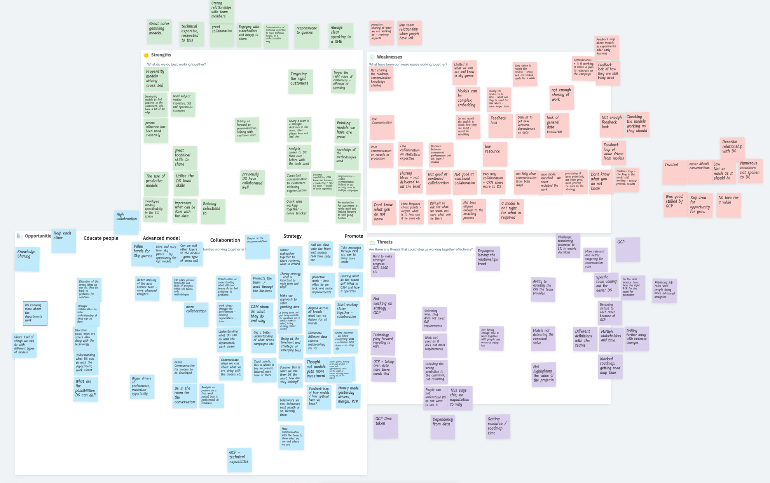

Appendix B – SBG Data Science Team – Whiteboarding Session
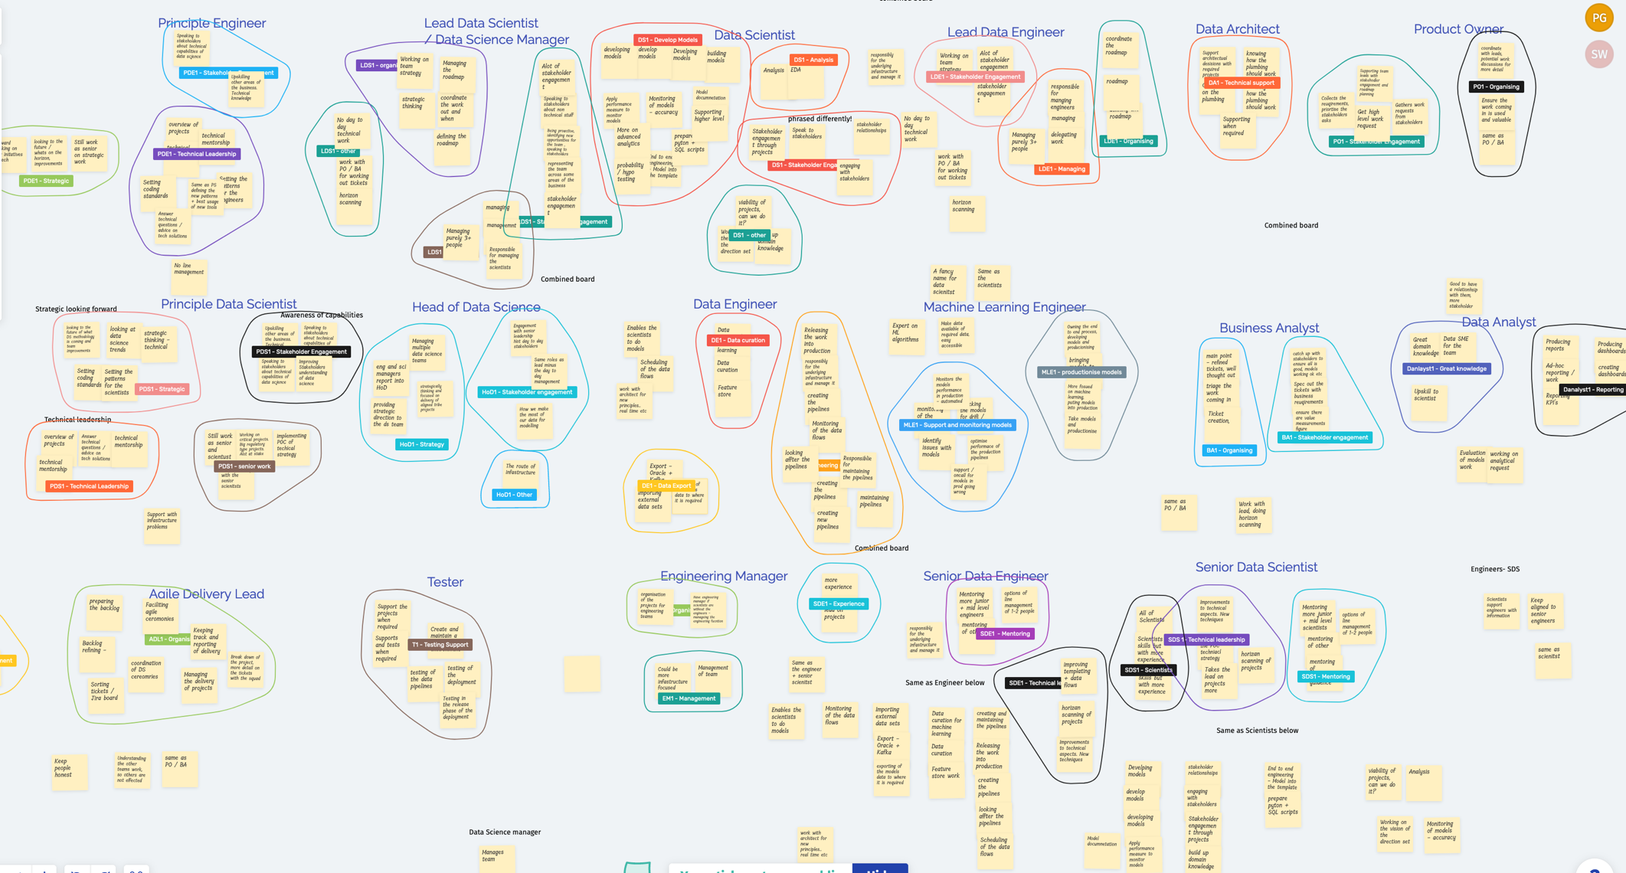

Appendix C – SBG Data Science Team Whiteboard Session - Grouped Themes
