The Impact of ICT on Veddhas- The Sri Lankan Indigenous Community

Dr. Hemamali Tennakoon
Senior Lecturer in Strategy and Management
Global Management Division
Brunel University London
Brunel Business School
Kingston Lane, Uxbridge, UB8 3PH, United Kingdom
Tel. +44(0)1895 266455
hemamali.tennakoon@brunel.ac.uk

Abstract
Studies on the impact of digital divide on indigenous people are scarce. This is applicable to indigenous people of Sri Lanka or Vaddhas who are a marginalised group of individuals living in Sri Lanka, with limited access to Information and Communication Technologies (ICT). In this research, we focus on Sustainable Development Goals (SDGs) #8, and #10 and aim to investigate if ICT can create job opportunities, facilitate economic growth and reduce inequalities among the Veddha communities through indigenous tourism. Also, under investigation would be the effects of generational gap on use and adoption of ICT among the members of the Veddha community. Further, possibility of using ICT to preserve Veddhas cultural heritage, particularly knowledge pertaining to environmental protection and sustainability will also be explored. A constructivist, phenomenological, qualitative research design will be used involving focused ethnographic case study method. The findings will benefit a range of stakeholders including the Vaddha community, policy makers, and academia.
Key words: Sri Lanka, Indigenous communities, Vaddha, Sustainable Development Goals (SDGs), Indigenous Tourism.
Introduction
Indigenous communities around the world are often identified as marginalised groups. Those living in remote areas are particularly seen as digitally disconnected with little or no access to information and communication technologies (ICT) and the digital universe. Perez-Escolar and Canet (2023: 1064) identifies indigenous people or native communities as vulnerable communities who are one of the most likely groups to be excluded or marginalized from the digital realm. A UN report also identifies indigenous communities as affected by the digital divide and state that indigenous peoples “face unique challenges in digital inclusion, including the lack of digital content in their native languages.” (Deganis et al., 2021:3).
The United Nations permanent forum on indigenous issues who assembled in Geneva in December 2003 for the Global Forum of Indigenous Peoples and the Information Society declared that “Information and Communication Technology (ICT) should be used to support and encourage cultural diversity and to preserve and promote indigenous languages, distinct identities and traditional knowledge of Indigenous peoples, nations and tribes” (United Nations Permanent Forum on Indigenous Issues, 2023: 2). Further, in their 2030 agenda, international agencies such as the United Nations recognise the importance of global interconnectedness and spread of ICT to accelerate human progress, in Sustainable Development Goals (SDGs). In the context of ICT and Sri Lankan indigenous communities, SDG #8, and SDG#10 are particularly salient (Sustainable Development Goals, 2023). Burga and Pavel (2020) argue that ICT can enhance the overall quality of life for people living in isolated communities and have presented compelling evidence in the context of remote Northern Ontario Indigenous communities (with reference to SDG#4 and 11). Therefore, it is important to explore whether use of ICT in a Sri Lankan could facilitate and accelerate human progress amongst the Veddhas communities by improving their quality of life through economic, social and cultural development.
While digital inclusion is identified by many as an enabler for social and economic development, especially for minority and isolated, marginalised communities such as indigenous people, there is also augment that digital technologies can be addictive and therefore, harmful to individuals. For example, UNESCO Institute for Information Technologies in Education (2011:3) points out that “ICTs may be viewed as a two-edged sword that has the potential to accelerate the erosion of indigenous culture and knowledge”. Thus, it is important to explore how ICT can be used to improve the wellbeing of Veddhas while using it preserve the cultural identity of these indigenous communities. In light of this, the current research investigates the digital divide among the Veddhas communities in Sri Lanka and the potential impact of introducing technology to these communities.
Context, Aims and Objectives
The First People of Sri Lanka, also known as Veddhas, are a small community of around 2,000 individual who are in danger of extinction (Stegeborn, 2004; Tomei, 2005). Accounting for less than 1 percent of the national population, their settlements are scattered from central Sri Lanka to the east coast of the island (Punchihewa, 2011; Rathnayake, 2022; Harrigan, 2023). A recent study shows that 43% of the Veddha population is employed and that 82% of those who work are employed within their own village (Sumanapala and Wolf, 2023: 3). While there is evidence to suggest that they are a marginalised minority, neglected by officials and governments (see Rathnayake, 2022), Sumanapala and Wolf (2023) found that one of the Veddhas villages- Dambana received governmental assistance to develop tourism related activities. Some argue that Veddhas marginalization is also voluntary, as remaining an isolated community is central to tourism related economic activities (see Ranasinghe, 2020; Ananda & Nahallage, 2022). While the indigenous people from Dambana are heavily involved in Indigenous tourism related activities (Fig.01), there are five other Veddhas settlements located around Sri Lankan in Pollebedda, Rathugala, Henanigala, Dalukana and Wakare. Information pertaining to the socio-economic status of these communities are scarce.
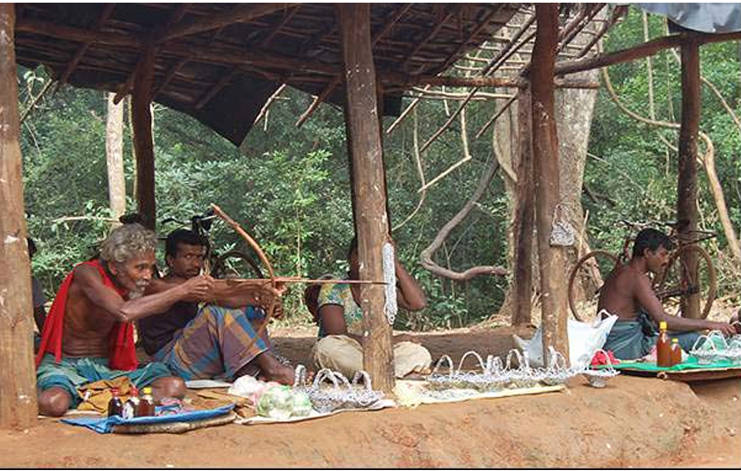
Figure 1: Veddha salesmen in the Dambana village (Source: Mozelius, 2014: 54)

There are several socio-anthropological studies being conducted about indigenous people of Sri Lanka (Thangaraja, 1995; Obeyesekere, 2002; De Silva & Punchihewa, 2011), but there is lack of interdisciplinary, in-depth research conducted to date on the adaptation and impact of ICT on these indigenous communities. In a global context, there are several studies conducted on indigenous people’s interactions with technologies involving such communities in Australia (Du, 2017; Du and Haines, 2017; Ormond-Parker et al., 2013; Rice et al., 2016), Indonesia (Toyoda and Kanegae, 2021), Bangladesh (Ashraf et al., 2015; Hasan et al., 2022), and Malaysia (Walid et al., 2015). Some evidence from a recent study of the media usage of Veddha community in Dambana shows that “cellular phones are popular especially among the young population” and that “tablet PCs are given among considerable number of school children for their educational purposes during the Covid 19 pandemic period and they are continuing to use those devices.” (Senarath, 2023: 21). However, there is no further information provided on ICT usage of other members of the community and whether they use ICT for income generation purposes such as tourism. Therefore, it is fair to argue that a knowledge gap remains regarding indigenous people’s interactions with technologies from a Sri Lankan context. From a technological and business management/economic perspective, addressing this gap matters due to number of reasons.
Firstly, if indigenous cultural tourism could act as an income generating, job creating, economic activity, then this should be further explored in line with SDG #8. Therefore, this research aims to investigate how ICT can facilitate growth in indigenous cultural tourism. If successful, this could lead to increased income generation, which in turn could reduce income inequality (SDG#10) within Sri Lanka between minority indigenous communities and the majority. Evidence from other counties support this notion and suggest that ICT can support development objectives related to poverty reduction, healthcare, education and overall quality of life (Hak et al., 2018; Hefler et al., 2019; Hasan et al., 2022).
Secondly, addressing the above-mentioned gap is also important from a sustainability perspective (SDG#13). For instance, indigenous communities are known for having a strong ecological attachment with nature (Kurth et al., 2020) and viewed through a social–ecological systems lens, this human-nature connection is found to be crucial for sustainability of the biocultural diversity (Briggs et al., 2019). In such a context, Garai et al. (2022: 2) argue that indigenous communities are not “passive victim of climate change extremity but their accumulated and experienced knowledge make them excellent observers of environmental change and its impacts.”. Therefore, it is important to preserve these experiences and knowledge and integrate them into modern environmental sustainability practices. However, Perera (2023:1197) argue that Sri Lanka’s traditional cultural heritage, including indigenous knowledge is currently practiced as a ‘living heritage’ and ‘transmitted orally from one person to another person or to a group of persons’. Thus, we aim to explore how ICT and modern technologies could help facilitate digital preservation this cultural heritage.
Finally, the current research proposes to study the generation gap among the indigenous communities in Sri Lanka mainly because researchers have found that different generations within Sri Lankan indigenous communities perceive technology differently. For example, “the older generation identify the value of keeping their traditions and culture intact. The older generation also believe that their relaxed and pristine free lifestyle has negatively impacted”, while the “new generation believe that they are also entitled to benefit from the new technology and modernisation” (De Silva and Punchihewa, 2011: 257). A recent study of the impact of “Dambana Radio” (the only indigenous community radio in Sri Lanka) provides supporting evidence. Researchers found that the younger generation of the Veddha community is not interested in listening to the radio channel because they have other distraction such as mobile phones and have adapted to novel modes of communication (Dissanayaka and He, 2023). These differences mean that it could affect the closing of the digital divide, even when these indigenous communities are exposed to ICT.
In such a context, there are several questions as listed below that we aim to investigate in this research.
Key Research Questions (Aims) and Objectives
- With reference SDG#8 and #10, can ICT help create job opportunities, facilitate economic growth and reduce inequalities among the Veddha communities through indigenous tourism?
- Can ICT help facilitate digital preservation of Veddhas cultural heritage, particularly knowledge pertaining to environmental protection and sustainability.
- How does the generation gap affect the use and adoption of ICT among the Veddha communities?

We propose to address the above research questions as follows:
- To evaluate if ICT could benefit Sri Lankan Indigenous communities in terms of economic, social, or cultural development.
- To explore how ICT can help preserve indigenous knowledge related to human-nature connection and sustainability;
- To assess if there are attitudinal difference among the different age groups within Indigenous communities towards the use of ICT.

Theoretical Background

As mentioned earlier, some of the previous studies on technology adoption by indigenous communities in Sri Lanka has a socio-anthropological connotation. The current study uses a broader theoretical backdrop. We use a sociotechnical and social-cultural anthropological lens to explore the indigenous culture of Veddha people and technology adoption for economic, social, or cultural development. This notion is supported by Pfaffenberger (1992: 492) who raised a number of important questions regarding the anthropology of technology and material culture. For example, he questions whether there is a “relationship between technological development and cultural evolution?”, “what kind of cultural meaning is embodied in technological artifacts?”, “how does culture influence technological innovation -and how does technological innovation influence culture?.” He greatly favoured the use of sociotechnical system concept to explore these questions. A domain of sociotechnical theory known as community informatics (CI) can also be used to investigate how the well-being of people and their communities can be improved through more effective use of ICTs (Stillman and Denison, 2014: 201). This include exploring community ICT-based initiatives (e.g. e-commerce, community technology centres) and innovative ways in which members of the community can use ICT to benefit from economic, social and cultural activities (Simpson, 2005). Further, Ahlborg et al. (2019: 1) argue that a socio-technical-ecological systems approach is needed to understand “technological mediation of human–environment relationships.” and that it could be used to investigate how technology can be used in sustainability initiatives. These theoretical perspectives align well with the research questions we aim to explore.

Methods
Given the anthropological nature of this study, a constructivist, qualitative, phenomenological research design is deemed more appropriate. Pilarska (2021: 64) argue that this is a “humanistic and respectful approach to the researched and their cultural as well as social and psychological realities, followed by their dialogical, interpretive nature and interactive dynamics.”. Further, Wilson et al. (2022: 381) posit that an ‘indigenous research methodology’ should be used when studying indigenous communities because such research has distinctive dimensions (e.g. the need to focus on “issues of local concern rather than being reliant on Euro-Western theory to define the research”). Therefore, a phenomenological approach would allow the researcher to “understanding and describing the phenomenon based on the human experience” and avoid “invalidating indigenous voices and worldviews.”, as often happens in “classical western research approaches” (Ngulube and Ngulube, 2017: 127). Within this context, a blended design involving focused ethnography and case study method i.e. mini-ethnographic case study is considered best suited for the research (Fusch et al., 2017). Such an exploratory study involving cross-sectional data would help the researcher to study the Veddha community in their cultural setting.
Sample selection and data collection
The Vaddha population is scattered around Sri Lanka in a number of settlements, but over the years their numbers have dwindled and their current settlements are confined to a few isolated pockets (Fig. 2 and 3).
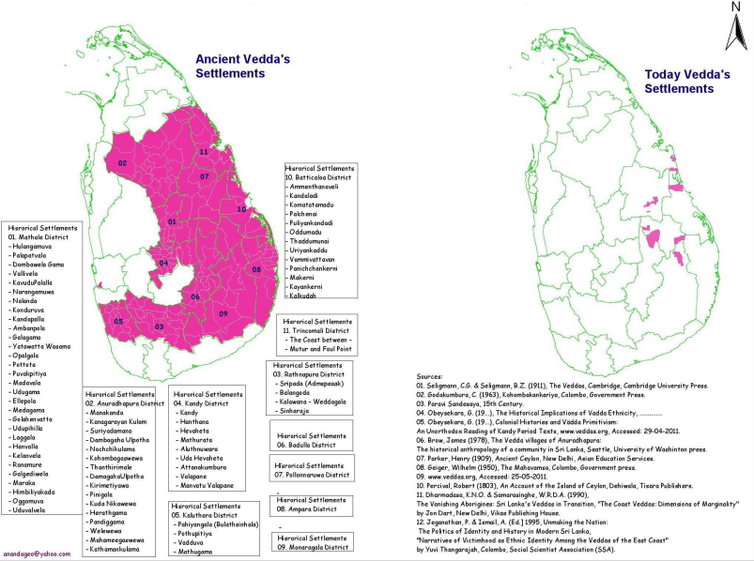
Figure 2: Changes to Veddha settlements over the years (Source: De Silva and Punchihewa, 2011:11)

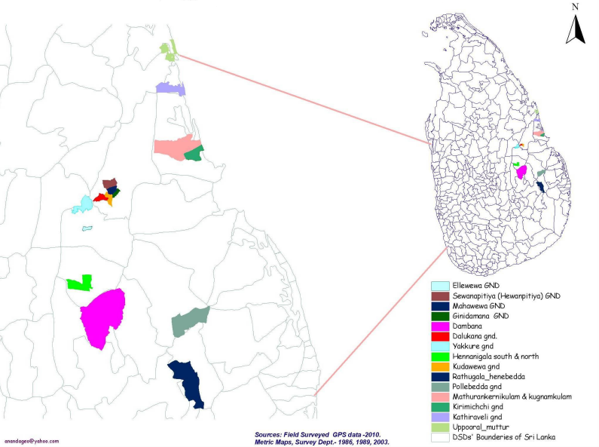
Figure 3: Veddha settlements in 2011 (Source: De Silva and Punchihewa, 2011:12)
According to Fig.3, Dambana is the largest Veddha settlement. As mentioned previously, Dambana has also received government assistance to develop tourism related activities (Sumanapala and Wolf, 2023) and the indigenous community living in this settlement are already involved in tourism related activities (Fig.1). Further, this village is located in close proximity to several top tourist destinations in Sri Lanka (Fig.4).
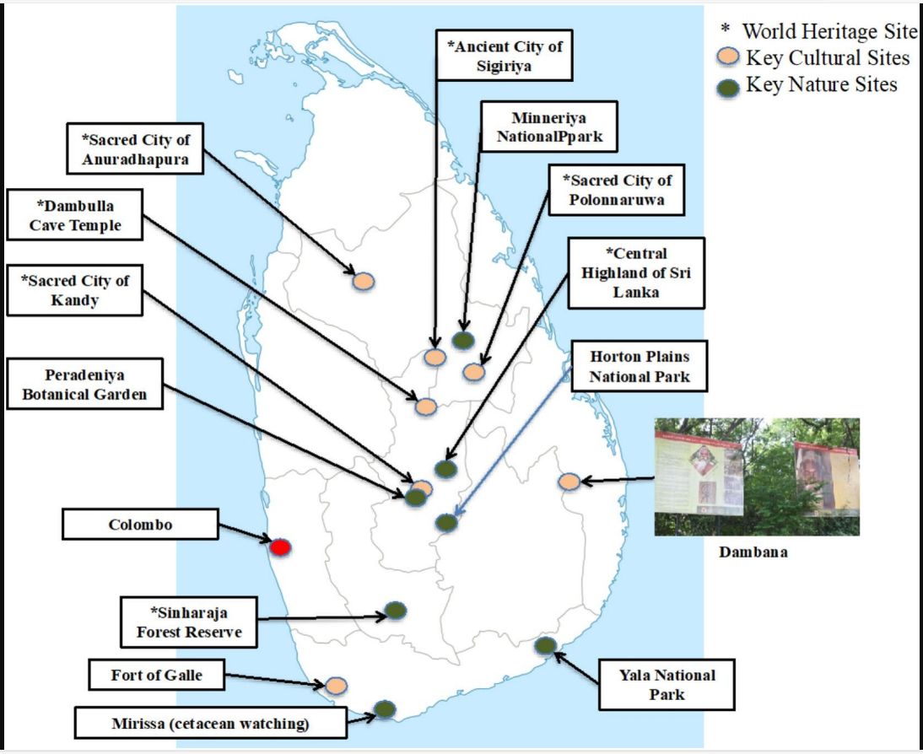
Figure 4: Top tourist destinations located near the Indigenous Dambana Veddha village (Source: Sumanapala and Wolf, 2023:3)
Therefore, as the only indigenous settlement involved in tourism and open to external visitors, Dambana village will be selected as the geographic scope. In a focused ethnographic case study research
We intend to use several data collection methods. Firstly, in-depth, semi-structured interviews will be conducted involving a sample of indigenous people selected from the Dambana community (Ghorbani et al., 2021; Kariippanon and Senior, 2017). Then, fieldwork where direct observations of the population of interest can be made (Ezeh, 2003; Marshall and Rossman, 2014). With permission from the indigenous community, examples of this type of data would include photographs and video recordings of tourism related activities or any other instances where ICT use is visible in the community. Appropriate video and audio recording equipment will be used for this purpose. To supplement this, the researcher can maintain a reflective journal which can help “create transparency in the research process” (Ortlipp, 2008: 695) and help “establish quality and validity of the interpretative phenomenological analysis” (Vicary et al., 2017: 550). These data collection methods will help with triangulation and enhancing the validity of the study results (Fusch et al., 2017).
We aim to include individuals already involved in tourism related activities in our sample as well as other who are not. Also, for the study of generational gap, we aim to recruit participants from between age 18-60+. Although we would prefer to ensure gender balance and equal participation of male versus female participants, this cannot be guaranteed due to cultural norms in interviewing female members of the community (Sumanapala and Wolf, 2023). The sample size would depend on the number of individuals willing to take part in the study. Data collection will stop upon reaching saturation of emergent themes. At a minimum, we aim to interview 20-25 individuals.
In addition to the primary data collected via the above methods, secondary qualitative data will also be collect from literature, Government surveys, policy documents etc..
Quantitative
We will use official documents to obtain data and statistics on ICT infrastructure development in the country, Internet penetration rate, ICT literature figures etc.
Data analysis
Qualitative data, particularly the interview data will be analysed using thematic analysis. Any secondary, quantitative data we may obtain from official documents and other publications will be analysed using appropriate analytical software to identify any trends or patterns.
Ethical considerations
Ethnographic, observational nature of this research means that the researcher needs to pay special attention to ethical aspects such as preserving the privacy of participants and show respect towards the indigenous culture. Prior to data collection, ethical approval will be obtained for the study from Brunel University’s ethics committee. Then, before commencing field work, the researcher will seek consent from the community leader of the Indigenous Veddha people. This is a practice supported by Kariippanon and Senior (2017: 5) who state:
“It is important that Indigenous leaders and senior elders in the community are consulted first and permission, given to conduct interviews, before turning to participant sampling.” In this research, we intend to do the same.”
Before semi-structured interviews, informed consent will be obtained from the participants. In recording direct observations using video or photography, prior consent will be sought from those involved.

Expected Contributions
There is lack of research on ICT usage of Indigenous communities of Sri Lanka, particularly for economic/revenue generation activities and for the preservation of their cultural heritage. Thus, the proposed research would act as a pioneering research project in this area. This exploratory study will pave the way for other researchers to design and conduct studies related to technology adoptation, indigenous tourism, sustainable practices of indigenous people and use of ICT for digitisation of such cultural knowledge etc. The scientific community will benefit from the proposed research through an improved understanding of the social, cultural, and economic implication of connecting with digital technologies for marginalised groups such as the Veddha community in Sri Lanka. Particularly, the findings of this research could provide insights about how other marginalised, isolated communities and minorities (e.g. ethnic minorities, gender based marginalised groups, neurodivergent groups etc.) could benefit from ICT with regards to economic, social and cultural development.
Further, the research findings will be presented at scientific conferences and workshops. This provides an opportunity for communication and interaction with academic and non-academic beneficiaries.
This project has been designed to have an impact beyond its immediate academic environment. Its influence, while intended to be significant within academia, is planned to extend to the local communities. For instance, these findings could provide directions for the Government of Sri Lanka to plan and implement economic and social/cultural development programmes for the Veddha communities scattered around Sri Lanka and move forward to achieve SDG #8, and SDG#10.
Further, upon reaching our research objectives, the proposed study could provide recommendations to indigenous communities on how to use ICT for tourism related income generation activities. Recommendations could also be provided on how to preserve and digitise indigenous knowledge related to sustainability and environmental protection.
Engagement with non-academic communities though non-academic channels such as press releases, documentary videos etc, will further maximizing impact.
It also intends that these research findings will inform public policy-makers, and hence contribute to processes intended to improve social inclusion of Indigenous communities.

References
Ahlborg, H., Ruiz-Mercado, I., Molander, S. and Masera, O., 2019. Bringing technology into social-ecological systems research—motivations for a socio-technical-ecological systems approach. Sustainability, 11(7), p.2009.
Ananda, T. and Nahallage, C., 2022. Present sociocultural status of the Sri Lankan indigenous people (the Veddhas) and future challenges. In Indigenous People and Nature (pp. 381-398). Elsevier. https://doi.org/10.1016/B978-0-323-91603-5.00024-5
Ashraf, M.M., Grunfeld, H. and Quazi, A., 2015. Impact of ICT usage on indigenous peoples’ quality of life: Evidence from an Asian developing country. Australasian Journal of Information Systems, 19.
Briggs, L., Stedman, R. and Krasny, M., 2019. Place attachment and social–ecological system sustainability examined through the voices of indigenous Guatemalan women. Sustainability Science, 14, pp.655-667.
Burga, R. and Pavel, C., 2020. Opportunities for Information and Communication Technology Development in remote Northern Ontario indigenous communities in spite of COVID-19 physical restrictions: Infrastructure and ICT Development in remote Northern Ontario regions. Journal of Indigenous Social Development, 9(3), pp.76-91.
De Silva, P. and Punchihewa, A., 2011. Socio-anthropological research project on Veddha community in Sri Lanka. Department of Sociology, University of Colombo: Colombo, Sri Lanka. Available online https://www.researchgate.net/profile/Asitha-Punchihewa/publication/235335142_Socio-_Anthropological_Research_Projecton_Veddha_Community_in_Sri_Lanka/links/09e41510fbdb7b07c4000000/Socio-Anthropological-Research-Project-on-Veddha-Community-in-Sri-Lanka.pdf Accessed on 23 January 2024.
De Silva, P. and Punchihewa, A., 2011. Socio-anthropological research project on Veddha community in Sri Lanka. Department of Sociology, University of Colombo: Colombo, Sri Lanka. Available online https://www.researchgate.net/profile/Asitha-Punchihewa/publication/235335142_Socio-_Anthropological_Research_Projecton_Veddha_Community_in_Sri_Lanka/links/09e41510fbdb7b07c4000000/Socio-Anthropological-Research-Project-on-Veddha-Community-in-Sri-Lanka.pdf
Deganis, I., Haghian, P.Z., Tagashira, M. and Alberti, A., 2021. Leveraging digital technologies for social inclusion. United Nations Department of Economic and Social Affairs.
Dissanayaka, D.N.N. and He, M., 2023. Exploring Impact of “Dambana Radio” as an Indigenous Community Radio in Sri Lanka. Advances in Journalism and Communication, 11(3), pp.247-262.
Du, J.T. and Haines, J., 2017. Indigenous Australians' information behaviour and Internet use in everyday life: an exploratory study. Information Research: An International Electronic Journal, 22(1), p.1.
Du, J.T., 2017. Research on Indigenous people and the role of information and communications technology in development: A review of the literature. Journal of the Australian library and information association, 66(4), 344-363.
Ezeh, P.J., 2003. Participant observation. Qualitative research, 3(2), pp.191-205.
Fusch, P.I., Fusch, G.E. and Ness, L.R., 2017. How to conduct a mini-ethnographic case study: A guide for novice researchers. The Qualitative Report, 22(3), pp.923-941.
Garai, J., Ku, H.B. and Zhan, Y., 2022. Climate change and cultural responses of indigenous people: a case from Bangladesh. Current Research in Environmental Sustainability, 4, p.100130.
Ghorbani, M., Eskandari-Damaneh, H., Cotton, M., Ghoochani, O.M. and Borji, M., 2021. Harnessing indigenous knowledge for climate change-resilient water management–lessons from an ethnographic case study in Iran. Climate and Development, 13(9), pp.766-779.
Hak, S., McAndrew, J. and Neef, A., 2018, March. Challenges of governance responses to land use change and poverty among indigenous people in northeast Cambodia. In Proceedings of the Annual World Bank Conference on Land and Poverty “Land Governance in an Interconnected World”, Washington, DC, USA (pp. 19-23)..
Harrigan, P., 2023. Sri Lanka’s Indigenous Wanniya-laeto: A Case History. Available online https://Veddha.org/adivasis/sri-lankas-indigenous-wanniya-laeto-a-case-history/
Hasan, N., Bao, Y. and Miah, S.J., 2022. Exploring the impact of ICT usage among indigenous people and their quality of life: operationalizing Sen’s capability approach. Information Technology for Development, 28(2), pp.230-250.
Hasan, N., Bao, Y. and Miah, S.J., 2022. Exploring the impact of ICT usage among indigenous people and their quality of life: operationalizing Sen’s capability approach. Information Technology for Development, 28(2), 230-250.
Hefler, M., Kerrigan, V., Henryks, J., Freeman, B. and Thomas, D.P., 2019. Social media and health information sharing among Australian Indigenous people. Health Promotion International, 34(4), pp.706-715.
Kariippanon, K.A. and Senior, K., 2017. Engagement and qualitative interviewing: an ethnographic study of the use of social media and mobile phones among remote indigenous youth. . SAGE Research Methods Cases, 1-15.
Kurth, A.M., Narvaez, D., Kohn, R. and Bae, A., 2020. Indigenous nature connection: A 3-week intervention increased ecological attachment. Ecopsychology, 12(2), pp.101-117.
Marshall, C. and Rossman, G.B., 2014. Designing qualitative research. Sage publications.
Mozelius, P., 2014. ICT4D hubs for region‐wide dissemination of blended learning. Education for All in Sri Lanka. Report Series/DSV No. 14-017. Stockholm University. Available Online https://www.diva-portal.org/smash/get/diva2:762169/FULLTEXT01.pdf Accessed 23 January 2024.
Ngulube, P. and Ngulube, B., 2017. Application and contribution of hermeneutic and eidetic phenomenology to indigenous knowledge research. In Handbook of research on theoretical perspectives on indigenous knowledge systems in developing countries (pp. 127-155). IGI Global.
Obeyesekere, G., 2002. Where have all the Väddas gone? Buddhism and aboriginality in Sri Lanka. In Neluka Silva (ed.), The Hybrid Island: Culture Crossing and the Invention of Identity in Sri Lanka, pp. 1-19. Colombo: Social Scientists’ Association.
Ortlipp, M., 2008. Keeping and using reflective journals in the qualitative research process. The qualitative report, 13(4), pp.695-705.
Ormond-Parker, L., Corn, A., Fforde, C., Obata, K. and O’Sullivan, S., 2013. Information technology and indigenous communities. AIATSIS Research Publications.
Perera, K., 2023. Heritage at risk: digital preservation of traditional cultural heritage (TCH) in Sri Lanka. The International Archives of the Photogrammetry, Remote Sensing and Spatial Information Sciences, 48, pp.1197-1207.
Perez-Escolar, M. and Canet, F., 2023. Research on vulnerable people and digital inclusion: toward a consolidated taxonomical framework. Universal access in the information society, 22(3), pp.1059-1072.
Pfaffenberger, B., 1992. Social anthropology of technology. Annual review of Anthropology, 21(1), pp.491-516.

Pilarska, J. 2021. 6 The Constructivist Paradigm and Phenomenological Qualitative Research Design. In: Pabel, A., Pryce, J. and Anderson, A. ed. Research Paradigm Considerations for Emerging Scholars. Bristol, Blue Ridge Summit: Channel View Publications, pp. 64-83. https://doi.org/10.21832/9781845418281-008

Ranasinghe, R., 2020. Marginalization of Indigenous Communities: Evidence from Veddha Indigenous Minority in Sri Lanka. Available online https://www.researchgate.net/publication/339138983_Marginalization_of_Indigenous_Communities_Evidence_from_Veddha_Indigenous_Minority_in_Sri_Lanka
Rathnayake, Z., 2022. Sri Lanka's last indigenous people. Available online https://www.bbc.com/travel/article/20220327-sri-lankas-last-indigenous-people
Rice, E.S., Haynes, E., Royce, P. and Thompson, S.C., 2016. Social media and digital technology use among Indigenous young people in Australia: a literature review. International journal for equity in health, 15(1), 1-16.
Senarath, S.M., 2023. The Media Impact on Sri Lanka's Indigenous People; Wannilaeto (“Veddha”) of Dambana. European Journal of Communication and Media Studies, 2(1), pp.18-22.
Simpson, L., 2005. Community Informatics and Sustainability: Why Social Capital Matters. The Journal of Community Informatics, 1(2), pp.103-120.

Stegeborn, W., 2004. The Disappearing Wanniyala-aetto ('Veddhahs') of Sri Lanka: a Case Study. Nomadic Peoples, 43-63.
Stillman, L. and Denison, T., 2014. The capability approach community informatics. The Information Society, 30(3), pp.200-211.

Sumanapala, D. and Wolf, I.D., 2023. A wellbeing perspective of Indigenous tourism in Sri Lanka. Annals of Tourism Research Empirical Insights, 4(2), p.100099. https://doi.org/10.1016/j.annale.2023.100099
Sustainable Development Goals, 2023 Online. Available from: https://sdgs.un.org/goals Accessed: 22 January 2024.
Thangaraja, Yuvi., 1995. Narratives of Victimhood as Ethnic Identity among the Veddhas of the East Coast” In (eds) Ismail. Q, Jeganathan. P.Unmaking the Nation: the Politics of Identity and History in Modern Sri Lanka. Colombo: Social Scientist’s Association.
Tomei, M. 2005. Indigenous and Tribal Peoples: An Ethnic Audit of Selected Poverty Reduction Strategy Papers (Geneva: ILO), 37–38
Toyoda, Y. and Kanegae, H., 2021, March. Analysis of the Impact of Technology on Culture in Indigenous Communities: Mentawai Islands, Indonesia. In 2nd Southeast Asian Academic Forum on Sustainable Development (SEA-AFSID 2018) (pp. 269-276). Atlantis Press.
United Nations Permanent Forum on Indigenous Issues. 2023. Online. Available from: https://www.un.org/esa/socdev/unpfii/documents/ips_genderand_icts_en.pdf . Accessed: 22 January 2024.
Vicary, S., Young, A. and Hicks, S., 2017. A reflective journal as learning process and contribution to quality and validity in interpretative phenomenological analysis. Qualitative social work, 16(4), pp.550-565.
Walid, N., Ibrahim, E.N.M., Ang, C.S. and Noor, N.M., 2015. Exploring socioeconomic and sociocultural implications of ICT use: An ethnographic study of indigenous people in Malaysia. In Cross-Cultural Design Methods, Practice and Impact: 7th International Conference, CCD 2015, Held as Part of HCI International 2015, Los Angeles, CA, USA, August 2-7, 2015, Proceedings, Part I 7 (pp. 403-413). Springer International Publishing.
Wilson, D., Mikahere-Hall, A. and Sherwood, J., 2022. Using indigenous kaupapa Māori research methodology with constructivist grounded theory: Generating a theoretical explanation of indigenous womens realities. International Journal of Social Research Methodology, 25(3), pp.375-390.

Promote sustained, inclusive and sustainable economic growth, full and productive employment and decent work for all
Reduce inequality within and among countries
Quality of education
Make cities and human settlements inclusive, safe, resilient and sustainable
Climate action
Vaddhas do not have a written or symbolic syllable system for their unique ‘Vedi’ language

