Does faster internationalization enhance firm performance? The moderating roles of organizational slack and FDI ratios in emerging countries
Abstract
Despite numerous efforts exploring the relationship between internationalization speed and performance, the conclusions remain inconsistent, especially for multinational enterprises from emerging markets (EMNEs). Using organizational slack and the ratios of foreign direct investments (FDIs) in developing countries as moderators, this study reexamines the impact of internationalization speed on firm performance. We collect data from 63 listed electronic firms in Taiwan to form panel data with 315 firm-years. The empirical results show that the speed of internationalization positively impacts firm performance. Organizational slack demonstrates a positive moderating effect on the relationship between internationalization speed and firm performance. However, the FDI ratio in developing countries negatively moderates the relationship between internationalization speed and firm performance. Our research framework and findings can contribute to existing internationalization speed literature and Asian business research.
Keywords: Internationalization speed, organizational slack, FDI ratio in developing countries
1. Introduction
By entering international markets to enhance their scale and performance, internationalization is one of the crucial strategies for growth. The speed, the level of internationalization during a specific period (Hilmersson & Johanson, 2016), and its impact on performance have become significant research issues in fields such as international business and strategic management. Although there are numerous efforts to explore the relationship between internationalization speed and multinational enterprise (MNE) performance, the theoretical arguments and empirical findings remain mixed. The resource-based view and learning perspective suggest that firms with controlled resources can exploit the attached competencies, skills, and knowledge in foreign locations by quickly entering multiple foreign markets to access foreign market potential. The faster an MNE enters overseas markets, the faster it can overcome the limitations of the domestic market and speed up the learning and accumulation of foreign market knowledge to mitigate internationalization risks (Bolívar et al., 2022; Contractor et al., 2007; Hadley & Wilson, 2003; Hilmersson & Johanson, 2016; Jiang et al., 2014). Some empirical works support this positive speed-performance argument (Chetty et al., 2014; Morck & Yeung, 1991; Musteen et al., 2010). Gripsrud et al. (2023) report that survival rates can be increased when new ventures go international faster and enter new countries more quickly. However, some studies argue that rapid internationalization may lead to time compression diseconomies, affecting decision-making and poor performance. Thus, a negative relationship between internationalization speed and performance has been reported (Vermeulen & Barkema, 2002; Wagner, 2004). Some research has even proposed a curvilinear relationship between internationalization speed and firm long-term performance, showing an inverted U-shaped pattern (García-García et al., 2017). Biçakcioğlu-Peynircin (2023) reports that only 6.3% of papers address the speed issue of the internationalization of EMNEs. The relationship between international speed and EMNEs' performance is overlooked. It remains a puzzle, which indicates a limited understanding of this connection and the need for further systematic examination of the linkage between internationalization speed and MNE performance.
After carefully examining the literature, this study identifies potential research gaps in previous works. First, most studies have employed a cross-sectional approach to assessing the relationship between internationalization speed and MNE performance that analyzes only the starting phase and focuses on the start activity in the first foreign markets (Hilmersson & Johanson, 2016). However, the internationalization speed of MNEs may not be constant; it could vary annually, leading to varying impacts each year. Second, as a dimension of international strategy, speed needs to balance a firm’s resource limitations and international opportunities (Chetty et al., 2014). The performance of a strategic choice, such as internationalization speed, may be affected by resource endowments. Firms need ownership advantages and a certain level of slack resources for foreign expansion. Organizational slack provides resource allocation flexibility, enabling MNEs to respond to customers’ needs more quickly to seize emerging opportunities in foreign markets. Thus, organizational slack may moderate the speed-performance relationship. Finally, the attribute of foreign markets may be another issue for moderating the relationship between internationalization speed and MNEs' performance. There are different motivations for a firm to be involved in foreign operations, such as seeking the market or seeking resources. Location advantage is crucial for MNEs to enter (Dunning, 1977). Kiss and Danis (2008) indicate that countries with more developed institutions offer a more stable and reliable business environment, making resource acquisition easier and facilitating faster internationalization for MNEs. Developing countries with less developed institutions offer lower labor costs and relatively more straightforward entry barriers, providing advantages (Huang et al., 2023). Therefore, the ratios that an MNE invests in developed and/or developing countries may affect the speed-performance linkage.
To solve the puzzle regarding the speed-performance relationship, this study aims to re-examine the relationship between international speed and MNE performance by using the longitudinal data of Taiwanese MNEs, which includes organizational slack and the FDI ratios in developed and/or developing countries as moderators. This paper addresses the research gaps identified above. It contributes to the existing literature by answering the following questions: (1) What is the impact of the speed of internationalization on MNE performance? (2) How does the level of organizational slack influence the relationship between internationalization speed and MNE performance? (3) How do the FDI ratios in advanced and developing countries that MNEs entered influence the relationship between internationalization speed and firm performance? This empirical work may also be able to contribute to the literature on the internationalization of EMNEs.
The subsequent sections will review relevant literature concerning the speed of internationalization to formulate our research hypotheses. The third section illustrates the research method. Section four reports the empirical results. The theoretical and managerial implications will be discussed in the final section.

2. Literature Review and Hypothesis Development
  - Theoretical background of internationalization speed
Numerous internal and external factors will affect the foreign market entry choice. These factors are also pivotal in determining the speed of a firm's internationalization. Internal factors encompass aspects like company strategic orientation, stage of internationalization, company strategic objectives, and overseas market selection experience. External factors include accessible resources, the similarity of foreign markets, and market portfolio congruity. The resource-based view suggests that resource endowments drive the growth of multinational enterprises. Thus, firms with superior resources that are difficult to imitate, such as knowledge and skills (Barney, 1991), can enter a foreign market by internalizing these resources through foreign direct investment. Thus, resource endowments are the key to determining the speed of internationalization. Adopting faster internationalization can enhance a firm’s efficiency, elevate its competitive advantage in the market, and secure a first-mover position. However, faster internationalization may also consider the endowments of internal resources. The network perspective emphasizes the effects of a business relationship on the speed of internationalization by accessing critical knowledge through inter-organizational networks. The business network enables firms to overcome resource barriers, uncertainties, and risks stemming from foreign markets, cultures, policies, and laws, consequently speeding up internationalization (Hadley & Wilson, 2003). A firm's core capabilities and resources should align with market demands and competitive environments to achieve sustained competitive advantage (Koch, 2001). Therefore, when making decisions regarding foreign market entry, MNEs may need to comprehensively consider internal and external factors that determine the optimal internationalization speed that facilitates growth in international performance.

Hypotheses development

2.2.1 Internationalization speed and MNE performance
The knowledge-based view emphasizes the impact of a firm's knowledge and resources on internationalization growth. The knowledge-based view suggests that faster entry into international markets enhances the intensity of a firm's knowledge base. Faster internationalization allows the firm to seize the first-mover advantage, acquiring crucial resources and technologies ahead of competitors and enhancing its international performance (Autio et al., 2000; Lieberman & Montgomery, 1988). Therefore, firms with faster internationalization speed can benefit from the advantages of being the first entrants to a market. Firms with first-mover advantage can control resources, establish brand recognition, capture market opportunities, and achieve better performance outcomes.
Furthermore, faster internationalization exposes firms to many challenges in international markets. This environment compels firms to swiftly learn and adapt to the varying demands and conditions of different markets. Learning experiences aid companies in effectively addressing challenges in international markets and enable them to expedite their international expansion (Dimitratos et al., 2004). By accumulating knowledge and experience, firms can enhance their capabilities and efficiency in executing international business strategies. Therefore, rapid internationalization allows companies to amass valuable learning experiences, improving efficiency and enhancing international performance.
Firms embark on their internationalization journey, establishing and expanding relationships with partners, customers, and networks relevant to international markets becomes imperative. Burt (1992) suggests that firms with diversified, densely interconnected business networks enhance the resources and knowledge flow, sharing, and exchange. The resource flow and exchange facilitate the speed of internationalization by supporting a firm in overcoming resource barriers and providing more international opportunities. Through rapid internationalization, firms gain new knowledge and enhance internal organizational capabilities through internal learning processes. Thus, faster internationalization accelerates the accumulation of knowledge, promoting business growth and performance improvement (Tang et al., 2021).
Accordingly, faster internationalization may enhance firm performance by increasing the scope of first-mover advantages (Bolivar et al., 2022). Rapid internationalization enables businesses to capture market niches swiftly and enhances their learning capabilities and efficiency. Faster internationalization also fosters the establishment of stronger business network relationships that promote the further growth of international performance. Therefore, this study expects a positive relationship between internationalization speed and its outcome with the following hypothesis.
H1: Internationalization speed has a positive impact on firm performance.

2.2.2 The role of organizational slack on speed-performance linkage
Ownership, location, and internalization advantages are the factors a firm considers when adopting the foreign direct investment strategy (Chetty et al., 2014). Organizational resources that are valuable, rare, unique, and difficult to imitate are the source of competitive advantages (Barney, 1991; Wernerfelt, 1984). Organizational resources also serve as a constraint for firms to adopt foreign direct investments. Organizational slack, indicating the surplus resources within a firm, reflects the extent of resource endowments exceeding the minimum operational requirements. This surplus gives the company more flexibility and opportunities for foreign investment and expansion. Liu (2010) suggests that firms with higher levels of organizational slack are more likely to engage in foreign investments because they possess more resources and capacity to deal with the risks of foreign expansion. For firms with organizational slack, foreign expansion can enhance a firm's profitability by effectively using resources. Abundant organizational slack enhances competitive advantages by facilitating the capability toward risk tolerance. When a firm can allocate resources effectively, it can enter the international market more quickly and deploy its slack resources in foreign market development to gain better performance.
Organizational slack can support firms more effectively in managing international portfolios and speed when pursuing internationalization as the growth strategy. The level of organizational slack may also affect a firm's FDI capacity and long-term strategies. When a company possesses enough organizational slack, it can adopt a rapid internationalization strategy to utilize idle resources effectively. Therefore, organizational slack may enhance the positive relationship between internationalization speed and its performance outcome. We propose the following hypothesis.
H2: The positive relationship between internationalization speed and firm performance is strengthened by the level of organizational slack.

2.2.3 The moderating role of the ratios of FDI in developing countries
In making FDI location decisions, firms are not only the economic and efficiency issues that exploit their idiosyncratic resources and capabilities internationally but also take the risks and adaptation costs of the host country into account (Huang et al., 2023; Jain et al., 2016). Developing countries may attract inward FDI by lower labor costs. Developing countries may be more likely to provide favorable host government policies to attract MNEs that aim to develop economic growth that may generate risk premiums. However, entering into a developing country and/or market with weak institutions may result in higher external uncertainty, such as frequent changes in policy (Filippaios et al., 2019), unfair law and regulation enforcement (Buckley, 2018; Han et al., 2018), and corruption, which increases constraints in operations (Peng et al., 2008; Remero-Martínez et al., 2019). Therefore, the weak institutions of developing countries increase post-entry transaction costs, such as information processing costs and adapting costs that impede the performance outcome of MNEs (Buckley & Casson, 2019; Maggioni et al., 2019; Meyer et al., 2011; Rabbiosi & Santangelo, 2019).
Regarding geography and region, developing countries often occupy crucial geographical locations, facilitating alignment with markets. Setting up subsidiaries by FDI in these countries allows MNEs to effectively enter markets, expand operations, and enhance their influence. Developing countries exhibit substantial differences in institutions compared to developed countries with less well-developed legal systems, elevated political risks, and capacity in markets. Some firms enter developing countries that play the role of manufacturing at the early stage of internationalization, especially for Taiwanese firms. Although there are vast populations and rapidly growing economies in some developing countries, most developing countries are characterized by a lower level of consumer purchasing power, which leads to MNEs finding it difficult to gain profits.
The institutions directly impact firms' behaviors and strategic decisions through restrictions and constraints (Meyer & Peng, 2005; Meyer & Rowan, 1977). Institution theory highlights the uncertainty and risks of developing countries. Although firms will face several challenges and barriers from institutions when they want to enter developing countries, post-entry adaptation should be another dimension that MNEs need to address. Higher adaptative costs that MNEs need to respond to political, legal environments, economic and cultural challenges when establishing subsidiaries in developing countries may hinder their growth and profit.
This study considers the location where MNEs enter as a portfolio. MNEs need to balance external uncertainty and infrastructure and face issues related to institutions and advantages simultaneously (Huang et al., 2023). We suggest that while developing countries offer lower-cost resources, the need for risk premiums and the accompanying adaptation costs would be higher. Continuing the foreign expansion in developing countries may slow down the growth of MNEs (Geringer et al., 1989). The ratios of FDI in developing countries will lower the positive linkage between internationalization speed and firm performance. As a result, the more significant the proportion of FDI in developing countries, the lower the impact of internationalization speed on the firm performance. Therefore, we propose a negatively moderating role played by the ratios of FDI in developing countries on the speed-performance relationship.
H3: The ratios of FDI in developing countries will negatively moderate the positive relationship between internationalization speed and business performance.
Based on the perspectives presented above, the conceptual framework of this study is summarized in Figure 1.
- Insert figure 1 about here -

3. Methods
  - Sample and data collection
Since the Taiwanese electronics industry plays a vital role in the worldwide value chain, this industry is relatively active in international markets. Therefore, studying the international activities of the electronics industry can provide a deeper understanding of corporate strategic decisions (Wagner, 2004). In addition, choosing a single industry as the research object can better control the differences in the industrial environment and more accurately assess the impact of strategic decisions (Li, 2014). For avoiding the impact of COVID-19 on firm performance, this investigation selected electronic industry firms from 2015 to 2019 that were publicly listed as the objects of study. Considering the resources and capability limitations, small and medium firms might face more significant challenges in internationalization. We selected the firms listed in the Top 1000 Manufacturing Firms List published by Common Wealth Magazine in 2019, with 149 firms on the list. Some firms did not disclose their international information in the Market Observation Post system that the Taiwan Stock Exchange Inc. & Taipei Exchange established (https://mops.twse.com.tw/). We excluded the firms with incomplete international information, which yielded 63 complete data from 2015 to 2019 that formed a panel dataset with 315 observations. These data were analyzed by STATA/SE 16.

3.2 Measurements

3.2.1 Internationalization speed

Internationalization speed referred to the duration it takes for a firm to enter international markets from its domestic market by FDI. The international speed of the firm might vary depending on the firm's strategies, decisions, and conditions at the time of market entry. This study adopted the post-entry stage perspective to define internationalization as the average speed that calculated the number of FDIs and time length after the first FDI occurred (Gripsrud et al., 2023). Following the procedure suggested by Vermeulen and Barkema (2002), this research calculated the number of foreign subsidiaries established by a firm in the years 2015-2019. The total number of the firm's subsidiaries was divided by the years since the firm's first FDI to the specific year as the proxy of internationalization speed. For example, if a firm had seven foreign subsidiaries by 2015, the first subsidiary was established in 1998. The years from 1998 to 2015 were seventeen years. The internationalization speed for this firm would be 0.411 (7/17=0.411) in 2015. Therefore, the internationalization speed was coded as 0.411 for the year 2015. This measurement concerned how quickly the percentage of foreign direct investments was increased with the international expansion commitment (Gripsrud et al., 2023).

3.2.2 Organizational slack

This research adopted an objective measurement approach to use financial indicators to assess organizational slack. Many financial indicators can be used to measure organizational slack, such as cash, current ratio, quick ratio, and other relevant metrics. Following the suggestion of Bourgeois (1981), this study used the current ratio, currently the most widely accepted measurement, as the proxy of the organization slack. The current ratio reflects the resources readily available for an organization and might be more accurate regarding the impact of organizational slack on the relationship between internationalization speed and performance (Bergh, 1997).

3.2.3 FDI ratios in developing countries
We obtained the FDI data from the Market Observation Post System (MOPS) website (https://mops.twse.com.tw/), which illustrated the locations of the FDI each year. Following the standard of the Organization for Economic Cooperation and Development (OECD) (https://www.oecd.org/), the FDI locations would be categorized into developed or developing countries according to the gross domestic product (GDP) as the criteria to assess the level of development. Developed countries typically have higher per capita income. We calculate the number of foreign subsidiaries invested by a firm in developing countries each year and divide it by the total number of foreign subsidiaries established by the firm in that year to calculate the ratios of the firm's FDI in developing countries of that year (Sullivan, 1994). For example, a firm had seven foreign subsidiaries in 2015, three of which were in developing countries. As a result, the ratios of FDI in developing countries would be coded as 0.429. Company A's share of overseas subsidiaries in developing countries is 0.429.

3.2.4 Firm performance
Firm performance is the dependent variable of this study that evaluated the business outcome. Various indicators can be the proxy of firm performance. This empirical work used return on equity (ROE) as the proxy of firm performance, as suggested by Li (2014). Considering the deferred effect of performance outcome, this investigation used the subsequent year's ROE (year t+1) as the proxy of firm performance (Hart & Ahuja, 1996). Therefore, we collected ROE data from 2016 to 2020.

3.2.5 Control variables
To control for the potential impacts of other factors on firm performance, this study includes three control variables: firm size, ratio of foreign sales to total sales (FSTS), and R&D intensity. All these variables are known to have an impact on internationalization and performance. The size of a firm might affect its capacity for internationalization (Geringer et al., 2000), which would be reflected in performance outputs such as market share and profit margins. Therefore, this study incorporates firm size as a control variable, measured by the natural logarithm of the firm's registered capital. When a company makes a foreign direct investment, the foreign sales to total sales (FSTS) is a crucial factor that affects the firm's internationalization decision-making (Calabrò et al., 2013; Biçakcioğlu-Peynircin, 2023). High FSTS intensified the importance of global operations (Bolívar et al., 2022). Therefore, this study included the ratio FSTS in each year as one of the control variables. Furthermore, Kumar (2001) indicated that R&D intensity can affect market selection for international investments, subsequently impacting the speed of internationalization. Thus, this study included R&D intensity as a control variable that used the R&D expenses divided by annual operating income as the proxy of R&D intensity.

4. Results
The descriptive statistics of the sample in this study were presented in Table 1. Table 1 showed that the maximum value of the FDI ratios of investments in developing countries was 1, which indicated that some firms allocated 100% of their international resources to developing countries when they adopted a foreign direct investment strategy. Conversely, the minimum value of the FDI ratio was 0, illustrating that some companies invest 100% of their international resources in developed countries. The value 0 might result in infinite impact or invalid outcomes when using the product term to estimate the moderating effect. To avoid this concern, we followed the suggestion of Chin et al. (2013) by adding 0.1 to the original value.
Table 1 also reported the results of a correlation analysis, showing the degree of correlation coefficients among various variables. The highest correlation coefficient was the association between the FDI ratios in developing countries and the internationalization speed (r = -0.434, p < 0.001).
- Insert Table 1 about here -
In this study, we first tested the influence of internationalization speed on business performance, as shown in Table 3. Model 1 included control variables with adequate model fit (Wald χ2=48.14, p<0.001). The impact of firm size on its performance was insignificant ((β= -0.718, p>0.100). However, R&D intensity (β= -87.969, p<0.001) and the FSTS (β= -7.336, p<0.001) showed significant negative effects on firm performance. Model 2 included the independent variable, internationalization speed, demonstrating good model fit (Wald χ2=52.88, p<0.001). Model 2 showed the positive impact of internationalization speed on firm performance (β=5.451, p<0.050). Therefore, our H1 was supported.
- Insert Table 2 about here -
Model 3 included the moderator of organizational slack. The model fit was also significant (Wald χ2=53.75, p<0.001). The negative impact of R&D intensity (β= -95.727, p<0.001) and FSTS (β= -7.514, p<0.001) remained significant, respectively. The direct impact of internationalization was also significant (β= 5.644, p<0.050). However, the direct effect of the moderator, organization slack, was insignificant (β= 0.463, p>0.100). Model 4 included the product term of internationalization speed and organization slack to estimate the moderating effect. The empirical results showed a good model fit (Wald χ2=86.37, p<0.001). The impact of R&D intensity on firm performance was significant (β= -168.035, p<0.001). The impact of the FSTS on firm performance was marginally significant (β= -5.520, p<0.100). In this model, the direct impact of international speed was negatively significant (β= -24.960, p<0.010). The direct effect of the moderator was also negative (β= -3.739, p<0.010). However, the organizational slack positively affected firm performance (β= 17.723, p<0.001).
To confirm the moderating effect of organizational slack on the speed-performance relationship, we drew the interactive diagram in Figure 2. Figure 2 demonstrated that faster internationalization led to better firm performance in a situation with higher organizational slack. Therefore, H2 was supported.
- Insert Figure 2 about here -
Model 5 included another moderator, the FDI ratios in developing countries with good model fit(Wald χ2=55.43, p<0.001). The results indicated that the negative impact of R&D intensity (β= -90.139, p<0.001) and ratios of foreign sales (β= -7.472, p<0.001) were significant. The direct impact of internationalization speed on firm performance was significant (β= 7.178, p<0.050). However, the effect of the FDI ratio in developing countries was insignificant (β= 3.073, p>0.100). Model 6 included the product term of the internationalization speed and FDI ratios in developing countries. The empirical results showed that the model fit was significant (Wald χ2=58.81, p<0.001). The impact of R&D intensity (β=-93.530, p<0.001) and FSTS (β=-7.747, p<0.001) still exhibited a significant negative effect. The internationalization speed has a significant positive impact on its performance (β= 16.564, p<0.010), and the direct effect of the FDI ratio in developing countries on firm performance was positively significant (β= 6.811, p<0.050). However, the moderating effect of FDI ratios in developing countries on speed-performance linkage was marginally significant (β=-16.397, p<0.100).
To further confirm the moderating effect of the FDI ratios in developing countries, this study drew the interactive diagram shown in Figure 3. Figure 3 indicated that in the situation with a higher FDI ratio in developing countries, faster internationalization would lead to lower firm performance. In the situation with a lower FDI ratio in developing countries, a faster internationalization speed results in higher firm performance. Therefore, H3 was supported.
- Insert Figure 3 about here -

5. Discussions and Conclusions

5.1 Theoretical Implications
Although numerous works explore the relationship between internationalization speed and its performance output, the theoretical arguments and empirical findings remain incongruent. The Uppsala model suggests that MNEs need to learn from international experience. Thus, the process model suggests a gradual process of international expansion (Gripsrud et al., 2023). Some empirical studies report that faster internationalization speed may lead to poor performance outcomes for the time compression diseconomies that affect the decision-making quality (Vermeulen & Barkema, 2002; Wagner, 2004). However, some studies indicated that the phenomenon of being born global is that the faster the internationalization process, the higher the performance is. Some other studies have even indicated a U-shaped relationship between internationalization speed and performance. Biçakcioğlu-Peynircin (2023) indicates that internationalization speed does receive enough interest in the existing literature. Thus, García-García et al. (2017) suggest that more studies that explore the moderators are needed to clarify the speed-performance puzzle. This study re-examines the speed-performance linkage by including the FDI ratio in developing countries and organizational slack as moderators, which would have the following theoretical implications.
Our empirical work confirms the positive relationship between internationalization speed and firm performance by establishing a panel dataset from Taiwanese electronic firms. It is the first theoretical implication that this study can contribute to the internationalization literature by clarifying the impact of internationalization speed on firm performance. We also support the positive role of organizational slack on the relationship between internationalization speed and firm performance. Firms with financial abundance can manage uncertainty better and capture benefits from international expansion, resulting in a more significant commitment to foreign entry (Luo & Bu, 2018). To obtain a superior performance outcome, an MNE may need to align and/or balance its resources and international expansion speed (Chetty et al., 2014).
Assessing resources and quickly exploiting existing and/or acquired resources may speed up internationalization (Bolívar et al., 2022). This study examines the moderating effect of the FDI ratio in developing countries on the speed-performance relationship. Firms may want to exploit local resources to enhance operational efficiency. Some studies argue that the location portfolio is an antecedent for EMNEs internationalization (Biçakcioğlu-Peynircin, 2023). However, our framework suggests and supports that the portfolio of location may be a critical contingency that influences the relationship between internationalization speed and firm performance. This may have implications for existing literature regarding international expansion and its outcome.
Finally, our findings may contribute to the internationalization literature on emerging market MNE (EMNE) studies. Biçakcioğlu-Peynircin (2023) reports that EMNEs are increasing in the outward FDI ratio and becoming a new heavyweight in the worldwide markets. Location choice, therefore, becomes a key factor of international strategy (Huang et al., 2023). Suffering from resources and capabilities, the internationalization trajectory of EMNEs usually neither follows a sequential process model nor expands by contrast to the stage models to acquire needed resources (Biçakcioğlu-Peynircin, 2023). Developing countries may offer cost advantages such as low labor costs and FDI incentives, but it also entails high adaptation costs due to differences in formal and informal institutions. Luo and Bu (2018) report that Chinese MNEs with strong asset-seeking intent will perform international expansion quickly. These high adaptation and transaction costs may outweigh the benefits and risk premiums, negatively moderating the relationship between internationalization speed and performance. Our empirical findings indicate that the FDI ratio in developing countries will lower the positive relationship between internationalization speed and its performance outcome. This finding can have implications by answering where a faster internationalization firm might go for international expansion.
  - Managerial implications
We will further discuss the managerial implications for practitioners of this study, including the roles played by organizational slack and the ratio of FDI in developing countries in the speed-performance relationship. First, timing is critical for firms to adopt internationalization as a growth strategy. Faster entry into foreign markets can facilitate the acquisition of foreign resources and exploit existing internal resources that enhance firm performance. Speeding up internationalization supports recognizing and seizing opportunities for acquiring resources that enhance firms' dynamic capabilities and performance (Biçakcioğlu-Peynircin, 2023; Bolívar et al., 2022). Firms constrained by small domestic market size, such as Taiwan, should go international quickly to gain a larger scale of economies (Gripsrud et al., 2023).
Second, our empirical results demonstrate that the impact of internationalization speed on firm performance will be more substantial when firms have a higher level of organizational slack. Therefore, managers should consider internal resource allocation and assess the adequacy of organizational slack before embarking on internationalization. When a company has a higher level of organizational slack, it becomes easier to expand internationally.
Finally, this study indicates that the FDI ratio in developing countries will negatively moderate the positive relationship between internationalization speed and firm performance. Many firms, particularly Taiwanese firms, chose developing countries as FDI destinations to transfer their manufacturing activities and leverage the lower labor costs with lower entry costs. However, to enhance firm performance, managers can use the concept of the portfolio (Biçakcioğlu-Peynircin, 2023) to increase the FDI ratio in advanced countries and facilitate the positive linkage between internationalization speed and performance by balancing the risk premiums and adapting costs (Huang et al., 2023).
  - Conclusions
This paper re-examines the relationship between internationalization speed and firm performance to address the research gaps in the existing literature by including organizational slack and FDI ratio in developing countries. Although internationalization speed is a construct with multiple dimension concepts (Hilmersson & Johanson, 2016), we use the post-entry stage to define the speed of internationalization. We confirm the positive linkage between the speed of internationalization and firm performance. This suggests that a quicker entry into international markets allows companies to possess higher knowledge intensity, seize early market entry opportunities, and gain a competitive advantage, leading to improved performance.
Furthermore, the study identified two moderators that play positive and negative roles in the speed-performance relationship. The organizational slack plays the role of a positive moderator. The empirical results reveal that faster internationalization leads to better performance in situations where organizational slack is higher. The FDI ratio in developing countries plays a role as a negative moderator. These two contradictory moderating effects may be able to explain why existing literature regarding the speed-performance relationship remains mixed.
5.4 Research limitations and future research directions
This study is still subject to several limitations. First, regarding the data collection, this study collects the data of electronic firms from 2015 to 2019 that have rankings in the Top 1000 manufacturing firms published by Common Wealth Magazine. Thus, the study focused on a single industry when examining the impact of internationalization speed on performance with bigger firm sizes. The scope of the firms is not broad enough. Collecting small and medium-sized firms and a cross-industry analysis may be a direction for future study.
Furthermore, this study explored two moderating factors: organizational slack and the FDI ratio in developing countries. Both factors were analyzed from an internal perspective within organizations. External factors, such as institutional factors in home and host countries (Biçakcioğlu-Peynircin, 2023; Huang et al., 2023), may complement this study in explaining the speed-performance linkage. Finally, differences exist in geographical heterogeneity, resource endowment, economic and infrastructure development, and social diversity within the same country (Chan et al., 2010). These differences are pronounced in large countries. (Dheer et al., 2015; Ketelhöhn & Quintanilla, 2012). Inter-regional diversity seems to be a critical antecedent that determines the speed of internationalization (Biçakcioğlu-Peynircin, 2023). Some recent studies suggest that internationalization research should pay attention to location factors at the subnational level and incorporate geographical location heterogeneity within the same country (Beugelsdijk & Mudambi, 2013; Chan et al., 2010; Goerzen et al., 2013; Ma et al., 2013). Thus, the impact of subnational factors on speed-performance relationships may be a direction for future research.

References
Autio, E., Sapienza, H. J., & Almeida, J. G. (2000). Effects of age at entry, knowledge intensity, and imitability on international growth. Academy of Management Journal, 43(5), 909-924.
Barney, J. B. (1991). Firm resources and sustained competitive advantage. Journal of Management, 17(1), 99-120.
Bergh, D. D. (1997). Predicting divestiture of unrelated acquisitions: an integrative model of ex-ante conditions. Strategic Management Journal, 18(9), 715-731.
Beugelsdijk, S., & Mudambi, R. (2013). MNEs as border-crossing multi-location enterprises: The role of discontinuities in geographic space. Journal of International Business Studies, 44(5), 413-426.
Biçakcioğlu-Peynircin, N. (2023). Internationalization of emerging market multinational enterprises: A systematic literature review and future directions. Journal of Business Research, 164, 114022.
Bolívar L. M., Roldán, J. L., Castro‑Abancéns, I., & Casanueva, C. (2022). Speed of international expansion: The mediating role of network resources mobilization. Management International Review, 62(5), 541-568
Bourgeois, L. J. (1981). On the measurement of organizational slack. Academy of Management Review, 6(1), 29-39.
Buckley, P., & Casson, M. (2019). Decision-making in international Business. Journal of International Business, 50(8), 1424-1439.
Burt, R. S. (1992). Structural Holes: The Social Structure of Competition. Cambridge, MA: Harvard University Press.
Calabrò, A., Torchia, M., Pukall, T., & Mussolino, D. (2013). The influence of ownership structure and board strategic involvement on international sales: The moderating effect of family involvement. International Business Review, 22(3), 509-523.
Chan, C. M., Makino, S., and Isobe, T. (2010). Does subnational region matter? Foreign affiliate performance in the United States and China. Strategic Management Journal, 31(11), 1226-1243.
Chen, W. R., & Miller, K. D. (2007). Situational and institutional determinants of firms' R&D search intensity. Strategic Management Journal, 28(4), 369-381.
Chetty, S., Johanson, M., & Martín Martín, O. (2014). Speed of internationalization: conceptualization, measurement and validation. Journal of World Business, 49(4), 633-650.
Chiao, Y.-C., Yu, J. C.-M., & Lin, C. Y.-Y. (2002). Internationalization, Capability for Product Differentiation and Performance: An Examination of Large Taiwanese Firms. Journal of Management and Business Research, 19(5), 811-842。
Contractor, F. J., Kumar, V., & Kundu, S. K. (2007). Nature of the relationship between international expansion and performance: The case of emerging market firms. Journal of World Business, 42(4), 401-417.
Cuervo-Cazurra, A. (2008). The multinationalization of developing country MNEs: The case of multilatinas. Journal of International Management, 14(2), 138-154.
Dheer, R. J. S., Lenartowicz, T., and Peterson, M. F. (2015). Mapping India’s regional subcultures: Implications for international management. Journal of International Business Studies, 46(4), 45-66.
Dimitratos, P., Lioukas, S., & Carter, S. (2004). The relationship between entrepreneurship and international performance: The importance of domestic environment. International Business Review, 13(1), 19-41.
Dunning, J. H. (1993). Multinational Enterprises and the Global Economy, Addison-Wesley Publishing Co.
Filippaios, F., Annan-Diab, F., Hermidas, A., & Theodoraki, C. (2019). Political governance, civil liberties, and human capital: Evaluating their effect on foreign direct investment in emerging and developing economies. Journal of International Business Studies, 50(7), 1103-1129.
García-García, R., García-Canal, E., & Guillén, M. F. (2017). Rapid internationalization and long-term performance: The knowledge link. Journal of World Business, 52(1), 97-110.
Geringer, J. M., Beamish, P. W., & DaCosta, R. C. (1989). Diversification strategy and internationalization: Implications for MNE performance. Strategic Management Journal, 10(2), 109-119.
Geringer, J. M., Tallman, S., & Olsen, D. M. (2000). Product and international diversification among Japanese multinational firms. Strategic Management Journal, 21(1), 51-80.
Gripsrud, G., Hunneman, A., & Solberg, C.A. (2023). Speed of internationalization of new ventures and survival in export markets. International Business Review, 32(4), 102121.
Hadley, R. D., & Wilson, H. I. M. (2003). The network model of internationalization and experiential knowledge. International Business Review, 12(6), 697-717.
Han, X., Liu, X., Gao, L., & Ghauri, P. (2018). Chinese multinational enterprises in Europe and Africa: How do they perceive political risk? Management International Review, 58(1),121-146.
Hart, S. L., & Ahuja, G. (1996). Does it pay to be green? An empirical examination of the relationship between emission reduction and firm performance. Business Strategy and the Environment, 5(1), 30-37.
Hilmersson, M., & Johanson, M. (2016). Speed of SME internationalization and performance. Management International Review, 56(1), 67-94.
Huang, M.-C., Gong, T.‑J., Sun, S.‑P., & Lin, P.‑H. (2023). Obstacles or catalysts? A balanced view of formal institutional risks on FDI location choice. Asian Business & Management, 22(5), 2077-2105.
Jiang, R. J., Beamish, P. W., & Makino, S. (2014). Time compression diseconomies in foreign expansion. Journal of World Business, 49(1), 114-121.
Ketelhöhn, N. W., & Quintanilla, C. (2012). Country effects on profitability: A multilevel approach using a sample of Central American firms. Journal of Business Research, 65(12), 1767-1772.
Kiss, A. N., & Danis, W. M. (2008). Country institutional context, social networks, and new venture internationalization speed. European Management Journal, 26(6), 388-399.
Koch, A. J. (2001). Factors influencing market and entry mode selection: developing the MEMS model. Marketing Intelligence & Planning, 19(5), 351-361.
Kumar, N. (2001). Determinants of location of overseas R&D activity of multinational enterprises: The case of US and Japanese corporations. Research Policy, 30(1), 159-174.
Li, P.-Y. (2014). Top management team characteristics and the scope and speed of internationalization: Evidence from electronic firms in Taiwan, Journal of Organization and Management, 7(1), 41-82.
Lieberman, M. B., & Montgomery, D. B. (1988). First-mover advantages. Strategic Management Journal, 9(S1), 41-58.
Luo, Y., & Bu, J. (2018). When are emerging market multinationals more risk taking? Global Strategy Journal, 8(4), 635-664.
Ma, X., Tong, T. W., & Fitza, M. (2013). How much does subnational region matter to foreign subsidiary performance? Evidence from Fortune Global 500 corporations’ investment in China. Journal of International Business Studies, 44(1), 66-87.
Maggioni, D., Santangelo, G. D., & Koymen-Ozer, S. (2019). MNE’s location strategies and labor standards: The role of operating and reputational considerations across industries. Journal of International Business Studies, 50(6), 948-972.
Marian, V-J., & Coviello, N. E. (2005) Internationalisation: Conceptualising an entrepreneurial process of behaviour in time. Journal of International Business Studies, 36(3), 284-303.
Meyer, J. W., & Rowan, B. (1977). Institutionalized organizations: Formal structure as myth and ceremony. American Journal of Sociology, 83(2),340-363.
Meyer, K. E., & Peng, M. W. (2005). Probing theoretically into central and eastern Europe: transactions, resources, and institutions. Journal of International Business Studies, 36(6), 600-621.
Meyer, K. E., Mudambi, R., & Narula, R. (2011). Multinational enterprises and local contexts: The opportunities and challenges of multiple embeddedness. Journal of Management Studies, 48(2), 235–252.
Morck, R., & Yeung, B. (1991), Why investors value multinationality, Journal of Business, 45(3), 197-205.
Musteen, M., Francis, J., & Datta, D. K. (2010). The influence of international networks on internationalization speed and performance: A study of Czech SMEs. Journal of World of Business, 64(2), 165-187.
Peng, M. W., Wang, D. Y. L., & Jiang, Y. (2008). An institution-based view of international business strategy: A focus on emerging economies. Journal of International Business Studies, 39(5), 920-936.
Rabbiosi, L., & Santangelo, G. D. (2019). Host country corruption and the organization of HQ-subsidiary relationships. Journal of International Business Studies, 50(1), 111-124.
Romero-Martínez, A., García-Muiña, F. E., Chidlow, A., & Larimo, J. (2019). Formal and informal institutional differences between home and host country and location choice: Evidence from the Spanish Hotel Industry. Management International Review, 59(1), 41-65.
Sullivan, D. (1994). Measuring the degree of internationalization of a firm. Journal of International Business Studies, 25(2), 325-342.
Tang, T-W., Lin, K-H., Tseng, W-K., Ou, C-C., & Jiang, W-L., (2021). The internationalization context in environmental turbulence: The effects of international entrepreneurial orientation and network relationships on the knowledge capabilities and the internationalization speed. Journal of Management and Business Research, 38(1), 55-79.
Tseng, C.-H., Tansuhaj, P., Hallagan, W., & McCullough, J. (2007). Effects of firm resources on growth in multinationality. Journal of International Business Studies, 38(6), 961-974.
Wagner, H. (2004). Internationalization speed and cost efficiency: Evidence from Germany. International Business Review, 13(4), 447-463.
Wernerfelt, B. (1984). A resource-based view of the firm. Strategic Management Journal, 5(2), 171-180.

Ｈ2 (+)
Internationalization Speed
Business Benefits
Organizational Slack
FDI ratios in developing countries
Ｈ1
Ｈ3 (–)

Figure 1 The conceptual framework of this study

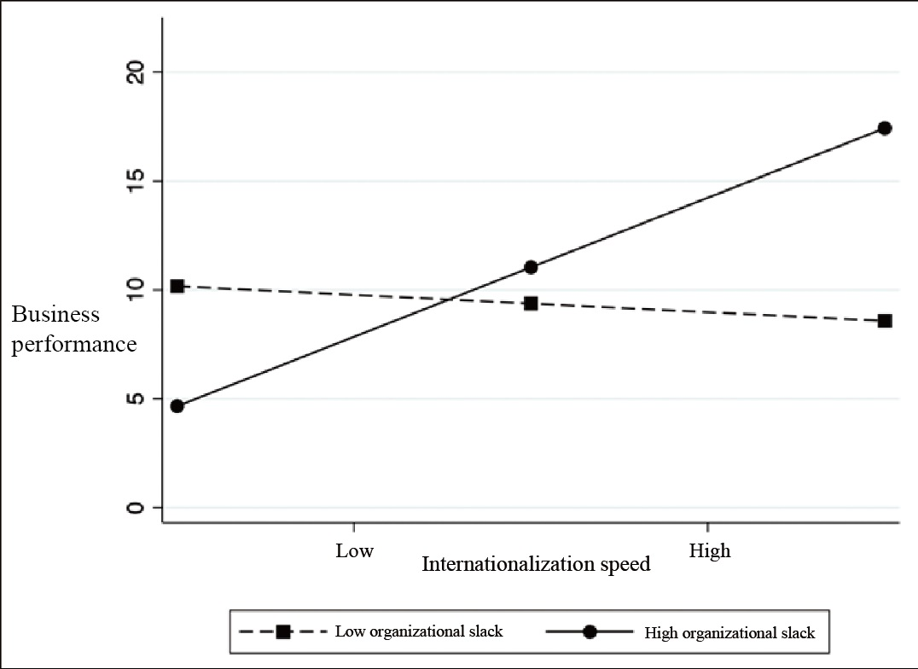

Figure 2 The moderating effect of organizational slack on the speed-performance relationship

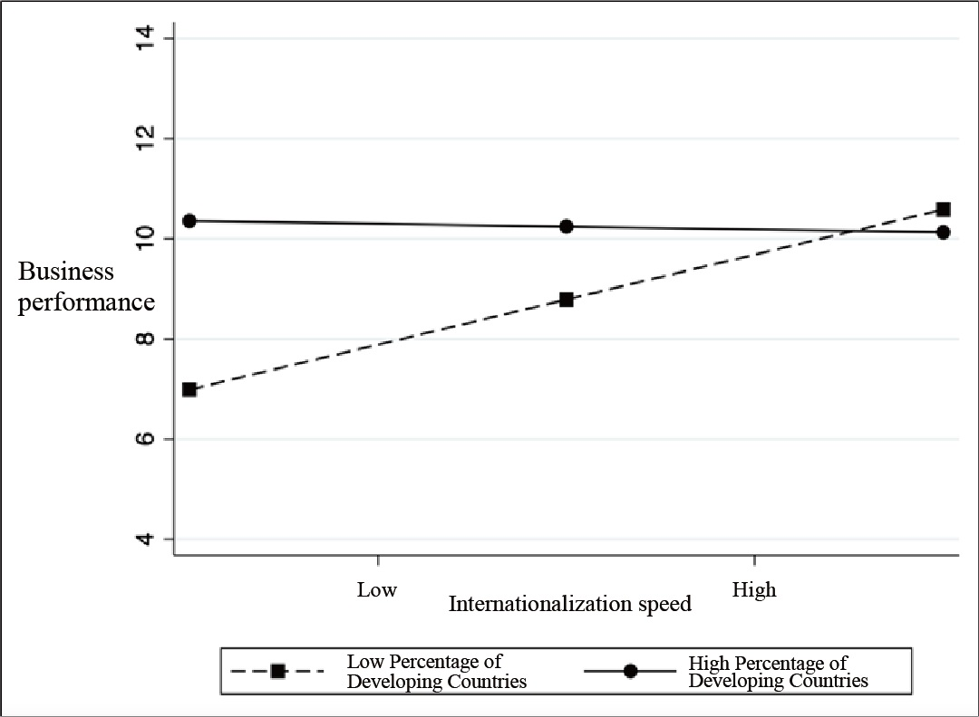

Figure 3 The moderating effect of the FDI ratio in developing countries on the speed-performance relationship

Table 1 Means, standard deviation, and correlation coefficient
Variables | Means | SD | Min. | Max. | 1 | 2 | 3 | 4 | 5 | 6
- Internationalization speed | 0.259 | 0.206 | 0.050 | 1.538
2. FDI ratios in developing countries | 0.760 | 0.284 | 0.000 | 1.000 | -0.434***
3. Organizational slack | 2.175 | 0.985 | 0.833 | 6.592 | -0.080 | -0.096†
4. R&D intensity | 0.030 | 0.029 | 0.001 | 0.316 | 0.144* | -0.195** | 0.091
5. FSTS | 0.744 | 0.294 | 0.019 | 1.000 | 0.118* | -0.096† | -0.044 | 0.037
6. Firm size (capital) | 6.314 | 0.440 | 5.000 | 7.600 | 0.252*** | -0.153** | -0.059 | -0.040 | 0.223**
7. Firm performance | 9.927 | 10.039 | -44.290 | 43.384 | 0.023 | 0.101† | 0.021 | -0.262*** | -0.229*** | -0.069
Note: n=315; †: p <0 .100; *: p<0.050; **: p<0.010; ***: p<0.001

Table 2 The relationship between internationalization speed, organizational slack, proportion of developing countries, and business performance
Variable | Firm performance _{(t+1)}
Variable | Model 1 |  | Model 2 |  | Model 3 |  | Model 4 |  | Model 5 |  | Model 6
Variable | β | SE | β | SE | β | SE | β | SE | β | SE | β | SE
Firm size | -0.718 | 1.230 | -1.341 | 1.260 | -1.315 | 1.259 | -1.349 | 2.332 | -1.245 | 1.258 | -1.380 | 1.254
R&D intensity | -87.969*** | 18.300 | -94.110*** | 18.432 | -95.727*** | 18.505 | -168.035*** | 20.978 | -90.139*** | 18.564 | -93.530*** | 18.587
FSTS | -7.336*** | 1.842 | -7.564*** | 1.833 | -7.514*** | 1.832 | -5.520† | 3.052 | -7.472*** | 1.828 | -7.747*** | 1.827
Internationalization speed |  |  | 5.451* | 2.688 | 5.644* | 2.694 | -24.960** | 9.257 | 7.178* | 2.923 | 16.564** | 6.251
Organizational slack (OS) |  |  |  |  | 0.463 | 0.536 | -3.739** | 1.342
FDI ratio in developing countries |  |  |  |  |  |  |  |  | 3.073 | 2.078 | 6.811* | 3.022
Internationalization speed × OS |  |  |  |  |  |  | 17.723*** | 4.889
Internationalization speed × LDCs |  |  |  |  |  |  |  |  |  |  | -16.397† | 9.665
Wald χ² | 48.14*** |  | 52.88*** |  | 53.75*** |  | 86.37*** |  | 55.43*** |  | 58.81***
Year | Included |  | Included |  | Included |  | Included |  | Included |  | Included
Number of firms | 63 |  | 63 |  | 63 |  | 63 |  | 63 |  | 63
Note：n=315; †: p <0 .100; *: p<0.050; **: p<0.010; ***: p<0.001; LDCs: ratio of FDI in developing countries

