A Developmental Paper

Title of Paper: Challenges in Enterprise Risk Management and Project Risk Management Integration: Two Case Studies from the Energy Sectors of Saudi Arabia and the United Kingdom

Authors:
Naif Aldwais: PhD student at Newcastle University
N.K.S.Aldwais2@newcastle.ac.uk
Karen Elliott: Professor in Finance and Fintech at the University of Birmingham
k.elliott@bham.ac.uk
Rebecca Casey: Assistant Professor in Information System Management at Newcastle University
Rebecca.Casey@newcastle.ac.uk

Summary: Key challenges have emerged, including a lack of appreciation for Enterprise Risk Management (ERM) among lower-level employees, insufficient comprehension of ERM as a catalyst for organisational change, and a significant disconnect between overarching risk systems and subsidiary components like Project Risk Management (PRM). This developmental paper illuminates the integration of PRM/ERM adopting an applied Complex Adaptive Systems (CAS) perspective. Critical realism facilitates understanding the generative mechanisms beyond ERM/PRM integration via semi-structured interviews and documentary analysis.

Track: Project Experiences
Word Count: 1939
Date: 05/06/2024

Plan for the next six months
Following the identification of findings, the next step involves a comprehensive discussion of each company's level of integration and maturity. We explore the contribution of complexity theory in considering the feasibility of developing a framework based combining the existing literature and insights from the case studies. This framework offers a practical empirical contribution for researchers and practitioners focused on effectively integrating Project Risk Management (PRM) into Enterprise Risk Management (ERM). We see the upcoming conference as a valuable opportunity to gather feedback, refine the methodology, and effectively present findings.

---
Kew words: Project Risk Management (PRM), Enterprise Risk Management (ERM), and Complex Adaptive Systems (CAS).

Introduction
An organisation can be viewed as a car, requiring all its wheels to move in one direction when coordination is in place to achieve organisational objectives (Frigo & Anderson, 2014). Under Project Risk Management (PRM) risks are usually identified, mitigated, and controlled against project constraints. In contrast, Enterprise Risk Management (ERM) conceptualises risks as growth, profit, or creating value, based on the organisational risk appetite (Agarwal & Virine, 2019). Within these distinct management systems, an objective and subjective views of risk differ between PRM metrics of scope, time, and budget versus ERM managing the interdependencies of risks across organisational outcomes (see Appendix 1). Achieving alignment between PRM/ERM becomes challenging. In this sense, through a complex adaptive system (CAS) perspective, we discuss and critique the core of PRM/ERM integration via the ISO 31000, COSO frameworks, and PMI’s Risk Management Standard, given their ubiquitous use amongst academics and professionals for integration purposes (see for example, Alijoyo, 2021; Albasteki, 2021). We also investigate the role of risk governance structures on the effectiveness of PRM/ERM interaction. Figure 1 illustrates the conceptual and theoretical frameworks informing this study.

Figure 1: The Conceptual and Theoretical Frameworks Informing this Study

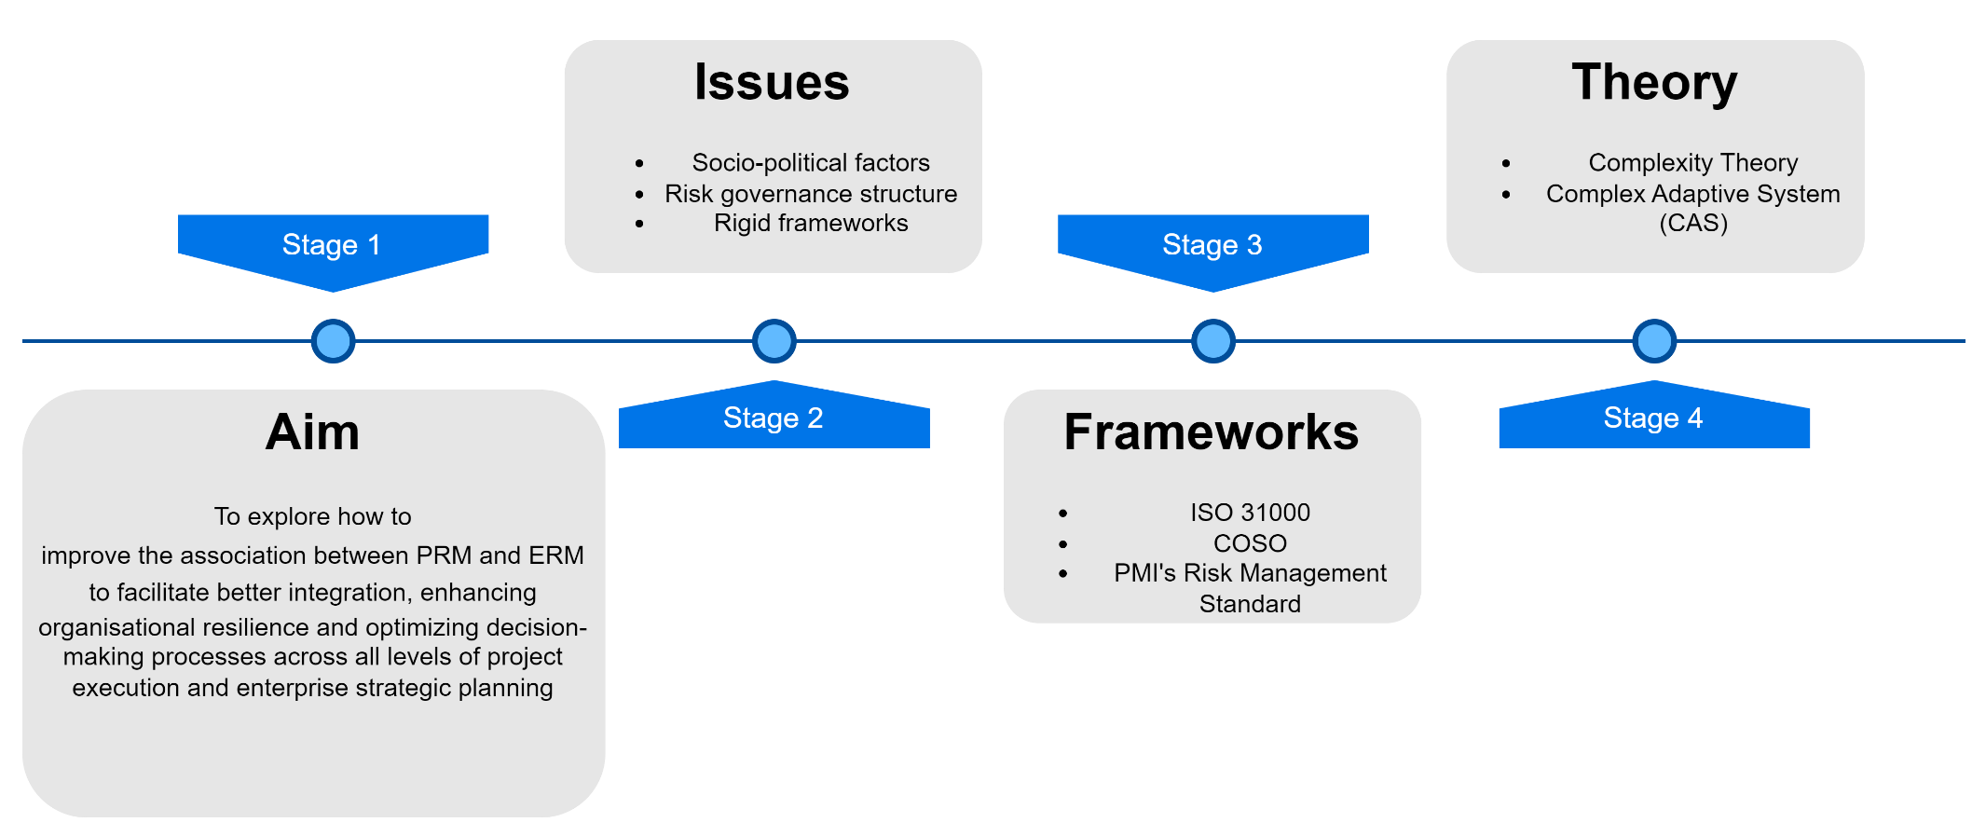

Literature Review
Established risk management literature contains a dual approach to risk from both an objective positivist perspective (Carlsson-Wall et al., 2019) and a qualitative approach influenced by cultural and human tacit values (subjective perspective, Polanyi, 2015). One may find the logic behind a positivist PRM stance is due to common familiarity of projects risks associated to certain industries. For example, petrochemical projects have common risks that usually occur in different project phases (e.g., chemical spill and environmental risks), where algorithms can predict the probability of risks occurrence. Consequently, project managers are preoccupied with micro-level risk measures rather than considering PRM as part of the holistic ERM macro-level risks. While functions like financial risk management also have their own distinct agendas, focusing on cost/benefit analysis relative to the nature and duration of projects presenting challenges for ERM alignment. ERM has wider internal/external cultural environment including stakeholders and industries, which necessitates subjectivity to manage uncertainty emerging from socio-political complexity (see Maylor & Turner, 2017). In exploring PRM/ERM integration, two popular standards dominate the ERM literature, namely, ISO 31000 and COSO, 2017 (see Figures 2 and 3).

These two standards create a platform of principles for risk management (Al-Tayan, 2022). Both emphasise the importance of integrating risk management with strategy, objectives, culture, and performance, while assuming a rational and linear ‘one-size-fits-all’ approach for organisations, whereby organisation’s tailor the frameworks to complement their needs. Thus, serving as guidelines without accounting for the complexities and non-linearity of the real-world dynamic project environment. Although ISO 31000 touches on establishing the scope and context as the first process to implement the framework, risk governance structures are omitted for project-based structures. We explore how to integrate the constraints of scope, time, and budget against the subjective ERM context of organisational strategies and objectives. PMI’s Risk Management Standard can assist PRM teams identify risks but does not specify communicate modes with ERM/senior management beyond escalation of risks to resolve. Hence, the central question revolves around how can complexity theory like CAS assist linear processes in integrating PRM/ERM systems? And how can the concept of self-organising systems improve risk governance structures impacting on PRM/ERM integration? We now turn to discuss Complex Adaptive System theory.

Figure 2: ERM Principles, Framework, and Process (ISO, 2018, p. 11)

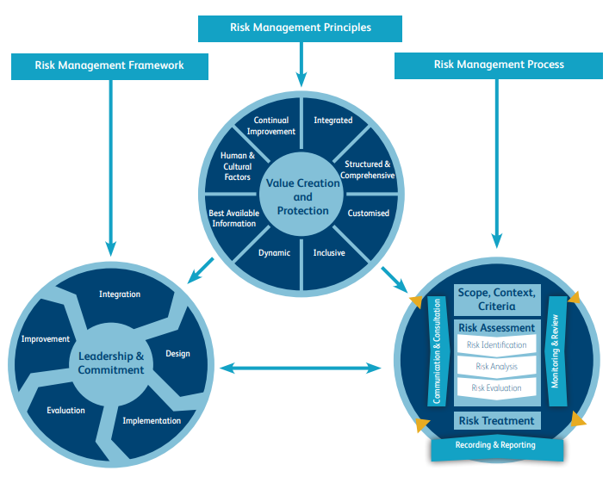

Figure 3: ERM Framework (Coso, 2004, p. 3)
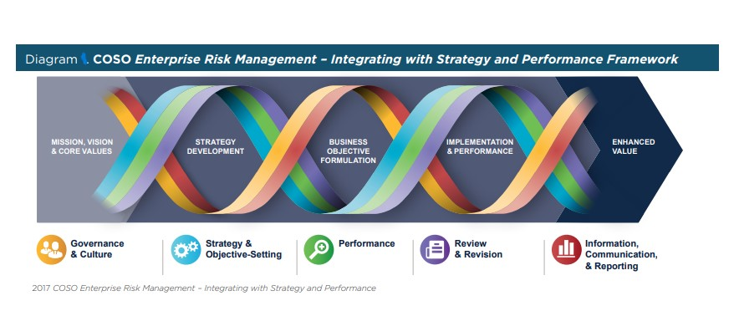

Complex Adaptive Systems (CAS)
CAS is a combination of linked yet, independent agents, forming part of a social system with multiple interdependent parts, where agents having the capability to interact, adjust, or learn by producing models to predict the future (Turner & Baker, 2019). Such systems are nonlinear with the capability to adapt, change, and emerge in unpredicted ways within their environment (e.g., context). To explain, agents within the PRM/ERM integration context, interact with each other by exchanging information (through feedback loops) in a complex environment leading to the emergence of the systems resultant behaviour that can provide better insights for the organisation’s decision makers (Carmichael & Hadzikadic, 2019, see Appendix 2).

Methodology
Critical realism underpins this approach to explore the underlying generative mechanisms and structures influencing PRM/ERM integration. Semi-structured interviews and documentary analysis were employed as data collection methods, providing rich qualitative insights that captures both subjective experiences and objective organisational documentation. Thus, allowing an in-depth exploration of PRM/ERM integration in contrasting stages of organisational maturity.

Case studies
A purposive sampling approach led to recruiting Company A based on its extensive experience in ERM since 2004. This organisation operates in over 50 countries, spanning diverse industries such as steel, agriculture, petrochemicals and the energy sector. Company A’s established ERM system provides a comprehensive view of PRM/ERM integration, and the lessons learned to contrast with Company B. Company B was a convenience selection via a referral from a UK risk profession from the energy sector given their recent PRM/ERM integration in 2020. Company B is a subsidiary of an Indian multinational conglomerate. The implementation of ERM originated in the UK subsidiary to ensure the establishment of consistent and integrated risk management processes at this specific UK site. Company A was examined between February to May 2022 and overlapped with Company B’s integration between October 2021 to July 2023.

Across the hierarchical structure of the organisations, convenience sampling was adopted to obtain stratification across managerial positions. Semi-structured interviews (n=20) were conducted with PRM project managers, ERM directors and members, and heads of departments and members across both companies. Each participant received an information and consent form prior to the interview taking place and were made aware of confidentiality and privacy via being able to withdraw consent to be included in the analysis at any time. Signed documentation was stored on encrypted files and only viewed by the researchers. The interviews lasted between 45-60+ minutes. Critical realists believe that other perspectives are required to understand the nature of a certain phenomenon (Sayer, 1997). A realist interview is therefore, a substantial data collection method for identifying and anticipating the generative mechanisms in context (Connelly, 2001). Documentary analysis involved access to PRM risk registers, frameworks, and processes, supplemented with ERM Knowledge Sharing documentation. Documentary analysis is a significant qualitative method for case study research to provide supporting evidence for the interviews to enhance, quality and reliability of the research (Elhoush, 2017). Document selection was based on two factors (Bowen, 2009). First, the quality of the document, assessed against subjectivity and bias factors. Second, the relevance of the document to the PRM/ERM scope. The evolving practices of Company B were explored via CAS to capture a broad spectrum of PRM/ERM challenges and solutions informed by lessons learned from Company A. Therefore, aligning with CR regarding generative mechanisms from A to B that can be evidenced as influencing effective PRM/ERM integration. The findings account for the integration context and examined influence from the uncertainty of COVID-19, which will be addressed in the findings and conclusion sections.

Findings
Company B revealed a lack of support from senior management for PRM/ERM integration coupled with a high turnover rate among staff, resulting in insufficient resources allocated to risk management initiatives and the integration process. An explanation for this observation, could be attributed to COVID-19 uncertainties across the globe. However, none of the participants cited COVID-19 as impacting on the integration outcomes. Furthermore, the siloed structure of the ERM framework emerged as failing to establish a cohesive link with the parent company, leading to a disparity in risk perception between Indian and UK leadership. Conversely, Company A revealed a well-defined ERM governance structure that recognises the dynamic and fluid nature of implementing change. This structure permitted the integration of PRM into ERM structures and objectives, as PRM teams maintained a degree of autonomy over risk management methods whilst sharing information for ERM guidance and requirements, supporting integration outcomes. Company A revealed their practice of engaging periodic reviews during the PRM lifecycle, accompanied by monthly review meetings to align with ERM objectives for integration. Despite both companies referencing the ISO 31000 framework, neither organisation fully adhered to the standard, recognising its limitations and the cultural generative mechanisms specific to their organisation. Ignoring these aspects would have jeopardised integration (Albasteki, 2021; Al-Tayan, 2022). In contrasting Company A and B’s approaches, differences emerged in top-down or bottom-up processes for PRM/ERM implementation. Company B opted for a bottom-up approach, focusing on the micro-organisational level, diverging from the top-down approach advocated by ISO 31000 framework, emphasising risk management originating from the macro and senior management level. Company A adopted a hybrid approach, integrating top-down and bottom-up methods, thus, permitting a degree of autonomy for PRM teams around risk frameworks, processes, and tools while providing data and information to support the ERM guidelines. Despite the implementation periods for both company’s took place during the COVID-19 pandemic, this factor was not reported as a key constraint for implementation. Rather, in Company B’s case as a subsidiary of the main Indian organization, it was reported that demonstrating the value-add of ERM was a key pain point in the integration process, resulting in delays. As stipulated at the outset of this working paper, over the coming 6 months, these findings will be expanded to include more critique from the CAS perspective and produce suggestions as to how this lens can assist in improving the integration of PRM/ERM for energy sector organisations.

Conclusion
This developmental paper has centred on the challenges or generative mechanisms impacting on the integration of PRM/ERM protocols. Two case studies operate in the energy sector of Saudi Arabia and the United Kingdom, and initial key findings suggest that the lack of appreciation for ERM amongst the hierarchical positions across the companies creates a disconnect between overarching risk systems and subsidiary components like PRM. Generative mechanisms and the impact of risk governance structures also emerge in unpredictable ways that effect ERM/PRM integration, further elucidation of evidence will continue over the research period.
The dominant risk frameworks in ERM, namely ISO 31000 and COSO, focus on addressing inherent risks at the outset of the risk management process but, fail to deal with the fluid and dynamic nature and feedback loops inherent in managing projects. Such frameworks often assume rational and linear risk management, which does not reflect the complexities and non-linearity of risk in real-world, dynamic environments driven by the behaviours of the agents nested in the complex adaptive systems of each company. On the other hand, PMI's Risk Management Standard was found to provide guidance for PRM project teams in identifying project risks but lacks clarity on how projects should communicate with ERM or senior management to ensure effective PRM/ERM integration processes, particular in the immature ERM environment in Company B. To address these challenges, this paper proposes leveraging the insights provided by the applied CAS perspective. A CAS perspective recognizes the interconnectedness and interdependence of agents within a social system, such as projects and enterprises, and emphasizes the exchange of information and feedback loops between PRM/ERM.
The case studies highlight the importance of senior management support or ‘buy-in’ found in the literature to be an essential aspect predicting the likelihood of project success and a well-defined ERM governance structure in facilitating the integration of PRM/ERM. Company A, with its mature PRM/ERM systems, showcased effective integration through a hybrid approach that allowed PRM teams to maintain independence in utilising their own risk management methodologies whilst demonstrating interdependencies characteristic of CAS in adhering to overarching ERM guidelines. In contrast, Company B, with its siloed ERM framework and lack of support from top management, struggled to achieve integration.

References

Agarwal, R., & Virine, L. (2019). Integration Stages of Project Risk Management (PRM) into Enterprise Risk Management (ERM). International Journal of Risk and Contingency Management (IJRCM), 8(1), 13–33.
Albasteki, O. N. M. S. (2021). Corporate stakeholders, environmental and social risks, and enterprise risk management: Towards an integrating framework [Thesis, Brunel University London]. http://bura.brunel.ac.uk/handle/2438/23105
Al-Tayan, R. (2022). Empirical analysis of Enterprise Risk Management in Middle East countries [Thesis, Loughborough University]. https://doi.org/10.26174/thesis.lboro.21636827.v1
Bowen, G. A. (2009). Document Analysis as a Qualitative Research Method. Qualitative Research Journal, 9(2), 27–40. https://doi.org/10.3316/QRJ0902027
Carlsson-Wall, M., Kraus, K., Meidell, A., & Tran, P. (2019). Managing risk in the public sector–The interaction between vernacular and formal risk management systems. Financial Accountability & Management, 35(1), 3–19.
Carmichael, T., & Hadzikadic, M. (2019). The Fundamentals of Complex Adaptive Systems (pp. 1–16). https://doi.org/10.1007/978-3-030-20309-2_1
Connelly, J. (2001). Critical realism and health promotion: Effective practice needs an effective theory. Health Education Research, 16(2), 115–120. https://doi.org/10.1093/her/16.2.115
Coso, I. I. (2004). Enterprise risk management-integrated framework. Committee of Sponsoring Organizations of the Treadway Commission, 2.
Elhoush, R. (2017). Investigation into the current project risk management practices within the Libyan oil and gas industry [Ph.D., University of Salford]. http://usir.salford.ac.uk/id/eprint/44592/
Frigo, M. L., & Anderson, R. J. (2014). Risk management framework: Adapt, don’t adopt. Strategic Finance, 96(1), 47–52.
ISO. (2018, February). International Organization for Standardization. https://www.iso.org/files/live/sites/isoorg/files/store/en/PUB100426.pdf
Maylor, H., & Turner, N. (2017). Understand, reduce, respond: Project complexity management theory and practice. International Journal of Operations & Production Management, 37(8), 1076–1093. https://doi.org/10.1108/IJOPM-05-2016-0263
Sayer, A. (1997). Critical realism and the limits to critical social science. Journal for the Theory of Social Behaviour, 27(4), 473–488.
Turner, J. R., & Baker, R. M. (2019). Complexity theory: An overview with potential applications for the social sciences. Systems, 7(1), 4.

Appendix 1 Comparison between ERM and PRM
Comparison between ERM and PRM (Liu et al., 2013)

Key features | Expressions in ERM | Expressions in PRM
Objectives | Align to the four enterprise objectives—strategic, operations, reporting, and compliance | To complete the project successfully
Scope | Internal and external events affecting achievement of an entity’s objectives must be identified | Cost, time, quality, safety, and environment- related risks (that influence the implementation of the project)
Risk categories | Strategic risks, market risks, operation risks, financial risks, and compliance risks | Owner-contractor agreement, owner conditions, subcontractor conditions, project execution, project preparation and planning, contracting and administration procedures, and external risks
Framework and methods | Relatively stable in a period of time | Changing from project to project
Person in charge | Top managers (e.g., Chief Risk Officer) of the entity | Project managers

Appendix 2 Complex Adaptive Systems Framework
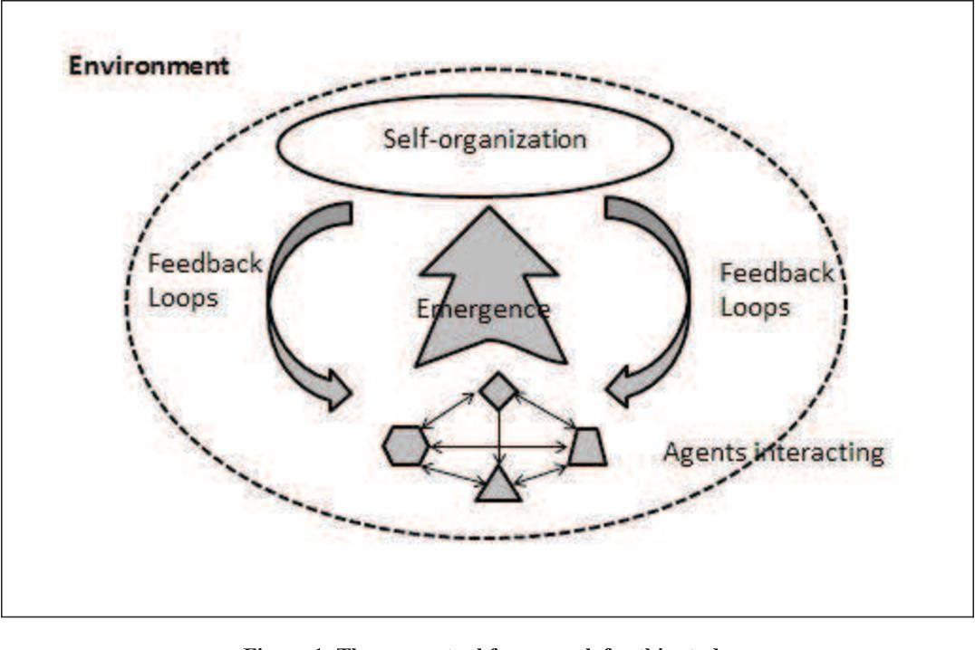
Source (Turner & Baker, 2019)

Socio-political complexity: “increases with the divergence of people involved, level of politics or power-play to which the project is subjected, lack of stakeholder/sponsor commitment, degree of resistance to work being undertaken, lack of shared understanding of the project goals, lack of fit with strategic goals, hidden agendas, conflicting priorities of stakeholders” (Maylor & Turner, 2017, p.6).

