Author Details:

Sagnika Datta
PhD Scholar
Indian Institute of Management, Lucknow
India
phd22033@iim.ac.in

Prof. Neeraj Dwivedi
Professor
Strategic Management
Indian Institute of Management, Lucknow
India
neerajd@iiml.ac.in

Circular Economy related Innovations in Organizations and the Increasing Role of Digital Technologies: A Systematic Literature Review and Future Research Prospects

Abstract:

Over the last decade, governments, practitioners, and researchers worldwide have increasingly focused on the new concept of Circular Economy (CE), aiming to offer a better alternative to the existing dominant linear economic model. The Circular Economy (CE) is a regenerative system aimed at eliminating waste by transforming end-of-life products into resources for new production cycles. Literature has appreciated the role of innovation in enabling CE in organizations. However, a significant portion of CE innovation literature focuses on Circular Business Model Innovation, Circular Economy through Eco-Innovation (EI), and CE-based supply chains. Studies focused on CE-product innovation and CE-process innovation are relatively few. The CE- innovation literature remains fragmented and disjointed, with diverse dimensions investigated in isolation. There is a gap when it comes to the overall coverage of the types of circular innovation that organizations can undertake. Considering the fragmented nature of research streams and the absence of a comprehensive perspective on the type of circular economy innovations, this paper does an over-encompassing systematic review of the types of circular economy innovation that has tremendous theoretical and managerial implications. The review shows that apart from Business model innovation, Eco-innovation is one of the major themes in CE innovation Literature.. an interesting takeaway from the analysis is that Innovation with the aid of Digital or I4.0 technologies is becoming the dominant trend under each category of circular innovation. It signals the huge potential of technological innovation for sustainability, specifically circular-driven organizations.

Keywords: Circular Economy, Innovation, Business Model, Eco-Innovation, Industry 4.0

- Introduction
Environmental problems like biodiversity loss, pollution, resource depletion, and land use threaten the earth's life-support systems (WF, 2014). Scholars around the world indicate the urgency of transitioning to sustainable sociotechnical systems (Markard et al., 2012). One approach to ensure a sustainable way of production and consumption of resources is the Circular Economy (CE). CE has gained prominence in academic research and policymaking, evidenced by initiatives like the ECEP (European Commission, 2015) and China's Circular Economy Promotion Law. Rising GHG emissions and global warming have made environmental stewardship a critical role for businesses (Triguero et al., 2022). Business strategies promoting CE are increasingly relevant in policy and research, particularly regarding climate change (Antonioli et al., 2022; Kennedy & Linnenluecke, 2022). CE is crucial for addressing global issues like resource depletion, environmental degradation, and climate change. It enhances economic resilience by creating business opportunities, jobs, and sustainable growth pathways. The Ellen MacArthur Foundation (2021) notes that CE can significantly contribute to achieving net-zero emission targets through efficient resource use and waste reduction.
CE is a transformative approach addressing economic and environmental challenges.The Circular Economy (CE) contrasts with the conventional linear model of 'take-make-dispose' by prioritizing waste elimination through prolonged product use, sustainable design, and the regeneration of natural systems (Blomsma et al., 2023).Its goal is to separate economic growth from the consumption of finite resources, promoting sustainable production and consumption patterns, thus reducing reliance on virgin materials and minimizing waste (Cainelli et al., 2020). CE aims to minimize non-renewable material extraction, reduce consumption and waste, extend product lifetimes, facilitate reuse and recycling, and utilize renewable resources (Cordella et al., 2020). Circular economy strategies induce transformations in corporate operations, products, services, and supply chains, all contributing to reduced waste and pollution (Ness and Xing, 2017). Shifting to a CE significantly reduces greenhouse gases and eases pressure on new resources (Circularity Gap Report, 2021). CE aims to maximize the value of resources by using waste as a resource and minimizing waste generation (Moktadir et al., 2020; Urbinati et al., 2017). This approach offers substantial economic benefits and reduces greenhouse gas emissions through improved material flow efficiency and extended product life (Munaro et al., 2020).
Organizations worldwide are increasingly embracing Circular Economy (CE) practices to address the mounting issues of resource scarcity, environmental degradation, and changing regulatory demands. This shift is motivated not only by the need to comply with regulations but also by the understanding that circular practices can result in sustainable economic advantages (Paula Pinheiro et al., 2021), improved operational efficiency (Rodríguez-Espíndola et al., 2022), and enhanced environmental performance (Marrucci et al., 2022). In 2020, the predominant global business risks were environmental, encompassing failures in climate action, biodiversity loss, and human-induced environmental disasters (WEF, 2020). To address these risks, many large corporations have set goals to transition toward a circular economy (Jabbour et al., 2019; Frishammar and Parida, 2019). By embracing CE principles, organizations can enhance their reputation and achieve substantial cost savings. This is accomplished by promoting social inclusion (Padilla-Rivera et al., 2020), extracting value from waste (Bocken et al., 2014), building supply chain resilience (Kennedy & Linnenluecke, 2022), and improving resource utilization efficiency (Stankevičienė et al., 2020). Organizations adopting CE practices can reduce risks linked to resource dependency and price volatility while exploring new market opportunities through sustainable products and services (Castro-Lopez et al., 2023). The increasing consumer demand for environmentally responsible products pressures companies to align with these values to maintain customer loyalty and meet market expectations. This alignment is crucial in an increasingly VUCA world (Schoemaker et al., 2018). Moreover, companies that prioritize sustainability and environmental conservation tend to be more highly valued by the capital market (Palea et al., 2023). However, adopting CE in organizations involves overcoming a number of challenges, such as Lack of Legislation (Kazancoglu et al., 2021), Lack of Knowledge (Cantu et. al, 2021), High Financial Investment (Kirchherr et al., 2018), Lack of Infrastructure (Adams et al., 2017) and Market Complexity (Nubholz, 2017) among others. Internally organizations require significant innovation throughout the value chain in order to adopt CE practices (Eisenreich et al., 2022).
Research on circular economy and innovation has gained significant attention in academic literature over the past decade. Innovation is defined as the incorporation, integration, and utilization of value-enhancing novelty that leads to the rejuvenation and ongoing enhancement of products, processes, and markets (Christensen et al., 2013). Literature has acknowledged the importance of innovation for implementing circularity in organizations (Suchek et al., 2021; Prieto et al., 2018). Studies acknowledge that transforming to Circular economy necessitates a fundamental change in organizations' mindset, values, practices, and related ecosystems (Kuhlmann et al., 2023). Altering the approach to economic activities necessitates shifts in mindset and methodologies, these modifications may range from gradual enhancements to transformative shifts, all underpinned by innovation (Sehnem et al., 2022). Extant studies show that organizations can engage in complete or partial implementation of circular economy in their businesses primarily through innovation in Business Model (Maher et al., 2022) or Product (Diaz et al., 2022) and (or) process innovation (Momeni et al., 2022), respectively. These transformations necessitate adopting new methods for configuring and executing the firm's operations (Heredia et al., 2022; Gusmerotti et al., 2019). Achieving circularity demands significant alterations along the entire value chain and can result in the development of distinct products, services, and revenue models (Geissdoerfer et al., 2018; Stahel, 2019).
While researchers have acknowledged the importance of innovation for transforming overall business logic, products, and processes in organizations to achieve circularity, relevant studies have predominantly focused on innovating business models to facilitate the transition to this emerging economic paradigm (Julkovski et al., 2023). Studies in this domain have shed light on the success factors, drivers, and barriers of circular BMI (Geissdoerfer et al., 2023; Rocca et al., 2023), digital-enabled circular BMI (Sjödin et al., 2023; Khan et al., 2023); exploration of circular BMI in various contexts and industries (Abbate et al., 2023; Costanza, 2023) among others. The second most studied area in the context of Circular Economy-Innovation is Eco-innovation (López Pérez et al., 2023; Liu et al., 2023). Prieto-Sandoval et al. (2018) suggested eight types of EIs to facilitate the development of the Circular Economy. Eventually, some studies have also focussed on how product (Castro-Lopez et al., 2023) and process innovation (Meili and Stucki, 2023) in organizations help in achieving circularity, but the volume of such studies is still a handful. While all these studies broadly acknowledge the crucial role of innovation in CE, the studies remain somewhat generalized and disjointed, with diverse and different dimensions investigated in isolation (Ahmad et al., 2023; Evertsen et al., 2022). Previous systematic reviews on CE and innovation (Suchek et al., 2021; Sehnem et al., 2022) have focused on the research trends at the intersection of overall CE and innovation and from the capabilities perspective respectively; however, there is a gap when it comes to the overall coverage of the types of circular innovation that organizations can undertake; the presence of which can have tremendous managerial implications. No study has been done to systematically investigate the types of innovations undertaken by organizations to achieve circularity. Previous literature has broadly identified the various types of circular innovation taking cue from the literature on innovation (Ranta et al., 2020; Arranz et al., 2023) which are predominantly Business Model Innovation, Product Innovation, Process Innovation, and service innovation; but there are no studies that analyze each circular innovation type systematically and uncover the components of each circular innovation.

The recent advancement in technology also known as Industry 4.0 has been found to enable CE. There are a growing number of articles exploring and explaining the role of I4.0 in facilitating CE (Lu et al., 2024; Maria et al., 2022). Industry 4.0 (I4.0) technologies encompass advanced digital tools and innovations such as the IoT, AI, big data analytics, blockchain, and robotics. These technologies support the Circular Economy by improving resource utilization, increasing efficiency, and enabling real-time monitoring and decision-making (Nascimento et al., 2024). IoT sensors can track the lifecycle of products, ensuring materials are reused or recycled effectively. AI and big data analytics help predict maintenance needs and optimize production processes, reducing waste. Blockchain technology enhances supply chain transparency and traceability, promoting trust and adherence to sustainability standards.

Considering the fragmented nature of research streams and the absence of a comprehensive perspective on the type of circular economy innovations, there is a need for an over-encompassing systematic review of the types of circular economy innovation that will help in strengthening the managerial and practical perspective on the topic. Considering the following gap in view, this paper attempts to answer the following research questions in this study:

RQ1: What is the present status of the research on CE- Innovation in the management domain?
RQ2: What are the different types of CE-Innovations that organizations can undertake?
RQ3. What research themes, under each type of CE-Innovation, have been explored in the existing literature?
RQ4. What are the avenues for future research?

This study is organized as follows: Section 2 outlines the methodology used in the review. Section 3 presents the results of the descriptive and bibliographic analysis of the articles, including a detailed examination of the themes that emerged from this analysis. Section 4 introduces the framework developed from these findings. Finally, Section 5 discusses prospects for future research.

METHODOLOGY
The methodology for the research article, as depicted in the flowchart, consists of several systematic steps aimed at identifying, screening, and selecting relevant articles for review. These steps ensure a comprehensive and rigorous selection process, enhancing the reliability and validity of the study. Below is an elaboration of each step:

Identification
The initial step in the methodology involves the identification of potentially relevant articles from two prominent academic databases: Scopus and Web of Science (WoS). The search strategy was formulated using specific keywords associated with the CE and innovation. The keywords used in the search query included combinations such as "Circular economy," "reverse logistics," "close loop," and "innovation." The focus was restricted to articles written in English and falling within the discipline of Business, Management, and Accounting. The search, conducted on March 31, 2024, yielded 283 eligible articles from WoS and 394 from Scopus.

Screening
Following the identification phase, a screening process was undertaken to refine the list of eligible articles. Initially, duplicates across the two databases were identified and removed, resulting in a consolidated list of 377 articles. This step is crucial to ensure that each article is unique and to avoid redundancy in the review process.

Eligibility
The next phase involved assessing the eligibility of the remaining articles based on predefined criteria. Articles that did not belong to the ABDC A/A* or ABS 3/4 categories were excluded from further consideration. This criterion ensured that only high-quality articles were included in the review. Consequently, 208 articles were removed at this stage.

Inclusion
The final step involved a detailed examination of the abstracts of the remaining 169 articles to determine their relevance to the study's objectives. Articles that were not directly relevant to the study's focus on CE and innovation were excluded. After this thorough screening process, 57 articles were found to be irrelevant and were removed. Ultimately, 112 articles were selected for in-depth review and analysis.
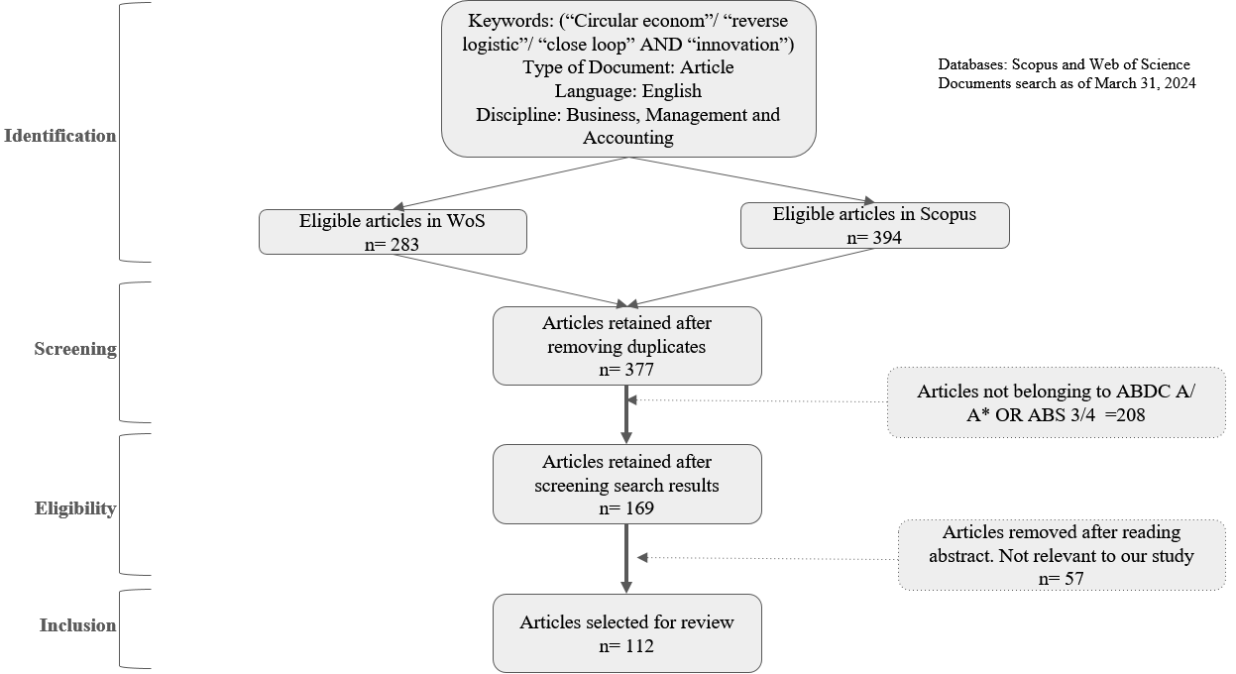
Fig 1: Research Methodology

RESULTS
All studies underwent evaluation based on criteria including research quality and study characteristics, as outlined by Dybå and Dingsøyr (2008).

3.1 Descriptive analysis
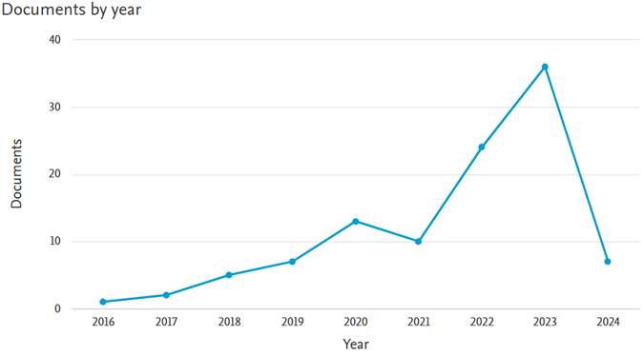
Fig 2: No. of Documents per year

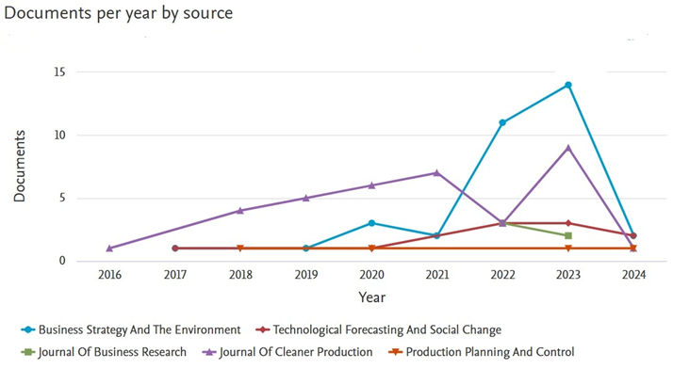
Fig 3: Documents per year by source

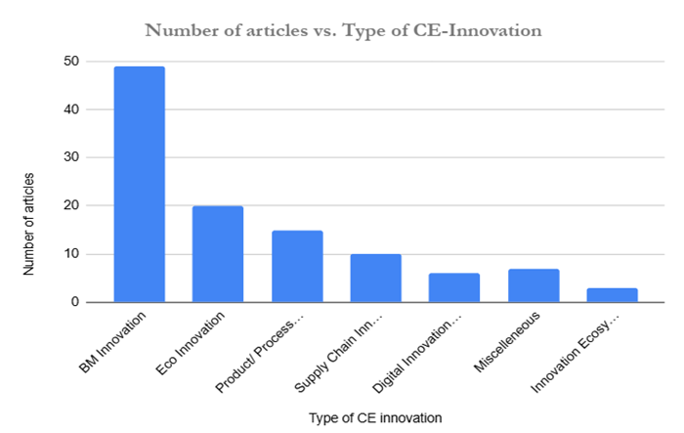
Fig 4: Number of articles per type of CE-Innovation

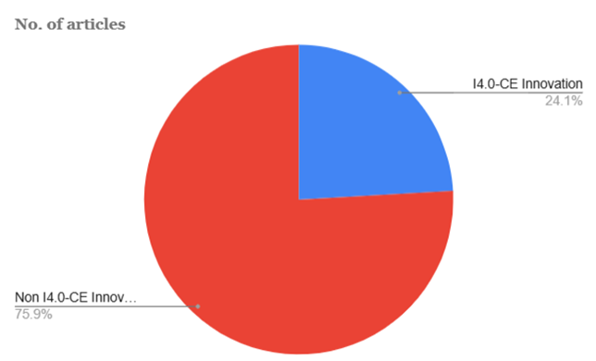
Fig 5: Percentage of articles on I4.0 and Non I4.0-CE Innovation

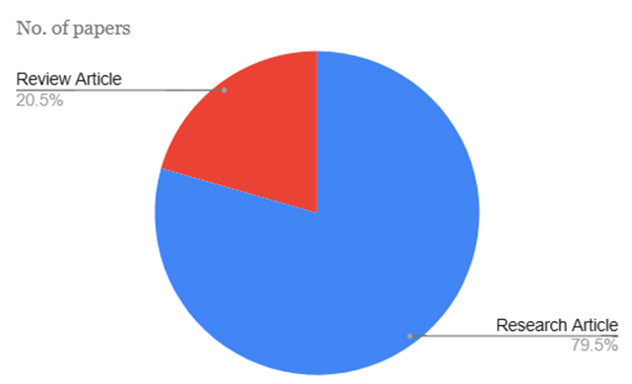
Fig 6: Percentage of Review Articles Vs No. of Research Articles

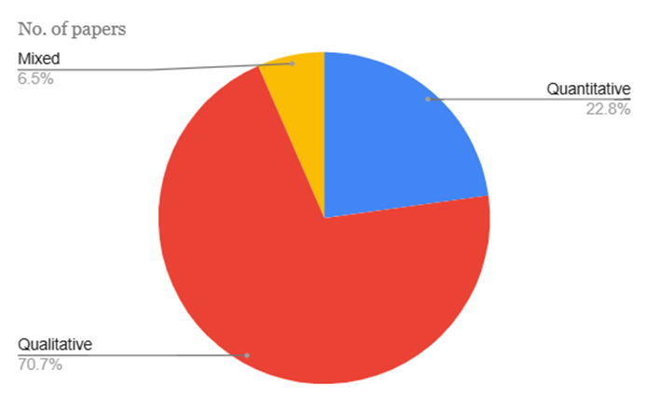
Fig 7: Percentage of papers based on methodology used

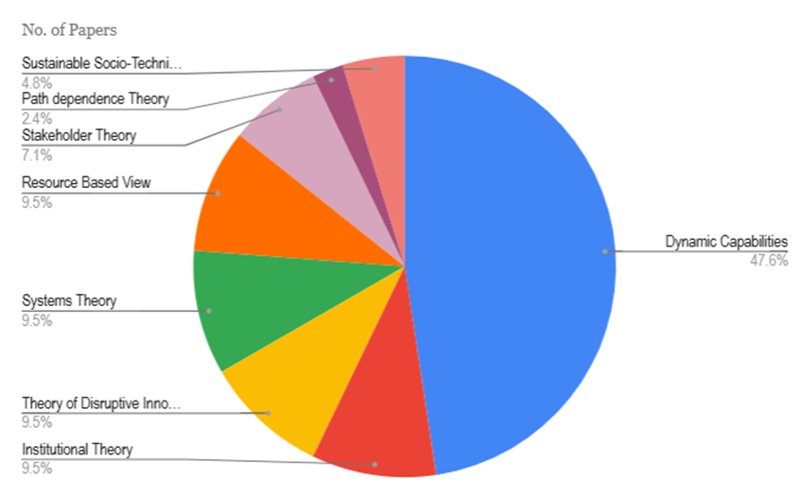
Fig 8: Percentage of papers based on theory used

3.2 Analysis of Bibliographic Coupling
Table 1: Bibliographic coupling of contributing authors and countries (Using VOS Viewer)

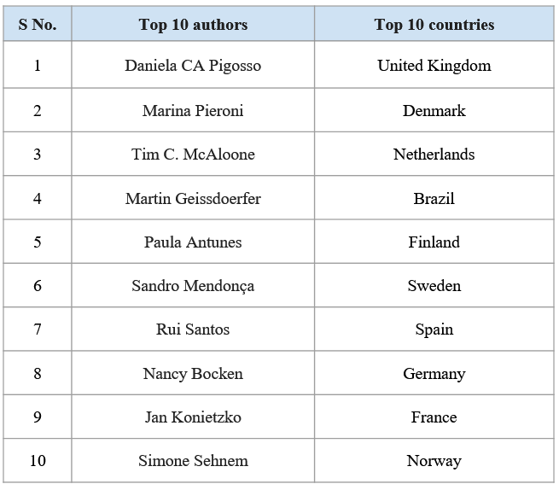

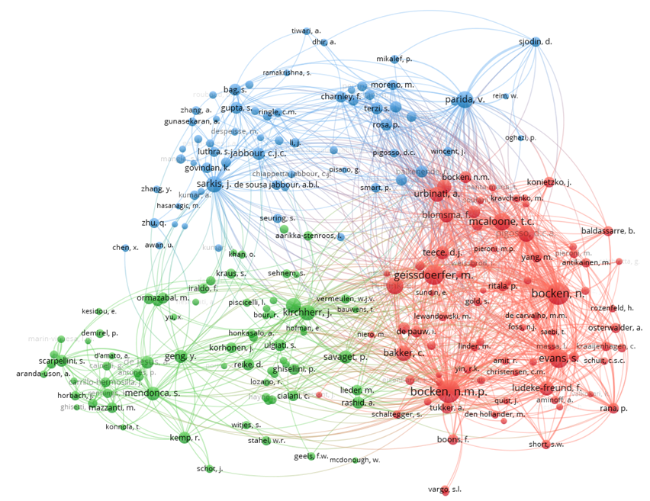
Fig 9: Bibliometric analysis: Co-Citation_Cited Authors
(Using VOS Viewer)

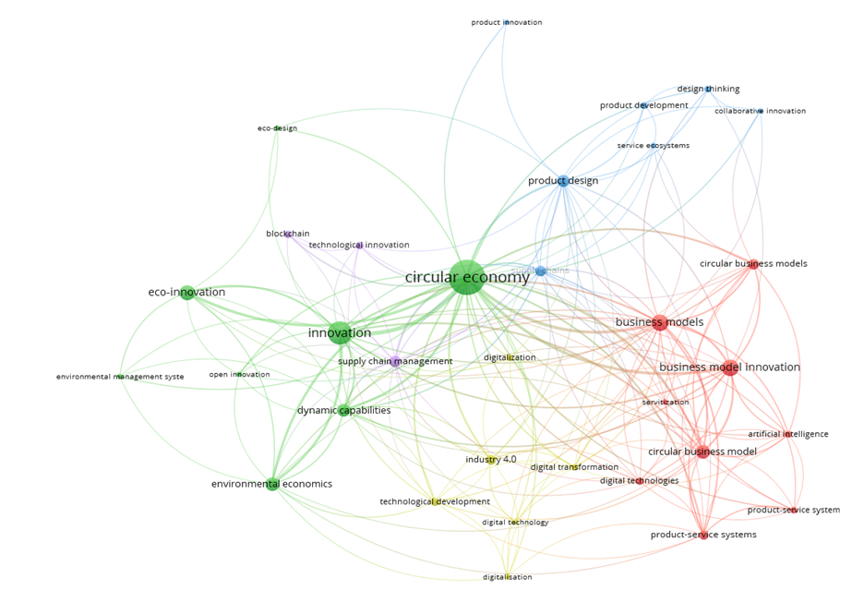
Fig 10: Co-occurrence analysis (All keywords)
(Using VOS Viewer)

Table 2: Clusters obtained from the Co-occurrence analysis of keywords using VOSviewer
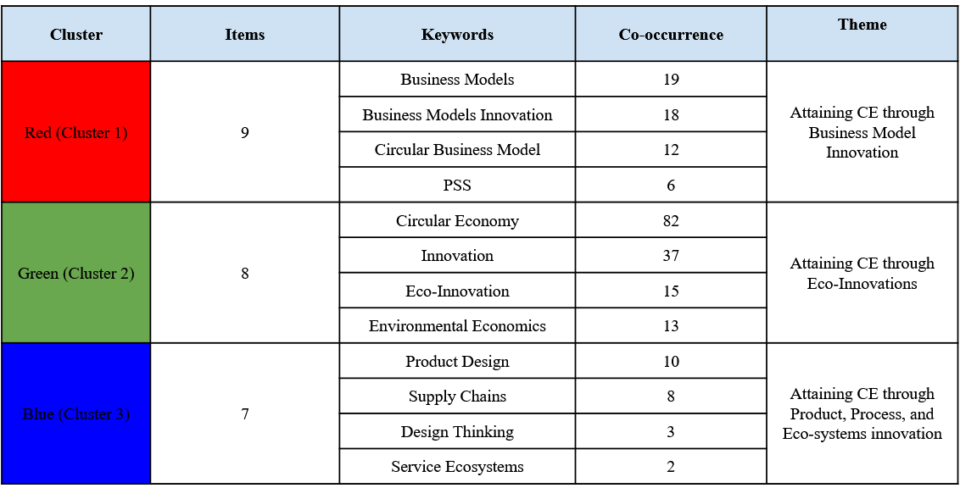
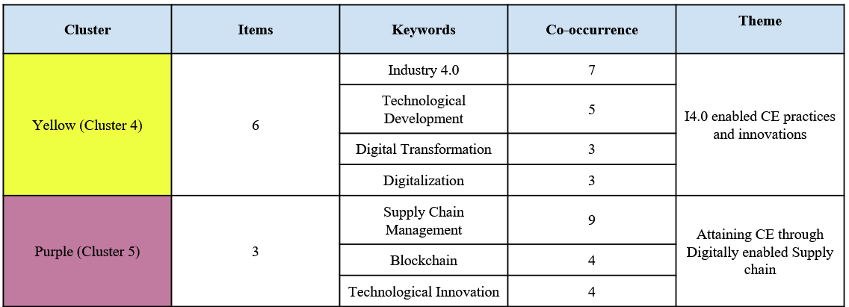

3.2.1 Theme 1: Attaining Circular Economy through Business Model Innovation
The shift to a Circular Economy (CE) requires a significant overhaul of business operations, primarily through the adoption of innovative business models (BMI). BMI is essential in this transition, as it involves reshaping value propositions, customer relationships, and revenue models to adhere to circular principles (Spieth et al., 2014). This theme investigates the various ways businesses can achieve CE through BMI, highlighting specific strategies, challenges, and technological enablers.
Heyes et al. (2018) explore how service-oriented ICT companies can develop and implement circular economy business models, emphasizing the move from product-oriented to user-centered eco-design. Their research indicates that ICT firms can support the circular economy by identifying and prioritizing sustainable business model innovations in the technology sector.
Pieroni et al. (2019) analyze 92 approaches to business model innovation for the CE and sustainability, categorizing and comparing them. A significant finding is that most approaches focus on individual stages of innovation without addressing the continuous activities needed to adapt companies' capabilities to the dynamic internal and external changes required by CE and sustainability thinking.
Chabowski et al. (2023) emphasize the need for a globalized circular economy and propose sustainable international business model innovations. They propose ideas such as circular inputs, sharing platforms, product-as-a-service, product lifespan extension, and resource recovery as potential business models to address significant challenges. These innovations, rooted in CE principles, are compared with the traditional linear economic model and presented as actionable options for companies to standardize or adapt in response to diverse international institutions.

3.2.1.1 Barriers and Enablers to CBM
The shift to Circular Business Models (CBMs) involves various barriers and enablers. Challenges include regulatory obstacles, high initial costs, and low consumer awareness or acceptance, as well as internal resistance to change due to entrenched practices (﻿Guldmann et al., 2020). However, enablers such as supportive policies, technological advancements, and increasing consumer demand for sustainable products can significantly aid this transition (Hina et al., 2022). Strategic partnerships and collaborations are vital for overcoming these barriers by pooling resources and sharing risks
Linder et al. (2017) investigate the reluctance to adopt CBMs, noting that these models present substantial challenges for entrepreneurs trying to reduce uncertainty. They also emphasize that product-service system variations, which facilitate control over return flows in CBMs, can exacerbate the negative consequences of unsuccessful uncertainty reduction due to higher capital investments.
Nußholz (2018) introduces a visualization tool for mapping CBMs, standardizing the representation of model elements and cycles to extend product lifespans and close material loops.
Geissdoerfer et al. (2018) assess the sustainability performance of CBMs and circular supply chains, proposing a framework for integrating them toward sustainable development. This framework, based on literature and case studies, illustrates how different CBMs drive circular supply chains by closing, slowing, intensifying, narrowing, and dematerializing loops, with varying supply chain complexities and value propositions.
Rossi et al. (2020) develop indicators linking Circular Economy principles, CBMs, and sustainability pillars, focusing on environmental, economic, and social dimensions. They highlight the lack of accessible data in the economic and social dimensions, which poses a barrier as many positive impacts of the Circular Economy, such as job creation and mindset change, occur in the social dimension.
Guldmann et al. (2020) identify barriers to adopting CBMs, showing that these hurdles primarily manifest at the organizational level, followed by challenges in the value chain, among employees, in the market, and at institutional levels. Their cross-case analysis demonstrates that these barriers are influenced by factors beyond company size, industry, and customer segment.
Geissdoerfer et al. (2023) investigate the factors influencing four types of circular business model innovations: start-ups, diversification, transformation, and acquisition. They identify 25 barriers and 10 drivers categorized into seven groups, highlighting their distinct impacts. Start-ups and diversifications are primarily motivated by market and financial factors, while transformations are influenced by both market conditions and organizational factors. Legal and financial challenges affect all types, with start-ups facing particular issues in integrating into value chains, and established companies encountering market and organizational hurdles.
3.2.1.2 CBM in Startups:
Circular business model innovation (CBMI) in start-ups focuses on integrating disruptive innovation and resource circularity into their business practices. This approach involves designing business models that emphasize sustainable resource use, minimizing waste, and creating value through circular strategies (Henry et al., 2020). Start-ups often lead the way in adopting CBMI by leveraging new technologies and innovative practices to enhance resource efficiency, close material loops, and create sustainable products and services (Rizos et al., 2016).
Sehnem et al. (2022) investigated how start-ups are incorporating these elements into their models. Their findings indicate that start-ups are advancing resource circularity through partially implemented initiatives that facilitate data management, artifact integration, connectivity, digitization, supply chain partnerships, new market opportunities, and efficient transition systems for resource circularity.
Geissdoerfer et al. (2020) enhance the conceptual clarity of CBMI through systematic database searches and cross-reference snowballing. Their work provides a historical overview of circular business models and CBMI, a synthesis of their definitions, and a synthesis of their conceptual frameworks. This comprehensive approach helps in understanding the evolution and application of CBMI in start-ups.

3.2.1.2 Incumbents Transition to CBM
Incumbent firms transitioning to Circular Business Models (CBMs) face significant challenges in reengineering their established operations to align with circular principles. This shift involves moving away from the traditional linear 'take-make-dispose' approach toward a model that emphasizes resource efficiency, waste minimization, and product lifecycle extension, requiring substantial organizational change and strategic realignment.
Hofmann et al. (2020) developed a conceptual model to explain why firms persist with linear business models and how incumbents maintain a linear value creation system. The model identifies organizational conditions and management strategies that hinder the adoption of linear models and facilitate the initial shift towards CBM innovation. The article also proposes strategies for configuring organizational transition management to navigate CBM innovation successfully.
Salvador et al. (2020) identified key aspects for implementing and managing business models using the Business Model Canvas framework. These aspects include fostering innovation, entering new markets, creating customer-centric value, managing logistics and feedstock effectively, understanding biomass valuation methods, developing technology, building resilient value chains, and ensuring value creation covers costs.
Pollard et al. (2021) developed a Circular Economy Business Model Innovation Process Framework through seven iterative workshops with stakeholders in the electrical and electronic equipment sector. The resulting five-layer framework provides manufacturers with a comprehensive process for developing and implementing circular economy business models tailored to their offerings.
Pieroni et al. (2021) identified sector-specific business model patterns to help manufacturing companies reduce complexity and uncertainty in CBM innovation. Through multidimensional scaling analysis of over 180 companies, sectoral patterns were identified for six selected sectors.
DiVito et al. (2022) examined how actors navigate multiple field logics and maintain legitimacy through business model innovation in the fashion industry. The study highlights a shift from materials innovation (e.g., recycling) to business model innovation (e.g., circular models), identifying four strategic responses—preserve, detach, integrate, and extend—that firms use to innovate business models and maintain legitimacy under external pressure.
Incumbent firms face a dilemma: circular innovations can disrupt profitable linear models, yet inaction risks obsolescence. Kuhlmann et al. (2023) analyzed challenges and solutions for circular innovation using disruptive innovation theory. Two case studies revealed that a separate organizational structure aids implementation but presents challenges, requiring alignment with a clear innovation strategy and consideration of necessary partnerships, culture, and competencies.
Julkovski et al. (2023) assessed the maturity of the circular economy using the ReSOLVE framework, evaluating technical and biological cycles and levels of sustaining and disruptive innovation in 11 Brazilian and 11 Portuguese companies. The study found that Portuguese companies are at an optimized level of disruptive innovation maturity, while Brazilian companies are progressing toward optimization. Sustaining innovation is fully incorporated and optimized in all 22 companies.
Rocca et al. (2023) explored the empirical spread and evolution of the circular economy (CE) and its associated opportunities. Using diffusion theory, the study analyzed how CE is proliferating in Italy, examining 62 instances of CE best practices.
Blomsma et al. (2023) introduced the concept of 'circular disruption' to address the incomplete understanding of accelerating the transition from a linear to a circular economy. The research outlines three crucial phases in this disruptive process, drawing on S-curve thinking and panarchy, and discusses strategies to expedite each phase, aiming to facilitate the swift adoption of the circular paradigm.

3.2.1.3 Adoption of CBMs by SMEs
Small and Medium-sized Enterprises (SMEs) are essential for adopting Circular Business Models (CBMs) due to their flexibility and ability to quickly innovate and implement circular practices. However, SMEs face distinct challenges such as limited financial resources and reduced bargaining power with suppliers (Prasanna et al., 2019). To overcome these obstacles, SMEs can leverage local networks and collaborative platforms to access shared resources, knowledge, and funding opportunities.
Maher et al. (2023) emphasize the crucial role of SMEs in driving niche innovations that support the transition to a circular economy. They provide insights into how SMEs can be empowered through government programs and policies. Using the multi-level perspective from sustainable socio-technical transitions theory, the study examines the interactions between cultural, market, and policy factors. It suggests that governments can create favorable conditions to foster and scale niche innovations, challenging and replacing traditional linear economic practices.
Ren and Albrecht (2023) explore how demand-pull and technology-push policies influence circular economy innovation in Europe. Their findings indicate that both command-and-control regulations and technology-push measures significantly encourage SMEs to adopt Circular Economy Innovations (CEI). Technology-push policies motivate SMEs to invest in redesigning activities for improved water, energy, and material efficiency, while environmental taxes drive the adoption of CEI focused on energy efficiency. Command-and-control regulations prompt SMEs to innovate in waste minimization through recycling and reuse.

3.2.1.4 Product-Service System (PSS)
The Product-Service System (PSS) is essential within Circular Business Models (CBMs), combining products and services to deliver value to customers. PSS models shift the focus from selling products to offering a mix of products and services that meet customer needs (Annarelli et al., 2016). This approach supports longer product lifecycles, higher product utilization, and reduced material consumption.
Yang et al. (2018) discuss how PSS can enhance circularity in supply chains by creating value within inner loops, extending use cycles, and cascading materials. Their findings indicate that result-oriented PSS models enable more efficient and faster operations, increasing rates of repair, reuse, and remanufacturing.
Ghafoor et al. (2023) use an integrative review to explore the relationship between PSS and the Circular Economy (CE) in the housing sector. They propose a conceptual framework positioning PSS as a viable life cycle approach to enhance efficiency, longevity, and sufficiency in housing, focusing on energy, material, and space use. The study also examines the economic and social value propositions of PSS and discusses how PSS practices could transform organizational structures in the housing industry.
Shao et al. (2023) investigate the factors that enhance or hinder innovation capabilities in producer-service enterprises implementing circular business models. Using the fuzzy Delphi method, they identify ten primary drivers and barriers.

3.2.1.5 Digitally Enabled CBMs
Digital technologies are vital for enabling Circular Business Models (CBMs) by providing tools to track, manage, and optimize resource flows throughout product lifecycles (). Technologies like IoT, big data analytics, and blockchain improve transparency, traceability, and efficiency. Moreover, digital platforms support CBMs that prioritize access over ownership by facilitating the sharing and leasing of products (Findik et al., 2023).
Chauhan et al. (2022) examined the intersection of digital technologies and the circular economy (CE), highlighting the roles of IoT and AI in advancing CE. They identified Product-Service Systems (PSS) as a significant business model innovation for achieving a digitized CE.
Neligan et al. (2023) analyzed how digitalization supports CBMs in German manufacturing firms. They found that digitally focused companies have a higher rate of adopting resource-efficient business models, despite the overall low adoption rate.
Toth et al. (2023) provided a systematic overview of the transition to CBMs, emphasizing the interconnected factors and advocating for a holistic approach. Their findings suggest that these changes impact value chains, operational models, and collaborations throughout the product lifecycle.
Industry 4.0 technologies like AI, 3D printing, and IoT are transforming CBMs. AI enhances supply chain management, demand forecasting, and decision-making, improving operational efficiency and sustainability. 3D printing enables on-demand production of customized parts, reducing waste and inventory costs (Gebhardt et al., 2022). IoT facilitates real-time monitoring and management of products throughout their lifecycle, enabling proactive maintenance and resource optimization. These technologies not only support CBMs but also create new opportunities for innovation and value creation in a circular economy.
Sjödin et al. (2023) explored AI's role in CBM innovation for industrial manufacturers. They identified AI's capacities for perception, prediction, and prescription, which improve resource efficiency through automated data analysis and decision-making. The study highlighted two types of AI-enabled CBMs: augmentation (e.g., optimization solutions) and automation (e.g., autonomous solutions), along with the dynamic capabilities needed for AI-driven business model innovation.

3.2.1.6 Role of Dynamic Capabilities in Facilitating CBM
Dynamic capabilities, which encompass integrating, building, and reconfiguring internal and external competencies, are vital for advancing CBMs. These capabilities enable firms to identify opportunities and threats, capitalize on opportunities, and adjust resources to maintain a competitive edge in a circular economy (). Firms with robust dynamic capabilities can more effectively innovate their business models, adapt to regulatory changes, and meet evolving consumer demands, which is crucial in the ever-changing CE environment..
Santa et al. (2022) highlighted 26 practices for CBMI, organized into 12 micro-foundations of sensing, seizing, and reconfiguring. Essential practices include adopting a lifecycle perspective, using sustainability-oriented tools, developing sustainable value propositions, creating a sustainability strategy and culture, and engaging stakeholders.
Chaudhuri et al. (2022) discovered that SMEs in the circular economy show exploitation and adaptive capabilities with CE resources and exploration and adaptive capabilities with digital technologies. Wade et al. (2022) examined Rock Trade Industries, emphasizing the importance of innovation, R&D, and stakeholder connections in redefining waste as a resource, showcasing the firm's adherence to circular economy principles.
Castro et al. (2023) studied how institutional pressures and organizational agility influence the adoption of CBMs and specific circular practices in manufacturing firms. They found that organizational capabilities greatly impact circular product innovation and production, while external pressures more significantly affect recycling processes.
In digital CBMI, dynamic capabilities are equally crucial. Organizations need these capabilities to effectively integrate digital technologies into their CBMs. This involves identifying technological trends, capitalizing on digital innovation opportunities, and reconfiguring resources and processes for digital transformation. Firms that excel in these areas can better harness the benefits of digitalization, drive sustainable innovation, and maintain a competitive edge in the CE landscape.
Van Eechoud et al. (2023) presented a framework based on empirical evidence, emphasizing the importance of dynamic capabilities in innovating digital CBMs, particularly in supply chain collaboration, lean methodologies, and project management.
Madanaguli et al. (2024) explored the link between AI capabilities and CBMs. Their review identified four key capabilities, integrated intelligence capability, process automation and augmentation capability, AI infrastructure and platform capability, and ecosystem orchestration capability, as drivers of AI-enabled CBMs. They noted that while AI can boost efficiency and facilitate CBM adoption, firms often lack the sophisticated processes needed to fully leverage AI.

3.2.2 Theme 2: Attaining Circular Economy through Eco-Innovations (EI)
The transition towards a Circular Economy (CE) increasingly relies on Eco-Innovations (EI), which involve developing and implementing new products, processes, and practices to reduce environmental impacts and promote sustainability. EI plays a pivotal role in enabling CE by fostering resource efficiency, minimizing waste, and establishing sustainable value chains. This exploration delves into various aspects of how EI contributes to CE, emphasizing drivers, barriers, adoption by SMEs, and the influence of digitalization and Industry 4.0 technologies ()
3.2.2.1 EI as an enabler of CE
Jesus et al. (2018) aimed to define Circular Economy (CE) and Environmental Innovation (EI) through a review of existing literature and explored EI's roles at macro, meso, and micro levels within the CE framework. Their study characterized CE-promoting EI by examining objectives, mechanisms, and impacts, highlighting the need for tailored strategies across operational levels for transitioning towards a CE.
Jesus et al. (2019) focused on identifying transformative eco-innovation pathways towards a CE using a neo-Schumpeterian perspective on sustainability transition and a bottom-up foresight methodology. Comparing participatory evidence with systematic literature reviews, the study emphasized CE as both a holistic concept and operational tool, advocating for systemic eco-innovation strategies supported by comprehensive policies to achieve a profound transition.
Demirel et al. (2019) investigated the impact of circular eco-innovations and external funding on SME growth across 28 European countries in 2016. Their findings indicated that SMEs investing more than 10% of revenues in circular eco-innovations, particularly eco-design innovations, were more likely to experience growth. They noted that while traditional debt and grants did not significantly boost growth in CE activities, equity finance like angel and venture capital investments had a positive effect.
Scarpellini et al. (2020) assessed formal and informal environmental management systems within the context of dynamic capabilities, linking firms' circular eco-innovation capabilities to their environmental management practices. Their study found that informal environmental management tools, unlike formal EMSs, not only enhanced circular eco-innovation but also indirectly improved CE performance by promoting more efficient use of circular materials.
Cainelli et al. (2020) examined the role of policies/regulations and market demand in driving the adoption of clean technologies within the CE framework, using a comprehensive dataset of EU firms. Their research highlighted the critical influence of environmental policies and demand-side factors in promoting innovations that enhance recycling, reduce waste, and improve material efficiency.
Durán et al. (2020) explored how eco-innovations within the CE contribute to climate change mitigation goals, focusing on actors within the Quintuple Helix Model (QHM). Their study proposed an analytical framework and identified technological innovations across various sectors, including energy, waste management, transportation, construction, and manufacturing, to support eco-innovation-driven initiatives.
Kiefer et al. (2021) analyzed the causal relationship between environmental innovation (EI) features and the CE using data from small- and medium-sized firms in Spain. Their findings underscored the critical role of systemic EIs in advancing the global CE agenda, noting that while incremental changes to existing processes were common, they did not significantly contribute to achieving high levels of circularity.
Amoozad et al. (2022) addressed challenges in Supply Chain Management (SCM) focused on CE and EI within Iran's pharmaceutical industry. Their case study recommended coordination mechanisms such as cost-tariff, profit-sharing, cost-sharing, and revenue-sharing-commission mechanisms to enhance SCM efficiency and sustainability.
Durar et al. (2023) investigated the relationship between knowledge dynamics and firm orientations in the circular economy through eco-innovation (EIN). Their framework integrated organizational learning and orientation dynamics, emphasizing the importance of leveraging knowledge resources and adopting orientation strategies like stakeholder, sustainability, organizational learning, and entrepreneurial orientation for successful CE transitions.
Green innovation and eco-design are critical for advancing product and process innovation within Environmental Innovation (EI). Eco-design involves integrating environmental considerations into product development to minimize negative impacts throughout the product lifecycle (). This includes using sustainable materials, energy-efficient manufacturing processes, and designing for disassembly and recyclability.
Wang et al. (2022) indicate that adopting circular economy (CE) systems and technologies, such as product take-back and recycling, enhances firms' EI performance. Prior commitments to these systems, rather than direct managerial initiatives, drive higher EI performance by enabling continuous improvements and building capabilities for future environmental innovations. Effective implementation requires collaboration with external partners, emphasizing the role of environmental supply chain policies, while environmental management systems and data protection policies do not mediate this relationship.

3.2.2.2 Drivers and Barriers to EI-Enabled CE
The adoption of Environmental Innovation (EI) to achieve a Circular Economy (CE) is driven by regulatory pressures, market demand for sustainable products, and corporate social responsibility initiatives. Market demand for eco-friendly products incentivizes companies to innovate and differentiate themselves. However, high implementation costs, technological challenges, and lack of consumer awareness can hinder EI adoption. Overcoming these barriers requires concerted efforts from policymakers, industry leaders, and consumers to create an ecosystem conducive to sustainable innovation.
Jesus and Mendonça (2018) examine the factors facilitating and hindering CE development, focusing on the eco-innovation pathway. They synthesize fragmented evidence on transformative innovation driving CE transition while addressing sustainability challenges. The study introduces a framework to analyze obstacles to a greener economy, arguing that integrating the innovation systems perspective with recent trends in innovation studies offers a suitable approach to understanding the CE transition. It emphasizes the importance of technological innovation alongside institutional changes in markets, public policies, and social practices.
Triguero et al. (2022) investigate factors influencing EU firms' adoption of environmental innovations for CE, highlighting the role of technological capabilities and external support. They identify financial and technological capabilities as key drivers for all CE actions. Public funding supports recycling and redesigning efforts, while private sector knowledge enhances reduce and recycle strategies. An inverted U-shaped relationship is found between collaboration diversity and product redesign in CE contexts.
Liu et al. (2023) explore the mixed effects of internal and external drivers on manufacturing firms' circular eco-innovation developments using the awareness-motivation-capability (AMC) framework. They find that CSR social engagement and technological innovation efficiency enhance circular EIs through market awareness and innovation capability. Environmental regulations and industrial competition externally moderate the impact of these internal drivers on circular EIs. Firms achieve greater circular EI outputs by aligning with stakeholder and public expectations through CSR and excelling in technological innovation.

3.2.2.3 Adoption of EI and Green Practices by SMEs
Small and Medium-sized Enterprises (SMEs) are pivotal in advancing eco-innovation (EI) and green practices due to their agility and innovation potential. Despite facing challenges like limited resources and sustainability expertise, SMEs can leverage government grants, industry partnerships, and collaborative platforms to overcome barriers.
Prieto et al. (2018) conducted a systematic literature review to unify understanding of the circular economy and its relationship with eco-innovation amid varied scholarly interpretations. Their study yielded four key insights: a comprehensive knowledge map of the circular economy, an analysis of its fundamental concepts, principles, and drivers. This research enhances comprehension of the circular economy's fundamentals and suggests a definition encompassing four primary elements: recycling of resources and energy, waste reduction, and value extraction from waste, a multi-level perspective, its contribution to sustainable development, and its integration with innovation
Bag et al. (2022) explore how institutional pressures and eco-innovation drive SMEs' contributions to the Circular Economy (CE). Their study highlights the positive impact of coercive, normative, and mimetic pressures on eco-innovation, which in turn enhances green supply chain management (GSCM) practices and CE capability. GSCM plays a crucial role in fostering sustainable practices within SMEs and improving supply chain performance.
Darmandieu et al. (2022) investigate the cost-effectiveness of circular production processes for European SMEs. They find that higher process circularity correlates with reduced production costs, particularly when coupled with eco-innovativeness. The presence of green jobs in the workforce further moderates these cost savings, emphasizing the role of human resources in driving sustainable business practices.

3.2.2.4 I4.0 and EI
Industry 4.0 (I4.0) technologies like AI, 3D printing, and advanced robotics are revolutionizing eco-innovation (EI) and the Circular Economy (CE). Digitalization enhances eco-innovation with tools like big data analytics, blockchain, and IoT, improving sustainability practices. These technologies enable real-time operations monitoring, waste reduction, and resource efficiency. IoT sensors track product usage for predictive maintenance, extending product lifecycles, while blockchain ensures transparent, sustainable supply chain.
Hojnik et al. (2023) explore how demographic shifts and digitization influence eco-innovation and CE practices. Companies adapt products to meet changing demographics, using digitization to optimize processes in environmentally friendly ways. This oversight reduces energy consumption and environmental impact, underscoring digitization's role in advancing eco-innovation and CE.

3.2.3 Theme 3: Attaining CE through Product, Process, and Eco-systems Innovation
The shift towards a Circular Economy (CE) is being significantly driven by innovations in products, processes, and ecosystems. These innovations are pivotal in redesigning traditional business models to align with sustainable development goals, promoting resource efficiency, waste reduction, and closed-loop systems. This theme explores the various facets of how product, process, and ecosystem innovations contribute to achieving CE, focusing on subthemes like Circular Product Design (CPD), eco-design, and the role of digitalization and dynamic capabilities.

3.2.3.1 Circular Product Design (CPD)
Circular Product Design (CPD) is crucial for advancing the Circular Economy (CE) by focusing on creating products that facilitate reuse, remanufacturing, or recycling. It involves designing products with extended lifespans, modular components, and materials that are easily recoverable and recyclable, thereby minimizing waste and maximizing product lifecycle efficiency.
Zikopoulos (2022) develops a quantitative model to assess the impact of upgradable product design on sustainability dimensions and sales of newly manufactured and remanufactured products. This study integrates technological innovation, consumer preferences for product types and versions, and includes social and cultural factors. The findings demonstrate that remanufacturing provides superior social, environmental, and financial benefits compared to scenarios focused solely on manufacturing. Product updating also shows competitive economic performance, occasionally outperforming remanufacturing in financial outcomes.
Modular product design enhances product longevity and recyclability but requires user-friendly service innovations. Amend et al. (2022) investigate how modular smartphone design influences self-repair behaviors, repair satisfaction, and attitudes towards the circular economy, highlighting the importance of integrating effective product and service strategies for sustainable product durability.
Chen et al. (2023) introduce a strategic framework integrating CE principles into product design by evaluating waste electrical and electronic equipment products across their lifecycle and operational processes. Using the Fuzzy Analytic Network Process method, they develop a Circular Design Degree (CDD) index to assess product designs and identify innovative ideas to improve product attributes.
Vellesalu et al. (2023) explore multi-level institutional reconfiguration patterns affecting resource integration and value co-creation in circular product development within service ecosystems. Their research, based on a healthcare workwear supply chain case study, underscores the role of interdependencies among reconfiguration patterns at micro, meso, and macro levels in facilitating value co-creation opportunities.
3.2.3.2 Drivers and Barriers to CPD
The adoption of Circular Product Design (CPD) is influenced by several factors, including regulatory pressures, market demand for sustainable products, and corporate social responsibility initiatives. However, barriers such as high implementation costs, technological challenges, and resistance to change can impede its adoption. Jugend et al. (2024) address these challenges through an exploratory study focused on identifying and analyzing barriers to implementing circular product design in Brazil. Their research combines theoretical analysis with the fuzzy analytic hierarchy process and insights from semi-structured interviews with sustainability, marketing, and R&D experts. Key findings highlight challenges in integrating circular products into supply chains, deficiencies in reverse logistics systems, and issues related to consumer acceptance and technological readiness.

3.2.3.2 Role of Dynamic Capabilities in CPD
Dynamic capabilities are essential for facilitating Circular Product Design (CPD), enabling organizations to adapt to market changes and capitalize on new opportunities. These capabilities encompass sensing and seizing opportunities, integrating and reconfiguring resources, and fostering continuous innovation..
Saari et al., (2023) explore the innovation capabilities necessary for implementing Circular Economy (CE) practices and driving product/service innovations in different industrial sectors. While previous research has focused on developing circular business models, this study categorizes specific types of innovation capabilities crucial for CE implementation. The research reveals that employees in various sectors emphasize CE implementation capabilities as pivotal for fostering innovation within their organizations. Additionally, it identifies differences in how CE innovation capabilities and IT resource orchestration influence CE practice adoption and product/service innovation across sectors.
Fernandez et al., (2021) investigate the influence of Circular Economy (CE) capabilities on the development of CE-compatible products and processes. Adopting a dynamic capabilities perspective, the study suggests that promoting CE within firms requires aligning and leveraging internal capabilities to drive innovation. Drawing on data from the 2015 EU survey on the Circular Economy, the research examines factors affecting the adoption of CE business models. It underscores that CE-related capabilities significantly enhance the adoption of CE business models, emphasizing competencies, standards, and information crucial for developing CE products and processes.

4.2.3.3 Digitalization (I4.0) and CPD
Digitalization and Industry 4.0 (I4.0) technologies are revolutionizing Circular Product Design (CPD) by providing advanced tools and capabilities that enhance every phase from design to lifecycle management. Technologies like AI, IoT, and digital twins enable real-time monitoring, predictive maintenance, and optimized resource efficiency.
Paula et al. (2021) introduce a method to evaluate how Industry 4.0 technologies and stakeholder pressures in Brazil's electric-electronic and equipment sectors influence circular product design (CPD) and company performance. Their research underscores that Industry 4.0 tools such as AI and big data facilitate CPD implementation, while pressures from suppliers encourage the adoption of circular strategies, ultimately enhancing market performance despite academic controversies.

3.2.4 Theme 4: I4.0 Enabled CE Innovations
Industry 4.0 (I4.0) technologies, such as IoT, AI, big data analytics, and blockchain, are pivotal in advancing Circular Economy (CE) principles, providing the digital foundation needed for sustainable business models.
Findik et al., (2023) investigate how Industry 4.0 technologies impact circular economy practices among European SMEs, emphasizing their role in enhancing sustainability and waste management within the EU. Using the ReSOLVE framework, the study shows a positive correlation between these technologies and SMEs' adoption of circular economy practices, highlighting the need for policy support to integrate them effectively.
Nascimento et al., (2024) propose a classification framework to explore the connection between Industry 4.0 technologies and CE principles, categorizing research into efficient material use, product lifespan extension, and improved manufacturing processes. Their study identifies key technologies for advancing CE and sets guidelines for implementation, aiming to bridge research gaps and support sustainable practices in supply chains.

3.2.4.1 Digital Functions for Circularity
Digital technologies play a crucial role in enabling circularity by providing real-time data, predictive analytics, and automation capabilities. For instance, IoT sensors can monitor product lifecycles, track usage patterns, and forecast maintenance needs, thereby extending product lifespans and reducing waste.
The rise of Industry 4.0 is set to transform organizational operations through various technological innovations, with blockchain emerging as a critical component. However, its broad applicability and contextual intricacies require thorough examination, especially regarding potential conflicts in its implementations. Kouhizadeh et al., (2020) investigate how blockchain technology is anticipated to revolutionize the implementation of circular economy principles, drawing from multiple case studies across different industrial sectors and organizational contexts. Their study systematically analyzes blockchain applications through the lens of the ReSOLVE model, identifying practices, gaps, and potential tensions.
Böhmecke et al., (2022) explore the role of blockchain in advancing the circular economy based on sustainability transition literature. Through interviews with experts in Europe and the U.S., they develop a theoretical model connecting drivers and barriers of circular economy transition, blockchain innovations, technical challenges, and the circular economy itself. Blockchain is conceptualized as a moderating factor and infrastructural resource rather than a comprehensive solution.
Patyal et al., (2022) link Industry 4.0 technologies with the circular economy to promote sustainable operations and achieve specific Sustainable Development Goals (SDGs). Using the ReSOLVE framework, they illustrate how these technologies support CE practices and contribute to various SDGs, proposing a conceptual framework to guide organizations in aligning management practices with sustainable development objectives.
Liu et al., (2022) address the effectiveness of digital technologies in advancing production and consumption towards a circular economy. Through a systematic literature review, they propose a framework outlining seven mechanisms through which digital functions strengthen CE strategies. Their work identifies mature digital functions ready for implementation in CE practices while pinpointing areas needing further empirical and theoretical exploration, enhancing understanding of digital technology's role in the circular economy paradigm.

3.2.4.2 Smart Supply Chain for CE
The integration of Industry 4.0 (I4.0) technologies into supply chain management fosters smart supply chains essential for achieving Circular Economy (CE) goals. These smart supply chains utilize real-time data, IoT, and AI to enhance visibility, agility, and operational efficiency. By enabling precise material tracking, efficient resource allocation, and optimized logistics operations, these technologies support effective demand prediction and inventory management, thereby minimizing waste and maximizing resource utilization.
Nascimento et al., (2024) conducted a comprehensive literature review on the intersections between Circular Economy (CE) principles and Industry 4.0 (I4.0) technologies, categorizing studies based on specific I4.0 technologies and CE principles (10Rs). They identified critical I4.0 technologies that enhance CE principles and address gaps in the literature. The review underscores positive interrelationships between CE and I4.0.

4.2.4.3 I4.0 as an Enabler in Transitioning to CBM
Industry 4.0 technologies enable Circular Business Models (CBMs) by providing tools for monitoring, analysis, and optimization that enhance resource efficiency and sustainability. Recent global disruptions like the pandemic and European conflicts have accelerated digitalization and emphasized the importance of sustainability and circularity. Oghazi et al., (2024) explore how international industrial firms are adapting to these trends through digitally enabled circular business models, showcasing enhanced resource utilization, supply chain efficiency, and sustainable practices.

3.2.4 Theme 5: Attaining CE through Digitally Enabled Supply Chain
The transition to a Circular Economy (CE) requires a significant overhaul in supply chain management practices, necessitating efficiency and sustainability improvements. Industry 4.0 (I4.0) technologies play a pivotal role in enabling these changes by providing advanced digital tools that enhance transparency and operational effectiveness. These innovations empower businesses to build smart, circular supply chains capable of addressing both facilitators and obstacles to implementation.
Chen et al., (2021) explore the relationship between R&D investment levels and the adoption of circular supply chain management (CSCM) among high-tech manufacturing firms in China. Their study investigates how regulatory, mimetic, and normative pressures moderate the influence of R&D intensity on CSCM adoption, finding that state ownership and industry competition strengthen this relationship. Overseas operating income, however, does not significantly impact this association.
Saide et al., (2023) focus on integrating ICT innovations within CSCM frameworks to enhance circular economy practices. Their work advocates for fostering knowledge-sharing practices among supply chain managers, ICT departments, and industry leaders. Path-goal leadership is recommended to effectively implement CSCM, with exchange ideology serving as a moderating factor to align team orientations and enhance knowledge-sharing initiatives led by managers.

3.2.4.1 Dynamic Capability View: Smart Circular Supply Chain
The dynamic capability perspective underscores the imperative for businesses to cultivate and adapt their capacities for competitiveness and sustainability. In the context of the Circular Economy (CE), this entails integrating intelligent technologies into supply chain management. Smart circular supply chains utilize IoT, AI, and big data analytics to monitor, analyze, and optimize all facets of the supply chain, enabling real-time material tracking, predictive equipment maintenance, and logistics optimization.
Chari et al. (2022) explore dynamic capabilities theory's role in fostering resilient and circular manufacturing supply chains. Their three-stage qualitative study—comprising a literature review, European project analysis, and expert interviews—identifies key manufacturing capability variables. They propose five research propositions: dynamic capabilities enhance competitive advantage in manufacturing supply chains, support circular economy adoption, strengthen resilience in circular supply chains, leverage Industry 4.0 capabilities for circularity and resilience, and establish causal links between circular economy capability development, supply chain resilience, and resilience capabilities in circular economy implementation.
Lu et al. (2024) conducted a systematic review to explore integrating Circular Economy (CE) and Industry 4.0 for sustainable supply chain management (SSCM). Their findings highlight the synergy between Industry 4.0 technologies and CE, enabling CE applications in SSCM. While maximizing product and resource utility drives CE, challenges persist in deploying advanced technologies and data analytics in integrated supply networks.

3.2.4.2 Supply Chain Integration as a Mediator between I4.0 and CE
Supply chain integration is pivotal in linking Industry 4.0 (I4.0) technologies with Circular Economy (CE) outcomes. Effective integration ensures seamless incorporation of digital tools into supply chain operations, facilitating information and material flow across the value chain. This enables businesses to utilize real-time data for informed decision-making, process optimization, and enhanced collaboration with partners.
Gebhardt et al. (2022) explore how Industry 4.0 technologies support collaboration crucial for CE implementation in supply chains. They develop an analytical framework and conduct a literature review to identify collaboration mechanisms facilitated by technologies like IoT, Blockchain, and Cloud Systems. The study categorizes findings into three archetypes for Industry 4.0-enabled circular supply chain collaboration.
Maria et al. (2022) propose that Industry 4.0 technologies positively influence supply chain integration (SCI) among actors, enhancing CE outcomes. They distinguish between smart manufacturing and data processing technologies, noting the former's stronger impact on CE. The research confirms SCI mediates the relationship between smart manufacturing technologies and CE outcomes, underscoring its role in sustaining CE performance.

3.2.4.3 Blockchain-Driven Circular Supply Chain
Blockchain technology presents a promising solution for establishing transparent and traceable supply chains aligned with Circular Economy (CE) principles. By offering a decentralized and immutable ledger, blockchain ensures data integrity throughout the supply chain, crucial for verifying sustainable practices, monitoring product lifecycles, and ensuring compliance with environmental standards.
Globally, companies face increasing pressure to optimize resource use and reduce costs, driving interest in sustainable supply chains and circular economy approaches. Adoption of technologies like blockchain is pivotal in supporting these initiatives. Quayson et al. (2023) propose a framework focused on blockchain-enabled dynamic capabilities tailored for circular supply chains. Their study examines three core dynamic capabilities and their sub-capabilities, emphasizing the role of sensing, seizing opportunities, and reconfiguring strategies to enhance circular supply chain practices.

FRAMEWORK FOR INNOVATION AND THE CIRCULAR ECONOMY
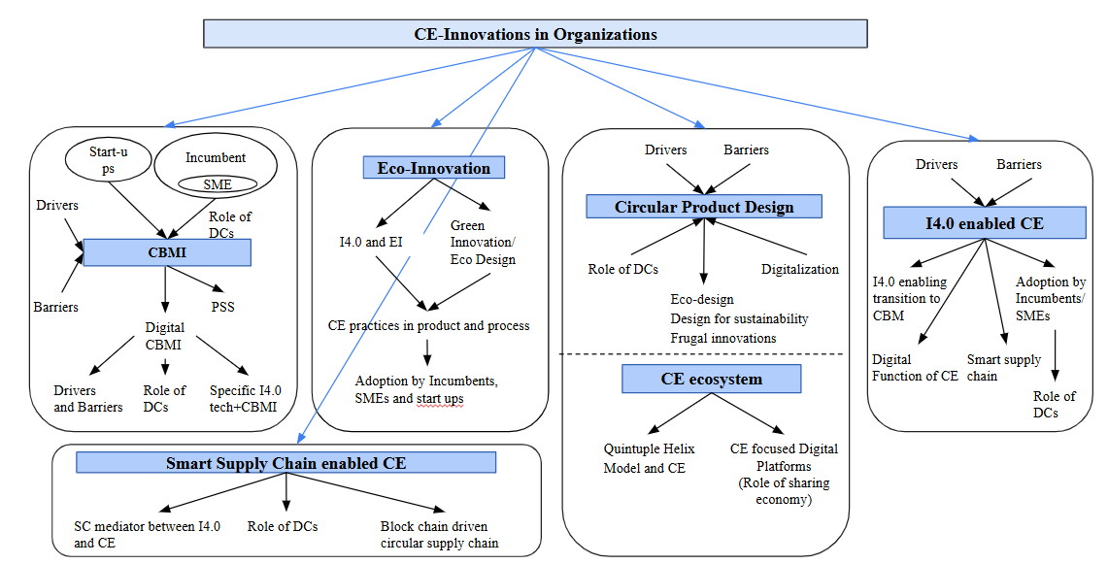
Fig 11: Framework of CE and Innovation Research

FUTURE LINES OF RESEARCH
List of future research prospects under each theme are mentioned below

Themes | Future Research Prospects
Attaining Circular Economy through Business Model Innovation | Future research should combine insights from strategic planning, entrepreneurship, and dynamic capabilities, considering inter-organizational and societal boundaries, and develop quantitative tools to support decision-making. It should implement circular economy indicators in different sectors, create metrics to measure  Various methodological techniques should validate results and identify applicable contexts. Structural analyses of circular innovations could distinguish between disruptive and incremental types, clarifying the elements that make innovations disruptive.  It is essential to investigate causal relationships between business models and systemic transformation, especially in industries such as fashion.  Possible research directions include increasing sample sizes, encouraging product innovations, and evaluating financial impacts.  Creating pilot projects to shift linear production chains to circular ones, especially in the brewing industry, and investigating stakeholder-focused models for resource circularity are crucial.  Further investigation into the role of digitalization in transitioning to a circular economy, improving CBMI processes, and validating the CEBMI Process Framework through case studies is essential.  Long-term studies following businesses from conceptualizing CE to full implementation and controlled case studies linking specific factors to CE outcomes are necessary.  Researching PSS business models for circular supply chains, exploring digitalization strategies for CBMs, and analyzing interconnected relationships among business elements can provide valuable insights for industrial decision-makers.  Research should investigate barriers specific to AI-enabled CBMs, conduct longitudinal studies to assess their long-term impact, compare performance outcomes, and explore stakeholder perspectives. Large-scale quantitative studies should validate these findings, delve into biological cycles of the circular economy, and compare sustainability-oriented practices against standard innovation cases.  Further research is needed to explore SMEs' capabilities in adopting digital technologies and understand the role of dynamic capabilities in transitioning to circular business models.  Future research should prioritize studying dynamic capabilities, exploring their variations across different types of circular business models, and investigating the applicability of the Lean Startup method in fostering innovation within circular business frameworks.
Attaining Circular Economy through Eco-Innovations (EI) | Further theoretical exploration of each stakeholder within the QHM is crucial to grasp their distinct characteristics and impacts on the model. Empirical studies are required to examine the Circular Economy's effects on climate change and evaluate the implementation of recommendations. Moreover, it is imperative to investigate successful instances of enhancing resource efficiency and reducing GHG emissions.  Future research should dynamically analyze the impact of circular eco-innovation on firm performance as longitudinal data becomes available. It is essential to investigate contextual factors influencing SME participation in the Circular Economy across different countries and industries. Additionally, there is a need for further studies to enhance eco-design capabilities in SMEs, given increasing interest in eco-design.  Future research could investigate variations in Circular Economy (CE) actions specific to sectors and countries, examining managerial behavior variables influencing these actions. Further studies should concentrate on developing environmental value propositions for firms adopting new CE business models and integrating the role of consumers in the circular economy transition.  Future studies should encompass a wider array of companies and quantitatively evaluate the influence of demographic shifts and digitization on eco-innovation and practices within the circular economy.
Attaining CE through Product, Process, and Eco-systems innovation | Future research should expand its scope to encompass broader product super-systems and incorporate additional factors into the evaluation framework to achieve more comprehensive analysis outcomes. This approach is essential for advancing future developments in patent evolution analysis.  Future research should explore various product categories across different industries and contexts to validate findings. Similar studies should be conducted in settings with varying industry and policy approaches to circular product development. Additionally, future research should consider perspectives from stakeholders at both meso and macro levels, as they mutually influence institutional reconfiguration patterns and value co-creation.  Research should investigate employee perceptions across roles and company sizes, exploring how diverse circular business models are influenced by varying business characteristics and strategic approaches to circular economy (CE). Larger sample sizes and longitudinal data are essential for validation, supplemented by empirical field experiments. Moreover, the study should connect product/service innovations with Circular Business Models (CBMs), expanding on capabilities identified for CE and product/service innovations.  Future research should focus on transforming linear business models into circular ones, identifying key processes and essential managerial capabilities needed. It should also consider how these capabilities interact with external factors such as market competition, customer demands, and technological advancements.  Research could explore additional factors influencing CPD adoption by integrating new elements and testing across diverse sectors or countries. Incorporating organizational theories could provide deeper insights, with further studies using case analyses to examine the impact of emerging technologies on company performance.
I4.0 enabled CE innovations | Future research could validate proposed relationships through surveys or experiments. Exploring blockchain-enabled business models could uncover economic benefits in both short and long terms, balancing profitability with environmental sustainability. Further inquiry into policy recommendations supporting blockchain innovation in the circular economy is also warranted.  Comprehensive empirical work, such as large-scale surveys or case studies, should be pursued to statistically verify proposed frameworks. Testing these propositions will confirm their validity, while deeper exploration into specific links between CE and the SDGs could expand upon this review.  Research should clarify how various technologies interact and complement each other, addressing barriers digital technologies pose to the circular economy. Investigating structural and dynamic changes in business models and ecosystems resulting from digital technology implementation is crucial. Moreover, studying potential rebound effects of smart circular economy initiatives, such as social impacts or increased energy consumption from digital technology adoption, is essential.  Future studies should involve additional stakeholders to strengthen findings through triangulation. Exploring industries with different contextual factors will broaden our understanding and applicability of research outcomes.
Attaining CE through Digitally enabled Supply chain | Future research should explore additional factors that might influence the relationship between R&D intensity and the adoption of Circular Supply Chain Management (CSCM), thereby enhancing our understanding. Moreover, future studies could extend this investigation by exploring how R&D intensity affects CSCM adoption in other emerging markets or developing regions. It is crucial to explore other facilitative factors for CSCM adoption within the current B2B context.  Future research should expand the current analysis by investigating specific technologies and activities throughout the value chain.  Future studies could employ methods such as structural equation modeling to examine how blockchain-driven dynamic capabilities impact the circular economy, potentially providing firms with a competitive edge. Furthermore, these findings could be corroborated through case studies in various sectors in future research.

References:

"A new circular economy action plan for a cleaner and more competitive Europe. Off. J. Eur. Union, COM/2020/98 final (2020)
https://eur-lex.europa.eu/resource.html?uri=cellar:9903b325-6388-11ea-b735-01aa75ed71a1.0017.02/DOC_1&format=PDF"
Abbate, S., Centobelli, P., & Cerchione, R. (2023). From Fast to Slow: An Exploratory Analysis of Circular Business Models in the Italian Apparel Industry. International Journal of Production Economics, 260, 108824.
Ahmad, F., Bask, A., Laari, S., & Robinson, C. V. (2023). Business management perspectives on the circular economy: Present state and future directions. Technological Forecasting and Social Change, 187, 122182.
Alam, G. M., Erdiaw-Kwasie, M. O., Nagy, G. J., & Leal Filho, W. (2021). Climate vulnerability and resilience in the Global South: Human adaptations for sustainable futures. Springer Nature. https://doi.org/10.1007/978-3-030-77259-8
Amend, C., Revellio, F., Tenner, I., & Schaltegger, S. (2022). The potential of modular product design on repair behavior and user experience – Evidence from the smartphone industry. Journal of Cleaner Production, 367, 132770. https://doi.org/10.1016/j.jclepro.2022.132770
Amoozad Mahdiraji, H., Govindan, K., Yaftiyan, F., Garza-Reyes, J. A., & Razavi Hajiagha, S. H. (2022). Unveiling coordination contracts’ roles considering circular economy and eco-innovation toward pharmaceutical supply chain resiliency: Evidence of an emerging economy. Journal of Cleaner Production, 382, 135135. https://doi.org/10.1016/j.jclepro.2022.135135
Angelis, R. D. (2022). Circular economy business models as resilient complex adaptive systems. Business Strategy and the Environment, 31(5), 2245-2255. https://doi.org/10.1002/bse.3019
Annarelli, A., Battistella, C., & Nonino, F. (2016). Product service system: A conceptual framework from a systematic review. Journal of cleaner production, 139, 1011-1032.
Antonioli, D., Ghisetti, C., Mazzanti, M., & Nicolli, F. (2022). Sustainable production: The economic returns of circular economy practices. Business Strategy and the Environment, 26(1), 95–115. https://doi.org/10.1002/bse.3046
Arekrans, J., Ritzén, S., & Laurenti, R. (2023). The role of radical innovation in circular strategy deployment. Business Strategy and the Environment, 32(3), 1085-1105.
Arranz, C. F., & Arroyabe, M. F. (2023). Institutional theory and circular economy business models: The case of the European Union and the role of consumption policies. Journal of Environmental Management, 340, 117906.
Bag, S., Dhamija, P., Bryde, D. J., & Singh, R. K. (2022). Effect of eco-innovation on green supply chain management, circular economy capability, and performance of small and medium enterprises. Journal of Business Research, 141, 60-72.
Bag, S., Dhamija, P., Bryde, D. J., & Singh, R. K. (2022). Effect of eco-innovation on green supply chain management, circular economy capability, and performance of small and medium enterprises. Journal of Business Research, 141, 60-72. https://doi.org/10.1016/j.jbusres.2021.12.011
Blomsma, F., Bauwens, T., Weissbrod, I., & Kirchherr, J. (2023). The ‘need for speed’: Towards circular disruption—What it is, how to make it happen and how to know it's happening. Business Strategy and the Environment, 32(3), 1010-1031. https://doi.org/10.1002/bse.3106
Blomsma, F., Tennant, M., & Ozaki, R. (2023). Making sense of circular economy: Understanding the progression from idea to action. Business Strategy and the Environment, 32(3), 1059-1084.
Bocken, N., & Konietzko, J. (2022). Circular business model innovation in consumer-facing corporations. Technological Forecasting and Social Change, 185, 122076. https://doi.org/10.1016/j.techfore.2022.122076
Böhmecke-Schwafert, M., Wehinger, M., & Teigland, R. (2022). Blockchain for the circular economy: Theorizing blockchain's role in the transition to a circular economy through an empirical investigation. Business Strategy and the Environment, 31(8), 3786-3801. https://doi.org/10.1002/bse.3032
Böhmecke‐Schwafert, M., Wehinger, M., & Teigland, R. (2022). Blockchain for the circular economy: Theorizing blockchain's role in the transition to a circular economy through an empirical investigation. Business Strategy and the Environment, 31(8), 3786-3801.
Brennan, G., Tennant, M., & Blomsma, F. (2015). Business and production solutions: Closing the Loop in Kopnina, H. and Shoreman-Ouimet, E.(Eds). Sustainability: Key Issues. EarthScan. Routledge.
Burke, H., Zhang, A., & Wang, J. X. (2023). Integrating product design and supply chain management for a circular economy. Production Planning & Control, 34(11), 1097-1113.
Cainelli, G., D’Amato, A., & Mazzanti, M. (2020). Resource efficient eco-innovations for a circular economy: Evidence from EU firms. Research Policy, 49(1), 103827. https://doi.org/10.1016/j.respol.2019.103827
Castro-Lopez, A., Iglesias, V., & Santos-Vijande, M. L. (2023). Organizational capabilities and institutional pressures in the adoption of circular economy. Journal of Business Research, 161, 113823. https://doi.org/10.1016/j.jbusres.2023.113823
Chabowski, B. R., Gabrielsson, P., Hult, G. T. M., & Morgeson III, F. V. (2023). Sustainable international business model innovations for a globalizing circular economy: a review and synthesis, integrative framework, and opportunities for future research. Journal of International Business Studies, 1-20.
Chari, A., Niedenzu, D., Despeisse, M., Machado, C. G., Azevedo, J. D., Boavida-Dias, R., & Johansson, B. (2022). Dynamic capabilities for circular manufacturing supply chains—Exploring the role of Industry 4.0 and resilience. Business Strategy and the Environment, 31(5), 2500-2517. https://doi.org/10.1002/bse.3040
Chaudhuri, A., Subramanian, N., & Dora, M. (2022). Circular economy and digital capabilities of SMEs for providing value to customers: Combined resource-based view and ambidexterity perspective. Journal of Business Research, 142, 32-44. https://doi.org/10.1016/j.jbusres.2021.12.039
Chauhan, C., Parida, V., & Dhir, A. (2022). Linking circular economy and digitalisation technologies: A systematic literature review of past achievements and future promises. Technological Forecasting and Social Change, 177, 121508. https://doi.org/10.1016/j.techfore.2022.121508
Chen, W. C., & Rau, H. (2023). A product evaluation and innovation process based on the circular design degree and patents evolution. Journal of Cleaner Production, 405, 136888. https://doi.org/10.1016/j.jclepro.2023.136888
Chen, X., Chen, L., Jiang, M., & Yan, J. (2021). Does R&D intensity promote the adoption of circular supply chain management? Evidence from China. Industrial Marketing Management, 99, 153-166. https://doi.org/10.1016/j.indmarman.2021.10.015
Ciani, A., Gambardella, A. and Pociovalisteanu, D.M. (2016), “Circular economy and sustainable rural development. Theory and best practice: a challenge for Romania”, Annals- Economy Series, Vol. 1, pp. 52-56.
Cordella, M., Alfieri, F., Sanfelix, J., Donatello, S., Kaps, R., & Wolf, O. (2020). Improving material efficiency in the life cycle of products: a review of EU Ecolabel criteria. The International Journal of Life Cycle Assessment, 25, 921-935.
Costanza, F. (2023). When the business is circular and social: A dynamic grounded analysis in the clothing recycle. Journal of Cleaner Production, 382, 135216.
De Jesus, A. and Mendonça, S. (2018), “Lost in transition? Drivers and barriers in the eco-innovation road to the circular economy”, Ecological Economics, Vol. 145 No. 3, pp. 75-89.
De Jesus, A., & Mendonça, S. (2018). Lost in transition? Drivers and barriers in the eco-innovation road to the circular economy. Ecological economics, 145, 75-89.
De Jesus, A., & Mendonça, S. (2018). Lost in Transition? Drivers and Barriers in the Eco-innovation Road to the Circular Economy. Ecological Economics, 145, 75-89. https://doi.org/10.1016/j.ecolecon.2017.08.001
De Jesus, A., Antunes, P., Santos, R., & Mendonça, S. (2018). Eco-innovation in the transition to a circular economy: An analytical literature review. Journal of Cleaner Production, 172, 2999-3018. https://doi.org/10.1016/j.jclepro.2017.11.111
De Jesus, A., Antunes, P., Santos, R., & Mendonça, S. (2019). Eco-innovation pathways to a circular economy: Envisioning priorities through a Delphi approach. Journal of Cleaner Production, 228, 1494-1513. https://doi.org/10.1016/j.jclepro.2019.04.049
Demirel, P., & Danisman, G. O. (2019). Eco-innovation and firm growth in the circular economy: Evidence from European small- and medium-sized enterprises. Business Strategy and the Environment, 28(8), 1608-1618. https://doi.org/10.1002/bse.2336
DiVito, L., Leitheiser, E., & Piller, C. (2022). Circular Moonshot: Understanding Shifts in Organizational Field Logics and Business Model Innovation. Organization & Environment. https://doi.org/10.1177/10860266221111587
Durán-Romero, G., López, A. M., Beliaeva, T., Ferasso, M., Garonne, C., & Jones, P. (2020). Bridging the gap between circular economy and climate change mitigation policies through eco-innovations and Quintuple Helix Model. Technological Forecasting and Social Change, 160, 120246. https://doi.org/10.1016/j.techfore.2020.120246
EEA Report (2016), “Circular economy in Europe: developing the knowledge base”, Luxembourg, available at: www.socialistsanddemocrats.eu/sites/default/files/Circular%20economy%20in%20Europe.pdf
EMF (2012), Towards the Circular Economy – Economic and Business Rationale for an Accelerated Transition, Vol. 1, Ellen MacArthur Foundation, Isle of Wight.
EMF (2013), Towards the Circular Economy: Opportunities for the Consumer Goods Sector, Ellen MacArthur Foundation, Isle of Wight
European Commission. (2011). Communication from the Commission to the European Parliament, the Council, the European Economic and Social Committee and the Committee of the Regions Youth Opportunities Initiative. Brussels, Belgium: European Commission.
Evertsen, P. H., Rasmussen, E., & Nenadic, O. (2022). Commercializing circular economy innovations: A taxonomy of academic spin-offs. Technological Forecasting and Social Change, 185, 122102.
Fernandez de Arroyabe, J., Arranz, N., Schumann, M., & Arroyabe, M. (2021). The development of CE business models in firms: The role of circular economy capabilities. Technovation, 106, 102292. https://doi.org/10.1016/j.technovation.2021.102292
Findik, D., Tirgil, A., & Özbuğday, F. C. (2023). Industry 4.0 as an enabler of circular economy practices: Evidence from European SMEs. Journal of Cleaner Production, 410, 137281. https://doi.org/10.1016/j.jclepro.2023.137281
For certain consumer goods (food, beverages, textiles and packaging) a global potential of $700bn per year in material savings is estimated, that is, about 20 per cent of the material input costs in these sectors (EMF, 2013)
Frishammar, J., & Parida, V. (2019). Circular business model transformation: A roadmap for incumbent firms. California Management Review, 61(2), 5-29.
Gebhardt, M., Kopyto, M., Birkel, H., & Hartmann, E. (2022). Industry 4.0 technologies as enablers of collaboration in circular supply chains: A systematic literature review. International Journal of Production Research, 60(23), 6967-6995.
Geissdoerfer, M., Morioka, S. N., de Carvalho, M. M., & Evans, S. (2018). Business models and supply chains for the circular economy. Journal of cleaner production, 190, 712-721.
Geissdoerfer, M., Morioka, S. N., De Carvalho, M. M., & Evans, S. (2018). Business models and supply chains for the circular economy. Journal of Cleaner Production, 190, 712-721. https://doi.org/10.1016/j.jclepro.2018.04.159
Geissdoerfer, M., Pieroni, M. P., Pigosso, D. C., & Soufani, K. (2020). Circular business models: A review. Journal of Cleaner Production, 277, 123741. https://doi.org/10.1016/j.jclepro.2020.123741
Geissdoerfer, M., Santa-Maria, T., Kirchherr, J., & Pelzeter, C. (2023). Drivers and barriers for circular business model innovation. Business Strategy and the Environment, 32(6), 3814-3832. https://doi.org/10.1002/bse.3339
Geissdoerfer, M., Santa‐Maria, T., Kirchherr, J., & Pelzeter, C. (2023). Drivers and barriers for circular business model innovation. Business Strategy and the Environment, 32(6), 3814-3832.
Geissdoerfer, M., Savaget, P., Bocken, N. M., & Hultink, E. J. (2017). The Circular Economy – A new sustainability paradigm? Journal of Cleaner Production, 143, 757-768. https://doi.org/10.1016/j.jclepro.2016.12.048
Geissdoerfer, M., Savaget, P., Bocken, N. M., & Hultink, E. J. (2017). The Circular Economy–A new sustainability paradigm?. Journal of cleaner production, 143, 757-768.
Genovese, A., Acquaye, A. A., Figueroa, A., & Koh, S. L. (2017). Sustainable supply chain management and the transition towards a circular economy: Evidence and some applications. Omega, 66, 344–357. https://doi.org/10.1016/j.omega.2015.05.015
Ghafoor, S., Hosseini, M. R., Kocaturk, T., Weiss, M., & Barnett, M. (2023). The product-service system approach for housing in a circular economy: An integrative literature review. Journal of Cleaner Production, 403, 136845. https://doi.org/10.1016/j.jclepro.2023.136845
Ghisellini, P., Cialani, C., & Ulgiati, S. (2016). A review on circular economy: the expected transition to a balanced interplay of environmental and economic systems. Journal of Cleaner production, 114, 11-32.
Gnekpe, C., & Plantec, Q. (2023). Regulatory push-pull and technological knowledge dynamics of circular economy innovation. Technological Forecasting and Social Change, 196, 122767.
Guldmann, E., & Huulgaard, R. D. (2020). Barriers to circular business model innovation: A multiple-case study. Journal of cleaner production, 243, 118160. https://doi.org/10.1016/j.jclepro.2019.118160
Gusmerotti, N. M., Testa, F., Corsini, F., Pretner, G., & Iraldo, F. (2019). Drivers and approaches to the circular economy in manufacturing firms. Journal of Cleaner Production, 230, 314-327.
Heyes, G., Sharmina, M., Mendoza, J. M. F., Gallego-Schmid, A., & Azapagic, A. (2018). Developing and implementing circular economy business models in service-oriented technology companies. Journal of Cleaner Production, 177, 621-632. https://doi.org/10.1016/j.jclepro.2017.12.168
Hina, M., Chauhan, C., Kaur, P., Kraus, S., & Dhir, A. (2022). Drivers and barriers of circular economy business models: Where we are now, and where we are heading. Journal of Cleaner Production, 333, 130049.
Hofmann, F., & Jaeger-Erben, M. (2020). Organizational transition management of circular business model innovations. Business Strategy and the Environment, 29(6), 2770-2788. https://doi.org/10.1002/bse.2542
Hojnik, J., Ruzzier, M., Konečnik Ruzzier, M., Sučić, B., & Soltwisch, B. (2023). Challenges of demographic changes and digitalization on eco-innovation and the circular economy: Qualitative insights from companies. Journal of Cleaner Production, 396, 136439. https://doi.org/10.1016/j.jclepro.2023.136439
Hojnik, J., Ruzzier, M., Ruzzier, M. K., Sučić, B., & Soltwisch, B. (2023). Challenges of demographic changes and digitalization on eco-innovation and the circular economy: Qualitative insights from companies. Journal of Cleaner Production, 396, 136439.
Iacovidou, E., Hahladakis, J. N., & Purnell, P. (2021). A systems thinking approach to understanding the challenges of achieving the circular economy. Environmental Science and Pollution Research, 28, 24785-24806.
Jabbour, C. J. C., Fiorini, P. D. C., Wong, C. W., Jugend, D., Jabbour, A. B. L. D. S., Seles, B. M. R. P., Pinheiro, M. A. P., & da Silva, H. M. R. (2020). First-mover firms in the transition towards the sharing economy in metallic natural resource-intensive industries: Implications for the circular economy and emerging industry 4.0 technologies. Resources Policy, 66, 101596. https://doi.org/10.1016/j.resourpol.2020.101596
Jackson, T. (2009). Prosperity without growth: Economics for a finite planet. Routledge.
Joensuu, T., Edelman, H., & Saari, A. (2020). Circular economy practices in the built environment. Journal of Cleaner Production, 276, 124215. https://doi.org/10.1016/j.jclepro.2020.124215
Jugend, D., Garrido, S., Siqueira, R. M., & Mesa, J. A. (2024). Circular product design challenges: An exploratory study on critical barriers. Business Strategy and the Environment. https://doi.org/10.1002/bse.3703
Julkovski, D. J., Sehnem, S., Ramos, C. P., & Chiappetta Jabbour, C. J. (2023). Circular business models and the environment: Maturity levels of the circular economy and innovation in greener craft breweries. Business Strategy and the Environment, 32(6), 3465-3488. https://doi.org/10.1002/bse.3311
Kennedy, S., & Linnenluecke, M. K. (2022). Circular economy and resilience: A research agenda. Business Strategy and the Environment, 1–12. https://doi.org/10.1002/bse.3004
Kessler, M. M. (1963). Bibliographic coupling between scientific papers. American documentation, 14(1), 10-25.
Khan, K., Su, C. W., & Khurshid, A. (2022). Circular economy: The silver bullet for emissions?. Journal of Cleaner Production, 379, 134819.
Kiefer, C. P., & Carrillo-Hermosilla, J. (2021). On the contribution of eco-innovation features to a circular economy: A microlevel quantitative approach. Business Strategy and the Environment, 30(4), 1531-1547. https://doi.org/10.1002/bse.2688
Kirchherr, J., Piscicelli, L., Bour, R., Kostense-Smit, E., Muller, J., Huibrechtse-Truijens, A., & Hekkert, M. (2018). Barriers to the circular economy: Evidence from the European Union (EU). Ecological economics, 150, 264-272.
Kouhizadeh, M., Zhu, Q., & Sarkis, J. (2020). Blockchain and the circular economy: potential tensions and critical reflections from practice. Production Planning & Control, 31(11-12), 950-966.
Kuhlmann, M., Bening, C. R., & Hoffmann, V. H. (2023). How incumbents realize disruptive circular innovation - Overcoming the innovator's dilemma for a circular economy. Business Strategy and the Environment, 32(3), 1106-1121. https://doi.org/10.1002/bse.3109
Kuhlmann, M., Bening, C. R., & Hoffmann, V. H. (2023). How incumbents realize disruptive circular innovation‐Overcoming the innovator's dilemma for a circular economy. Business Strategy and the Environment, 32(3), 1106-1121.
Lee, S. M., & Trimi, S. (2021). Convergence innovation in the digital age and in the COVID-19 pandemic crisis. Journal of Business Research, 123, 14-22.
Lieder, M., & Rashid, A. (2016). Towards circular economy implementation: a comprehensive review in context of manufacturing industry. Journal of cleaner production, 115, 36-51.
Linder, M. and Williander, M. (2017), “Circular business model innovation: inherent Ncertainties”, Business Strategy and the Environment, Vol. 26 No. 2, pp. 182-196
Linder, M., & Williander, M. (2017). Circular Business Model Innovation: Inherent Uncertainties. Business Strategy and the Environment, 26(2), 182-196. https://doi.org/10.1002/bse.1906
Liu, Q., Trevisan, A. H., Yang, M., & Mascarenhas, J. (2022). A framework of digital technologies for the circular economy: Digital functions and mechanisms. Business Strategy and the Environment, 31(5), 2171-2192. https://doi.org/10.1002/bse.3015
Liu, Z., Han, S., Yao, M., Gupta, S., & Laguir, I. (2023). Exploring drivers of eco-innovation in manufacturing firms’ circular economy transition: an awareness, motivation, capability perspective. Annals of Operations Research, 1-36.
Lopez, F. J. D., Bastein, T., & Tukker, A. (2019). Business model innovation for resource-efficiency, circularity and cleaner production: What 143 cases tell us. Ecological Economics, 155, 20-35.
Lu, H., Zhao, G., & Liu, S. (2024). Integrating circular economy and Industry 4.0 for sustainable supply chain management: A dynamic capability view. Production Planning & Control, 35(2), 170-186.
Lyeonov, S., Pimonenko, T., Bilan, Y., Štreimikiene, D., & Mentel, G. (2019). Assessment of green investments' impact on sustainable development: Linking gross domestic product per capita, greenhouse gas emissions and renewable energy. Energies, 12(20), 3891. https://doi.org/10.3390/en12203891
Madanaguli, A., Sjödin, D., Parida, V., & Mikalef, P. (2024). Artificial intelligence capabilities for circular business models: Research synthesis and future agenda. Technological Forecasting and Social Change, 200, 123189. https://doi.org/10.1016/j.techfore.2023.123189
Maher, R., Yarnold, J., & Pushpamali, N. (2023). Circular economy 4 business: A program and framework for small-to-medium enterprises (SMEs) with three case studies. Journal of Cleaner Production, 412, 137114. https://doi.org/10.1016/j.jclepro.2023.137114
Maria, E. D., Marchi, V. D., & Galeazzo, A. (2022). Industry 4.0 technologies and circular economy: The mediating role of supply chain integration. Business Strategy and the Environment, 31(2), 619-632. https://doi.org/10.1002/bse.2940
Markard, J., Raven, R., & Truffer, B. (2012). Sustainability transitions: An emerging field of research and its prospects. Research policy, 41(6), 955-967.
Missemer, A. (2018), “Natural Capital as an economic concept, history and contemporary issues”, Ecological Economics, Vol. 143 No. C, pp. 90-96.
Moktadir, M. A., Kumar, A., Ali, S. M., Paul, S. K., Sultana, R., & Rezaei, J. (2020). Critical success factors for a circular economy: Implications for business strategy and the environment. Business Strategy and the Environment, 29(8), 3611–3635. https://doi.org/10.1002/bse.2600
Momeni, M. A., Jain, V., Govindan, K., Mostofi, A., & Fazel, S. J. (2022). A novel buy-back contract coordination mechanism for a manufacturer-retailer circular supply chain regenerating expired products. Journal of Cleaner Production, 375, 133319.
Moreno, M., Delos Rios, C., Rowe, Z. and Charnley, F. (2016), “A conceptual framework for circular design”, Sustainability, Vol. 8 No. 9, p. 937.
Moshood, T. D., Nawanir, G., Mahmud, F., Mohamad, F., Ahmad, M. H., AbdulGhani, A., & Kumar, S. (2022). Green product innovation: A means towards achieving global sustainable product within biodegradable plastic industry. Journal of Cleaner Production, 363, 132506.
Munaro, M. R., Tavares, S. F., & Bragança, L. (2020). Towards circular and more sustainable buildings: A systematic literature review on the circular economy in the built environment. Journal of Cleaner Production, 260, 121134. https://doi.org/10.1016/j.jclepro.2020.121134
Nascimento, M., Moyano-Fuentes, J., Maqueira Marín, J. M., & Garza-Reyes, J. A. (2024). Interrelationships between circular economy and Industry 4.0: A research agenda for sustainable supply chains. Business Strategy and the Environment, 33(2), 575-596. https://doi.org/10.1002/bse.3502
Neligan, A., Baumgartner, R. J., Geissdoerfer, M., & Schöggl, P. (2023). Circular disruption: Digitalisation as a driver of circular economy business models. Business Strategy and the Environment, 32(3), 1175-1188. https://doi.org/10.1002/bse.3100
Nußholz, J. L. (2018). A circular business model mapping tool for creating value from prolonged product lifetime and closed material loops. Journal of Cleaner Production, 197, 185-194. https://doi.org/10.1016/j.jclepro.2018.06.112
Oghazi, P., Mostaghel, R., & Hultman, M. (2024). International industrial manufacturers: Mastering the era of digital innovation and circular economy. Technological Forecasting and Social Change, 201, 123160. https://doi.org/10.1016/j.techfore.2023.123160
Okorie, O., Salonitis, K., Charnley, F., Moreno, M., Turner, C., & Tiwari, A. (2018). Digitisation and the circular economy: A review of current research and future trends. Energies, 11(11), 3009.
Patyal, V. S., Sarma, P. R. S., Modgil, S., Nag, T., & Dennehy, D. (2022). Mapping the links between Industry 4.0, circular economy and sustainability: A systematic literature review. Journal of Enterprise Information Management, 35(1), 1-35.
Paula Pinheiro, M. A., Jugend, D., Jabbour, S., Chiappetta Jabbour, C. J., & Latan, H. (2021). Circular economy-based new products and company performance: The role of stakeholders and Industry 4.0 technologies. Business Strategy and the Environment, 31(1), 483-499. https://doi.org/10.1002/bse.2905
Pieroni, M. P., McAloone, T. C., & Pigosso, D. C. (2019). Business model innovation for circular economy and sustainability: A review of approaches. Journal of Cleaner Production, 215, 198-216. https://doi.org/10.1016/j.jclepro.2019.01.036
Pieroni, M. P., McAloone, T. C., & Pigosso, D. C. (2021). Circular economy business model innovation: Sectorial patterns within manufacturing companies. Journal of Cleaner Production, 286, 124921. https://doi.org/10.1016/j.jclepro.2020.124921
Pollard, J., Osmani, M., Cole, C., Grubnic, S., & Colwill, J. (2021). A circular economy business model innovation process for the electrical and electronic equipment sector. Journal of Cleaner Production, 305, 127211. https://doi.org/10.1016/j.jclepro.2021.127211
Prasanna, R. P. I. R., Jayasundara, J. M. S. B., Naradda Gamage, S. K., Ekanayake, E. M. S., Rajapakshe, P. S. K., & Abeyrathne, G. A. K. N. J. (2019). Sustainability of SMEs in the competition: A systemic review on technological challenges and SME performance. Journal of Open Innovation: Technology, Market, and Complexity, 5(4), 100.
Prieto-Sandoval, V., Jaca, C., & Ormazabal, M. (2018). Towards a consensus on the circular economy. Journal of cleaner production, 179, 605-615.
Prieto-Sandoval, V., Jaca, C., & Ormazabal, M. (2018). Towards a consensus on the circular economy. Journal of Cleaner Production, 179, 605-615. https://doi.org/10.1016/j.jclepro.2017.12.224
Quayson, M., Bai, C., Sun, L., & Sarkis, J. (2023). Building blockchain-driven dynamic capabilities for developing circular supply chain: Rethinking the role of sensing, seizing, and reconfiguring. Business Strategy and the Environment, 32(7), 4821-4840. https://doi.org/10.1002/bse.3395
Ranta, V., Keränen, J., & Aarikka-Stenroos, L. (2020). How B2B suppliers articulate customer value propositions in the circular economy: Four innovation-driven value creation logics. Industrial Marketing Management, 87, 291-305.
Ren, Q., & Albrecht, J. (2023). Toward circular economy: The impact of policy instruments on circular economy innovation for European small medium enterprises. Ecological Economics, 207, 107761. https://doi.org/10.1016/j.ecolecon.2023.107761
Rocca, L., Veneziani, M., & Carini, C. (2023). Mapping the diffusion of circular economy good practices: Success factors and sustainable challenges. Business Strategy and the Environment, 32(4), 2035-2048. https://doi.org/10.1002/bse.3235
Rossi, E., Bertassini, A. C., Ferreira, C. D. S., Neves do Amaral, W. A., & Ometto, A. R. (2020). Circular economy indicators for organizations considering sustainability and business models: Plastic, textile and electro-electronic cases. Journal of Cleaner Production, 247, 119137. https://doi.org/10.1016/j.jclepro.2019.119137
Saari, U. A., Damberg, S., Schneider, M., Aarikka-Stenroos, L., Herstatt, C., Lanz, M., & Ringle, C. M. (2023). Capabilities for circular economy innovation: Factors leading to product/service innovations in the construction and manufacturing industries. Journal of Cleaner Production, 434, 140295. https://doi.org/10.1016/j.jclepro.2023.140295
Saide, S., & Sheng, M. L. (2023). ICT team dual-innovations in the microlevel of circular supply chain management: explicit-tacit knowledge, exchange ideology, and leadership support. IEEE Transactions on Engineering Management.
Salmenperä, H., Pitkänen, K., Kautto, P., & Saikku, L. (2021). Critical factors for enhancing the circular economy in waste management. Journal of Cleaner Production, 280, 124339. https://doi.org/10.1016/j.jclepro.2020.124339
Salvador, R., Puglieri, F. N., Halog, A., Andrade, F. G. D., Piekarski, C. M., & De Francisco, A. C. (2020). Key aspects for designing business models for a circular bioeconomy. Journal of Cleaner Production, 278, 124341. https://doi.org/10.1016/j.jclepro.2020.124341
Santa-Maria, T., V. Vermeulen, W. J., & Baumgartner, R. J. (2022). How do incumbent firms innovate their business models for the circular economy? Identifying micro-foundations of dynamic capabilities. Business Strategy and the Environment, 31(4), 1308-1333. https://doi.org/10.1002/bse.2956
Scarpellini, S., Valero-Gil, J., Moneva, J. M., & Andreaus, M. (2020). Environmental management capabilities for a “circular eco-innovation”. Business Strategy and the Environment, 29(5), 1850-1864. https://doi.org/10.1002/bse.2472
Sehnem, S., de Queiroz, A. A. F. S., Pereira, S. C. F., dos Santos Correia, G., & Kuzma, E. (2022). Circular economy and innovation: A look from the perspective of organizational capabilities. Business Strategy and the Environment, 31(1), 236-250.
Sehnem, S., Provensi, T., & Farias Pereira, S. C. (2022). Disruptive innovation and circularity in start-ups: A path to sustainable development. Business Strategy and the Environment, 31(4), 1292-1307. https://doi.org/10.1002/bse.2955
Shao, J., Aneye, C., Kharitonova, A., & Fang, W. (2023). Essential innovation capability of producer-service enterprises towards circular business model: Motivators and barriers. Business Strategy and the Environment, 32(7), 4548-4567. https://doi.org/10.1002/bse.3380
Sjödin, D., Parida, V., & Kohtamäki, M. (2023). Artificial intelligence enabling circular business model innovation in digital servitization: Conceptualizing dynamic capabilities, AI capacities, business models and effects. Technological Forecasting and Social Change, 197, 122903.
Sjödin, D., Parida, V., & Kohtamäki, M. (2023). Artificial intelligence enabling circular business model innovation in digital servitization: Conceptualizing dynamic capabilities, AI capacities, business models and effects. Technological Forecasting and Social Change, 197, 122903. https://doi.org/10.1016/j.techfore.2023.122903
Spieth, P., Schneckenberg, D., & Ricart, J. E. (2014). Business model innovation–state of the art and future challenges for the field. R&d Management, 44(3), 237-247.
Stahel, W. R. (2019). The circular economy: A user's guide. Routledge.
Suchek, N., Fernandes, C. I., Kraus, S., Filser, M., & Sjögrén, H. (2021). Innovation and the circular economy: A systematic literature review. Business Strategy and the Environment, 30(8), 3686-3702.
Toth-Peter, A., de Oliveira, R. T., Mathews, S., Barner, L., & Figueira, S. (2023). Industry 4.0 as an enabler in transitioning to circular business models: A systematic literature review. Journal of Cleaner Production, 136284.
Toth-Peter, A., Torres de Oliveira, R., Mathews, S., Barner, L., & Figueira, S. (2023). Industry 4.0 as an enabler in transitioning to circular business models: A systematic literature review. Journal of Cleaner Production, 393, 136284. https://doi.org/10.1016/j.jclepro.2023.136284
Triguero, Á., Cuerva, M. C., & Sáez-Martínez, F. J. (2022). Closing the loop through eco-innovation by European firms: Circular economy for sustainable development. Business Strategy and the Environment, 31, 2337–2350. https://doi.org/10.1002/bse.3024
Triguero, Á., Cuerva, M. C., & Sáez-Martínez, F. J. (2022). Closing the loop through eco-innovation by European firms: Circular economy for sustainable development. Business Strategy and the Environment, 31(5), 2337-2350. https://doi.org/10.1002/bse.3024
Triguero, Á., Cuerva, M. C., & Sáez‐Martínez, F. J. (2022). Closing the loop through eco‐innovation by European firms: Circular economy for sustainable development. Business Strategy and the Environment, 31(5), 2337-2350.
Ul-Durar, S., Awan, U., Varma, A., Memon, S., & Mention, A. L. (2023). Integrating knowledge management and orientation dynamics for organization transition from eco-innovation to circular economy. Journal of Knowledge Management, 27(8), 2217-2248.
Urbinati, A., Chiaroni, D., & Chiesa, V. (2017). Towards a new taxonomy of circular economy business models. Journal of Cleaner Production, 168, 487–498. https://doi.org/10.1016/j.jclepro.2017.09.047
Van Eechoud, T., & Ganzaroli, A. (2023). Exploring the role of dynamic capabilities in digital circular business model innovation: Results from a grounded systematic inductive analysis of 7 case studies. Journal of Cleaner Production, 401, 136665. https://doi.org/10.1016/j.jclepro.2023.136665
Vellesalu, A., Chkanikova, O., Hjelmgren, D., & Salomonson, N. (2023). Institutional re-configuration and value co-creation in circular product development: A service ecosystem perspective in the textile and apparel industry. Journal of Cleaner Production, 414, 137682. https://doi.org/10.1016/j.jclepro.2023.137682
Wade, B., Meath, C., & Griffiths, A. (2022). Capabilities for circularity: Overcoming challenges to turn waste into a resource. Business Strategy and the Environment, 31(6), 2658-2681. https://doi.org/10.1002/bse.2998
Wang, H., Masi, D., Dhamotharan, L., Day, S., Kumar, A., Li, T., & Singh, G. (2022). Unconventional path dependence: How adopting product take-back and recycling systems contributes to future eco-innovations. Journal of Business Research, 142, 707-717. https://doi.org/10.1016/j.jbusres.2021.12.057
World Wide Fund for Nature. (2002). Living planet report. The Fund.
Yang, M., Smart, P., Kumar, M., Jolly, M., & Evans, S. (2018). Product-service systems business models for circular supply chains. Production Planning & Control, 29(6), 498-508.
Zikopoulos, C. (2022). On the effect of upgradable products design on circular economy. International Journal of Production Economics, 254, 108629. https://doi.org/10.1016/j.ijpe.2022.108629

