Cerebral imagining and the role of governance in developing entrepreneurial ecosystems
Michael Andrew Bailey, MA, MBA, PhD Student
University of North Carolina at Greensboro
Bryan School of Business and Economics
516 Stirling Street, Greensboro, NC 27412
Mabailey2@uncg.edu
+1 (207) 801-8739
Cerebral imagining and the role of governance in developing entrepreneurial ecosystems
ABSTRACT
Research on entrepreneurial ecosystems (EE) has recently refined unique elements that differentiate heterogeneity between environmental conditions for entrepreneurship. Previous studies have applied these elements to the known stages of entrepreneurial enterprises to analyze their influence on various outcomes of interest. Entrepreneurial action theory has recently revealed a previously unconceptualized temporal starting point in the entrepreneurs contemplation of uncertainty in the decision of starting a venture: the cerebral imagining. As an envisioning of actions through interaction with the EE are an unexplored dynamic. Adopting the structural approach of EEs, this study examines the cerebral narrative and intent to start a business across a 55-country sample, exploring the role these elements play in sizing up venture uncertainty, across economies. Findings suggest that governmental and policy frameworks extend support into this earliest stage of entrepreneurship in developing economies. More generally, the conventional methods available to entrepreneurs to evaluate uncertainty (e.g., market analysis, prototyping, data collection) may be expandable to environmental conditions unique within their environment.
INTRODUCTION
Extant literature has developed an intuitive elaboration of how an entrepreneur makes the decision to act in pursuit of an entrepreneurial endeavor, prefaced by the understanding that she does so in the face of great uncertainty (Wood, Bakker, & Fischer, 2021). Uncertainty, here is nontrivial, with direct ties between exogenous variables (e.g., markets) and entrepreneurial outcomes (Agnus et al., 2022). In the earliest contemplation, the entrepreneur's choices of action and the resulting consequences are truly unknowable and exist only as mental models of reality (Johnson-Laird, 1983). As Wood et al. (2021) conceptualize, the entrepreneur vividly imagines the path forward, as a cerebral exercise, envisioning the future endeavor’s creation as a series of possible actions (see also, Lachmann, 1976; Shackle, 1969, 1979). Entrepreneurial action theory argues this is no different than the uncertainty mitigation techniques (e.g., market testing and prototyping), only in the absence of interaction and feedback in the form of consequence and informed contingencies (Agnus et al., 2022; Wood et al., 2021).
There exist two primary streams of literature that stand to benefit theoretically from the application of this newly conceptualized temporality: 1) the entrepreneurial ecosystem (EE) factors that interact with the data processing, measurement, search, and observation of nascent entrepreneurs as they contemplate endeavoring (Agnus et al., 2022); and 2) where differences in ecosystems matter to entrepreneurs of varying socioeconomic circumstances during this decision (Welter et al., 2017). To date, literature on this earliest phase, coined the “conception” phase merely assumes that environmental factors influence the emergence of opportunities and the imagining of resource orchestration and time allocation (Reynolds & White, 1997; Busenitz et al., 2014; Liñán & Fayolle, 2015; George et al., 2016). Entrepreneur and entrepreneurship types are as diverse and nuanced as their ecosystems across the globe, making it imperative to draw attention to underdeveloped nations to understand these differences, shifting the focus of EE literature toward compelling global issues (Guerrero et al., 2021).
The purpose of this paper is to identify the unique combination of EE factors that entrepreneurs analyze during the conception phase, per type of economy. Specifically, this investigation is focused on the interaction of various EE factors in the cerebral process of imagining the formation of an entrepreneurial venture, providing an expansion of the boundary conditions to this earliest temporality. Based on the Global Entrepreneurship Monitor (GEM) Adult Population Survey, comprising 36,588 entrepreneur respondents from 55 countries, I conduct a longitudinal analysis of nascent entrepreneurs’ start up intent as it relates to eight pillars (as defined and measured by the World Economic Forum) of the entrepreneurial ecosystem they reside. I examine the extension of the role of government and policy frameworks in developing economies to the cerebral imagining of navigating entrepreneurial uncertainties. Further, I draw distinction between the unique role that government and policy frameworks play in developing economies versus developed economies, across the globe.
This study provides an original contribution to the literatures expansion of individual entrepreneurs assessment of the ecosystem within which they reside. It expands upon the earliest conceptualized notion of contemplating entrepreneurship beyond the business planning and opportunity identification mechanisms of uncertainty navigation. This extension provides suggestion for the role of the various components of the EE in the contemplation, evaluating, and accepting entrepreneurial uncertainty beyond what can be found within extant literature. Finally, it confirms the role of government and policy in developing economies identified as critical for later stage entrepreneurial activities.

THEORY & HYPOTHESIS
The act of entrepreneurship can be defined as a creative process of introducing something new and of value within an EE, with strategizing toward allocating resources to this end (Kansheba & Wald, 2020; Shepherd et al, 2018). Because the initial conception of a new idea has unknowable outcomes or “paths” forward, the temporal nature of entrepreneurship has a point of origin prior to the decision of entry, a dimension of entrepreneurial stages that has not been explored until recently. Where previous works point to the timing of entry as the first act an entrepreneur can make (Wood et al., 2021), the imagining of coordination leading up to entry must be heavily reliant upon such cerebral works (Haynie et al., 2010; Yilmaz, 2023). As an exciting new avenue of analysis, more traditional tools of navigating uncertainty cannot be employed by the entrepreneur (e.g., prototyping) and the EE itself becomes a key element of business planning, a combination of factors that facilitate the entrepreneur in pursuing an opportunity (Angus et al., 2023).
Early to Earliest Stage of Entrepreneurship
Recent developments in entrepreneurial action theory’s temporal nature suggest that a critical component of an entrepreneur’s navigation of entrepreneurship itself, begins at a purely cerebral imagining of a path forward, an estimation of impossibly uncertain outcomes of that action path and a series of contingencies to thwart less than ideal outcomes (Wood et al., 2021). The nature of entrepreneurial action conceptually changes beyond the explicit strategizing and orchestration of resources to a purely mental series of hypothetical actions and outcomes. This insightful first phase predicts future actions of the entrepreneur, including subsequent “initialization” (timing of entry). Foundational work shifted the focus from the entrepreneurial dynamics influencing the EE, to the EE’s influence on the entrepreneurial process (Acs et al., 2014; Acs et al., 2016; Feldman & Lowe, 2014; Isenberg, 2010; Malecki, 2018). Despite progress toward this end, the role of the EE during this cerebral phase remains less understood. This phase represents a breakdown of the feedback characteristic of the scientific method many entrepreneurs employ: experimentation, feedback analysis, and alter their personal theories (Zellweger & Zenger, 2023). Ali & Jabeen (2022) pioneer a conceptual model applying a theory of planned behavior that yields insights into the imaginative processes within this early stage. Aside from key demographics, the entrepreneur’s perception of attitudes towards entrepreneurship, the social norms towards entrepreneurship, and perceived behavioral control the entrepreneur thinks towards venturing. Together, these four factors constitute the prescribed mental model towards intent to start a business: however, this model as only been proven in a static, limited context.
Entrepreneurial Ecosystems
While defining EEs has taken various forms in its early conceptualization, a modern definition is a set of coordinated factors and independent actors that facilitate entrepreneurship within a geographical boundary (De Brito & Leitão, 2021). The entrepreneur is fundamentally a stock of creative human capital, an “actor” within an EE, colliding with the “factors” that are the support of the ecosystem and creates subsequent additional network interactions, creating a positive feedback loop resulting in a chain reaction of events that ignite an entrepreneurial action (Gonzalez & Dentchev, 2020). Of the analytical approaches taken, the structural view of EEs, that is the aspects of support they provide entrepreneurs, is proven as the most robust avenue of analysis (Urbano, Aparicio, & Audretsch, 2019). The entrepreneurial action theory’s development has benefitted greatly from this more holistic analysis of actor and factor interactions. Recent developments in the structure of these support systems and the most infant state of entrepreneurial action, the “cerebral act” of imagining a new venture, create insight new boundary conditions between an entrepreneur and her ecosystem. More simply stated, the locus of entrepreneurial action must take place in the mind of the entrepreneur as she sizes up the stock of resources, the coordination of interactions, the utilization of existing infrastructures, and the leveraging of cultural elements into an endeavor. In other words, she imagines interactions with her EE. In cerebral consultation with other actors within the EE, this ideation phase is an investment of the entrepreneur's time and mental faculties; however, it may be devoid of traditional explicit expenses associated with entrepreneurial action. These interactions of this type characterize and define the regulation of flow and stock of resources within an EE (Roundy, Bradshaw, & Brockman, 2018). This initial conceptualization derived from laying significant groundwork, prior to deciding on the entry timing, is largely a function of the support within the EE. Ultimately bidirectional in nature (Roundy & Lyons, 2023), relationships between the entrepreneur and specific structures of her ecosystem are less understood. A key understanding of EEs is that the network interactions are random, the interactions of the EE and the entrepreneur are a challenge to map (Roundy & Lyons, 2023). When the endeavor is only an idea, at the earliest stages of what Wood, Bakker, & Fischer (2021) call “a cerebral act” (p. 154), the entrepreneur “time travels” (p. 155) through the start-up timeline, imagining a series of actions (a path), possible consequences of these actions, and a game tree of contingency actions in response. As noted by EE scholars (Cohen, 2006; Neumeyer & Santos, 2018), how these contextual factors shape entrepreneurs’ intent is at a nexus of one of the most critical within the EE literature. The EE itself can therefore be conceptualized as a “strategically actionable knowledge” (Kimjeon & Davidsson, 2022).

Entrepreneurial Ecosystems: Governmental & Policy Framework
From the literature, we glean two conceptual roles that the ecosystem may play during this nascent period. Traditionally, the accepted pillars of any EE reside between policy, markets, finance, culture, support, and human capital (Cantner et al., 2021). The interactions within which are complex and ever-changing or evolving (Scott, Hughes, & Ribeiro-Soriano, 2020). EEs’ effect on the production of high-growth oriented entrepreneurial ventures is coveted for the symbiotic relationship between the innovation, wealth creation, community development that these ventures bring and the EE itself (Uyarra & Ramlogan, 2016). Guerrero and colleagues (2020) cite this as a painful gap in the literature for solving some of the world’s global economic problems found in developing countries. The role of effective governance with an eye toward stimulating economic development plays a central and critical role in incentivizing entrepreneurship (Acs, Estrin, Mickiewicz, & Szerb, 2018; Isenberg, 2011; Stam, 2015). However, the most salient feature of distinguishable EEs is their level of maturity in terms of stage of development. To this end, a focus on the governance of highly versus loosely coordinated regional development alignment in the formal institutional structures of EEs shall serve as a productive first step. From literature, one can expect entrepreneurs to be at a disadvantage within developing countries (Coa & Shi, 2021). From Audretsch and colleagues (2021), the formal institutions (i.e., government) play a critical role in developing countries in conjuring entrepreneurship, through the policy mechanisms for tax policy, anti-corruption measures, and a focus on public spending.
Hypothesis Development
Given the shortcomings of entrepreneurial support in developing countries, it would be prudent to theory development to establish a link between entrepreneurial intent and the EE within which the potential entrepreneur lives in the absence of potent government intervention. Developed countries, on the other hand, are more likely to be free from EE deficiencies: institutional voids, resource scarcity, and network structural gaps (Cao & Shi, 2021). When an entrepreneur in a fully matured EE considers the EE itself when weighing the possibility of entrepreneurship, the input should be no different as the bridge between cerebral imagining as an entrepreneurial action is no less considerate of the EE. This notion proposes sufficient but not necessary condition linking the two, conceptually. Therefore:
H1: EEs of developing countries negatively mediate the positive relationship between cerebral imagining and entrepreneurial intent.
H2a: EEs of developed countries positively mediate the positive relationship between cerebral imagining and entrepreneurial intent.
While these structural ecosystem factors influence entrepreneurial intent, the governance logic of EE dynamics predicts that the immaturity of developing country EEs are insufficient in coordination to reliably promote entrepreneurship, thereby reducing the degree of regional economic development (Audretsch et al., 2022). However, when the policies and governmental incentives are properly coordinated, they bridge the “institutional void” so characteristic of emerging economies (Audretsch et al., 2022; Coa & Shi, 2021). The codified formal rules and laws in an EE have spillover effects into other structural factors, influencing informal institutions (i.e., cultural norms, ideologies, etc.) (Cao & Shi, 2021). In part, this is one justification of the emphasis placed on government actions as a key EE structural factor (Acs et al., 2018).
H2b: Governmental and Policy Framework moderates the mediated relationship between EEs and entrepreneurial intent such that entrepreneurs are encouraged to start a business the greater the formal institution support.
[ Insert Figure 1 about here]

METHODS
Data and Sample
The primary individual-level entrepreneur dataset was derived from the Global Entrepreneurship Monitor (GEM) Adult Population Survey (APS) from 2015-2019, to avoid confounding due to COVID-19. The sample size is estimated as large (36,588 entrepreneurs) within six (6) EEs from around the globe, all six (6) populated continents represented (see also: Appendix A). Recent developments in the measurement of EEs as developed by Leendertse, Schrijvers, and Stam (2022) are utilized wherever possible to ensure strong alignment of measure to conceptualization. Application of these measures and their various sources of data are cited throughout the following. EE data collected by the World Economic Forum (WEF) for 2014, across 1,042 high-growth oriented entrepreneurs, represent the lagged conditions in which the entrepreneur finds within her region at the time of conceptualization (Rottenberg & Morris, 2014). The grand economic activity instigated by this activity is often not isolated to a single EE, but between EEs, challenging the isolation of individual EEs as a scope of study (Xu et al., 2021). The WEF data is therefore representative of six aggregated continents, each with their own mix of developing and developed countries. Forty-six (46) items represent structural EE components across eight (8) categories, or pillars. For an exhaustive list, see Appendix B.
Measures
Entrepreneurial Ecosystems. The entrepreneurial ecosystem and its measurement have historically been difficult to operationalize (Leendertse et al., 2022). The following is a 46-item measure of the ecosystem, utilizing measures from more recent developments in EE research. The responses were binned into one of two conditions as developing or developing economies by the United Nations definition. The parsing of EEs along these national lines allows for the broadest interpretation of the “regional” definition of an ecosystem. This allows for specific inquiry into the differences in nature between developing and developed economies across the globe. While there exist exceptions within these super regional definitions, the insights gained from grouping them in this way cannot be overlooked due to their broad similarities in structural deficiencies (Sun, Chen, Sunny, & Chen, 2019). Further, it allows for bifurcation of emerging markets along broad cultural lines of similarity (Sunet et al., 2019): Central and South America, Greater Asia, and Africa paired with the Middle East. Respondents were asked to assess which elements of their EE are most important to growth of their endeavor and how available each of the eight “pillars” of EEs are within their EE. With a focus on for-profit endeavors, the entrepreneur’s assessment of the small, medium, and large-sized companies and government clients is a cornerstone concern. Moreover, this pillar is assessed in the domestic and foreign markets of interest, resulting in 6 items representing the pillar. “Funding & Finance” includes a myriad of traditional and non-traditional sources of capital: friends and family; angel investors; private equity; venture capital; and access to debt. Policies and infrastructure are captured by the Government & Regulatory Framework pillar: the ease of starting a business; incentives in tax codes; the general business-friendliness of policies; and access to physical infrastructure in both transportation and telecommunications. The ability of universities to act as EE catalysts through quality human capital creation is represented in idea formation, providing new graduates, and promoting respect for entrepreneurs in the greater EE culture. Access to quality workforce talent, both technical and managerial; the ability to outsource; availability of an immigrant workforce; and entrepreneurial experience constitute the Human Capital elements. The support systems and mentoring available within the EE are measured by the availability of a peer network; access to incubators and accelerators; supportive professional services; and mentors and advisors. Training specific to the entrepreneur and the education level of the workforce available to them indicate the level of training and education available within the EE. Finally, six items make up the support found within the EE culture, including: tolerance of risk/failure; a cultural celebration of innovation; the positive image of entrepreneurship; a pervasive research culture; promotion of success stories; and the intrinsic preference to be self-employed.
Entrepreneurial Action: Cerebral Imagining. Demographic information pertaining to the entrepreneur respondent is included in the GEM APS (age, family size, household income, education level, and working status) (Ali & Jabeen, 2020). Attitude towards entrepreneurship is a variable consisting of survey questions toward potential entrepreneurs as to the prospect of beginning an endeavor in the next 6 months, whether being an entrepreneur is desirable in their country, and whether the fear of failure would dissuade the respondent from starting an endeavor (Ali & Jabeen, 2020). Subjective norm toward entrepreneurship is composed of survey questions related to five (5) key aspects of media coverage, social esteem, and knowledge of entrepreneurs in their area as well as the general sense of socioeconomic equality and welfare (Ali & Jabeen, 2020). Perceived behavioral control toward entrepreneurship is a two-item measure consisting of a self-assessment of skills, experience, and knowledge to start an endeavor and the ease with which one can start a business in the country (Ali & Jabeen, 2020). While Ali & Jabeen (2020) constructed three latent variables, confirmatory factor analysis (CFA) and Cronbach’s Alpha failed to meet the required fit measures for global data. As such, items were left as independent variables to be assessed via regression analysis.
Intent to Start a Business. The dichotomous outcome of the intention to start a business is coded as zero (0) if the entrepreneur does not intend to begin a business within a given year and one (1) if they do intend. The GEM APS provides entrepreneurial responses for individuals contemplating endeavoring. This measure is distinct from nascent entrepreneurs who are actively organizing resources toward a venture. The “intent” is unique in that it indicates only the mental decision to commit to starting a business.
RESULTS
Measurement Evaluation
Prior to testing the hypothesized model, I assessed the quality of the measurement model. Using all forty-six items within the EE measure, the standardized Cronbach’s alpha of 0.95, indicating strong reliability in measurement. As an assessment of the presence of multicollinearity, variance inflation factor (VIF) scores were calculated for each of the variables within the regression model. All VIF scores were favorably below four (4) (O’brien, 2007), at a maximum of a mere 2.26, suggesting that multicollinearity was not an issue within the analysis.
The application of a multi-level model is desirable in this case due to the nested nature of the data (Luo, Li, Baek, Chen, Lam, & Semma, 2021) as entrepreneurs are nested within EEs. Careful consideration of the level of analysis of each of the operationalizations is taken to ensure the inclusion of the measure at the appropriate level within the model (Leendertse, Schrijvers, & Stam, 2022). The nesting of this data also requires supplementary analysis in the form of intraclass correlation (ICC1) to confirm the need for multi-level modeling (Bliese, 2013). A base model was computed for comparison purposes with grouping by year, proving higher variance was explained by EE than by any year under the period of analysis (0.04). This implies that the variance in intent to start a business is not strongly justifiable by year; however, to control for market munificence, year was used.
Descriptive Statistics and Correlations
Descriptive statistics and correlations are reported in Table 1.
[Insert Table 1 about here]
Hypothesis Testing Using Logistic Regression
I conducted regression analysis to test the hypotheses. Because the dependent variable “intent to start a business” is bivariate, a logistic specification is recommended. The lmer function from the lme4 library in R 4.3.2 (version, “Eye Holes”) statistical software generated the regression-estimated model presented in Table 2. I analyzed ANOVA to generate log-likelihoods between models to compare fit with the data. The first model omits the variables for EE and the second contains the variable. This means that the results of the log-likelihood calculation are tainted based on the improvement in fit of this additional variable, regardless of significance within the model’s results (Zeitouni, Ziv, & Merhav, 1992). Therefore, a second model fit measure, the Akaike Information Criterion (AIC), indicates that inclusion of the random EE variable improves model fit with the data by two-hundred and sixty-three (263), exceeding the significance implied by an improvement of greater than two (2) (Bozdogan, 1987). I therefore conclude that the second model, which includes the measure for EE fits the data better by a significant improvement in AIC, despite an additional variable—suggesting that this model fits the data well and is significantly improved upon over the first model.
[Insert Table 2 about here]
DISCUSSION AND CONCLUSION
The results of the linear mixed effects model are presented in Table 2. Model 1 (i), or the “micro model” contains only those variables that uniquely represent the individual entrepreneur. The coefficient estimates of the variables “opportunity identification” (b = 0.03, SE = 0.03, p = 0.00), “fear of failure” (b = -0.02, SE = 0.01, p = 0.00), “know an entrepreneur” (b = -0.01, SE = 0.01, p = 0.02), “entrepreneurs in the media” (b = 0.02, SE = 0.01, p = 0.00), “entrepreneurs’ status” (b = 0.04, SE = 0.01, p = 0.00), “entrepreneurship solves social problems” (b = 0.01, SE = 0.01, p = 0.01), “have entrepreneurial skills” (b = 0.06, SE = 0.01, p = 0.00) “it is easy to start a business” (b = -0.01, SE = 0.1, p = 0.00) represent the statistically significant relationships. Of the demographics, all proved significant (p < 0.01) with age (b = 0.00, SE = 0.00, p = 0.00), gender (b = -0.03, SE = 0.01, p = 0.00), and household income (b = -0.02, SE = 0.00, p = 0.00), having a negative effect on the likelihood of starting a business, whereas education (b = 0.02, SE = 0.00, p = 0.00) and household size (b = 0.01, SE = 0.00, p = 0.00) each had a positive effect. The grouping variable, year, took a range of values (b = 0.46-0.066, SE = 0.04, p = 0.00) as exogenous conditions were allowed to vary over the period under analysis. Finally, the coefficient for developing countries (b = 0.08, SE = 0.01, p = 0.00), indicated that developing country entrepreneurs are marginally more likely to imagine starting a business. This proved insufficient to support Hypothesis 1.
Model 2 (ii), or the “full model” contains the added 46-item measures of entrepreneurial ecosystems. The coefficient estimates of the variables included in the original Model 1 (i) remained largely unchanged in significance and effect size within Model 2 (ii). For specifics, please refer to Table 2. A seven (7) item measure of governmental and policy framework was constructed with a simple average, scoring a standardized Cronbach’s Alpha of (0.28), however low for an indication of reliability, the theoretical basis for inclusion of this unique variable is justified. Governmental and policy framework variables omitted, the remaining EE latent variable achieved a standardized Cronbach’s Alpha of (0.94), with sufficient reliability. Inclusion of these two variables allows for the analysis of the inclusion of all measured EE structural components. Per my proposed hypotheses, construction of a moderating interacted term between the dummy variable for developing country was multiplied by the constructed variable for governmental and policy framework.
Developed country entrepreneurs, when the EE was considered in the model were no more or less likely to report a higher likelihood of intent to start an endeavor and micro-level explanatory variables remained highly similar with the micro model, lacking in support for Hypothesis 2a. Developing country entrepreneurs, when the ecosystem was considered in the model were less likely to display an intent to start a business (b = -0.16, SE = 0.05, p = 0.00); however, when supported by governmental and policy frameworks, these entrepreneurs displayed a positive intent to start a business (b = 0.49, SE = 0.09, p = 0.00). These findings are consistent with significant support for Hypothesis 2b. The grouping variable, year, took a range of values (b = 0.93-1.11, SE = 0.05, p = 0.00) as exogenous conditions were allowed to vary over the period under analysis.
These findings support like findings found within the entry literature, suggesting that entry antecedents can be extended to the cerebral state of conception. This suggests that the members of an EE may contemplate the components of the region that they live as a means of navigating the uncertainty of entrepreneurship, in the absence of more traditional feedback loops.
Theoretical Implications
The application of a structural approach through entrepreneurial action to newly established temporal boundaries is an important distinction because this ideation or cerebral action antecedes all other entrepreneurial actions. Understanding these mental approaches to dealing with intense uncertainty, the mapping of action paths, consequences, and contingencies can be more clearly attributed to the EE. In this way, EE governance via formal institutions can support shortcomings of developing country EEs, supporting other facets of the EE via spillover effects. These implications are critical for developing the conceptualization of the temporality of entrepreneurial action theory because the traditional methods of “scientific” entrepreneurship cannot be applied. Therefore, it is an exciting new avenue to explore the inspiration of entrepreneurial intent to further tap into the entrepreneurial mentality required to inspire venture creation. While many studies have focused on entry, after the cerebral stage, the boundary conditions of entry antecedents must be tested to ensure they apply.
Practical Implications
The interconnectedness of a region's EEs in today’s modern business environments, link EEs in immeasurable ways. As the continual shift toward service-based economies is coupled with the pervasiveness of online platforms and web-based commerce, services, and networks, the boundaries of any individual EE or the web of EEs that interact is becoming more global than ever before (Malecki, 2018). Understanding the mental processes that entrepreneurs go through to achieve confidence in their endeavoring via the EE is paramount to the development of vibrant EEs.
Limitations and Future Directions
Despite the various approaches acceptable to the measurement of EEs, region-based measurements are less common in research application. Sternberg, Bloh & Coduras (2018) spatially define EE at the sub-national level, for example. However, the technological advances in more recent years have challenged assumptions as to the geographic limits of actor interactions (Cao & Shi, 2021; Ghazinoory, Phillips, Afashari-Mofrad, & Bigdelou, 2021), and certain liberties are contingent upon the nature of data used (Fernandes & Ferreira, 2022). Future research can expand upon this work by further testing the dynamics of the interconnected factors on entrepreneurial intent. This study excludes path analysis to each component of the EE, treating the EE as a given environmental state. Analyzing paths to refine these findings could provide fruitful insights.
REFERENCES
Acs, Z. J., Autio, E., & Szerb, L. (2014). National systems of entrepreneurship: Measurement issues and policy implications. Research policy, 43(3), 476-494.
Acs, Z., Åstebro, T., Audretsch, D., & Robinson, D. T. (2016). Public policy to promote entrepreneurship: a call to arms. Small business economics, 47, 35-51.
Acs, Z. J., Estrin, S., Mickiewicz, T., & Szerb, L. (2018). Entrepreneurship, institutional economics, and economic growth: an ecosystem perspective. Small Business Economics, 51, 501-514.
Angus, R. W., Packard, M. D., & Clark, B. B. (2023). Distinguishing unpredictability from uncertainty in entrepreneurial action theory. Small Business Economics, 60(3), 1147-1169.
Ahl, H. (2004). The scientific reproduction of gender inequality: A discourse analysis of research texts on women's entrepreneurship. Liber.
Ali, J., & Jabeen, Z. (2022). Understanding entrepreneurial behavior for predicting start‐up intention in India: Evidence from global entrepreneurship monitor (GEM) data. Journal of Public Affairs, 22(1), e2399.
Altshuler, C., Holland, D., Hong, P., & Li, H. Y. (2016). The world economic forecasting model at the United Nations. Development Policy and Analysis Division, Department of Economic and Social Affairs, United Nations.
Audretsch, D. B., Belitski, M., Chowdhury, F., & Desai, S. (2022). Necessity or opportunity? Government size, tax policy, corruption, and implications for entrepreneurship. Small Business Economics, 58(4), 2025-2042.
Baugh, E., Mullis, R., Mullis, A., Hicks, M., & Peterson, G. (2010). Ethnic identity and body image among Black and White college females. Journal of American College Health, 59(2), 105-109.
Bliese, P. (2013). Multilevel modeling in R (2.5). Retrieved September, 3, 2013.
Bozdogan, H. (1987). Model selection and Akaike's information criterion (AIC): The general theory and its analytical extensions. Psychometrika, 52(3), 345-370.
Busenitz, L. W., Plummer, L. A., Klotz, A. C., Shahzad, A., & Rhoads, K. (2014). Entrepreneurship research (1985–2009) and the emergence of opportunities. Entrepreneurship: Theory and Practice. https://doi.org/10.1111/etap.12120.
Cao, Z., & Shi, X. (2021). A systematic literature review of entrepreneurial ecosystems in advanced and emerging economies. Small Business Economics, 57, 75-110.
Cantner, U., Cunningham, J. A., Lehmann, E. E., & Menter, M. (2021). Entrepreneurial ecosystems: a dynamic lifecycle model. Small Business Economics, 57, 407-423.
Cardella, G. M., Hernández-Sánchez, B. R., Monteiro, A. A., & Sánchez-García, J. C. (2021). Social entrepreneurship research: Intellectual structures and future perspectives. Sustainability, 13(14), 7532.
Carriles-Alberdi, M., Lopez-Gutierrez, C., & Fernandez-Laviada, A. (2021). The influence of the ecosystem on the motivation of social entrepreneurs. Sustainability, 13(2), 922.
Carter, D. A., Simkins, B. J., & Simpson, W. G. (2003). Corporate governance, board diversity, and firm value. Financial review, 38(1), 33-53.
Clark Muntean, S., Ozkazanc-Pan, B., 2016. Feminist perspectives on social entrepreneurship: critique and new directions. Int. J. Gender Entrepreneurship 8 (3), 221–241. https://doi.org/10.1108/IJGE-10-2014-0034.
Coffman, C. D., & Sunny, S. A. (2021). Reconceptualizing necessity and opportunity entrepreneurship: A needs-based view of entrepreneurial motivation. Academy of Management Review, 46(4), 823-825.
Cohen, B. (2006). Sustainable valley entrepreneurial ecosystems. Business strategy and the Environment, 15(1), 1-14.
De Brito, S., & Leitão, J. (2021). Mapping and defining entrepreneurial ecosystems: A systematic literature review. Knowledge Management Research & Practice, 19(1), 21-42.
de Bruin, A., Roy, M. J., Grant, S., & Lewis, K. V. (2023). Advancing a contextualized, community-centric understanding of social entrepreneurial ecosystems. Business & Society, 62(5), 1069-1102.
de Vasconcelos Gomes, L. A., Salerno, M. S., Phaal, R., & Probert, D. R. (2018). How entrepreneurs manage collective uncertainties in innovation ecosystems. Technological Forecasting and Social Change, 128, 164-185.
Diaz Gonzalez, A., & Dentchev, N. A. (2021). Ecosystems in support of social entrepreneurs: A literature review. Social Enterprise Journal, 17(3), 329-360.
Diaz‐Gonzalez, A., & Dentchev, N. A. (2022). A resource‐based view on the role of universities in supportive ecosystems for social entrepreneurs. Business and Society Review, 127(3), 537-590.
Feldman, M.P., Lowe, N., 2014. Firm Strategy and the Wealth of Regions. Mimeo. University of North Carolina, Chapel Hill.
Fernandes, A. J., & Ferreira, J. J. (2022). Entrepreneurial ecosystems and networks: a literature review and research agenda. Review of Managerial Science, 16(1), 189-247.
George, N. M., Parida, V., Lahti, T., & Wincent, J. (2016). A systematic literature review of entrepreneurial opportunity recognition: insights on influencing factors. International Entrepreneurship and Management Journal, 12(2), 309– 350.
Ghazinoory, S., Phillips, F., Afshari-Mofrad, M., & Bigdelou, N. (2021). Innovation lives in ecotones, not ecosystems. Journal of Business Research, 135, 572-580.
Gupta, V. K., Turban, D. B., Wasti, S. A., & Sikdar, A. (2009). The role of gender stereotypes in perceptions of entrepreneurs and intentions to become an entrepreneur. Entrepreneurship theory and practice, 33(2), 397-417.
Guerrero, M., Liñán, F., & Cáceres-Carrasco, F. R. (2021). The influence of ecosystems on the entrepreneurship process: a comparison across developed and developing economies. Small Business Economics, 57(4), 1733-1759.
Hampel-Milagrosa, A. (2010). Identifying and addressing gender issues in doing business. The European Journal of Development Research, 22, 349-362.
Haynie, J. M., Shepherd, D., Mosakowski, E., & Earley, P. C. 2010. A situated metacognitive model of the entrepreneurial mindset. Journal of Business Venturing, 25: 217–229.
Hechavarría, D. M., Terjesen, S. A., Ingram, A. E., Renko, M., Justo, R., & Elam, A. (2017). Taking care of business: the impact of culture and gender on entrepreneurs’ blended value creation goals. Small Business Economics, 48, 225-257.
Isenberg, D. J. (2010). How to start an entrepreneurial revolution. Harvard business review, 88(6), 40-50.
Isenberg, D.J. (2011) The Entrepreneurship Ecosystem Strategy as a New Paradigm for Economic Policy: Principles for Cultivating Entrepreneurship, the Babson Entrepreneurship Ecosystem Project, Babson College, Massachusetts.
Jeong, E., & Yoo, H. (2022). A systematic literature review of women in social entrepreneurship. Service Business, 16(4), 935-970.
Johnson-Laird, P. N. (1983). Mental models: Towards a cognitive science of language, inference, and consciousness. Harvard University Press.
Kansheba, J. M. P., & Wald, A. E. (2020). Entrepreneurial ecosystems: a systematic literature review and research agenda. Journal of Small Business and Enterprise Development, 27(6), 943-964.
Kimbu, A. N., & Ngoasong, M. Z. (2016). Women as vectors of social entrepreneurship. Annals of Tourism Research, 60, 63-79.
Kimjeon, J., & Davidsson, P. (2022). External enablers of entrepreneurship: A review and agenda for accumulation of strategically actionable knowledge. Entrepreneurship theory and practice, 46(3), 643-687.
Koenig, A. M., Eagly, A. H., Mitchell, A. A., & Ristikari, T. (2011). Are leader stereotypes masculine? A meta-analysis of three research paradigms. Psychological bulletin, 137(4), 616.
Lachmann, L. M. (1976). From mises to shackle: An essay on Austrian economics and the kaleidic society. Journal of Economic Literature, 14(1), 54–62.
Leendertse, J., Schrijvers, M., & Stam, E. (2022). Measure twice, cut once: Entrepreneurial ecosystem metrics. Research Policy, 51(9), 104336.
Liñán, F., & Fayolle, A. (2015). A systematic literature review on entrepreneurial intentions: citation, thematic analyses, and research agenda. International Entrepreneurship and Management Journal, 11(4), 907–933.
Lluent, T. (2022). Befriend Thy Neighbor: Office Seating, Social Networks and Gender. In Academy of Management Proceedings (Vol. 2022, No. 1, p. 11729). Briarcliff Manor, NY 10510: Academy of Management.
Luo, W., Li, H., Baek, E., Chen, S., Lam, K. H., & Semma, B. (2021). Reporting practice in multilevel modeling: A revisit after 10 years. Review of Educational Research, 91(3), 311-355.
Malecki, E. J. (2018). Entrepreneurship and entrepreneurial ecosystems. Geography compass, 12(3), e12359.
Maleki, A. H., Funk, C., Moghaddam, K., & Sanusi, E. (2022). A Cross-National Study of Entrepreneurial Intent: The Effect of Social Trust and Trust in Government. In Academy of Management Proceedings (Vol. 2022, No. 1, p. 13629). Briarcliff Manor, NY 10510: Academy of Management.
Marlow, S., & Patton, D. (2005). The financing of small businesses: Female experiences and strategies. International Handbook of Women and Small Business Entrepreneurship, 66-77.
Nakagawa, S., & Schielzeth, H. (2013). A general and simple method for obtaining R2 from generalized linear mixed‐effects models. Methods in ecology and evolution, 4(2), 133- 142.
Neumeyer, X., & Santos, S. C. (2018). Sustainable business models, venture typologies, and entrepreneurial ecosystems: A social network perspective. Journal of cleaner production, 172, 4565-4579.
Nicolás Martínez, C., Rubio Bañón, A., & Fernández Laviada, A. (2019). Social Entrepreneur: Same or Different from the rest?. VOLUNTAS: International Journal of Voluntary and Nonprofit Organizations, 30, 443-459.
O’brien, R. M. (2007). A caution regarding rules of thumb for variance inflation factors. Quality & quantity, 41, 673-690.
Olutuase, S. O., Brijlal, P., Yan, B., & Ologundudu, E. (2018). Entrepreneurial orientation and intention: Impact of entrepreneurial ecosystem factors. Journal of Entrepreneurship Education, 21(3), 1-14.
Pich MT, Loch CH, De Meyer A (2002) On uncertainty, ambiguity, and complexity in project management. Management Science 48(8):1008– 1023. https://doi.org/10.1287/mnsc.48.8.1008.163
Queissner, M., Stolz, L., & Weiss, M. (2022). A Meta-Analysis of Entrepreneurial Ecosystems and their Effects on Entrepreneurial Activity. In Academy of Management Proceedings (Vol. 2022, No. 1, p. 14432). Briarcliff Manor, NY 10510: Academy of Management.
Raffiee, J., & Feng, J. (2014). Should I quit my day job?: A hybrid path to entrepreneurship. Academy of management journal, 57(4), 936-963.
Reynolds, P. D., & White, S. B. (1997). The entrepreneurial process: economic growth, men, women, and minorities. Westport: Quorum Books.
Rosca, E., Agarwal, N., & Brem, A. (2020). Women entrepreneurs as agents of change: A comparative analysis of social entrepreneurship processes in emerging markets. Technological Forecasting and Social Change, 157, 120067.
Rottenberg, L., & Morris, R. (2014). Entrepreneurial ecosystems around the globe and early- stage company growth dynamics. In Industry Agenda. Geneva, Switzerland: World Economic Forum.
Roundy, P. T., Bradshaw, M., & Brockman, B. K. (2018). The emergence of entrepreneurial ecosystems: a complex adaptive systems approach. Journal of Business Research, 86: 1–10. https://doi.org/10.1016/j.jbusres.2018.01.032.
Roundy, P. T., & Lyons, T. S. (2023). Where are the entrepreneurs? A call to theorize the micro- foundations and strategic organization of entrepreneurial ecosystems. Strategic Organization, 21(2), 447-459.
Santos, F. M. (2012). A positive theory of social entrepreneurship. Journal of business ethics, 111(3), 335-351.
Santos, F. J., Roomi, M. A., & Liñán, F. (2016). About gender differences and the social environment in the development of entrepreneurial intentions. Journal of Small Business Management, 54(1), 49-66.
Scott, S., Hughes, M., & Ribeiro-Soriano, D. (2021). Towards a network-based view of effective entrepreneurial ecosystems. Review of Managerial Science, 1-31.
Shackle, G. L. S. (1969). Decision, order, and time in human affairs (2nd ed.). Cambridge University Press.
Shackle, G. L. S. (1979). Imagination and the nature of choice. Edinburgh University Press.
Shepherd, D. A., Wennberg, K., Suddaby, R., & Wiklund, J. 2018. What are we explaining? A review and agenda on initiating, engaging, performing, and contextualizing entrepreneurship. Journal of Management, 45: 159–196.
Sommer, H. (2009). Project management for building construction: 35 years of innovation at drees & sommer. Springer Science & Business Media.
Sommer, S. C., & Loch, C. H. (2009). Incentive contracts in projects with unforeseeable uncertainty. Production and Operations Management, 18(2), 185-196.
Spigel, B. (2017). The relational organization of entrepreneurial ecosystems. Entrepreneurship theory and practice, 41(1), 49-72.
Stam, E. (2015). Entrepreneurial ecosystems and regional policy: a sympathetic critique. European planning studies, 23(9), 1759-1769.
Sternberg, R., Bloh, J. V., & Coduras, A. (2019). A new framework to measure entrepreneurial ecosystems at the regional level. Zeitschrift für Wirtschaftsgeographie, 63(2-4), 103- 117.
Sun, S. L., Chen, V. Z., Sunny, S. A., & Chen, J. (2019). Venture capital as an innovation ecosystem engineer in an emerging market. International Business Review, 28(5), 101485.
Uhlaner, L., & Thurik, R. (2010). Postmaterialism influencing total entrepreneurial activity across nations (pp. 301-328). Springer Berlin Heidelberg.
Urbano, D., Aparicio, S., & Audretsch, D. (2019). Twenty-five years of research on institutions, entrepreneurship, and economic growth: what has been learned?. Small business economics, 53, 21-49.
Uyarra, E., & Ramlogan, R. (2016). The impact of cluster policy on innovation. Handbook of innovation policy impact, 196-238.
Welter, F., Baker, T., Audretsch, D. B., & Gartner, W. B. (2017). Everyday entrepreneurship—a call for entrepreneurship research to embrace entrepreneurial diversity. Entrepreneurship Theory and Practice. https://doi. org/10.1111/etap.12258.
Wood, M. S., Bakker, R. M., & Fisher, G. (2021). Back to the future: A time-calibrated theory of entrepreneurial action. Academy of management review, 46(1), 147-171.
Xu, L., Yang, S., Liu, Y., Newbert, S. L., & Boal, K. B. (2023). Seeing the Forest and the Trees: Exploring the Impact of Inter-and Intra-Entrepreneurial Ecosystem Embeddedness on New Venture Creation. Academy of Management Journal, (ja).
Yılmaz, M. (2023). Investigation of Human Brain in the Relationship between Entrepreneurship and Economic Growth. Research on Education and Psychology, 7(Special Issue 2), 413-429.
Yitshaki, R., Kropp, F., & Honig, B. (2022). The role of compassion in shaping social entrepreneurs’ prosocial opportunity recognition. Journal of Business Ethics, 179(2), 617-647.
Zak, P. J., & Knack, S. (2001). Trust and growth. The economic journal, 111(470), 295-321.
Zeitouni, O., Ziv, J., & Merhav, N. (1992). When is the generalized likelihood ratio test optimal?. IEEE Transactions on Information Theory, 38(5), 1597-1602.
Zellweger, T., & Zenger, T. (2023). Entrepreneurs as scientists: A pragmatist approach to producing value out of uncertainty. Academy of Management Review, 48(3), 379-408.

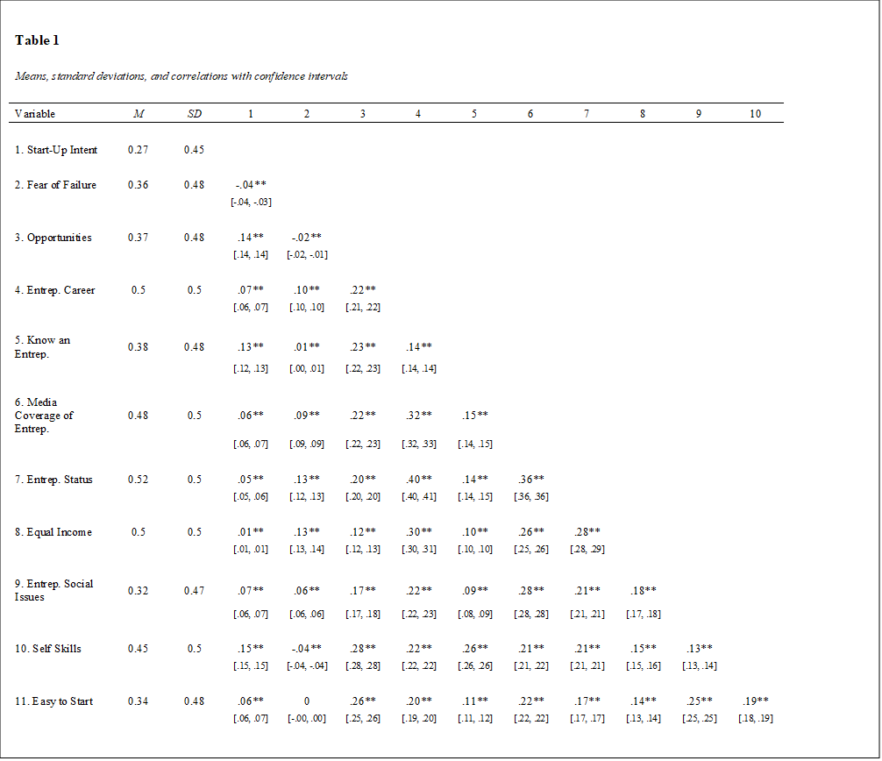
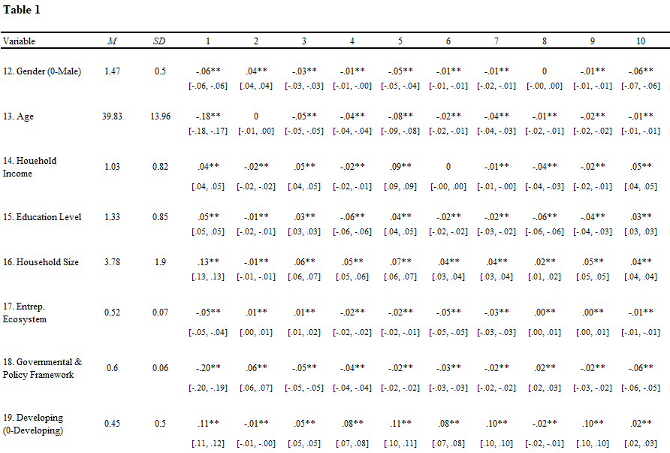
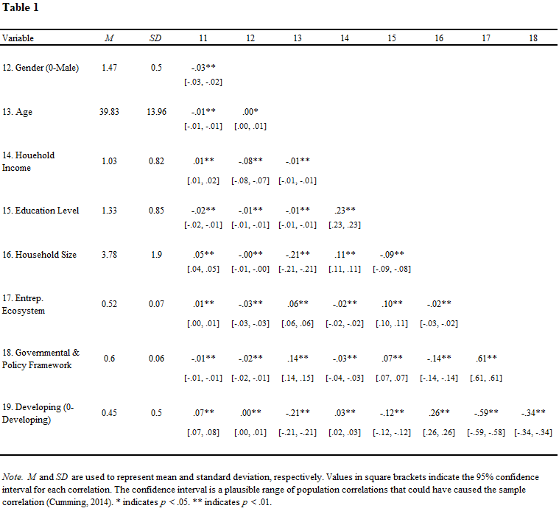

Table 2
Regression Results
Dependent variable
 |  | Micro Model (i) |  | Full Model (ii)
Start-Up Intent |  | Micro Model (i) |  | Full Model (ii)
Intercept (Random) |  | Coeff. |  | Coeff.
Year
2015 |  | 0.46 (0.04)*** |  | 0.93 (0.05)***
2016 |  | 0.55 (0.04)*** |  | 1.00 (0.05)***
2017 |  | 0.54 (0.04)*** |  | 0.99 (0.05)***
2018 |  | 0.53 (0.04)*** |  | 0.97 (0.05)***
2019 |  | 0.66 (0.04)*** |  | 1.11 (0.05)***
Macro-Level
EE |  |  |  | -0.04 (0.10)
EE: Government Support |  |  |  | -0.78 (0.05)***
Developing (0-Developed) |  | 0.08 (0.01)*** |  | -0.16 (0.05)***
Govt. Support x Developing |  |  |  | 0.42 (0.09)***
Micro-Level
Opportunities |  | 0.02 (0.01)*** |  | 0.02 (0.01)***
Entrep. Career |  | 0.01 (0.01) |  | 0.00 (0.01)
Fear of Failure |  | -0.01 (0.01) |  | 0.00 (0.01)
Know an Entrepreneur |  | -0.01 (0.01) |  | 0.00 (0.01)
Media Coverage of Ent. |  | 0.03 (0.01)*** |  | 0.03 (0.01)***
Entrep. Status |  | 0.02 (0.01)*** |  | 0.02 (0.01)***
Entrep. Social Issues |  | 0.00 (0.01) |  | 0.00 (0.01)
Equal Income |  | -0.01 (0.01)** |  | -0.01 (0.01)**
Self Skills |  | 0.07 (0.01)*** |  | 0.07 (0.01)***
Easy to Start |  | -0.01 (0.01)** |  | -0.01 (0.01)*
Demographics
Age |  | 0.00 (0.00)*** |  | 0.00 (0.00)***
Gender (0-Male) |  | -0.03 (0.01)*** |  | -0.03 (0.01)***
Household Income |  | -0.02 (0.00)*** |  | -0.02 (0.00)***
Education Level |  | 0.03 (0.00)*** |  | 0.03 (0.00)***
Household Size |  | 0.01 (0.00)*** |  | 0.00 (0.00)**
R- squared |  | 0.04 |  | 0.05
Akaike Information
Criterion (AIC) |  | 51,263 |  | 51,000
Log likelihood (df) |  | -25,613 |  | -25,478 (3)
Note. Standard errors are in parentheses; Significance levels are ***p < 0.001; **p < 0.01; *p < 0.05

Figure 1. Graphical Research Framework
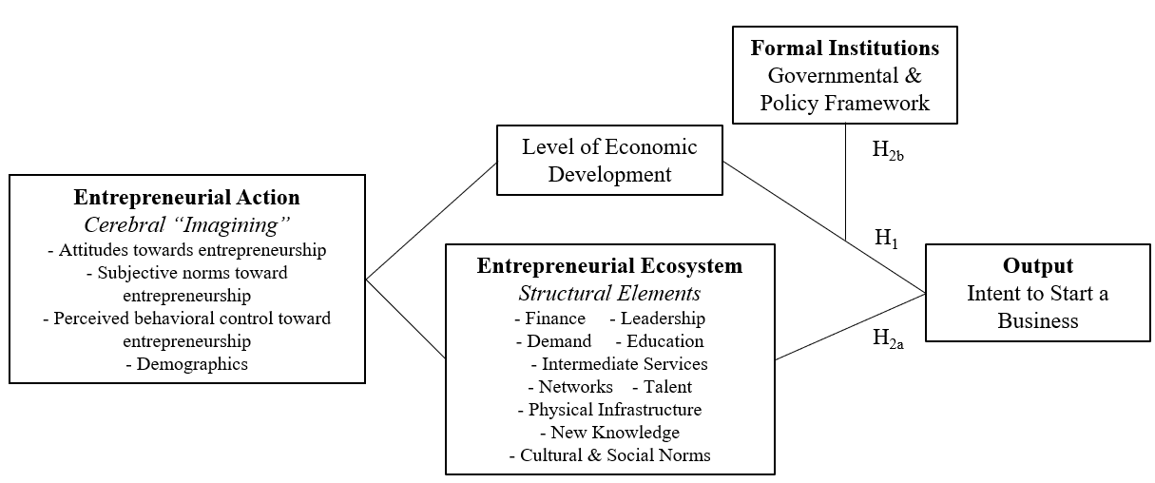

Appendix A.
 | North America | Europe | Australia/  New Zealand | Asia | Africa/  Middle East | Central/South America
Developed/ Developing | 100% / 0% | 81% / 19% | 100% / 0% | 10% / 90% | 0% / 100% | 56% / 44%
Argentina |  |  |  |  |  | 240
Australia |  |  | 430
Barbados |  |  |  |  |  | 186
Botswana |  |  |  |  | 431
Brazil |  |  |  |  |  | 267
Bulgaria |  | 109
Burkina Faso |  |  |  |  | 180
Cameroon |  |  |  |  | 458
Canada | 687
Chile |  |  |  |  |  | 6502
China |  |  |  | 1364
Colombia |  |  |  |  |  | 2032
Croatia |  | 591
Ecuador |  |  |  |  |  | 1508
Egypt |  |  |  |  | 494
Estonia |  | 377
Greece |  | 250
Guatemala |  |  |  |  |  | 1242
Hungary |  | 137
India |  |  |  | 1232
Indonesia |  |  |  | 1301
Iran |  |  |  |  | 1016
Israel |  |  |  | 481
Italy |  | 125
Japan |  |  |  | 163
Kazakhstan |  |  |  | 269
Latvia |  | 436
Luxembourg |  | 210
Macedonia |  | 174
Malaysia |  |  |  | 395
Mexico |  |  |  |  |  | 1844
Morocco |  |  |  |  | 516
Netherlands |  | 298
Norway |  | 61
Panama |  |  |  |  |  | 731
Peru |  |  |  |  |  | 762
Philippines |  |  |  | 259
Poland |  | 371
Portugal |  | 273
Puerto Rico |  |  |  |  |  | 798
Romania |  | 163
South Africa |  |  |  |  | 638
Slovakia |  | 421
Slovenia |  | 217
South Korea |  |  |  | 493
Spain |  | 1790
Sweden |  | 351
Switzerland |  | 342
Taiwan |  |  |  | 205
Thailand |  |  |  | 889
Tunisia |  |  |  |  | 151
UK |  | 26
US | 901
Uruguay |  |  |  |  |  | 551
Vietnam |  |  |  | 250
 | 1,588 | 6,722 | 430 | 7,301 | 3,884 | 16,663

Appendix B.
Pillar/Category | Description
Accessible Markets | Domestic & Foreign: Large Companies as Customers; Small/Medium-sized Companies as Customers; Government as Customers
Human Capital/Workforce | Management & Technical Talent; Entrepreneurial Company Experience; Outsourcing Availability; Access to Immigrant Workforce
Funding & Finance | Friends & Family; Angel Investment; Private Equity; Venture Capital; Access to Debt
Support Systems/Mentors | Mentors/Advisors; Professional Services; Incubators/Accelerators; Network of Entrepreneurial Peers
Government & Regulatory Framework | Ease of Starting a New Business; Tax Incentives; Business-friendly Legislation/Policies; Access to Basic/Telecoms/Transport Infrastructure
Education & Training | Available Workforce with Pre-University Education; Available Workforce with University Education; Entrepreneur-Specific Training
Major Universities as Catalysts | Promoting a Culture of Respect for Entrepreneurship; Playing a Key Role in Idea- Formation for New Companies; Playing a Key Role in Providing Graduate for New Companies
Cultural Support | Tolerance of Risk & Failures; Preference for Self-Employment; Success Stories/Role Models; Research Culture; Positive Image of Entrepreneurship; Celebration of Innovation
Rottenberg & Morris, 2014

