Crystallizing Nebulous Identities: How New Work Identities are Born and Maintained in the face of Image Discrepancy

INTRODUCTION
Our beliefs about ourselves deeply affect our attitudes and behaviour, even at work. Identity, a core constituent of the self, has been shown to be associated with a host of individual, group and organizational outcomes such as well-being (Kahn, 1990), work engagement (Blader & Tyler, 2009), performance (Mael & Ashforth, 1992), creativity (Swann, Kwan, Polzer, & Milton 2003) and workplace conflict (Rink, & Jehn, 2010) to name a few. We know from prior work that employees rely on organizational referents in construction of work identity (Ashforth & Schinoff, 2016; Ibarra, 1999; Pratt, Rockmann & Kaufmann, 2006). But how do workers lacking organizational affiliation manage this process? Employees who join an organization have some insight into what their work identity entails even as it continues to develop. But what if there are contexts where workers have no insight into their work identity as they begin work and slowly discover it with passage of time? This study aims to answer such questions.
Though emerging research on independent work provides some clue that these workers struggle with precarious identities (Petriglieri, Ashford, & Wrzesniewski, 2019), we still do not know how work identities are formed from inception in the independent workforce. These workers possibly face great challenges but also opportunities. This hitherto unexplored space presents a ripe opportunity to explore experiences of an unheard section of the working population which can offer important insights for all workers, both within and beyond the organization. Thus, we start with the broad question of “How do independent workers construct their work identity in absence of organizational referents?” The subsequent sections outline the methodology and preliminary results. Finally, we discuss the anticipated contributions of this study.
CONTEXT
To address the above research question, we studied content creators who work on the online social media platform Instagram. Creators earn an income from corporations in exchange for endorsing their products or services (Shan, Chen, & Lin, 2020). They create content in a specific niche such as fashion, travel, food, fitness, lifestyle or photography etc. by posting images, videos and stories on Instagram. In the process, they emerge as an expert of their niche and amass a large audience who follow them for advice and content. This is an apt context in which to study identity construction for two reasons. First, creators use their accounts on Instagram for self-expression and to create a personal brand identity that can be leveraged to generate livelihood. Because their Instagram identity is key for establishing their online presence and subsequent revenue stream, they devote significant effort into crafting that identity. Second, because financial rewards are closely tied with audience numbers and endorsement of their content, creators interact closely with their audiences constantly and iteratively through their work. The audience also has an opportunity to look at creators’ personal brand identity on the platform in a progressive manner from its conception onward (via creators’ accounts), an opportunity rarely found elsewhere.

Methods
Due to the exploratory nature of the research question, we used semi-structured qualitative interviews to elicit “detailed accounts of the processes and nuances under investigation” (Kreiner, Hollensbe, & Sheep, 2009, p. 707). We interviewed participants who consider content creation on Instagram their primary occupation or were working towards making it so. We sampled across creators at different stages in their career trajectory, with a range of follower counts from 1,000 to 1,200,000. 53 semi-structured interviews have been conducted averaging 70 minutes each. Data was analyzed using principles of grounded theory, including open and axial coding, and building a theoretical framework based on aggregate themes (Corbin & Strauss, 1990; Gioia, Corley, & Hamilton, 2013).

PRELIMINARY FINDINGS
We found that participants went through three stages of identity work. Because of working in an unstructured, independent work environment, their work identity was initially nebulous or unclear to them. Gradually, important external events called ‘turning points’ granted them the identity of a content creator. Experiencing multiple such events helped them crystallise that identity. In the third phase, participants engaged in identity displays that at times led to image discrepancy.
Nebulous Identity Phase: Starting the Journey
In the creator economy, participants went through different phases of identity construction until they had a clear idea of who they were with respect to their work and occupation. Participants often joined Instagram to use it as a social media platform, that is, for sharing images and staying in touch with friends and family. Developing the identity of ‘content creator’ was not a goal in the beginning of their journey on Instagram and happened organically along the way. We term the identity in this initial stage as ‘nebulous’ because participants were not even able to at times verbalize how they saw themselves. We define nebulous identity as the vague, confused, and hazy understanding of one’s identity in the initial stages of creator identity construction. We asked a participant what he called himself to which he responded:
“I do not know because I've just ventured into so many creative pursuits as of now that all the lines are blurred…I don't think that I can categorise myself so easily because I have worked on so many different projects side by side throughout the year. So, I would just say that I like to produce things, I like to create a lot of things.” [P#47]
As can be seen in this quote, the participant had only general descriptions to offer when asked about his identity. Participants explained that it was not only them who had difficulty in describing who they were and what they did but people in general did not know how to define this work and the individuals performing it.

Crystallizing and Forming Work Identity: The Role of Turning Points
Turning points were often exogenous events that provided the realization that one is a content creator. Examples of turning points are a video getting millions of views, getting recognized on the street by strangers, getting invited to a TV show, etc. In the creator economy, turning points played a critical role in forming and crystallizing work identity in the second phase. We use the term identity crystallization, which we define as sudden clarity, structure and definition of a previously nebulous or vague identity. Turning points led the audience to directly grant the content creator identity via an external event. In the absence of an organizational scaffold, participants subconsciously yearned for external validation of their identity which is why turning points had a sudden and intense effect. For instance, the following participant suddenly internalized the content creator identity after getting recognized by strangers in public:
“It really hits you when you're out and about and people are like, “Oh, you're Ramon! I follow you on TikTok. I know you from this”. That's when I was like, okay, I'm a content creator. This is it, I'm an influencer now!”. [P#29]
In this quote, we can see the participant being granted (and accepting) the content creator identity, illustrating the effect of the turning point event of being recognized and validated by followers. Moreover, participants usually experienced multiple turning points which crystallized the creator identity. Through multiple instances of identity crystallization, the work identity of content creator was formed.

Figure 1: The three phases of identity work in the creator economy

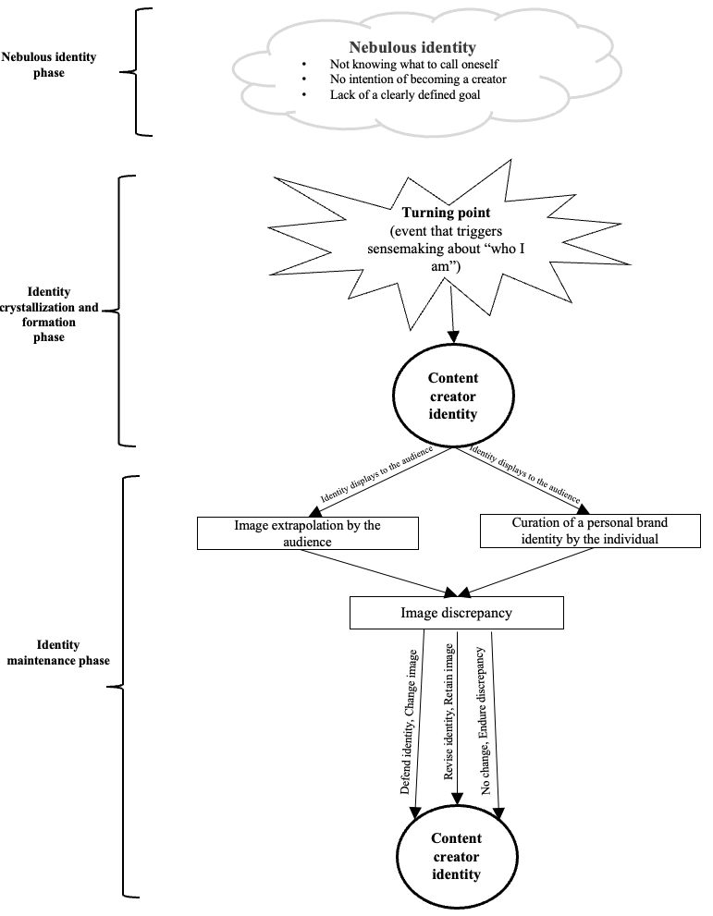

Identity Maintenance in the face of Image Discrepancy
Several participants observed a tendency in their audience to observe them and construct a more complete image of who the participants are based on limited identity displays. Additionally, some participants also sought to curate a specific personal brand identity. For instance, they strategically chose to showcase only a specific aspect of themselves but not their entire selves. Image extrapolation and identity curation both led to image discrepancy.
Identity displays and image extrapolation
Expression of identity or identity displays to others, e.g., followers and the wider Instagram audience, led to image extrapolation by these others. Participants perceived that their audience tended to observe them and construct a more complete image of who the participants are based on their limited identity displays. We call participants’ identity displays ‘limited’ because people never completely disclose every aspect of themselves to another person. There are many aspects of oneself that are unknown to the external world.
“My husband doesn't like to come on camera. There were times when I felt that people thought “she does not have a good relationship with her husband”. I also got comments like “Are you a single mom? Why is your husband not on camera?”” [P#45]
The above quote illustrates how this participant who only presented herself and her work on Instagram experienced image extrapolation by the audience. Because her husband did not appear on camera, the audience erroneously surmised that she is a ‘single mom’. Thus, image extrapolation led to misalignment between who one is (identity) and how one is seen by the audience (image).
Image extrapolation, personal brand identity curation and image discrepancy
Both image extrapolation and personal brand identity curation led to image discrepancy. In the literature, image discrepancy has been defined as the misalignment between how you see yourself (identity) and how others see you (image) (Patil, 2019; Vough et al., 2013). Participants tried to manage the discrepancy in three ways. First, they defended their identity and tried to change the image. This occurred when participants were certain of their identity, and it was possible to change the image. Second, some participants changed their identity to align with the discrepant image and reduce the cognitive dissonance (Aronson, 1973). This happened when the image was more positive than the self-views rather than the other way around. It also happened when participants had deliberately attempted to curate a personal brand identity that was different from who they really were. In such instances, participants tried to internalize the curated and often aspirational identity to become that person. Third, participants seldom chose not to resolve the image discrepancy either because they were not too concerned about other people’s perception of them and/or when the discrepant image would not lead to any adverse consequences. That is, they chose to endure the discrepancy.

CONTRIBUTIONS
First, this study contributes to the literature on how individuals engage in identity work especially outside the conventional boundaries of the organization. We add to the growing literature of identity work in the independent work force (Petriglieri et al., 2019) by highlighting novel processes experienced by workers. Moreover, extant theory on identity granting suggests that identity is granted by others such as followers to a leader (DeRue & Ashford, 2010). However, we found that important events can also grant identity. Other individuals working as entrepreneurs or in hobby jobs might may also share similar experience of identity construction and management. Moreover, we know that audience feedback helps shape identity and image where the ‘audience’ consists of members the focal individual is acquainted with such as manager, subordinate, colleague, client etc. (Ibarra, 1999, Vough et al., 2013). In the context of the independent workforce, this feedback can come from individuals who are unacquainted with the focal individual. This study sheds light on the critical role these ‘strangers’ play in crystallising nebulous work identities.
Second, we contribute to the literature on image construction and image discrepancy (Vough et al., 2013; Patil, 2019). We propose two novel antecedents of image discrepancy- image extrapolation and identity curation. Pioneering work on image discrepancy suggested that this phenomenon is more common in highly visible occupations (Patil, 2019; Vough et al., 2013). But we do not have much insight into why this happens. Image discrepancy occurs not only because of a tendency of the audience but also of the focal individual. This changes our understanding of image management and informs both theory and practice on when image discrepancy should be anticipated which, in turn, facilitates its management. Limited identity displays and curation of a specific identity pave the way for image discrepancy. Therefore, these findings can guide workers within and beyond organizational contexts in preventing and/or managing image discrepancy.

APPENDIX 1

Overview of Data Structure

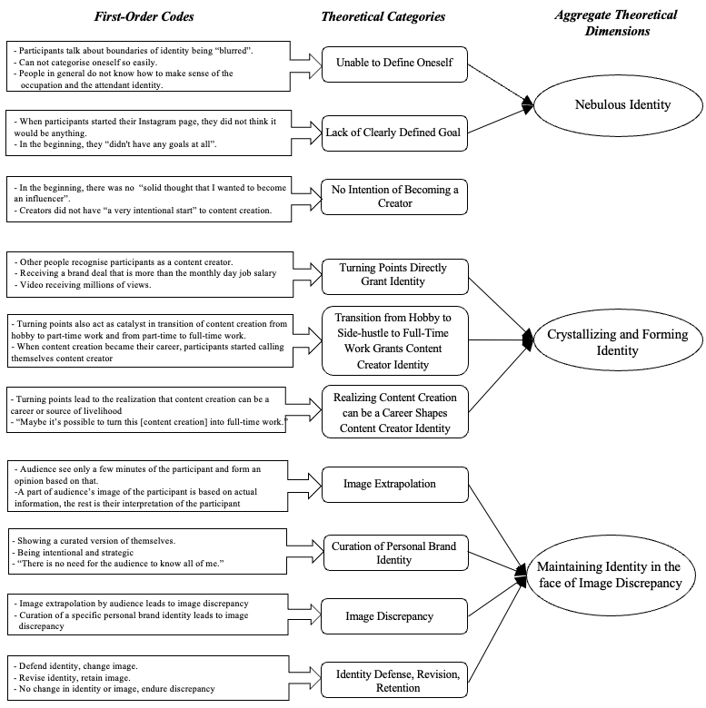

APPENDIX 2

The following table provides key details about participants included in this study.

Participant Number | Gender | Account based in* | Year joined Instagram* | Instagram Niche | Recruitment method
1 | M | Germany | 2018 | Food | Online forum
2 | F | Germany | 2020 | Beauty, mental health | Online forum
3 | F | India | 2018 | Beauty, fashion | Author's personal network
4 | F | India | 2015 | Movie reviews, fashion | Author's personal network
5 | F | India | 2013 | Motherhood, lifestyle | Influencer management agency
6 | F | India | 2019 | Motherhood, lifestyle | Influencer management agency
7 | M | India | 2016 | Fitness | Influencer management agency
8 | F | India | 2014 | Motherhood, comedy | Influencer management agency
9 | F | U.A.E | 2016 | Body positivity, midsize fashion | Author's personal network
10 | F | U.S. | 2011 | Motherhood, beauty, lifestyle | Cold call on Instagram
11 | F | U.K. | 2018 | Fashion, travel | Author's personal network
12 | M | India | 2013 | Food, photography | Author's personal network
13 | F | U.K. | 2014 | Tarot, art | Cold call on Instagram
14 | F | U.K. | 2018 | Brutalist photography | University newsletter ad
15 | F | U.K. | 2017 | Photography | University newsletter ad
16 | F | U.K. | 2020 | Baking | University newsletter ad
17 | M | U.S. | 2016 | University car racing | University newsletter ad
18 | M | U.K. | 2020 | Music | Author's personal network
19 | M | India | 2013 | Music, memes | Author's personal network
20 | F | Pakistan | 2020 | Home and event decor | Author's Personal network
21 | F | U.S. | 2012 | Sustainable living | Author's Personal network
22 | F | U.S. | 2012 | Fashion, Travel | Author's personal network
23 | F | U.K. | 2018 | Fashion | Author's personal network
24 | F | Canada | 2013 | Lifestyle, beauty, skincare | University social media call out
25 | F | Indonesia | 2016 | Social enterprise | Author's personal network
26 | F | Thailand | 2019 | Marketing, branding | Author's personal network
27 | F | U.K. | 2012 | Food, travel, style | Cold call on Instagram
28 | F | U.K. | 2018 | Travel, fashion | Cold call on Instagram
29 | M | U.K. | 2020 | Beauty | Cold call on Instagram
30 | F | U.A.E | 2012 | Comedy, fashion | Cold call on Instagram
31 | F | U.S. | 2013 | Beauty | Cold call on Instagram
32 | M | U.K. | 2012 | Travel, food | Author's personal network
33 | F | Singapore | 2013 | Food, multicultural humour | Cold call on Instagram
34 | F | India | 2013 | Comedy | Author's personal network
35 | F | Australia | 2020 | Financial advice, money tips | Cold call on Instagram
36 | M | India | 2017 | Fitness | Influencer management agency
37 | M | U.K. | 2021 | Travel, London living, food | Influencer management agency
38 | F | Canada | 2013 | Travel | Cold call on Instagram
39 | M | U.K. | 2014 | Harry Potter | Cold call on Instagram
40 | F | U.A.E | 2022 | Fashion, lifestyle | Cold call on Instagram
41 | F | India | 2022 | Reading, travel, lifestyle | Author's personal network
42 | M | India | 2016 | Travel, food, lifestyle | Cold call on Instagram
43 | M | India | 2014 | Technology | Influencer management agency
44 | F | Canada | 2011 | Travel | Snowballing
45 | F | U.S. | 2019 | Food, healthy recipes | Cold call on Instagram
46 | F | India | 2012 | Lifestyle, beauty, fashion | Cold call on Instagram
47 | M | India | 2018 | Music | Author's personal network
48 | M | Spain | 2012 | Fitness, entrepreneurship | Author's personal network
49 | M | U.S. | 2013 | Food, comedy | Snowballing
50 | M | India | 2012 | Fitness | Snowballing
51 | F | U.K. | 2020 | Food, cozy living | Cold call on Instagram
52 | F | U.K. | 2019 | Motherhood | Cold call on Instagram
53 | M | India | 2013 | Technology | Cold call on Instagram

*Location of the Instagram account and the year the participant joined Instagram are public information available on the participants’ Instagram profiles.

REFERENCES

Aronson, E. (1973). The rationalizing animal. In B. M. Staw (Ed.), Psychological Dimensions of Organizational Behavior (2nd ed., pp. 131-138). Englewood Cliffs, NJ: Prentice-Hall.
Ashforth, B. E., & Schinoff, B. S. (2016). Identity under construction: How individuals come to define themselves in organizations. Annual Review of Organizational Psychology and Organizational Behavior, 3, 111-137.
Blader, S. L., & Tyler, T. R. (2009). Testing and extending the group engagement model: Linkages between social identity, procedural justice, economic outcomes, and extrarole behavior. Journal of Applied Psychology, 94(2), 445.
Corbin, J. M., & Strauss, A. (1990). Grounded theory research: Procedures, canons, and evaluative criteria. Qualitative Sociology, 13(1), 3-21.
DeRue, D. S., & Ashford, S. J. (2010). Who will lead and who will follow? A social process of leadership identity construction in organizations. Academy of Management Review, 35(4), 627-647.
Gecas, V. (1982). The self-concept. Annual Review of Sociology, 8(1), 1-33.
Gioia, D. A., Corley, K. G., & Hamilton, A. L. (2013). Seeking qualitative rigor in inductive research: Notes on the Gioia methodology. Organizational Research Methods, 16(1), 15-31.
Ibarra, H. (1999). Provisional selves: Experimenting with image and identity in professional adaptation. Administrative Science Quarterly, 44(4), 764-791.
Kahn, W. A. (1990). Psychological conditions of personal engagement and disengagement at work. Academy of Management Journal, 33(4), 692-724.
Kreiner, G. E., Hollensbe, E. C., & Sheep, M. L. (2009). Balancing borders and bridges: Negotiating the work-home interface via boundary work tactics. Academy of Management Journal, 52(4), 704-730.
Mael, F., & Ashforth, B. E. (1992). Alumni and their alma mater: A partial test of the reformulated model of organizational identification. Journal of Organizational Behavior, 13(2), 103-123.
Mead, G. H. (2015). Mind, self & society. Chicago: University of Chicago Press.
Patil, S. V. (2019). "The public doesn't understand": The self-reinforcing interplay of image discrepancies and political ideologies in law enforcement. Administrative Science Quarterly, 64(3), 737-769.
Petriglieri, G., Ashford, S. J., & Wrzesniewski, A. (2019). Agony and ecstasy in the gig economy: Cultivating holding environments for precarious and personalized work identities. Administrative Science Quarterly, 64(1), 124-170.
Pettigrew, A. M. (1990). Longitudinal field research on change: Theory and practice. Organization science, 1(3), 267-292.
Pratt, M. G., Rockmann, K. W., & Kaufmann, J. B. (2006). Constructing professional identity: The role of work and identity learning cycles in the customization of identity among medical residents. Academy of Management Journal, 49(2), 235-262.
Rink, F. A., & Jehn, K. A. (2010). Divided we fall or united we stand? How identity processes affect fault line perceptions and the functioning of diverse teams. In R. J. Crisp (Ed.), Psychology of social and cultural diversity (pp. 281–296). Oxford: Wiley-Blackwell.
Shan, Y., Chen, K. J., & Lin, J. S. (2020). When social media influencers endorse brands: The effects of self-influencer congruence, parasocial identification, and perceived endorser motive. International Journal of Advertising, 39(5), 590-610.
Swann, W. B., Kwan, V. S., Polzer, J. T., & Milton, L. P. (2003). Fostering group identification and creativity in diverse groups: The role of individuation and self-verification. Personality and Social Psychology Bulletin, 29(11), 1396–1406.
Vough, H. C., Cardador, M. T., Bednar, J. S., Dane, E., & Pratt, M. G. (2013). What clients don't get about my profession: A model of perceived role-based image discrepancies. Academy of Management Journal, 56(4), 1050-1080.

