Phd. Cand. Daina Bilkštytė-Skanė
Prof. dr. Vita Akstinaitė

ABSTRACT
This paper examines how adopting data-driven decision-making in organisations changes the C-suite role. The qualitative research design (interviews with 18 C-level executives) was employed. The study shows that adopting a data-driven decision-making (DDDM) process allows executives to focus on the higher priority tasks, gain more confidence, and reduce risk in decision-making. These findings have implications for executives to enhance the quality and confidence in their decision-making. Furthermore, the identified internal motivators might help executives to encourage DDDM adoption in organisations.

INTRODUCTION
The COVID-19 pandemic and the fifth industrial revolution accelerated the adoption of new technologies that make daily life easier and revolutionise the general understanding of how and when we use technologies (Amankwah-Amoah et al., 2021). One of the outcomes of adopting new technology is data that influences decision-making (Provost and Fawcett, 2013, Hupperz et al., 2021). Therefore, the transition to data-driven decision-making (DDDM) requires a complete transformation of the organisation, including the need for the executives “to develop a combination of digital and human skills” (Cortellazzo et al., 2019) and to adapt their role to the new way decisions are made.
Previous research focused on the technological and change management perspectives required to adopt DDDM, but there is a lack of research on executives’ role changes after the DDDM is adopted (Korherr et al., 2022, Bilkštytė‐Skanė and Akstinaite). Therefore, this study’s research question is: “How does adopting a data-driven decision-making process change the executive role?” To address this gap, this study concentrates on how adopting DDDM processes alters the executive role and identifies the changes that need to be implemented.

THEORETICAL BACKGROUND

Executive as a strategic decision-maker
High-level, complex strategic decisions are the prerogative of the top management, who are responsible for directing and controlling the organisation (Josephkim-Keung, 2015, Thys et al., 2023, Drucker, 1967). Contextual factors like decision-specific, environmental, organisational characteristics or even executives’ “highly personalised lenses” and tolerance for uncertainty, risk and a desire for success and aggressiveness might influence strategic decisions (Hambrick and Mason, 1984, Balzano, 2022).
As risk-taking is one of the executives’ managerial attributes, the risk perspective can explain executive functions in decision-making (see Figure 1). According to Schiebener et al., (2014) the executive’s function is to process “information about the decision situation [categorising alternatives according to gains, losses, and probabilities, understanding rules for gains and losses, etc.] and for developing and applying decision-making strategies”.
Figure 1. A model of decision-making under risk, adapted according to Schiebener et al. (2014)
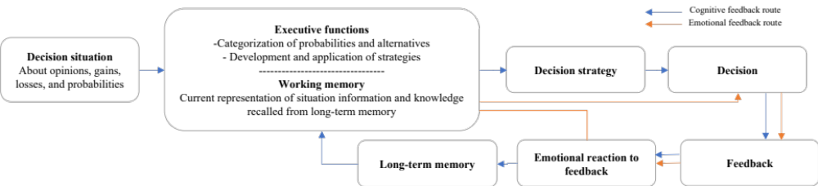
To reduce risk in decision-making, executives are looking at how to use the data generated by adopting new technologies. A positive relationship has been proven between data usage in decision-making and organisational performance (Gökalp et al., 2021).
Adoption of new technologies in the decision-making process
Data-driven decisions include valuing and analysing a wide range of data rather than relying solely on intuition (Provost and Fawcett, 2013, Dodman et al., 2021, Lepri et al., 2017). Therefore, special tools such as business intelligence solutions and customer data platforms are employed to collect data. Combining these tools with new technologies like artificial intelligence, they can analyse data and extract predictive patterns useful for decision-making (Provost and Fawcett, 2013).
Undoubtedly, executives play a significant role in organisational changes by adopting DDDM, role-modelling desired mindset and behaviour, and building a strong and committed top management team (Aiken and Keller, 2006, Heyden et al., 2017). Implementing new technologies means transforming strategies, processes, and interactions with “organisational and managerial characteristics” (Blanka et al., 2022, Calderon-Monge and Ribeiro-Soriano, 2023).
Oakland and Tanner (2007) proposed an organisational change management model with two phases: readiness for change followed by the external drivers, need for change, leadership and directions, and planning and implementation of change, where control, processes, behavioural and organisational changes are done. The original model was later adapted to DDDM by adding a section to implementing technologies and clarifying the changes needed during the implementation phase (Bilkštytė‐Skanė and Akstinaite, 2023).

RESEARCH METHODOLOGY
A qualitative research approach was employed. Executives (CEO or one level below) whose organisations have already adopted or are in the process of adopting the DDDM process were interviewed (N=18). Purposive sampling was used to recruit participants. The participants represent organisations of various sizes, industries (i.e., IT, healthcare, etc.), and countries (i.e., Lithuania, United Kingdom, Australia, etc.). All the interviews were conducted in English. The recorded interviews were transcribed verbatim, and thematic analysis was done using MAXQDA software.
The questionnaire was built based on previous research by Svensson et al. (2019). The following questions were asked:
- How has your organisation adopted a data-driven decision-making process in general? Why did you decide to adopt DDDMP?
- Could you describe the data-driven decision-making process within your organisation?
- What role did you play in adopting this process? What were the opportunities and challenges you faced?
- How did your decision-making role look before the adoption of DDDMP?
- How has your role changed after DDDMP was implemented? How do you feel about those changes?
- What do these changes mean to you as an executive? How do those changes affect your day-to-day activities as an executive?
- What are the most pivotal changes in an executive's role when adopting a data-driven decision-making process? Why are they significant?

RESULTS
A study explored how DDDM adoption altered the role of executives. Results reveal that DDDM adoptions reduce executive decision-making risk, improve quality, and boost confidence. In addition to external factors, internal motivators include making better decisions, increasing efficiency and productivity, reducing human bias and errors, and understanding consumers better motivate DDDM adoption. Moreover, executives might take different roles during this adoption: initiating, supporting, or leading the adoption process.

Internal motivators for the DDDM adoption
The most common reasons for implementing this process are to understand the customer (e.g., “analyse their data usage patterns to determine what they find valuable” (P4)), be more efficient (e.g., “emotions do not monetise; numbers do” (P13)), minimise human bias and error, and make better decisions, especially in places where they need sharp insights and metrics for strategic changes.

Executive role in data-driven decision implementation
Most respondents were the key drivers of the transition to the DDDM by creating and communicating a vision and providing future direction, establishing the frameworks and models, or even building the foundations for the DDDM. These respondents were less involved in operational transformation tasks.
Another group of respondents supported and managed the adoption, hired new or created teams from current employees, or even built the foundations for the DDDM. Respondents took the responsibility to extend the employees’ skills by adding general knowledge of how to read the data or how to use specific tools that support the DDDM.
To summarise, the executive’s primary role is to create a vision or direction, support or even manage the DDDM implementation while providing education and forming teams to materialise the vision.

Executive role after DDDM adoption
Respondents reported that the significant benefits of DDDM adoption are a time to focus on higher-priority tasks and improved decision quality. Predicting the future, minimising decision-making steps and improving decision quality allow executives to reduce frustration and take some strategic actions in advance, leading to less risky decisions. Executives no longer need to combine data from different systems manually and descend to the operational level.
Finally, by providing more control over the decisions, augmenting the concreteness of the required information, and simultaneously granting greater freedom and independence in decision-making, the DDDM boosts the executives’ confidence in making decisions. In contrast, the biggest challenge is trusting the data, accuracy, and completeness. Therefore, executives have “to take off the “know-it-all hat” and question the data to understand its quality.

The recommended changes in executive role
The most common recommendation is to spend time on self-education to become “familiar with data and the latest technologies” (P6), to understand the data’s relationship with business and to discuss the DDDM adoption process with other organisations that have already adopted the DDDM to gain more confidence in this process to avoid the most common mistakes.
Besides learning activities, it is recommended to build “cultural awareness” and to “establish the norms” by agreeing on new metrics, moving to personal accountability for the data, and explaining the high quality of data importance to decision-making. That means executives have to reduce their tolerance for decisions made without data and question why the data is not up-to-date.

DISCUSSION
DDDM adoption requires the implementation of new technologies followed by organisational changes and a change in the executive role and mindset. Understanding the drivers of DDDM process adoption makes aligning with organisational strategy and goals easier and fosters a culture towards DDDM. The study findings supplement Oakland’s (2007) organisational change management framework (extended by Bilkštytė‐Skanė and Akstinaite, 2023) clarifying the drivers for DDDM adoption and what responsibilities this adoption typically executives take (see Figure 2). Results reveal that executives' internal motivation to boost organisational efficiency and productivity, minimise human bias and errors in decision-making, and increase customer knowledge drives DDDM adoption. Executives might take on different roles in implementing DDDM, from initiating the change by providing vision and direction to "hands-on" responsibilities such as team formation, framework development, employee education and training.

Figure 2. An updated DDDM process adoption framework
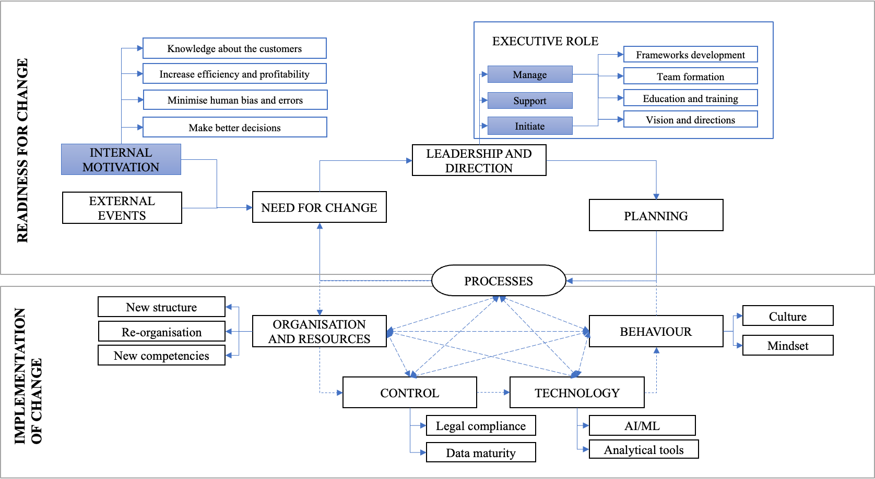

The findings show that DDDM affects the executive role by improving quality, boosting confidence, creating the ability to forecast the future and reducing risks associated with decision-making. These findings suggest that DDDM might be chosen as a decision-making strategy to minimise the executive’s risks (Figure 3) by eliminating misleading opinions and providing limited alternatives for the decisions. Feedback from data-driven decisions helps the executive improve algorithms and models to make better, less risky decisions in the future.

Figure 3. DDDM, as a decision-making strategy to reduce an executive’s risk, was adapted from Schiebener et al. (2014).
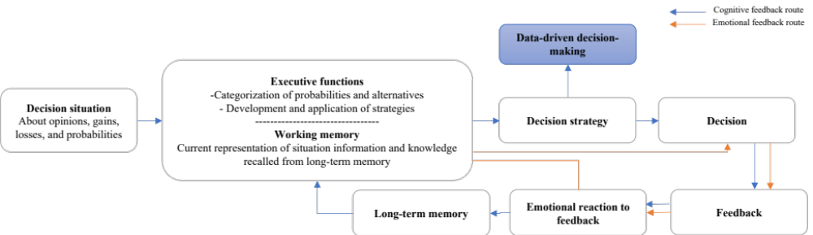

Theoretical implications
This research adds to Oakland's (2007) organisational change management framework adapted to the DDDM process by revealing internal executives' motivators to adopt the DDDM and explaining that executives may initiate or support the process by providing directions and visions or managing the whole DDDM adoption by forming teams, creating frameworks, and educating and training employees. This paper contributes to the decision-making model under risk developed by Schiebener et al. (2014) by proposing adopting the DDDM process to reduce risk in executive decision-making. It offers a comprehensive review of the changes in executive roles after the implementation of DDDM. To the author’s knowledge, no such research has been conducted.

Practical implications
The outcomes of this research add more clarity to executives regarding what internal motivators (i.e., reducing human error and bias) might encourage DDDM adoption in the organisation and what role they might take during the adoption (see Figure 2): to initiate by providing the vision and directions, support, or even to manage the whole transformation by developing frameworks, forming teams, and educating and training employees. Furthermore, the study shows that executives should become familiar with the data to be more confident and independent in decision-making.
This study also found that executives may devote more time to higher-priority tasks and make better decisions that boost confidence and reduce risk after adopting DDDM. Therefore, executives might consider DDDM as a strategy to minimise the risk of decision-making.

Limitations and Future Directions
A qualitative study on executive changes in roles is limited by its generalizability and executives’ perspectives and experiences; therefore, quantitative data should be used in subsequent studies to complement and expand the qualitative findings. The proposed framework could also be tested in a natural business environment.

CONCLUSION
Adopting the DDDM process is a journey that requires the transformation of the whole organisation. Typically, external events like global digitalisation, advanced competitors, and rapidly changing business environments are the main drivers for implementing new technologies. However, internal motivators like the desire to know the customer, increase efficiency and profitability, minimise human bias and errors, and make better decisions might also create a strong need for change, especially when the executive initiates, supports, or even leads the change. The findings of this research show that DDDM process adoption might be chosen as a strategy to reduce risk in the decision-making process and, simultaneously, increase the quality and executives’ confidence in the decision-making process. Moreover, the reduced risk in decision-making after the DDDM process is another benefit arising from DDDM adoption in organisations.

REFERENCES
AIKEN, C. B. & KELLER, S. P. 2006. The CEO’s role in leading transformation. Management quarterly. 48, 30-39.
AMANKWAH-AMOAH, J., KHAN, Z., WOOD, G. & KNIGHT, G. 2021. COVID-19 and digitalization: The great acceleration. Journal of business research, 136, 602-611.
BALZANO, M. 2022. Serendipity in management studies: a literature review and future research directions. Management Decision, 60, 130-152.
BILKŠTYTĖ‐SKANĖ, D. & AKSTINAITE, V. 2023. Strategic organizational changes: Adopting data‐driven decisions. Strategic Change. 1-10
BLANKA, C., KRUMAY, B. & RUECKEL, D. 2022. The interplay of digital transformation and employee competency: A design science approach. Technological Forecasting and Social Change, 178, 121575.
CALDERON-MONGE, E. & RIBEIRO-SORIANO, D. 2023. The role of digitalization in business and management: a systematic literature review. Review of Managerial Science. 1-44.
CORTELLAZZO, L., BRUNI, E. & ZAMPIERI, R. 2019. The role of leadership in a digitalized world: A review. Frontiers in psychology, 10, 1938.
DODMAN, S. L., SWALWELL, K., DEMULDER, E. K., VIEW, J. L. & STRIBLING, S. M. 2021. Critical data-driven decision making: A conceptual model of data use for equity. Teaching and Teacher Education, 99, 1-12.
DRUCKER, P. F. 1967. The effective decision, Harvard University. Graduate school of business administration. Routledge.
GÖKALP, M. O., GÖKALP, E., KAYABAY, K., KOÇYIĞIT, A. & EREN, P. E. 2021. Data-driven manufacturing: An assessment model for data science maturity. Journal of Manufacturing Systems, 60, 527-546.
HAMBRICK, D. C. & MASON, P. A. 1984. Upper Echelons: The Organization as a Reflection of Its Top Managers. The Academy of Management Review, 9, 193-206.
HEYDEN, M. L. M., FOURNÉ, S. P. L., KOENE, B. A. S., WERKMAN, R. & ANSARI, S. 2017. Rethinking ‘Top-Down’ and ‘Bottom-Up’ Roles of Top and Middle Managers in Organizational Change: Implications for Employee Support. Journal of Management Studies, 54, 961-985.
HUPPERZ, M. J., GÜR, I., MÖLLER, F. & OTTO, B. 2021. What is a Data-Driven Organization? AMCIS, 2021.
JOSEPHKIM-KEUNG, H. A review of frameworks for classification of information systems, notably on the Anthony@ s Triangle. 2015.
KORHERR, P., KANBACH, D. K., KRAUS, S. & MIKALEF, P. 2022. From intuitive to data-driven decision-making in digital transformation: A framework of prevalent managerial archetypes. Digital Business, 2, 100045.
LEPRI, B., STAIANO, J., SANGOKOYA, D., LETOUZÉ, E. & OLIVER, N. 2017. The Tyranny of Data? The Bright and Dark Sides of Data-Driven Decision-Making for Social Good. Transparent data mining for big and small data. 3-24.
OAKLAND, J. & TANNER, S. J. 2007. A new framework for managing change. The TQM Magazine, 19, 572-589.
PROVOST, F. & FAWCETT, T. 2013. Data science and its relationship to big data and data-driven decision making. Big data, 1, 51-59.
SCHIEBENER, J., WEGMANN, E., GATHMANN, B., LAIER, C., PAWLIKOWSKI, M. & BRAND, M. 2014. Among three different executive functions, general executive control ability is a key predictor of decision making under objective risk. Frontiers in Psychology, 5, 1386.
SVENSSON, R. B., FELDT, R. & TORKAR, R. 2019. The Unfulfilled Potential of Data-Driven Decision Making in Agile Software Development. In: KRUCHTEN, P., FRASER, S. & COALLIER, F., eds. Agile Processes in Software Engineering and Extreme Programming, Cham. Springer International Publishing, 355. 69-85.
THYS, K., VANDEKERKHOF, P., STEIJVERS, T. & CORTEN, M. 2023. Top management team and board of directors as the strategic leadership system: The effect of behavioral integration on strategic decision-making quality. European Management Journal.

Words: 1996

