Human Capital and Its Role in Generating Entrepreneurial Self-efficacy in Deprived Areas

Yuxi Zhao
Nottingham Business School, Nottingham Trent University, Nottingham, UK
yuxi.zhao@ntu.ac.uk

Piers Thompson
Nottingham Business School, Nottingham Trent University, Nottingham, UK
piers.thompson@ntu.ac.uk

- Introduction
Policymakers have a history of providing support and incentives to encourage entrepreneurial activities in deprived areas (Devins, 2009) as this is regarded as a key mechanism for rejuvenating and facilitating economic growth in those areas (Frankish et al., 2014). Greene et al. (2007), however, question the success of such interventions. They argue that policy makers often ignore the fact that one in four new businesses in deprived areas are founded in sectors which are considered as ‘easy to enter’ such as the motor sale and repairs trades, hairdressing or beauty. Businesses in these sectors are unlikely to make substantive contributions to improving the welfare of deprived areas through employment creation or productivity improvements. Support, therefore, may increase quantity but not necessarily increase the quality of entrepreneurship in deprived areas (Shane, 2009).

One potential barrier preventing entrepreneurs from engaging in the highly productive types of business activity that policymakers envisage as making a difference in regenerating deprived areas, might be the level of entrepreneurial self-efficacy (ESE) of individuals living in deprive areas (Schmutzler et al., 2019). ESE has been defined as a person’s perceived capabilities not only to successfully perform the tasks and roles of an entrepreneur, but also the expectation to creating a new business (BarNir et al., 2011; McGree et al., 2009). Generally, people demonstrating higher levels of self-efficacy believe they are able to create change and have control over their thoughts and actions (Bandura, 2000). Drnovšek et al. (2010) believe that ESE involves at least two dimensions referring to a person’s beliefs about their capabilities to not only attain goals (i.e. goal beliefs) but also control both positive and negative cognitions (i.e. control beliefs) in the process of starting new businesses. This means while the engagement rate of entrepreneurial activities in deprived areas is relatively low (Williams and Williams, 2011, 2017), self-motivated individuals with clarity of vision potentially could be encouraged to engage in successful entrepreneurship, which can be regarded as a form of assisted self-help (Williams and Windebank, 2016; Mouraviev and Avramenko, 2020).

Promoting ESE in deprived areas may be problematic as human capital levels are generally low (Welter et al., 2008). This relates to skills acquired through formal education and training (Diochon et al., 2008), and also experience from employment in sectors and occupations conducive to entrepreneurial endeavours (Fritsch and Wyrwich, 2014; Dimov, 2016). Interventions based around boosting human capital may have been successful in creating entrepreneurial individuals in the population as a whole (Thompson and Kwong, 2016), but the unsupportive context of a deprived area makes it questionable whether similar training and education will be effective (Graham and Bonner, 2019). This can relate to Brixiová et al.’s (2020) perspective of the importance of the complementarity of skills and training. Their focus is on gender gaps in entrepreneurial performance, but we argue that similar considerations might be relevant in deprived areas where the socio-spatial context affects both the range of cognitive skills acquired and the non-cognitive skills formed. The restricted formation of non-cognitive skills to complement the cognitive may limit the effectiveness of formal education and training.

The evidence base remains limited, particularly with regard to how human capital from different sources interacts with the deprived context to determine ESE. This lack of a full understanding of this relationship may in part explain why resources put into regenerating deprived areas have not been as successful as hoped and even led to further marginalisation of those they sought to help (Shane, 2009; Thompson et al., 2009). This study combines insights from the entrepreneurial search model of Brixiová et al. (2020) with the entrepreneurial intention model, developed by Zhao et al. (2022), focused specifically on deprived areas, and seeks empirical evidence of the patterns implied by these models. This study further investigates the theoretical understanding of how deprivation impacts on the human capital-ESE relationship and responds to Zhao et al.’s (2022) call to employ mixed-method approaches to empirically analyse these key relationships within deprived area contexts. To strengthen our understanding of ESE and the role of human capital in generating entrepreneurial intention in deprived areas, this study investigates the following research questions (RQs): 1) Is increasing human capital a way to improve ESE in deprived areas?; 2) If so which type of human capital is the most effective in increasing ESE in deprived areas?; and 3) Are there interrelations between a deprived context, human capital development and ESE?

In order to understand the role of human capital in deprived areas, and more fully answer the research questions above, it is necessary to utilise data focused on a specific case study city, Nottingham in the East Midlands of England. Data from a survey of entrepreneurs are utilised to first establish the role of human capital and the types of human capital with the strongest relationship to ESE, before data from semi-structured interviews are employed to analysis the more complex interactions between deprivation, human capital development and ESE. The potential relevance of softer factors associated with non-cognitive skills that are captured less well by simple surveys make deeper qualitative insights of considerable value.

This study enriches our understanding of the intertwined relationships between a deprived context, human capital development and ESE compared to a broad perspective of unidirectional relationships from deprivation to human capital or the influence of human capital on ESE respectively. As such, the findings enable policymakers to realize the gap between current provision of support and incentives and the real demands of local residents in deprived areas. This facilitates greater effectiveness in designing policies and implementing supportive programmes to allocate resources more appropriately.

- Literature Review
In this section, we consider the different streams of literature associated with the key concepts. We first briefly examine the literature on the key role of ESE in generating entrepreneurial intentions before focusing on studies covering how different types of human capital may affect individuals’ ESE. However, much of this literature does not focus specially on the deprived area context. Therefore, in order to generate hypotheses with regard to these relationships in deprived areas, it is necessary to use the literature that considers the wider impact of the deprived context and the more limited existing literature that focuses on concepts closely related to self-efficacy, such as confidence, in deprived areas. The potential for multiple interactions between types of human capital, and the deprived area context are also considered by drawing on work covering entrepreneurial search.

ESE and Entrepreneurial Intention
ESE enables people to overcome difficulties in the process of starting new businesses, such as opportunity recognition, resource integration and performance improvement (Tumasjan and Braun, 2012). Many scholars considered entrepreneurial intention (frequently defined as the intention to start a new business) to be the key consequence of ESE (Schmutzler et al., 2019; Şahin et al., 2019). Self-efficacy differs across individuals’ efforts, ability to overcome impediments and the extent to which they maintain persistent goal pursuit despite external disadvantages (Bandura, 1997). An individual’s ESE may not remain constant over time. Bledow (2013) argues that an increase in self-efficacy can be considered a result of internal mechanisms that mobilize resources for a task. This demonstrates that ESE is a dynamic response to situational factors rather than a static belief. In a deprived area, an unsupportive entrepreneurial ecosystem, the network of entrepreneurs and other actors providing resources required for businesses to be created and operate effectively, may reduce ESE (Bullough et al., 2014). Thus, maintaining the conviction of an entrepreneur pursuing entrepreneurial goals despite external disadvantages in deprived areas is particularly important.

However, increased ESE for all residents of deprived areas may also not be beneficial for such communities, as it could result in those ill-equipped for entrepreneurship to engage in and lower the overall quality of entrepreneurship (Shane, 2009). Even where start-ups are achieved successfully, Mellahi (2005) argues there are still dangers, as instant success may lead entrepreneurs to overestimate their capabilities to carry out entrepreneurial activities. This excessive confidence may harm rather than help the business. Starting from a position of disadvantage may bring about the perceived lack of skills and lower self-efficacy, acting as a deterrent to business creation (Graham and Bonner, 2019) and restricting the growth and even survival prospects of businesses (Morris et al., 2022). This increases the likelihood of unsuccessful entrepreneurship, which can further marginalise those already in hardship (Thompson et al., 2009; Morris et al., 2022) and can have long-term negative consequences including negative labour market experiences in later life (Klimas et al., 2021). This means that any intervention that boosts ESE in deprived areas is more likely to avoid undesirable long-term consequences when based on raising both actual and perceived capabilities. As discussed below this is likely to be best achieved through investments in human capital aimed to improve ESE.

Human Capital and ESE
In entrepreneurship literature, a broader proposed division is between general and specific human capital, where the former relates to education and general work experience, while the latter includes prior entrepreneurial, managerial and industry-specific experiences (Rauch and Rijsdijk, 2013; Unger et al., 2011). On one hand, formal education delivers essential knowledge and capabilities to learn about the market, solve problems and make decisions through better recognition of potential opportunities (Shane, 2000), cognitive skills to adapt to a changeable environment (Rauch and Rijsdijk, 2013), and better resource channels such as development of social networks to connect individuals (Pickernell et al., 2011), as well as enabling individuals to more easily become paid employees (Bapista et al., 2014). General work experience also shapes individuals’ entrepreneurial alertness and facilitates a higher capability of dealing with business related challenges such as interpersonal relationships and conflict as well as making decisions (Koellinger et al., 2007).

On the other hand, specific human capital tends to be applicable in a narrower sense and is related to specific tasks or activities (Barney, 1991), for example, the procedure and different channels of setting up a business (Hopp and Sonderegger, 2015), risk management (van Gelderen et al., 2008), development of skills to overcome difficulties and uncertainties (Rauch and Rijsdijk, 2013), and opportunity exploitation (Kim et al., 2006). In addition, it promotes industry specific knowledge and establishment of relevant contacts (Shane and Venkataraman, 2000). Therefore, the important role of human capital in discovering and exploiting entrepreneurial opportunities has been recognised broadly in the literature (Hopp and Sonderegger, 2015; Hsu et al., 2019). Thus, individuals with high levels of human capital have greater confidence that they possess the required skills for business success (Davidsson and Honig, 2003).

Skills obtained from general human capital boost confidence relating to successful new venture creation (Koellinger et al., 2007; Lazear, 2005). However, in terms of specific human capital, Moser (2016) argues that managerial experience does not provide experiences that are fully transferable and applicable to the field of entrepreneurship, when compared to previous entrepreneurial experience. On the other hand, specific-industry experience links with knowledge relating to the profitability of niches, providing a deeper understanding of the value chain, and existing relationships with customer and business contacts (Shane and Venkataraman, 2000). The acquisition of this human capital that directly relates to the activities associated with entrepreneurship would therefore be expected to boost ESE (Chowdhury et al., 2019).

Brixiová et al. (2020) provide a model of entrepreneurial search that has commonalities with these different forms of human capital. They assume that entrepreneurs will search for entrepreneurial opportunities, but the choice to search is related to their efficiency of search. They suggest this depends on their cognitive skills (technical or business skills more closely related with specific human capital), and non-cognitive skills (tenacity, motivation and leadership, which might also be generated from specific human capital, but might also be linked to general human capital in its broadest sense). Some care does need to be taken as various studies have defined non-cognitive skills quite differently from one another ranging from personality traits to economic preferences (Humphries and Kosse, 2017). Nevertheless, Brixiová et al. (2020) suggest it is the combination of cognitive and non-cognitive skills that makes search more efficient. In other words, a more balanced set of skills makes entrepreneurship more likely than where an individual is a specialist (Lazaer, 2005). Although Brixiová et al. (2020) focus was on the African context, there may be commonalities with the deprived area context in developed countries. In the African context entrepreneurial opportunities will be taken up where the marginal payoff from the productivity of the business opportunity less the opportunity cost of working in informal sector exceeds the search cost (considered the startup cost). In the context of deprived areas in more developed economies employment in the informal sector may still provide the opportunity cost to be considered, but employment in low wage sectors of the formal economy (Zwysen and Demireva, 2020), and payments available from the welfare system (Cowling and Bygrave, 2007) will also be relevant. Although details may differ from the original context it is clear that such a model can provide insights and as will be discussed below the role of deprivation in affecting the type of skills development may be particularly relevant.

The Role of Deprivation
The literature outlined above shows how human capital may boost ESE but is focused on the general population rather than those specifically living in deprived areas. Deprivation may affect this relationship, by reducing the quantity and changing the nature of the human capital (Butler and Hamnett, 2007). As argued by Brixiová et al. (2020), any influence on the balance of the type of human capital generated will affect the efficiency of opportunity search and reduce the likelihood that those from disadvantaged areas will start businesses. Whereas Brixiová et al.’s (2020) particular focus was on the balance of cognitive and non-cognitive skills, Lazaer’s (2005) broader insights with regard to having a less specialised set of skills suggest that similar inferences might also apply to the mix of cognitive skills generated. Zhao et al. (2022) in their model of entrepreneurial intentions in deprived areas recognise these influences. Below we build from the insights of these studies to focus on the links between human capital, ESE and deprivation to generate hypotheses that will be tested within this research.

General human capital acquired by the resident population through formal education in deprived areas tends to be lower (Butler and Hamnett, 2007). Influential factors include disadvantaged school locality (McNally and Blanden, 2006), peer group effects of problematic behaviour or lower performance (Delgado et al., 2016), and family influence on educational aspirations (Frostick et al., 2016). Meanwhile, other socio-economic pressures for those living in deprived areas mean that support from within the family cannot make up for the less conducive context in formal education arenas (Camacho-Thompson et al., 2016). As well as limited general human capital acquired through formal education, the labour market in deprived areas limits access to employment in general (van Ham et al., 2012). A negative reputation may reduce and even exclude residents from employment opportunities (Galster, 2012). Regarding occupational outcomes, Koursatos (2017) proposes the possibility that unemployment will become a social norm in deprived areas. Where the social norm of work disappears, the loss of reputation or psychological cost suffered by unemployed individuals will be less severe (Koursaros, 2017). Although limited formal qualifications and years in employment might be how this is most evidently measurable, it may also be the non-cognitive skills and attitudes these experiences generate that are also important (Kassenboehmer et al., 2018; Bolli and Hof, 2018). Therefore, Hypotheses 1 and 2 have been proposed.
H1: Residence in deprived areas will reduce general human capital acquired from formal education.
H2: Residence in deprived areas will reduce general human capital acquired from work experience.

These two influences on general human capital acquisition are certainly not independent of one another. Lower educational levels will limit the potential of individuals to successfully enter the labour market, thereby reducing the acquisition of general human capital further (Edzes et al., 2015). Similarly non-cognitive skills acquired from education are associated with labour market outcomes (Campos-Vazquez, 2017). However, a higher likelihood of unemployment or lower paid employment reduces family income which will prevent relocation to those areas with better schooling (McNally and Blanden, 2006). There is also evidence that both cognitive and non-cognitive skills may be transmitted from one generation to the next promoting or limiting the ability to gain from education and ultimately benefit in the labour market (Blanden et al., 2007). The existence of a vicious circle operating inter-generationally is noted (Schoon et al., 2012). However, given limited intergenerational data, it is the former effect that can be most readily identified where limited human capital from education reduces the ability to acquire further general human capital from employment as outlined in Hypothesis 3.
H3: There is a bidirectional relationship between education and employment in deprived areas.

In considering the barriers to entrepreneurship and limited general human capital in deprived areas outlined above, employment opportunities in deprived areas are likely to be in lower paid jobs with less managerial responsibility (Crisp et al., 2009). The types of occupation and industries present will tend to limit access to knowledge of those sectors where higher value-added opportunities are available (McKnight et al., 2016). This does not necessarily mean that self-employment rates will be lower given that some low value sectors have high levels of self-employment, but rather that there will be less access to those sectors where new ventures created are likely to have greater growth potential and be innovative in nature (Greene et al., 2007). Overall, this means that the specific human capital relevant for the creation of entrepreneurial ventures will be reduced as outlined in Hypothesis 4. In addition, as discussed before, both general and specific human capital are expected to increase ESE (Chowdhury et al., 2019), therefore, Hypothesis 5 has been proposed as:
H4: A lack of general human capital limits the development of specific human capital in deprived areas.
H5: Limited human capital will reduce ESE in deprived areas.

Based on the consideration of the unsupportive entrepreneurial ecosystem in a deprived context, it is argued that human capital may have less effect in raising ESE in deprived areas than other areas. Directly examining the impact on self-efficacy, Boardman and Robert (2000) found even after controlling for socio-economic status, residents of deprived areas displayed lower levels of self-efficacy. Furthermore, those who did possess higher levels of self-efficacy were more likely to move to areas with a more supportive environment, where their self-efficacy was further enhanced. This improvement in self-efficacy from moving to less deprived areas was found to be entirely mediated by their perceptions of improved safety. One potential explanation is the manner that a participant socio-spatial context shapes the formation of non-cognitive skills (Kautz et al., 2014). Given the need for both cognitive and non-cognitive skills to be present for successful entrepreneurial search (Brixiová et al., 2020), measures of human capital such as education and work experience will not fully reflect where a context has hindered the development of the non-cognitive skills required to complement any technical knowledge gained. This means that it would be expected that even after controlling for different types of human capital there will still be a negative effect on ESE from being located in a deprived area as outlined in Hypothesis 6:
H6: Deprivation has a direct contextual effect on the ESE of residents.

The hypotheses developed above are highlighted in Figure 1, as a part of the model developed by Zhao et al. (2022). The data and methods used to analyse the hypothesised relationships covered here are discussed in Section 3 below, but when considering the results and their interpretation in Sections 4, the potential for a vicious circle nature ought to be kept in mind.

Figure 1 Relationships between Deprivation, Human Capital and ESE
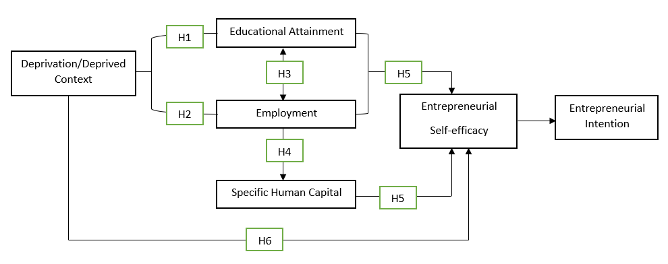
Source: Developed from Zhao et al. (2022)

- Data and Methods
Nottingham is a medium sized city with a population of 337,100 located in the East Midlands of England (Nomis Official Labour Market Statistics, 2020), which was selected as a case study to examine the impact of deprivation on human capital and its impact on ESE through collecting both quantitative (i.e. survey) and qualitative (i.e. semi-structured interviews) data. It was ranked 6th in terms of hosting a greater proportion of the areas defined as being the most deprived areas in England, as captured by the Index of Multiple Deprivation (Office for National Statistics, 2016, Table 1). Nottingham was also recently highlighted as being the city with the largest income gap to the most affluent areas of the UK (Judge and McCurdy, 2022). The domain of education in Nottingham ranked the city as being the 7th most deprived town or city in England in this regard (Table 1). More specifically, the result demonstrated by the Local Government Association indicates that the percentage of people aged between 16-64 years old who do not have qualifications in Nottingham was 10.9% in 2021 compared to 6.4% in England as a whole. Because of this, Nottingham can be considered as a good case study to investigate ESE in a more deprived city context where specifically there is a lower education level.

Table 1 Rankings of the most deprived towns and cities in England by the Index of Multiple Deprivation (IMD) across all IMD dimensions
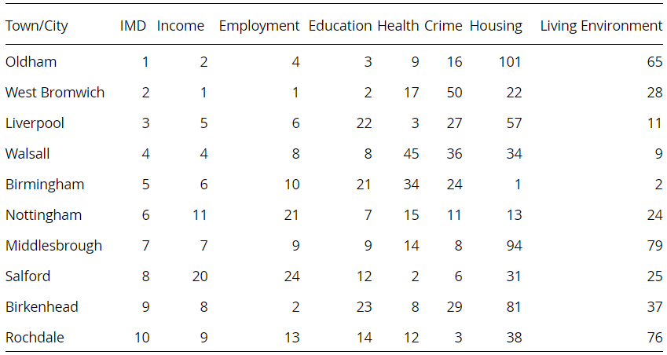
Source: Office for National Statistics and Department for Communities and Local Government
*Notes: A rank of 1 indicates the most deprived town or city and a rank of 109 the least. The overall most deprived towns and cities are determined by those with the greatest proportion of Lower Layer Super Output Areas (LSOAs) in the most deprived 20%.

Data
Given the more deprived nature of the Nottingham city area, the primary quantitative survey captured data from most areas of the city including those classified as being among the most deprived in England (Appendix 1). However, the most affluent areas of the greater Nottingham area, such as Croft Road, West Bridgford, Endsleigh Gardens and Edwalton (Pritchard, 2017), were excluded from the data collection. The data was collected through both cooperating with local supportive organizations and directly visiting businesses with physical presences in the targeted areas. The hard copies of questionnaires were given out to both nascent and active entrepreneurs by hand, which allowed the researchers to clarify the research purpose and explain related information as well as respond to entrepreneurs’ inquiries about the research face-to-face. In all, survey data was collected between December 2017 and November 2018 from 80 entrepreneurs, with a majority of these (70) being active entrepreneurs.

Furthermore, 6 semi-structured interviews were carried out with active entrepreneurs from the areas of Nottingham classed as being some of the 10% of most deprived in England (i.e. darker areas of the map, Appendix 1) to collect qualitative data. All interviewees were selected from the population which engaged in the survey and identified their postcodes based on the Nottingham Deprivation Data. Semi-structured interviews were carried out during the first half of 2019.

Measures and Analysis of Survey Data
In terms of primary quantitative data, it should be noted that some of the survey questions asked participants’ to provide the rating scale for a relationship instead of a single variable. For example, the question of ‘To what extent do you feel the following capabilities, skills and knowledge obtained from formal education are important factors influencing your confidence for business start-up?’ refers to the influence of benefits obtained from formal education on ESE rather than the rating for either the variable of qualification or the variable of ESE. Therefore, the total sample will be split to test the relationship between one variable and a single relationship, it means the total sample employed to test this kind of relationships will only include the responses collected from people who reside and/or set up a business in deprived areas of Nottingham.

A full sample (i.e. 80 responses) will be employed to examine the influence of deprivation on general human capital (Hypotheses 1 and 2) and ESE (Hypothesis 6) respectively. More specifically, benefits acquired from general human capital will be also considered to examine which skills and capabilities are perceived by people in deprived areas as important to increase ESE (Hypothesis 5). The measures for examining Hypotheses 1, 2 and 6 are represented in Table 2a, the measures for Hypothesis 5 have been demonstrated in Table 2b. The sub-sample (i.e. 34 responses) of respondents from the most deprived areas of Nottingham will be used to further test the influence of various deprived neighbourhood mechanisms on general human capital (Hypotheses 1 and 2), the influence of qualifications on employment status (Hypothesis 3) and the influence of general human capital on specific human capital (Hypothesis 4). The measures for testing Hypotheses 1 and 2 using the deprived area sub-sample are presented in Table 3a and the measures for Hypotheses 3 and 4 in Table 3b. This means Hypotheses 1 and 2 will be tested in two different ways. The full sample will be used to examine the influence of deprived localities on the development of general human capital; by using the sub-sample, the result will look at the influence of different neighbourhood mechanisms in deprived areas on the development of general human capital in a more detailed manner.

Analysis Approach
The analysis approach utilises binary logistic regressions to control for other influences. This includes considering the relationship between general human capital (GenHC_{aj}) and ESE (Self_{j}) directly as in equation (2) below:
$Prob\left({Self}_{j}\right)=α_{2}+β_{2}{GenHC}_{a,j}+γ_{2}Y_{2,j}+ε_{2,j}$ (2)
$$Prob\left({Self}_{j}\right)=ln\frac{\hat{p}}{1-\hat{p}}$$
Here GenHC_{a,j} reflects the general capital of type a (from education or work experience) held by individual j. This is hypothesised to be related to entrepreneur j’s self-efficacy. We control for entrepreneurially held controls Y_{j}.

In addition, the analysis considers how in a deprived city environment general human capital from education (GenHC_{ed,j}) can influence the accumulation of human capital from work experience (GenHC_{work,j}).
$Prob\left({GenHC}_{work,j}\right)=α_{3}+β_{3}{GenHC}_{ed,j}+γ_{3}Y_{3,j}+ε_{3,j}$ (3)
$$Prob\left({GenHC}_{work,j}\right)=ln\frac{\hat{p}}{1-\hat{p}}$$

Specifications can be run with both general human capital from education and work experience being allowed to enter along with deprived area conditions. It is possible that general human capital from education might operate through work experience and the deprived area conditions. As such it would be expected that GenHC_{ed,j} will lose significance (β₅ = 0) while any significant coefficients will be found on GenHC_{work,j} and Dep_{j} (β₆ > 0; β₇ > 0):
$Prob\left({Self}_{j}\right)=α_{5}+β_{5}{GenHC}_{ed,j}+β_{6}{GenHC}_{work,j}+β_{7}{Dep}_{j}+γ_{5}Y_{5,j}+ε_{5,j}$ (5)
$$Prob\left({Self}_{j}\right)=ln\frac{\hat{p}}{1-\hat{p}}$$
An equivalent set of regressions can be run but examining the role that the different types of general human capital and deprived area conditions have on the development of specific human capital, and whether they retain a direct impact on self-efficacy or operate indirectly through specific human capital.

Analysis of Interview Data
The qualitative analysis is used to further examine the mechanisms identified by the quantitative analysis as (not) operating to determine the ESE in deprived areas. This analysis therefore provides more insight into why the relationships between different types of human capital and ESE in deprived areas may differ from those found in studies of less deprived areas. It also allows the exploration of those relationships predicted by studies focused on deprived areas, such as Zhao et al. (2022), and also entrepreneurial search models that highlight how different types of human capital and the deprived context may interact, to understand where they differ to what was hypothesised. For analysing the qualitative data, thematic analysis as a generic approach is used to identify themes or patterns (Saunders et al., 2016). As the major themes, participants’ perceptions of human capital levels, both generally and individually (Figure 2), and the perceived factors affecting their ESE (Figure 3) are coded as nodes. In light of the nature of semi-structured interviews, factors influencing ESE are subsequently coded as sub-nodes.

Table 2a Measures for Hypotheses 1, 2 and 6 by Using the Full Sample of Survey Data

Relationships | Independent Variables | Binary Coding | Dependent Variables | Binary Coding | Control Variables
Hypothesis 1 | Deprivation | 1: Deprived areas  0: Less deprived areas | Qualification  ‘What is your highest achieved qualification level? | 1: High qualification levels; 0: Low qualification levels | - Identity  - Gender  - Ethnicity
Hypothesis 2 | Deprivation | 1: Deprived areas  0: Less deprived areas | Employment Status  - For nascent entrepreneurs: ‘What is your current employment status?’  - For actual entrepreneurs: ‘What was your employment status before setting up the business?’ | 1: Employed; 0: Not employed | - Identity  - Gender  - Ethnicity  - Qualification Level
Hypothesis 6 | Deprivation | 1: Deprived areas  0: Less deprived areas | Entrepreneurial Self-efficacy  - Capability of achieving desired outcomes  - Capability of completing tasks  - Capability of keeping a positive attitude to complete tasks  - Capability of controlling negative emotions when faced with difficulties | 1: Strongly agree/agree; 0: Strongly disagree/disagree/neutral | - Identity  - Gender  - Ethnicity  - Qualification Level  - Employment Status
Source: The Table is created by authors.

Table 2b Measures for Hypothesis 5 by Using the Full Sample of Survey Data

Relationships | Independent Variables | Binary Coding |  | Dependent Variables | Binary Coding | Control Variables
Hypothesis 5 | Deprivation |  | 1: Deprived areas  0: Less deprived areas | Entrepreneurial Self-efficacy acquired from formal qualification  - Adapt to a changing environment  - Solve problems and make decisions  - Basic learning capabilities  - Development of social networks from formal education  - Better recognize potential opportunities  - Easy to be employed | 1: Strongly agree/agree; 0: Strongly disagree/disagree/neutral | - Identity  - Gender  - Ethnicity
Hypothesis 5 | Deprivation |  | 1: Deprived areas  0: Less deprived areas | Entrepreneurial Self-efficacy acquired from work experience  - Solve problems and make decisions  - Better recognize potential opportunities that are ignored by others  - Increased alert awareness for potential risks | 1: Strongly agree/agree; 0: Strongly disagree/disagree/neutral | - Identity  - Gender  - Ethnicity  - Qualification Level
Source: The Table is created by authors.

Table 3a Measures for Hypotheses 1 and 2 by Using the Split Sample of Survey Data
Relationships | Independent Variables | Binary Coding | Dependent Variables | Binary Coding | Control Variables
Hypothesis 1 | Deprived Neighbourhood Mechanisms  - School quality  - Local residents’ attitude towards the education level  - Family income level  - Parents’ capability to provide resources and conditions  - Parents’ education levels and expectations for children’s educational levels  - Local role models | 1: Strongly agree/agree; 0: Strongly disagree/disagree/neutral | Qualification  ‘What is your highest achieved qualification level? | 1: Higher qualification; 0: Low and no qualification | - Identity  - Gender  - Ethnicity
Hypothesis 2 | Deprived Neighbourhood Mechanisms  - Local economic conditions and sources of employment opportunities  - Local residents’ attitude towards employment  - Reputation of local area and racial attitude | 1: Strongly agree/agree; 0: Strongly disagree/disagree/neutral | Employment Status  - For nascent entrepreneurs: ‘What is your current employment status?’  - For actual entrepreneurs: ‘What was your employment status before setting up the business?’ | 1: Employed; 0: Not employed | - Identity  - Gender  - Ethnicity  - Qualification Level
Source: The Table is created by authors.
Table 3b Measures for Hypotheses 3 and 4 by Using the Split Sample of Survey Data
Relationships | Independent Variables | Binary Coding | Dependent Variables | Binary Coding | Control Variables
Hypothesis 3 | Qualification  ‘What is your highest achieved qualification level? | 1: High qualification levels; 0: Low qualification levels | Employment Status  - For nascent entrepreneurs: ‘What is your current employment status?’  - For actual entrepreneurs: ‘What was your employment status before setting up the business?’ | 1: Employed; 0: Not employed | - Identity  - Gender  - Ethnicity
Hypothesis 4 | Employment Status  - For nascent entrepreneurs: ‘What is your current employment status?’  - For actual entrepreneurs: ‘What was your employment status before setting up the business?’ | 1: Employed; 0: Not employed | Specific Human Capital  - Capabilities relating to management procedures  - Specific capabilities, skills and knowledge in a specific industry | 1: Strongly agree/agree; 0: Strongly disagree/disagree/neutral | - Identity  - Gender  - Ethnicity  - Qualification Level
Source: The Table is created by authors.

Figure 2 Coding the theme of human capital in deprived areas
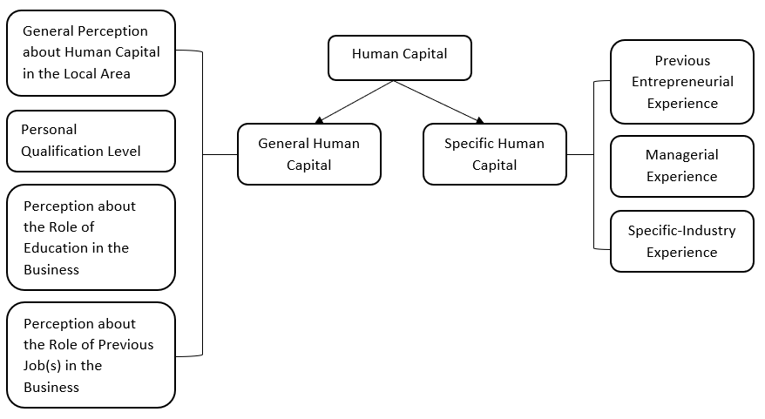
Source: The Figure is created by authors.

Figure 3 Coding the theme of factors influencing ESE in deprived areas
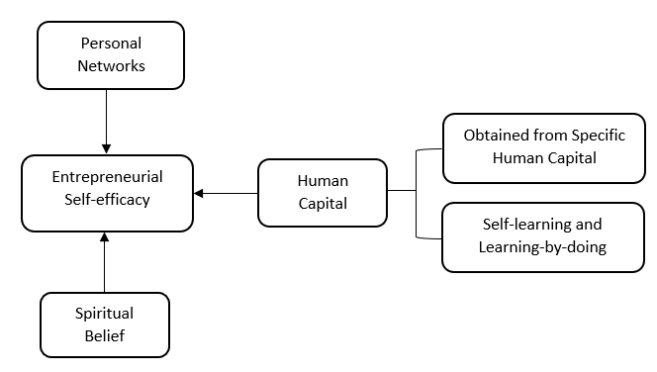
Source: The Figure is created by authors.

- Results and Discussion
Results of Survey Data
The demographic information for the survey respondents indicates that 50% have achieved higher qualifications (i.e. NVQ Level 4 and NVQ Level 5), the same as participants who have achieved a lower qualification (i.e. NVQ Level 1-3, including ‘No Qualification’). This distribution is likely to be reflective of the rising proportion of the UK population attending university and in the focus on those who are entrepreneurially active. Regarding participants’ employment status, it is shown that 83.5% were either employed before their business start-up or are currently employed if they are nascent entrepreneurs. Only 16.3% are either previously or currently unemployed. The descriptive results relating to participants’ general human capital level indicate that no large differences in unemployment exist by level of educational attainment. A majority of both the less and more highly qualified groups are in employment. In this vein, the descriptive result is different to the previous finding (Edzes et al., 2015) and does not support H1 and H3.

The binary regressions presented in Table 4 partially support Hypothesis 5, indicating that people from deprived areas are more than threefold likely to agree that basic learning capabilities acquired from formal qualification increase ESE. However, the influence of deprivation on general human capital acquisition (Hypotheses 1 and 2) and ESE (Hypothesis 6) are not found.

By using the sub-sample of respondents from the most deprived areas of Nottingham and running both correlation coefficients and logit regressions, no evidence is found of deprived neighbourhood effects on general human capital (Hypotheses 1 and 2), qualifications influencing employment status (Hypothesis 3) and general human capital generating specific human capital (Hypothesis 4). This could be due to the small sample size of 34 people from deprived areas of Nottingham. It is also likely to reflect the survey capturing employment but it does not necessarily capture the quality of this employment. Similarly for formal educational qualifications, data on the subject and institution of the awarding body are not available. Bapista et al. (2014) find success of necessity driven entrepreneurs is unrelated to human capital, while both general and specific human capital does relate to the success of opportunity driven entrepreneurs. To compensate for this restriction, qualitative data collected through semi-structured interviews will be further explored in the next subsection.

Table 4 Influence of deprivation on the perceived role of benefits acquired from formal qualification on ESE

 | Adapt to a changing environment | Solving problems and make decisions | Basic learning capabilities | Better recognize potential opportunities | Development of social networks | Easy to be employed
Deprivation | 0.852 | 0.947 | 1.252 | 0.564 | 0.854 | 0.072
 | (0.089) | (0.085) | (0.028) | (0.262) | (0.082) | (0.883)
Identity | 0.527 | 0.653 | 0.313 | 0.684 | -0.098 | -0.758
 | (0.465) | (0.374) | (0.695) | (0.341) | (0.895) | (0.294)
Gender | 0.458 | 0.211 | 0.047 | -0.227 | -0.473 | -0.573
 | (0.334) | (0.673) | (0.926) | (0.635) | (0.320) | (0.226)
Ethnicity | -0.489 | 0.659 | -0.329 | -0.044 | -0.711 | -0.539
 | (0.229) | (0.212) | (0.556) | (0.932) | (0.166) | (0.286)
Qualification | -0.215 | 0.017 | 0.073 | 0.544 | 0.017 | 0.270
 | (0.656) | (0.974) | (0.889) | (0.263) | (0.972) | (0.576)
F test | 4.805 | 4.759 | 6.242 | 4.043 | 7.237 | 4.761
df | [5] | [5] | [5] | [5] | [5] | [5]
 | (0.440) | (0.446) | (0.283) | (0.543) | (0.204) | (0.446)
Nagelkerke R² | 0.078 | 0.081 | 0.107 | 0.067 | 0.115 | 0.078
Hosmer and Lemeshow test | 6.353 | 3.640 | 8.323 | 6.652 | 17.385 | 3.369
 | (0.608) | (0.820) | (0.305) | (0.575) | (0.019) | (0.849)
PAC | 62.5% | 71.3% | 67.1% | 66.3% | 58.8% | 61.3%
N | 80 | 80 | 79 | 80 | 80 | 80
The p value is given in parentheses; degrees of freedom in bracket
Results of Semi-structured Interviews
It is suggested that most residents of deprived areas do not have higher qualifications, in some cases have no qualifications at all, which is consistent with results found in previous studies (Galster, 2002). It also indicates a possible outcome of a higher level of unemployment or economic inactivity, which is effectively hidden unemployment (Barr et al., 2019), in such areas. Although the overall qualification level in deprived areas is lower, there is still a sub-group of the population achieving higher education levels in deprived areas, for example, two participants were at the other end of the spectrum and achieved higher qualification levels (i.e. NVQ level 4).

Rather than employment status, participants’ occupational situations are more likely to reflect the difficulties in the labour market such as low payment in the service industry with limited prospects for promotion and personal development, regardless of qualifications. It means qualifications do not necessarily determine the occupational opportunities and/or development in deprived areas. As outlined in section 3, the sample was drawn from those participating in entrepreneurship support training and/or those who have established businesses. If only considering the employment status, it is reasonable that participants were employed or self-employed. This explains why the survey data provided little evidence of influence of qualification on employment status (Hypothesis 3). Interestingly, Participant C who obtained a higher qualification described an attitude of reluctance towards employment, ‘I have never tried to be employed. I do not agree or like being employed’. Meanwhile, work experiences are severely limited in such areas regardless of employment status, this is because being employed does not mean the acquisition of the diversified and required skills and experiences (i.e. cognitive skills) noted in the literature (Brixiová et al., 2020; Lazaer, 2005). Based on daily observation of local residents, the provision of welfare payments leads to a reluctance, or lack of urgency in seeking a job. It does not mean this behaviour has shaped a social norm of being unemployed in deprived areas; however, it is a phenomenon existing in deprived areas which is regarded as one of the reasons for unemployment. It also reflects local residents’ lack of non-cognitive skills, such as motivation of being employed or attitude towards employment, in deprived areas.

The restriction of specific human capital is found to be due to frequent changes in different jobs and temporary duration of each job (Participants C, E and F). This provides an explanation of why the survey found no support for general human capital restricting specific human capital acquisition (Hypothesis 4). The measures of employment status used could not pick up the quality of the capital being acquired. Other interviewees expressed that they have, or they believe they have, either previous entrepreneurial experiences, managerial experience and capabilities or specific-industry experiences (Participants A, B and D). A consistency between previous studies and/or jobs with the current businesses reflects the possession of corresponding skills and experiences that can be transferable to current businesses. In considering ESE, 5 out of 6 participants have shown a high level of ESE before business start-up, either goal belief or control belief. This runs counter to Hypothesis 6. The result also shows that specific human capital is perceived as having a more important role in enhancing ESE, particularly goal belief, rather than general human capital. In other words, the necessity of acquiring the right combination of both cognitive and non-cognitive skills to make entrepreneurship sufficiently rewarding to overcome the costs of search (Brixiová et al., 2020).

However, the questions are further proposed: Why specific human capital is perceived as more important than general human capital? How do people in deprived areas, particularly those who experienced restrictions in obtaining specific human capital or transferable skills and experiences, acquired this type of human capital? How acquired specific human capital increases ESE, and what other factors facilitate ESE? It is found that specific human capital is obtained by either engaging in short-term (free) courses (Participants E and F) or self-help methods such as self-learning (Participants B and C). In deprived areas people find different approaches to compensate for their restricted skills and capabilities acquired from more traditional sources of human capital. Such approaches could be regarded as a shortcut not only enabling individuals to selectively obtain the knowledge and skills required. It also overcomes concerns regarding the consumption of time and monetary investment associated with the slower accumulation of human capital through more a formal process. Even so, the role of specific human capital in increasing ESE is less than we expect or assume in deprived areas. Participant B who had a lower qualification presented a higher level of ESE; by contrast, Participant C who acquired a higher qualification displayed a lower level of ESE. The results reveal other factors including friends’ support (Participant E), the capability of self-learning along with either an opportunity to practice self-learning outcomes (Participant B) or perceived progress through learning-by-doing (Participant F), and personal spiritual belief (Participant C) were also seen as important.

Formal education or higher qualification levels provide an opportunity to develop better social networks (Ucbasaran et al., 2008), it is found that the support from personal social networks is another factor increasing individuals’ ESE in deprived areas. However, this kind of social network tends to be characterised by homogenous bonding ties, rather than the heterogeneous bridging networks proposed in the literature. The development of social capital has the potential to empower people to become entrepreneurs in deprived areas (Wyrwich et al., 2016) due to a strong sense of embeddedness within networks of mutual support (Schnell and Sofer, 2003). Nonetheless, it is argued these networks should not be regarded as resources either to generate economic benefits, or for starting a business venture (Hays and Kogl, 2007) due to the restricted access to valuable information or suggestions. Regardless of the role of bonding capital in business performance or survival, it is found that personal social networks in the form of bonding capital significantly strengthen some respondents’ ESE in deprived areas. In some cases, people do not have knowledge or experience in the industry in which they intend to set up a business. In these circumstances, the knowledge and relevant experience of friends who are working or have previously worked in that industry are found to be more valuable than bridging capital. This is because this kind of personal social network includes both technical help and emotional support (Bailey, 2015). Again, providing a mix of cognitive and non-cognitive skills. However, relying heavily on the support and help from their social network decreases people’s ESE when these friends are absent. Therefore, the limited relevant human capital present is compensated for by leveraging that of close contacts.

In Participant B’s case, his ESE is derived from ‘using online (platforms) to get as much information about this new skill that I wanted to acquire’. Specific human capital he mentioned includes ‘repairing water tap by myself’ to save the cost and ‘how to run or manage a business’, could be acquired from the online sources, and worked well during the period they were covering for the previous owner. Taking this into account, the absence and quitting of the previous owner provides a serendipitous opportunity that enabled him to become involved in the business operations and practice the feasibility of his self-searching and learning outcomes, which enabled his accumulation of this specific human capital and enhanced his ESE to a large extent. Similarly, Participant F’s ESE is derived from a ‘slow building process’ that allowed him to ‘realize what you are doing and learn from mistakes, so you will not take it the next time’.

These cases explain the contradictory result from previous studies presenting a lower level of ESE in deprived areas (Williams and Williams, 2011, 2017). In deprived areas, the result shows individuals’ ESE is related to the application of self-help methods (i.e. self-learning and learning-by-doing). They are able to solve immediate problems in a reactive fashion, rather than having the confidence in possessing knowledge, skills and experiences directly relating to the business, or business start-up per se. As depicted in Figure 4, responses suggest it is likely to be a cornerstone that allows individuals to carry out the later self-learning rather than directly increasing ESE. In other words, individuals’ cognitive skills (i.e. skills are practically and feasibly related to their business operations) are acquired through their non-cognitive skills (i.e. tenacity and motivation of overcoming existing barriers) as in combination they increase individuals’ softer skills (self-confidence or the perception of their problem-solving and searching capabilities); the softer skills, in turn, facilitate individuals’ continuous acquisition of cognitive skills in deprived areas.

Figure 4 Relationships between Deprivation, Human Capital and ESE in Deprived Areas
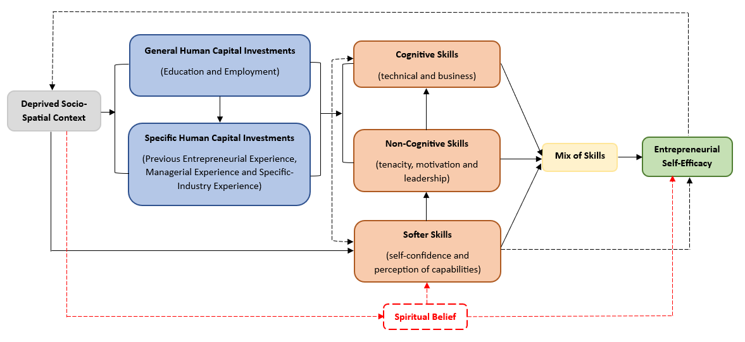
Source: The Figure is created by authors.

Notably, Participant C’s case is also shown in Figure 4 and illustrated by the red dotted lines as an exceptional case. This respondent achieved higher levels of qualification but displayed a lack of confidence in his own strengths, including the ESE. More accurately, the only driving force increasing not only the ESE, but also non-cognitive and softer skills is the belief in following the guidance from God. Participant C’s response also reveals feelings of hopelessness and desperation generated by the deprived context people are embedded in. Deprivation might shape their non-cognitive skills and spiritual belief could be regarded as a psychological sustenance that re-establishes their own softer skills to provide feelings of relief from the deprived context. While there is no evidence to prove the prevalence of this case in deprived areas, it still stresses the importance and necessity of acquiring and possessing the right combinations of cognitive, non-cognitive and softer skills, particularly when comparing with those who lack high levels of cognitive skills, to constantly identify possibilities and approaches to search for information and opportunities, as well as to overcome obstacles in deprived areas.

- Contributions, Limitations and Future Research Directions
This study investigated whether increasing human capital is a way to facilitate ESE in deprived areas. It is found that human capital is a factor increasing individuals’ ESE in deprived areas (RQ1). Although specific human capital is perceived to be the more important factor enhancing individuals’ ESE in such areas (RQ2), the two are complementary and at different points in time are key for acquiring the right combination of cognitive and non-cognitive skills needed. This study also found other more important factors that are deeply embedded in deprived areas influence local residents’ ESE, which could explain the barriers and unsatisfactory entrepreneurial performance identified by previous studies. The results show that a deprived context not only negatively impacts on local residents’ human capital but also severely causes psychological, cognitive, mental and behavioural deviations. The consequence is a negative image and reputation of such areas, subsequently limiting employment opportunities through perceived ‘discrimination’ and ‘exclusion’ that have been acknowledged by local residents as a major factor, in turn reducing family income through the generational effect (RQ3).

The study has highlighted how the goals of residents of deprived areas of the UK may not be set particularly high. This means that contrary to expectations individuals display relatively high levels of ESE as they have confidence in achieving these goals. In order to achieve these goals human capital is acquired, but it is often through lower quality often fragmented experiences. Future studies could look at local residents’ initial goal orientation, this is because people residing in a deprived context may be more likely to aim to survive, or meet ordinary living demands, or escape from unsatisfactory employment, rather than to achieve business expansion or growth. Meanwhile, perceived progress achieved through applying self-help methods is another facilitator increasing ESE in deprived areas. The changes in individuals’ goal orientation could be further investigated because individuals’ goals and purpose of setting up a business could be dynamic, instead of being static, along with perceived progress.

The results overall show human capital has a key role in generating ESE. This may aid efforts to regenerate deprived areas, but as was shown the human capital which is more readily formed and effective in deprived areas is not necessarily that provided by traditional mainstream support. In part, this reflects the high importance of specific human capital, which general human capital does not provide access to. Not because jobs are not available in deprived areas, but rather because of the quality of these employment opportunities. Instead, skills in self-learning and self-reliance may be more readily taken up and utilised by latent entrepreneurs in deprived areas, effectively the act of ‘teaching someone to fish’ in contrast to ‘giving them a fish’. However, whether the ESE formed sees policymaker’s ambitions and those of residents aligned appears doubtful. Therefore, there is a need to urgently consider who are interventions for. Are they for the community as a whole, or the individual deprived area entrepreneur?

- References
Bailey N (2015) The place of neighbourhood in entrepreneurship: attitudes, resources and sorting. In: Mason C, Reuschke D, Syrett S and van Ham M (eds.) Entrepreneurship in Cities. Edward Elgar Publishing Limited, pp19-38.
Bandura A (1997) Self-efficacy: the exercise of control. New York: Freeman.
Bandura A (2000) Cultivate self-efficacy for personal and organizational effectiveness. In: Locke EA (eds.) The Blackwell Handbook of Principles of Organization Behavior. Oxford: Blackwell, pp120-136.
Bapista R, Karaöz M and Medonça J (2014) The impact of human capital on the early success of necessity versus opportunity-based entrepreneurs. Small Business Economics 42: 831-847.
Barney J (1991) Firm resources and sustained competitive advantage. Journal of Management 17(1): 99-120.
BarNir A, Watson WE and Hutchins HM (2011) Mediation and moderated mediation in the relationship among role models, self-efficacy, entrepreneurial career intention, and gender. Journal of Applied Social Psychology 41(2): 270-297.
Barr J, Magrini E and Meghnagi M (2019) Trends in economic inactivity across the OECD: The importance of the local dimension and a spotlight on the United Kingdom. Available at: https://www.oecd-ilibrary.org/industry-and-services/trends-in-economic-inactivity-across-the-oecd_cd51acab-en (accessed 12 October 2022)
Blanden J, Gregg P and Macmillan L (2007) Accounting for intergenerational income persistence: noncognitive skills, ability and education. Economic Journal 117(519): C43-C60.
Bledow R (2013) Demand-perception and self-motivation as opponent processes: A response to Bandura and Vancouver. Journal of Management 39(1): 14-26.
Boardman JD and Robert SA (2000) Neighbourhood socioeconomic status and perception of self-efficacy. Sociological Perspectives 43(1): 117-136.
Bolli T and Hof S (2018) The impact of work-based education on non-cognitive skills. Journal of Research in Personality 75: 46-58.
Brixiová Z, Kangoye T and Said M (2020) Training, human capital, and gender gaps in entrepreneurial performance. Economic Modelling 85: 367-380.
Bullough A, Renko M and Myatt T (2014) Danger zone entrepreneurs: The importance of resilience and self-efficacy for entrepreneurial intention. Entrepreneurial Theory and Practice 38(3): 473-499.
Butler R and Hamnett C (2007) The geography of education: Introduction. Urban Studies 44(7): 1161-1174.
Camacho-Thompson DE, Gillen-O’Neel C, Gonzales NA and Fuligni A (2016) Financial strain, major family life events, and parental academic involvement during adolescence. Journal of Youth and Adolescence 45(6): 1065-1074.
Campos-Vazquez RM (2017) Returns to cognitive and non-cognitive skills: Evidence from Mexico. Applied Economics Letters 25(16): 1153-1156.
Chowdhury S, Endres ML and Frye C (2019) The influence of knowledge, experience, and education on gender disparity in entrepreneurial self-efficacy. Journal of Small Business & Entrepreneurship 31(5): 371-389.
Cowling M and Bygrave WD (2007) Entrepreneurship, welfare provision, and unemployment: Relationships between unemployment, welfare provision, and entrepreneurship in thirty-seven nations participating in the Global Entrepreneurial Monitor (GEM) 2002. Comparative Labor Law and Policy Journal 28(4): 617-636.
Crisp R, Batty, IC and Robinson D (2009) Work and worklessness in deprived neighbourhoods: Policy assumptions and personal experiences. Report. Joseph Rowntree Foundation, UK, October.
Delgado MY, Ettekal AV, Simpkins SD and Schaefer DR (2016) How do my friends matter? Examining Latino adolescents’ friendships, school belonging, and academic achievement. Journal of Youth and Adolescence 45: 1110-1125.
Davidsson P and Honig B (2003) The role of social and human capital among nascent entrepreneurs. Journal of Business Venturing 18(3): 301-331.
Devins D (2009) Enterprise in deprived areas: What role for start-ups? International Journal of Entrepreneurship and Small Business 8(4): 486-498.
Dimov D (2016) Toward a design science of entrepreneurship. In: Katz JA and Corbett AC (eds.) Models of Start-Up Thinking and Action: Theoretical, Empirical and Pedagogical Approaches. Advanced in Entrepreneurship, Firm Emergence and Growth. UK: Bingley: pp1-31.
Diochon M, Menzies TV and Gasse Y (2008) Exploring the nature and impact of gestation-specific human capital among nascent entrepreneurs. Journal of Developmental Entrepreneurship 13(2): 151-165.
Drnovsek M, Wincent J and Cardon MS (2010) Entrepreneurial self-efficacy and business start-up: Developing a multi-dimensional definition. International Journal of Entrepreneurial Behavior & Research 16(4): 329-348.
Edzes A, Hamersma M, Venhorst V and van Dijk J (2015) Labour market performance and school careers of low educated graduates. Letters in Spatial and Resource Sciences 8: 267-289.
Frankish JS, Roberts RG, Coad AC and Storey DJ (2014) Is entrepreneurship a route out of deprivation? Regional Studies 48(6): 1090-1107.
Fritsch M and Wyrwich M (2014) The long persistence of regional levels of entrepreneurship: Germany 1925 to 2005. Regional Studies 48(6): 955-973.
Galster G (2002) An economic efficiency analysis of deconcentrating poverty populations. Journal of Housing Economics 11(4): 303-329.
Galster G (2012) The mechanism(s) of neighbourhood effects: Theory, evidence, and policy implications. In: van Ham M, Manley D, Bailey N, Simpson L and Maclennan D (eds.) Neighbourhood Effects Research: New Perspectives. Springer Science + Business Media B.V.
Graham B and Bonner K (2019) Entrepreneurship and Regional Deprivation. In: Irish Academy of Management, Dublin, Ireland, 28-30 August 2019, pp1-22.
Greene FJ, Mole KF and Storey DJ (2007) Three Decades of Enterprise Culture: Entrepreneurship, Economic Regeneration and Pubic Policy. Basingstoke: Palgrave.
Hays A and Kogl AM (2007) Neighbourhood attachment, social capital building, and political participation: A case study of low- and moderate-income residents of Waterloo, Iowa. Journal of Urban Affairs 29(2): 181-205.
Hopp C and Sonderegger R (2015) Understanding the dynamics of nascent entrepreneurship – prestart-up experience, intentions, and entrepreneurial success. Journal of Small Business Management 53(4): 1076-1096.
Hsu DK, Shinnar RS and Anderson SE (2019) “I wish I had a regular job”: An exploratory study of entrepreneurial regret. Journal of Business Research 96: 217-227.
Humphries JE and Kosse F (2017) On the interpretation of non-cognitive skills – What is being measured and why it matters. Journal of Economic Behavior and Organization 136: 174-185.
Judge L and McCurdy C (2022) Income outcomes: Assessing income gaps between places across the UK. Report, The Resolution Foundation, UK, June.
Kassenboehmer SC, Leung F and Schurer S (2018) University education and non-cognitive skill development. Oxford Economic Paper 70(2): 538-562.
Kautz T, Heckman JJ, Diris R, ter Weel B and Borghans L (2014) Fostering and measuring skills: Improving cognitive and non-cognitive skills to promote lifetime success. NBER Working Paper, National Bureau of Economic Research, UK, December.
Kim PH, Aldrich HE and Keister LA (2006) Access (not) denied: The impact of financial, human, and cultural capital on entrepreneurial entry in the United States. Small Business Economics 27: 5-22.
Klimas P, Czakon W, Kraus S, Kailer N and Maalaoui A (2021) Entrepreneurial failure: A synthesis and conceptual framework of its effects. European Management Review 18(1): 167-182.
Koellinger P, Minniti M and Schade C (2007) “I think I can, I think I can”: Overconfidence and entrepreneurial behaviour. Journal of Economic Psychology 28(4): 502-527.
Koursaros D (2017) Labor market dynamics when (un)employment is a social norm. Journal of Economic Behavior & Organization 134: 96-116.
Krishnan P and Krutikova S (2013) Non-cognitive skill formation in poor neighbourhoods of urban India. Labour Economics 24: 68-85.
Lazaer E (2005) Entrepreneurship. Journal of Labor Economics 23(4): 649-680.
Lee N and Cowling M (2012) Place, sorting effects and barriers to enterprise in deprived areas: Different problems or different firms? International Small Business Journal 31(8): 914-937.
Longitudinal Small Business Survey (2016) Longitudinal Small Business Survey Year 1 (2015): Technical Appendix. BIS Research Paper no.291, London: Department for Business Innovation & Skills.
McGee JE, Peterson M, Mueller SL and Sequeira JM (2009) Entrepreneurial self-efficacy: Refining the measure. Entrepreneurship Theory and Practice 33(4): 965-988.
McKnight A, Stewart K, Himmelweit SM and Palillo M (2016) Low pay and in-work poverty: Preventative measures and preventative approaches. Report, European Commission, Luxembourg, May.
McNally S and Blanden J (2006) Mind the gap: Child poverty and educational attainment. Poverty 123: 10-13.
Mellahi K (2005) The dynamics of boards of directions in failing organizations. Long Range Planning 38(3): 261-279.
Morris J, Morris W and Bowen R (2022) Implications of the digital divide on rural SME resilience. Journal of Rural Studies 89: 369-377.
Mouraviev N and Avramenko A (2020) Entrepreneurship for Deprived Communities: Developing Opportunities, Capabilities and Enterprise Culture. Bingley: Emerald.
Moser J (2016) It does matter: How human capital influences a new firm. In: The 39th Annual
Conference of the Institute for Small Business and Entrepreneurship, Paris, France, 27th October 2016.
Nomis Official Labour Market Statistics (2020) Labour Market Profile – Nottingham. Available at: https://www.nomisweb.co.uk/reports/lmp/la/1946157131/report.aspx?town=Nottingham (accessed 12 October 2022)
Nottingham Insight (2019) Indices of Deprivation. Available at: https://www.nottinghaminsight.org.uk/themes/deprivation-and-poverty/indices-of-deprivation-2019/ (accessed 18 September 2020)
Office for National Statistics (2016) Towns and cities analysis, England and Wales, March 2016. Available at: https://www.ons.gov.uk/peoplepopulationandcommunity/housing/articles/townsandcitiesanalysisenglandandwalesmarch2016/2016-03-18#:~:text=Towns%20and%20cities%20had%20a%20higher%20proportion%20of%20the%20most,north%20or%20midlands%20of%20England. (accessed 12 October 2022)
Pickernell D, Packham G, Jones P, Miller C, and Thomas B (2011) Graduate entrepreneurs are different: they access more resources? International Journal of Entrepreneurial Behaviour & Research 17(2): 183-202.
Pritchard J (2017) This is the most expensive street in Nottinghamshire to live. Available at: https://www.nottinghampost.com/news/local-news/most-expensive-street-nottinghamshire-live-972297 (accessed 12 August 2020)
Rauch A and Rijsdjk S (2013) The effects of general and specific human capital on long-term growth and failure of newly founded businesses. Entrepreneurship Theory and Practice 37(4): 923-941.
Şahin F, Karadağ H and Tuncer B (2019) Big five personality traits, entrepreneurial self-efficacy and entrepreneurial intention: A configurational approach. International Journal of Entrepreneurial Behaviour & Research 25(6): 1188-1211.
Saunders M, Lewis P and Thornhill A (2016) Research Methods for Business Students. 7th
Edition. England: Pearson Education Limited.
Schmutzler J, Andonova V and Diaz-Serrano L (2019) How context shapes entrepreneurial self-efficacy as a driver of entrepreneurial intention: A multilevel approach. Entrepreneurship Theory and Practice 43(5): 880-920.
Schnell I and Sofer M (2003) Embedding entrepreneurship in social structure: Israeli-Arab entrepreneurship. International Journal of Urban and Regional Research 27(2): 300-318.
Schoon I, Jones E, Cheng H and Maughan B (2012) Family hardship, family instability, and cognitive development. Journal of Epidemiology and Community Health 66(8): 716-722.
Shane S (2000) Prior knowledge and the discovery of entrepreneurial opportunities. Organization Science 11(4): 448-469.
Shane S (2009) Why encouraging more people to become entrepreneurs is bad public policy. Small Business Economics 31(2): 141-149.
Shane S and Venkataraman S (2000) The promise of entrepreneurship as a field of research. Academy of Management Review 25(1): 217-226.
Thompson P and Kwong C (2016) Compulsory school-based enterprise education as a gateway
to an entrepreneurial career. International Small Business Journal 34(6): 838-869.
Thompson P, Jones-Evans D and Kwong C (2009) Women and home-based entrepreneurship:
evidence from the United Kingdom. International Small Business Journal 27(2): 227-239.
Tumasjan A and Braun R (2012) In the eye of the beholder: how regulatory focus and self-
Efficacy interact in influencing opportunity recognition. Journal of Business Venturing 27(6):
622-636.
Ucbasaran D, Wright P and Wright M (2008) Opportunity identification and pursuit does an
entrepreneur’s human capital matter? Small Business Economics 30: 153-173.
Van Gelderen M, Brand M, van Praag M, Bodewes W, Poutsma E and van Gils A (2008)
Explaining entrepreneurial intentions by means of the theory of planned behaviour. Career
Development International 13(6): 538-559.
Van Ham M, Manley D, Bailey N, Simpson L and Maclennan D (2012) Neighbourhood Effect
Research: New Perspectives. Springer: Science + Business Media B.V.
Welter F, Trettin L and Neumann U (2008) Fostering entrepreneurship in distressed urban
neighbourhoods. International Entrepreneurship and Management Journal 4(1): 109-128.
Williams N and Williams CC (2011) Tackling barriers to entrepreneurship in a deprived urban
neighbourhood. Local Economy 26(1): 30-42.
Williams N and Williams CC (2017) Entrepreneurship and deprived urban areas:
Understanding activity and the hidden enterprise culture. In van Ham M, Reuschke D,
Kleinhans R, Mason C and
Williams CC and Windebank J (2016) Revitalising Deprived Urban Neighbourhoods.
Abingdon: Routledge.
Wyrwich M, Stuetzer M and Sternberg R (2016) Entrepreneurial role models, fear of failure,
And institutional approval of entrepreneurship: A tale of two regions. Small Business
Economics 46(3): 467-492.
Zhao Y, Arici C, Galanakis K and Thompson P (2022) The influence of human capital in
entrepreneurial intention in deprived areas: A theoretical framework. In: Pickernell DG, Battisti
M, Dann Z and Ekinsmyth C (eds.) Disadvantaged Entrepreneurship and the Entrepreneurial
Ecosystem, Bingley: Emerald Publishing Limited, pp33-60.
Zwysen W and Demireva N (2020) Ethnic and migrant penalties in job quality in the UK: The
Role of residential concentration and occupational clustering. Journal of Ethnic and Migration
Studies 46(1): 200-221.

- Appendices
Appendix 1 Nottingham City 2019 Indices of Multiple Deprivation
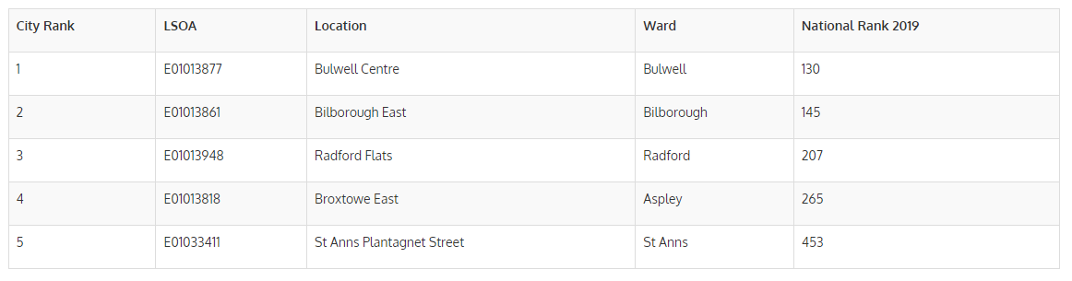
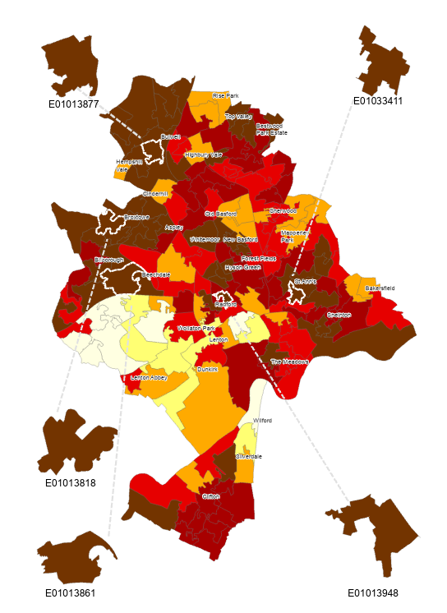
Source: Nottinghamshire Insight, (2019)
https://www.nottinghamshireinsight.org.uk/research-areas/deprivation/ [Available access at 21/06/2019]

Appendix 2 Demographic information about interview participants
 | Gender | Age | Ethnicity | Educational Attainment | Employment Status before Business | Business Type | Start-up Method | Business Duration
Participant A | Female | 40-55 | White | NVQ Level 3 | Employed  (i.e. Freelance florist) | Flower shop | Take over the business from the previous owner who she knows | More than 3.5 years
Participant B | Male | 25-39 | White | NVQ Level 2 | Employed | A tattoo shop | Take over the business from the previous owner | Almost 2 years
Participant C | Male | 25-39 | Mixed Group | NVQ Level 4 | A Student/Graduate | No physical shop: Private Training | Cooperating with other institutions | More than 3.5 years
Participant D | Female | 40-55 | Asian/Asian British | NVQ Level 4 | Employed  (i.e. designer) | Clothing design shop | Self-established | More than 3.5 years
Participant E | Male | 25-39 | White | NVQ Level 2 | Employed | Café | Self-established | Less than one year
Participant F | Male | 40-55 | Black | No Qualification | Employed  (i.e. worked in night clubs) | No physical shop: Handmade bags | Self-established | Around 3 years

Multiple deprivation contains seven domains, including income, employment, education, health, crime, housing and living environment.
The Local Government Association (https://lginform.local.gov.uk/reports/lgastandard?mod-metric=98&mod-period=4&mod-area=E92000001&mod-group=E06000018&mod-type=area) is the national membership body for local authorities.
Local supportive organizations refer to those provide entrepreneurship training and social network events such as Nottingham City Council, Creative Quarter Nottingham and Newforms
Both nascent and active entrepreneurs are included for the entire sample of the survey. Nascent entrepreneurs are those who intend to set up a new business in Nottingham within the next three years and have started to prepare in some manner including seeking finance or attending relevant training events. Active entrepreneurs are those who have established at least one business with one employee (including the entrepreneur).
Nottingham Deprivation Data includes 10,060 postcodes, both those in use and those previously in use for Nottingham. For each postcode, the ‘Index of Multiple Deprivation Decile’ is reported. The extent of deprivation of each postcode in Nottingham ranges from 1 representing the postcode reflecting a location in 10% of the most deprived areas of England to 7 showing the place is located among the least deprived areas of Nottingham.
Findings explored from semi-structured interviews include not only the participants’ own experiences but also their observations of local people and local situations from their daily life. Participants’ demographic information is presented in Appendix 2.
As participant A stated: ‘Certainly, they (local residents) do not have good education, I have got a next-door neighbourhood who got two sons, they never have a job. I think it is very difficult for the younger people to find a job, a lack of good education is a big issue, a big factor for employment.’
Participant E pointed out: ‘I know a few people that feel that they are happy the way that they are, living off the state, to be fair, this is for them to choose, and not for me to say it is right or wrong. But that is how they live their life in a bad area, and they do not get a lot of money, they survive.’
For example, Participant E stated: ‘My business is quite different to my previous jobs’.
As Participant E stated: ‘When the shop is quiet and I have a bad day, it can trigger the depression certainly, it is intrusive thoughts and very bad thoughts. I know that the shop is not advertised well for whatever reason, and I have not done everything that I would like to’.
His current business was taken over from the previous owner. As he stated: ‘I came and I worked for the previous owner of the business for a few months, but the business was neglected. There was money that should have going into the business, and it was not really managed correctly. The owner had already left the country and I came in and was basically practically running his business for him’.
Participant C: ‘Jesus, my spiritual encounter is the most important and most impactive thing why I do everything I do. Started my business, everything I have done has come from listening to God and doing what he tells me to do. Confidence come from God, I haven’t got the confidence in my own strength, I do not even have a desire to do business, everything from the spirit’.
Participant C: ‘What is going to change that (barriers existing in deprived areas)? Nothing, apart from a spiritual encounter, that is the only thing that is going to change that situation. What is the biggest thing that has to change or influence my life or what I did, it is always spiritual’.

