Uzma Batool b, Muhammad Mustafa Raziq a,b,*, Naukhez Sarwar b
a College of Business Administration, University of Sharjah, Sharjah, United Arab Emirates,
b NUST Business School, National University of Sciences and Technology (NUST), Islamabad, Pakistan

Paradoxical Leadership: Extending the Debate on Paradox Perspective into leadership Literature

Abstract:
Organizational systems are drenched in tensions and paradoxes. For a leader, addressing and engaging those tensions in constructive ways may unlock greater benefits for the followers, teams and the organization at large. A leader with a paradox mindset successfully deals with contradictory yet interdependent demands with their paradoxical thinking. While embracing these tensions leverages performance and innovation, experiencing these tensions may also lead to frustration and defensiveness, resulting in negative some consequences. Considering the burgeoning importance of PLB in paradox management and leadership literature, we conduct a systematic review of paradox theory of leadership. Based on the review we propose a multi-level conceptual model stating the dual effect of being a paradoxical leader. To do so, we unveil the individual and contextual factors influencing PLB on the individual followers, teams and the organization. Study’s findings contribute to the paradox theory and extends the literature on paradoxical leader behavior by introducing how paradoxical leader behavior can influence followers in contradictory ways. We present future research avenues and discuss theoretical and practical implication.

Keywords: Paradoxical Leadership, PLB, paradox mindset, follower characteristics, sustainability.

Track: Leadership and Leadership Development Track

Word count: 6024 excluding references

Introduction

With the rise of globalization, emerging technologies, ever-changing economic conditions, and the demands of flexible firm structures, inconsistencies are now a commonplace occurrence in the organizations (Mumby et al., 2014). To remain competitive, contemporary organizations, hence, make several shifts in their organizational settings, which include flexible work processes, and integrating advanced technologies, all of which result in the emergence of paradoxes (Putnam et al., 2016). Organizational leaders facing such paradoxes, end up prioritizing one challenge over the other by adopting tradeoffs, and compromising on strategies, making static resolutions based on the situationally relevant alternatives. Paradoxes persist over time and the ideal role of the leader is to embrace the persistent nature of tensions, respect the interdependence of opposing elements, and simultaneously keep managing the connections between the opposing elements to get the best out of them (Lewis, 2000; Smith & Lewis, 2011). The essence of this ideal leadership practice lies in adopting “both/and” approach toward conflicting demands (Smith et al., 2016).
A paradoxical leadership behavior refers to those interrelated behaviors that are seemingly competing yet interdependent arising from structural and follower demands (Zhang et al., 2015). PLB is different from earlier leadership approaches, in that earlier leadership theories were based on either/or strategy. This suggested that a leader would weigh available alternatives and choose (one) among competing tensions according to the situation, and would consistently stick to the chosen tension, largely overlooking the other available alternatives (Lewis, 2000; Smith & Lewis, 2011). Choosing one tension here, however, may be useful for shorter period, and may result in re-emergence of tensions. Whereas, PLB follows both/and strategy, seeks to holistically understand the competing elements instead of separating the tensions into parts (Smith et al., 2016), positively predicts creativity (Miron-Spektor et al., 2011) innovation (Zhang et al., 2021) resilience (Franken et al., 2020) as well as performance (Sparr et al., 2022).
Cunha and Putnam (2019), however, point out that paradoxes are vicious circles and may have negative effects, which research has generally ignored. Overlooking the dark side of paradoxes exogenous and endogenous pressures become cause of over ambitiousness and conflicting demands force organizations to appear what they are not (Delmas & Burbano, 2011). Consequently, emerging studies have labeled the paradoxes and experience of tensions as double edged sword (Miron-Spektor et al., 2018; Shao et al., 2019). However, little is known about how, when and under what situations leader’s paradox experience works as double edged sword and how it influences other organizational actors. Hence, it is imperative for paradox scholars to gain in-depth knowledge regarding both the positive and negative consequences of adopting paradoxical frames before fully embracing the recommendation to stimulate paradoxical thinking at work (Lewis & Smith, 2022).
Application of paradoxical frames depends on conditions which further guide behavior – such conditions provide an opportunity to individuals with paradox mindset by indicating features of both of the two contrasting categories (Keller et al., 2017). Despite of growing interest in the phenomenon, earlier research on paradoxical leadership has broadly focused on theoretical development of paradox perspective, identifying dimensions and nature of paradoxes embedded in organizational system (Waldman & Bowen, 2016; Zhang et al., 2015). However, while research is now moving from macro to micro level, emphasizing measure development (Miron-Spektor et al., 2018), for example, an understanding on the influence of PLB on individual followers, team and organizations is still at an infancy stage (Volk et al., 2022).
To this end, this study seeks to fill some gaps and contribute to paradox theory and leadership literature in many ways. Our study mainly revolves around addressing what is known, what needs to be known and what is still missing about paradox theory of leadership. To do so, we first critically and systematically review available literature to understand the progress made and the existing loopholes in paradoxical leadership literature. We also compare paradoxical leadership with contingency based leadership approaches to identify why even paradoxical leadership is needed. Secondly, we present a nomological net highlighting the commonly used theoretical perspectives, antecedents, moderators, mediating mechanisms and consequences of paradoxical leader. Thirdly, based on our review we address the largely neglected dual impact of paradoxical leader on multiple levels. To do so, we propose a conceptual framework highlighting how paradoxical leader influences individual followers, teams and organizations at large. Since paradox perception varies for different individuals working in an organization, we identify the situations under which paradoxical leader may influence subordinates in positive and negative ways. To this end, we present the moderating mechanisms which can intensify, weaken or balance the dual effect of paradoxical leadership. Fourthly, we highlight key areas which need scholars’ attention and provide future direction.
In practical terms, our contribution may help organizational executives to identify team leaders and followers with paradoxical mindset and use their potential to the fullest. Managers may be able to train employees by putting them in contextual settings disclosed in our study to help them practice paradoxical mindset as still it is not proved that whether paradoxical thinking is a trait or can be learned with practice (Schad et al., 2016). Additionally, executives can identify possible negativities associated with team leads paradoxical behavior and find strategies to reduce these for long term leadership effectiveness.

Empirically measuring paradoxical leadership
Paradoxical leader behavior is based on five behavioral dimensions which are derived from three fundamental organizational paradoxes i.e., paradox of belonging, and paradoxes of organizing and learning (Smith & Lewis, 2011; Zhang et al., 2015). The five dimensions’ exhibit both/and leader behavior and while complementary in nature, are opposite to each other. These are: (a) leader confirming his/her leadership while sharing the locus of influence with members; (b) leader emphasizing individuality of followers while considering them all equal; (c) leader providing autonomy to followers while taking control of the decisions; (d) preserving both hierarchical distance and interpersonal closeness with members; and, (e) providing tight work requirements whilst maintaining flexibility. Among these five dimensions last three are specific to tensions between leader and the follower based on the organizing and belonging paradoxes (Smith & Lewis, 2011), and are interdependent and significant for the leader’s management.
Zhang et al. (2015) developed a 22 items scale based on the above 5 dimensions. Most of the studies following Zhang et al. (2015) are coming with new and slightly different versions of paradoxical leadership measure, which are applicable in different organizational settings. In corporate development contextual settings, Zhang and Han (2019) developed a 20 items scale based on four dimensions which are: (a) keeping short-term effectiveness and also long-term growth in business; (b) keeping stability in organization and flexibility; (c) taking care of shareholders and stakeholder interests; and, (d) fulfilling and determining collective forces in the organizational environment. Fürstenberg et al. (2021) validated a five items scale based on Zhang et al. (2015) 22 items construct in a contextual settings of global paradoxical leader behavior. Resultantly, there is no general agreement on a precise yet comprehensive measure of paradoxical leadership.

Paradoxical Leadership Versus Traditional (Contingency) Leadership Approaches
A paradoxical leader stresses on embracing co-existence and persistent nature of contradictory elements and this makes paradoxical leadership different from traditional leadership approaches (Zhang et al., 2015). For example, a situation which requires a follower to be provided with autonomy and at the same time a leader requiring the follower to be controlled, the leader with a paradox mindset there will take both/and stance by holistically understanding both opposing tensions of providing autonomy and controlling the follower simultaneously (Zhang et al., 2015). This is unlike traditional approaches of leadership, which emphasize or/either strategy which advocates weighing available alternatives and picking among one suitable alternative (Waldman & Bowen, 2016). Choosing among suitable alternative no doubt resolves the matter for the time being, but these tensions keep emerging time and again. For the sake of sustainability, paradoxical leadership emphasizes separating the two sides of paradoxes, benefiting from their interdependent advantages and then considering them as an ongoing, iterative process (Smith et al., 2016). Table 1 compares the paradoxical leadership with contingency leadership.
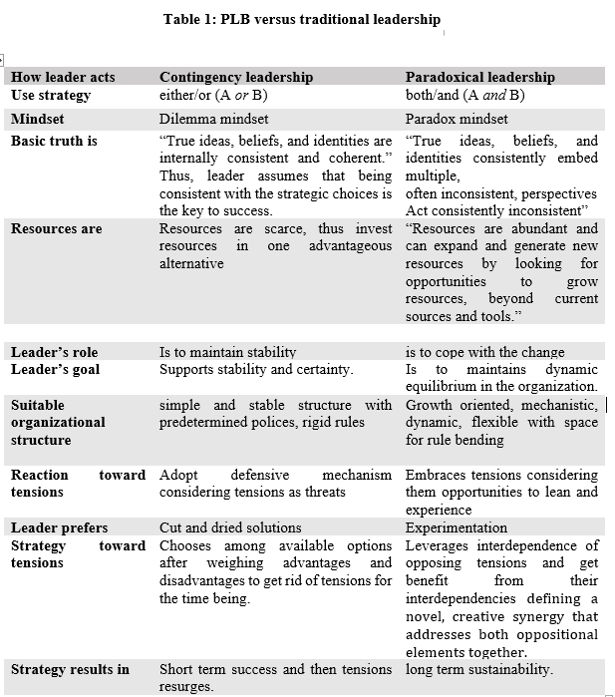

A Systematic Literature Review
Methodology
We follow a systematic review procedure (Jesson et al., 2011). In order to identify studies pertinent to the paradoxical leadership, a Boolean search in the “Web of Sciences”, and “google scholar” outlets are conducted. The keywords we include are: “paradoxical leader”, “paradox mindset,” “PLB,” and “paradoxical leadership”. Our initial sample consisted of 90 articles. To make sure that review includes only scholarly authenticated knowledge, we filtered the search results consisting of only full-length studies published in peer-reviewed academic journals (Podsakoff et al., 2005). Therefore, other resources for example book chapters, commentary essays, editorials, and conference proceedings were excluded from the review. We excluded studies that were only relevant to paradox perspective/paradox theory and not on paradoxical leadership. We were, hence, left with 60 articles.

Data Analysis and Results
To make analysis process legit, constructive discussions were made with the research team to resolve any discrepancies found and any concerns raised. Majority of the articles consisted of qualitative, narrative, conceptual/theoretical development methods, and a few and most recent studies employed quantitative methods. Our review identified that earlier research on paradox theory of leadership largely emphasized theory development, application of paradox perspective in different contextual settings, and measure validation (Lewis et al., 2014; Smith et al., 2016; Waldman & Bowen, 2016; Zhang et al., 2015). Consequently, the primary focus remained around identification of different types of macro paradoxes, and how leaders with different mindsets respond to paradoxes.

Antecedents of a Paradoxical Leadership Behavior

Our review (see fig 1) identified that literature on predictors of paradoxical leadership is at an infancy stage. With regard to the characteristics of the paradoxical leader, holistic thinking, integrative complexity, extraversion and openness to experience were found to be positively predicting paradoxical behaviour (Ishaq et al., 2021; Zhang et al., 2015). Besides personal attributes, context also plays a vital role in the emergence of paradoxical leaders. For example, organic organizational structure with comparison to mechanistic help enable paradoxical leadership (Zhang et al., 2015).
Outcomes of PLB
Studies suggest that paradoxical leaders are highly creative (Park et al., 2021; Shao et al., 2019) and more linked to innovative behaviors (Miron-Spektor et al., 2018; Zhang et al., 2021) and work engagement (Fürstenberg et al., 2021) enhances follower’s performance (Backhaus et al., 2021; Ishaq et al., 2021; She et al., 2020; Sparr et al., 2022), work engagement, job satisfaction (Backhaus et al., 2021), employee resilience (Franken et al., 2020), individual ambidexterity (Klonek et al., 2021), and escalation of commitment (Sleesman, 2019). Similarly, organizational citizenship behavior (Meng et al., 2021; Pan, 2021), and promotive and prohibitive voice behaviors (Li et al., 2018; Li et al., 2020; Xue et al., 2020) are positive outcomes of paradoxical leadership.
Besides identifying the positives, recent research also indicates some negatives of paradoxical leadership, for example, job insecurity and job stress (Bashir, 2021). It has, hence, been argued that paradoxical leadership may act as a double-edged sword. Research on how paradoxical leaders influences followers has recently caught attention (Sparr et al., 2022).

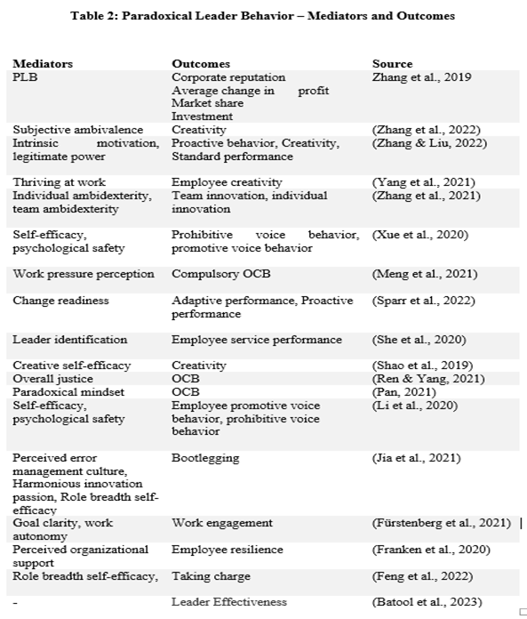

Mediators and moderators
Generally, there is limited research examining mediating mechanisms and moderators of paradoxical leadership. Shao et al. (2019) identify employees’ creative self-efficacy as an underlying mediating mechanism linking PLB with employees’ creativity. Similarly, paradoxical leader’s creative self-efficacy and psychological safety altogether enhance employees’ promotive and prohibitive voice behaviors (Xue et al., 2020). Moderating mechanisms studied are even fewer than the mediators (see Table 3).
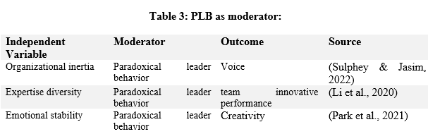
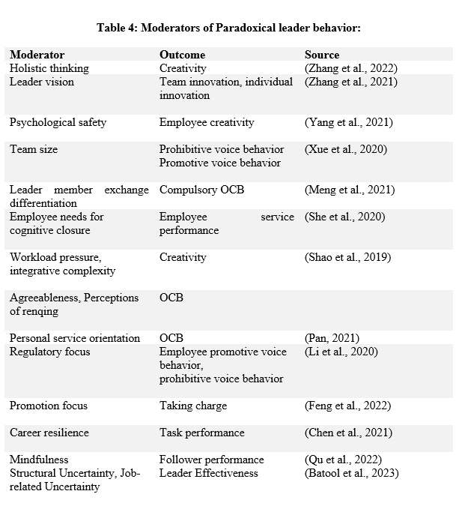

Figure 1 presents the framework based on literature review.
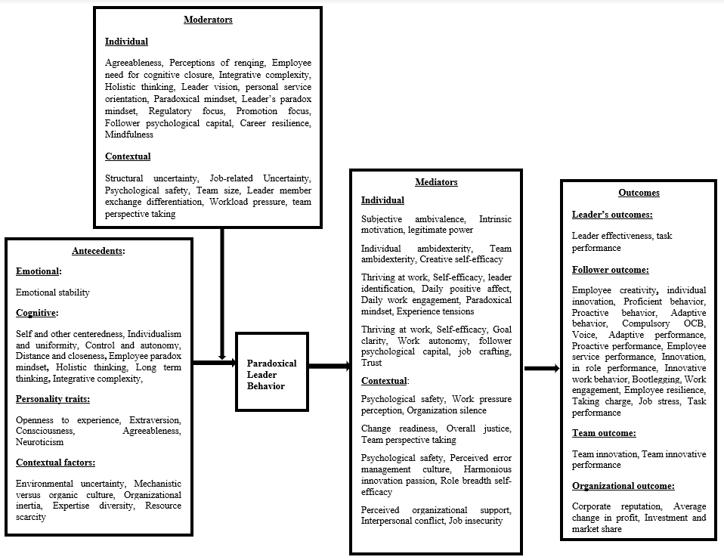
Figure 1: Paradoxical leadership Nomological Net

A Multi-level Conceptual Model of Paradoxical Leadership

Based on identified gaps from our comprehensive systematic literature review, we further inform the much-neglected paradox of how and under what conditions paradoxical leader behavior yields positive and negative outcomes simultaneously. To do so, we present a conceptual model explaining how the double-edged sword of paradoxical leadership influences individual follower, team and organization. We also present individual and contextual factors as moderating mechanism/situations/conditions, which strengthen or weaken positivity and negativity at all levels.

PLB: A Double-Edged Sword

Tensions are embedded in organizational systems. These latent tensions become salient due to environmental/contextual factors of plurality, scarce and change (Smith & Lewis, 2011). Upon confronting contradictions, individuals use mental templates to identify and embrace conflicting demands. These mental templates are basically individual’s paradoxical frames which if activated, result in individual’s recognition with the opposing elements, yet appreciating the significance of synergistic combinations of opposing elements (Smith & Tushman, 2005).
Comparatively, if paradoxical frames are not activated, individuals focus on only one dimension ignoring the other, largely overlooking the opportunity to achieve both (Miron-Spektor et al., 2011). Contradictions enable actor’s responses, either spurring virtuous cycle of positivity or vicious cycle of negativity (Lewis, 2000). Positive virtuous cycle enables when actors embrace the persistent nature of tension, considering the tension as an opportunity to be creative. Such individuals adopt paradoxical thinking looking for both/and possibilities. Negative vicious cycle enacts if actor prefer consistency, experience emotional anxiety upon facing tensions, and responds in a defensive way by denying and repressing the existence of tensions. Such actors adopt either/or strategy preferring one option over the other to find short term solution (Smith & Lewis, 2011). To cope up with today’s turbulent world and expedite the incorporation of conflicting and inconsistent demands, supervisors and employees ought to adopt paradoxical frames (Lewis & Smith, 2022; Volk et al., 2022).
Paradoxes work as a double-edged sword, stimulating innovative ideas along with spurring nervousness and stress (Lewis, 2000; Miron-Spektor et al., 2018; Smith & Lewis, 2011). Subsequently, paradoxical leadership has also been labeled as double-edged sword (Shao et al., 2019; Zhang et al., 2015). Stimulating positive outcomes but only under specific situations, like enhancing employees creativity but under workload pressure (Shao et al., 2019) and for those followers only who are holistic thinker (Zhang et al., 2022).
Below we present a conceptual model explaining how double-edged sword of paradoxical leadership influences individual follower, team and organization both positively and negatively. We also present individual and contextual factors as moderating mechanism/situations/conditions, which strengthen or weaken positivity and negativity at all levels.

Paradoxical Leadership Influencing Individual Follower
Literature suggests that paradoxical leader positively influences individual follower’s creativity (Yang et al., 2021), task performance, proficient behavior, proactive behavior, (Zhang et al., 2022), compulsory OCB (Meng et al., 2021), proactive and adaptive performance (Sparr et al., 2022) as well as resilience (Fürstenberg et al., 2021). Based on above findings it can be deduced that mostly paradoxical leader positively influences followers to enhance follower’s overall task relevant performance and well-being. However, these positive outcomes are highly reliant on specific conditions, hence, paradox experience enhances learning and agility if followers are receptive toward leader’s paradoxical demands and own a thought process which help them understand what the leader expects.
A paradoxical leader influences individual followers work relevant performance by presenting themselves as role models and expect followers to be learning oriented, flexible and open toward conventional approaches and communicating a clear vision (Zhang et al., 2015). Though leader vision communication strengthens the individual and team innovation, it is argued that leader’s effective vision communication does not guarantee that followers perceive, process and collectively share the message as intended by the leader (Zhang et al., 2015). Unless and until followers are open to experience tensions, considering them opportunities to grow, and have the cognitive and behavioral complexity (to holistically understand the phenomenon), leader’s sense making is most likely to be perceived as a mixed message. If followers lack paradox mindset, they are more likely to view the opposing tasks to be done as merely tensions which are going to burden them (Miron-Spektor et al., 2018). Eventually, this will result in denial and may offer a temporary solution to tensions. Such complexities leave followers ambivalent - scant and largely peripheral, failed or exaggerated attempts to engage paradoxes may lead to negative or unintended outcomes, such as chaos, conflict and decline (Schad et al., 2016).
Similarly, there are situations where the paradoxical leader can negatively influence followers. First, where the followers have, for example, a dilemma mindset, they experience contradictory demands, which leaves them ambivalent, and confused. This only adds anxiety to the followers, because of their inability to process what the leader wants from them, hence resulting in negative outcomes like turnover intentions, for example. Experience of a paradox enables vicious cycle of negativity, through which the immediate reaction of followers will be a tradeoff among the conflicting tensions leading to a defensive attitude (Miron-Spektor et al., 2018).
Secondly, leader can intentionally generate paradoxes with the intent to show power by trapping followers in a double bind situation. In such situations, followers are left with no option to do right things, but are still held liable for a failure (Julmi, 2021). This enables a vicious cycle, which not only continues but strengthens over time (Berti & Simpson, 2021). This becomes an organizational norm as it encourages other leaders to imitate the same (Julmi, 2021).
Thirdly, a paradoxical leader faces continuous challenges from the organizational structure. Sometimes goal achievement can be unrealistic. Leader having a paradox mindset get thrilled by the opportunity to excel (Miron-Spektor et al., 2018) without realizing whether the challenge is attainable or not for the followers. Such leaders indulge in stretching goals too far and then expect the followers to be open to experience new challenges (Pina e Cunha et al., 2017). This adds to follower’s burnout, particularly when individuals are consistently demanded to perform more than their capability to perform. These situations result in a follower’s distress, and a sense of being helpless and powerless (Julmi, 2021). Putting employee mental health, and well-being at stake and ultimately causing burnout. Hence:

Proposition 1a, 1b: Paradoxical leader fosters follower’s task performance where the follower has a paradoxical mindset and causes follower’s burnout, where the follower has a dilemma mindset
Paradoxical Leader Influencing Teams
Teamwork per se is paradoxical in nature, as conflicting challenges keep emerging within teams and outside teams. While facing different contradictions, a balanced approach lies in paradoxical cognition and processes that let teams effectively embrace, rather than avoid, contradictions (Smith & Tushman, 2005). Literature examining the impact of PLB on teams is limited to suggesting that paradoxical leadership fosters team innovation (Zhang et al., 2021) and team innovative performance (Li et al., 2018) – other than that little else is known.
A paradoxical leader may influence followers at collective level by creating an independent and structured environment simultaneously (Zhang et al., 2015). This balanced approach of stressing the structural demands while not neglecting follower’s agenda motivates followers to perform well. A team member, for example, wanting to be recognized individually based on his/her individual efforts, at the same time wants to be recognized as a member of the team which completed the task. A paradoxical leader can deal with this paradox of assigning team a uniform task and also identifying individuals based on their expertise by providing them sub task relevant to their skills (Lewis, 2000; Zhang et al., 2015).
Group members with paradoxical thinking foster group effectiveness. In order to foster paradox of innovation, for example, exploration tasks can be assigned to different members based on their skill set and exploitation to other members. Differentiating tasks based on member’s skill set and then integrating for greater organizational cause proves fruitful (Smith & Tushman, 2005). Consequently, different rewards and incentives are provided. However, it can be argued that teams consist of different individuals with varying degrees of characteristics, qualities, expertise, and mindsets, and, hence, may not all the time show an overall enhanced performance.
Team member’s differentiation according to skill set is justified to those who identify with leader mindset. Comparative to those with dilemma mindset, for them, such differentiation will be perceived differently. These group members will react negatively as they are unable to holistically understand the rationale behind such differentiation. Thus, same piece of information can be perceived differently by different members working in group. Zhang et al. (2021) suggests that team members with innovative behaviors are more likely to experience conflict with other team members having less innovative behaviors. This impacts group cohesion, group potency and leads to poorer relation among group members. This strengthens the argument that differences in task allocation among group members may lead to detrimental results. This situation of team members perceiving and reacting to tensions differently creates in-group, and out-group divisions. Differences in perception of what is being expected creates chaos, and confusion among team members. Which leverages team conflict, impacting overall team performance.
Hence, we argue that this division forms the basis of categorization among team members. Such comparisons may lead to changes in behavior, and lack of uniformity becomes unpleasant for followers, instilling a sense of jealousy welcoming negative outcomes among team members. When there already exists a spark of in-group, out-group categorization among team members, social comparison adds fuel to fire, which fosters conflict among team members. Additionally, team members in order to hide their incapability, try to scapegoat and belittle their fellow members (Lok & Willmott, 2014). Consequently, group members involve in unnecessary politics which pushes organizations into deadlocks reproducing paradoxes, hence making the already ambivalent system more toxic. Thus, we propose that paradoxical leader’s attempt to enhance team effectiveness may result in team conflict as team members share different mental models, mindsets and cognitive processes to understand and comprehend the complexities associated with conflicting demands.

Proposition 2a: A paradoxical leader nurtures team cohesiveness where team members collectively share a paradoxical mindset.
Proposition 2b: A paradoxical leader causes team conflict where follower’s orientation toward tensions varies across the team.

Paradoxical Leadership Influencing Organization
Paradoxes appear in almost every organization varying in the level of intensity. For example, paradoxes appearing where the organization is engaged in product development and innovation, and sales and marketing activities (where task achievements, for example, can be quite challenging at times) will be relatively intense than where the organization is engaged more in daily routine activities.
With regard to organizational performance, the responsibility of sustainable performance lies at the leader’s shoulders to successfully cope up to and deal with the challenges of operating in different timeframes and strategic logics (He and Wong 2004) – this enables growth and long term sustainability (Smith et al., 2016). Sustained organizational performance is rooted in embracing tensions which enables peak performance (Lewis et al., 2014) and organizational sustainability in an ongoing, repetitive manner. Sustainability includes achieving both short- and long-term goals, attaining short-term objectives but without sacrificing the capability to accomplish those goals in the future (Smith & Lewis, 2011).
When sustainability is at stake, adoption of paradoxical framing is more valuable than a one-sided focus on business case framing. For example, to foster innovation, a paradoxical framing which emphasizes on both exploration and exploitation simultaneously can be a better strategy than one that focuses on either exploration or exploitation (Andriopoulos & Lewis, 2010). Paradoxical leader positively influences long term sustainability by engaging individuals and teams in innovation, creativity, achieving short-term and long-term goals simultaneously.
There are some situations where leaders put the organizational sustainability at stake. First, for example, the organizational structure does not provide the opportunity to a leader with paradoxical thinking – that is, where the organization prefers short-term goals, whilst leader prefers working on short- and long-term goals simultaneously. Second, sometimes paradoxical leaders becomes paratoxical, misusing their power urging the followers to achieve unrealistic goals making them responsible for every failure (Julmi, 2021). A persistent practice of toxic leadership behavior develops into a toxic organizational culture, which then in turn becomes the glue that keeps the toxicity together and attracts more leaders to engage in destructive behaviors (Erickson et al., 2015). When organizational system creates paradoxes, and the organizational actors do not have paradoxical thinking, paradoxes might be dealt with by creating a fake illusion of handling tensions successfully, rather than reacting to the tensions.
Similarly, powerful leaders may exploit their authority by trapping and making followers responsible for the leader’s own wrong doings (Berti & Simpson, 2021). Such leaders fake being paradoxical even though they do not have a paradox mindset, and rather seek to solve issues temporarily at the cost of long-term sustainability. Taken together, such toxic culture and inability to deal with the paradoxes altogether may impede innovation, creativity and organizational performance.

Proposition 3a: A paradoxical leader promotes organization stability where the individual followers, and the team share same orientation towards (dealing with) tensions as the leader.
Proposition 3b: A paradoxical leader causes toxic organizational culture where the individual followers, and the team collectively have different orientations towards (dealing with) tensions.

Individual Factors Moderating the Influence of Paradoxical Leadership
Followers’ Characteristics
To make sense of a leader’s complex paradoxical behavior, the followers’ characteristics weigh equal importance. Since, not every leader has the ability to cope with a paradox; not every follower possesses the ability to be paradox savvy. Just like leaders (Waldman & Bowen, 2016), followers dealing with conflicting demands need to be flexible enough to embrace challenges, and cognitively complex enough to understand paradoxes. Followers who are more open to experience are more likely to handle the paradoxical leader’s demands. Openness to experience stimulates individual’s mindsets in response to clashes by using both cognitive structures and motivational forces (Wuthrich & Bates, 2001). Such people are driven by novelty and complication, which helps them develop cognitive flexibility, and critical and divergent thinking (Ishaq et al., 2021; Zheng et al., 2018).
To enable paradoxical frames, the followers need to be emotionally intelligent. Emotional intelligence can be explained as an individual’s ability to effectively understand and manage one’s own and others’ emotions and their relationships with cognition for effective functioning and decision making (Zhou & George, 2003). Paradoxical leader fosters follower’s creativity, but mainly for those who are holistic thinkers (Zhang et al., 2022) and possess integrative complexity (Shao et al., 2019). Similarly, followers with high self-monitoring ability regulate their behaviors and attitudes in order to be consistent with the organizational values and goals (Zhu et al., 2009). It can be argued that followers who self-monitor themselves assume greater responsibility toward shared goal, monitor whether their activities are in organization’s favor and identify with a paradoxical leader vision. Moreover, followers with high positive psychological capital are characterized with self-efficacy, hope, risk taking ability, optimism and resilience when confronted with organizational challenges (Luthans et al., 2006). Accordingly, these characteristics motivate followers to be risk takers and task achievers.
Followers possessing more positive set of characteristics, such as initiative taking, responsible, independent and critical thinkers, would have higher needs for growth (Dvir & Shamir, 2003). Comparatively, if followers have rigid approach and are less open-minded, with no wish to experience, they are more likely to respond to tensions in a defensive manner and are less likely to own a paradoxical mindset. Hence, we propose that follower’s ability to process tensions and respond toward paradoxes, either positively or negatively, depends upon their thought process, mindset and individual characteristics.

Proposition 4: The impact of a PLB on follower’s outcomes is moderated by followers’ characteristics (such as psychological capital, self-monitoring and emotional intelligence), such that followers respond positively towards paradoxes when they are high on such characteristics and respond negatively when they are low on such characteristics.

Contextual Factors Moderating the Influence of Paradoxical Leadership:
Psychological Safety
Psychological safety in a leader-follower context is defined as follower’s perception of safety while taking part in risky activities at workplace (Edmondson, 1999). Those followers experiencing higher levels of psychological safety feel free to express their opinions without worrying about consequences and are more likely to take risks (Kahn, 1990). Based on social exchange processes, when followers are supported by the leader, the followers reciprocate similar supportive behaviors, building a psychologically safe environment for the rest of the members (Schaubroeck et al., 2011). According to Google's People Analytics longitudinal survey, among the characteristics of high performing teams, psychological safety stood at number one (Bergmann & Schaeppi, 2016). Psychological safety on the team strengthens and reinforces positive team interactions (Edmondson, 1999). Furthermore, literature reveals that psychological safety facilitates ideal team functioning, engages followers in proactive team discussions, and work groups which facilitate a safe organizational environment, and an enhanced sense of security and followers wellbeing (Kessel et al., 2012). Accordingly, a workplace that encourages psychological safety leads to enhanced cohesiveness and increased performance among team members (Baer & Frese, 2003).
Based on above, we argue that the influence of paradoxical leader conflicting demands on team outcomes can be balanced by providing a sense of psychological safety to team members. Higher psychological safety will encourage team members to share their thoughts and concerns related to conflicting demands with other group members without a fear of being judged on having a different orientation toward tensions. Fearless sharing about mixed messages as perceived by team members will provide clarity, and the team members (instead of being defensive) will engage in ‘out of the box’ discussions, minimizing conflicts. Comparatively, in case of low psychological safety, the followers would feel unsafe, be defensive when tensions emerge, and will less likely communicate their concerns with others (Yang et al., 2021). Hence,

Proposition 5: Psychological safety moderates the PLB influence on team outcomes such that paradoxical behavior will lead to team effectiveness when psychological safety is high and to team conflicts, when psychological safety is low.
Organizational Learning Orientation
Organizational learning orientation refers to a set of organizational values that are related to the firm’s tendency to create and use knowledge (Hult et al., 2004). Organizations which nurture a learning orientation keep critically evaluating their routines and embrace new ideas (Sinkula et al., 1997) believing that the key to learning lies in the ability to produce new responses and in making radical changes (Crossan et al., 1995). Growth and innovation oriented leaders adopt specific leadership behaviors according to situational requirements (Raziq et al., 2018; Vera & Crossan, 2004).
Similarly, paradoxical leaders may integrate different leader behaviors to foster individual, team and organizational learning. However, if the organizational structure is rigid, inflexible toward experiences, less growth oriented, and not ready to experience novelty or challenges, the positive role of paradoxical leader in this regard may become limited. Organizational learning occurs through change in thought and actions at multiple levels (Schilling & Kluge, 2009). Learning oriented organizations keep questioning long-held practices, norms, beliefs, and fundamental principles which give rise to new ideas (Sinkula et al., 1997). Organizations which emphasize learning are more likely to provide opportunities to their leaders to exercise a paradox mindset (Zheng et al., 2018). Comparatively, organizations preferring consistency and stability are not welcoming toward new knowledge and are less likely to give such opportunities to leaders. Hence,

Proposition 6: Organizational learning orientation moderates the positive influence of PLB on organizational performance such that the relationship is stronger when the organization is learning-oriented and weaker (organizational culture is toxic) when the organization has a lower orientation toward learning.

We present our conceptualized propositions in Figure 2.
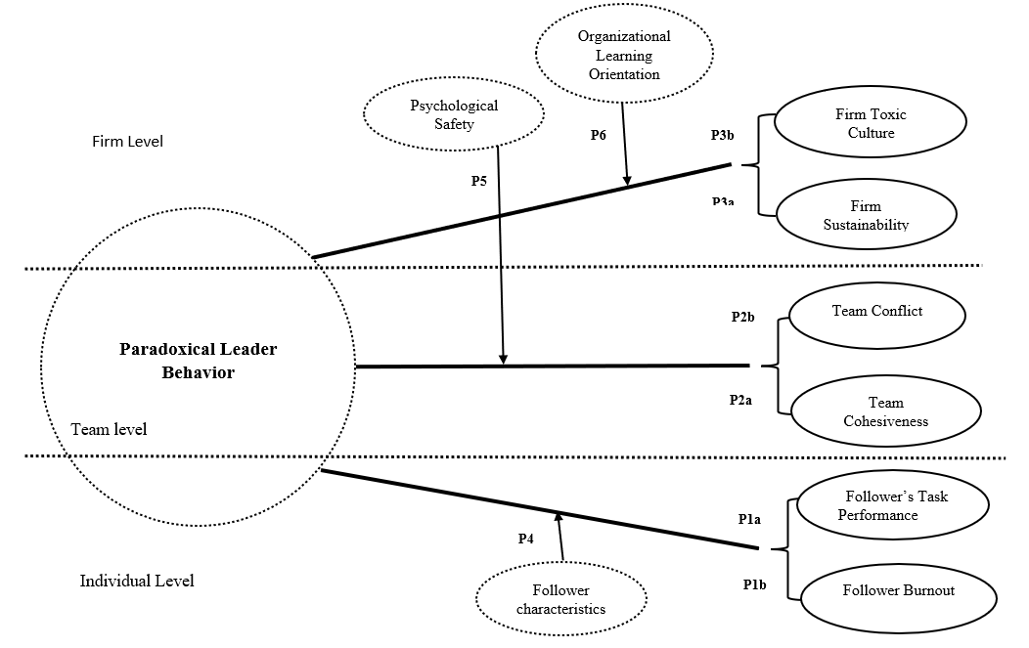

Figure 2: The Paradox of Paradoxical Leadership

Discussion
The Purpose of this conceptual paper was to advance conversation on paradox theory of leadership by first reviewing the available literature, providing an integrative framework, highlighting the contradictions seeking attention followed by a conceptual model offering interesting propositions. We proposed a conceptual model explaining how paradoxical leadership positively and negatively influences followers, team and organizations. To this end, we believe to have bridged the gap between what is known, what is missing and what needs to be known.

Theoretical Implications
This paper theoretically contributes to the paradox management literature in following ways. First, we presented an integrative framework of what is known about paradox theory of leadership by comprehensively reviewing available literature. To date, according to our knowledge, there is no review available on paradox theory of leadership. Our review explains the origin, evolution, how paradoxical leadership is different from earlier leadership approaches, and its various measurement development in different organizational settings. Furthermore, our framework shows the enablers, mediating mechanisms, contextual variables and consequences of paradoxical leadership behavior for overarching understanding.
Second, based on our review we identified the contradictions and developments prevailing in paradoxical leadership behavior literature over time. We attempted to differentiate paradoxical approach to leadership from early established contingency based leadership styles. We also paid heed to significance of adopting both/and approach toward organizational paradoxes. Furthermore, we presented a conceptual model offering significant implications embedded in the form of propositions. Drawing on paradox theory of leadership, we addressed the basic conundrum of opposing effects of paradoxical behavior, and the contingencies which strengthen or weaken the positive and negative impact of paradoxical thinking on multiple levels. We contribute to the literature by advancing an understanding on how the PLB per se faces a paradox interfacing positive and negative influences not only toward followers but also the teams and the organization.

Future Research Direction
Our theoretical framework bids several promising future directions. First of all, based on questions being addressed here, future researchers may conduct longitudinal studies to examine how leaders handle multiple paradoxes over time (Sparr et al., 2022; Zhang et al., 2021). Specifically, targeting those organizations which are being merged and acquired, going through change process, researchers should focus on examining how leaders with paradox mindset are handling paradoxes emerging from this change process. Based on our review, we find that the PLB impacts on the individual’s followers are well known, however, how paradoxical behavior influences team composition, and organizations is largely neglected. Future research should consider this avenue. Considering paradoxical leadership and its double-edged sword image, future emphasis should be on mitigating negative consequences attached with paradoxical behavior (Shao et al., 2019). Doing so will provide guidance to executives on how paradoxical leaders can provide maximum benefit to the organization without incurring significant damages to the organization.

Practical Implications
Our conceptualization of how leaders with paradoxical thinking influences multiple actors has various implications for what leaders should do differently to achieve organizational long-term sustainability. The fact that PLB is a complex behavior can’t be denied. To expect organizational members to deal with multi-level paradoxes, leaders and followers should be provided training on practicing paradoxical leadership behavior. Organizational executives can artificially create competing tensions and uncertain environments and provide task to team leaders to deal with these tensions in most constructive ways as acting paradoxically is becoming a highly sought skill (Smith & Tushman, 2005).
Lastly, our study indicates that acting paradoxically may take a toll on leader’s cognitive resources resulting in negative influences on followers, teams and organization, causing stress and anxiety to followers, conflict among team members, and compromised organizational performance. Based on this finding managerial action can be taken to prevent over burdening leaders, stretching goals too far, strategies should be considered to keep paradoxical leaders motivated and power dynamics of followers should not be ignored – all in all saving leader, follower, and organization from detrimental effects a paradoxical leader can cause.

Declarations
- There are no conflicts of interests (financial or non-financial).
- This study did not receive any funding.
- The study is conceptual and there are no data involved.

References
Andriopoulos, C., & Lewis, M. W. (2010). Managing innovation paradoxes: Ambidexterity lessons from leading product design companies. Long range planning, 43(1), 104-122.
Backhaus, L., Reuber, A., Vogel, D., & Vogel, R. (2021). Giving sense about paradoxes: paradoxical leadership in the public sector. Public Management Review, 1-21.
Baer, M., & Frese, M. (2003). Innovation is not enough: Climates for initiative and psychological safety, process innovations, and firm performance. Journal of Organizational Behavior: The International Journal of Industrial, Occupational and Organizational Psychology and Behavior, 24(1), 45-68.
Bashir, F. (2021). Dark Side of Paradoxical Leadership: Social Comparison Theory Perspective. NICE Research Journal, 107-130.
Bergmann, B., & Schaeppi, J. (2016). A data-driven approach to group creativity. Harvard Business Review, 12, 43-62.
Berti, M., & Simpson, A. V. (2021). The dark side of organizational paradoxes: The dynamics of disempowerment. Academy of management Review, 46(2), 252-274.
Crossan, M. M., Lane, H. W., White, R. E., & Djurfeldt, L. (1995). Organizational learning: Dimensions for a theory. The international journal of organizational analysis.
Cunha, M. P. e., & Putnam, L. L. (2019). Paradox theory and the paradox of success. Strategic organization, 17(1), 95-106.
Delmas, M. A., & Burbano, V. C. (2011). The drivers of greenwashing. California management review, 54(1), 64-87.
Dvir, T., & Shamir, B. (2003). Follower developmental characteristics as predicting transformational leadership: A longitudinal field study. The Leadership Quarterly, 14(3), 327-344.
Edmondson, A. (1999). Psychological safety and learning behavior in work teams. Administrative science quarterly, 44(2), 350-383.
Erickson, A., Shaw, B., Murray, J., & Branch, S. (2015). Destructive leadership: Causes, consequences and countermeasures. Organizational Dynamics, 44(4), 266-272.
Franken, E., Plimmer, G., & Malinen, S. (2020). Paradoxical leadership in public sector organisations: Its role in fostering employee resilience. Australian Journal of Public Administration, 79(1), 93-110.
Fürstenberg, N., Alfes, K., & Kearney, E. (2021). How and when paradoxical leadership benefits work engagement: The role of goal clarity and work autonomy. Journal of Occupational and Organizational Psychology.
Hult, G. T. M., Hurley, R. F., & Knight, G. A. (2004). Innovativeness: Its antecedents and impact on business performance. Industrial marketing management, 33(5), 429-438.
Ishaq, E., Bashir, S., & Khan, A. K. (2021). Paradoxical leader behaviors: Leader personality and follower outcomes. Applied Psychology, 70(1), 342-357.
Jesson, J., Matheson, L., & Lacey, F. M. (2011). Doing your literature review: Traditional and systematic techniques.
Julmi, C. (2021). Crazy, stupid, disobedience: The dark side of paradoxical leadership. Leadership, 17(6), 631-653.
Kahn, W. A. (1990). Psychological conditions of personal engagement and disengagement at work. Academy of Management Journal, 33(4), 692-724.
Keller, J., Loewenstein, J., & Yan, J. (2017). Culture, conditions and paradoxical frames. Organization Studies, 38(3-4), 539-560.
Kessel, M., Kratzer, J., & Schultz, C. (2012). Psychological safety, knowledge sharing, and creative performance in healthcare teams. Creativity and innovation management, 21(2), 147-157.
Klonek, F. E., Volery, T., & Parker, S. K. (2021). Managing the paradox: Individual ambidexterity, paradoxical leadership and multitasking in entrepreneurs across firm life cycle stages. International Small Business Journal, 39(1), 40-63.
Lewis, M. W. (2000). Exploring paradox: Toward a more comprehensive guide. Academy of management Review, 25(4), 760-776.
Lewis, M. W., Andriopoulos, C., & Smith, W. K. (2014). Paradoxical leadership to enable strategic agility. California management review, 56(3), 58-77.
Lewis, M. W., & Smith, W. K. (2022). Reflections on the 2021 Decade Award: Navigating Paradox is Paradoxical. Academy of management Review(ja).
Li, Q., She, Z., & Yang, B. (2018). Promoting innovative performance in multidisciplinary teams: The roles of paradoxical leadership and team perspective taking. Frontiers in psychology, 9, 1083.
Li, X., Xue, Y., Liang, H., & Yan, D. (2020). The impact of paradoxical leadership on employee voice behavior: a moderated mediation model. Frontiers in psychology, 2408.
Lok, J., & Willmott, H. (2014). Identities and identifications in organizations: Dynamics of antipathy, deadlock, and alliance. Journal of Management Inquiry, 23(3), 215-230.
Luthans, F., Avey, J. B., Avolio, B. J., Norman, S. M., & Combs, G. M. (2006). Psychological capital development: toward a micro‐intervention. Journal of Organizational Behavior: The International Journal of Industrial, Occupational and Organizational Psychology and Behavior, 27(3), 387-393.
Meng, X., Chenchen, N., Liang, F., & Liu, Y. O. (2021). Research on the Influence of Paradoxical Leadership on Compulsory Organizational Citizenship Behavior. Psychology Research and Behavior Management, 14, 1959.
Miron-Spektor, E., Gino, F., & Argote, L. (2011). Paradoxical frames and creative sparks: Enhancing individual creativity through conflict and integration. Organizational Behavior and Human Decision Processes, 116(2), 229-240.
Miron-Spektor, E., Ingram, A., Keller, J., Smith, W. K., & Lewis, M. W. (2018). Microfoundations of organizational paradox: The problem is how we think about the problem. Academy of Management Journal, 61(1), 26-45.
Mumby, P. J., Chollett, I., Bozec, Y.-M., & Wolff, N. H. (2014). Ecological resilience, robustness and vulnerability: how do these concepts benefit ecosystem management? Current Opinion in Environmental Sustainability, 7, 22-27.
Pan, Z. (2021). Paradoxical leadership and organizational citizenship behaviour: the serial mediating effect of a paradoxical mindset and personal service orientation. Leadership & Organization Development Journal.
Park, I.-J., Shim, S.-H., Hai, S., Kwon, S., & Kim, T. G. (2021). Cool down emotion, don’t be fickle! The role of paradoxical leadership in the relationship between emotional stability and creativity. The International Journal of Human Resource Management, 1-31.
Pina e Cunha, M., Giustiniano, L., Rego, A., & Clegg, S. (2017). Mission impossible? The paradoxes of stretch goal setting. Management Learning, 48(2), 140-157.
Podsakoff, P. M., MacKenzie, S. B., Bachrach, D. G., & Podsakoff, N. P. (2005). The influence of management journals in the 1980s and 1990s. Strategic management journal, 26(5), 473-488.
Putnam, L. L., Fairhurst, G. T., & Banghart, S. (2016). Contradictions, dialectics, and paradoxes in organizations: A constitutive approach. Academy of Management Annals, 10(1), 65-171.
Raziq, M. M., Borini, F. M., Malik, O. F., Ahmad, M., & Shabaz, M. (2018). Leadership styles, goal clarity, and project success: Evidence from project-based organizations in Pakistan. Leadership & Organization Development Journal.
Schad, J., Lewis, M. W., Raisch, S., & Smith, W. K. (2016). Paradox research in management science: Looking back to move forward. Academy of Management Annals, 10(1), 5-64.
Schaubroeck, J., Lam, S. S., & Peng, A. C. (2011). Cognition-based and affect-based trust as mediators of leader behavior influences on team performance. Journal of Applied Psychology, 96(4), 863.
Schilling, J., & Kluge, A. (2009). Barriers to organizational learning: An integration of theory and research. International journal of management reviews, 11(3), 337-360.
Shao, Y., Nijstad, B. A., & Täuber, S. (2019). Creativity under workload pressure and integrative complexity: The double-edged sword of paradoxical leadership. Organizational Behavior and Human Decision Processes, 155, 7-19.
She, Z., Li, Q., Yang, B., & Yang, B. (2020). Paradoxical leadership and hospitality employees’ service performance: The role of leader identification and need for cognitive closure. International Journal of Hospitality Management, 89, 102524.
Sinkula, J. M., Baker, W. E., & Noordewier, T. (1997). A framework for market-based organizational learning: Linking values, knowledge, and behavior. Journal of the academy of Marketing Science, 25(4), 305-318.
Sleesman, D. J. (2019). Pushing through the tension while stuck in the mud: Paradox mindset and escalation of commitment. Organizational Behavior and Human Decision Processes, 155, 83-96.
Smith, W. K., & Lewis, M. W. (2011). Toward a theory of paradox: A dynamic equilibrium model of organizing. Academy of management Review, 36(2), 381-403.
Smith, W. K., Lewis, M. W., & Tushman, M. L. (2016). Both/and” leadership. Harvard Business Review, 94(5), 62-70.
Smith, W. K., & Tushman, M. L. (2005). Managing strategic contradictions: A top management model for managing innovation streams. Organization Science, 16(5), 522-536.
Sparr, J. L., van Knippenberg, D., & Kearney, E. (2022). Paradoxical leadership as sensegiving: stimulating change-readiness and change-oriented performance. Leadership & Organization Development Journal.
Vera, D., & Crossan, M. (2004). Strategic leadership and organizational learning. Academy of management Review, 29(2), 222-240.
Volk, S., Waldman, D. A., & Barnes, C. M. (2022). A circadian theory of paradoxical leadership. Academy of management Review(ja).
Waldman, D. A., & Bowen, D. E. (2016). Learning to be a paradox-savvy leader. Academy of Management Perspectives, 30(3), 316-327.
Wuthrich, V., & Bates, T. C. (2001). Schizotypy and latent inhibition: Non-linear linkage between psychometric and cognitive markers. Personality and Individual Differences, 30(5), 783-798.
Xue, Y., Li, X., Liang, H., & Li, Y. (2020). How does paradoxical leadership affect employees’ voice behaviors in workplace? A leader-member exchange perspective. International journal of environmental research and public health, 17(4), 1162.
Yang, Y., Li, Z., Liang, L., & Zhang, X. (2021). Why and when paradoxical leader behavior impact employee creativity: Thriving at work and psychological safety. Current Psychology, 40(4), 1911-1922.
Zhang, M. J., Zhang, Y., & Law, K. S. (2021). Paradoxical leadership and innovation in work teams: The multilevel mediating role of ambidexterity and leader vision as a boundary condition. Academy of Management Journal(ja).
Zhang, Y., & Han, Y.-L. (2019). Paradoxical leader behavior in long-term corporate development: Antecedents and consequences. Organizational Behavior and Human Decision Processes, 155, 42-54.
Zhang, Y., Waldman, D. A., Han, Y.-L., & Li, X.-B. (2015). Paradoxical leader behaviors in people management: Antecedents and consequences. Academy of Management Journal, 58(2), 538-566.
Zhang, Y., Zhang, Y., Law, K., & Zhou, J. (2022). Paradoxical Leadership, Subjective Ambivalence, and Employee Creativity: Effects of Employee Holistic Thinking. Journal of Management Studies.
Zheng, W., Kark, R., & Meister, A. L. (2018). Paradox versus dilemma mindset: A theory of how women leaders navigate the tensions between agency and communion. The Leadership Quarterly, 29(5), 584-596.
Zhou, J., & George, J. M. (2003). Awakening employee creativity: The role of leader emotional intelligence. The Leadership Quarterly, 14(4-5), 545-568.
Zhu, W., Avolio, B. J., & Walumbwa, F. O. (2009). Moderating role of follower characteristics with transformational leadership and follower work engagement. Group & organization management, 34(5), 590-619.

