DEVELOPING A HOLISTIC FRAMEWORK TO DEVELOP AWARENESS OF CONTEMPORARY PROJECT MANAGEMENT CHALLENGES
Dowson¹, J., Rost², M.R; Bryde¹, D.J; Ibarra-Gonzalez³, V; Kamal⁴, E.M.; Tabassi⁵, A.A; Michaelides⁵, R; Wilson¹, H.K; Poole¹, H.M; Perez-Ezcurdia⁶, A; Mustafa⁴, M.J; Liu¹, H.

¹Liverpool John Moores University, UK; ²University of Stuttgart, Germany; ³Refine Projects, Germany; ⁴Universiti Sains Malaysia, Malaysia; ⁵Manchester Metropolitan University, UK; ⁶University of Navarra, Spain

Extended Abstract

Introduction
The advancement of project management (PM) knowledge and the development of people’s PM capability is crucial to successful project delivery. The PM has to cope with a diverse range of project stakeholders, with often complex and competing requirements. The organization of work within the contemporary PM landscape typically take places in turbulent and changing environments, creating complex open systems (Eason, 2014). As the diversity and requirements of stakeholders increase and change and the landscape shifts, major challenges emerge that PM has to address. There is a need to analyse what these challenges are, and what implications they have, so that the PM function can be proactive in developing systems and methods that are both resilient and adaptive, in order to meet them.

Purpose
The aim of our research was to design a holistic framework for PM to respond to the challenges outlined in the introduction above. We take a broader and more holistic perspective than a purely solution-focused output, that includes the process of raising awareness of the challenges, reflecting on, and including, contextualisation, social and political aspects, complexity and uncertainty, the actuality of projects, and practice-based approaches (Svejvig & Andersen, 2015). This paper details the process undertaken in synthesizing and distilling findings to propose a final framework that reflects project environments at the macro, meso and micro levels. The following objectives were instrumental in gathering evidence to develop the framework:
- To identify challenges and trends of PM
- To explore the effectiveness of lean and agile approaches to PM
- To analyse methods of innovation and change within PM
- To investigate the role of psycho-social aspects in PM
- To understanding the wider and the global context of PM, including international and industry-driven contexts

Theoretical approach
We utilised framing theory, which refers to the process by which people develop a particular conceptualization of an issue or re-orient their thinking about an issue (Chong & Druckman, 2007). This is particularly useful in environments of high uncertainty, which require more creative, flexible, iterative, and innovative solutions to better deal with disruptive forces (Schön, 1988; von Krogh & Geilinger, 2015). Reframing or reformulation of the initial frame facilitates the emergence of more disruptive and more innovative improvements (Norman & Verganti, 2014) and considers issues we take for granted and consider immutable (McCaffrey & Krishnamurty, 2015). Framing helps to focus on complex problems, facilitating innovative and creative solutions (Sanz-Llopis & Osterman, 2019) especially in rich and complex contexts, where previous system borders need to be re-opened and the inner dynamics and challenges better understood (Dorst, 2015).
It is posited that preconceived or predefined ideas, biases and logical inferences prevent people from modifying or redefining problems, as there is no obvious solution immediately to hand (Bessant et al, 2014; Sanz-Llopis & Osterman, 2019). Therefore, we deemed framing theory as an appropriate approach, as we required people to interpret, act, and ascribe meaning from a subjective reality (McCabe, 2002) as a set of premises, values and practices that promote dealing with contemporary issues (Cicmil et al, 2006; Winter et al, 2006; Blomquist et al, 2010; Schatzki, 2001; Hällgren & Söderholm, 2010; Andrew & Evans, 2011; Söderlund, 2013). The process of framework design and development followed Eppler’s (2011) 5 Knowledge Visualisation principles: variety, unfreezing, discovery, playfulness, and guidance, which steered participants to immerse themselves in knowledge exchange activities of elicitation, integration, and application.

Methods
The research was an academic/industry collaboration involving people from management and psychology disciplines in 5 universities: 2 from the UK, 2 from Germany, and 1 from Malaysia; and individuals from 6 companies working in construction, engineering, consultancy, IT, and supply chain sectors. The team reviewed examples of PM frameworks already published in academic literature (Secundo et al, 2017; Bakchan et al, 2019, Rush & Connolly, 2020; Glen, 2021; Issa & Pan, 2021; Svejvig, 2021). This review informed a creative framework development process, which synthesised findings from data collected through the following data collection methods; systematic literature review, case study, observation, survey, interview, focus group (FG). A series of models and explanatory narratives were produced in 5 research thematic areas: 1) trends and challenges of PM, 2) lean and agile PM, 3) psycho-social aspects of PM, 4) innovation & change and 5) global context of project delivery. Table 1 shows the details of each theme, in terms of the period covered, the data collected, the outputs and a diagrammatic model (M1-M9 in the final column of table 1). The models from the 5 themes were then integrated into an initial holistic framework to encompass a multi-disciplinary perspective for managing projects in the 21st century by the research team. Three exploratory FGs were undertaken to further develop the framework. A fourth follow-up FG with the project’s academic supervisory board was then undertaken to further refine the framework. A fifth validation FG, with academic and practitioner participants followed and from this a final refinement of the framework was undertaken. This final framework includes 2 models (M9 and M10) and several figures, each supported by explanatory narratives.
Findings and Discussion
The design and development of the holistic framework (M9 and M10 in table 1) was undertaken in the wider context of the major trends and challenges that face PM in the 21st century, which were explored as the foundation for the framework. The creation of a graphical or visual network displaying the project’s main components and their interdependencies enabled a visual “bigger picture” to be created, which facilitates a shared understanding between participants (Secundo et al, 2021). This includes knowledge in how the components inter-relate and can be dealt with, or exploited, in a timely manner. As shown in figure 1, effective PM, which we conceive as a multi-dimensional construct incorporating meeting cost, time and quality-related criteria, client, team, and other stakeholders’ satisfaction, involves responding to trends and challenges and contextual factors at the macro, meso and micro-levels. Where levels meet i.e.; macro/meso – it is necessary to understand the requirements for innovation, change and ambidexterity; meso/micro – there is a requirement to consider psycho-social/behavioural factors. Whilst at the meso level the appropriate PM approach is selected and implemented. The next stage of the holistic framework development focused on the temporal nature of PM evolution and, as shown in Figure 2 below, there is an iterative process of learning, adaptation, and evaluation, in which the constituent parts of the framework, visualised as M9 and shown in figure 1 take place.

Summary
We present a holistic framework to respond to the challenges of undertaking effective PM. The framework is the culmination of a process of co-creation involving academics and PM practitioners. The framework builds on the platform of understanding the trends & challenges of PM and the context in which a project is undertaken, with constituent parts of the framework comprised of aspects relating to: lean and agile PM, psycho-social aspects of PM, innovation and change and the global context of project delivery. It includes macro-, meso- and micro organisational perspectives and is bounded by an iterative process of learning, adaption and evaluation.
Table 1: Research focus, process, data collection and outputs
Objective/Research theme | Period covered | Data collected | Output | Diagrammatic model:
1. Trends & Challenges of PM | 2018-2019, 2022 | Literature review  Survey (n=265 responses)  Interviews (n=49)  Focus Groups (n=8) | Current trends and challenges in PM- key questions M1  Witnessed and predicted trends M2a  Witnessed and predicted challenges M2b | M1  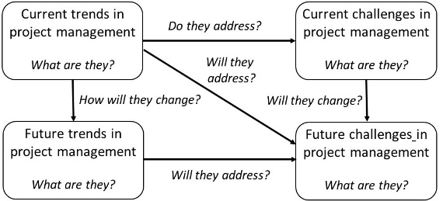  M2a  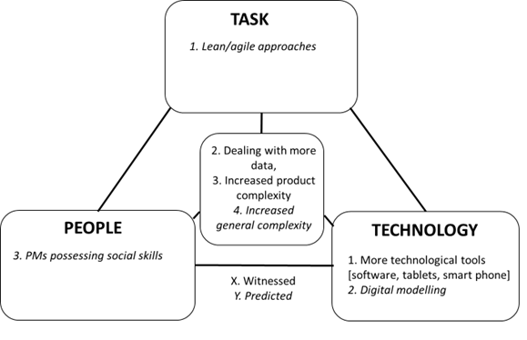  M2b  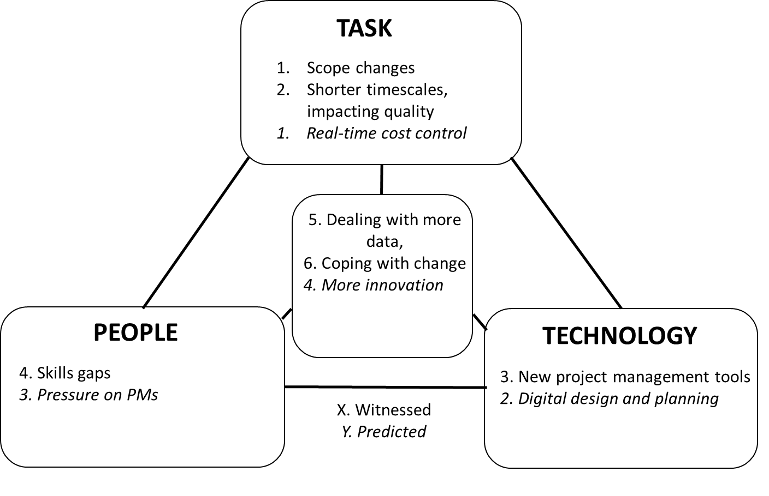
2. Lean and Agile PM | 2018-2021 | Interviews (n=78)  A single case study involving 8 project teams,  Focus Group (n=8) | Factors influencing the decision to implement PM approaches M3  Conditions for effective evaluation of PM approach M4 | M3  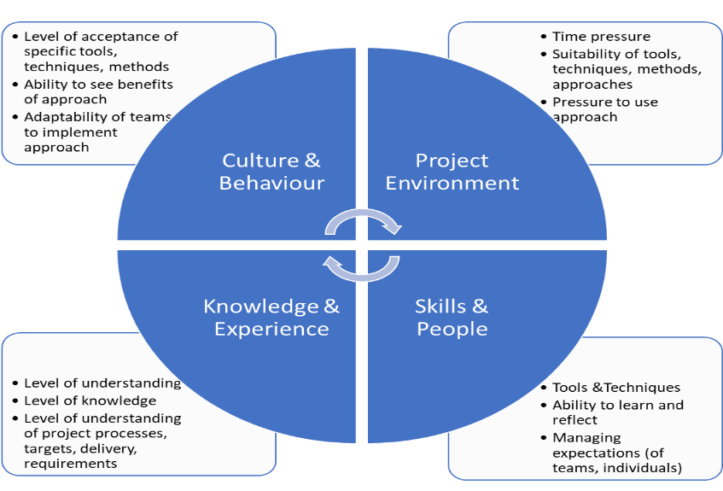  M4  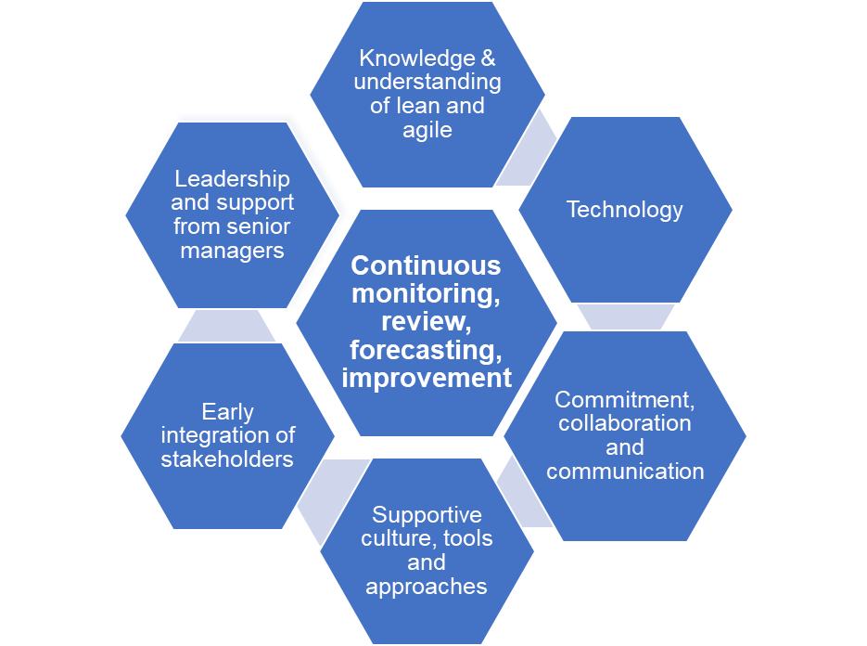
- Psycho-social aspects of PM | 2018-2021 | Observations (n=3),  Interviews (n=32)  Survey (n=68 responses) | Conceptual model: Psychosocial variables influencing project success M5  Significant psycho-social predictors of project success M6 | M5  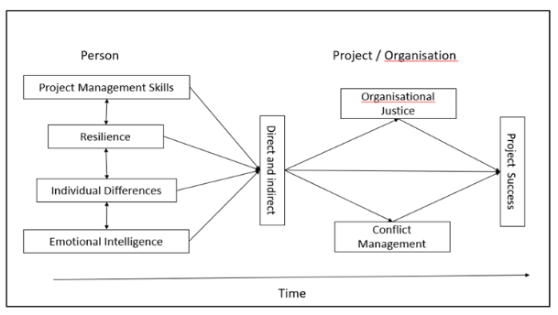  M6  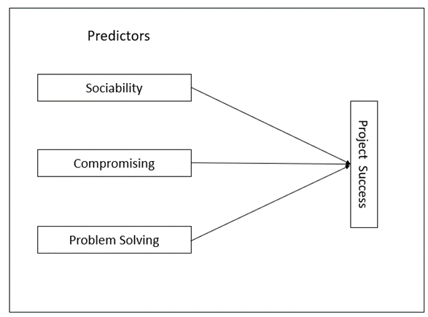
- Innovation & Change | 2018-2021 | Case studies (n=9),  Interviews (n=72) | Challenges, ambidexterity, and complexity M7  Framework to facilitate ambidexterity in PM  M8 | M7  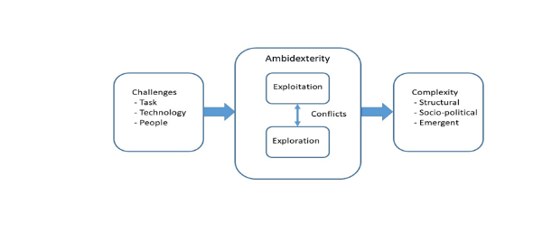  M8  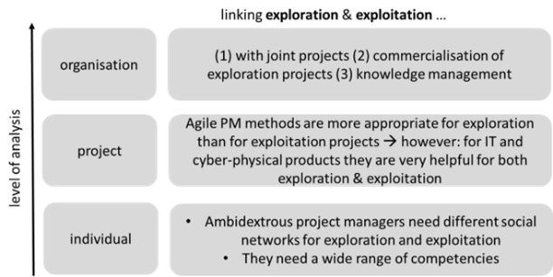
- Global context of project delivery | 2018-2022 | Focus Groups (n=6) | Holistic Framework M9 and M10 | M9…………………………………………….M10  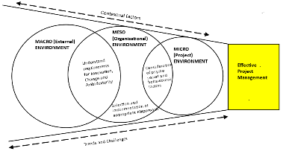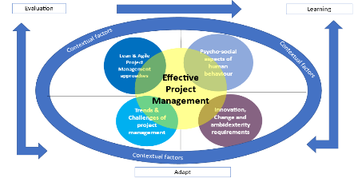

Figure 1: M9 - Multi-level framework for effective project management (extracted from table 1)

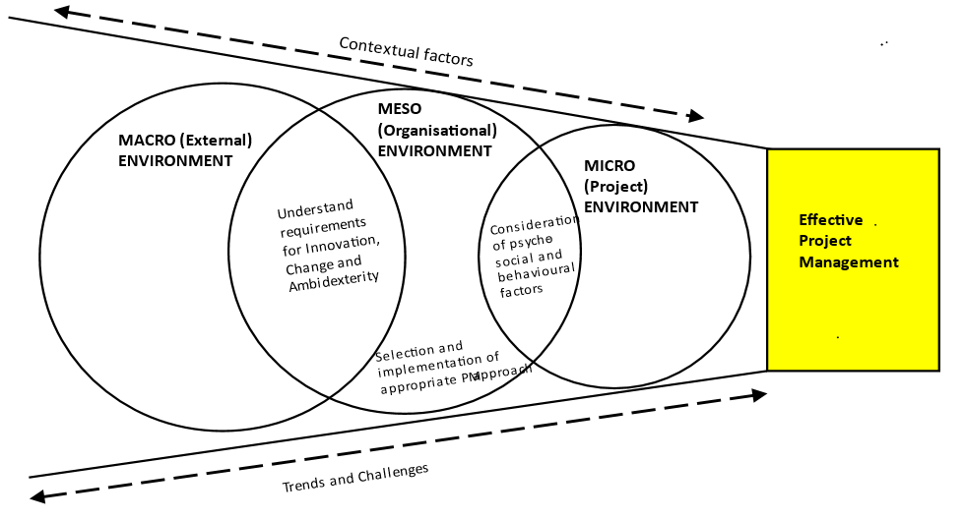

Figure 2: M10 – Inter-relating the themes (extracted from table 1)

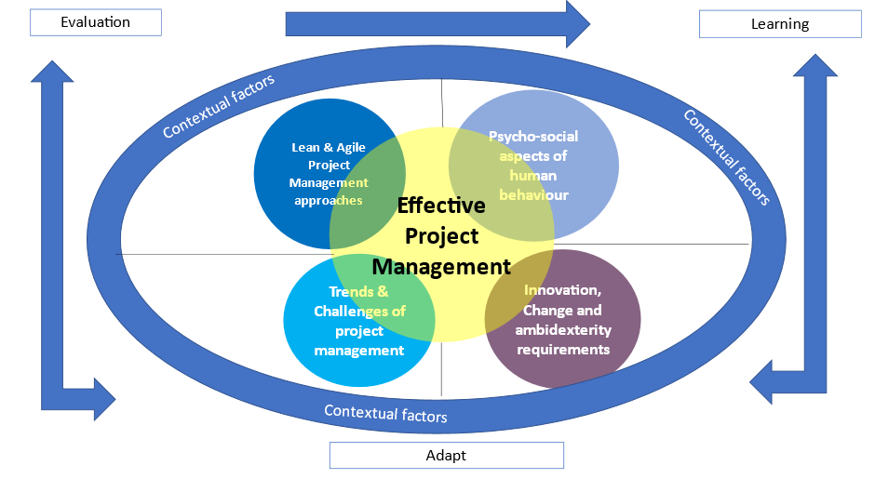

References
Andrew, N. L., & Evans, L. (2011). Approaches and frameworks for management and research in small-scale fisheries. In Smallscale fisheries management: Frameworks and approaches for the developing world (pp. 16–34). Oxfordshire: CAB International.
Bakchan, A., Faust, K.M., & Leite, F. (2019). Seven-dimensional automated construction waste quantification and management framework: Integration with project and site planning. Resources, Conservation and Recycling, 146: 462–474.
Bessant, J., Oberg, C., & Trifilova, A. (2014). Framing problems in radical innovation”, Industrial Marketing Management, 43(8): 1284-1292
Blomquist, T., Hällgren, M., Nilsson, A., & Söderholm, A. (2010). Project-as-practice: in search of project management research that matters, Project Management Journal, 41, 5-16
Budler, M., & Trkman, P. (2019) .The nature of management frameworks, Journal of Management & Organization 1-18, doi:10.1017/jmo.2019.83
Chong, D., & Druckman, J.N. (2007). Framing Theory, Annual Review of Political Science, 10:103–26, doi: 10.1146/annurev.polisci.10.072805.103054
Cicmil, S., Williams, T., Thomas, J., & Hodgson, D. (2006). Rethinking project management: researching the actuality of projects, International Journal of Project Management, 24(8): 675-686
Dorst, K. (2015). Frame Creation and Design in the Expanded Field, The Journal of Design, Economics, and Innovation 1(1): 22-33
Eason, K. (2014). Afterword: The past, present and future of sociotechnical systems theory, Applied Ergonomics 45, 213-220.
Eppler, M. (2011). What is an Effective Knowledge Visualization? Insights from a Review of Seminal Concepts, 15th International Conference on Information Visualisation, DOI 10.1109/IV.2011.13
Glen, S. (2021) Competency Framemworks that deliver tangible results, Training & Development Sep2021, 48(3): 24-27
Hällgren, M., & Söderholm, A. (2010) Orchestrating deviations in global projects: Projects-as-practice observations, Scandinavian Journal of Management 26 (4): 352-367
Issa, R., & Pan, Y.-C. (2021). A framework to address stress and improve productivity of project teams, Journal Modern PM, 8(25): 3-4
McCabe, D. (2002). Waiting for dead men’s shoes’: Towards a cultural understanding of management innovation, Human Relations, 55(5): 505–536
McCaffrey, T., & Krishnamurty, S. (2015). The obscure features hypothesis in design innovation, International Journal of Design Creativity, and Innovation, 3(1):1–28, doi.org/10.1080/21650349.2014.893840
Norman, D.A., & Verganti, R. (2014). Incremental and radical innovation: design research vs. technology and meaning change, Design Issues, 30(1): 78-96
Rush, D.E., & Connolly, A.J. (2020). An Agile Framework for Teaching with Scrum in the IT Project Management Classroom, An Agile Framework for Teaching with Scrum in the IT Project Management Classroom, Journal of Information Systems Education, 31(3): 196-207.
Sanz-Llopis, J., & Osterman, M. (2019). Innovation in project management through framing and challenge redefinition, International Journal of Managing Projects in Business, 13 (4): 745-766, DOI 10.1108/IJMPB-08-2019-0210
Schatzki, T.R. (2001). Introduction: Practice Theory, in Feldman, M.S. & Orlikowski, W.J. (2011) Theorizing Practice and Practicing Theory, Organization Science, 22: 1240- 1253
Schön, D.A. (1988), Designing: rules, types and worlds, Design Studies, 9(3): 181-190
Secundo, Romero, A., Par ́e, M., & Khemici, N. (2017). The Hot Potato Game: Roles and responsibilities for realizing IT project benefits. Journal of Modern Project Management, 5(2): 73–79. https://doi.org/10.19255/JMPM01407
Secundo, G., Elia, G., Margherita, A., & Leitner, K-H. (2021). Strategic decision making in project management: a knowledge visualization framework, Management Decision 60(4): 1159-1181, DOI 10.1108/MD-02-2021-0196
Söderlund, J., (2013). Pluralistic and processual understandings of projects and projects organizing towards theories of project temporality. In: Drouin, N.,Müller, R., Sankaran, S. (Eds.), Novel Approaches to Project Management Research: Translational and Transformational. CBS Press, Copenhagen, Denmark, pp. 117–135
Svejvig, P., & Andersen, P. (2015). Rethinking project management: A structured literature review with a critical look at the brave new world, International Journal of Project Management, 33 (2): 278-290
Svejvig, P. (2021). A Meta-theoretical framework for theory building in project management, International Journal of Project Management, 39(8): 849-872, https://doi.org/10.1016/j.ijproman.2021.09.006
von Krogh, G., & Geilinger, N. (2015). Valve’s Organization: Opportunities and Open Questions, Journal of Organization Design, 4(2): 18-19

