Title: An investigation of how Industry 4.0 supports servitization and its impact on manufacturing’s value chain

Dr Jiachen Hou, School of Management, University of Bradford

Summary:

Through a systematic and comprehensive review of the literature on Industry 4.0 and servitization, this paper analyses the research focus on the analysis of how Industry 4.0 enables servitization from the perspective of value-added activities. Through reading all the selected 38 articles, the authors identified three areas of focus in this research: (1) innovation &knowledge-based perspective, (2) operational perspective, and (3), technology perspective. The findings from the thematic analysis will inform the development of a survey questionnaire, which will be distributed to UK manufacturers.

Track: Operations, Logistics and Supply Chain Management

Word count: 2030 (including title and summary)

- Introduction and literature review

Servitization is recognized as the transformation process of shifting from manufacturing towards offering integrated bundles (Vandermerwe & Rada, 1988). While the debate on firms adding additional values through servitization was initially coined in the 90s, the opportunities to provide individualized solutions received more attention only in the last decade with the development of Internet Technology, particularly with the Hanover Trade Fair in 2011, where the Industry 4.0 was recognized as a collective interface between products and services to provide integrated solutions, demonstrating the importance of technology in product-service integration. Industry 4.0 is about interdisciplinary integration between people, machinery, process, and systems with smartly connected devices which cultivate a new level of cross-boundary collaboration whereby the increasing competition and growing demand for individualized products/services are driving forces. The revolution of Industry 4.0 and Servitization are reshaping the structure of the industry and redesigning the business process.

With a handful of relevant papers available, Grubic (2014) discussed the benefits and challenges of using remote monitoring technologies to support servitized strategies. The findings reveal that interdependence has existed between remote monitoring technology and servitized business model; however, there are no clear findings on what benefits and risks contributed by using remote monitoring technology and how it added value to the servitized businesses. Paschou, et. al (2017) classified the key Industry 4.0 technologies that have been applied in the process of servitization, such as big data, additive manufacturing, cloud computing, cyber security, IoT, predictive analysis, and remote monitoring. It was found that research on how Industry 4.0 related technologies support servitization is under-investigated explained why the benefit and risks are not articulated from Grubic’s research. Unlike Grubic’s findings, Suppatvech, Godsell, and Day (2019) reviewed papers published from 2009 to 2018 and identified benefits and challenges corresponding to IoT- enabled servitized business model. Chowdhury, Haftor, and Pashkevich (2018) examined the value-generating characteristics of Smart Product-Service Systems (PSS) during the design and delivery phases in industrial firms. It was evident that smart technologies facilitated the retrieval of data across organizational boundaries. Parida, Sjodin, and Reim (2019) conducted a literature review that emphasized how digitization can support firms in adding value through various means, such as creating value by utilizing digital platforms, understanding customer needs, and fostering collaboration. Additionally, the review highlighted value delivery by managing new capabilities and revising operational processes and responsibilities, as well as value capture.

While the existing research indicates using Industry 4.0 technology supports servitization is recognized as a diverse and complicated journey for adding value to firms., the intersection of these two fields has only recently gained more attention (Grubic 2014; Paschou, et. al, 2017; Chowdhury, Haftor, and Pashkevich 2018; Suppatvech, Godsell, and Day 2019; Kohtamäki, et al. 2019; and Parida, et al. 2019). As a result, we currently lack a clear understanding of how value is generated through industry 4.0 supported Servitization. Thus, the research aim is to investigate to what extent Industry4.0 supports value-added activities in Servitization?

There are two stages involved in this study. First, the author carried out a systematic review. The author’s aim is not to conduct a complete view of servitization and Industry 4.0 literature but to identify and evaluate the intersection of these two domains. Second, the systematic review-based findings will be utilized to create a survey questionnaire that will be distributed to selected manufacturing companies in the UK. At this point, the author completed the task for the first stage.

- Research methods

Using a mixed-method approach, this research investigates the extent to which Industry 4.0 facilitates value-added activities in servitization. The qualitative stage involved descriptive and thematic analysis of previous studies linking Industry 4.0 and servitization, with the aid of the text analysis tool Leximancer to gain a deeper understanding of their relationship. The scope of the systematic review includes papers published in the academic literature which specifically deal with business and management implications on those using Industry 4.0 to support servitization. In the subsequent quantitative stage, the findings from the thematic analysis will inform the development of a survey questionnaire, which will be distributed to UK manufacturers.

- Findings from the descriptive analysis and thematic analysis

3.1 Descriptive analysis

The total scholarly articles used in this study were 42 papers which were published in 19 targeted journals between 2013 and 2023, demonstrating the relevance of the topic to a wide array of research disciplines. With 45 articles, the most important source of empirical evidence in the sample is qualitative approaches where interview studies are the most frequently applied method. With respect to countries, there is no single country takes the lead. The analysis shows that how Industry 4.0 supports servitzation research is still a young field.

3.2 Thematic analysis

The study is motivated by the need to identify a clear picture for understanding how value is realized through industry 4.0 supported servitization? Leximancer is a content analytic tool that applies a clustering algorithm to carry out conceptual and relational analysis, it has been used to analyse large collections of articles by academics, for example on social responsibility(Lin, McKenna et al. 2019), sustainable supply chain(Kim and Kim 2017), open innovation (Randhawa, Wilden et al. 2016), service-dominant logic(Esmaeilian, Behdad et al. 2016), social marketing(Dann 2010), etc. Leximancer quantifies the conceptual structure of text to identify: 1) the concepts with a theme, 2) the frequency of the concepts, and 3) the correlation between concepts and themes.

The text mining analysis was carried out to explore the themes that are used to group the key concepts. Figure 1 displays a conceptual map that shows the list of developed concepts and themes. Through reading all the selected articles, the authors identified three areas of focus in this research: (1) innovation &knowledge-based perspective, (2) operational perspective, and (3), technology perspective.

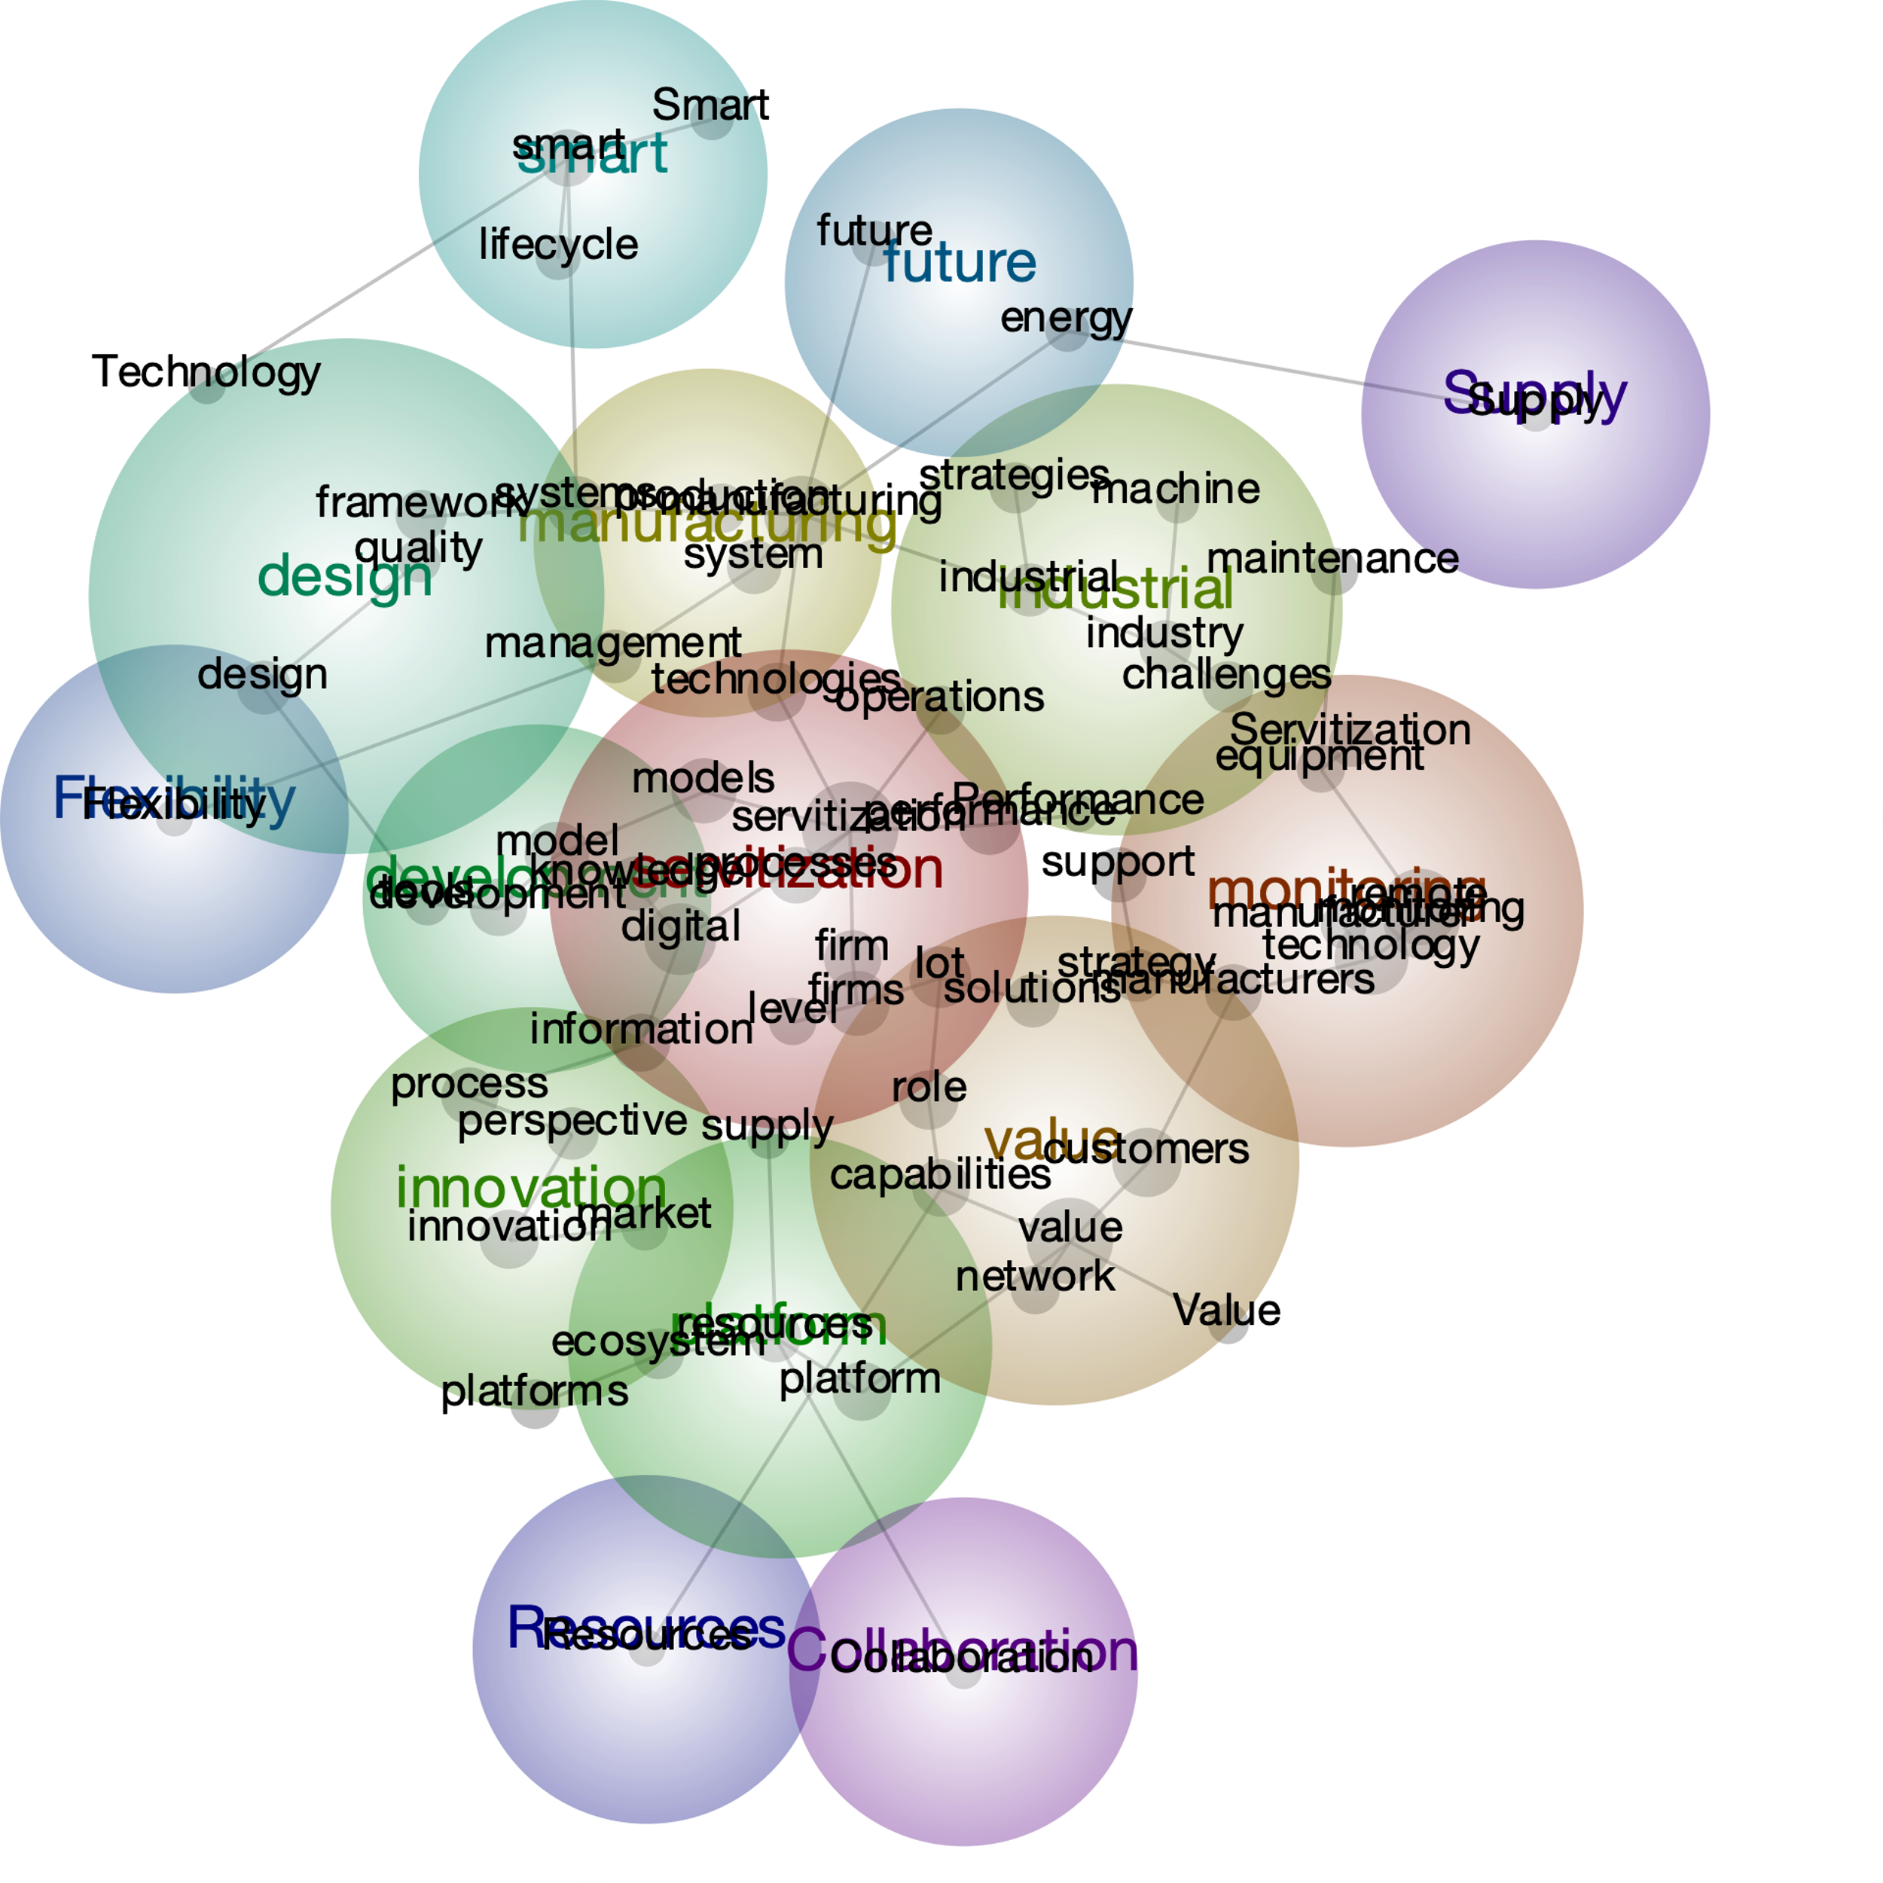
Innovation &knowledge-based perspective
Technology-based perspective
Operational-based perspective
Figure 1: A conceptual map

3.2.1 Technology based perspective

Technology-based perspective indicates the important role of technology in the process of servitisation. Many studies draw on the notion of connectivity, intelligence and analytics to illustrate how products and services can be benefited from servitised activities (Lightfoot et al, 2011; Kamp et al. 2016; Klein et al. 2018; Alcayaga et al. 2019; Dreyer et al. 2019; Kohtamäki, et al. 2019; and Ren et al. 2019). There is an emphasis on utilising the platform approach to deliver the values to the focal firms and their clients to manage resources, capabilities, relationships, trust and boundaries for servitized activities (Clausen, 2013; Obal and Lancioni, 2013). Integration between product and service modularity with appropriate business models has changed how platforms work, from product platforms to platform ecosystems(Cenamor, et al. 2017; Hasselblatt et al. 2018; Frank, 2019; and Sklyar, 2019). The ‘Platform’ concept indicates capabilities are essential to manufacturers focusing on servitisation because it links processes and resources.

The focus here is the role of the capabilities in delivering servitized solutions among various parties. Research has shown that human resources, physical resources, knowledge, and processes are essential components that create capabilities enabling servitized business models (Kohtamäki et al. 2019; Suppatvech et al. 2019). While resources may eventually wear out, capabilities refer to a firm's ability to continually update its resources in a constantly changing environment (Opresnik and Taisch 2015). Capabilities can be identified from various angles; strategic capabilities require firms to develop their core competencies that cannot be easily replicated by other firms (Hasselblatt et al. 2018), Digital capabilities, namely intelligence capability, connect capability, and analytic capability enable value-creation by identifying customers’ needs and actively respond to demands (Lenka et al. 2017). Operational capabilities refer to the processes, systems, and resources that a company has in place to carry out its operations which are important to monitoring, controlling and optimising equipment and processes (Grubic 2014; Kohtamäki et al. 2019; Chirumalla, 2023).

Key question is: How should capabilities be configured to deliver advanced services?

3.2.2 Innovation-Knowledge based

Information and knowledge exchange is necessary to enable predictive maintenance service(Dreyer, et al. 2019), for example, the importance of understanding ‘know-hows’ and ‘know-whys’ that can help to convert data into knowledge that helps monitor machine behaviors (Kamp, et al. 2016); to predict the condition, various data is gathered from the real-time monitoring, including performance data, product usage (Grubic 2014). Product-level data are translated into diagnostic and prognostic information for further analysing the state of interrelated components as well as maintenance history and mitigating the potential risks(Grubic and Jennions 2017; Alcayaga, Wiener et al. 2019). Knowledge management is required to support modular product architecture and subsystems/components (Marion et al. 2015). Knowledge is required for the product and the product’s performance from clients’ processes(Grubic and Jennions 2018).

In the area of innovation-knowledge aspect of industry 4.0 supported servitization, the results show that customers expect solutions that don’t exist in the current market (Goduscheit and Faullant 2018); this indicates servitization could lead to further innovation. In an ecosystem, information sharing and knowledge exchange across the internal level also lead to innovation activities(Kroh et al. 2018). Therefore, it indicates the impact of knowledge sharing on servitization. However, the research carried out by (Kroh et al. 2018) explores that companies with a high degree of servitization aren’t necessarily lead to innovation performance.

Key question is: To what extent do knowledge sharing and innovation contribute to the drive towards servitization?

3.2.3. Operational-based perspective

The ultimate goal for servitization is to enhance firms’ competitiveness by adding services offering. The findings suggest that servitization strategy needs to be aligned with different product life cycle stages (Ren et al. 2019), and the Operational process is central to managing various product life cycle stages. Servitization involves complex processes, not only require to restructure and redeployment of firms resources and the relationships between various players, but also require changes to the current processes in order to meet the transaction of adding value to the physical goods (Baines et al 2009; Turunen and Finne, 2014; Kowalkowski, 2017; Martín-Peña, et. al. 2019; Kolagar, et. al. 2022; Schiavone, et. al., 2022; Bortoluzzi, et. al. 2022; Iriarte, et. al. 2023).

From operations management’s perspective, servitization is achieved through various value-added activities that equip manufacturing flexibility. Flexibility is the centre of advanced services for servitized firms. It refers to the ability to change in terms of product and service offering, production volume, variety of products, delivery of the time and mode, etc. From a servitization perspective, flexibility means capabilities that supplement firms’ traditional product offerings. More specifically, the ability to deal with unexpected changes both internally and externally to enhance the value that customers expect. Eliminating waste is the first step towards adding value. Even though the original purpose was about reducing negative environmental impact, what wasteful (non-value added) activities are and where are exist in the transformation of servitization/PSS process haven’t been properly explored.

Key questions are:
- In what ways does Industry 4.0-supported servitization improve operational flexibility?
- How does Industry 4.0 eliminate non-value-added activities in the process of servitization?
- How does Industry 4.0-supported servitization contribute to efficiency or effectiveness?

- Contribution:

In this research, the authors identified three key areas of focus which provide insights into capabilities, knowledge sharing, innovation, operations and technology with servitization. The findings can contribute to the development of frameworks and models that explore the value chain in relation to Industry 4.0-supported servitization.

- Next stage: Quantitative research

The aim of the quantitative research is to confirm the qualitative research findings and answer the above questions which will assess to what extent Industry4.0 supports value-added activities in Servitization?

My plan to further develop the paper prior to discussion/presentation at the conference including:
- Finalize the survey questionnaire.
- Pilot study for the questionnaire.
- Collect data from UK based manufacturing industry.

References:

Alcayaga, A., Wiener, M., and Hansen. E. (2019). "Towards a framework of smart-circular systems: An integrative literature review." Journal of Cleaner Production 221: 622-634.

Baines, T., and Lightfoot, H. (2014). "Servitization of the manufacturing firm:Exploring the operations practices and technologies that deliver advanced services" International Journal of Operations & Production Management 34/1: 2-35.

Bortoluzzi, G., Chiarvesio, M., Romanello, R., Tabacco, R. & Veglio, V. (2022). "Servitisation and performance in the business-to-business context: the moderating role of Industry 4.0 technologies". Journal of Manufacturing Technology Management. 33(9):108-128.

Cenamor, J., Sjodin, D., and Parida, V. (2017). "Adopting a platform approach in servitization: Leveraging the value of digitalization." International Journal of Production Economics 192: 54-65.

Chirumalla, K., Leoni, L. & Oghazi, P. (20230, "Moving from servitization to digital servitization: Identifying the required dynamic capabilities and related microfoundations to facilitate the transition.” Journal of Business Research. 158

Goduscheit, C., and Faullant, R. (2018). "Paths Toward Radical Service Innovation in Manufacturing Companies-A Service-Dominant Logic Perspective." Journal of Product Innovation Management 35(5): 701-719.

Chowdhury, S., Haftor, D., Pashkevich, N. (2018). "Smart Product-Service Systems (Smart PSS) in Industrial Firms: A Literature Review." Procedia CIRP 2018: 26-31.

Coreynen, W., Matthyssens, P., and Bockhaven, W.(2017). "Boosting servitization through digitization: Pathways and dynamic resource configurations for manufacturers." Industrial Marketing Management 60: 42-53.

Dann, S. (2010). "Redefining social marketing with contemporary commercial marketing definitions." Journal of Business Research 63(2): 147-153.

Dreyer, S., Olivotti, D., Lebek, B., and Breitner, M. (2019). "Focusing the customer through smart services: a literature review." Electronic Markets 29(1): 55-78.

Esmaeilian, B., Behdad, S., and Wang, B. (2016). "The evolution and future of manufacturing: A review." Journal of Manufacturing Systems 39: 79-100.

Frank, A., Mendes, G., Ayala, N., and Ghezzi, A. (2019). "Servitization and Industry 4.0 convergence in the digital transformation of product firms: A business model innovation perspective." Technological Forecasting and Social Change 141: 341-351.

Grubic, T. (2014). "Servitization and remote monitoring technology: a literature review and research agenda." Journal of Manufacturing Technology Management 25(1): 100-124.

Grubic, T. and I. Jennions (2017). "Remote monitoring technology and servitised strategies – factors characterising the organisational application." International Journal of Production Research 56(6): 2133-2149.

Grubic, T. and I. Jennions (2018). "Do outcome-based contracts exist? The investigation of power-by-the-hour and similar result-oriented cases." International Journal of Production Economics 206: 209-219.

Grubic, T. and J. Peppard (2016). "Servitized manufacturing firms competing through remote monitoring technology." Journal of Manufacturing Technology Management 27(2): 154-184.

Hasselblatt, M., Huikkola, T., Kohtamaki, M., and Nickell, D. (2018). "Modeling manufacturer’s capabilities for the Internet of Things." Journal of Business & Industrial Marketing 33(6): 822-836.

Iriarte, I., Hoveskog, M., Nguyen Ngoc, H., Legarda, I., Uranga, M., Nazabal, M. & Atxa, A. (2023). "Service design for digital servitization: Facilitating manufacturers' advanced services value proposition design in the context of Industry 4.0". Industrial Marketing Management 110: 96-116.

Kamp, B., Ochoa, A., and Rozo, J. (2016). "Smart servitization within the context of industrial user–supplier relationships: contingencies according to a machine tool manufacturer." International Journal on Interactive Design and Manufacturing (IJIDeM) 11(3): 651-663.

Kim, D. and S. Kim (2017). "Sustainable Supply Chain Based on News Articles and Sustainability Reports: Text Mining with Leximancer and DICTION." Sustainability 9(6).

Klein, M., Biehl, S., and Friedli, T. (2018). "Barriers to smart services for manufacturing companies – an exploratory study in the capital goods industry." Journal of Business & Industrial Marketing 33(6): 846-856.

Kohtamäki, M., Parida, V., Oghazi. P., and Baines, T. (2019). "Digital servitization business models in ecosystems: A theory of the firm." Journal of Business Research 104: 380-392.

Kolagar, M., Reim, W., Parida, V. & Sjödin, D. (2022). "Digital servitization strategies for SME internationalization: the interplay between digital service maturity and ecosystem involvement". Journal of Service Management, 33(1): 143-162.

Kroh, J., Luetjen, H., Globocnik, D., Schultz, C. (2018). "Use and Efficacy of Information Technology in Innovation Processes: The Specific Role of Servitization." Journal of Product Innovation Management 35(5): 720- 741.

Lenka, S., Parida, V., and Wincent, J. (2017). "Digitalization Capabilities as Enablers of Value Co-Creation in Servitizing Firms." Psychology & Marketing 34(1): 92-100.

Lightfoot, H., Baines, T., and Smart, P. (2011). "Examining the information and communication technologies enabling servitized manufacture." Proceedings of the Institution of Mechanical Engineers, Part B: Journal of Engineering Manufacture 225(10): 1964-1968.

Lin, X., Mckenna, B., Ho. C., and Shen, G. (2019). "Stakeholders’ influence strategies on social responsibility implementation in construction projects." Journal of Cleaner Production 235: 348-358.

Marion, T., Meyer, M., and Barczak, G. (2015). "The Influence of Digital Design and IT on Modular Product Architecture." Journal of Product Innovation Management 32(1): 98-110.

Martín-Peña, M., Sanchez-Lopez, J. and Garrido, E. (2019). "Servitization and digitalization in manufacturing: the influence on firm performance." Journal of Business & Industrial Marketing 35(3):564-574.

Opresnik, D., and Taisch , M. (2015). "The value of Big Data in servitization." International Journal of Production Economics 165: 174-184.

Parida, V., Sjodin, D., and Reim., W. (2019). "Reviewing Literature on Digitalization, Business Model Innovation, and Sustainable Industry: Past Achievements and Future Promises." Sustainability 11(2):391.

Paschou, T., Adrodegari, F, Perona, M., and Saccani，N. (2017). “The digital servitization of manufacturing: a literature review and research agenda”. 27th RESER Conference Bilbao

Randhawa, K., Wilden, R., and Hohberger, J. (2016). "A Bibliometric Review of Open Innovation: Setting a Research Agenda". Journal of Product Innovation Management 33(6): 750-772.

Ren, S., Zhang, Y., Liu Y. Sakao, T., Huishingh, D. and Almeida, C. (2019). "A comprehensive review of big data analytics throughout product lifecycle to support sustainable smart manufacturing: A framework, challenges and future research directions." Journal of Cleaner Production 210: 1343-1365.

Rymaszewska, A., et al. (2017). "IoT powered servitization of manufacturing – an exploratory case study." International Journal of Production Economics 192: 92-105.

Schiavone, F., Leone, D., Caporuscio, A. & Lan, S. (2022). "Digital servitization and new sustainable configurations of manufacturing systems”. Technological Forecasting and Social Change. 176.

Sklyar, A., Kowalkowski, C., Tronvoll, B., and Sorhammar, D. (2019). "Organizing for digital servitization: A service ecosystem perspective." Journal of Business Research 104: 450-460.

Suppatvech, C., Godsell, J., and Day, S. (2019). "The roles of internet of things technology in enabling servitized business models: A systematic literature review." Industrial Marketing Management 82: 70-86.

Vandermerwe, S., and Rada, J. (1989). “ Servitization of Business: Adding Value by Adding Services”. European Management Journal, 6:314-324.

