Construction Scheduling

With Critical Chain Project Management (Ccpm)

In Agent-Based Modelling Using Ppo Algorithm

Miss Jong Ye Xian, MSc Student, School of Architecture, Building and Design (SABD) Taylor’s University, Malaysia
Mr Lee Xia Sheng, Senior Lecturer, School of Architecture, Building and Design (SABD) Taylor’s University, Malaysia
Dr Georgios Kapogiannis, Assistant Professor in Project Management, Warwick Manufacturing Group, University of Warwick, Georgios.Kapogiannis@warwick.ac.uk
Dr Lydia Adigun, Assistant Professor in Project Management, Warwick Manufacturing Group, University of Warwick, Lydia.Adigun@warwick.ac.uk
Dr Dennis Chapman, Assistant Professor in Project Management, Warwick Manufacturing Group, University of Warwick, Dennis.Chapman@warwick.ac.uk

Keyword: Critical Chain Project Management (CCPM)

Agent-Based Modelling (ABM)

PPO algorithm (PPO)

Critical Path Method (CPM)

Project Scheduling

Optimisation

Work Breakdown Structure (WBS)

Abstract

Timely and cost-effective delivery in construction projects relies on effective scheduling under resource constraints and uncertainty. This study proposes a hybrid framework integrating Agent-Based Modelling (ABM) with Critical Chain Project Management (CCPM), enhanced by the Proximal Policy Optimisation (PPO) algorithm. The resulting PPO-ABM-CCPM model enables adaptive scheduling through dynamic resource allocation, intelligent buffer management, and real-time responsiveness. ABM captures task-resource interactions, while PPO refines scheduling decisions in complex environments. The model achieved a 16.53% reduction in resource usage and a 2.20% decrease in project duration, outperforming traditional methods such as the Critical Path Method (CPM). A key contribution is the integration of ABM within CCPM, offering improved modelling of task interdependencies. The framework is scalable and adaptable, combining structured scheduling with reinforcement learning. However, its practical application depends on addressing data sensitivity, computational demands, and the inclusion of human and organisational factors for broader real-world adoption.

- Background
Construction is an inherently by nature dynamic, and as a result a rigid scheduling approach is not sometimes fit for purpose, leading to inefficiencies, rework, and delays (Milat et al., 2022). Resolving the Resource-Constrained Project Scheduling Problems of (RCPSP), Parkinson's Law, Student Syndrome and Multitasking may be relatively daunting in construction project management. Now, if people faced similar challenges; they would lean on tried-and-true techniques of project management from methods such as the Programme Evaluation Review Technique (PERT) and the Critical Path Method (CPM) to help the progress of the project. However, the execution seldom seems to work in the typical instability and resource constraint landscape of construction project execution. Conventional techniques such as Critical Path Method (CPM) frequently find it tough to manage construction projects that are dynamic and uncertain (Enshassi et al, 2019). To overcome the limitations of traditional project management methodologies, Dr. Eliyahu M. Goldratt introduced Critical Chain Project Management (CCPM) (Taghipour et al., 2020). CCPM introduces the utilisation of buffers at strategic points in the schedule to absorb unexpected delays and protect the critical chain path, decreasing the likelihood of slippage of tasks and enabling the overall project timeline to be maintained (Narita et al., 2021). Although it has great potential, CCPM is rarely used on building projects because the methods are complex, and resource and schedule changes are challenging to make in real time.
Proximal Policy Optimisation (PPO) is a reinforcement learning algorithm that learns optimal decision-making policies for agents through interaction with its environment (Zhang et al., 2022). The PPO algorithm would allow the framework to dynamically adjust itself and update the rules in a way that could optimize the resource allocation and scheduling of the tasks. This makes it a very good fit for the turbulent and chaotic world of construction projects. In the realm of CCPM field, the integration of Agent-based Models (ABM) has led to new opportunities and challenges. ABM replicate autonomous agents in complicated systems like project management (Mazzetto,2024). In CCPM, ABM models tasks, resources, and personnel as active agents with specific characteristics and behaviour patterns. These agents work cooperatively and adaptively to facilitate the problem, closely mimicking practical project settings' actual dependencies and constraints. Such an approach enables one to monitor new activity patterns as an organisation tries to go through its process; thus, one is likely to identify many delay points. Therefore, it allows one to make new and improved decisions and change the use of resources in an ABM. This leads to a better understanding of the persistent dynamics within a project, simplifies risk management, and allows for better control over a project’s schedule. To achieve the optimal outcome, by combining PPO and CCPM inside an ABM framework, it could continuously learn and adapting to optimise decision-making processes (Shanmugapriya and Venkatramaraju, 2024).
Moreover, construction faces significant challenges in Critical Path Method (CPM) project scheduling regarding efficient of task management. Aramesh et al. (2020) discover that the critical path method (CPM), by considering resource limitations, becomes a Resource-Constrained Project Scheduling Problems (RCPSP), assume a prominent position, as their objective is to optimise the allocation of limited resources among various project duties while adhering to specified constraints. However, the challenges still faced by RCPSP when resource availability and task durations may be uncertain or subject to change, making it difficult to create a stable schedule. Critical Chain Project Management Method (CCPM) ensures that project deadlines are met, even in the face of disruptions, by focusing on buffer management and resource allocation. While CCPM has significant potential benefits, it is not appropriate for all projects. However, the construction industry still does not widely adopt CCPM due to difficulty of overload human cognitive capacity and limited intuition where easily lead to errors or suboptimal decisions when processing and analysing large amounts of information related tasks, resources and buffers (Sweller et al., 2011).
Furthermore, the Berlin Brandenburg Airport (BER) project is a clear case of construction scheduling problems. The construction of the airport was slated to start in 2011, but there were enormous challenges of delayed time, and they include flawed planning and management, inefficiency in coordination, and poor estimations of time (Glucroft, 2020). Likewise, scheduling disruptions were also a major problem in the Sydney Opera House that began construction in 1959 (Admin, n.d.). Originally conceived to last four years, the project spanned 14 unprofitable years due to drastic design and material requirements estimations as well as time misjudgements. The Sydney Opera House project shows how ineffective traditional calendars are in managing dynamic situational characteristics that are typical to today’s project environments. These examples demonstrate the need for a more adaptive and powerful scheduling framework.
Through much work has been done concerning reinforcement learning, the related studies about it in CCPM are little addressed (Szwarcfiter et al., 2023). The construction industry has been slow to adopt features like simulation and reinforcement learning. These technologies are highly beneficial but are not yet widely used in the construction sector. The building project management is extremely complicated by the unpredictability of the weather, the time and place limitation of material availability and the lack of relevant available labourers (Misnan et al., 2024). Unforeseen events such as legislation or natural disasters pile on even more uncertainty. Such a setting makes it rather difficult to build realistic simulators and train effective reinforcement learning agents. Given the fluidity and uncertainty in the construction industry, it's understandable that it has been cautious in adopting new sciences. This leads researchers to an important research question: What elements are missing to address these challenges, and how can be successfully bridge the gap in the use of simulation and reinforcement learning within construction?
To explore this, it is necessary to consider the feasibility of applying Agent-Based Modelling (ABM) with Critical Chain Project Management (CCPM) for improving construction scheduling. Specifically, how effective is the Proximal Policy Optimisation (PPO) algorithm in optimizing dynamic construction scheduling compared to conventional optimization techniques and, how does the proposed hybrid PPO-ABM model improve the efficiency of critical chain project scheduling in complex and uncertain construction scenarios? Hence, the aim of this research is to investigate the efficacy and feasibility of the hybrid PPO-ABM model in refining and controlling construction scheduling processes by leveraging CCPM principles. This includes assessing the feasibility of integrating ABM within the framework of CCPM, analyzing the effectiveness of the PPO algorithm in optimizing dynamic construction scheduling, and evaluating the performance of the proposed hybrid model in improving critical chain project scheduling efficiency.
- Related Study
Figures. 2.1, 2.2, 2.3 and 2.4 shows the past studies from 2019 to 2024 which indicate a dearth of research papers proposing critical chain project management in construction scheduling, utilizing the PPO algorithm within the agent-based modelling framework. The major findings across these studies are insufficient to consistently indicate that the integration of CCPM, ABM, and PPO leads to significant improvements in construction project scheduling. (Kedir et al., 2022) demonstrated that significant improvements of RL-ABM method in optimizing project durations. The RL-ABM method can dynamically adapt to changing project conditions was a notable strength. By adjusted activity sequencing in response to real-time changes, providing multiple scheduling scenarios to achieve the minimum project duration while considering resource levelling.

  - Critical Chain Project Management (CCPM) and Buffer Management
Studies have shown that Critical Chain Project Management (CCPM) enhances project performance through features such as scheduling buffers, which protect the critical chain from disruptions caused by multitasking and resource overcommitment (Leach, 2014). Research confirms that CCPM can lead to shorter project durations and greater delivery certainty compared to traditional methods, especially in volatile and resource-constrained environments (Anastasiu et al., 2023). A central component of CCPM is buffer management, which includes project buffers, feeding buffers, and resource buffers. Project buffers absorb fluctuations in task completion times; feeding buffers shield the critical chain from upstream delays, and resource buffers address risks arising from constrained resource availability (Huang et al., 2023). These buffers are widely recognised for improving reliability and project performance (Leach, 2014; Steyn, 2002). However, as noted by Herroelen and Leus (2001), conventional buffer sizing methods are often static and normative, risking over- or under-buffering, which can lead to either resource inefficiencies or inadequate delay protection—contradicting CCPM's aim for optimality and flexibility.

  - Agent-Based Modelling (ABM) in Construction Scheduling
ABM has become an essential method in the processes of reproducing interactions between project participants (workers, equipment, and materials) in the enterprise construction management. Identifying all the agents and modelling each of their behaviours enables the understanding of the results of the construction process (Domenteanu et al., 2023) with ABM. This because it enables a greater understanding of the influence designer’s action on others can have on the larger project, which is appropriate for larger more complex dynamic construction projects. As an example, an agent-based model is created to improve resource allocation, and thus performance of the project, during a simulation of interactions among different stakeholders of a construction project (Mazzetto,2024). In the same vein, (Helo & Rouzafzoon, 2023) took advantage of the ABM to model construction logistics with the constraints of supply chain management, and the simulation made in this study revealed, among other things, improved efficiency, and no long delays. These capabilities render ABMs highly significant for construction project managers, who can simulate diverse scenarios and experiment with the impacts of alternative strategies; they can envision the likely end results and hence refine the plan. Application of ABM with CCPM has been revealed to possess potential for enhancing project scheduling and resource management.
Previous works state that ABM feature of dynamic real-time conditions and the possibility of observing the influence of resource limitations make it complementary to CCPM, which also concentrates on buffer and critical resource exploitation. One relevant study was conducted by (Herroelen & Leus, 2004), who used ABM to simulate the effects of different buffer management strategies for CCPM. Their studies showed that using ABM, it is possible to point out which buffer size and position have the highest critical impact; hence, project managers should better protect these schedules against delays. In different research (Araya, 2020), the author used an agent-based model to demonstrate the behaviours of construction project stakeholders based on the principles of CCPM. This study simulated impacts of relevant inputs, including resource availability, predecessor tasks, and interruptions on the project. ABM is found more suitable in estimating how the behaviours and interactions of different agents influence the overall performance of projects governed by CCPM.

  - Reinforcement Learning (RL) for Construction Scheduling
It has been ascertained in fresh research work noted in the recent past that RL methods for construction scheduling and negotiating conditions as the project unfolds can substantially bring down the project completion time. The authors (Bahroun et al., 2023) have shown how the RL-based scheduling system can understand how to curb variability and reintroduce uncertainties into the project more accurately thus increasing project throughput. Additionally, by applying RL in construction programming, it enhances the resilience of the fixed timetable, meaning proposed construction timetables are less susceptible to multiple changes and disruptions. A notable example is the use of Markov Decision Processes (MDPs), which optimise project schedules by improving resource utilisation and minimising timelines (Xie et al., 2021). Nevertheless, existing works applying RL to construction scheduling focus on single-objective functions (e.g., minimizing project duration). While this approach shows its potential, (Al-Sinan et al., 2024) highlighted the necessity for further, more complicated studies into multi-objective optimisation in construction projects that would attempt to achieve equilibrium among the circulation of several objectives, including resources and time, and arrive at a more holistic solution.

Figure 2.1: Past studied regarding PPO algorithm | Figure 2.2: Past studied regarding Construction Scheduling | Figure 2.3: Past studied regarding Agent-Based Modelling | Figure 2.4: Past studied regarding Critical Chain Project Management
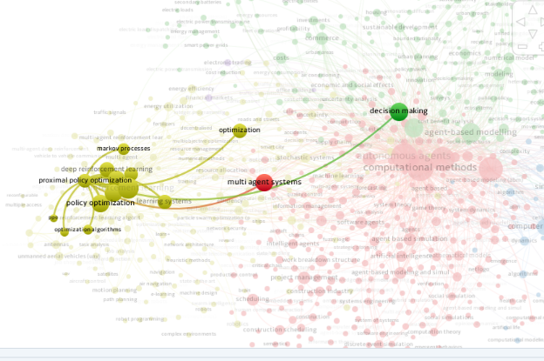 | 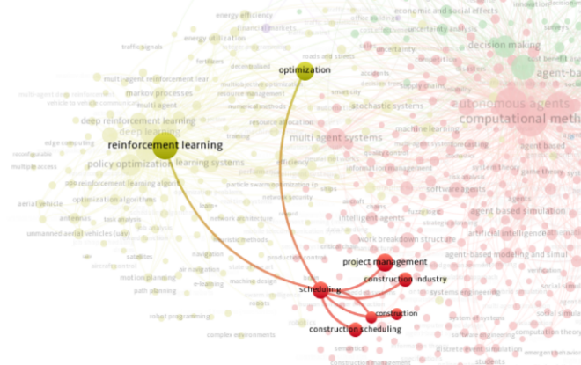 | 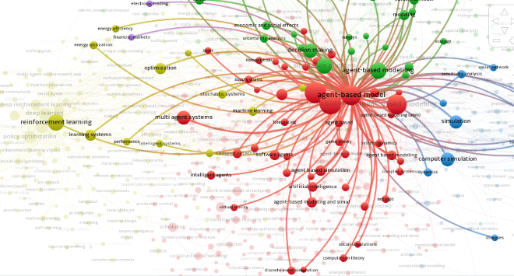 | 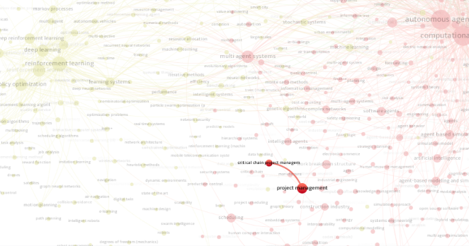

  - Proximal Policy Optimization (PPO) and Construction Scheduling
Proximal Policy Optimization (PPO), a reinforcement learning method, enhances policy gradient approaches by stabilizing updates through a surrogate objective function constrained by a clipping mechanism, which limits deviations between new and old policies (Schulman et al., 2017). This ensures incremental adjustments, mitigating instability common in traditional methods. In construction scheduling, PPO optimizes resource allocation, task sequencing, and deadline adherence, adapting dynamically to project uncertainties such as fluctuating resource availability (Shyalika et al., 2020). When integrated with Critical Chain Project Management (CCPM) and Agent-Based Modelling (ABM) within a Markov Decision Process (MDP) framework, PPO-driven agents determine optimal actions—such as task scheduling or resource reallocation—based on real-time project states. Reward mechanisms incentivize reductions in time gaps and resource inefficiencies, with policies refined iteratively via value or policy iteration to manage stochastic project risks (Shyalika et al., 2020).
While the fusion of CCPM, ABM, and PPO offers adaptive solutions to minimize delays and improve scheduling precision, challenges persist. Computational complexity and implementation barriers, such as high resource demands and industry resistance to advanced models, hinder widespread adoption despite demonstrated performance gains (Schulman et al., 2017; Shyalika et al., 2020). Future research must prioritize validating hybrid frameworks in real-world construction environments to bridge theoretical promise and practical application. Developing comprehensive methodologies that leverage CCPM’s buffer management, ABM’s dynamic simulation, and PPO’s optimization capabilities could address existing gaps, fostering efficient, data-driven project management tailored to the construction sectors volatile nature.

- Theoretical Framework
The research's design is based on programming experiment, which involved developing a Python simulation environment. The original Work Breakdown Structure (WBS) scheduling data will be arranged to an excel file as example shown in Table 1. which is created by using model-derived WBS data from mock BIM Dragonfly Tower model as shown in Figure 3.1, this 17th floor high-rise building will be used as the basis of the simulation, underpinning the testing of a complex, realistic, yet challenging scenario for the hybrid PPO-ABM model. The justification for employing the mock BIM model is that it assists in controlling the risk of scheduling by listing down the construction phasing and identifying any event of potential delay or conflict in real projects (Subramani & Ammai, 2018). The PPO algorithm is developed with the framework of ABM to assist agents in the improvement tactics of the management of buffers such as project buffer, feeding buffer, and resource buffer. It will keep simulating multiple iterations to capture elaborate performance data, which will be analysed to test how far the PPO agent maintains a minimum degree of project delay and resource waste. This process can be run recursively for different project conditions and scenarios to evaluate the model's effectiveness.
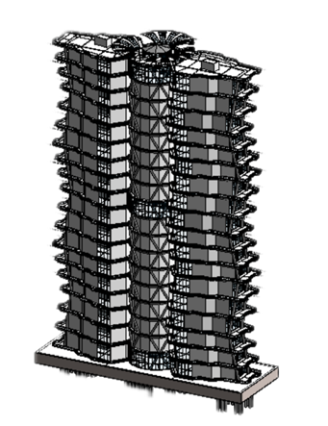

Figure 3.1: Mock BIM Model – Dragonfly Tower

Task data is analysed to determine original resource requirements by utilizing durations and dependencies in relation to a realistic key to build resource and buffer values from. For buffer management in the program, a project buffer is set at 50% the critical chain duration and placed after the critical chain, according to Olson (2024). This acts as a postpone or a spring for the project plan, ensuring that the project has leeway for any unpredictable slippage on significant tasks. Further, feeding buffers are offered at junctions where non-critical tasks and the critical chain intersect, usually equalling half the length of the non-critical path and can feed into any subsequent step in the process, to ensure non-critical paths do not hinder the critical chain. Last on the list are resource buffers that act as a backup resource or time for performing the critical chain tasks such that the chance of project disruption in terms of resources is minimized. These settings combined help to form a reliable fundamental structure of the adaptive and recovery-based project scheduling in the model of PPO-ABM.
The research methodology approximating the performance of the proposed hybrid PPO-ABM model in the CCPM context for enhancing the construction scheduling. This work assesses a BIM model developed based on the WBS task scheduling using CCPM as a simulated environment for the evaluated model. This initial task data will give a complex project scenario that has several tasks, resources, and constraints that are solved. This approach integrates advanced reinforcement learning techniques with detailed agent-based simulations to address the complexities of construction project management.

Table 1: WBS data format in Gannt Chart

Task Name | Task ID |  | Predecessor |  | Successor |  | Duration
Preliminary and Site Preparation | 1 | None |  | None |  | 12
Hoarding Erection | 1.1 | None |  | 1.2 |  | 2
Mobilization and Site Setup | 1.2 | 1.1 |  | 2.1.1 |  | 10
Foundation | 2 | None |  | None |  | 45
Excavation | 2.1 | None |  | None |  | 30
Foundation Excavation zone 1 | 2.1.1 | 1.2 |  | 2.2.1,2.1.2 |  | 10
Foundation Excavation zone 2 | 2.1.2 | 2.1.1 |  | 2.2.2,2.1.3 |  | 10
Foundation Excavation zone 3 | 2.1.3 | 2.1.2 |  | 2.2.3 |  | 10
Pilling | 2.2 | None |  | None |  | 30
Foundation Pilling zone 1 | 2.2.1 | 2.1.1 |  | 2.3.1 |  | 10
Foundation Pilling zone 2 | 2.2.2 | 2.1.2 |  | 2.3.2 |  | 10
Foundation Pilling zone 3 | 2.2.3 | 2.1.3 |  | 2.3.3 |  | 10
Install Pile cap | 2.3 | None |  | None |  | 25
Foundation Pile cap zone 1 | 2.3.1 | 2.2.1 |  | 3.3.1.1 |  | 5
Foundation Pile cap zone 2 | 2.3.2 | 2.2.2 |  | 3.1.2.1,3.3.2.1 |  | 5
Foundation Pile cap zone 3 | 2.3.3 | 2.2.3 |  | 3.1.3.1,3.3.3.1 |  | 5

  - Libraries AI

The provided table lists various programming libraries and modules utilized in a script for optimizing project management tasks. Each entry specifies the library or module name, its import alias, and a brief description of its role in the program. These tools collectively facilitate tasks such as handling file operations, creating visualizations like Gantt charts, performing numerical computations, managing data with Excel, simulating environments for reinforcement learning, and manipulating date and time information. This setup is instrumental in efficiently scheduling tasks, allocating resources, and analyzing project data to optimize overall project performance.
This table 2 organizes the libraries and modules by their names, import aliases, and descriptions of their functions within a program context.

Table 2: Libraries and Modules
Library/Module | Import Alias | Description
os |  | Provides functions to interact with the operating system, such as handling file paths. Used for file-related operations like locating the CSV file with task data.
gantt |  | A library for creating and visualizing Gantt charts. Used to visualize project timelines before and after optimization.
logging |  | Offers a flexible framework for emitting log messages, configured to log only critical messages to suppress less severe logs.
numpy | np | A core library for numerical computations, used for array operations and various data manipulations throughout the simulation and optimization routines.
pandas | pd | A data analysis library used to load, process, and manipulate task data as DataFrames.
gymnasium | gym | A library for defining and managing simulation environments, underpinning the custom project management environment for training reinforcement learning agents.
scipy.stats | norm | Imports the normal distribution function, typically used in simulation contexts for probabilistic behaviors.
matplotlib.pyplot | plt | Used for plotting and visualization, creating various charts and bar plots that compare task parameters.
matplotlib.dates | mdates | Provides functions to handle and format dates on plots, ensuring readable date displays on time-based data.
stable_baselines3 | PPO | Imports the Proximal Policy Optimization algorithm, used to train agents for optimizing task scheduling and resource allocation.
openpyxl | load_workbook | Used to load Excel workbooks for reading or modifying Excel files, supporting task data and comparison outcome management.
openpyxl.styles | PatternFill | Provides styling options like cell color fills for Excel files, used to highlight differences in task data when saved to Excel.
matplotlib.ticker | MaxNLocator | Helps control the number of ticks on plot axes to improve the readability of charts.
datetime | timedelta, date | Supplies classes for date arithmetic and manipulation, used to calculate task dates and manage working days.
project_management_env | ConstructionEnv | Imports a custom environment class for simulating project management scenarios using a reinforcement learning framework.
stable_baselines3.common.vec_env | DummyVecEnv | Provides a vectorized environment wrapper, required by Stable-Baselines3 to standardize the environment interface for PPO training.

The implementation will be done in Python language, using OpenAI’s gym environment and the Stable-Baselines3 library. A unified framework for assessing reinforcement learning algorithms is available thanks to the OpenAI Gym (Brockman et al., 2016). At the same time, Stable-Baselines3 provides stable, efficient, and thoroughly tested versions of practically all known reinforcement learning methods, such as PPO (Raffin et al., 2021). Python was chosen due to its relatively high flexibility and the availability of an extensive series of libraries for scientific computations and data analysis, namely NumPy for numerical calculations (Harris et al., 2020). Further, the created scheduling data of the Mock BIM model could be visualized by using Synchro 4D Pro software incorporated the work breakdown structures in the form of Gantt charts. These software tools supported the key research method in the work that involved the study of sophisticated project management tools in construction.
  - Agent Action Execution and Policy Update in PPO
The first step is to initialize the Proximal Policy Optimisation (PPO) algorithm, which necessitates the definition of the actor-critic approach. This initialization is important as it lays the groundwork for learning from the environment the best actions to take. After the initialization of the PPO policy, there is a setup of the abstract agent-based model (ABM) environment. This environment replicates the construction project in terms of tasks, resources, dependencies, and buffers. The ABM environment is important for creating a realistic setting in which agents may interact, thereby allowing one to compare various policies in terms of their efficiency under given constraints and conditions. The next step is to explore the Critical Chain Project Management (CCPM) framework analysis which the framework is designed strictly following CCPM’s rules. Project, feeding and resource buffers are applied to the critical path activities to minimise risks that affect the timely delivery of projects. Tasks, resources, and buffers are represented through different agents in the ABM. All the initial conditions of all the agents are given, including the statuses of condition check for the tasks ‘ready’ and the availability of the resources.

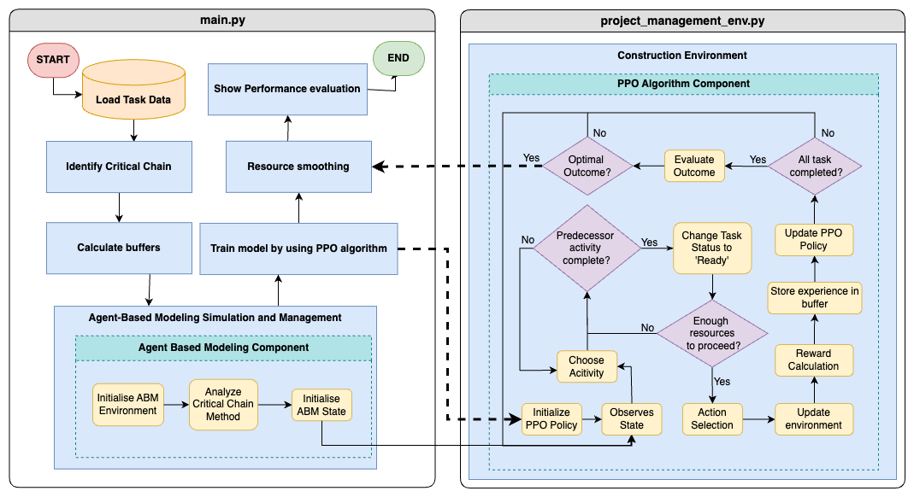
Figure 3.2: Streamline Flow Diagram of Environmental Setup for PPO-ABM model
The first step is to initialize the Proximal Policy Optimisation (PPO) algorithm, which necessitates the definition of the actor-critic approach. This initialization is important as it lays the groundwork for learning from the environment the best actions to take. After the initialization of the PPO policy, there is a setup of the abstract agent-based model (ABM) environment. This environment replicates the construction project in terms of tasks, resources, dependencies, and buffers. The ABM environment is important for creating a realistic setting in which agents may interact, thereby allowing one to compare various policies in terms of their efficiency under given constraints and conditions. The next step is to explore the Critical Chain Project Management (CCPM) framework analysis which the framework is designed strictly following CCPM’s rules. Project, feeding and resource buffers are applied to the critical path activities to minimise risks that affect the timely delivery of projects. Tasks, resources, and buffers are represented through different agents in the ABM. All the initial conditions of all the agents are given, including the statuses of condition check for the tasks ‘ready’ and the availability of the resources.

Agent’s Action
Project observation begins with the agent checking the status of existing tasks as well as their durations and buffers and resource distributions. The policy network accepts the supplied data from the observation step then generates a probability distribution that shows potential action options. The agent obtains its selected action starting or continuing work or moving resources or changing buffers from the probability distribution under the condition of adequate resource availability. The environment generates a new state which represents the modified task progress and resource allocation and project time duration. After executing an action, the system determines rewards through two factors: the benefit measure of the chosen action combined with documented negative results. The observed states and actions are preserved within a trajectory memory buffer until they are utilized for computing advantage functions during PPO policy and value network updates that refine upcoming decision-making capabilities.
The agent (policy) perceives the current state of the environment ‘ConstructionEnv’ in which the project is implemented (Figure 3.2). This state encompasses including task completion, duration, buffers, and resource usage. The observation is the input to the policy network, which then determines the next step of action based on the information available. The agent ‘TaskAgent’ observes this state to understand the current project conditions. Depending on the current state, the output of the agent determines which task to perform or resume. The policy network produces distribution over the possible actions, and an action is sampled from this likelihood distribution. This decision making corresponds to selecting the next action or activity for the agent. Before doing an action, the environment and agent logic are checking the availability of resources. Resource management is critical, and tasks are based on resource allocations.
The agent appears at the chosen action, which can include the initiation or continuation of tasks, resource reallocation, or changes in buffers. This is done to maximise the expected discounted cumulative reward based on the policy. This execution entails the conversion of policy decisions into practical measures that have an impact on the progress of a project. When the action is done taken, the environment moves to a new state. The state transition function can capture the behaviour of the construction project based on the actions implemented by the agent. The environment updates the state of the project, reflecting changes in resource usage, task progress, and time. The reward is given with respect to the new state of the environment that has been explored. Rewards are designed to incentivize those behaviours such as reducing resource buffers, shortening task durations, or efficiently using resources. The reward function is designed in the same way as to reward the actions that CCPM aims at and penalise the actions that are undesirable. The observed states are stored in a trajectory memory buffer. This buffer stores episodes over multiple timesteps and gives the data required for policy change. The trajectory memory is essential to train and update the PPO policy by calculating the advantage function as well as for the optimisation of policy and value function networks in PPO.

  - Experiment – Hybrid PPO – ABM Algorithm
The flowchart in Figure 3.3 illustrates a project scheduling program using a mock BIM model in a Critical Chain Project Management (CCPM) environment. The program checks for missing columns and data, categorizes tasks in a hierarchical sequence, and allocates resources based on task time. The program scales resources down proportionally to avoid exploitation and maintains resource consumption at the optimal point. The critical chain is identified by identifying the chain of required tasks and the longest chain of dependent tasks where delay affects project duration. The application learns what is most vital to the project deadlines and reallocates resources to limit delays. One relates to the project buffer which is calculated to safeguard the critical chain as well as the rest of the project. This also includes dispersing allocations from resource restrictions, to minimize cases of resource running. Buffers allow the program to verify for possible problems while not interrupting the remainder of the program. This function is in accordance with CCPM theory of separating project work that affects the project schedule from other work and thereby reducing the project time and resource usage.

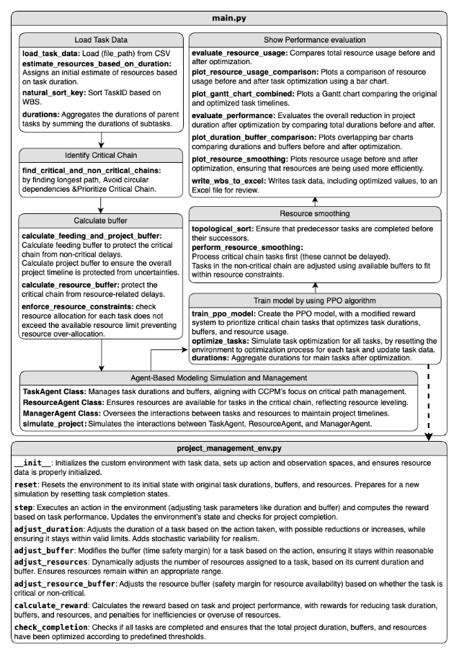
Figure 3.3: Streamline Flow Diagram of Entire Program

This code implements a basic skeleton of simulation environment in construction project governance, which has agents who govern tasks and resources. These features of CCPM materialize using the ‘TaskAgent’ class, which is used to model individual tasks with necessary duration, buffers and dependency. The critical chain; ‘ResourceAgent’ — a resource allocation and management agent. ‘ManagerAgent’ manages the interactions and queries on task status and resource utilization. This is a much more adaptive, and responsive, approach than many real-world projects, especially when one considers resource and environment availability and changes. We use the PPO algorithm to solve the task selection problem and the duration/buffer/other parameters for these tasks. Environment checks the progress of tasks, buffer state, and resource consumption to ensure buffer integrity and minimize project time and resource consumption. The ‘optimize_tasks’ function simulates the refinement of tasks, using the trained PPO model to improve efficiency. The task times and resource used can be reduced, while still ensuring its adequate buffer levels.
Resource levelling is a critical aspect of project management that ensures resources are neither over-allocated nor underutilised. In line with CCPM principles, the model redirects non-critical activities using available buffers to optimise resource usage without disrupting the critical chain. Within the custom environment (‘project_management_env.py’), agents observe task data and take actions to adjust durations or assign resources, while stochastic elements simulate real-world uncertainties such as delays. The environment incorporates a reward system that penalises multitasking, encouraging agents to stay focused on the critical path, a key tenet of CCPM. Fine-tuning ensures tasks remain within their initial duration and buffer limits, promoting flexible yet controlled optimisation. A built-in performance assessment module compares resource usage and scheduling outcomes before and after optimisation, visually demonstrating efficiency improvements through graphical outputs. This integrated approach enhances learning reliability and aligns closely with real-world resource management and scheduling challenges.

- Results & Discussion
The impact of the hybrid PPO-ABM model on construction scheduling, with special emphasis on the level of uncertainty where optimization is necessary, is assessed and compared at the beginning of this chapter. It then examines how well PPO and ABM have been applied for construction planning optimization by analyzing transient changes of an agent-based system in terms of task duration, buffer management, and resource utilization. The chapter then investigates the performance of the hybrid PPO-ABM model in different construction scenarios where the effects of uncertainty and complexity on the evaluation results are examined. This finding reveals how the model maintains optimal project performance while facing these challenges. The last section shows that the hybrid PPO-ABM approach has the benefit of shorter project duration, and less resource consumption as compared to traditional planning methods. The results are consistent with the objectives of the study to find the optimal project scheduling as well as to minimize the project length and compare the hybrid model to conventional methods.

  - Findings
    - Finding 1: Optimized Resource Utilization
Monitoring checks indicate that the optimization process effectively targets resource efficiency while maintaining project deadlines. Rather than applying uniform cuts, the model identifies and reduces excess allocations—particularly in tasks with initially high resource use or large buffers. Figure 4.1 illustrates this trend, showing that high-resource tasks undergo the most significant reductions, reflecting the PPO algorithm’s ability to identify and eliminate inefficiencies. This selective approach ensures that essential resources are preserved where needed, safeguarding task quality and timelines. The analysis reveals a positive correlation between initial resource allocations (including buffers) and the reductions achieved, suggesting the model is particularly effective in areas with overestimated contingency provisions. Overall, the redistribution of resources is not only more efficient but also more equitable, allowing the project to remain adaptive to unforeseen disruptions without compromising performance.
After optimisation, most parent tasks show a clear reduction in resource usage, indicating that the process effectively trims excess allocations. The “Structure Slab” task demonstrates the most significant decrease, suggesting it was initially over-resourced and offered substantial room for adjustment. Other tasks, such as “Structural Beam” and “Foundation,” also display moderate reductions, reflecting a balanced reallocation strategy.

Figure 4.1: Bar chart example showing each tasks resources usage before and after optimization
The optimisation particularly targets tasks with the highest initial resource allocations, addressing the largest inefficiencies first. This results in a consistent trend where all parent task bars are shorter in the optimised scenario, yet none are reduced to zero—highlighting a careful approach that maintains adequate resources for successful task completion.

    - Finding 2: Resources Smoothing
In finding 2, it established that the proposed PPO-ABM model resulting in shorter overall timeliness compared to conventional CPM approaches. Study suggests that through buffers, CCPM can manage variability and project duration for construction projects to have the most favorable length (Kothari, 2025). Smaller and specific buffers in the model also fit CCPM’s resource-buffering approach regarding continuous important task performance without supplementing too much contingency (Leach, 2014). Some of the projects that have activities that are related, heavily resource dependent, nested, and interrelated, like the foundation and structural column works, are best suited for the PPO-ABM model.

Figure 4.2: Bar chart showing total resource usage in each week before and after smoothing
The chart illustrates a 53-week project schedule, comparing resource usage before and after smoothing against a 40-hour weekly limit. Smoothing significantly reduces the extreme peaks and valleys in resource allocation, helping to prevent both overallocation above the limit and underutilisation far below it. This results in a more consistent workload, as shown by the reduced week-to-week variation in the optimised (dark green) bars. The closer alignment with the 40-hour benchmark enhances planning efficiency, enabling better capacity management while minimising risks of bottlenecks and downtime.

    - Finding 3: Improvement in Duration & Buffer Management
The bar chart provided in Figure 4.3 shows the comparison of total duration, buffer before and after optimization with CPM and hybrid models of proximal policy optimization (PPO) and critical chain project management (CCPM) for all tasks. Optimized durations in nearly all task categories are much shorter than those calculated using the conventional CPM method. This implies that the hybrid approach is efficient in reducing time requirements, especially in complex construction activities where interdependence and resource constraints are of importance.

Figure 4.3: Bar chart showing parent tasks durations and buffers before and after optimization

Additionally, the reduced buffer sizes derived by the optimized approach demonstrate improved performance in handling contingencies. The original buffers are consistently larger than optimized buffers, which implies a more precise allocation of time for potential delays. In construction projects, uncertainty and variability can cause schedule disruption, and this aspect is crucial. Particularly significant improvements are observed for tasks like "foundation" and "structural columns," which are more complex and time-intensive tasks, indicating that the model can handle more complex and time-intensive tasks well. The simulation confirm that the hybrid PPO-ABM model significantly reduces task durations and buffers compared to traditional methods like CPM, and these improvements are statistically meaningful rather than random.
The optimisation results show the largest reductions in major structural tasks like “Structure Slab” and “Structure Wall,” indicating these tasks had substantial slack or overestimated durations in the original plan. Rather than eliminating buffers entirely, the optimised bars are proportionately trimmed, maintaining enough margin to handle uncertainties while reducing excess. The impact varies across tasks—some, such as “Preliminary and Site Preparation” or “Other Work,” show only minor changes, suggesting they were already efficiently planned. A clear reduction in the red buffer segments highlights the algorithm’s focus on cutting unnecessary padding while preserving essential contingency. Overall, the contrast between the tall original bars and the shorter optimised ones reflects a meaningful improvement in efficiency and a shortened total project duration.
The bar chart in Figure 4.2 shows the resource usage during a total in 53-week period of the entire construction project scheduling of Dragonfly tower and how resource smoothing before and after optimization affects resource usage. This data is one of the outputs after executes the program. It compares resource demand to a limit of 40 hours per week. First, resource usage is initially highly uncoupled to capacity, with peaks far exceeding the weekly limit and valleys of underutilized resources. Once smoothed, the resource allocation is more balanced, closer to the 40-hour weekly limit, and less peaking and troughing. An optimized approach would lead to better alignment of the resource constraints and, hence, a more stable and predictable workload. Reduction in volatility means better resource management because resources allocation is more consistent over the duration of the project. Even distribution of resources means that you don’t have periods of overallocation and underuse, which can help improve scheduling efficiency.
This model prevents overloading of work during the working weeks while at the same time avoiding having lengthy free periods. Optimizations required in resource smoothing and Critical Chain Project Management (CCPM) show how the same may reduce overall worker fatigue, decrease project length, and increase productivity because of equal spreading of resource requirements in line with principle proposed by Allu et al. (2024). As found in the results of this PPO-ABM modeling, the practice supported by CCPM is beneficial in terms of resource buffering and making proactive adjustments to resource allocation so that resource breakdown in important construction phases could be avoided. In terms of resource distribution, the model organically ascribes resources to projects in response to fluctuating activity conditions while providing performance data that marks an advancement over conventional real-time project management models such as CPM in highly pressured tasks. This is in support of literature arguing that CCPM is flexible and robust in construction project management (Montazeri, n.d.). The literature points out that the rational utilization of resources is consistent with CCPM principles, which prevent resources from bucking the system and adjust the workload so that it does not overwhelm workers and reduce productivity (Herroelen & Leus, 2004).

    - Finding 4: Performance Evaluation (program outcomes)
Figure 4.4 and 4.5 shows the outputs of performance evaluation before and after optimisation which are calculated at the end of the program. As shown in Figure.4.4, the substantial decrease implies that the optimization model found and eliminated redundancies or inefficiencies in resource allocation so that the resource usage was streamlined throughout the project. Based on Figure 4.5, the project duration was reduced from 1000 days (about 2.74 years) to 978 days (about 2.68 years), or 22 days (about 2.20%). While the time saving is smaller in percentage terms than the resource saving, this reflects improved scheduling efficiency, probably because tasks are better matched to resource availability. These results show that the optimization process can significantly decrease the resources required and time necessary to accomplish the project, hopefully resulting better resource management.

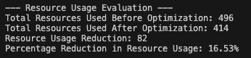
Figure 4.4: Figure printed evaluation of the performance of resource and resources buffer before and after optimization
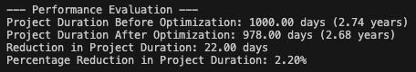
Figure 4.5: Figure printed evaluation of the performance of project durations and buffer before and after optimization
The optimisation model achieves a substantial 16.53% reduction in resource usage (Figure 4.4), effectively eliminating inefficiencies without compromising quality. While the time savings are more modest, with project duration reduced from 1000 to 978 days (a 2.20% decrease, Figure 4.5), this still provides meaningful financial and scheduling advantages. These improvements reflect enhanced scheduling efficiency, with better alignment between tasks and available resources, resulting in a smoother, less bottlenecked workflow. The outcome aligns well with Critical Chain Project Management (CCPM) principles by maximising resource efficiency and minimising unnecessary effort. Even a small percentage decrease in duration carries practical implications, proving that the model can adapt to constraints while maintaining progress and balance.
The output significance of the 16.53% decrease in resources and that the optimization process removes enough redundancies that the project can still meet its needs with fewer resources without compromising quality. It is in line with objectives of critical chain project management (CCPM) to optimize resource use. The 22 days saved in construction projects may not seem much, but the 2.20% reduction in project duration can have significant financial implications. The results show that the model can operate under resource constraints and time limits, respond to changes in conditions, and balance progress without overextending resources.

    - Finding 5: Gantt Chart (Created by Primavera 6 with WBS data from the program outcome)

These Gantt charts shown in Figures 4.6 and 4.7 are created by using the WBS data before and after optimization and input to the Primavera 6 software to do comparison. The optimized Gantt chart demonstrated in Figure 4.7 shows a shortening of timelines than Figure 4.6. This implies the overlap of some tasks and the minimization of the idle time between phases during the optimization process. In addition, the improved alignment of dependent tasks facilitates earlier start of tasks, which reduces gaps and synchronizes interdependent tasks—a major CCPM principle. After refining the task sequencing, it further streamlines the project and makes the transitions smoother, which indicates the removal of unnecessary buffers and delays. This after optimization schedule gained better task synchronization, beginning earlier in the course of preceding activities, and facilitated more graceful transitions between phases. It is this adjustment that minimizes delays since project momentum must be maintained through task synchronization.
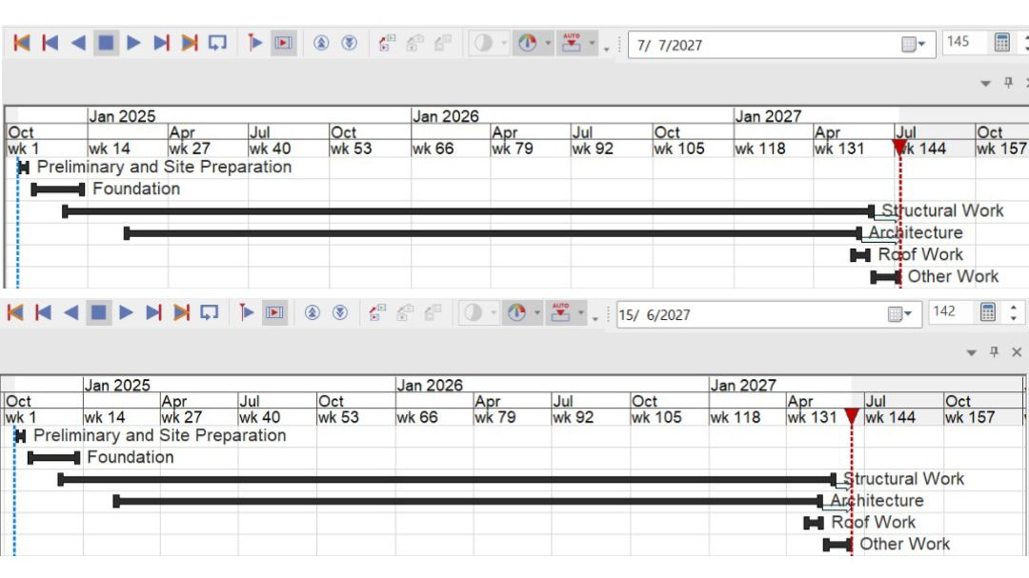
Figure 4.6: Gantt Chart of before optimization scheduling
The “after optimisation” Gantt chart shows tasks finishing earlier, indicating a shorter overall project timeline. This visual shift highlights efficiency gains achieved through task re-sequencing and buffer reduction, resulting in a more streamlined and orderly schedule.

Figure 4.7: Gantt Chart of after optimization scheduling
PPO integration improves flexibility, each imperative when dealing with limited resources as well as when conditions in projects are ever-changing, especially in large construction projects. CCPM’s two features of dynamic sequencing of tasks and of adaptive resource buffers contribute to flexibility and high resilience as concerns timeline disruption. From Montazeri (n.d.) CCPM vs. CPM analysis, CCPM is more applicable when environments are dynamic. In addition, ABM simulations, which are practical interactive, depict resource issues that define real construction and reiterate the model’s effectiveness. Additional value of ABM is provided by its capability to simulate interactions among the project agents and the corresponding ability of the model to adapt the periods required to accomplish the tasks. Specifically, this interactive simulation is consistent with Macal’s (2016) ABM findings regarding the model’s usefulness and contribution, strengthening the original model’s claim that it can model complex systems to enhance project management results. Hence, in table 1, research findings are presented.

Table 1: Research’s Findings from Project Management Optimization Study
No | Findings | Description | Figure Description | Discussion
4.1.1 | Optimized Resource Utilization | The optimization process efficiently utilizes resources to achieve project deadlines by targeting high-resource tasks for significant reductions. This strategic reduction of resources in tasks with large buffers leads to substantial cost savings and improved resource allocation efficiency. The analysis demonstrates that the optimization was selective, focusing on areas with resource inefficiencies, and avoided uniform resource cuts across all tasks. This ensures quality and adherence to timelines without compromising the project's integrity. The bar chart demonstrates a visible decrease in resource usage for tasks with initially high allocations, showing the effectiveness of the Proximal Policy Optimization (PPO) algorithm in reducing excesses while maintaining necessary buffers for unforeseen circumstances. | Figure 4.1: Bar chart comparing resource usage before and after optimization. | Avoids Overloading and Idle Time: The model ensures balanced workload distribution across working weeks, preventing overloads and underutilization (Allu et al., 2024).  Proactive Resource Allocation: Demonstrates CCPM’s practice of resource buffering and timely adjustments to prevent breakdowns during critical construction phases, dynamically assigning resources as needed (Herroelen & Leus, 2004).  Adaptive Resource Distribution: Outperforms traditional real-time management models by dynamically adjusting resource allocation in response to activity conditions, highlighting the superiority of CCPM under pressure.
4.1.2 | Resource Smoothing | Over a 53-week project timeline, resource smoothing has been implemented to even out the distribution of resource usage, adhering to a 40-hour weekly limit. This approach reduces the occurrence of resource overallocation and underutilization, creating a more stable and predictable workflow. The bar chart illustrates a narrower variation in resource usage week-to-week, demonstrating improved operational consistency and better alignment with workforce capacity, which reduces bottlenecks and idle times. This adjustment in resource distribution ensures a continuous workflow without excessive peaks and valleys, facilitating smoother project progression and enhancing overall scheduling efficiency. | Figure 4.2: Bar chart showing total resource usage weekly before and after smoothing. | Resource Smoothing and CCPM Benefits: Spreading resource requirements more evenly across the project timeline helps reduce worker fatigue and boost productivity while shortening project durations (Allu et al., 2024).  Rational Utilization of Resources: CCPM principles facilitate the prevention of system overload and ensure productivity by matching workload to worker capacity (Herroelen & Leus, 2004).
4.1.3 | Improvement in Duration & Buffer Management | The optimization significantly reduces task durations and buffer sizes, particularly in complex and resource-intensive tasks such as foundations and structural components. The bar chart shows that the hybrid model combining PPO with critical chain project management (CCPM) effectively trims excess buffer while maintaining enough contingency time to manage project uncertainties effectively. This results in a substantial decrease in total project duration, indicating a more precise and efficient project scheduling. The data highlight major reductions in tasks that initially had significant slack, suggesting that the model is capable of identifying and minimizing overestimations in both duration and resource allocation. | Figure 4.3: Bar chart comparing task durations and buffers before and after optimization. | Shorter Timelines Compared to CPM: Demonstrates enhanced efficiency in scheduling, reducing overall project durations significantly compared to traditional methods (Kothari, 2025).  Ideal for Interrelated Tasks: Shows significant improvements in handling complex tasks with heavy resource dependencies through targeted optimization (Leach, 2014).  Effective Buffer Management: Strategic employment of buffers manages variability effectively, enhancing project outcomes (Kothari, 2025).
4.1.4 & 4.1.5 | Performance Evaluation and Gantt Chart Analysis | The evaluation of performance metrics before and after optimization indicates a significant enhancement in resource management and project timing. Resource usage was cut by 16.53%, and project duration was reduced by 22 days (2.20%), underscoring the effectiveness of the optimization in refining resource allocation and scheduling tasks more accurately according to available resources. These improvements suggest that the optimization model is not only effective in reducing unnecessary expenditures but also in maintaining project quality and meeting deadlines. The figures provide a visual confirmation of these results, demonstrating the tangible benefits of applying advanced optimization techniques in project management. Gantt charts created with Primavera 6 using WBS data from before and after optimization illustrate a more efficient project schedule with reduced timelines and minimized idle times between phases. The optimization results in better task synchronization and a reduction in unnecessary delays, demonstrating the model's capability to enhance the sequencing of project activities. This leads to a streamlined project timeline, where tasks are more aligned and interdependencies are managed more effectively, facilitating earlier starts and smoother transitions between project phases. The improved Gantt chart showcases these optimization benefits visually, providing clear evidence of the model's impact on project management practices. | Figure 4.4 & 4.5: Performance evaluation metrics before and after optimization.  Figure 4.6 & 4.7: Gantt charts before and after optimization scheduling. | Improved Overlaps and Consistency with CCPM Principles: Enhances flexibility and resilience against timeline disruptions by overlapping tasks without conflicting resource needs, adhering to CCPM's adaptive buffering and dynamic sequencing (Macal, 2016).  Reduced Gaps and Idle Time: Shows a tightly arranged schedule in the optimized version, minimizing idle periods and enhancing overall project efficiency (Macal, 2016).  Enhanced Flexibility via PPO and Realistic Resource Depiction via ABM: Integrates PPO to adapt under limited resources and volatile conditions, and ABM captures the complexities of real construction environments, reinforcing the model's practical relevance and its ability to adjust task durations dynamically (Macal, 2016).

The findings of this research provide strong evidence supporting the feasibility and effectiveness of integrating Agent-Based Modelling (ABM) with Critical Chain Project Management (CCPM) and leveraging Proximal Policy Optimisation (PPO) for improving construction scheduling in complex and uncertain environments. Firstly, the model demonstrates optimised resource utilisation (Finding 4.1.1), where PPO effectively identifies and reduces inefficiencies in high-resource tasks while preserving performance and project integrity. As shown in Figure 4.1, the PPO-ABM model selectively trims resource excess without indiscriminate reductions, confirming its capability to dynamically adapt and allocate resources based on task conditions—something traditional optimisation methods often lack. This illustrates the efficacy of PPO in managing dynamic resource constraints, a critical challenge in real-world construction scheduling.
Secondly, the model achieves resource smoothing across a 53-week period (Finding 4.1.2), reinforcing the potential of ABM to simulate and manage the interactions of workforce, task conditions, and availability under realistic constraints. Figure 4.2 shows reduced variation in weekly resource usage, aligning closely with CCPM’s goal of workload stabilisation. This highlights ABM’s feasibility as a dynamic engine within CCPM, effectively capturing complex behavioural patterns and enabling adaptive planning strategies.
Thirdly, the reduction in duration and buffer sizes (Finding 4.1.3) for resource-heavy and complex tasks demonstrates how the hybrid PPO-ABM model improves critical chain scheduling by trimming inflated estimates while maintaining contingency. Figure 4.3 validates the model’s precision in managing slack and uncertainty—an essential aspect of CCPM. These results underscore PPO’s superiority over static scheduling approaches, enabling more realistic planning without jeopardising flexibility or risk mitigation.
Furthermore, the performance evaluation (Finding 4.1.4) confirms that PPO-ABM delivers measurable efficiency gains. A 16.53% drop in resource use and a 2.20% reduction in project duration (Figures 4.4 and 4.5) reflect not only the efficacy of PPO in dynamic optimisation but also ABM’s feasibility in modelling and managing construction dynamics realistically. The model adapts well under constrained and evolving conditions, supporting agile decision-making and resource reallocation.
Lastly, the Gantt chart comparison (Finding 4.1.5) illustrates the model’s capacity to enhance task sequencing and project flow (Figures 4.6 and 4.7). Tasks start earlier, idle times are reduced, and dependencies are more efficiently managed—directly improving critical chain scheduling performance. This visual evidence supports the claim that the hybrid PPO-ABM model outperforms conventional methods by simulating real-world complexities and delivering robust, adaptive schedules in alignment with CCPM principles.
In summary, this study confirms that the hybrid PPO-ABM model is both feasible and effective in advancing CCPM-based construction scheduling. By combining the adaptive learning capacity of Proximal Policy Optimisation (PPO) with the system-level realism of Agent-Based Modelling (ABM), the model delivers measurable improvements in resource allocation, scheduling precision, and project flow management under uncertainty. PPO enables dynamic optimisation through iterative learning, while ABM facilitates the simulation of task-resource interactions within the structured framework of Critical Chain Project Management (CCPM).
The integration of mathematical constructs such as the Fibonacci sequence, Shannon’s entropy, and Sornette’s critical transitions adds theoretical rigour, supporting the model’s ability to represent recursive adaptation, uncertainty, and cascading risks. However, while these abstractions provide a strong analytical foundation, they inevitably limit engagement with key human and organisational dynamics. The model currently overlooks crucial aspects such as decision-making behaviour, team collaboration (Kapogiannis and Sheratt, 2018), and resistance to change, all of which significantly influence the success of scheduling systems in practice.
Moreover, while the model demonstrates promising results and a solid foundation for further development, addressing its current limitations—particularly in data dependency, real-world applicability, and the integration of human and organisational factors—will be critical to ensuring its practical relevance and long-term impact in the construction industry. As such, future research should aim to enhance the model’s responsiveness to real-time project dynamics and embed behavioural insights to bridge the gap between computational optimisation and the complex realities of construction project execution.

  - Limitations
While the hybrid PPO-ABM model shows strong potential in controlled settings, several limitations affect its real-world applicability. It is highly sensitive to input accuracy—such as task durations and resource availability—making it vulnerable to performance issues. Its focus on minimising time and resources limits adaptability to real-time disruptions like delays or weather impacts. The rule-based structure and a fixed resource cap (500) restrict scalability in large or multi-project environments requiring flexible coordination. Additionally, the computational demands of PPO and ABM may limit accessibility for smaller firms. The model’s performance in multi-project contexts remains untested, and the lack of comparison with alternative methods, such as Monte Carlo simulations or other machine learning techniques, weakens its validation. While ABM adds behavioural realism, it may oversimplify complex human and environmental factors, and CCPM’s reliance on accurate estimates may not reflect real-world variability. Future improvements should address these issues to enhance practicality and adoption.

- Conclusion
This study explored the feasibility and effectiveness of a hybrid Proximal Policy Optimisation–Agent-Based Modelling (PPO-ABM) framework for improving construction scheduling using Critical Chain Project Management (CCPM) principles. It examined the integration of ABM within CCPM, the optimisation capability of PPO, and the model’s performance under uncertainty. Results show that ABM enhances task-resource simulation and dependency management, while PPO achieved a 16.53% reduction in resource usage and a 2.20% decrease in project duration, outperforming traditional methods like the Critical Path Method (CPM). Despite these promising results, the model’s reliance on accurate input data and limited responsiveness to real-time changes constrain its generalisability in dynamic contexts. Nevertheless, this research contributes a novel, AI-integrated scheduling approach that bridges reinforcement learning and project planning theory. It provides a strong foundation for future work on real-time adaptability, scalability, and multi-project applications, marking a step forward in intelligent and adaptive construction scheduling.

- References
Admin. (n.d.). Sydney Opera House failed project - What can you learn? https://blog.beyondsoftware.com/learning-from-failed-projects-sydney-opera-house

Al-Sinan, M. A., Bubshait, A. A., & Aljaroudi, Z. (2024). Generation of Construction Scheduling through Machine Learning and BIM: A Blueprint. Buildings, 14(4), 934. https://doi.org/10.3390/buildings14040934

Allu, S. R., Bhaumik, A., Ramakrishna, A., & Bhaumik. (2024). A Critical review of resource allocation optimization in project management. ResearchGate. https://www.researchgate.net/publication/382049201_A_Critical_Review_of_Resource_Allocation_Optimization_in_Project_Management

Aramesh, S., Mousavi, S., Mohagheghi, V., Zavadskas, E., & Antucheviciene, J. (2020). A soft computing approach based on critical chain for project planning and control in real-world applications with interval data. Applied Soft Computing, 98, 106915. https://doi.org/10.1016/j.asoc.2020.106915

Araya, F. (2020). Modelación basada en agentes: Revista De Ingeniería De ConstruccióN, 35(2), 111–118. https://doi.org/10.4067/s0718-50732020000200111

Bahroun, Z., Tanash, M., As’ad, R., & Alnajar, M. (2023). Artificial intelligence Applications in Project Scheduling: A systematic review, bibliometric analysis, and Prospects for Future research. Management Systems in Production Engineering, 31(2), 144–161. https://doi.org/10.2478/mspe-2023-0017

Brockman, G., Cheung, V., Pettersson, L., Schneider, J., Schulman, J., Tang, J., & Zaremba, W. (2016, June 5). OpenAI Gym. arXiv.org. https://arxiv.org/abs/1606.01540

Domenteanu, A., Delcea, C., Chiriță, N., & Ioanăș, C. (2023). From Data to Insights: A Bibliometric Assessment of Agent-Based Modeling Applications in Transportation. Applied Sciences, 13(23), 12693. https://doi.org/10.3390/app132312693

Enshassi, M. S. A., Walbridge, S., West, J. S., & Haas, C. T. (2019). Dynamic and proactive Risk-Based methodology for managing excessive geometric variability issues in modular construction projects using Bayesian theory. Journal of Construction Engineering and Management, 146(2). https://doi.org/10.1061/(asce)co.1943-7862.0001747

Glucroft, W. N. (2020, November 1). Berlin’s new airport: A story of failure and embarrassment. dw.com. https://www.dw.com/en/berlins-new-airport-finally-opens-a-story-of-failure-and-embarrassment/a-55446329

Harris, C. R., illman, K. J., Van Der Walt, S. J., Gommers, R., Virtanen, P., Cournapeau, D., Wieser, E. S., Taylor, J., Berg, S., Smith, N. J., Kern, R., Picus, M., Hoyer, S., Van Kerkwijk, M. H., Brett, M., Haldane, A., Del Río, J. F., Wiebe, M. W., Peterson, P., . . . Oliphant, T. E. (2020). Array programming with NumPy. Nature, 585(7825), 357–362. https://doi.org/10.1038/s41586-020-2649-2

Helo, P., & Rouzafzoon, J. (2023). An agent-based simulation and logistics optimization model for managing uncertain demand in forest supply chains. Supply Chain Analytics, 4, 100042. https://doi.org/10.1016/j.sca.2023.100042

Herroelen, W., & Leus, R. (2001). On the merits and pitfalls of critical chain scheduling. Journal of Operations Management, 19(5), 559–577. https://doi.org/10.1016/s0272-6963(01)00054-7

Herroelen, W., & Leus, R. (2004). Project scheduling under uncertainty: Survey and research potentials. European Journal of Operational Research, 165(2), 289–306. https://doi.org/10.1016/j.ejor.2004.04.002

Huang, J., Teo, C., Wang, F., & Xu, Z. (2023). Buffer Times Between Scheduled Events in Resource Assignment Problem: A Conflict-Robust Perspective. https://doi.org/10.1287/msom.2022.0572

Kapogiannis, G. and Sherratt, F. (2018) Impact of integrated collaborative technologies to form a collaborative culture in construction projects. Built Environment Project and Asset Management, 8 (1). pp. 24-38. doi:10.1108/BEPAM-07-2017-0043 ISSN 2044-124X.

Kedir, N. S., Somi, S., Fayek, A. R., & Nguyen, P. H. (2022). Hybridization of reinforcement learning and agent-based modeling to optimize construction planning and scheduling. Automation in Construction, 142, 104498. https://doi.org/10.1016/j.autcon.2022.104498

Kothari, A. (2025). Critical Chain Project Management (CCPM): All you need to know. Tallyfy. https://tallyfy.com/critical-chain-project-management-ccpm/

Leach, L. P. (2014). Critical Chain Project Management. Artech House. https://books.google.com.my/books?hl=en&lr=&id=UOxPAwAAQBAJ&oi=fnd&pg=PR13&dq=Leach,+L.+P.+(2014).+Critical+Chain+Project+Management.+Artech+House.&ots=-Fo7Sbi6Qs&sig=RSwYT_6CQ2NkDvbUFYqzafzFlUI&redir_esc=y#v=onepage&q&f=false

Macal, C. M. (2016). Everything you need to know about agent-based modelling and simulation. Journal of Simulation, 10(2), 144–156. https://doi.org/10.1057/jos.2016.7

Mazzetto, S. (2024). Interdisciplinary Perspectives on Agent-Based Modeling in the Architecture, Engineering, and Construction Industry: A Comprehensive Review. Buildings, 14(11), 3480. https://doi.org/10.3390/buildings14113480

Milat, M., Knezić, S., & Sedlar, J. (2022). Multi-Objective Optimization approach to develop resilient baseline schedules. https://www.croris.hr/crosbi/publikacija/prilog-skup/723546

Misnan, M. S., Ismail, M. Z., & Yan, T. J. (2024). Construction Project management Issues and Development in Current for Future Construction Project: Challenges and Prospects in Sustainable Project Management. International Journal of Research and Innovation in Social Science, VIII(II), 1997–2011. https://doi.org/10.47772/ijriss.2024.802141

Montazeri, B. (n.d.). Comparing Critical Chain Project Managemenet with Critical Path Method: A Case Study. TopSCHOLAR®. https://digitalcommons.wku.edu/theses/1935/

Narita, T. T., Alberconi, C. H., De Souza, F. B., & Ikeziri, L. (2021). Comparison of PERT/CPM and CCPM methods in project time management. GEPROS. Gestão Da Produção, Operações E Sistemas, 16(3), 01. https://doi.org/10.15675/gepros.v16i3.2815

Olson, D.L. (2024), "Critical Chain Scheduling", in Project Management Tools, Springer, Singapore, pp. 97-108. doi: 10.1007/978-981-97-1720-0_9.

Raffin, A., Hill, A., Gleave, A., Kanervisto, A., Ernestus, M., & Dormann, N. (2021). Stable-Baselines3: Reliable Reinforcement learning Implementations. https://jmlr.org/papers/v22/20-1364.html
Subramani, T., & Ammai, A. (2018). Maturing Construction Management Up The Bim Model & Scheduling Using Primavera. International Journal of Engineering & Technology, 7(3.10), 1. https://doi.org/10.14419/ijet.v7i3.10.15617
Schulman, J., Wolski, F., Dhariwal, P., Radford, A., & Klimov, O. (2017, July 20). Proximal Policy optimization Algorithms. arXiv.org. https://arxiv.org/abs/1707.06347
Shanmugapriya, M. M., & Venkatramaraju, Dr. D. (2024). Elevating Strategy with Cloud-Based Reinforcement Learning for Dynamic Decision-Making in Modern Enterprises. 1–6. https://doi.org/10.1109/inocon60754.2024.10511401
Shyalika, C., Silva, T., & Karunananda, A. (2020). Reinforcement Learning in Dynamic Task Scheduling: a review. SN Computer Science, 1(6). https://doi.org/10.1007/s42979-020-00326-5
Steyn, H. (2002). Project management applications of the theory of constraints beyond critical chain scheduling. International Journal of Project Management, 20(1), 75–80. https://doi.org/10.1016/s0263-7863(00)00054-5

Sweller, J., Ayres, P., & Kalyuga, S. (2011). Cognitive Load Theory. In Springer eBooks. https://doi.org/10.1007/978-1-4419-8126-4
Szwarcfiter, C., Herer, Y. T., & Shtub, A. (2023). Balancing Project Schedule, Cost, and Value under Uncertainty: A Reinforcement Learning Approach. Algorithms, 16(8), 395. https://doi.org/10.3390/a16080395
Taghipour, M., Seraj, F., Amin, M., & Changiz, D. M. (2020). Evaluating CCPM method versus CPM in multiple petrochemical projects. Management, 3(3), 1-20. https://doi.org/10.31058/j.mana.2020.32004

Xie, F., Li, H., & Xu, Z. (2021b). An approximate dynamic programming approach to project scheduling with uncertain resource availabilities. Applied Mathematical Modelling, 97, 226–243. https://doi.org/10.1016/j.apm.2021.03.048

Zhang, Y., Zhu, H., Tang, D., Zhou, T., & Gui, Y. (2022). Dynamic job shop scheduling based on deep reinforcement learning for multi-agent manufacturing systems. Robotics and Computer-Integrated Manufacturing, 78, 102412. https://doi.org/10.1016/j.rcim.2022.102412

