Modeling and Simulation – Extending Use Cases in the Military and Beyond

James A. Wall
Texas A&M Center for Applied Technology (Retired)
College Station, Texas
jim-wall@tamu.edu

ABSTRACT

Dr. James A. (Jim) Wall’s I/ITSEC Fellow paper focuses on his 39 years of M&S experience as a staunch advocate for promoting modeling and simulation as a National Critical Technology among military, government, academic, and industry leaders and the opportunities for its use in more diverse application environments. His experience includes work across multiple U.S. Government Departments including Defense, Homeland Security, Energy, and Agriculture. His presentation will cover some of the commonalities and differences in applying M&S across the departments. His reflections relate his efforts as a developer of M&S requirements, a user, and an M&S developer and highlights observations and lessons learned along the way. Dr. Wall will highlight some emerging trends in M&S and discuss how advances in other supporting technologies such as artificial intelligence, machine learning, and cloud architectures present both opportunities and challenges that M&S practitioners will need to address to realize the full potential of new and powerful applications. Such applications will be more commonplace and serve as an enabler to a broader, more diverse user community by providing greater access and utility at more levels to support problem-solving, decision-making, and training.

ABOUT THE AUTHOR
James A. (Jim) Wall, Ph.D., has spent nearly four decades of making indelible contributions to Modeling and Simulation (M&S). He is a technical leader, M&S textbook co-author, and iconic visionary whose work has fundamentally shaped simulation capabilities being delivered and used today. Jim’s work has enabled the transformation of operations, training, and testing across multiple communities that safeguard our national and personal security. Prior to retirement, Jim served as the Executive Director of the Texas A&M Center for Applied Technology and the inaugural Director of the Innovation Proving Ground, a component of the Bush Combat Development Complex located on the RELLIS Campus of Texas A&M University. Early on, as a researcher in the newly formed Uniformed Army Scientist Program at the Army Research Laboratory, He led development of the Virtual Sand Table, which was the first three-dimensional (3D) tabletop environment used to virtually represent military systems being driven by constructive simulations. Later, at Texas A&M, he and his team developed the Emergency Management Exercise System that has been used to train more than 20,000 emergency responders across the nation. Additionally, he was the Co-Principal Investigator for the highly successful Digital Emergency Medical System program that connects an ambulance with the receiving emergency room and transmits real-time video and physiological telemetry while on the move. His team’s bio-surveillance common operational picture developed for the Department of Homeland Security’s National Bio-surveillance Integration Center won the 2010 Department of Homeland Security Science & Technology Impact Award. In 2010, he served as the I/ITSEC Conference Chair, the first from an academic institution to serve in this capacity. He supported a Defense Science Board Task Force on a year-long study related to gaming, exercising, modeling, and simulation (GEMS) in 2021. Jim was commissioned as an Armor officer in the U.S. Army and retired as an Army Acquisition Corps officer with twenty-two years of service. His last Army assignment was as a Senior Computer Scientist with the Army Research Laboratory at Aberdeen Proving Grounds, Maryland. He has a Ph.D. in Computer Science (2003) from Texas A&M University and an M.S. in Systems Technology (Command, Control, and Communications; 1986) from the Naval Postgraduate School in Monterey, CA. He selected in 2002 as a charter member of NTSA’s certification program for modeling and simulation professionals (Certified Modeling and Simulation Professional (CMSP)). In 2009, Jim was designated as a Regents Fellow by The Texas A&M University System Board of Regents. He was inducted into the National Center for Simulation Modeling and Simulation Hall of Fame in October of 2022.

Modeling and Simulation – Extending Use Cases in the Military and Beyond

James A. Wall
Texas A&M Center for Applied Technology (Retired)
College Station, Texas
jim-wall@tamu.edu

INTRODUCTION

This paper is intended to provide some highlights of this author’s professional journey through a multifaceted career that includes a deep commitment to the discipline of modeling and simulation (M&S). While heavily involved with military M&S throughout his nearly four decades of related service within the U.S. Army and at the Texas A&M Center for Applied Technology, he sought out opportunities to extend this technology to non-military applications where it seemed obvious to blur the lines between operations and training, especially when providing support for command and control (C²) environments and decisionmakers. In fact, many of the programs are primarily focused on the use of information technology with M&S introduced as one of several means to increase the utility and enhance the effectiveness of a particular system. This author has played a role in each program covered in this paper either as a technical lead or principal investigator. He has been surrounded by many outstanding mentors and highly professional colleagues along the way that have contributed greatly to the overall success of these programs.

Writing a paper that covers a period of nearly forty years and is somewhat historical presents some challenges with a highly technical audience because related technologies have advanced so rapidly. It is important to remember the timeframe of a program and the state of the art during that period. One must also consider that many of the programs were considered applied research for sponsors with little background in many aspects of M&S and modest budgets. Hopefully, the growing experience base and lessons learned by all involved were instrumental in moving M&S technology forward in a more informed manner.

This author has the good fortune of a career that covered multiple uses of simulation such as training, operations, testing, and analysis in both military settings within the Department of Defense and various defense industries and non-military settings within the Departments of Homeland Security, Energy, and Agriculture, and various non-defense related industries. His experiences cover a wide spectrum of efforts from developing requirements for military simulations to using analytical simulations to support materiel development, to developing standalone modeling and simulation applications, to embedding models and simulations into other applications, as appropriate.

In the Beginning…

This author’s first exposure to modeling and simulation was during the years 1984-1986 as an Army student at the Naval Postgraduate School where he developed his first simulation - a tank negotiating a minefield and, arguably, the first 3D fish aquarium on a Silicon Graphics computer. This passion was fueled further during his subsequent assignment to the U.S. Armor School at Ft. Knox when he was instrumental in using modeling and simulation (Janus – a conflict resolution model) to support a Cost and Operational Effectiveness Analysis (COEA) to justify the nine improvements to the M1A1 main battle tank which gave rise to the M1A2. One interesting aside was the fact that improvements attributable to an on-board navigation system could not be demonstrated in the simulation. Everyone who had been “buttoned-up” in any combat vehicle knew that this a navigation aid had to be a significant improvement. As it turned out, vehicle movement from one point to another were always precisely executed in the simulation. The benefit of adding an on-board navigation system was later justified by analyzing data from the National Training Center at Ft. Irwin, CA, showing that poor navigation often resulted in the inability to synchronously concentrate combat power on an objective at the most critical time.

One of the key components of the M1A2 was the Inter-vehicular Information System (IVIS) which was the first digital information system in a ground combat vehicle. The author of this paper was a major contributor to the development of requirements for the M1A2, especially IVIS. It was immediately clear at that time that IVIS could be stimulated via simulation for tank crew training. IVIS was a crude, by modern standards, precursor to Force XXI Battle Command Brigade and Below-Blue Force Tracking (FBCB2-BFT) (Conatser and Grizio, 1995).

This was also during the period that SIMNET was being demonstrated at Fort Knox. SIMNET development began in the mid-1980s, was fielded starting in 1987, and was used for training until successor programs came online well into the 1990s. SIMNET was perhaps the world's first fully operational virtual reality system (Sterling, 1993) and was the first real-time, networked simulator.

This limited exposure to simulation and simulation environments was a catalyst for change in the author’s career and resulted in a Ph.D. in Computer Science from Texas A&M University (1993). While at Texas A&M multiple courses in M&S were taken and three years there led to a degree supported by his dissertation, Multilevel Abstraction of Discrete Event Models in an Interactive Object-Oriented Simulation Environment. During his time at Texas A&M, he also co-authored a textbook with Dr. Udo Pooch, entitled, Discrete Event Simulation: A Practical Approach.

The U.S. Army Research Laboratory (ARL) at Aberdeen Proving Ground, MD, was the first assignment after leaving Texas A&M University. This author would become part of the Uniformed Army Scientist Program and be immersed in many aspects of simulation.

VIRTUAL SAND TABLE (VST)

Perhaps the most significant contribution while at ARL (1993-1996) was the development of the Virtual Sand Table (VST). This was the first horizontal display integrated into a single unit for interacting with military simulations in three-dimensions (3D) (when combined with stereo glasses). The VST was inspired by a project called the Responsive Workbench which was designed by Wolfgang Krueger at the German National Research Center to support end users such as scientists, engineers, physicians, and architects (Krüger and Froehlich, 1994). The Responsive Workbench was a table with a rear projection screen, but the projector was located at the other end of a long black plywood “tunnel” to achieve the appropriate throw length for the image to be in focus and was not transportable as a single unit.

The Virtual Sand Table (VST) was a tabletop display (4’ x 6’) and associated human interfaces to be used in a manner similar to conventional sand tables and game boards. The VST was the first transportable stereo display integrated with combat simulations. The system featured an enclosed rear projection system with the projector’s electronics and optics separated and a folded light path with a single mirror inside the cabinet (see Figure 1). Stereoscopic glasses were used to create the 3D effect of simulated terrain, vehicles, and soldiers appearing on the tabletop. Interactions with the system were through the use of a Data Glove and/or pointer.

The VST had clear potential for both training and operational utility with respect to military applications. Among the most obvious applications were the following:
Figure 1. The Virtual Sand Table
- Initial Planning (Courses of Action)
- Mission Rehearsal/After Action Review (AAR)
- Contingency Planning
- Common Operational Picture (COP)

The VST proved to be a valuable technology driver for displays, software, and interactive devices as virtual reality applications were more frequently being investigated in research laboratories.

There were several important findings. The “Commander’s View” looking at the battle from a unique vantage point (a horizontal tabletop) eliminated the visual transformation that one must do when looking at a vertical display or a map on a wall. Vertical displays proved to be a great augmentation to the overall experience by creating additional information that could be presented in other graphical and textual formats providing additional understanding of what was going on in the battlespace. The greatest limitation was only a single undistorted view for people viewing with stereoscopic glasses. A viewer that was standing on the other side of the table had a view that was inverted 180 degrees from the person designated as the primary viewer. This problem has been partially corrected in recent years with the capability to display at higher frame rates thus enabling custom undistorted views for a limited number of viewers.

ARL proved to be an outstanding assignment and provided many opportunities to be immersed in M&S as it was becoming more pervasive throughout the Army, especially in support of training. Working closely with the Deputy Director of the Advanced Simulation and High Performance Computing Directorate, consultation and advice was provided to the Army leadership on the design and execution of the Synthetic Theater of War – Europe (STOW-E). This exercise became a critical milestone for demonstrating that M&S technology could be scaled to support the training of a large force located in multiple locations but seamlessly integrated in a common synthetic battlespace involving constructive, live, and virtual domains.

Additional accomplishments while at ARL included building compliancy with the Distributed Interactive Simulation (DIS) protocols into the Joint Tactical Simulation (JTS) for the 7th Army Training Center in Europe. JTS was then used to support a 3D environment constructed to support virtual training at the U.S. Secret Service training facility at Beltsville, MD. Based on this effort and further consultation with the U.S. Secret Service, this author and his team helped to establish the Secret Service’s Modeling and Simulation Division.

He served on many working groups for M&S during this period including the original Integrated Product Team (IPT) for OneSAF requirements. This author led a group of scientists and engineers from industry, academia, and government under DARPA sponsorship to develop a plan for transitioning the Defense Simulation Internet (DSI) from a private network to a public ATM environment with guaranteed quality of service. He also served on the Board of Directors for the Army’s Distributed Simulation Research Consortium (ADSRC) made up of multiple HBCU/MI’s.

Upon retiring from the Army in 1996 with 22 years of service, this author accepted a position with the Texas A&M Center for Applied Technology (TCAT) located in College Station, TX. While this position was more inclusive than just modeling and simulation, many of his research projects either focused on or leveraged M&S technology. As a mostly applied researcher, most of his work in modeling and simulation leveraged existing simulations by either integrating existing models or simulations (embedding or data streaming simulation output) or building new ones that could perform multiple functions based on a sponsor’s particular requirements.

BLURRING THE LINES BETWEEN OPERATIONS AND TRAINING – MAKING THE CASE

The position at TCAT was new and centered on creating a group for conducting applied research in computing and information technology. From the beginning M&S was considered as a key technology to be leveraged and offered to a broader range of sponsors funding the applied research. The approach was to use information technology (e.g., information/data fusion, visual analytics (and data visualization), and M&S for the purpose of facilitating knowledge discovery, knowledge management and support for decision-making. Decision support was to aid in command and control (shared situational awareness), risk assessment and mitigation, resource management, and the overall acquisition process. Additionally, there was a focus on improving training efficiency by providing more realistic environments that increase transfer in both individual and collective training events through the use of synthetic training environments and simulation-supported exercises.

The anticipated value proposition was as follows:
- Real-time integration and fusion of high-volume data streams coupled with custom spatial and non-spatial visualization techniques to support detailed analysis and decision-making
- Integration with existing tools and infrastructure increasing productivity by fusing both visual and tabular analysis products into a common web-accessible interface
- Seamless integration of real-time data streams with modeling and simulation techniques designed to improve operational efficiency and training effectiveness

A Commitment to Homeland Security

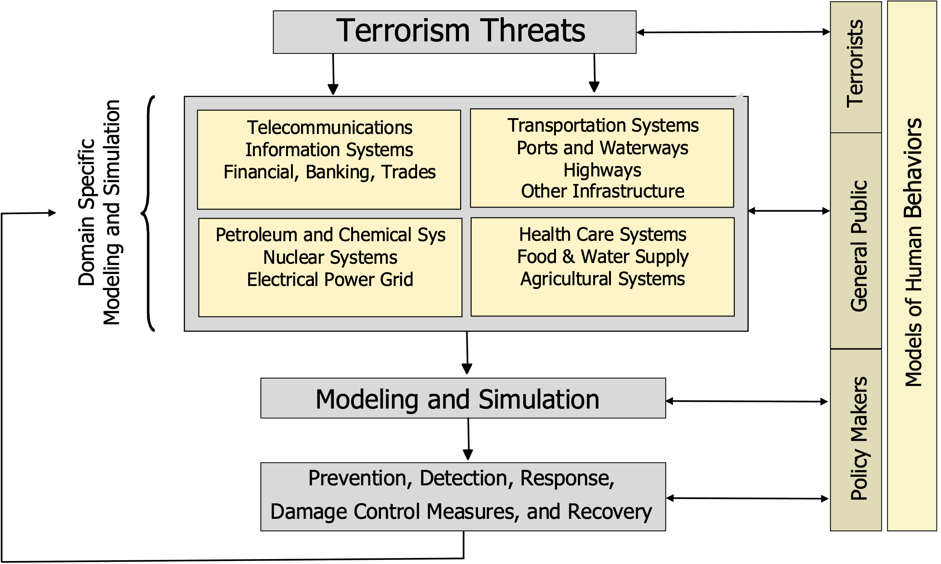
The Texas A&M University System is a major player in all aspects of homeland security, law enforcement, and emergency response. The lead agency within the System is one of its member agencies, the Texas A&M Engineering Extension Service (TEEX). This agency works closely with the Texas A&M Engineering Experiment Station (TEES) where TCAT is located. While TEEX has always been focused on police and firefighter training, a larger commitment was made to homeland security and emergency management following the Oklahoma bombing in 1995. There was a collective effort to understand the role that M&S could play in a landscape with emerging terrorism threats. This early model (see Figure 2) that a group of interested researchers developed provided a holistic view of how M&S could most effectively be used. This model is abstract but did an adequate job of framing emergent opportunities.

Command and Control and Decision-Making

Whether managing a small event or a large-scale incident, informed and efficient decision-making is a critical component to ensure successful emergency response operations. Decision-making relates to the process of choosing the appropriate course of action that is most likely to achieve a predefined objective (or set of objectives) given the available information relevant to the decision being made. In many cases, this information may come from a variety of disparate sources. Having this information timely displayed in a common integrated picture in an understandable and usable form at the appropriate time allows for better and more informed decision-making in a more expedient manner.

It is important to note that the decision-making process is greatly impacted by the amount of time available to make the decision. Time affects such variables as the number of courses of action that can be considered, the amount of information used to select a course of action, and the selection of analytical methods to support the evaluation of identified courses of action.

The simplest (and probably the first) command and control process model is simply Sense, Decide, Act . Sense represents the gathering of relevant information in the environment. This gathering of information includes both electronic means and human reporting. Decide refers to the actual decision-making process which results from the selection of the best course of action to take in order to accomplish the desired objective(s). Implicit in the decide node is an evaluation of the available information to determine its credibility, significance, and correlation into a situational picture. Finally, act is the issuance of directives and the subsequent actions taken by the emergency response personnel to execute the decision. This is an iterative process. Once a decision is acted upon, changes in the environment are likely to have occurred, either resulting from the decision or just naturally changing. The impact of decisions on the environment is sensed again and the process is repeated until the desired end state is reached. All changes in the environment are not based on the decision-maker’s actions, so sensing continues even if no actions have been taken.

An extension of this model is referred to as the Boyd’s OODA Loop – Observe, Orient, Decide, Act. This particular model is especially important in emergency management (and in military operations) because of the explicit call-out to Orient. Emergency management teams often dispatch teams (police, fire, medical, etc.) immediately based on the early information being reported. For example, a report may indicate that an apartment building is on fire. The dispatcher will ask some pertinent questions regarding the extent of flames that can be seen or if just smoke is present, if so, what color is the smoke? Are there any injuries? The answer to such questions formulates the size of the initial response. Once these teams are on the scene, they perform a “size-up” and provide additional details back to the incident command post to assemble a more tailored collection of responders and equipment suited to the overall scope and risk associated with the incident.

Because of the simplicity of the above command and control process models, it is obvious that each of the nodes is quite abstract and that there are other implicit processes taking place within each node. One of the most well-known command and control process models was defined by providing further details to the simple models described above. Dr. Joel S. Lawson, a researcher from what was then called the Naval Electronic Systems Command, further extended these models to five basic functions (Sense, Process, Compare, Decide, Act) and highlighted the interfaces to the environment external to the command center (Lawson, 1980). The Sense function is as before – the use of all available means to extract data from the environment. Process refers to the attempts to extract meaning from the data gathered. At this stage, data gathered from the environment is combined with external data such as intelligence analyses. The Process function should produce event and status reports for use by later functions. The Compare function is used to measure existing differences the between the environment (as determined by reports from the Process function) and some desired state. The purpose of the Decide function is to make a determination of how the actual state of the environment can be influenced or moved to the desired state. Again, the Act function represents the execution of the resulting decision from the previous Decide function.

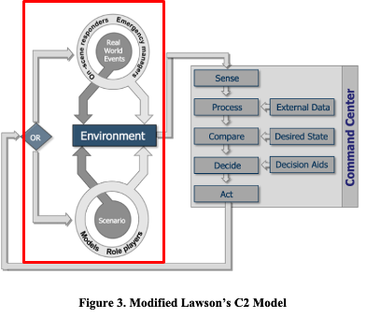
Lawson’s original C² model provides a valuable framework for the construction of a training environment for supporting the decision-making process for emergency managers. A modified version of Lawson’s command and control model (see the highlighted area in Figure 3) shows how real world and simulated feeds can be separately managed to allow the operational environment to be extended to support training environment. Operational environments involve emergency managers and on-scene responders being driven by real world events. Training environments involve the emergency managers and responders being trained driven by a simulation running a scenario that stresses the intended learning objectives. This is often referred to as simulation for stimulation.

Further, Lawson’s C² model can be used as the framework to discuss opportunities for the use of simulation and other decision aids during incident management. The Sense function represents opportunities to model and simulate information gathering processes and to aid in the allocation of constrained information gathering resources (e.g., sensors, on-scene personnel, etc.). How databases are built, maintained, integrated, and accessed to provide both environmental and external data to support the use of simulation and other decision aids throughout the entire C² cycle is especially important during the Process function. By its nature the use of simulation supports a what if approach to comparing (Compare) some desired state to results based on changing values for environmental variables. Perhaps the greatest payoff in using simulation and other decision aids is during the Decide function. Decision aids are explicitly shown in Lawson’s C² model.

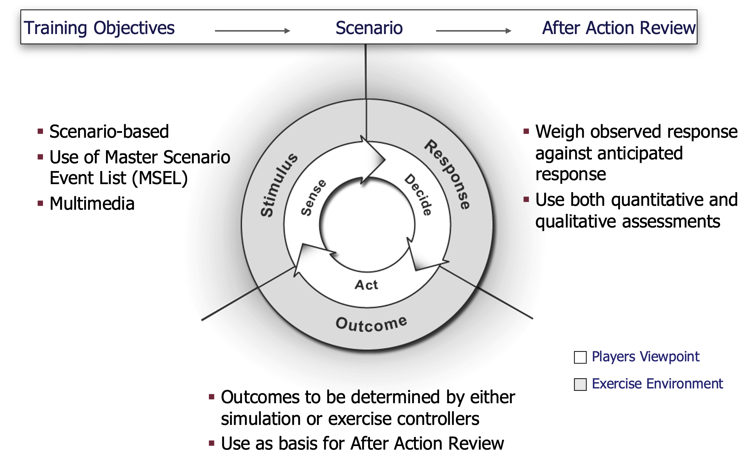
As we now consider the case for how to use this model for a training simulation supported exercise, refer back to the simpler model (Sense, Decide, Act). As stated previously, when training it is important to establish a set of training goals or objectives to accomplish the desired outcome. It is also important to conduct an After Action Review (AAR) following the training event to extend the learning opportunity based upon the challenges encountered during the training exercise and to assess strengths and weaknesses that will likely influence future scenarios and training objectives. We can now see in Figure 4 that while the training audience is working within the model, the trainers are synchronously applying the stimuli that must be sensed and evaluating the response that the training audience decided upon. Finally, the outcome (change to the environment) is assessed once the training audience has acted.

The trainers/controllers are responsible for providing the stimuli by way of the scenario expressed in the form of a Master Scenario Event List (MSEL) and multimedia products. In order to assess the response, trainers/controllers weigh observed responses against anticipated ones using both quantitative and qualitative assessments. Finally, the outcomes are determined by either the simulation itself or exercise controllers. This provides a basis for the AAR.

This discussion provided the basis for engaging the Texas A&M Engineering Extension Service to fund the development of a simulation environment called Emergency Operation Center (EOTC) Simulation which later became the Emergency Management Exercise System (EMES). The decision was made to build an operational C² system and integrate the necessary simulation components to use the system for training.

In the timeframe that EMES was developed, there was very little use of simulation for training emergency management, especially when compared to the advanced simulations that were being used in the military with great return on investment. In other words, the military made large investments in developing powerful simulations that were used in large training exercises that integrated live, virtual, and constructive simulations. This followed many years of large investments in digital transformation and advanced command and control environments. There has been significant effort and expenditure in the last few years to integrate these operational systems and the simulation environments.

During this period, the emergency management and responder community were not heavy users of simulations and had modest command and control systems. Much of this can be attributed to modest budgets and many jurisdictions with diverse needs. Because of the large disparity in experience with command and control systems and simulation within the military, it was not possible to fully transfer this technology over to the emergency management community. First, the evolutionary development process imparted knowledge to military users of this technology along the way. This could not easily be laterally moved to the emergency management community without great disruption. Secondly, there are similarities in both environments, but also many differences. The emergency management and response community must have a system that meets their own needs and requirements. Lastly, there are many competing requirements among the many jurisdictions and funding is diluted across these many geographically diverse jurisdictions. However, their limited investment thus far offers an opportunity based on the transfer of select capabilities that have been previously developed and the ability to spend funding for building a command and control system that can also be used as a training system. This has tremendous potential for reducing the overall costs of both systems over being built independently. This can be addressed by establishing the appropriate set of requirements.

EMERGENCY MANAGEMENT EXERCISE SYSTEM (EMES)

The above approach was taken in developing what was to become the Emergency Management Exercise System (EMES) that was built by this author’s team for TEEX whose employees provided much of the domain expertise. This system was ultimately built as a training system but could easily be adapted for operational use. The program was later funded by the Department of Homeland Security after the 9/11 attack on the World Trade Center. There was an increased emphasis on command and control and establishing standards at the national level so multiple jurisdictions could respond to large-scale emergencies.

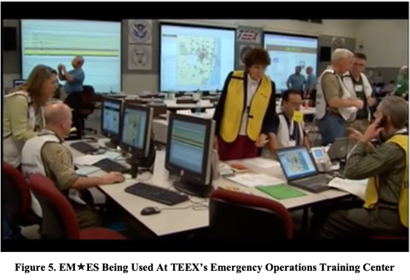
TEEX established an Enhanced Incident Management/Unified Command for All Hazards course based on the National Incident Management System (NIMS) and the National Response Framework (NRF) and is certified by the Department of Homeland Security/Federal Emergency Management Agency (DHS/FEMA) National Training and Education Division. EMES was developed to provide support for this four day course. TEEX developed a state of the art simulation center that has a NIMS-compliant Emergency Operation Center (EOC) with the five cells (Command, Operations, Planning, Logistics, and Finance & Administration) detailed in the NIMS documentation (see Figure 5). The EOC has multiple large screen displays, workstations, and dispersed microphones throughout the EOC to capture conversations as the teams collaborate. All decisions and actions are captured to support the AAR.

While many of the methods and techniques used in existing military simulations are applicable, the experience of working closely with emergency responders from across the nation led us to believe that a new foundational design was needed to support the emergency responders’ training requirements. However, it should be noted that the military approach to conducting a simulation-based training exercise (white cell for control, green cell for role players, etc.) was proven to be a good fit with little or no modifications. The training is conducted in a manner similar to the U.S. Army’s Mission Command Training Program (MCTP) (formerly Battle Command Training Program (BCTP)) located at Ft. Leavenworth, KS.

The Emergency Management Exercise System (EMES) offers a full command and control system capable of blurring the line between training and operations. EMES provides a common operational picture for emergency management personnel thereby facilitating a higher state of situational awareness for all participants (see Figure 6). EMES includes all the necessary tools for making decisions in complex situations, including a full GIS-based mapping system and various tools for communication, information sharing and resource, geospatial, and temporal management. The system also includes a common scenario authoring capability and exercise recording and playback. It is a fully operationally distributed desktop or web-based application.

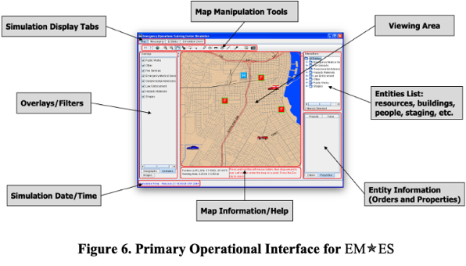
EMES is flexible and has been used to support large-scale distributed exercises, classroom-based instruction, and tabletop exercises. The primary goal of most of the emergency management exercises is to train emergency managers and response personnel to operate within the requirements of NIMS and NRF with participants from multiple jurisdictions, large and small. Participation in an exercise also increases the experience base of emergency response personnel in dealing with major disasters unlike most have seen and hopefully will not see in their careers – creating “virtual veterans” in the process. These exercises also provide a forum for decision-makers to have an appropriate level of feedback from a select group of recognized experts on the decisions that they make.

The two modules that transform the common operational picture (COP) for managing the incident and facilitating the decision-making process are the Scenario Manager and the Data Collection and Analysis Tool. The Scenario Manager (see Figure 7) is where the MSEL is transitioned to a graphical timeline. The events automatically scroll at a pre-determined rate from left to right. As an event passes under a static line representing the current (or simulated time) the event is executed. Events can be turned on or off or dragged in either direction for being triggered either sooner or later. Additionally, events can be launched conditionally.

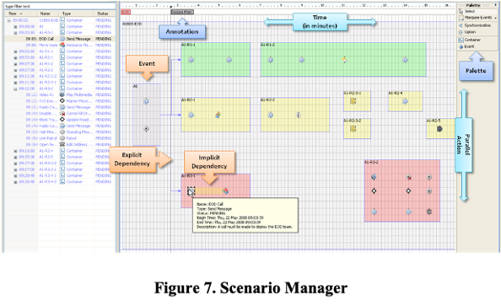
Events are linked for explicit dependency and placed in a container for implicit dependency and may be executed in parallel. Events can be replayed or stored in a library for reuse when designing another scenario. Events provide instructions or state changes to simulated assets or messages to players. There are three types of events:
- Programmed - Those events that are decided upon at runtime and may be the primary shaping function for the scenario being portrayed
- Generated - The events that result from state changes in the model due to decisions or actions taken by the actors or may be triggered by other events of any type
- Invoked - Events that may be introduced at any time by a controller in order to enhance the training value

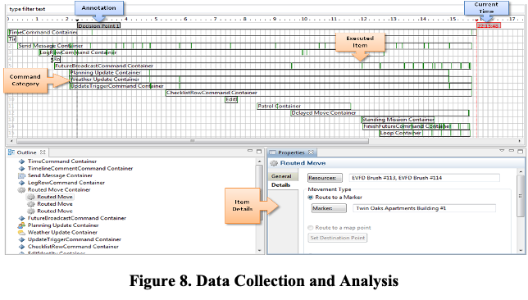
The Data Collection and Analysis Tool (see Figure 8) is used to collect analytical data and document the sequence of events that took place in the scenario and link them to communications occurring among staff members and other sections. By posting these two data streams on common timelines it provides a handy means to quickly assemble an AAR. The primary function of a command post is to assemble data/information, analyze, and decide on an action which is then communicated to on-scene commanders. Therefore, the events that serve as stimuli can easily be linked to the EOC’s communications which represent decisions and actions to be taken. This visual representation and ability to drill down to greater details in the tool supports the AAR process.

Differences Between M&S for Civilian Emergency Responders and the Military

The following three tables (Tables 1, 2, and 3) address organizational and operational comparisons and technical challenges encountered during this project. With the maturation of the NRF and NIMS along with the increased availability of Incident Command System (ICS) training, there have been many improvements. This is especially true when there are large incidents involving federal, state, and local jurisdictions. They now speak a common language and frequently train together. The results have been outstanding.

Table 1. Organizational Comparison

MILITARY | EMERGENCY RESPONDER
- Hierarchical organization emphasizing unity of command (top to bottom) | - Non-uniform structure
- Supported by a common, institutionalized set of policies, procedures and regulations | - Basic unit is the local jurisdiction
- Standardized command and unit structure, doctrine and terminology | - Bottom to top is the protocol flow for most situations
- Service-wide implementation and application of personnel and equipment systems | - Who is in charge = first on the scene
 | - Support is based upon a loose confederation of mutual aid agreements with an assortment of vertical and horizontal relationships with other agencies and jurisdictions
 | - Uneven implementation of higher level guidance & systems (NRF, NIMS, ICS)
 | - Proficiency and training of personnel is not standardized
 | - Equipment systems vary based on discipline preferences and jurisdiction

Table 2. Operational Comparison

MILITARY | EMERGENCY RESPONDER
- Command is positional and uses lawful authority | - Command is directing and ordering based on explicit statutes and regulatory authority
- Combat commanders have authority and responsibility over large forces that span multiple disciplines and functions | - Command is fluid during incident operations and is shared by discipline heads in unified CP’s
- Operation areas are large and can include a combination of land, air, and sea area | - In most cases, the incident area is confined to facilities, buildings or populated urban areas
- Forces are dispersed based upon objectives and tactics | - Emergency units generally can converge from numerous dispersed areas into a very confined incident Area of Operations
- Forces execute plans made before the specific combat segment. Objectives are clearly defined graphically/objectively | - Incidents can range in size from small fires to WMD and can involve complex infrastructure issues and sensitive political factors
- Standardized communications equipment and message formats are used to control and pass information | - Execution is reactive as a norm and is normally without prior alert or warning (incident initiation is “out-of-the-blue”)

Table 3. Technical Challenges

MILITARY | EMERGENCY RESPONDER
- Knowledge acquisition is facilitated by availability of experts with cross domain expertise | - Knowledge acquisition is often difficult due to lack of experts with cross domain expertise
- Simulation and exercises are the norm | - Training and exercises using simulation are not well developed
- Combat vehicles are platforms that primarily shoot and move | - Emergency vehicles & equipment perform more discrete and involved actions (fight fires, shore up collapsed buildings, treat casualties, etc.)
- Detailed CSS (medical & logistics) events are rarely played in high resolution | - Equipment is diverse and has multiple purposes for neutralizing, mitigating, and recovering from the incident effects
- Databases are unit/task organization-based (predictable and logical to load) for friendly and some enemy forces | - Decision making often requires highly detailed information about casualties, hospital beds, utilities, quarantines, public works, etc.
- Subordinate entities are logical and easily aggregated and symbolized | - Equipment and personnel cluster into confined areas and are hard to segregate for on-screen map info displays
- Intelligence actions and opposing force behaviors can be predicted and replicated for two or multi-sided conflict

To date, more than 20,000 civilian and military responders from most, if not all, fifty states and several U.S. territories have been trained using EMES.

COMMAND AND CONTROL ENVIRONMENTS (FERTILE GROUND FOR BLURRING THE LINE BETWEEN OPERATIONS AND TRAINING

Many of the simulation environments being used for training could be used to support military operations with little or no modifications other than changing the input data and directing the output to command and control system displays supported by innovative visual analytics. Along these same lines, large investments have been made in automating much of the AAR process that culminates most training activities. Again, with little or no modifications some of these AAR tools could be used to support military operations. There is no better time to alert a commander that he or she is violating sound tactics, techniques, and procedures than during real military operations where the score is often measured in human lives. As with training simulations, simulations supporting command and control need to be pushed to commanders and their staffs at the lowest levels. Given the early successes with EMES, the TCAT development team decided to focus more on the command and control capabilities and to seek out new opportunities.

User-defined Operational Picture (UDOP)

Incident management requires the careful coordination of decisions across jurisdictions, functional agencies, and sectors. The National Incident Management System (NIMS) provides a comprehensive approach to incident management that is capable of supporting incidents of different types, sizes, locales, and complexities [FEMA, 2017]. It provides standardization across jurisdictional levels (i.e., local, state, and federal), and across different operational domains. It helps to define a template for response operations by defining the roles, responsibilities, and processes to use while managing an incident. Finally, it is a dynamic and scalable system that can grow or shrink to support a particular incident.

Whether a responder is on-scene supporting the incident firsthand, managing it remotely from an incident command post (ICP) or emergency operations center (EOC), or monitoring it from a federal agency, an individual needs access to timely, accurate, and understandable information to support their situational awareness and decision-making processes. A user-defined operating picture (UDOP) is one such tool that can provide these capabilities. A UDOP is an extension to the standardized concept of a common operating picture (COP). A COP is defined as single integrated display of information, shared across decision-makers in an identical fashion that can be used to support the planning, execution, and analysis of a mission. The idea of a COP has been used routinely within the Department of Defense, the Department of Homeland Security, and other agencies where decision-making is key aspect of day-to-day operations (Steen-Tveit, 2020).

A UDOP provides many of the same capabilities as a COP, with one major difference. A COP provides a standardized interface where all decision makers are looking at the same underlying picture (i.e., all seeing the exact same thing) (Mulgund and Landsman, 2007). In many environments where the decision-making responsibilities may be quite different depending on the individual (i.e., a NIMS compliant command center), a COP can fail to provide all the information and tools required by a particular decision-maker. Thus, the concept of a UDOP was developed. A UDOP provides the decision-maker with a customizable display where he or she can pick and choose the information and tools they need to support his or her decision-making requirements. Thus, a user in a Planning section can setup their respective display, while a user in Admin/Finance section can develop their own customized display that may be very different. The overall concept of a UDOP allows for a more focused and relevant tool to support the operation at hand.

A UDOP as defined within this work goes one step further. While the tool must be customizable to the decision maker’s needs, it also needs to be customizable to fit the mission at hand. For example, the information and tools necessary to manage a response to an oil spill may be quite different from those needed to plan and prepare for a ship that has been lost at sea due to a power failure. Likewise, the tools required to monitor an incident at a local level may be quite different from those at a national level. Finally, the tool should be able to support not only operations, but also training and analysis-based missions. Through supporting these different aspects, the overall UDOP tool can be flexible, scalable, and re-configurable to support almost any mission at hand.

One underlying principal of the UDOP approach to supported decision-making is the identification and access to authoritative data sources. The use of authoritative data sources is key to synchronizing the decision-making process with respect to all decisions being rooted in common data sources. In fact, this ensures that all decision-makers can converge on a COP (all decision makers seeing the same perspective) if common data is accessed. Another fundamental of establishing a UDOP is an in-depth understanding of data needs and the value of the actual data being accessed. Data needs are developed once the types of decisions that are going to be made are defined. Further, the needs are the basis for establishing requirements. These requirements are then used to assess data sites for consideration as authoritative data sources. A number of considerations (expressed as requirements) must be evaluated to determine the value of the data (e.g., source, relevancy, resolution, rate of sampling, age of data, classification, etc.). These items are to be included as metadata.

Service-Oriented Architecture (SOA)

The underlying architecture chosen to support implementation of the Information Dashboard Framework (IDF) was that of a service-oriented architecture. This is a transformational architecture that supports remote services such as data, applications, sensors, or other information dashboards that can be accessed in the “cloud.” SOA is a methodology for designing and developing software in the form of interoperable services. SOA has evolved from the area of distributed computing and builds on the idea of grid computing and synchronous/asynchronous software development (Erl, 2005). SOA attempts to loosen software coupling through decomposition, with the goal of making software less rigid and stove piped. SOA builds on the concepts of reusable software components, while abstracting focused functionality behind different software services.

Services are typically developed as loosely coupled modules of functionality that encompass business logic and function. SOA supports data as a service (i.e., publishing and collecting), software as a service (i.e., computation), and service composition (i.e., mashups). End-user applications can be developed composing of one or more of these services, thereby abstracting away the low-level details of the function the service provides. In general, services should perform their task in a standard way without the application having to know anything about the implementation details behind what the service provides. Thus, services allow for protection of proprietary algorithms and data through this hiding approach. The end-user client only needs to understand the details of interface that the service offers (i.e., the inputs and outputs). Finally, services can be used and accessed from different software platforms (i.e., Windows, Unix, etc.) and from different physical devices (i.e., desktops, mobile devices, etc.). When developing SOA-based applications there are several underlying design goals . Services should be:
- Interoperable  - Language agnostic  - Reusable  - Independent | - Stateless  - Autonomous  - Published clear contract
Web-based services are the basis of cloud computing and are heavily used in today’s world. The World Wide Web Consortium (W3C) defines a web-based service as, “a software system designed to support interoperable machine-to-machine interaction over a network” [Booth and Haas, 2004]. When developing a service there are four main elements that include the service provider, service consumer, an optional service broker, and a protocol (along with its supported data format).

Software Development Frameworks

When deciding how to best implement a new system that we were developing to incorporate our new requirements into a working system, we chose to use a software development framework. Frameworks can support the systems engineering process by enabling:
- Modularity and reuse  - Anticipation of change  - Abstraction  - Low coupling | - High cohesion  - Reduction in development time  - Enforcement of standards  - Reduced maintenance costs
One result is the rapid development of prototypes for discovering new requirements or validating existing ones. Another result is the rapid development of tools that can be easily configured to support custom applications.

Two examples of the successful use of software development frameworks are:
- Information Dashboard Framework (IDF)
  - Supports development of user-defined common operating pictures (UDOP) for sponsors such as DoD, DHS, and USDA
  - Uses a service-oriented architecture
  - Supports use of prototype-driven requirements as opposed to requirements-driven prototypes

- Process-oriented Data Visualization Framework (ProDV)
  - Enforces process in the use of visual analytics for large data sets for sponsors such as the U.S. Army Operational Test Command, the Army’s intelligence community, and DoD’s Joint Electronic Warfare Center
  - Supports a graphical interface and visual (dataflow) programming
  - Focuses on the development of data visualizations as opposed to the data manipulation preceding the development of data visualizations

The IDF allows for seamless information exchange across multiple focus areas (e.g., emergency management, business continuity, laboratory capacity, enhanced passive surveillance) while the addition of the ProDV tool extends the overall capability further by providing increased visualization. Since both were developed by the Texas Center for Applied Technology, they are complementary tools, and the additional functionality of combining the components is critically important to improving the communication effectiveness of information being displayed.

ProDV is being used to develop information graphics for enhanced visualization and analysis of complex data. Currently, information is fragmented in multiple systems, and ProDV is leveraging the power of data/information aggregation, fusion, and presentation. Through the incorporation of these two frameworks, situational awareness is being improved by promoting vertical and horizontal information sharing in a manner demonstrated in other highly dynamic decision-making environments such as the military and emergency responder communities, thereby allowing for better and faster decision-making. Both IDF and ProDV are domain independent technology frameworks that are actively being used by several different customers to support a wide variety of applications. Further details about these two frameworks and their use are discussed below.

INFORMATION DASHBOARD FRAMEWORK (IDF)

The Information Dashboard Framework (IDF) (See Figure 9) was developed to support the construction of user-defined operational pictures and to provide situational awareness and to enable sensemaking. The ultimate goal was to shorten the decision cycle and to improve the decisions being made. These common integrated displays are composable and customizable based upon the set of included “pluggable” dashboard components (which are hot-swappable while the system is in use). The components represent both access and function. The architecture is comprised of the following:
- Presentation Layer – Implemented as a thin client and can be used on mobile devices. This is the common integrated display where the components can be arranged and linked to services via an editor.
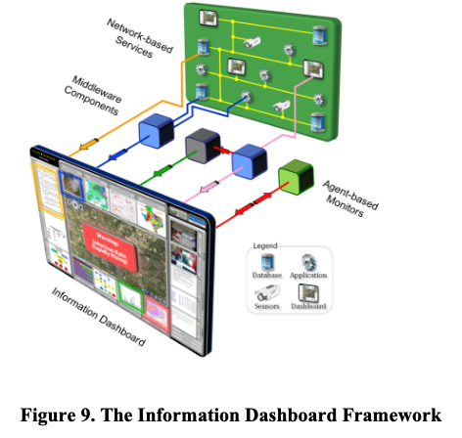
- Middleware Layer – This layer contains software models that can result in a direct presentation from a service, transformation and presentation from two or more services, or data routing from one service to another before presentation.
- Network-based Services – Network services include databases, applications (esp. models and simulations), sensors, and other dashboards. Data can be either accessed or streamed.
- Agent-based Monitors – Cautions, alerts, and warnings are reported based on defined conditions or threshold values.

The IDF is analogous to a traditional hardware backplane that has circuit boards plugged in to achieve its objective functionality. It is a “software” backplane that achieves its objective functionality based upon a collection of diverse software components.

The IDF is comprised of a core set of functional capabilities that be used to support many different domains depending upon the availability of components in the library. The core capabilities include the following:
- Specification of dashboard components, views, parameters, and source data formats
- Data and Visual analytics (including animation based on timelines)
- Data aggregation and grouping
- Information searching and filtering
- Information synthesis
- Alerting and notifications
- Plug-ability of new component views and composition engines
- Management of component parameters
- Security of data
- Access control

There a Service Interface and a Dashboard Interface. The Service Interface accepts data from a network-based service or a middleware component. The Dashboard Component feeds transformed data to the common integrated display or to another middleware component. Components can be maintained in a library for reuse. Typical library categories are shown in Figure 10. It also important to note that a component may perform a task that directly involves the display. A perspective is a collection of active dashboard components to support a particular mission or activity. Different perspectives can be defined and stored for access depending upon the role of the user. Perspectives may be defined for operations, training or analysis. Profile is generally used to describe a collection defined roles a user plays. A profile would be represented by a collection of perspectives. However, all of these collections and assignments can be changed at any time.

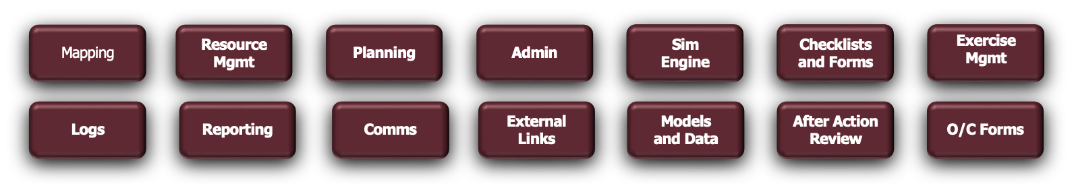
Figure 10. Component Categories

Development of the IDF was being developed in parallel to an application called the Dynamic Preparedness System that was funded by the Department of Homeland Security through the Foreign Animal and Zoonotic Disease Center (a DHS Center of Excellence). The focus was on building a common integrated display for managing a foreign animal disease outbreak. Shortly after this work began, there was a global H1N1 flu pandemic in 2009. There was congressional mandate for DHS to develop a COP. The FAZD Center contracted TCAT to use the IDF platform to create the Bio-surveillance Common Operating Picture (BCOP) for the DHS.

The requirements were derived from DHS and FAZD experts and the system was storyboarded in real-time with DHS participation in a DHS conference room. The BCOP enabled the DHS National Bio-surveillance Integration Center to track, organize and share information about outbreaks of contagious diseases daily from around the world. The BCOP was fully customizable by the user. This allowed DHS to disseminate this information more rapidly and prepare a response to outbreaks that may threaten the United States. FAZD Center researchers built, tested and launched the BCOP in weeks rather than months as originally scheduled! The DHS Science and Technology Directorate recognized the contributions of the BCOP to national biosecurity with its 2010 DHS Science and Technology Impact Award.

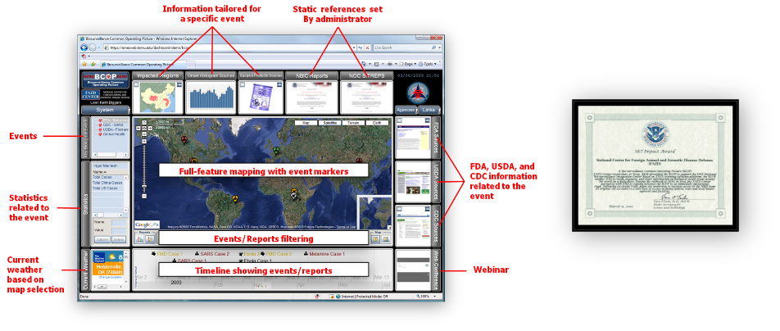
Figure 11. The Bio-Surveillance Common Operating Picture (BCOP)

Another interesting application using the IDF was the Coast Guard Display System (CGDS) (see Figure 12) that was built to support an exercise for the Coast Guard’s Joint Harbor Operations Center (JHOC) located on the Puget Sound in Seattle, Washington. The exercise involved more than 70 watercraft and more than 300 personnel. CGDS provided a COP and the system was distributed at multiple locations including with Coast Guard personnel on their boats. The Coast Guard’s “Planning P” was used to synchronize all planning for the operation. Some of the information included on the CDGS included nautical maps, real-time tracking of ships and smaller watercraft, weather conditions, live streaming of cameras around Puget Sound and hand-held cameras used when boarding a watercraft, marking of watercraft that had been searched, and access to remote plume models and population data.

The exercise itself was focused on locating a watercraft that was bringing in a nuclear device which involved boarding watercraft, conducting a search, and capturing video in some cases. Each watercraft in the area of operations had to be inspected and marked as cleared. This information was continuously being updated and distributed to all the Coast Guard participants. Once the watercraft was identified with the nuclear device, it had to be taken to a safe harbor which would create the least amount of destruction and casualties should something go wrong. Ordinarily, this would be a time-consuming event given the area has many coves and harbors where the offending watercraft could be taken for disarming or neutralizing the nuclear device. The ability for the CGDS to have components that could pass local data to remote models which could then combine the results with another model made this a relatively easy task that allowed a number of sites to be evaluated in a short time span. In this case local parameters were sent to a remote plume model (the ALOHA Model) which in turn was combined with population data from another site to produce a prediction on how many casualties (deaths, hospitalizations, etc.) could be expected at a given location (see Figure 13).

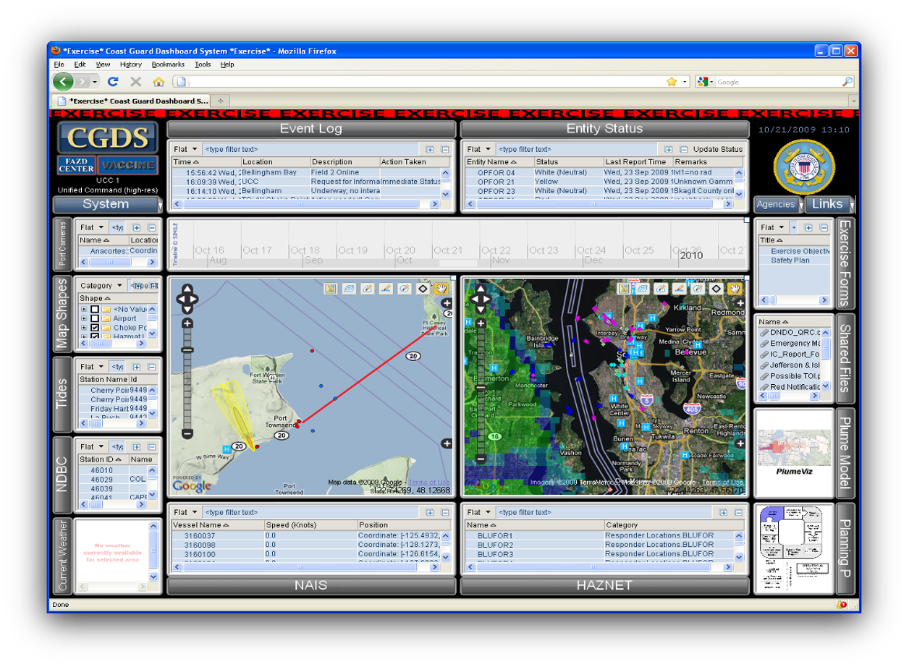
Figure 12. The Coast Guard Display System

This proved to be so easy that the JHOC Commander quickly evaluated numerous sites and chose the best site to tow the watercraft with the nuclear device. Because the Commander was so intrigued by this capability, the planning cell was initially bypassed. This was not the intent of how CGDS would be used but is a good example of how the introduction of new technology must be assessed for how it may impact current doctrine or policies.

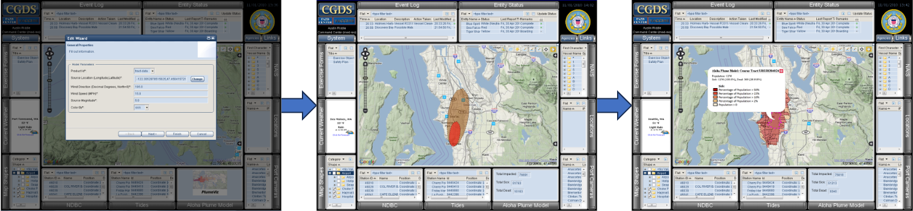

Figure 13. Accessing Models and Data from Multiple Sites to Locate the Best Safe Harbor

CGDS was used at a later time for an exercise focused on managing protesters that were on the water and trying to interfere with the loading of military equipment on roll-on/roll-off (RORO) ships. This particular scenario is important to the area given the sensitivity of delays in deploying military equipment to a troubled region of the world.

The Electromagnetic Battle Manager (EMBM) used the IDF to demonstrate an interactive and flexible data visualization and analysis workstation display prototype specifically tailored to the tasks of electronic warfare (EW). The framework and tools used were non-proprietary and demonstrated novel approaches to supporting EW plans development, analysis, and associated administrative functions. Concepts considered included web-based modular components, which when aggregated together, formed an intuitive and interoperable analytical dashboard for the management and visualization of EW functions. As it turns out, the sponsor in this developmental effort is a rigorous user of many analytical models throughout its operations including reach back during execution of a plan. A number of these models were integrated into EMBM with new visualization techniques to strengthen the outputs. Six general core capability areas were used to focus development of individual EMBM dashboard component functional capabilities. These six core capabilities are defined as:
- Visualizations - New and existing visualizations designed to enhance understanding, analysis and management of complex EMBM related information
- Analytical Tools - Capabilities for improved analysis and integration of disparate information that function in both a manual and automated fashion, and allow for increased collaboration of distributed decision-making
  - Supports both situational and predictive analysis while analyzing second and third order effects of actions
- Information Management and Sharing - Enhanced tools for better managing and sharing of information
  - Provides easier asset management, dynamic tracking, evaluation and resolution of issues
  - Supports collective intelligence and management of large volumes of information
- Automated Agent Support - Agent-based software for customized and intelligent decision support
  - Supports reactive feedback during mission planning and automated analysis of effectiveness for assets in use.
  - Provides intelligent information filtering and correlation for different users and echelons
- Decision Aids, Forms, and References - Quick and ready access to information for faster decision making
  - Provide tools for synchronization between distributed decision makers and offers real-time access to key forms and documents relevant to the current context
  - Delivers quick look up to online knowledge repositories
- Custom Reporting - Allows for the result of an assessment, planning or execution to be directly fed into a transportable report or presentation for external usage

The developed framework and conceptual tools (implemented as dashboard components) are configurable and provide menus to select primary, secondary and administrative modules based on the EW user’s specific role in the Strategic, Operational, Tactical and Machine to Machine EW constructs that are required to meet DoD standards (see Figure 14).

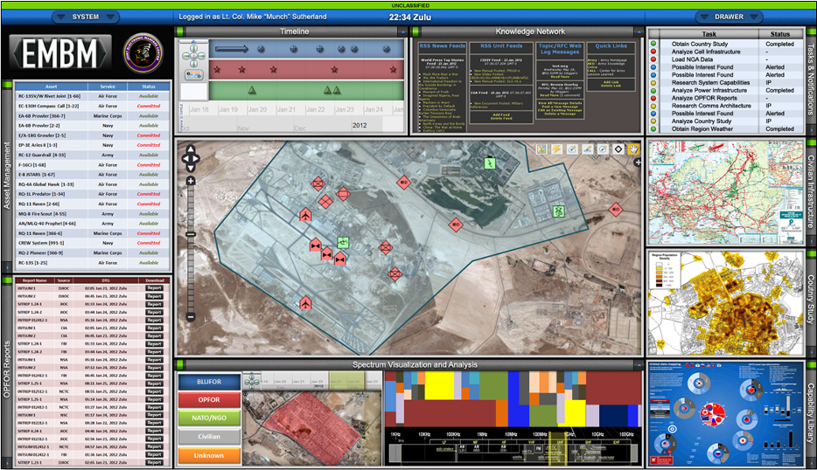

Figure 14. The Electromagnetic Battle Manager

The capabilities of the EMBM prototype was shown by way of an exercise set in a fictitious country overlayed in the Southwestern United States. Four EMBM profiles were developed, as shown in Figure 15 and listed below along with the capabilities/functions represented within EMBM for each profile.

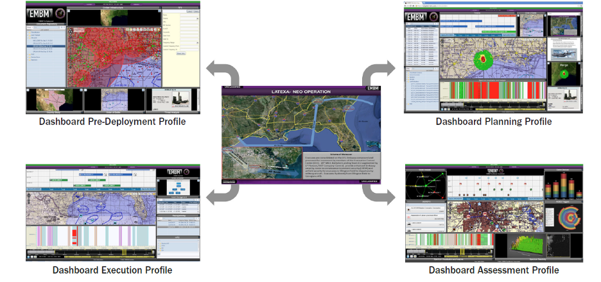

Figure 15. Four Different Profiles of EMBM

- Dashboard Pre-Deployment Profile – support for participants prior to deployment into the theater of operations
  - Consolidation and review of relevant documents
  - Consolidation, review and display of country-related informatics
  - Display of known orders-of-battle
  - Access and review of threat system details
  - Calculation of optimal towers
  - Review of key intelligence
  - Spectrum related course-of-action development
  - Geospatial display of the operational environment
- Dashboard Planning Profile - conduct of complex planning operations during and after deployment into the theater of operations
  - Real-time status of allocated assets
  - Shared repository of relevant planning and operations documents
  - Spectrum Visualization and Analysis capability
  - Review of key intelligence
  - Access and review of threat system details
  - Modeling and simulation reach back analysis capability
  - Ready access to detailed equipment capability information
  - Consolidation of Operational Planning Documents
  - Display of known orders-of-battle
  - Geospatial display of the operational environment
- Dashboard Execution Profile - support participants during the execution phase while deployed into the theater of operations
  - Temporal display of asset deployments
  - Geospatial display of the operational environment
  - Interactive spectrum visualization and analysis capability
  - Electronic messaging capability across functional areas
  - Dynamic hardware reprogramming capability
  - Real-time status of allocated assets
  - Display of known orders-of-battle
- Dashboard Assessment Profile - support participants during the assessment phase of each operation while deployed in theater of operations
  - Dynamic Visualization of Nodal Impacts
  - Tabular display of spectrum event information
  - Interactive spectrum visualization and analysis capability
  - 3D display of spectrum usage behavior over time
  - Graphical display of RCIED trigger usage
  - Graphical display of communication device usage
  - Temporal display of collected event data
  - Geospatial display of event information

The IDF proved to be an important and effective framework for developing solutions to sponsors that needed to assimilate more information from many sources in a timely manner based on feedback from a diverse collection of sponsors. One important part about IDF is the fact that the user can arrange and size the components on their display. While the initial reaction of many was to say the screens were “too busy.” As it turned out, more assimilation took place because of well thought out components were chosen for the task and their arrangement was tailored by the individual user. Therefore, the user knew where to look for information and assimilation was much higher. Figure 16 shows some of the larger and most successful programs that TCAT had using the IDF for a diverse set of customers. To reinforce a previous theme, these displays are data-driven and can be (and have been) used with synthetic data to support training. This training involves the use of the information dashboard itself or the larger context about the crisis/emergency operation/problem being solved or managed.

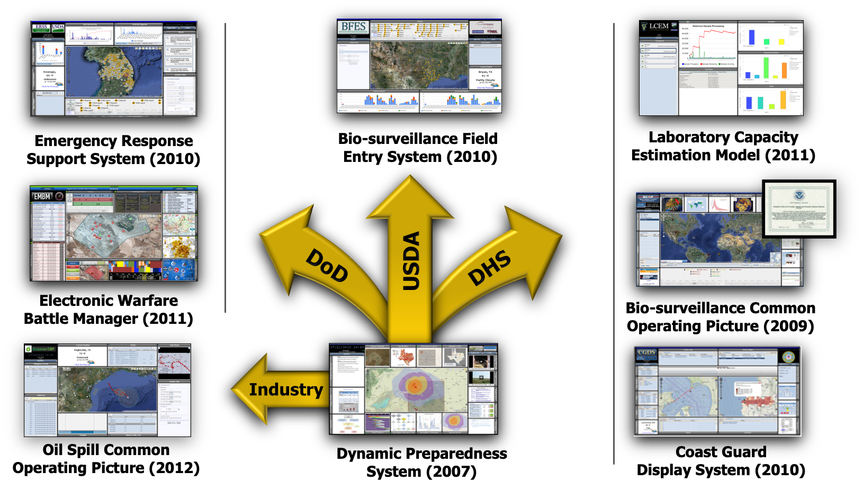

Figure 16. Applications of the IDF

The key to success in building each of the information dashboards (decision support systems) was a thorough front-end analysis with sponsor participation. The necessary steps for conducting the front‐end analysis were as follows:
- Determine an Operational Architecture
  - Obtain an understanding of the current operational environment used (i.e., organizational structure, roles of the various decision‐makers, and the responsibilities of each individual during a management, planning or analysis‐based mission)
  - Identify people (and their roles). policies, and procedures, information flow
  - Identify who talks to whom, by what means, and what information is conveyed for what purpose
  - Determine what decision are being made
  - Conduct Gap Analysis - Technology alone is rarely the total answer, must consider policies, regulations, and training also.
- Establish Information Needs
  - Identify the relationship between Critical Operational Issues (COI), measures of effectiveness (MOE), and measures of performance (MOP) that will focus the development of the decision support system
  - Obtain an understanding of the decisions being made and the necessary information requirements for the different members
  - Gain a familiarization with the existing applications and models used as part of the decision making process, the data sources used to feed these tools, and the gaps across the different platforms
  - Interface with the various owners of these tools, models and data, and establish a process for either obtaining access to or at a minimum representative exported data from each
- Analyze identified information needs
- Analyze current tools and determine their potential effectiveness within this environment
  - Identify key areas for enhancement based on the existing processes, tools and user needs
  - Identify areas where the integration of different sources of data, and the use of different categories of information visualization will improve the decision-making process
- Establish system requirements

Once the requirements are established, development begins. From a developer perspective, as the IDF became mature, more time was focused on building components that plugged into the framework. This greatly expedited the development process.

PROCESS-ORIENTED DATA VISUALIZATION (ProDV)

Contemporary data analysis efforts need support to effectively extract, record, and share the information that complex visualization methods can provide. The field of Visual Analytics provides guidelines for developing applications which can be used to both detect the expected and discover the unexpected in very large datasets. “Visual Analytics is the science of analytical reasoning facilitated by interactive visual interfaces. People use visual analytics tools and techniques to synthesize information and derive insight from massive, dynamic, ambiguous, and often conflicting data; detect the expected and discover the unexpected; provide timely, defensible, and understandable assessments; and communicate assessment effectively for action” (Thomas and Cook, 2005). This involves harnessing the power of human visual processing to quickly identify anomalous features hidden within massive volumes of data.

ProDV is a flexible data processing and visualization software environment that allows the user to import, transform, reduce, and visually explore data from any electronic data source. It is designed to be extensible in that developers can continually add new capabilities to the framework as required. The primary components that make up the ProDV framework are shown in Figure 17. By configuring and connecting components within ProDV’s easy-to-use drag-and-drop interface, you can create custom interactive data visualizations that will allow you to explore and analyze data from multiple sources. The interactive visualizations you create will allow you to both “detect the expected and discover the unexpected” [Thomas and Cook, 2005] in your data.

Generation of interactive visualizations from large datasets and collaborative analysis of these visualizations across can occur among multiple users. This framework allows for data importing, processing, and definition of visualizations using a visual programming interface. Caching of processed data allows for quick multi-resolution navigation through a dataset. Using both standard and custom information visualization techniques, along with user interactive displays, allow a user to quickly understand and assess data, thereby allowing them to detect expected behavior and discover any unexpected anomalies. ProDV provides alternative visualization methods that will represent data interactions and highlight correlations that are important to both situational awareness and risk management (assessment and mitigation).

The framework is composed of five different components. These are the data sources, data operators, processing modules, cached data, and visualizations as the primary objects in our abstraction of the visualization process. In terms of the visualization reference model, the framework divides the workspaces where transformations are conducted. Only data transformations and visual mappings are manipulated while interacting with framework components, while only view transformations can be manipulated from within the visualization environment. The components are further explained below:
- Data sources provide tuple records (records with multiple typed fields) from a variety of different sources. SQL databases, structured text files, and local database files (like Microsoft Access) are common examples; however, data sources can be defined from more custom data formats as well. For example, Raster Product Format (RPF) data, which provides standardized geo-rectified raster data, can also be used to provide tile data as records.
- Data operators perform common data transformation or simple data aggregation tasks. Operators can represent simple data casting operations (e.g., parsing text as an integer), or be more complex such as a multiplexor or look-up-table that has an internal data structure.
- Processing modules encapsulate algorithms that generate reduced intermediate data structures from input data. Examples include simple numerical computations such as summation, statistical analysis, or multi-pass clustering algorithms. Many of our current processing modules perform and store computations at multiple resolutions, so that visualization controls can allow users to quickly change scale for different analysis tasks. Any of these objects can also define any number of user parameters.
- The Cache contains intermediate data that enables performance improvements when working with large-remote datasets and when performing collaborative analysis. The cached intermediate data is a strength of this framework architecture.
- A selection of Interactive Visualizations makes up the final component of the framework. Each visualization defines a unique rendering method designed to be viewed in a standalone window. Several visualizations can be used to create multiple coordinated view (MCV) layouts, as is common in visual analytics applications. Each visualization must define its own generic routine for building a render cache containing all the data needed to render the current view. Each visualization can contribute multiple view mappings that define how its render cache can be assembled from the data structures created by processing modules. This architecture loosens the coupling between the processed data and the rendering algorithms, giving greater flexibility in the design of each. It is also worth noting that the visualization can accommodate custom visualizations and streaming data.

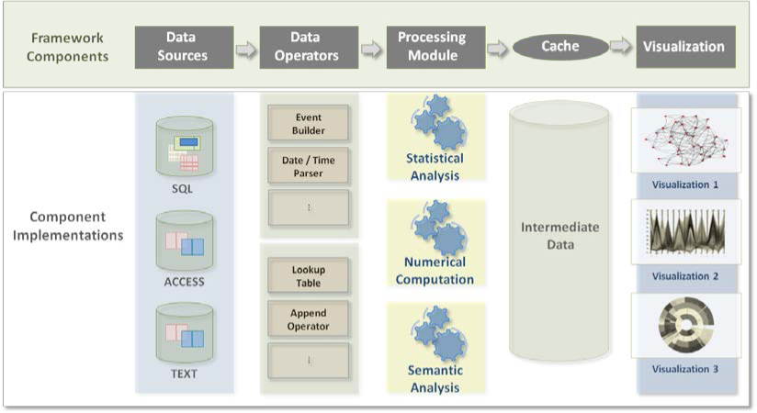

Figure 17. ProDV Framework

ProDV’s “drag-and-drop” visual programming interface (see Figure 18) is used to simplify the use of complex visualization and analysis algorithms. Data type errors are highlighted to help users build valid dataflow “products” within ProDV. Each dataflow product defines an interactive visualization application, customized to facilitate visual analysis of user data. Dataflow shown depicts two days of network data appended and linked to a protocol look-up table. Two distinct processing modules are used, each connected to two visualizations (4 total visualizations).

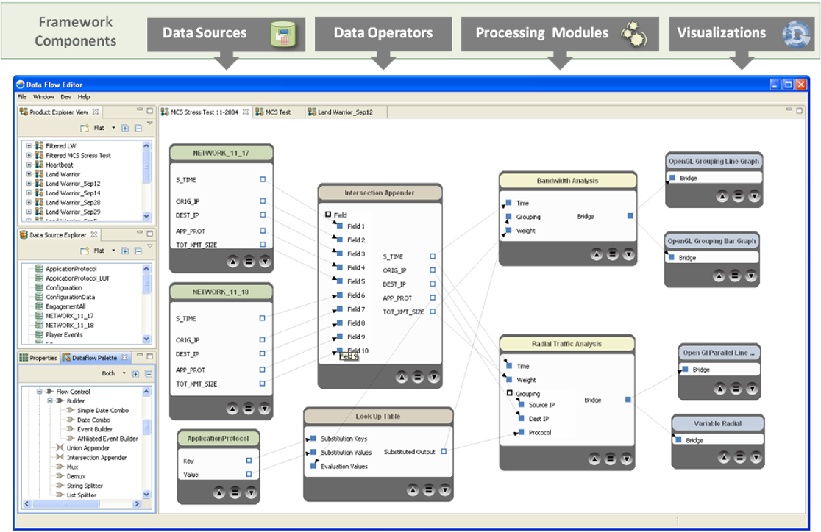

Figure 18. ProDV’s Visual Programming Interface

Two examples of visualizations produced from ProDV are shown below. The first is a Frequency Analysis Visualization (see Figure 19) that was used to assess the status of instrumentation on-board vehicles that were being tested. The bumper numbers of the vehicles are listed down the left hand side of the chart. The instrumentation’s status was evaluated based on two rules. The first rule that the instrumentation would transmit a “heartbeat” signal every five minutes to show it was operational. The second rule was to immediately transmit a signal if the vehicle was changing location. The graph depicts the time periods between position reports using colored triangles. Regular and irregular frequency patterns can be easily identified within large datasets. Patterns and out-of-threshold features are highlighted well by this method. Red areas indicate threshold violations (period is longer than the five minutes expected), and rectangular block regions indicate a high density of reports, caused by vehicle movement. Block areas replace sequences of triangles with sub-pixel width. If a rectangle is formed the vehicle is likely in an administrative move (e.g., a road march). Small triangles that are very close together represent slow movement as would be seen during tactical movement. Note red features on the left were caused by vehicles rebooting at the beginning of the exercise, and synchronized vehicle movement can be seen on the right.

Figure 20 is a collection of charts supporting Geospatial Analysis of a position reporting system. There is a Frequency Analysis Plot that shows changes in reporting pattern as entities are animated on the map. The line graph depicts the volume of report traffic generated by each entity in the exercise. The map display projects the reported location versus the actual location of the vehicles. There is a red cursor line through the charts that synchronously shows the time at which a data element was collected as it indexes different parts of the visualizations.

ProDV was originally developed as a desktop application that allows analysts to interactive work with the processing engine and visualization. However, ProDV was extended to support a SOA-based architecture. This extension allows for both data processing as a service and data visualization as a service. ProDV was used to build many of the graphical elements in the information dashboards shown earlier in this paper.

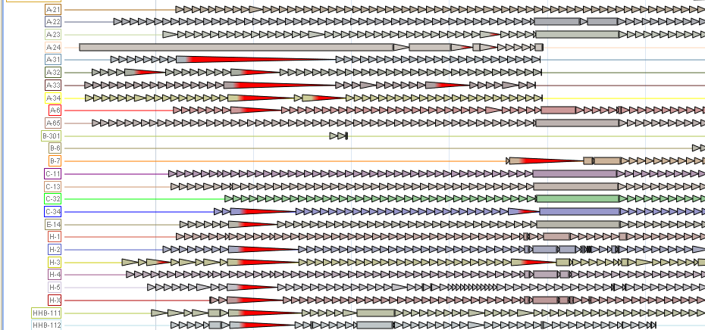

Figure 19. Frequency Analysis Visualization (A Custom Graphic)

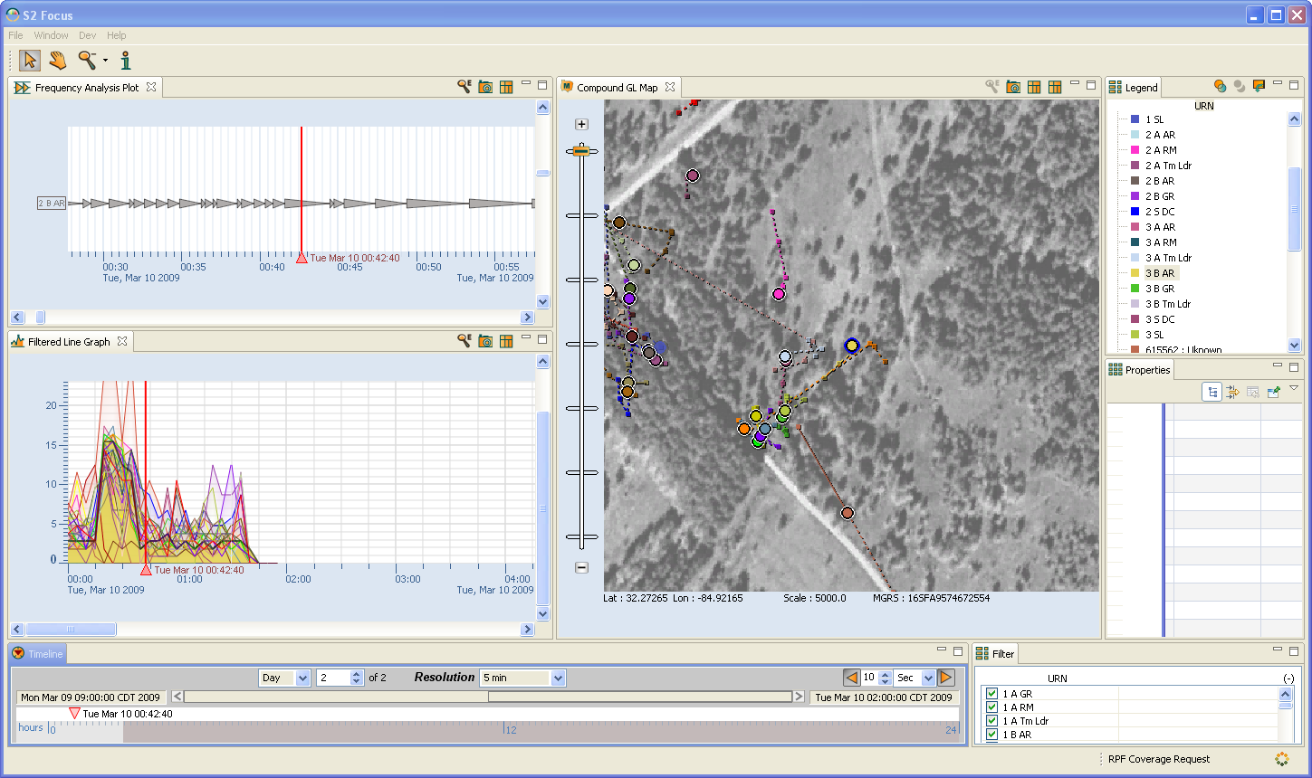

Figure 20. Geospatial Analysis

DISASTER RELIEF AND EMERGENCY MEDICAL SERVICES (DREAMSTM) AND DIGITAL EMS

The DREAMS™ program was a congressionally funded collaborative research initiative involving The Texas A&M University System and the University of Texas Health Science Center in Houston. The U.S. Army Medical Research and Materiel Command at Fort Detrick, Maryland, was responsible for program oversight. The DREAMS™ program was comprised of three related research areas: basic and clinical sciences; biological and chemical detection, identification, and remediation; and the Digital EMS vehicle. The Digital EMS vehicle represented the body of research centered on providing high quality video and physiological data links between an ambulance and the hospital, especially in rural areas. The objective was to create the virtual presence of a physician in the ambulance to allow higher or more sophisticated levels of treatment in severe trauma cases to begin earlier. The desired result was a decrease in the mortality rate due to trauma or an increase in the long-term quality of life in the most severe cases.

The Digital EMS Ambulance

The Digital EMS segment of the DREAMS™ project was a two-fold effort for revolutionizing trauma level care at a either a mobile or a remote site without a physician present. The first goal of this effort was to create a system which allows a physician at a trauma facility to create a virtual presence in an emergency vehicle for assisting emergency personnel during trauma level emergencies. These include cases in which emergency personnel do not have the expertise or training for dealing with the current situation or the authority. These situations involve not only typical EMS calls, but could apply to military battlefield operations, NASA space operations, offshore medical care, air EMS, and remote rural hospital care. It is possible to improve patient survivability and reduce morbidity by allowing the physician to telementor on-scene medical professionals and first responders that may be more limited in their knowledge and abilities or not authorized to perform a certain medical intervention.

The system creates a virtual presence at the remote site using multiple wireless and terrestrial communication means by providing high quality video, audio, and data channels capable of transmitting the necessary situational data back to an attending physician in a mobile environment. In this manner, emergency personnel at the remote site could be assisted directly by a physician and instructed on proper treatment. The goal was to improve the diagnosis and treatment of critically ill or injured persons in remote disaster or battlefield locations. The system allows for trauma facilities equipped with this system to virtually extend patient care to remote sites which would normally not be equipped to handle some types of trauma injuries.

The second goal of the project was to provide a system capable of assisting emergency personnel in situations that may require triage support. Situations such as disaster relief, domestic terrorist attacks, or other mass casualty situations would benefit from this system by bringing the expertise of a trauma facility to the affected area. Additionally, the connectivity provided by the system could be used to provide the capability for more effective situation management. Digital EMS systems were able to act as triage centers in which patients can be evaluated and prioritized by qualified physicians at a remote site. This is especially critical during situations in which large numbers of trauma patients require immediate treatment. Furthermore, this system could create a centralized control center and provide a point of presence at these sites with no setup time to enable communications into the affected area.

Figure 21 shows the systems that were developed to accomplish these two goals during the period of performance of the Digital EMS program. A brief description of each system is given below:

- Civilian Ambulance Prototype
  - Ambulance featuring integrated hardware and custom software applications focused on providing real-time video, physiological monitoring, and medical data to the physician at a remote location.
  - Other applications include medically related reference materials such as protocols, navigation system, portable ultrasound, automated wet blood analyzer, and an intelligent communications manager.
- Military HMMWV Ambulance
  - Features most of the hardware and custom software applications on the civilian ambulance.
  - Significant level of engineering to overcome form, fit, and function differences in the HMMWV ambulance.
  - New cameras developed to support multiple patients.
- Deployable Telemedicine System
  - A transportable, ruggedized telemedicine system that offers the relevant capabilities deployed on the Digital EMS ambulance.
  - Can serve as either the treatment center or the physician’s workstation.
  - Can be used at field hospitals, community centers, etc.
- Physician’s Workstation
  - Workstation used by physicians to exchange information with remote EMS personnel or combat medics using Digital EMS applications on mobile platforms or other fixed facilities.
  - Can serve as either the treatment center or the physician’s workstation.
- Intelligent Communications Manager
  - Provides intelligent communications management across multiple heterogeneous devices based on the following parameters:
    - Bandwidth
    - Reliability (Availability)
    - Cost
    - Data priority
    - Rule effects

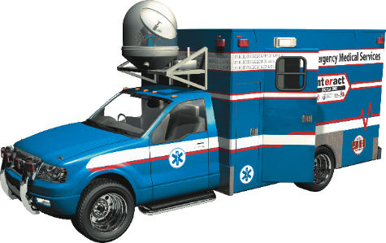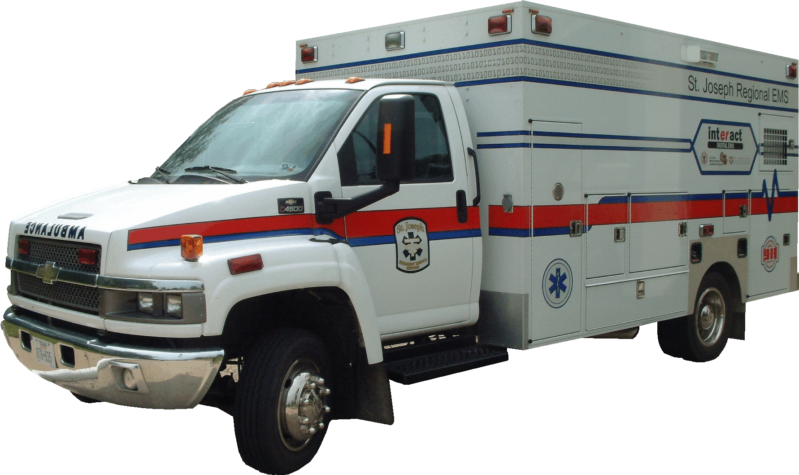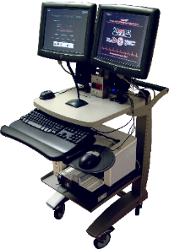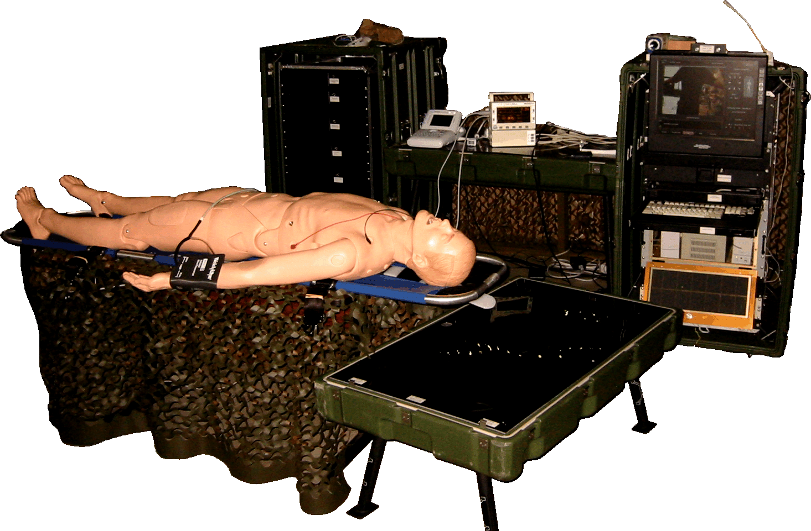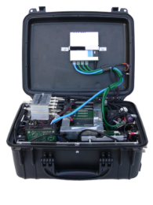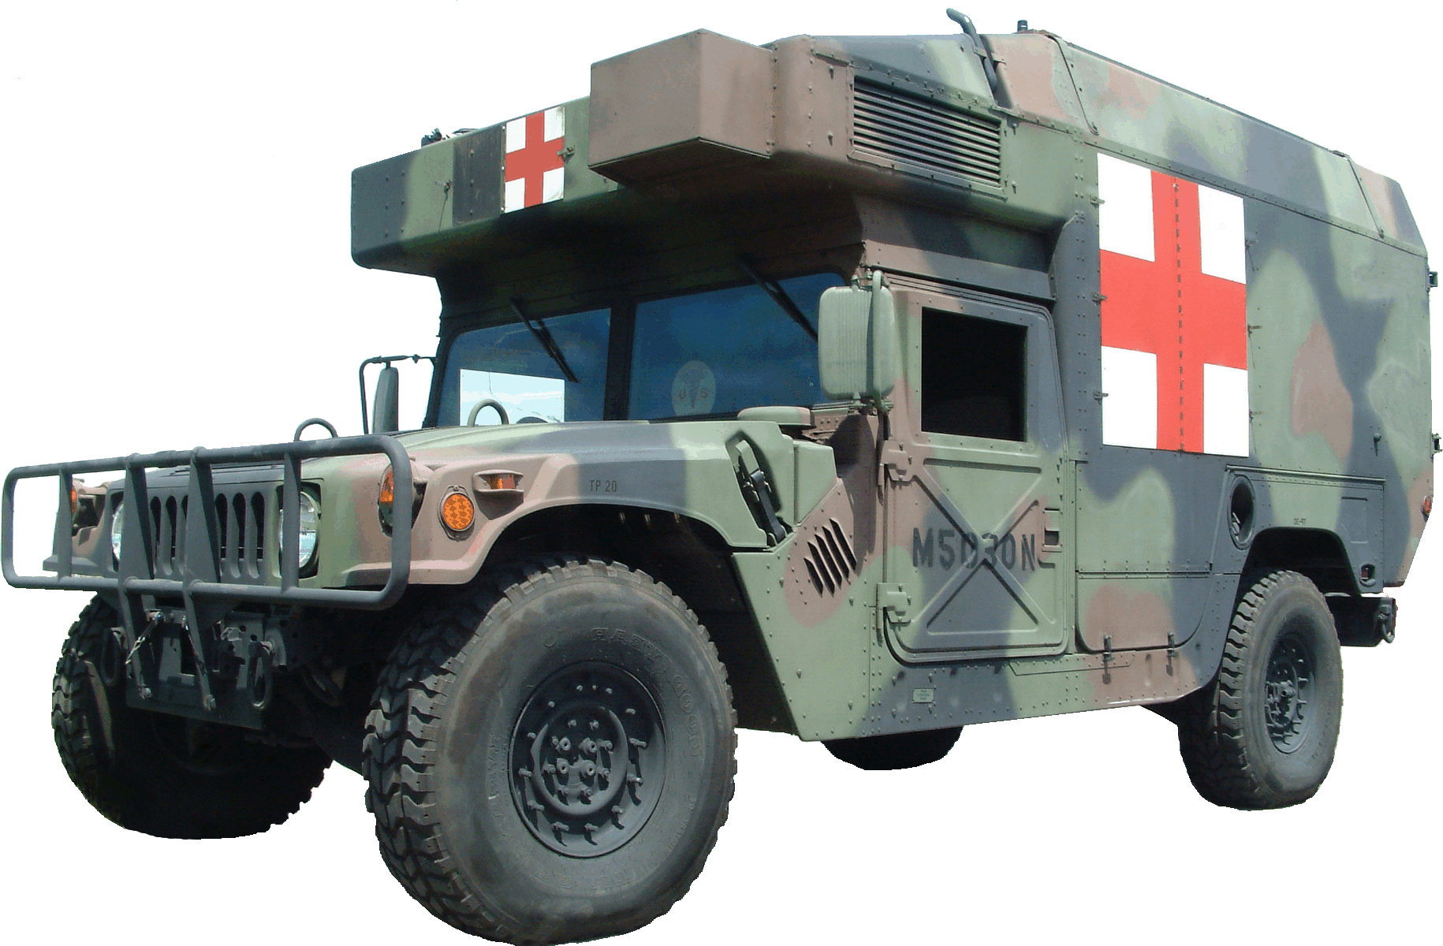
U
Deployable
Telemedicine
System
Physician
Workstation
Prototype
Intelligent
Communications
Manager
Testbed
Ambulance
Prototype
Field
Ambulance
Prototype
U.S. Army HMMWV
Ambulance
Prototype

Figure 21. Products Developed in Support of the Digital EMS Program

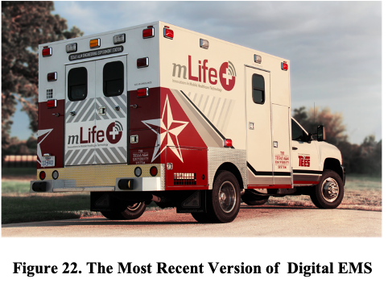
The feasibility of other missions such as disaster relief, telemedicine in medically under-served areas, and the transport of patients from one medical facility to another were also considered. In a disaster with mass causalities, the Digital EMS will transition from being a medical treatment facility into an advanced command and control facility utilizing its advanced communications technology and man portable systems for triage and the direction of other medical resources. Because the Digital EMS has integrated advanced medical systems on-board such as portable ultrasound and wet blood analysis “on a chip”, it is quite capable of performing telemedicine in medically under-served areas. Transporting patients from one medical facility to another necessitated new requirements that are especially pertinent to the role of the U.S. Army field ambulance.

The latest version of the Digital EMS ambulance was funded internally and was designated as the mLife vehicle (see Figure 22) and was intended to be a laboratory for supporting emergency medicine and healthcare applications. There was little difference in the capabilities from the previous five ambulances that had been put in the field in Liberty County, Texas serving six counties. However, the ambulance had some changes made during assembly and was organized to better integrate the on-board medical equipment The inside of the mLife vehicle and on-board equipment is shown in Figure 23.

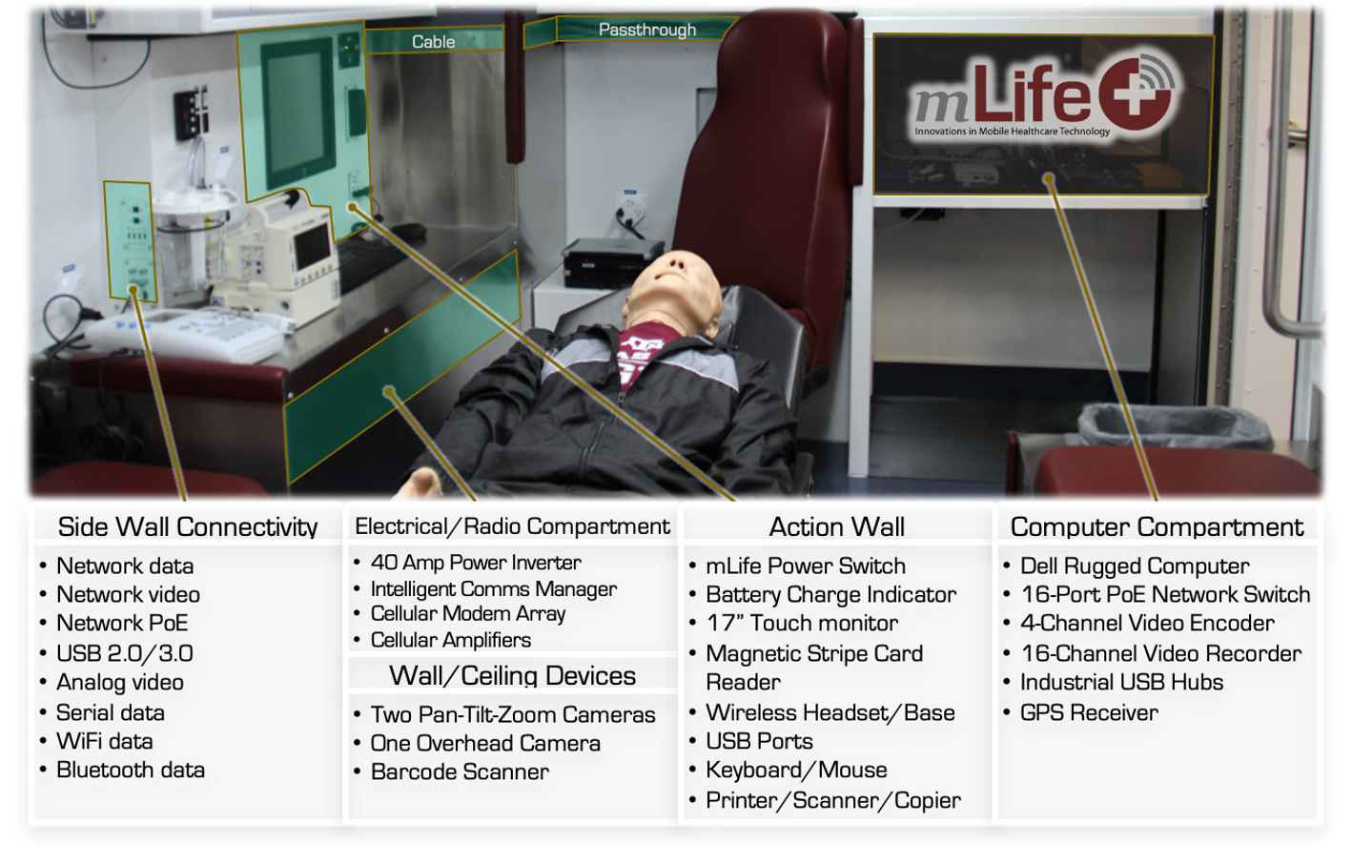
Figure 23. An Inside View of the mLife Vehicle and Its Integrated Equipment

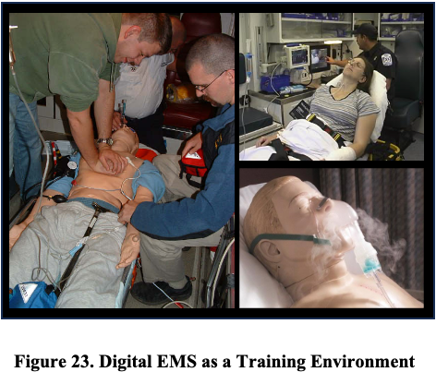
The Digital EMS ambulance provides and outstanding realistic training environment. (see Figure 23). Scenarios can be constructed that use either “actors” as patients or human patient simulators. Unfortunately, “actors” cannot stimulate the on-board medical diagnostic equipment. The human patient simulators have become very sophisticated and can play out detailed medical scenarios and even respond to medical intervention. Unfortunately, this realistic data can still not be acquired with the real on-board medical equipment (e.g., blood pressure). However, some of the higher end human patient simulators can be injected with medications and provide an appropriate response. Conducting training while the vehicle is in motion and communications are ongoing is very realistic. Studies have shown that training transfer is better when the environment is more realistic.

Several of the challenges in building and fielding a Digital EMS environment are listed below:
- Managing high bandwidth applications in a wireless environment
- Providing a common user interface while integrating many systems related to medical monitoring and diagnostics
- Human Subject Approval Process
- DoD-specific requirements
- DoD/local human subjects coordination
- Lack of Standard Medical Protocols
- HL7: Lack of Support for Multimedia in Electronic Medical Records HIPAA Compliance
- Introduction of new processes and procedures to users that are well-drilled on a previously well-defined set of processes and procedures.

REGIONAL ANALYSIS MODEL (RAM)

The Regional Analysis Model (RAM) is a simulation designed as a training tool for military personnel involved in military operations other than war (MOOTWs) that was developed with the Bush School of Government at Texas A&M University. International events and reports of civil violence and political dissent present a picture of a complicated world. People and groups behave in ways that can appear both incomprehensible and unpredictable to the observer. The intent of the RAM is to help users understand the complex dynamics of group behavior and interactions through simulated training scenarios, hopefully increasing effectiveness and decision making ability during peacekeeping, humanitarian and other non-war military missions.

Reactions that appear on the surface to be unreasonable or unpredictable can most often be explained by illustrating the manner in which the goals and concerns of individual groups either correspond or conflict. It is through understanding the logic behind group behavior and interaction within a particular region that we can more accurately predict the probable reactions of effected groups. As a result, it becomes possible to predict potential “bad” reactions to “good” actions. This is the approach used in the RAM simulation.

In working through simulated scenarios, the RAM user gains a better understanding of group behaviors and interactions within a region, thereby enabling pre-emptive events to be initiated that counteract probable “bad” reactions as well as modifications to proposed courses of action to avoid negative reactions entirely. The RAM simulation experience will hopefully improve trainee decision making skills as well as increase the probability of success of his or her actions and intervention decisions. A key to success of the RAM was the development of a document by the Bush School of Government detailing the theoretical underpinnings for the developed model.

In order to utilize the RAM simulation for a specific region and time period, it is first necessary for a regional or subject matter expert (SME) to collect background information to accurately depict the region. Among the background information collected is geographical information, social factors, political information, economic data, regional infrastructure, and sub-national groups. The concerns of groups are identified and categorized as economic concerns, political concerns, or social concerns (see Table 4).

Table 4. List of Concerns by Category
ç | Political Concerns | Social Concerns
Property Rights | Religious Freedom | Cultural Rights
Employment Choice | Political Participation | Education
Wealth (relative) | Government Representation | Housing
Economic Health and Stability | Political Equality | Health Care
Cost of Living | Political Opposition | Personal Security
Consumer Goods | Labor Organization | Public Services
Economic Equality | Censorship | Unrestricted Internal Travel
Labor Controls | Quality of Justice | Unrestricted International Travel
 | Freedom of Media

Based on satisfaction levels of the groups, the RAM continuously monitors a factional bias matrix in order to simulate the relationships between groups based on their similarity of concerns. However, satisfaction levels change during the course of the simulation. Group alliances and relationships are also simulated as the satisfaction levels change as well as relationships among the groups or factions, clout. and sources of power.

RAM has been used as an appliqué or influence model to influence actions in a combat model such as OneSAF. For example, combat forces moving in an area can be greatly impacted by the demeanor of the local population. If the local population is not friendly, it may take far more resources and time to safely move from one location to another. RAM is also embedded the Joint Non-Kinetic Effects Model (JNEM).

THE USE OF SIMULATION IN THE ACQUISITION PROCESS

Former Secretary of the Army Mark Esper once said: "Changing how we change - best value; prototype to learn; fail early/fail cheap; buy and adapt; product over process; preserve competition to fuel innovation. Speed, speed, speed - lives are at stake." This is clearly a challenge to the Military Acquisition processes that are in place today. In order to meet the challenge highlighted by Secretary Esper, the use of M&S must be fully integrated into the entire acquisition cycle. We must be able to share requirements and funding, in some cases, across multiple user communities in order to avoid duplication of effort in developing models and simulations.

Synthetic environments (including gaming, modeling, and simulation environments) must be integrated beyond training for providing cost-effective and innovative ways to test new ideas and concepts, and to design and prototype technology, components, systems, and processes. Effective use of synthetic environments provides an opportunity to involve military members earlier in the innovation exploration process and inform requirements for programs that enter the acquisition pipeline.

Technology is rapidly changing and decision cycles have to be shortened to put the most capable systems in the hands of our warfighters. The sooner new technically advanced systems can be fielded, the longer the period we will exceed or match threat capabilities.

THE INNOVATION PROVING GROUND (IPG)

The Innovation Proving Ground (IPG) is an outdoor experimentation site that includes state-of-the-art instrumentation to support development of innovative, synergistic strategies for the design, analysis, control, validation, and verification of complex autonomous vehicle and sensor systems operating in realistic and challenging environments (see Figure 24). These capabilities made possible through the specialized instruments are essential to assure this nation retains global leadership in security, mobility, and independence. The IPG is part of the Bush Combat Development Complex (BCDC) whose headquarters is housed in the new Research Integration Center (RIC).

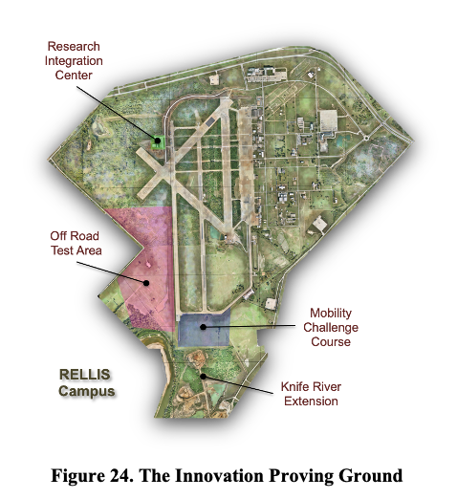
The IPG is a test site that will be in high demand, by the armed forces and supporting industries, as the lack of any well-instrumented open spaces is a recognized bottleneck to the process of accelerated innovation. Additionally, the demand exists because of the requirement for well-instrumented open space and researchers with high-caliber expertise across a number of scientific disciplines.

The IPG will also enable experimentation to advance development in hardware for all modes of transportation, necessary software networks, and unique human factors interface systems with conventional or unmanned aerial, off-road ground and subterranean vehicles. Additionally, the collection and curation of massive amounts of data via IPG instruments will position the BCDC as an ideal location for artificial intelligence (AI) development to support advanced military and civilian applications.

New technologies using sensors and data analytics have opened the door to a new vision of how experimentation in operation-like environments can accelerate the technology development cycle. The collection, curation, and analysis of massive amounts of instrument and sensor data will enable more rapid prototyping, AI algorithmic creation and optimization, as well as train domain expert students with the AI skill sets critical to future economic prosperity in Texas.

To support IPG operation, unique instrumentation, sensors, and test equipment that are in alignment with explicit DoD mission needs is required. The required equipment and capabilities, as shown in the following description, include:

Data Capture and Communication
Flexible wireless infrastructure is in place that supports software-defined radio and commercial 4G LTE and 5G LTE wireless technology. A software-defined network architecture allowing network reconfigurability with minimal hardware changes is available. Data collection at both the network layer and RF waveform layers is edge and cloud compute capable. RF communications for data capture, field communications, and range control can use 5G cellular modems or mesh radios.

A secure network communication of in-flight and field data uses internal and external fiber optic networks being put in place now. An on-site control and secure data curation center with data servers is required for logging telemetry data, as well as hosting an interactive analysis and display system telemetry will be built in the future. There is a focus on inter- and intra-vehicle communications and internal and external video when multiple vehicles are being tested in a coordinated manner.

Time-Space-Position Tracking
Time, space, and position tracking for ground and air vehicles is necessary to capture the precise dynamics of the vehicle and its payloads operating under test conditions. Depending upon the test parameters, different tracking technologies are used. This telemetric data is stored on-board and also communicated in real time to the range control center. It is also important to provide an external tracking means to establish absolute ground truth. For accurate vehicle positioning, high-accuracy GPS time/position, and differential GPS will be included with altitude dependent surveillance broadcast receivers. For monitoring and tracking the movements of air or ground vehicles, an air surveillance radar, a thermal imaging system, and an optical tracking system will be installed onsite as a collective unit.

Multi-purpose towers for worksite lighting and sensor placement are employed. Towers include LED lights, digital daytime and thermal cameras, and speakers. The towers will be controllable from the control center, and all captured video and audio will be recorded and archived. For validation of field applicability of relevant environmental conditions, a small-scale weather station is centrally located within the test site.

Test Vehicle and Site Parameters
The IPG enables experimentation with conventional or unmanned aerial, off-road ground and scaled subterranean vehicles, to advance development in hardware for all modes of transportation, necessary software networks, and unique human-factors interface systems. A suite of instrumented off-road tracks were developed for acceleration of off-road autonomous vehicle development. This specialized environment will enhance the industry-recognized capabilities that TAMUS provides in emerging technology for civilian transportation, as well as ensure the research-based capacities will support our national security needs.
Featured test sites are listed below:
- Off Road Test Area
Where appropriate, trails will be established for range administration, and terrain features will be constructed to challenge the mobility of the ground vehicles. Additionally, an area(s) will be established as Test Support Areas for both military sponsors and researchers.

- Off Road Challenge Course
Engineered mobility test track that has the appropriate obstacles and challenges for test and evaluation of the performance envelope is in place. The track encompasses multi-functional areas for testing of dynamics, handling, and off-road performance. The track includes artificial terrain, ramps, soil types, and obstacles in order to gauge maneuverability and performance.

- Subterranean Test Area
This area will provide a series of scaled subterranean tunnels for testing the navigational capabilities and sensor effectiveness in an area where communications are limited and autonomy can be stressed.

Battlefield Effects
Simulating battlefield effects is important in creating a high degree of realism during the conducting of tests. Obscurants are necessary to adequately test sensor suites and to limit the visibility of operators. Pyrotechnics add to the stress level of operators. Synthetic jammers will be used to attempt to deny or limit RF communications. Targets with the appropriate signatures (e.g., thermal) will aid in testing sensor suites.

While Test and Evaluation is vital to validating the potential of an innovative technology or characterizing the limits of a prototype or integrated platform, this author sees tremendous opportunity to inform new Test and Evaluation procedures for the DoD as many new technologies are introduced that may disrupt current paradigms with respect to military operations. This includes both developmental and operational T&E. Modeling and simulation (including the use of synthetic environments) is likely to play a more prominent role in managing this disruption to current paradigms. For example, the shift from manned vehicles to man-unmanned vehicles to autonomous vehicles is likely to require new methodologies for testing, especially given the challenges of testing “smart” components derived from the extensive use of AI/ML. This is especially true when the logic is derived from deep learning systems that may not provide clear audit trails for evaluating how their output was derived. Given the many possible outcomes, all of which cannot be physically tested, we will have to accept simulated results and be able to characterize the validity of such methods. Additional advances in support of test and evaluation will be made in the following areas:
- Large scale networking and cloud architectures
- Sensors and sensor fusion requiring real-time data streaming and big data analytics
- Cybersecurity (esp. cyber-physical)
- HPC and data visualization, and
- Instrumentation…to name a few

Advances in these technologies will both empower and challenge testing and evaluation and the development and employment of innovative models and simulations. Rigorous use of design of experiments (DOE) will be needed to gain efficiencies in testing and further help to describe interactions among various configurations of platforms and sensors, which may be a mix of virtual and physical systems, when integrated. Data from one test may increase the strength of testing results for another system.

A “shift left” testing approach enabling operational testers to become involved sooner in the Materiel Development Cycle must be incorporated. This requires the use of real world and simulated integration platforms representing a number of different technologies to assess the level of integration and interoperability much earlier so necessary changes to systems and components can be made sooner and at less cost.

The use of modeling and simulation will expand the physical testing of single or multiple systems (or components) to a larger context, as appropriate. Underlying Test and Evaluation environments will require improvements in secure communications and computational facilities to collect, assure, curate, store, and perform data analytics (combining real-time streaming data with retrieved data stored in the cloud). This same data will then be used to provide inputs to models and simulations which will in turn output back to the T&E environment. This vision is part of the foundation for the Innovation Proving Ground, a component of the Bush Combat Development Complex (BCDC) at Texas A&M University, where this author served as the Director prior to his retirement.

Test and evaluation is a key activity within the BCDC and presents important opportunities for involving soldiers early and often in determining whether innovative ideas can be validated as true innovations and making technology available to the warfighter sooner. This approach ensures that the positive impact of these innovations are available to soldiers for a longer period of time before the advantages derived from a particular technology diminish.

A truly disruptive approach is required to meet the unparalleled challenge of agile and responsive technology development that will provide and retain combat overmatch in the battlespace. This approach must integrate soldier-inspired, interactive technology development and design testing in a real-world environment that is instrumented with state-of-the-art hardware/software systems. The IPG can accommodate both developmental and operational testing protocols as required.

With the world-class instrumented range and its associated telemetry and methodologies being introduced within the Innovation Proving Ground at the RELLIS campus, technology can be rigorously tested and a range of prototypes along with integration platforms populated by a number of different technologies to assess interoperability. Technology and prototypes being tested are not limited to research and development products from The Texas A&M University but includes these services to both military, industrial and other academic partners.

The use of modeling and simulation (including synthetic environments) can be used to expand the physical testing to a larger context, as appropriate. Underlying the Test and Evaluation program is the secure communications and computational facilities to collect, assure, curate, store, and perform data analytics (detecting the expected and discovering the unexpected). Cybersecurity resiliency will be tested on the front end as opposed to the completion of development activities to gain insights early with respect to security vulnerabilities.

Testing and evaluation (T&E) can be delivered as a service by incorporating a data fusion framework and real-time streaming analytics in support of T&E activities. Implementation of a data lake(s) is required to support T&E in a diverse, high throughput collection environment. Use of virtual proving grounds and digital twins can enhance research and development and facilitate T&E. Extending the use of modeling and simulation is needed to meet the T&E challenges imposed by increasingly complex systems.

The BCDC represents the convergence of research objectives, as well as support for the acceleration of these emerging technologies through immersive user-soldier engagement. Therefore, it is the logical location for Range Operations and Test Control. The following units represent the manned units responsible for carrying out the various functions associated with Test and Evaluation activities being conducted at the IPG:

Instrumentation and Control Unit

Range operations and control is the focal point for current ongoing test and evaluation activities. This activity will provide real-time video feeds from the test area, map overlays with superimposed icons of equipment being tested, and real-time data analytics. Other support vehicles and equipment will be managed by this unit.

A key highlight of this unit is a full wall display for both testers and observers to view a common integrated display featuring daylight video/thermal imagery vehicles/equipment being tested, on-board sensor data streams, and real-time analytics.

Modeling and Simulation Unit (including Synthetic Environments)

Modeling and simulation (including synthetic environments) to expand the physical testing to a larger context, as appropriate. The simulation output can be output to the Range Operations Center and will also be compliant with the Test and Evaluation Network Architecture (TENA) protocol which will permit participation in other distributed tests around the country. Military simulations such as OneSAF (entity-based) and WARSIM (aggregate) will be hosted along with simulations designed to support autonomous vehicle development such as ANVEL and VANE.

Synthetic environments (including gaming, modeling, and simulation environments) will be integrated beyond training for the design and virtual prototyping of technology, components, systems, and processes. Effective use of synthetic environments provides an opportunity to involve soldiers earlier in the innovation exploration process and inform requirements for programs that enter the acquisition pipeline. Synthetic environments will be used to support research in the following ways:
- Accelerate the process (good idea to deployment) with compressed timeline focused on high confidence.
- Involve relevant stakeholders earlier (esp. the soldiers who are end users) to lessen the need circle back. This becomes more significant for changes later in the acquisition process.
- Use of Modeling, Simulation, and Exercises to support the overall Acquisition Process
  - Concept Evaluation
  - Prototype-driven Requirements
  - Operational Testing & Evaluation
- Manufacturing Processes (including Digital Twinning)
- Interoperability Accreditation
- Cybersecurity Evaluation
- Engineering Design
- System Impact in the Battlespace
- Safety Procedures
- Creation of a virtual proving ground focused on prototype development and testing

This unit will also provide support to platform researchers and agile methods by using synthetic environments to represent early minimum viable products (MVPs) attributed to the lean development process for engagement by soldiers before a physical prototype exists. Additionally, system and cybersecurity testing methods will be explored in virtual space as a means to shorten the overall testing cycle leading to an overall reduced acquisition cycle.

Data Analytics Unit

The responsibility of this cell is to collect, assure, curate, store, and perform data analytics associated with sponsored tests. Of significant importance is the native representation of data in its native formats or raw for which is then stored in a data lake. The transformed data from the data lake can then be used for tasks such as reporting, visualization, analytics (including streaming), and artificial intelligence (machine learning). The power of this approach stems from the overall size of the data store and the ability to compare data derived from multiple sources or complementary systems.

New technologies using sensors and data analytics have opened the door to a new vision of how experimentation in operation-like environments can accelerate the technology development cycle. The collection, curation, and analysis of massive amounts of instrument and sensor data will enable more rapid prototyping, AI algorithmic creation and optimization, as well as train domain expert students with the AI skill sets critical to the future.

The IPG will also have the following instrumentation, sensors, and test equipment. Gigabit network connectivity with fiber optics will exist on two networks (one connected to the internet and a second forming a local network). A weather station centrally located at the test site will be constructed. High-accuracy GPS time and position and differential GPS are critical testing assets of IPG, in addition to the complementary capability of automatic dependent surveillance broadcast receivers for each platform. For monitoring and tracking the movements of air and ground vehicles, and to generate precise data on their speeds and movements, air surveillance radar, a thermal imaging system, and an optical tracking system will be developed. For communications, a satellite communications system will be formed with long-range multi-channel radios used for the control room, ground control station, operators, test trailer, and ground communications. High-definition video cameras will be used for tracking cameras and to record high-definition video for live streaming to the test team. Antennas suitable for high bandwidth and long range will be positioned for wireless telemetry from test vehicles to operators in the various local control and monitoring areas. There will also be an on-site control room for managing and running experimentation in addition to a control room trailer with data servers for logging telemetry data and hosting Interactive Analysis and Display System telemetry.

Unique instrumentation, sensors, and test equipment are needed for the IPG operation. To achieve high-value technology and user interface, all experimentation must contain precise data describing device position/status/performance, specific data about the situation (test space and environment), and test management.

While the community has taken M&S to levels unimaginable only a few years ago for quality training, the future is incredibly promising for applying M&S to enhance the effectiveness and efficiencies of core functions in other important domains such as materiel development, operations, and testing to name a few. This is a challenge that we will all embrace and move forward, taking advantage of exciting new advances in artificial intelligence and machine learning and communications, especially the ubiquity of high-speed bandwidth that will be provided by 5G. This combined mesh networks will allow untethered systems to receive and pass data to and from other systems directly or data stores in cloud architectures.

A FEW PARTING THOUGHTS

Powerful tools used in the absence of well-formed processes have little value. Rarely is technology the full solution. Must address culture (people) and policies. DTLOM-PF is still relevant. Just remember if you get down to a materiel solution when looking for as solution to a deficiency you must still revisit all preceding and following areas to assess the impact of introducing new materiel.

No matter which department, agency, or jurisdiction professionals come from, they have the ability to impart knowledge to each other because of diversity in experiences, thoughts, and ideas.

Common language is needed when working with a diverse set of stakeholders (data dictionaries, ontology, etc.) to effectively communicate and avoid misunderstanding.

Modeling and simulation is a combat multiplier. It used to be thought that combat multipliers had to be better weaponry, more lethal munitions, improved armor. Former Chief of Staff of the Army General Gordon Sullivan recognized that command and control systems (and information) providing better situational awareness were a combat multiplier because we could use our combat systems and manpower more effectively and efficiently. Simulation used throughout, the acquisition lifecycle, next generation training systems, and routinely used in combat operations will have a similar effect.

Simulation development must be preceded by a comprehensive effort to establish functional requirements. Requirements are important – document, validate, and track. Exploring use cases with potential users is incredibly productive for rapid prototyping or validating requirements. Often, prototype-driven requirements are more useful than requirements-driven prototypes when developing a product.

Simulation-based Testing and Experimentation must be refined (and accepted) especially when testing systems with embedded AI derived from deep learning technology.

New emphasis on Model-based Systems Engineering (MBSE) will facilitate the use of simulation throughout the entire asset lifecycle. This will allow us to revisit the vision presented years ago in Simulation-based Acquisition (SBA) programs. Use of MVPs (Agile Development) is important and early MVPs may be simulated versions of the system being developed. This will be facilitated by MBSE and has the potential to support the construction of digital twins. These MVPs may allow operational testing to begin sooner (overlapping developmental testing). Operational testing is vital!

High Performance Computing is rapidly becoming more pervasive and accessible with implications for M&S. Dr. Marti Wortman, a retired Professor of Industrial and Systems Engineering at Texas A&M, who is a former colleague of this author made the following profound statement on HPC and how it relates to M&S. He said, “The emergence of abundant and accessible high-performance computing has elevated simulation technology to the level of strategic importance for both scientific discovery and technological innovation. In the coming decade "simulation, modeling and analysis" will stand along side "analytical theory" and "empirical investigation" as one of three pillars supporting basic research in science and engineering. Institutions that fail to develop a strong and easily approachable simulation capability (i.e., infrastructure) will not remain competitive, as they will lack an essential foundational research-enabling technology."

Augmented reality will have an increasingly greater impact as better wearables become available.

It has been said that data is the new oil. However, we are “drowning” in data, but do we have the right data? Did it come from an authoritative source? M&S and decision support systems will demand new requirements on data where metadata fully describing the data becomes increasingly more important. We need to better understand the full context of how the data was acquired and its reliability and we must also have the perspective of the data consumer in order to present the right data in the right way and at the right time to maximize its use. Metadata adds utility and value to data (identification, description (including the context related to its capture and its intended use), lineage, quality, and access).We must master the data lifecycle.

Data is a product. It is used to feed deep learning systems and generative AI platforms and to develop models. We must understand how to minimize bias when collecting data and identify and mitigate bias in existing large datasets to prevent corruption of new and emerging AI platforms. Synthetic data derived from simulations may have to be used for model building when real-world data capture is not an option. Be clear about the implications for its use.

Real-time streaming data analytics are powerful in testing and can be used to make in-stride changes in the ongoing test thus saving time and money.

Decision-making shares a great deal of similarity with high stakes gambling. Like a gambler, a decision-maker must evaluate risk vs. reward. To be effective, the gambler and the decision-maker must assess all available data and determine how much uncertainty exists with respect to this data in order to formulate a decision.

Aggregation/Disaggregation strategies are important when developing COPs because clutter must effectively be reduced without losing information in the operational picture.

ACKNOWLEDGEMENTS

This author is extremely grateful to be designated as the 2023 I/ITSEC Fellow based upon recommendations from his peers. His association with I/ITSEC for more than 25 years and the exposure to world-class colleagues and immersion in the latest modeling, simulation, and training technologies are a large part of any success he has enjoyed. In the workplace, he has been fortunate to be surrounded by mentors who represent the best of the best and colleagues who have been committed to the team and have always gone above and beyond to deliver leading edge technology to the those committed to our nation’s security. They have inspired and made great contributions to much of the work described in this paper.

REFERENCES

Booth, David & Haas, Hugo. (2004). Web Services Architecture W3C Working Group Note 11 February 2004.

Conatser, J. L., & Grizio, V. E. (2005). Force XXI Battle Command Brigade and Below-Blue Force Tracking (FBCB2- BFT). A Case Study in the Accelerated Acquisition of a Digital Command and Control System during Operation Enduring Freedom and Iraqi Freedom. Monterey: Naval Postgraduate School.

T. Erl, (2005) Service-oriented architecture: Concepts, technology, and design, Upper Saddle River: Prentice Hall PTR, ISBN 0-13-185858-0.

Krüger, W. and Froehlich, B., (1994), W. Krueger and B. Froehlich, "The Responsive Workbench [virtual work environment]," in IEEE Computer Graphics and Applications, vol. 14, no. 3, pp. 12-15, May 1994, doi: 10.1109/38.279036.

Lawson, J.S., (1980), "Command control as a process," 19th IEEE Conference on Decision and Control including the Symposium on Adaptive Processes, Albuquerque, NM, USA, pp. 1-6, doi: 10.1109/CDC.1980.272008.

Mulgund, S., & Landsman, S. (2007, June). User defined operational pictures for tailored situation awareness. In Proceedings of the 12th international command and control research and technology symposium–Adapting C2 to the 21st century, Newport, RI (pp. 19-21).

Steen-Tveit, K., (2020), Identifying information requirements for improving the common operational picture in multi-agency operations. Proceedings of the 17th ISCRAM conference, USA

Sterling, B., (1993), “War is Virtual Hell”, https://www.wired.com/1993/01/virthell/.

Thomas, J.J. and Cook, K.A., (2005) Illuminating the Path: The Research and Development Agenda for Visual Analytics: IEEE, 2005,

