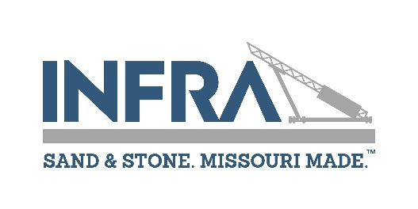

**80th Annual Convention**

**December 3rd ~ 5th at Margaritaville Lake Resort, Osage Beach, MO**

Company 

Your Name 

Cell Number  Email 

Spouse/Guest/Child Name 

*Please note that by providing your cell number you agree to receive text messages from Infra. Message frequency varies. Message and data rates may apply. Text STOP to opt out.

Registration price includes all events & meals scheduled for our convention. Your silent auction bid number is included on your name badge & is required to bid on items. $20 of your registration fee qualifies for an income tax deduction as a charitable donation. Registration is required if you attend ANY event.

**PRODUCER MEMBER REGISTRATION** prior to November 21st **$175 $** 

Polo Shirt Size  ***\*Order by November 1st*****$30**  **$**  after November 21st **$200 $** 

**Spouse/Guest/Child attending any Infra event** **$150** **$** 

The 11 am Thursday Brunch, Bingo & Refreshments is offered as an alternative to the Thursday Producer Lunch

**(Make checks payable to Infra) TOTAL AMOUNT PAID $** 

***NOTE:*** ⏩ (Everyone attending must register & payment is due at time of registration) ⏪

Please list the number of attendees/guests that will be at each of the activities below.

 Wednesday Opening Reception  Thursday Breakfast

 Spouse/Guest Bingo Brunch  Annual Producers Meeting & Lunch

 President’s Banquet  Friday Safety Awards Breakfast & Keynote Speaker

**Please email Connie with any dietary restrictions at** [**connie@inframissouri.org**](mailto:connie@inframissouri.org)

**EMERGENCY CONTACT NAME & NUMBER:**

**PLEASE CHECK IN WITH THE REGISTRATION TABLE UPON ARRIVAL**

Checks must be payable to Infra & mailed **WITH PAYMENT** to: PO Box 1725, Jefferson City, MO 65102

**Pre-Registration Deadline – November 21st. NO REFUNDS after November 21st.**