Hot Topics in Real Estate 2022  November 4, 2022-Live Virtual Forum  Co-Sponsors: Tennessee Bar Association and the Tennessee Land Title Association  Total Credits: 5 General; 1 Dual (Ethics)  Moderator: Joe Kirkland  This program is produced in cooperation with the Tennessee Land Title Association, is a staple for Tennessee dirt attorneys, designed to keep you on the cutting edge of developments in your practice. The hot topics forum will include legislative and case law updates, C-Pace, Airbnb restrictions, HPR issues, and ethics. |  | 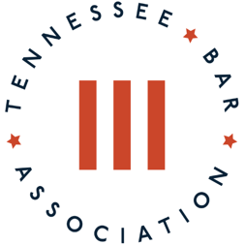  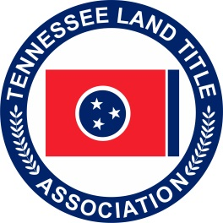
9:00 – 10:00 a.m. | Tennessee Real Estate Case Law Update  Staci Blackwell, Fidelity National Title
10:00 – 11:00 a.m. | Ethics in Split Closing Transactions  Ryan Martinez, DOMA
11:00 – 11:15 a.m. | Break
11:15 – 12:45 p.m. | Reining in the Woo-Girls: Navigating short-term rentals  STRs are different in every city. This seminar will help you understand your market and stay in compliance with local ordinances.  Doug Betty, Tennessee Real Estate Investors Association; Emily Lamb,  Thompson Burton PLLC; Erika Barnes, Stites & Harbison  Panel Moderator: Bob Mendes, Sherrard Roe Voigt & Harbison, PLC
12:45 – 1:15 p.m. | Lunch
1:15– 1:45 p.m. | 2022 Tennessee Legislative Report  Charles B. Welch, Jr., Farris Mathews Bobango Public Strategies, LLC; TNLTA Legislative Counsel
1:45 –2:45 p.m. | The Tall and Skinny of HPRs: A statewide survey  Where, when and how can you do a horizontal property regime. Andy Maloney, Millennial Title
2:45 – 3:45 p.m. | C-PACE financing: A New Tool for your Capital Stack  Nicholas Zuba, Deputy Director, C-PACE Alliance, Inc.  Michael Yaki, Petros PACE Finance, LLC

