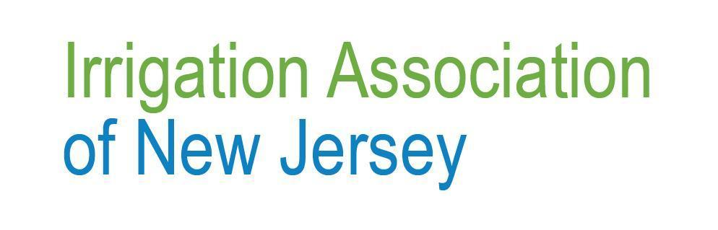
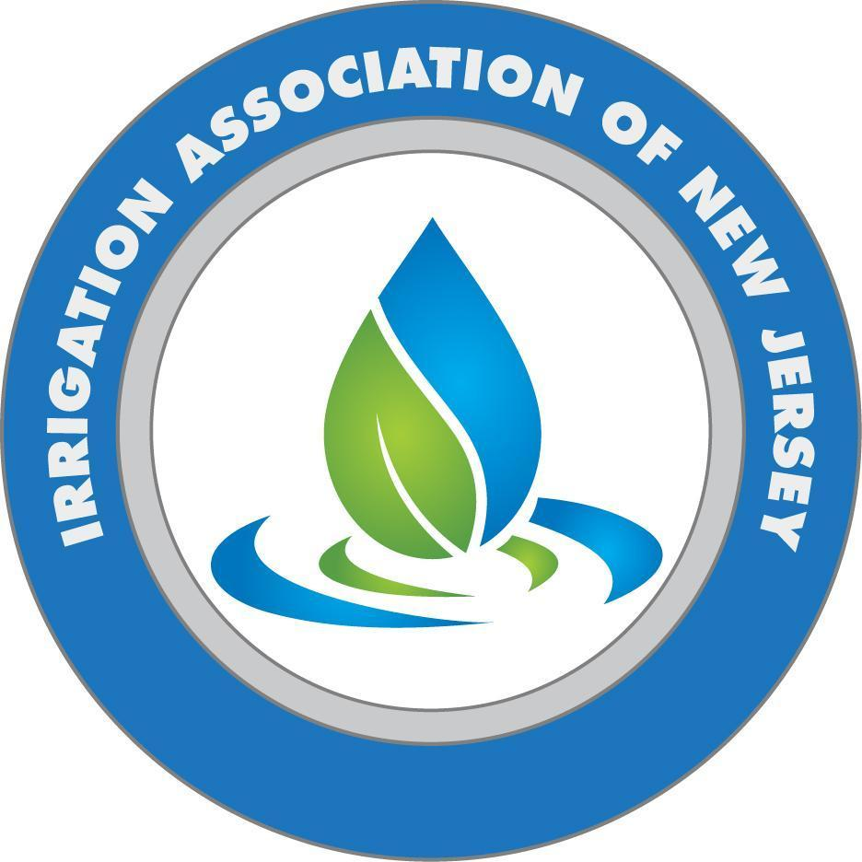

Fact Sheet: New Local Authority Powers for Enforcing Landscape Irrigation Licensing

Chapter 262, P.L. 2025, introduces important changes to the rules to protect residents from safety risks and liability arising from unlicensed irrigation work. Local authorities now have the power to investigate and fine anyone doing unlicensed work.
Who is responsible for enforcing the law?
The law gives the "local enforcing agency" the authority to investigate violations and issue orders.
- The municipal construction officials together with their assistants (as provided for in P.L. 1975, c.217).
- The county officials and their assistants.
- The people who are responsible (namely, those named in the state construction code laws).
- The officials from Pilot County and their assistants (acting under the "County Code Enforcement Pilot Program" as stated in section 1 of P.L.2018, c.157)
Penalties and Local Revenue:
The law sets significant fines to discourage unlicensed work. Local authorities keep 70 percent of the fine, and the State Board gets 30 percent.
A civil penalty may be imposed only after a formal administrative order is issued, as stated in Section 10 of the law.
- First Offense: A civil administrative penalty of up to $5,000.
- Second Offense: A civil administrative penalty of up to $10,000.
- Further offenses can lead to a civil penalty of up to $15,000. If unauthorized work continues for several days, each day counts as a separate offense, so daily fines can add up.
For more information and the state statute, visit https://ianj.com/page-18057.

