Conservationist Challenge
Imagine you have been hired as a conservationist by your local NRCS (Natural Resources Conservation Service). You visit a farm in order to help them identify natural resource concerns and develop remedies for any concerns.
Here are some of your observations:
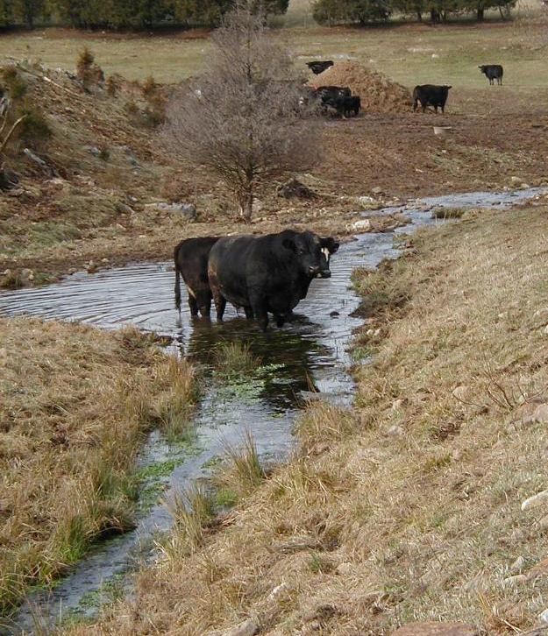
- Stream banks are eroded due to cattle activity, causing productive topsoil to wash into the water each time it rains.
- A nutrient-induced algae bloom last summer caused a fish-kill. Additionally, the town downstream advised people not to go tubing or swim due to the high pathogen load in the water.
- Areas where fish and other aquatic wildlife would live in the creek appear to now be smothered with a thick layer of silt.
- Trees and other vegetation that used to be great wildlife habitat along the banks have been trampled and killed.
You learned in school that cattle spend 95% of their grazing time in the area closest to their water source. If this creek is the only source of water in a large field, how might depending on this creek as the only water source affect how well cattle graze the distant parts of the pasture?
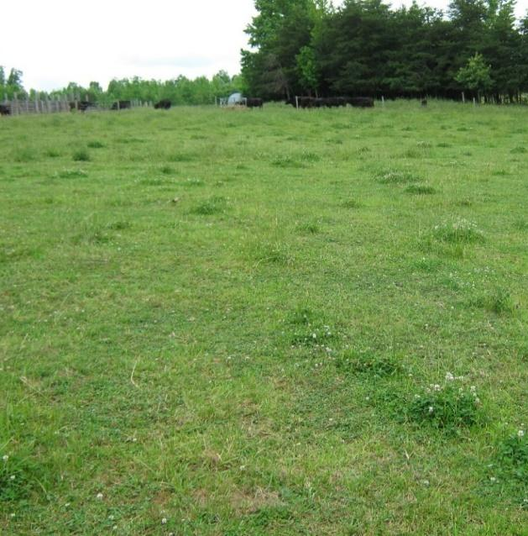
- Several of the main pastures have been consistently grazed tight to the ground. The farmer complains that she is constantly having to spray weeds and the grass no longer produces enough forage, so she has to buy expensive hay.
Think about what resources the grass and the weeds are competing for.
How can you influence this by controlling the height to which plants are grazed?

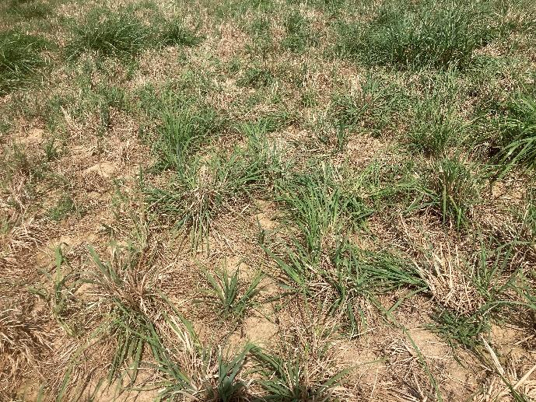
- The population of grass plants in many of the pastures has begun to thin. Bare soil is often visible, and small signs of erosion are present in between plant bunches.
What would cause plants to die out, and how might you change your grazing management before spending the money to re-seed the field?

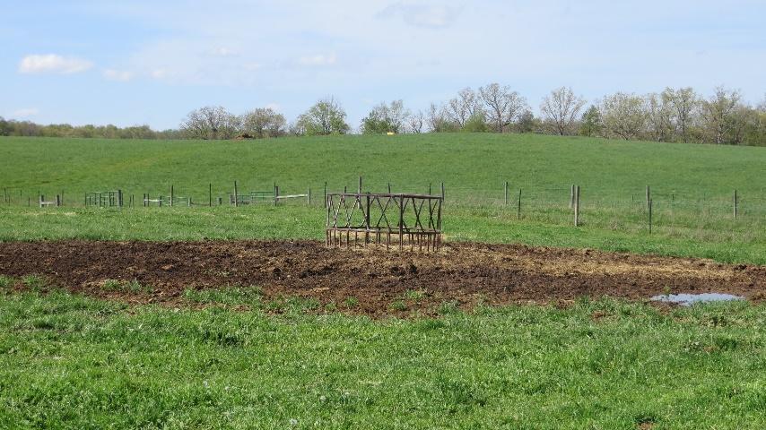
-Areas around hay feeders are completely denuded. Unlike the high and dry field next to it, this feeding site is in a creek bottom that tends to be wet.
Why might this location be poorly suited from a conservation standpoint?

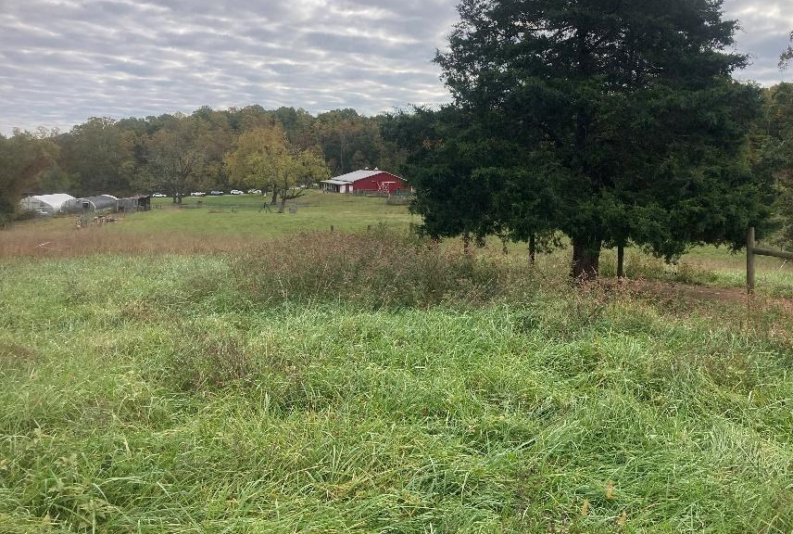
-The area around the herd’s favorite shade trees become infested with spiny pigweed each summer.
Why might grass might die out and allow weeds to gain a foothold in these spots?

Conservationist Challenge - Practice Options
Here are some conservation practices for you to choose from:
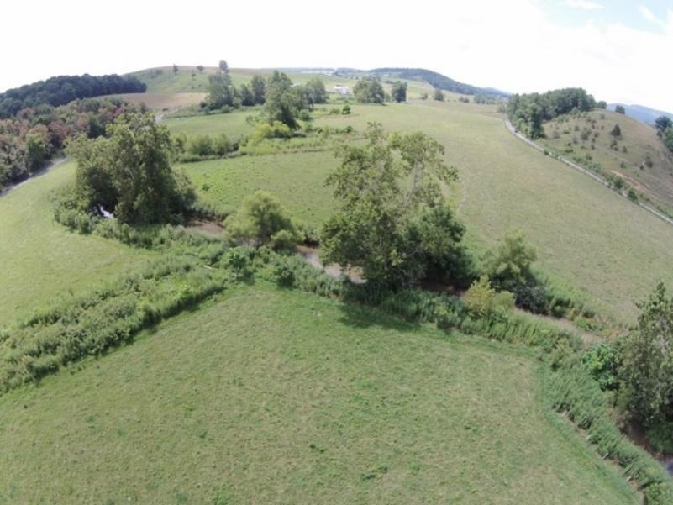
Vegetative stream buffers. Streams are fenced to exclude cattle and grasses are planted along the banks. This stabilizes the stream bank and creates a filter to remove nutrients from water entering the creek.

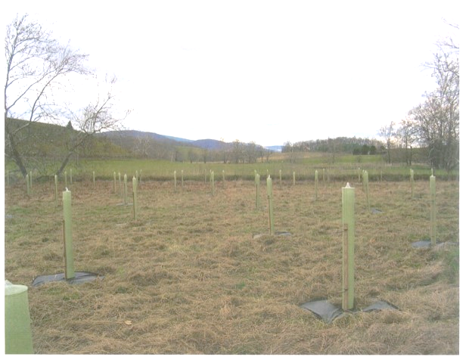
Forested buffer. The root systems of trees are the best at filtering water and stabilizing soil, so trees are often planted within vegetative buffers. Trees also produce nuts and berries for wildlife, as well as providing more wildlife habitat and shading the creek to keep water cool.

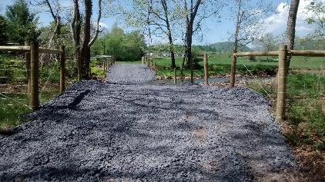
Hardened stream crossing. The creek is fenced out, but a single spot is retained for livestock and equipment to cross. The crossing is protected from erosion by adding erosion control fabric with stone on top. Stream crossings can additionally be used as a single-access point for cattle to drink from the creek.

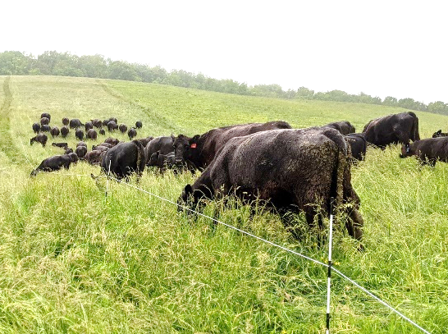
Grazing management. Dividing large fields into multiple smaller fields (paddocks). Then, cattle are moved (rotated) from one paddock to the next in order to ensure:
- Plants are not grazed lower than about 4” during the growing season. This retains enough plant leaves for a good “solar panel” and shady leaf canopy
- Plants are rested long enough to replenish their energy reserves (~30 days’ rest)
- Livestock don’t hang out in one spot and damage it!
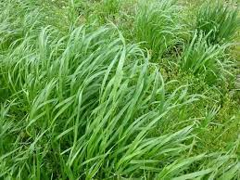
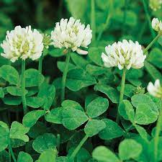
Re- seeding. Re-establishes plants to thicken plant density in pastures. Choosing forage species that spread (such as white clover or Kentucky bluegrass) is especially helpful for filling-in bare areas.

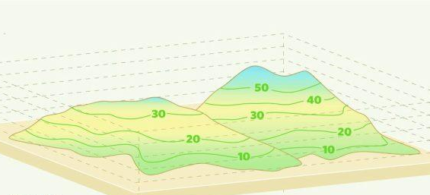
Site selection. This is often overlooked! Low-lying, wet areas are more sensitive to soil compaction and plant damage, so grazing or feeding in these areas should be done with care. Feeding should be done in areas that are “high-and-dry”.

