Conservation Catalog for Pasture
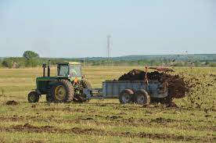
Nutrient Management Planning
A written plan for using manure and fertilizer in the right amounts at the right times to help you save money while improving crop yield. It also helps prevent nutrient pollution in streams and groundwater.

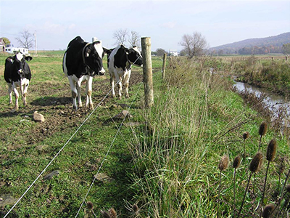
Stream Exclusion Fence and Grass Buffer
Keeps cattle out of the creek, reducing nutrient and sediment pollution. Grass buffers act as a filter to clean water entering the stream, while also creating wildlife habitat.

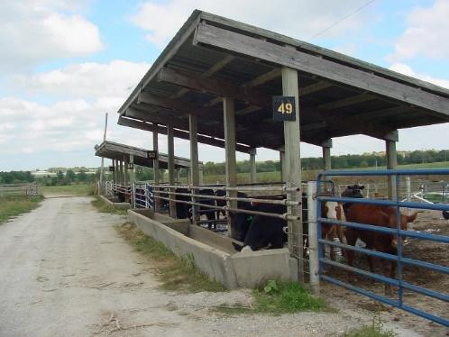
Hardened and Covered Feeding & Manure Storage
Keeps feed and manure high and dry until it can be scraped and hauled to crop fields or composted. Helps keep cattle clean and keeps nutrients from being washed off site.

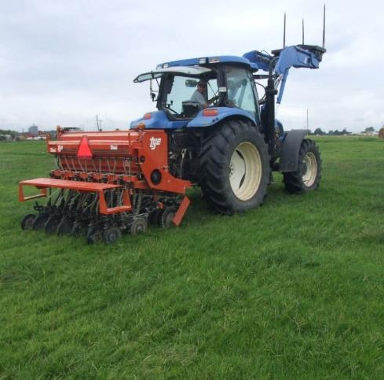
Pasture Renovation
Lime, fertilizer, herbicides and re-seeding used to renovate pastures. Keeps pastures productive, while also ensuring live plant cover to stop erosion and keep nutrients from washing/leaching away.

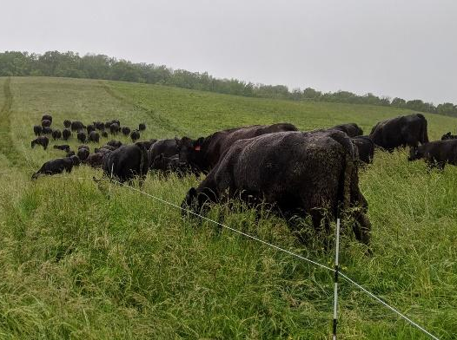
Grazing Management
Controlling when and where livestock graze keeps plants productive and healthy by avoiding overgrazing and by giving plants rest before they are grazed again. Healthy plants prevent soil erosion and nutrient pollution. They also result in better habitat for wildlife and pollinators.
Nutrient Management Planning
The purpose of a nutrient management is to:
- prevent overapplication of manure or fertilizer that could result in pollution. When more nutrients are applied than can be used by a crop, those nutrients can leach downward through soil and into groundwater, or they can be washed off the field by rainwater.
- provide nutrients to crops when they are actively growing, and in the amounts that they need.

Facts:
- A 1,000 lb. beef animal will produce about 9 tons of manure per year.
- Beef manure contains about 15 lbs. of nitrogen/ ton.
- Each acre of pasture needs about 50 lbs. of nitrogen in spring and 50 lbs. in fall
How much nitrogen does your herd excrete annually? _______ X ____________X________=
# cows tons of manure lbs. of
per year per cow annually nitrogen/ton

How much nitrogen is needed by your pasture field annually?_______________ X ________=
Nitrogen needed Number of
per acre annually acres

Does your herd produce more manure nitrogen than your pasture can use?

If yes, what might you do with the excess manure to avoid nutrient pollution?

If no, how many pounds of fertilizer nitrogen needs to be purchased each year (currently $0.50/lb.)?

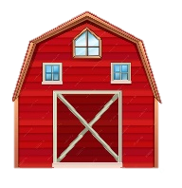
Nutrient Management Planning

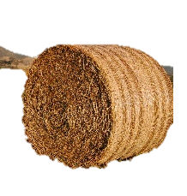
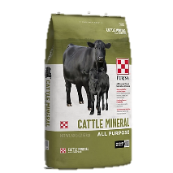

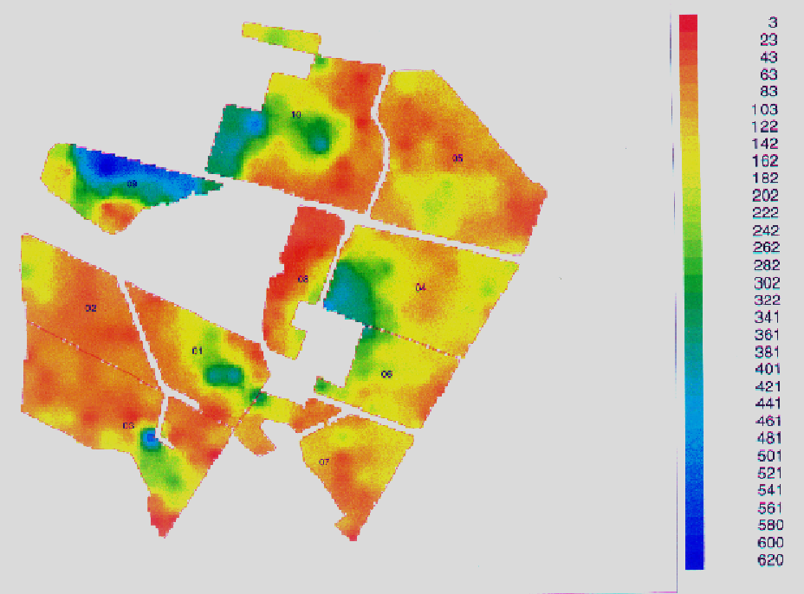
Another aspect of nutrient management includes grazing management.
This color-coded map (created from soil samples) shows the distribution of nutrients by cattle on a farm. The blue/purple areas contain nutrient levels hundreds of times higher than what the pasture plants can use. The red areas are very deficient in nutrients.
Where does it seem the cattle spend most of their time and why?

Can you think of some ways to get cattle to spend their time more uniformly throughout the pasture?

How might better nutrient distribution help your profitability?

Grazing Management
A big part of grazing management involves dividing large fields into multiple smaller fields (paddocks). Then, cattle are moved (rotated) from one paddock to the next in order to ensure:
- Plants are not grazed lower than about 4” during the growing season. This retains enough plant leaves for a good “solar panel”. During winter dormancy plants can be grazed lower.

- Plants are rested long enough to replenish their energy reserves (about 30 days’ rest)


The main tools for doing grazing management are:
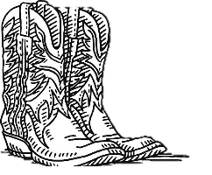
1) Your eyes! Observe how heavily plants have been grazed, if they’ve regrown well or need more rest.
2) Your boots! Get out there and move livestock to a new field when they need to be moved!
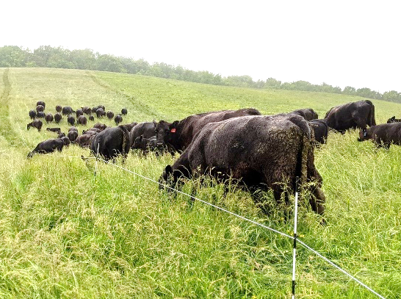
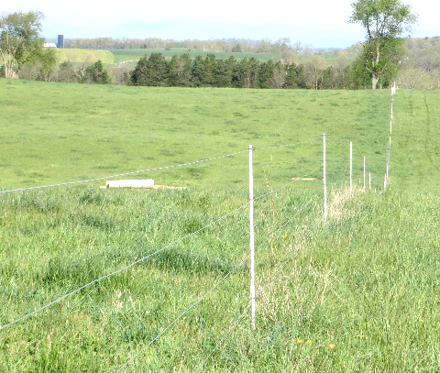
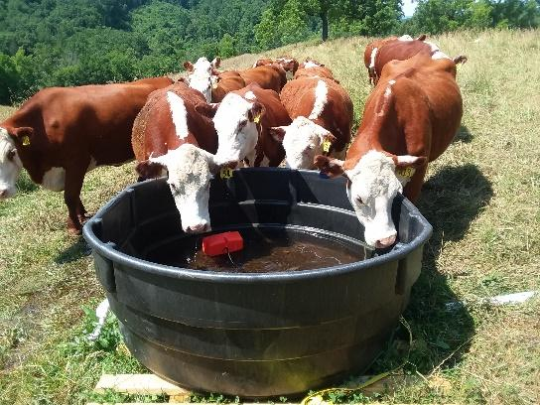
3) Fence and water! A simple rotational grazing system will have 4 or more paddocks of about equal size. Each one should have access to water (1 water source in the center works great). There are many different options out there for fence and water.

Pasture Renovation
This includes:
- Adding lime, phosphorus, or potassium based on a soil test.
- Seeding desirable plant species if needed to improve soil cover and pasture productivity
- Resting areas that have been overgrazed or overused
The main tools for pasture renovation are:
1) Lime, and Fertilizer or Manure.
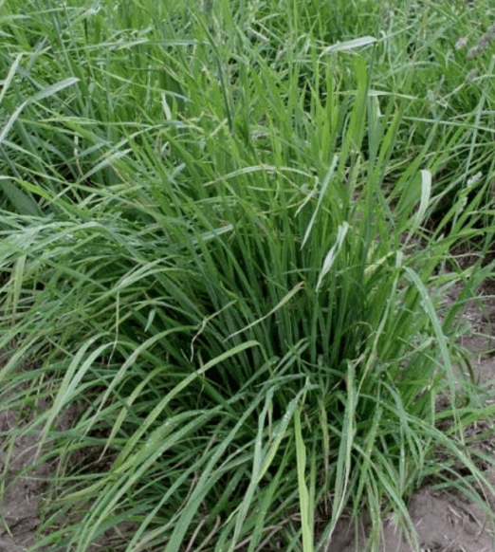
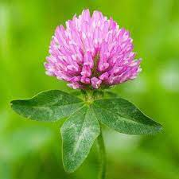
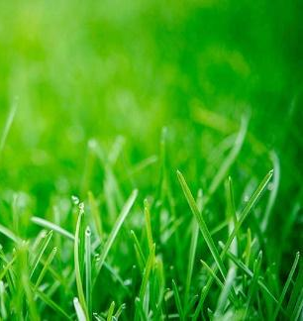
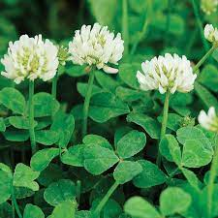
2) Seed. For high traffic areas, tall fescue and annual ryegrass are the go-to species in Virginia. In productive pasture areas, orchardgrass, tall fescue, Kentucky bluegrass, white clover, and red clover are great.
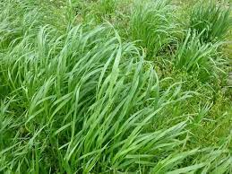

Annual ryegrass
Orchardgrass
Red clover
White clover
Kentucky bluegrass

Seed is best planted with mechanical means, but can be broadcasted…doing so in winter is called “frost seeding”, because freezing and thawing cycles of the soil place seed into the soil.
3) Fence, water, and hay location. Fencing can be used to keep animals away from an area that needs rest, especially during times of the year where soils are more susceptible to damage (wet soils). Water and hay placement can draw animals to under-used parts of the pasture.
