Animal Nutrition Background
Ruminant animals have a unique digestive system that allows them to eat fiber-containing plants and plant parts that many other animals cannot.
Ruminants are able to do this because of a specialized stomach with 4 compartments. Part of this stomach, the rumen, is home to microbes that digest plant fiber and other plant components. The microbes’ waste products and dead microbes are then used by the animal as their main source of energy, amino acids (protein), and vitamins.
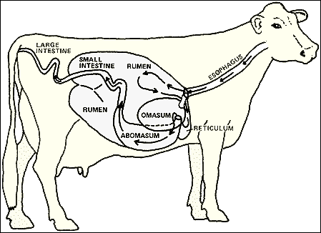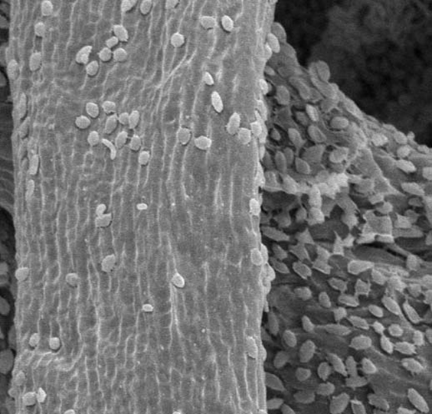
Microscopic image of microbes digesting fiber particles
The relationship between the ruminant animal and the rumen microbes is a symbiotic relationship—a relationship in which both organisms depend on and benefit one another.
For Good Rumen Health…
- Make sure at least 20% of the animals’ diet is fiber, such as hay or pasture. This feeds the microbes and keeps rumen pH correct
- Make any feed changes gradually (so microbes can adapt)
- Provide a complete mineral mix (microbes use this to make all the vitamins livestock need

Animal Nutrition and Nutrition Economics – Part 1
When feeding ruminant animals there are 5 main nutritional needs to consider.
- WATER
- Minerals
- Energy
- Protein
- Fiber
Today we will just be looking at ENERGY and PROTEIN
Researchers have tested and compiled information from many different feeds to guide us as we ensure our livestock have what they need.
- Animal nutritionists talk about energy in terms of “TDN” (total digestible nutrients).
Calories are how we people measure the energy in our diets. TDN is simply how we talk about energy for ruminants. You can think of TDN in the same way you might think of calories.
- Protein is measured in terms of “CP” (crude protein)
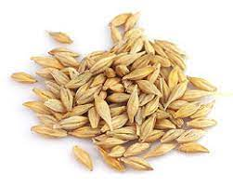
Because energy is usually the limiting nutrient determining how fast cattle grow, we often price feeds on their cost per pound of energy to help us make feeding decisions.
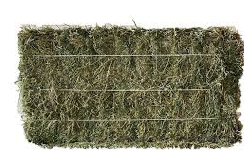
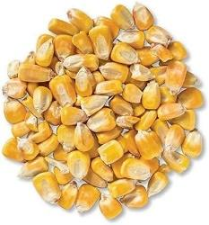
Example Feed Chart:
Feed Type | % TDN (Energy) | % CP (Crude Protein) | Cost per pound of TDN
barley grain | 77 | 14 | $0.25
corn grain | 88 | 8 | $0.21
12% stock blend | 75 | 12 | $0.24
alfalfa hay | 60 | 22 | $0.15
1st cut grass hay | 54 | 9 | $0.10
2nd/3rd cut grass hay | 65 | 13 | $0.11
spring & fall grass pasture | 60 | 10.8 | $0.01
summer grass pasture | 45 | 9 | $0.02

- Which feed can support the fastest growth of cattle?
- Which feed can support the least expensive growth of cattle?
- What kind of limitations on a farm might determine what kind of feed and how much feed can be raised?
- What farm resources (covered buildings, manure storage, feed storage, etc.) might be necessary for feeding livestock versus grazing livestock?
- How might our rainy climate and proximity to the Chesapeake Bay affect how we raise livestock? Hint: 90% of nutrients consumed come out the back end of the animal!
Animal nutrition and nutrition economics – Part 2
We’ve looked at the nutritional contents of some different feeds. Now let’s look at how those feeds compare to the needs of our livestock.
Livestock Type | % TDN (Energy) | % CP (Crude Protein) | Daily lbs. feed consumed | Daily lbs. of TDN consumed
beef cow (pregnant) | 58 | 8.7 | 32.5 | 18.9
beef cow (lactating) | 60 | 10 | 35.8 | 21.5
beef cow (dry) | 45 | 6 | 31.5 | 14.2
600-lb. calf (gain 3 lbs./day) | 70 | 13 | 18 | 12.6
800-lb calf (gain 3 lbs./day) | 70 | 11.4 | 20.4 | 14.3
1,000-lb calf (gain 3 lbs./day) | 65 | 9.7 | 23.9 | 15.5

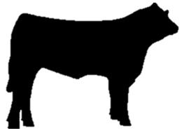

- Cattle that don’t gain weight fast enough when being backgrounded or fattened are often not ready to go to market on time.
- Mama cows that do not quickly regain weight lost while nursing a calf often do not re-breed quickly enough to have their next calf on time.
- The milk production of dairy cows fluctuates from day to day based on the energy and protein in their diet
Questions:
1. How many lbs. of 1st cut grass hay would it take to meet the 14.3 lbs. of energy (TDN) required daily by an 800-lb calf gaining 3 lbs./day?

14.3 lbs. of TDN per day (needed by calf) ÷ 0.54% TDN (% 1st cut hay) = **__________________ **Pounds of hay needed to be consumed daily to gain 3 lbs./day

2. Based on the amount of feed that can be consumed daily by an 800-lb calf (daily lbs. feed consumed), do your calculations show that the animal can eat enough 1st cut grass hay to meet their daily energy needs?

3. Suggest another feed that might pair well with the hay in order to keep costs low while also ensuring the calf gains adequately to go to market on time.

4. What differences exist between the Midwest and the Eastern U.S. that might change what we raise and how we raise them? Hints: soil suitability for grain vs. grass, weather differences, population density, environmental concerns.

5. Feed prices and availability are always changing due to supply and demand, seasonality, etc. What problems could this cause to, for example, someone fattening cattle on pasture?

