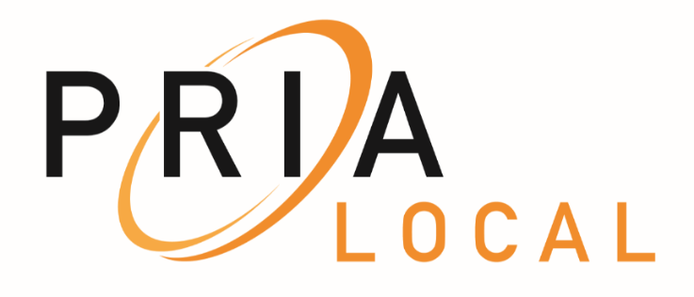

SOUTHEAST MINNESOTA CHAPTER

Meeting Agenda

March 13, 2019 - 10:00 a.m.

Hosted by: Rochester Title

Location: Crooked Pint

2723 Commerce Drive NW, Rochester, MN 55901

* **Welcome ~ New attendees to PRIA Local**
* **Name change from PREP to PRIA Local**
* **Introductions**
* **Approval of Minutes**
* **Remote Notaries and Electronic Signatures – Bert Black, Legal Advisor / Minnesota Secretary of State’s Office**
* **Subdivision Plats – everything you want to know on the process from the beginning stage to “I need an address and PID# to close for a client”! Mark Engel / Olmsted County Planning Supervisor and Mark Severtson / Olmsted County Surveyor**
* **Septic Systems – general discussion for the group on current county processes and thoughts on possible modification of state statutes to require documentation to be filed.**
* **Legislative update – Representative Gene Pelowski.**
* **Updates - questions / title agents, law offices, lending institutions – open forum**
* **County Recorder Updates**
* **Other items**
* **Next meeting date ~ May 8, 2019~ location & co-hosts to be determined**
* **Adjournment**

**Susan Kramer**

**Secretary ~ PRIA Local – SE MN Chapter**

**Phone (507)328-7673**

**Email:** [**Kramer.susan@co.olmsted.mn.us**](mailto:Kramer.susan@co.olmsted.mn.us)

**Chapter Co-Chairs:**

**Jim Ohly ~** [**jim@ohlylaw.com**](mailto:jim@ohlylaw.com) / **Kelly Callahan ~** [**Kelly.callahan@co.freeborn.mn.us**](mailto:Kelly.callahan@co.freeborn.mn.us)