Meet the President:

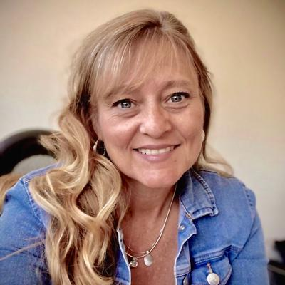

Brenda has worked for Teitle Law Offices, P.C., since 2002, beginning her career in the legal field in 1996, and deciding on her career path in 6th grade. Her current areas of work, in Iowa and/or Illinois, are real estate, family law, adoptions, estate planning, probate, personal injury, small business, and corporate law, with previous experience in workman’s comp and bankruptcy. She attended Sauk Valley Community College, and transferred to the American Institute of College, effectuating her permanent move across the river from little town Illinois to big town Iowa. Brenda returned to school attending Carl Sandburg College in 2018 continuing her education with her Paralegal Certificate. She is a member of NALA and IPA. Brenda resides in Davenport with her dog and two cats. She and her late husband have two adult daughters, Olivia (former Illinois Army National Guard servicemember) and Ciera, (former Iowa Army National Guard servicemember and currently enlisted in the U.S. Army). Her family is growing with the addition of two granddaughters born in 2019 and 2021! In her spare time, Brenda has an event planning business, she is actively involved in her church and other community organizations for fundraising and events. She has a passion for traveling, loves music, reading, crafting, wine, and spending time with her large family and friends.
Meet the 1st VP:

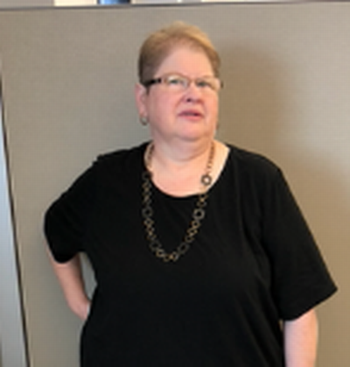

Sherry Darnielle is a Senior Paralegal at Wells Fargo. She has been employed there for 22 years working in defensive litigation regarding mortgage, credit card, personal lines and lending etc. For the past year she has been working on an paralegal internship program for Wells Fargo. Prior to Wells Fargo she worked for various small law firms and as a contractor for Child Support Recovery. She enjoys reading, quilting (all types), going on vacation trips with family and friends and photography. Favorite show of all time is Law and Order (the original) but loves the spin offs as well.
Meet the Treasurer:

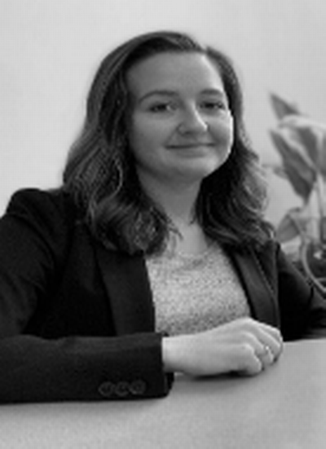

Kristina is currently employed as a paralegal with Peddicord Wharton in West Des Moines where she has been since 2017. She is a graduate from the Paralegal Program at DMACC in 2013 where she learned many skills that would help her excel at her career. In her daily work, Kristina supports her attorneys on a few different areas of law including workers compensation, personal injury, medical malpractice, and insurance malpractice. Kristina enjoys continuing to learn new skills and networking, and has served on the Board with the Iowa Paralegal Association since 2017. When she is not in the office, she enjoys traveling, traveling some more, floating down a river, hanging with her dog, painting, and board games with friends.
Meet the Secretary:

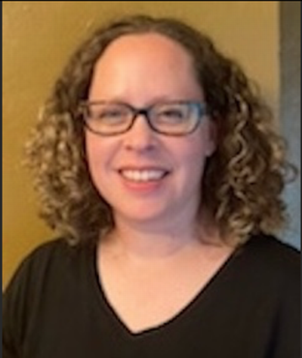

Jill is a Paralegal for the Office of the West Des Moines City Attorney which represents the city on all municipal law issues. The Attorney's advise and represent the Mayor and City Council, city boards and commissions and each city department. Currently Jill is working in alcohol and tobacco law violations, civil infractions, small claims, traffic and simple misdemeanor cases and real estate transactions.
Prior to working for the City, she was employed at a general practice law firm primarily working in criminal law, civil litigation, real estate and family law.
She has a Master of Arts and a Bachelor of Arts in Criminal Justice and an Associate of Science in Office System Specialist.

Meet the Technology Director:

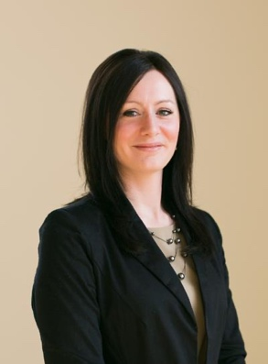

Jody is an Advanced Certified Paralegal (ACP) at O’Connor & Thomas, P.C. (ACP in Trial Practice). She has enjoyed working there since 2010 and is currently working in the area of litigation including workers compensation, personal injury, insurance defense and occasionally family law. Her attorneys practice in Iowa, Illinois and Wisconsin. Jody has obtained an Associate of Applied Science in Paralegal Studies and has obtained her CP® (Certified Paralegal) and ACP® (Advance Certified Paralegal) credentials through NALA. Jody is a member of Iowa Paralegal Association, National Association of Legal Assistants.Paralegals, National Federation of Paralegal Associations, Illinois Paralegal Association, Paralegal Association of Wisconsin and The Navy League. If you should have any questions, concerns or comments, please do not hesitate to contact Jody.
Meet the NALA Liaison:

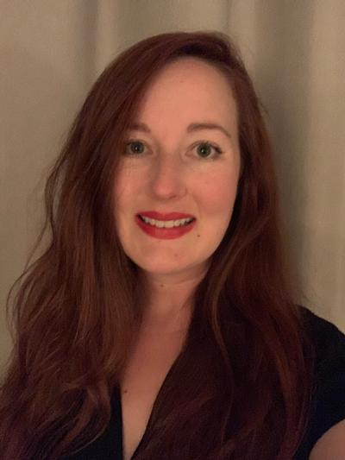

Nicole French is employed with Seidl & Seidl, P.L.C., located in both Cedar Rapids and Monticello, Iowa, a general practice law firm working mostly in the areas of civil litigation, personal injury, family law, and probate, including estates, guardianships, and conservatorships. She has been a Paralegal for 19 years and obtained her Associate of Applied Science Degree in Paralegal Studies from Hamilton Business College. In 2008, Nicole was admitted as a Paralegal Affiliate member of the American Association for Justice. She has been a member of the Cedar Rapids Kirkwood Paralegal Program Advisory Board Committee since 2016. Nicole is a member of the National Association of Legal Assistants & Paralegals (NALA), and longtime member of NALA's State Affiliate, Iowa Paralegal Association, being admitted in 2004 as a student member before advancing to active membership. She has dutifully volunteered her time and efforts serving on multiple committees as well as the Board of Directors since 2014 as Region VI Director from 2014-2016, Treasurer from 2015-2019, 1st Vice President & Seminar Director from 2019-2021, President from 2021-2023, and currently serving in her capacity as Past President and NALA Liaison.
Meet the ISBA Liaison and Region I Director:

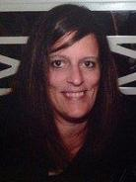

Shelley is a paralegal at Hammer Law Firm, P.L.C. in Dubuque, Iowa. She attended NICC and received her Associates Decree in Paralegal Studies in 2013. She was an intern at Hammer Law Firm, PLC and was hired in 2013 as a paralegal. Her areas of work include family law, criminal law, personal injury, estate planning, probate and municipality. She is a member of NALA, IPA and the Illinois Paralegal Association. Shelley enjoys volunteering in her community. Shelley resides in Dubuque, Iowa with her fiancé. Their family combined has five children and seven grandchildren.
In her spare time, Shelley enjoys spending time with family, being outdoors and decorating.

Meet the Region V Director:



I am a Family Law Paralegal for Noble Law PLLC. I enjoy using my skills to contribute to the best interests of children in my area and surrounding communities. I graduated from Kirkwood Community College in 2023 with an associate degree in paralegal studies. I currently live in Des Moines, Iowa, but I grew up on the beautiful eastern coast of Virginia. In my free time I enjoy reading, hiking, and spending time with friends and family.
Meet the Region VI Director:



Kimberly Postel is an accomplished paralegal at RSH Legal and a dedicated member of the Iowa Paralegal Association (IPA). With extensive experience in legal support, Kimberly plays a vital role in assisting attorneys with case management, legal research, and client advocacy.
At RSH Legal, she specializes in nursing home negligence, wrongful death, and medical malpractice, ensuring clients receive the highest level of professional support. Kimberly's keen attention to detail and commitment to justice make her an invaluable asset to her firm and the legal community.
As an active participant in the Iowa Paralegal Association, Kimberly contributes to the advancement of the paralegal profession through networking, continuing education, and professional development. She is passionate about upholding the highest ethical standards and fostering a strong legal support network across Iowa.
Outside of her professional work, Kimberly enjoys working in her yard (dirt therapy), spending time with her family, and mentoring her “Little” through Big Brothers Big Sisters (BBBS).

