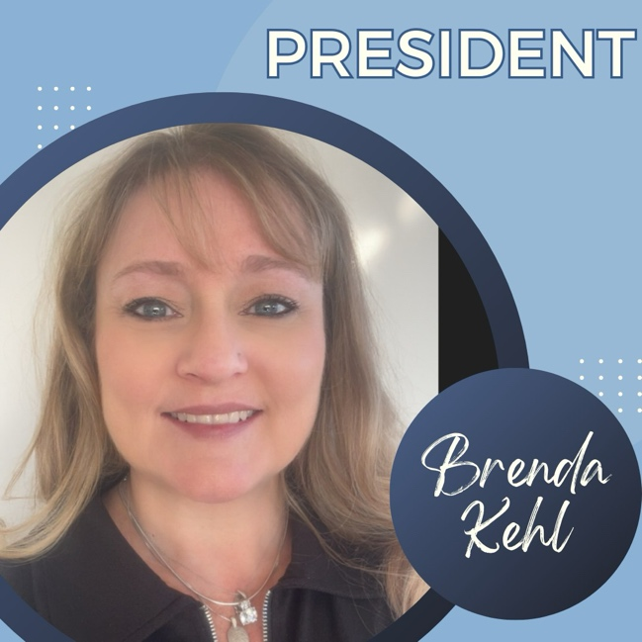

Brenda Kehl serves as President of the IPA, with a career dedicated to excellence in legal support and professional development. Her vision for the association centers on professional growth and advocacy, to ensure paralegals across Iowa have access to resources, recognition, and respect they deserve within the legal field.

Brenda began her career in 1996, and has worked for Teitle Law Offices, P.C., since 2002. Her current areas of work, in Iowa and/or Illinois, are real estate, family law, adoptions, estate planning, probate, personal injury, small business, civil litigation, criminal and corporate law, with previous experience in workman’s comp and bankruptcy. She is a member of NALA, IPA, ABA, and Iowa Bar.

Brenda resides in Davenport with her fiancé Steve, beloved dogs and cats. She has adult children with her late husband who have given her the treasured title of “Nana” with several grandchildren and step-grandchildren. In her spare time, Brenda has an event planning business, works evenings in retail, and is actively involved in her church and other community organizations for fundraising and events. She has a passion for traveling, loves music, reading, and spending time with her growing family and friends.

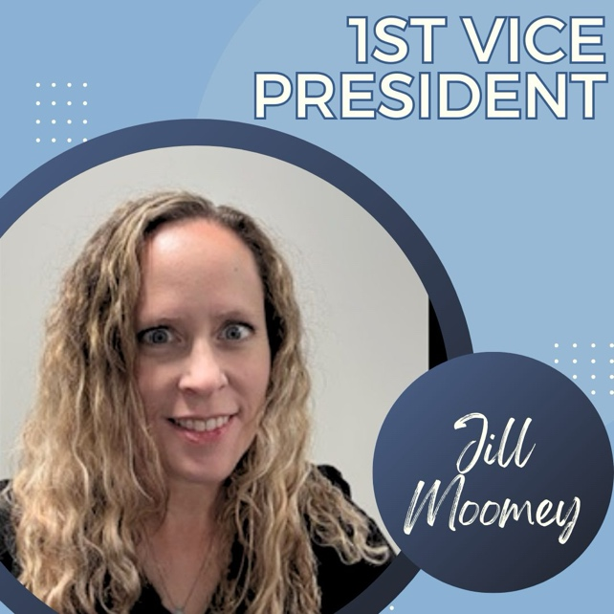

Jill is a Paralegal for the Office of the West Des Moines City Attorney which represent the city on all municipal law issues. The Attorney’s advise and represent the Mayor and City Council, city boards and commissions and each city department.

Prior to working for the City, she was employed at a general practice law firm primarily working on criminal law, civil litigation, real estate and family law.

She has a Master of Arts and a Bachelor of Arts in Criminal Justice and an Associate of Science in Office System Specialist.

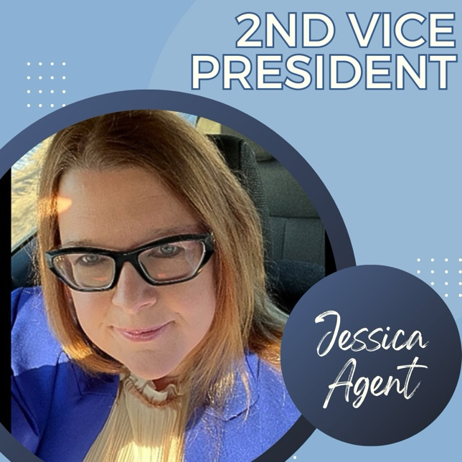

Jessica Agent grew up in Huxley, Iowa, and graduated from Ballard High School in 1999. After high school, she attended Blackhawk College in Kewanee, Illinois, where she majored in Equine Science. She later relocated to Dallas, Texas, to complete her Associate’s Degree in Paralegal Studies at El Centro College, now known as Dallas College – El Centro Campus. During her time there, she was active in the Student Paralegal Association and the Dallas Paralegal Association, and she was inducted into the Phi Theta Kappa Honor Society for Two-Year Colleges. She continued her education by earning her Advanced Paralegal Certification at Texas Christian University – Go Frogs!

While completing her education, she worked as a Case Clerk at a prominent Dallas insurance defense law firm, as well as an underwriter for a bail bonds company. Upon graduation, she accepted a position as a Post-Judgment Paralegal in Carrollton, Texas. Since returning to Iowa in 2022, she has served as a paralegal in Ames, Iowa, working with attorneys in the areas of criminal, family, and personal injury law.

She is honored to be part of this prestigious organization and looks forward to the opportunity to serve.

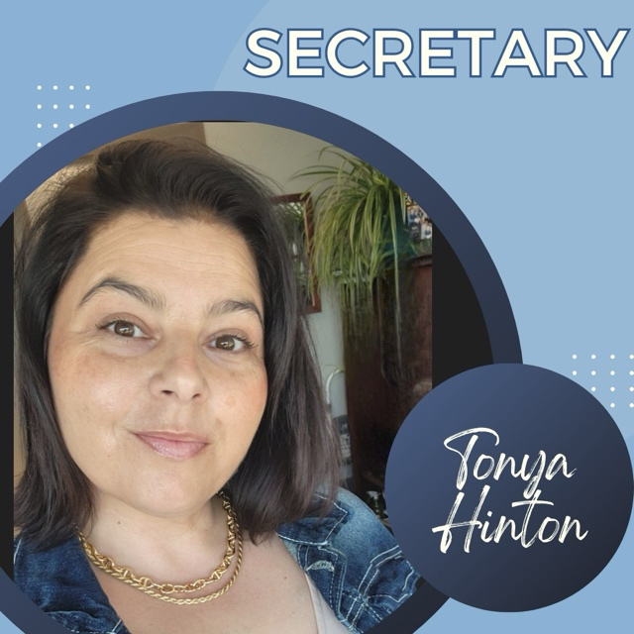

Tonya Hinton has been a litigation paralegal at RSH Legal, P.C. since September of 2021. At RSH she has worked personal injury cases handling premises liability, trucking and motor vehicle accidents, and dog attacks. She obtained her Associate of Applied Science in Paralegal Studies degree at Kirkwood Community College and is on track to complete her Liberal Arts -Associate of Arts degree in the Summer of 2026. She is a member of National Association of Legal Assistants, The Paralegal Association (NALA). Her professional background encompasses 15 years of legal experience. For 11 of those years, experience included engagement of outside counsel located in various states across the U.S., managing commercial litigation cases, as well as training and managing a litigation team. Tonya has three adult children who she adores and a very energetic German/English short haired pointer dog named Gema who is ridiculously spoiled. She enjoys traveling and staying home in equal measures.

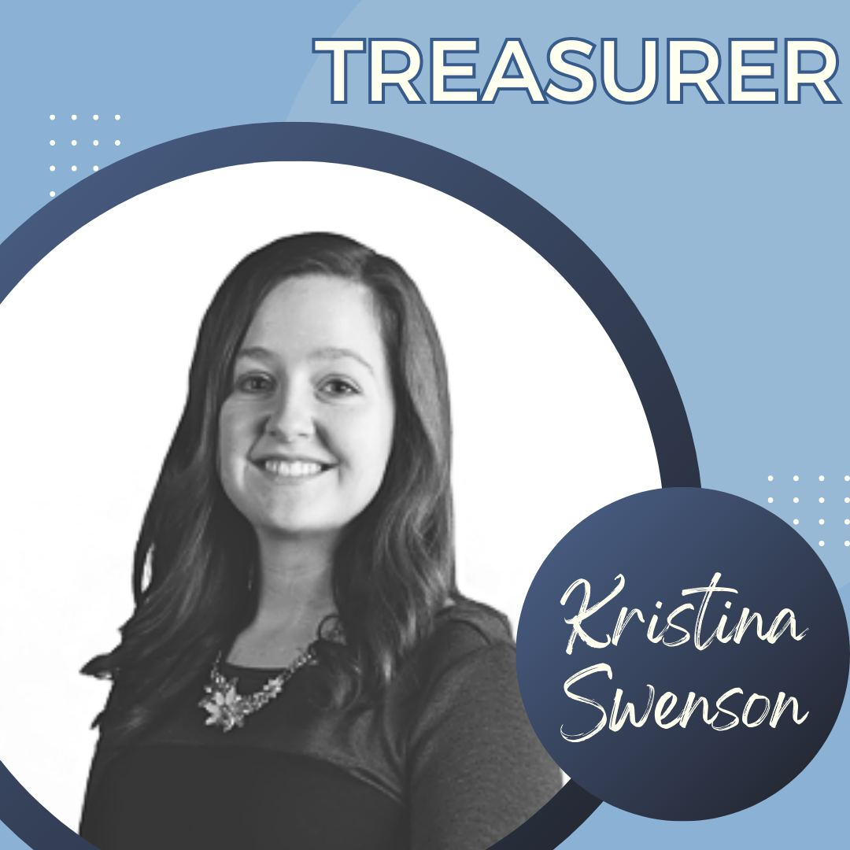

Kristina Swenson is a paralegal at Peddicord Lillis where she has worked for the last 8 years. She truly enjoys her work and finds it very fulfilling. When she is not in the office, she enjoys traveling in her camper van with her husband and dog (a Japanese Akita named Luca), painting, knitting, crafting, and playing board games with friends.

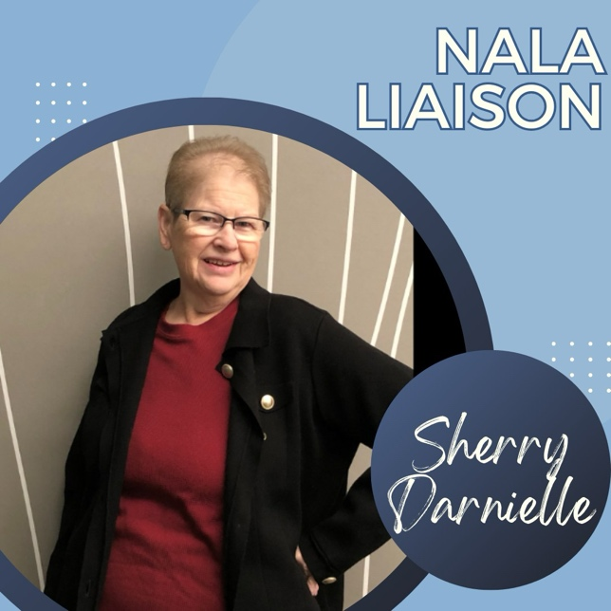

Sherry obtained her paralegal degree in 1986 and has worked for several small law firms. In 2001, she earned her degree in Business Administration, followed by a Master’s degree in Public Administration in 2004. Sherry has worked for Wells Fargo as an office manager in the legal department and, for the past several years, as a senior paralegal in mortgage litigation and currently credit card litigation. She will be celebrating 25 years with Wells Fargo in March 2026.
Sherry has held several positions on the board and has enjoyed working with the board!

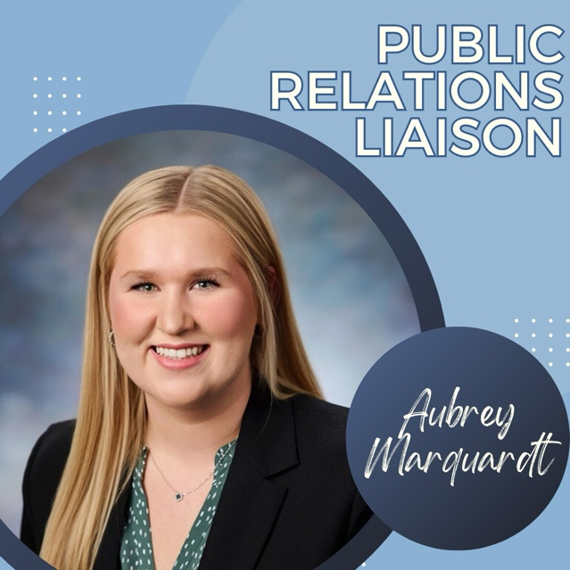

Aubrey works for RSH Legal in Dubuque. She graduated with honors from Northeast Iowa Community College, earning both an Associate of Applied Science degree in Paralegal Studies and an Associate of Arts degree. Aubrey actively seeks professional growth and holds memberships with the Iowa Paralegal Association, the Iowa State Bar Association, and NALA - The Paralegal Association.

Driven by a passion for helping others and supporting the legal community, Aubrey is honored to serve on the Board of the Iowa Paralegal Association as their Public Relations Liaison and looks forward to supporting both association members and the paralegal community.



Jody is a Certified Paralegal at O’Connor & Thomas Law Firm, with an Advanced Certification in Trial Practice and is a State Bar of Wisconsin Certified Paralegal. Jody is the Technology Director of the Iowa Paralegal Association, is on the Advisory Board for NICC’s Paralegal Program, is a member of the IA, IL, and WI paralegal associations and two national paralegal associations. She is dedicated to providing outstanding services for the firm and is committed to her volunteer work.

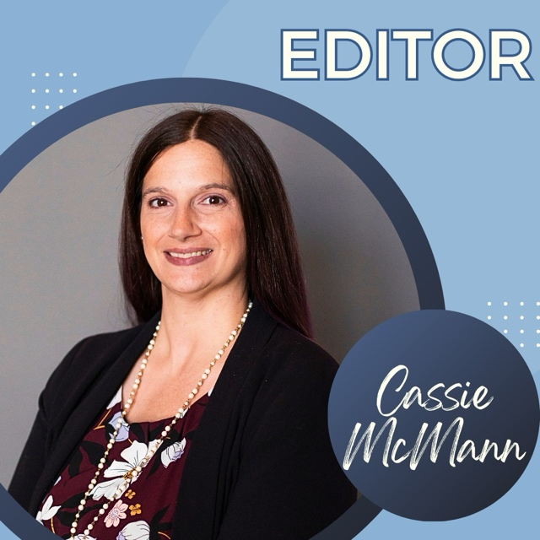

Cassie McMann graduated from DMACC with her A.A.S. in Paralegal Studies in December 2022. She has been a paralegal for Fidelity & Guaranty Life Insurance Company since March 2023 and has been employed with the company in other roles for over 10 years. She has over 20 years of experience in office administration and management, annuity and insurance operations, project management, and regulatory relationship management.

Cassie is a first-time board member and editor. She is excited for the opportunity to support association members and colleagues through her service to the organization.

In her spare time, Cassie enjoys knitting, reading, hiking, and spending time with her husband, Luke, and her dog, Helen.

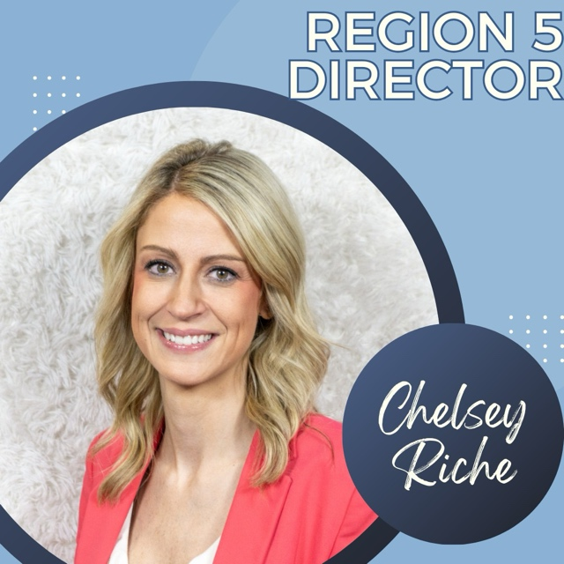

Chelsey is currently a Managing Paralegal at DLL, bringing over 16 years of experience in the legal field. Her journey began during her freshman year at Simpson College with the U.S. Attorney’s Office, followed by a role at the Attorney General’s Office. She later joined DLL, where she has been a team member for more than nine years.

Chelsey is excited to join the Board of the Iowa Paralegal Association and is committed to fostering connection, promoting professional growth, and advancing the visibility and value of paralegals across the state.

Outside of work, Chelsey enjoys a full and lively home life with her husband and their three children, who keep her on her toes and constantly remind her of the importance of balance and staying present.

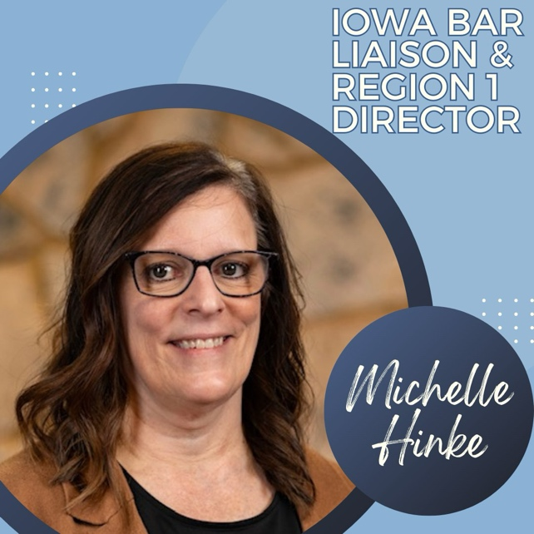

Shelley Hinke is a Paralegal at Hammer Law Firm, PLC in Dubuque, Iowa, where she has dedicated the past 14 years to supporting clients and attorneys with a wide range of legal matters.
She is an active member of the Iowa Paralegal Association, where she has served in multiple roles over the years. Shelley also serves on the Advisory Board for the NICC Paralegal Program and is a member of both the Illinois Paralegal Association and NALA.

In addition to her professional involvement, Shelley is committed to community service. She serves as a Commissioner on the City of Dubuque’s Community Development Advisory Commission and as Secretary on her Parish Council.

In her spare time, Shelley enjoys spending time with family, being outdoors, and decorating her home for every holiday and season.

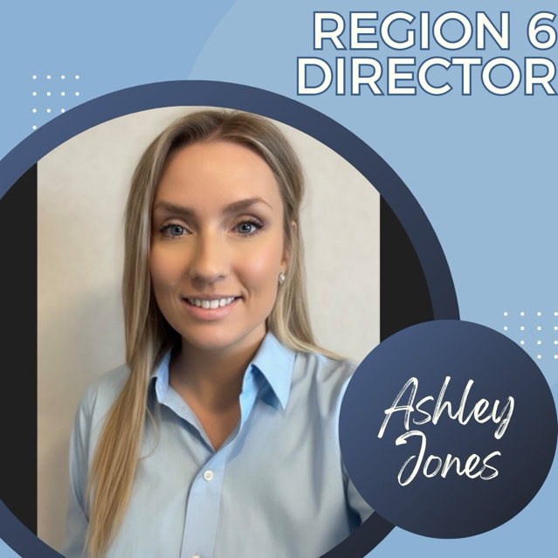

Ashley is currently a paralegal at RSH Legal, where she focuses on workers’ compensation. She is passionate about the law and dedicated to helping injured workers navigate the claims process. Ashley is thrilled to serve on the Board of the Iowa Paralegal Association and enjoys organizing her region’s quarterly Lunch & Learn meetings. Outside of the office, she likes to garden and spend time outdoors with her kids.

