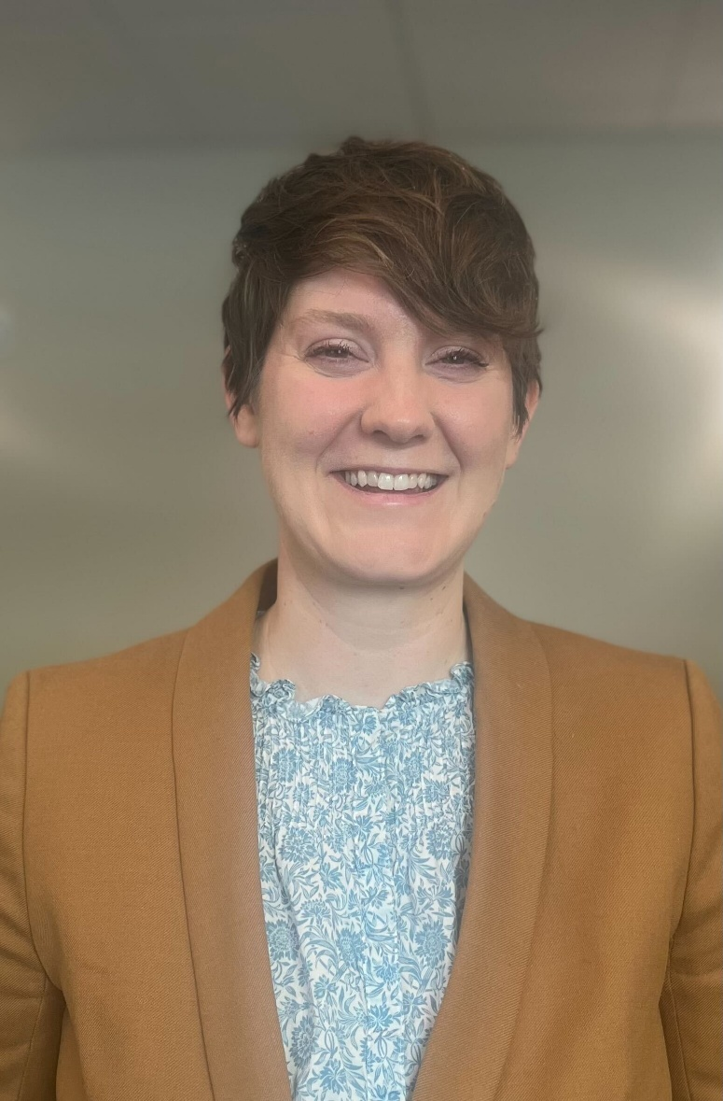
Allison Schmidt
Allison Schmidt joined the Iowa Supreme Court’s Office of Professional Regulation in 2019 and currently serves as the Deputy Director of Attorney Discipline and the Administrator for the Commission on the Unauthorized Practice of Law. Previously, Allison worked as an assistant attorney general in the area of professional licensing and administrative law. Allison graduated from the University of Iowa (2008) and returned to Iowa for law school (2016). She also has a master’s degree from Cleveland Institute of Music (2010), where she studied classical piano.

