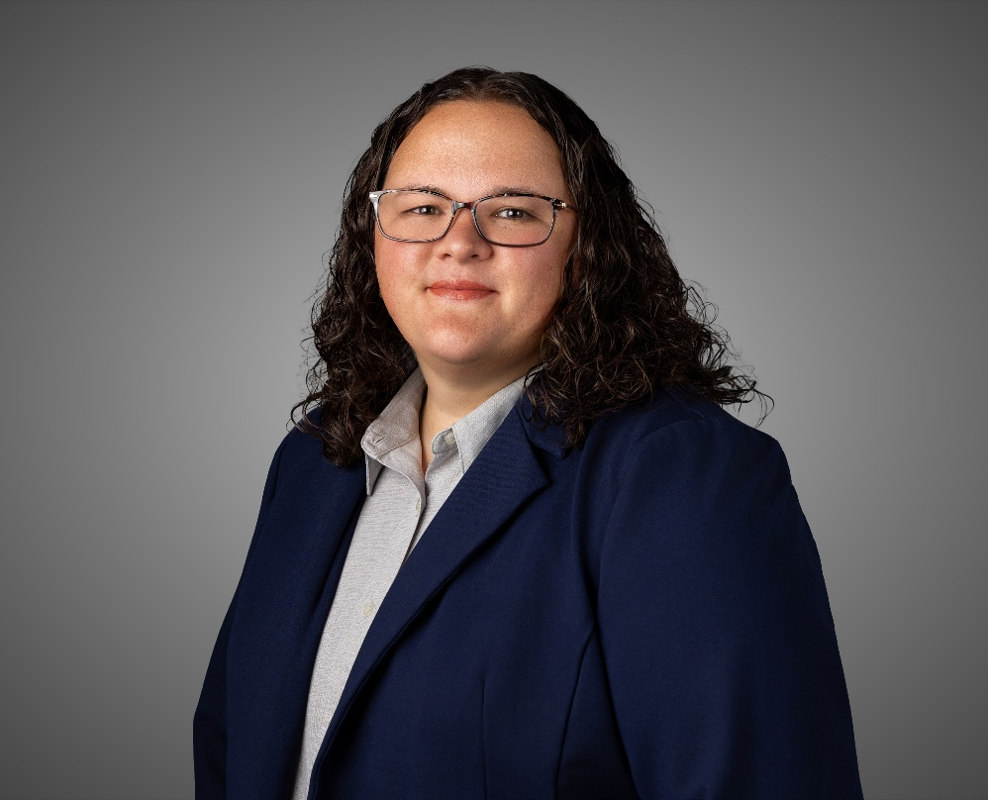


Rae Kinkead | Member
Simmons Perrine PLC
115 3rd Street SE, Suite 1200, Cedar Rapids, Iowa 52401
rkinkead@sp.law | (319) 896-4128 | www.sp.law
Rae Kinkead is a family law attorney and mediator. Having more than 10 years of experience, Rae recognizes that each case needs personalized legal strategies. She offers counseling and litigation services and is well-versed in mediation, limited representation, and collaborative law. Her practice focuses on family law litigation, child representation, collaborative law, limited representation, appellate advocacy, as well as guardianship and conservatorships for all ages, children and adults. She has been included in the Best Lawyers in America for family law in 2026.

