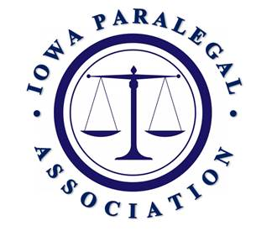
MID-YEAR MEMBERSHIP MEETING
APRIL 11, 2025, DMACC URBAN CAMPUS

- Convene/Call to Order: 12:34 p.m. Kehl and Moomey

- Approval of Minutes:
Annual Membership Meeting held September 13, 2024. Kristina Swenson moved to approve and Kaycee Schippers seconded.

- President’s Report: Kehl

74 total members
1 at large
4 in Region 1
5 in Region 2
3 in Region 3
2 in Region 4
31 in Region 5
25 in Region 6
3 in Region 7
0 in Region 8

Brenda gave a special thanks to all that helped with the Seminar and the Board.

- 1st VP/Seminar Director’s Report: Darnielle
Great seminar and planning the next seminar. Help is needed. The location will be back in Coralville/IA City area and we will have a date in the next couple weeks.

- Treasurer’s Report: Swenson
In good standing

- ISBA Liaison’s Report: Hinke
Reminder that paralegals can be members of the Iowa Bar. Shelly is working with the IA bar to get the IPA more connected.

- NALA Liaison’s Report: French
The NALA conference is coming up in July in Atlantic City. This year no one applied for the NALA scholarship.

- Region 5: Ryan
Planning on another lunch and learn next month

- Region 7: Postel
The next quarterly meeting is next week.

- Election of President for 2025-2027 Moomey
Brenda Kehl has been reappointed as President for the 2025-2027 years. We are very happy and honored to have her continue in the leadership role as President.

- Award Presentation Kehl
Kaycee Schippers was recognized for all her hard work with this seminar.

- Old Business Kehl
None.

- New Business Kehl
The board is in the process of amended the bylaws. We still have a few small correction, but notice will be given and all will be allowed to vote on the amendments.

- Adjourn:
12:45 p.m. motioned by Kaycee Schippers, seconded by Sherry Darnielle, motion carried.

