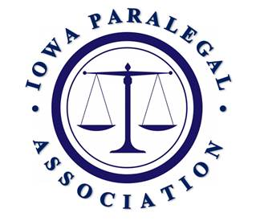

AGENDA – ANNUAL MEMBERSHIP MEETING

IOWA PARALEGAL ASSOCIATION
OCTOBER 10, 2025 KIRKWOOD COMMUNITY COLLEGE - CORALVILLE

A meeting of the members of the Iowa Paralegal Association, an Iowa non-profit corporation, will be held at Coralville, Iowa, on October 10, 2025 beginning at 12:30 p.m., for the following purposes:

- President’s Welcome, Announcements & Introductions
- Approval of Minutes of the Mid-Year Membership Meeting held April 11, 2025.
- Treasurer’s Reports
- Other Officer, Director & Committee Chair Reports
- Election results of 2025-2027 board of directors
- Award Presentations.
- Old Business.
- New Business
- To transact any other business that may properly come before the meeting.

Notice of the Annual Membership Meeting was given pursuant to Section 5.12 of the Bylaws of the Iowa Paralegal Association.

The minutes of the annual membership meeting held on April 11, 2025, are available on the dashboard sent to attendees.

Dated this 7th day of October, 2025.

Brenda Kehl
President
Iowa Paralegal Association

