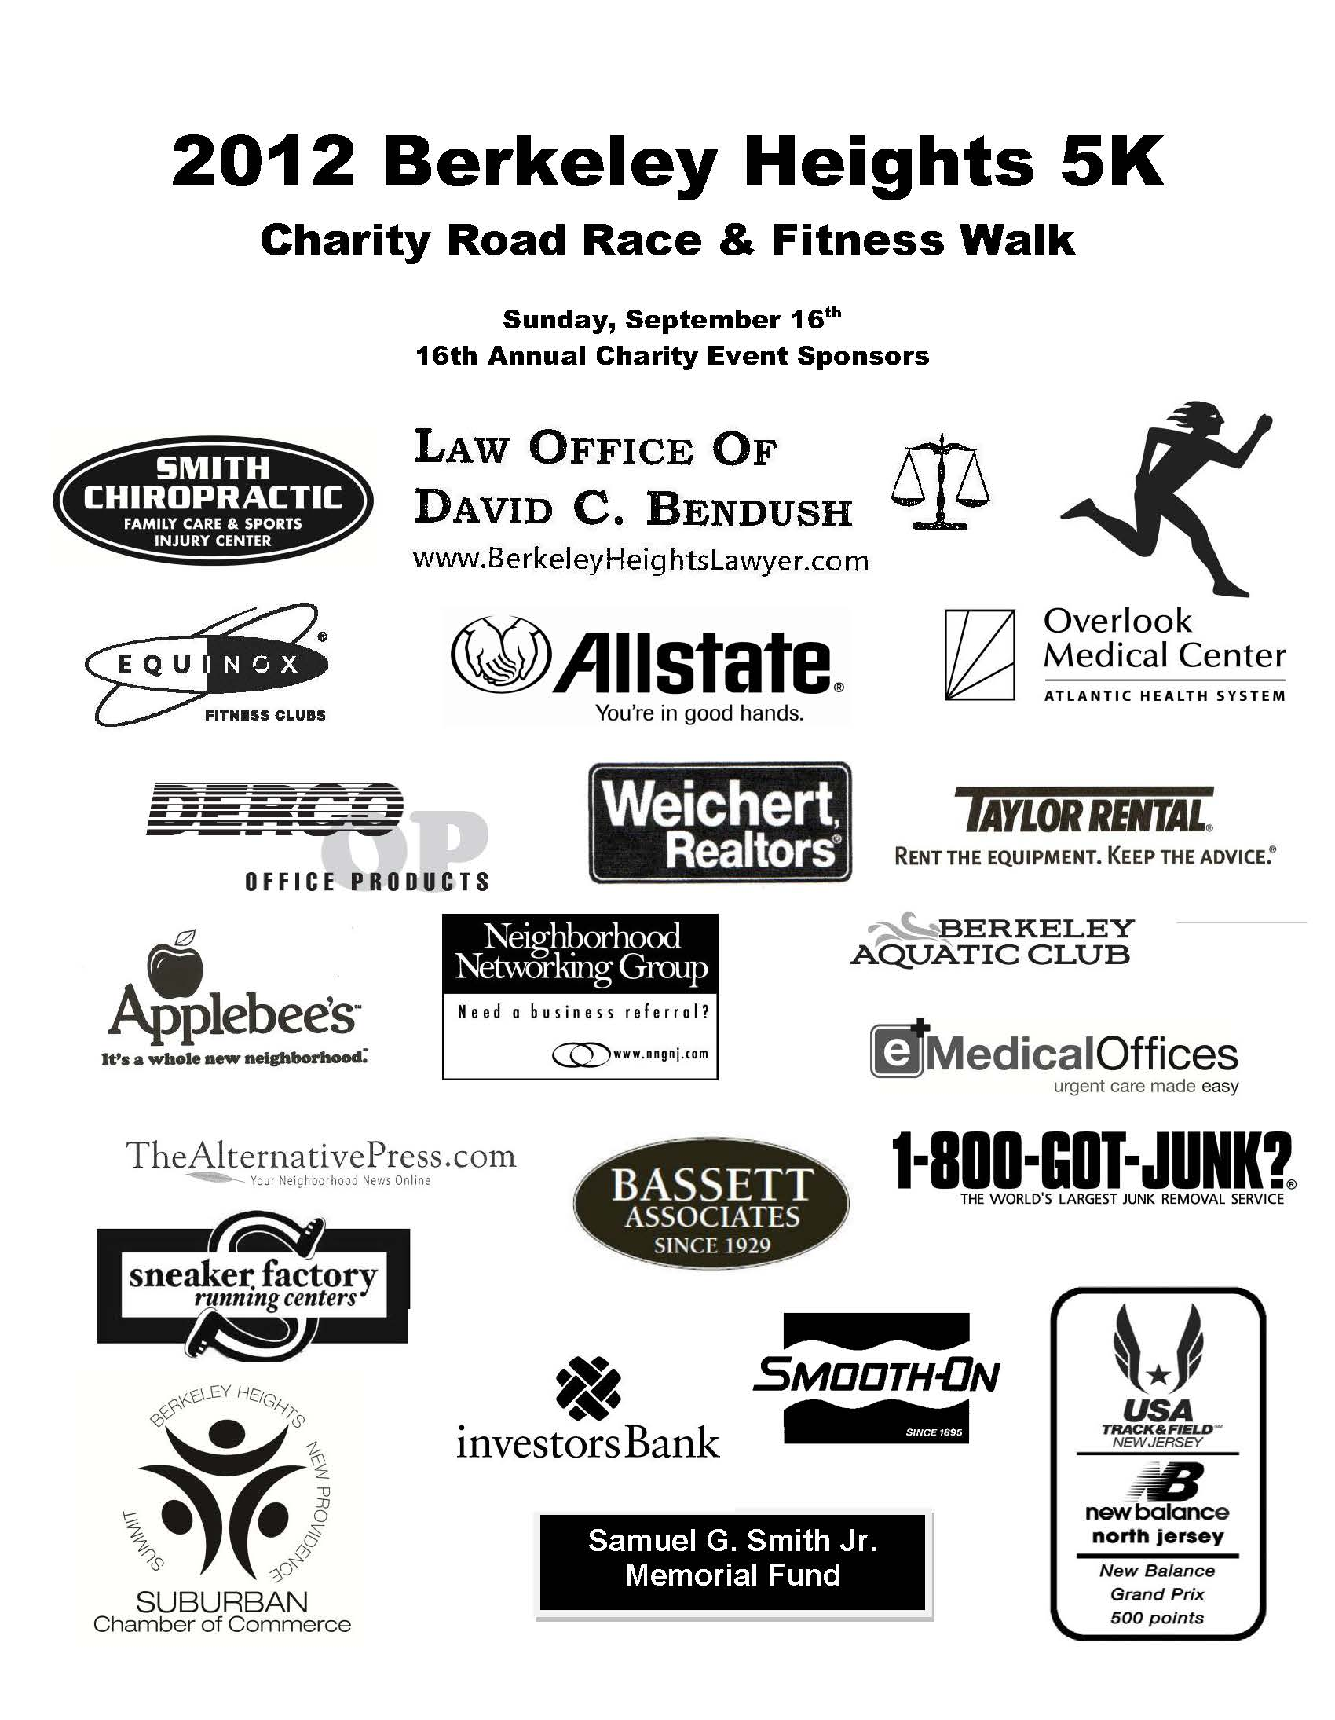
Acupuncture & Herbal Medicine- Dr. Zhou, OMD
AVAYA
Avelient Technology
Basking Ridge Country Club
betterway lawncare
Bleakley, Schwartz, Cooney, & Finney LLC
Cartridge World, New Providence
CET Heating and Air Conditioning, Inc.
Davies And Associates- Insurance Management
Family Foot Care- Gary L. Quartello, DPM
GABRIELE Fitness & Performance
Gary S. Crystal, DMD, Berkeley Heights
Glassworks of Summit

Goodman’s Restaurant & Deli
Hilltop Community Bank
Independent Press
John P. Sullivan, CFP, CPA
MAD NUTRITION
MARY’S Your Name Here
Paras & Paras, Summit
Philip E. Memoli, DMD, Natural Dentistry
Puro Clean Restoration Services, Cranford
Robinwood Kitchens
Summit Medical Group
Tee Bag Embroidery & Screen Printing
Walgreens

SCHEDULE OF EVENTS:
Late Registration/Packet Pick-Up: 7:45 AM
5K Run: 9:30 AM
1.5 Mile Fitness Walk: 9:35 AM
Fun Runs for Kids: 10:30 AM
Awards, iPod Drawings, & more: 10:50 AM
Registration & Info @ www.berkeleyheights5k.com
Red Cross Blood Drive
10:00 AM-3:00PM
Special I-Pad drawing
For more information,
please call 908-464-8899


