1 Часть I. Введение: о чем речь и почему это может быть интересно для Google. 5
Часть II. Основное содержание – изложение идей, путей их практической реализации. 7
2 Overview. 7
2.1 Introduction to the Philosophy of Technology. Objectives. 7
2.2 The Essence of Being. Synеrgetics. The Philosophical Basis of the Architecture. 7
3 The important inferences of synergetics used as key elements of the philosophical foundation of the proposed architecture. 8
3.1 The definition of the inevitability of self-organizing processes (from chaos to harmony, etc). 8
3.2 The Hierarchical Nature of Self-Organization Processes. 10
4 Requirements for the architecture of an information system that would be capable of ensuring evolution of data in concert with the ideas of synergetics. 10
5 Comparison of certain aspects of human thought with the ideas of synergetics concerning data evolution. 11
6 The delineation of the architecture of the perfect synthesis medium. 12
6.2 The composite nature of images created by the mind. The informational integrity of entities the mind operates with based on associative bonds. 13
6.3 The analysis of the deduction phenomenon from the viewpoint of synergetics. Synthesis of new IT with a lesser degree of order. The increase of the measure of chaos. 13
6.4 Discarding superfluous information in problem solving (Ockham’s Razor). Scaling of Informational Entities within the user’s attention span and focus. 13
7 Designing an architecture based on the above conclusions. How to mirror the main patterns of self-organization processes in information systems. 14
7.2 The analogy with the central nervous system (CNS) – architecture of the networks – the specialization of neuron groups – conveyor-like information processing. 14
7.3 CCA – Context Conveyor Architecture analogous to the architecture of the CNS. 15
8 Definition and implementation of CCA consistent with the proposed philosophy of informational evolution. 16
8.2 Subtle dosing of information. Seamless control of information scaling. ISM. 17
8.3 The problem of informational integrity in an Information System. Automated control of the relevance factor. 21
8.4 The broadened possibilities of data processing. 22
8.5 Improved handling of authorship issues. 22
8.6 Analysis of the dynamic chaos issue. Deduction. Fractioning/identifying information entities. 22
9 Дополнение: ККА в действии. 24
9.1.1 Пирамида узлов синтеза. Схема роста пирамиды узлов синтеза. 24
9.1.2 Дополнение: ККА как унифицированная основа сетевого взаимодействия (кооперации). 30
10 Association Management. 31
10.1 Defining the task of improving information’s ergonomics. 31
10.1.2 Introduction of the subsystem (Association Management) to interface processes. Requirements for Association Management. 31
10.1.3 The main purpose of Association Management, “what it does.” 33
10.1.4 The composite principle of AM image organization. The library of basic components (BC) for AM imaging. 33
10.1.5 Necessary conditions for AM’s efficiency. 35
10.1.6 How to ensure that the structure of each AM image resembles the actual structure of images in the human mind 36
10.1.7 The emotional tint requirement. 36
10.2 AM as a tool for improved text perception. 36
10.2.2 AM in improving text perception. 37
10.2.3 The composition of AM images that include text. 37
10.2.4 Improvement of text perception through interpretation of definitions and individual words. 43
10.3 The unification of the elements of the user interface. Increasing the recognition and informativeness factors of user controls. 43
11 Implementation of AM mechanisms. 44
11.1 The Principle of Composite Image Formation. 44
11.2 The principles of AM’s scaling mechanism. 46
11.2.1 New layers’ activation – the elements of an AM image. 47
11.2.2 Contrast and visibility control in AM imaging. Significance value. 48
11.2.3 Providing continuity (recognition) for AM images, as well as their individual components during scaling. 48
11.3 Grouping images with common features. Visualization of image community (не уверен в точности передачи смысла). 50
12 AM-powered search and navigation. Adaptive Associative Navigator (AAN). 52
12.1 Specifications. 52
12.2 Solutions. Examples. 53
12.3 Assessment of the advantages of Adaptive Associative Navigator (as opposed to traditional search and navigation systems). 54
12.4 AAN and dialogue; step-by-step modes of the user interface. 55
12.5 AAN in further development of keyword and tag searches. 55
12.6 AAN-based information structuring (object dragging). 56
13 Speeding up navigation by improving the user’s perception of quickly altered images. Improvement of scrolling ergonomics, dynamic animated processes, etc. 56
14 Marketing possibilities for CCA, AM, ISM, and AAN. AM and ISM-based manipulation of opinions. 59
14.2 Psychological manipulation via scaling tools. 59
14.3 The basics of AM-assisted manipulation. Introduction. 60
14.4 Creation of the required emotional association based on the composition of emotionally colored elements of AM images. 60
14.5 Emotionally colored content – donors of emotional coloring – the basis for the library of emotionally colored components of AM images. 63
14.6 AAN-based Context Advertising. 64
14.7 Copyright. Advantages. Assets. 64
14.8 Conclusions. Nominally free software and information resources. “A no-charge world.” Social aspects. 66
15 AI problematics. The Aggregate NeuroComputer (ANC). 67
Часть III. Выводы по основному содержанию. Формулировка предложений автора на ближайшую перспективу. 69
1 Приложение. About the author. 71
1.1 My credo. 71
1.2 Hobbies. 71
1.2.1 Target Practice. 72
1.2.2 Flying. 72
1.2.3 History. The History of Art. Historical figures. 73
1.3 Professional Interests. 74
1.3.1 IT. 74
1.3.2 Psychology, cognetics, pedagogics. 76
1.3.3 Philosophy and Theology. 76
1.3.4 Art (a professional interest as psychoactive material and embodiment of duality). 77
1.4 Some Chronological Matters. 79
2 Приложение. Словарь сокращений 80

Часть I. Введение: о чем речь и почему это может быть интересно для Google.

Данный документ содержит пакет предложений, касающийся одних из основных направлений отрасли информационных технологий:
- общая схема обработки информации, точнее, схема эволюции информации
- организация пользовательского интерфейса
- технологии рекламы.
На самом общем уровне суть предложений можно свести к следующему: в соответствии с выводами синергетики (научное направление о самоорганизации материи) предлагается реализовать системообразущую среду, с которой пользователь взаимодействует через особый слой программной логики, через особый программный объект – менеджер ассоциаций, который отвечает за управление ассоциациями его сознания. Менеджер ассоциаций реализуется таким образом, что он обладает способностью эмоционального манипулирования восприятием информации: он может перенести повышенный интерес с одних категорий информации на другие. Что открывает дополнительные возможности коммерческой эксплуатации информационного контента без какого-либо ущерба к традиционным схемам. Более того, для некоторых категорий контента открывается возможность эффективной коммерческой эксплуатации в принципе, что было ранее невозможно для этих категорий информации по традиционным схемам.
Почему я считаю, что мои предложения могут быть интересны Google. С одной стороны, Google имеет традиционный интерес к рекламе, рекламным технологиям в целом. А мои предложения в значительной мере касаются именно рекламных технологий. С другой стороны, к сетевым рекламным технологиям большой интерес проявляет Microsoft. Примеры из открытых источников:
http://www.informationweek.com/story/showArticle.jhtml?articleID=201001485 Заголовок: Microsoft Patents May Hint At The Future Of Windows… One patent application details advertising software that uses applications and data on a computer to provide context for and trigger advertising.
http://www.msnbc.msn.com/id/19962213/ Заголовок: Digg fires Google, hires Microsoft for online ads
При этом следует заметить, что Microsoft обладает мощной позицией в отношении контекстной рекламы за счет того, что Microsoft доминирует в области прикладного программного обеспечения – Microsoft может интегрировать ее software (MS Explorer, MS Office и пр.) с системами контекстной рекламы и построить таким образом более эффективное решение для рекламодателей, чем Google. С другой стороны мои предложения касаются не только лишь области рекламных технологий, но и схем, концепций и конкретных решений для обычного прикладного software, которые могут лечь в основу software, обладающего качественно новым уровнем. Поэтому я и считаю, что мои предложения могут быть интересны для Google во всех отношениях.
Относительно содержания документа. Объем – 25 000 слов, на его чтение требуется не более 1 часа. Три части: введение, содержание предложений, выводы по содержанию – формулировка предложений на ближайшую перспективу – и приложения, в том числе развернутая информация об авторе. Документ существует в двух версиях – в англоязычной и в русскоязычной. Правовой приоритет по изложенным здесь идеям защищен на уровне заявки на патент в России за номером (ТАКОЙ-ТО)

Часть II. Основное содержание – изложение идей, путей их практической реализации.

Overview.

Introduction to the Philosophy of Technology. Objectives.

In this presentation, I will attempt to demonstrate the principles of informational evolution on IT architecture level, and to show that it occurs in complete concert with the fundamental patters of evolution in general. The concept is rooted in synergetics, an interdisciplinary science dealing with the formation and self-organization of patterns and structures in open systems far from thermodynamic equilibrium. The practical conclusions of this presentation are supported by new qualitative possibilities in organization of information processing; as well as new (unprecedented) advertising possibilities the proposed architecture has to offer.

The starting point of this presentation is an attempt to demonstrate on IT architecture level the principles of information evolution which runs in complete concert with the fundamental patterns of evolution in general and reflects the self-organization of everything that exists in the Universe.

The Essence of Being. Synеrgetics. The Philosophical Basis of the Architecture.

Synergetics is a science that deals with the principles of self-organization of everything that exists. The ideas of synergetics based, among other things, on observable phenomena of the physical world, have much in common with the age-old human experience of seeking ultimate answers in religious teachings and beyond.

Synergetics: a science that deals with the principles of self-organization of everything that is.

The notion that the world’s structure is subject to a certain fairly limited common set of rules (sometimes referred to as “divine”) is not based solely on the necessity to manipulate human beings in the name of God (“God Himself speaks to me … Here’s what He told me the other night … And you should therefore do such and such things, and maybe even give up your life, if it comes to that. How does Iraq sound to you?”) For thousands of years, insightful individuals have observed certain repeating parasystemic patterns on all levels, grand and small. Their reports have plenty of supporting evidence in contemporary physics. At the lowest levels of matter’s existence – atomic and lower – as well as on a galactic scale where distances are measured in light years, identical structures have been detected. The view that nature is infinitely diversified can no longer bear close scrutiny. Synergetics, being an interdisciplinary science, maintains that everything in the Universe is subject to common principles of emergence, development, and decline.

Synergetics maintains that everything in the Universe is subject to certain common principles of emergence, development, and decline.

Whence does everything come? Where do we come from? Where is the beginning of everything that is? Synergetics very convincingly demonstrates that these age-old philosophical concerns can be resolved objectively. Some of the findings, or laws, can be, indeed have been, used in practice. In this presentation, the author will apply some of those universal laws to the general philosophy of data processing architecture.
Generally speaking, the term synergetics denotes a scope of scientific themes pertaining to the analysis of the self-organization of matter. The two basic concepts synergetics deals with are harmony and chaos (i.e. the states of, respectively, total order and a total lack thereof). The findings are used to elucidate a variety of matters ranging from achievements of technology (such as the laser beam) to sociological phenomena.

The term “synergetics” denotes a scope of scientific themes pertaining to the analysis of the principles of self-organization of matter

The important inferences of synergetics used as key elements of the philosophical foundation of the proposed architecture.

For reasons of greater clarity, minor liberties have been taken with synergetics’ terminology in this presentation. The word synergy is of Greek origin and denotes combined action. As far as synergetics is concerned, it means a certain state of order and cooperation. Also, the term is related to the nature of varying degrees of order in systems based on cooperative functioning of separate agents (as in, for instance, the phenomenon of coherent radiation of atoms in laser technology).
Synergetics studies the principles of self-organization of matter and human society. Its main concern is to determine how and why simple forms change into complex ones, and what the parasystemic properties and principles of such processes are.
In this presentation, the author skips the actual reasoning steps that helped celebrated scholars (I. Prigogine, H. Haken, I. Stengers, and others) arrive at their conclusions. It is the conclusions themselves that are important here.

The definition of the inevitability of self-organizing processes (from chaos to harmony, etc).

One of the key postulates of synergetics states that nothing that exists can be eternal. The idea stems from the law of universal evolution. Everything that lives has to follow certain patterns. The dialectics of life, the cyclical change of states – rise and fall of activity, waking hours and times of slumber, life and death – is reflected in the Yin and Yang symbol. A peak invariably contains the worm of demise, night starts gaining on daylight at noon; when Yin weakens, the seed of Yang begins to grow. As it says in one of the Tao parables, “Conception exists in life, return in death, the beginning and the end are opposite to each other yet neither has a beginning of its own, and when the end comes cannot be fathomed”.
Yin is the seed, a sum total of potential and purpose. The resulting plant is Yang – implemented, actualized, complete. Yin stands for uncertainty, intricacy, seemingly pointless wanderings in the evolutional labyrinth, while Yang represents completeness, attainment, implementation of the whole. Perhaps the etymological proximity of the words goal and whole is no accident.
Synergetics presents convincing evidence that the Yin and Yang principle can be found in the very fabric of nature – in folding and unfolding, evolution and involution, growth and contraction, development and decline.

Synergetics presents convincing evidence that the Yin and Yang principle can be found in the very fabric of nature – in folding and unfolding, evolution and involution, growth and contraction, development and decline.

Widespread in nature, non-linear positive feedback loops are the primary condition for development of structures in “blow-up regimes,” which goes to show that the life cycle of any structure is finite. Blow-up regimes are high-speed processes in which attendant variables (such as the temperature, energy, concentration, funding) increase during a limited time interval known as the blow-up time (S.P.Kurdyumov and his disciples, “ Blow-up Regimes. Evolution of the Idea. Laws of Co-evolution of Complex Systems”, Moscow: Nauka Publishers, 1999). When the factor generating dissimilarities in a medium (the influence of non-linear volumetric sources) surpasses the dissipative factor in intensity, localized processes begin to spring forth, accompanied by converging combustion waves. The overall process continues, gaining intensity, in a progressively narrow area in the proximity of the maximum. That, in a nutshell, is a “blow-up regime.”
As it turns out, however, a complex localized structure emerging in a blow-up regime is only relatively stable. As it draws closer to the blow-up point, it is likely to destabilize, becoming sensitive to the slightest commotions, and soon falling apart. The presence of the blow-up point, i.e. the ultimate symbol of finiteness of complex structure life cycles, is astounding: we see that the blow-up regime is necessary for a structure to appear; and yet the same regime is responsible for the structure’s potential instability. One cannot help but conclude that a complex structure only exists because it is finite in time.

Complex structures exist only because they are finite in time.

To live a finite life in order to live at all – only that which is mortal is capable of self-organization. Should you want to create a localized, complex structure, its lifetime would have to be limited by a “blow-up point.” The very act of subduing chaos and trying to keep the result in a structured state ensures the finiteness of that state.

only that which is mortal is capable of self-organization

Thus the disassociation process, the state of chaos is a necessary phase of the evolution of any entity.

the process of disassociation, the state of chaos is an absolutely necessary phase of the evolution of any entity.

To resume. As a rule, self-complicating processes can be observed in non-uniform media with well-pronounced interaction of separate agents. Paradoxical as it may sound, in chaotic interaction, complex, ordered structures emerge (get synthesized) as more energy-efficient. The kinetic energy of interaction thus transforms itself into potential bond-forming energy. In other words, under certain circumstances complexity is beneficial to chaotic systems. Self-organization of that nature – the energetically favorable regulated stable state – is the most widespread phenomenon on all levels in the Universe.

The Hierarchical Nature of Self-Organization Processes.

Now. The regulated state of material existence on some levels corresponds to the chaotic formations capable of self-complication on others – a combination of multi-level harmony and chaos. The chaos on one level leads to self-organization (a synthesis of order parameters) on another. Acting chaotically, these parameters become conducive to formation of structures in certain stages of the process. They can be viewed as a structure of the next level. Also, by association with microelectronics, they can be referred to as superstructures. A median, macrodynamic description is probably in order here. Its variables would be able to act chaotically. A dynamic chaos of the next level appears which could be called superchaos. In other words, the processes that occur in the synthesis of disassociations into order have a hierarchical nature.

States of coherence on some levels of matter’s existence appear as chaotic formations on others. The processes that take place in the synthesis of disassociations into order have a hierarchical nature.

Requirements for the architecture of an information system that would be capable of ensuring evolution of data in concert with the ideas of synergetics.

Let us see now what would happen if we introduced to the architecture of data processing the very principles upon which the Universe’s work depends.
First and foremost, the architecture should correspond, on all levels, to the principles and patterns of matter’s self-organization:
1. self-organization, i.e. the synthesis of orderly states, is only possible during the interaction of separate agents within a system;
2. only that which is mortal is capable of life; i.e. systems as they evolve and devolve, shuttling between the states of chaos and harmony, as life itself, constitute a cyclical process – from disassociation into order, then back into chaos;
3. self-organization of matter has a hierarchical nature.

The architecture of data processing should be consistent with the patterns of matter’s self-organization:

1. self-organization is only possible during the interaction of separate agents within a system;

2.only that which is mortal is capable of living; it is a cyclical process - from disassociation into order, then back into chaos;

3. the synthesis of orderly states cannot help being hierarchical

Comparison of certain aspects of human thought with the ideas of synergetics concerning data evolution.

It is an interesting phenomenon that man’s nature and man’s thinking processes seem to follow the aforementioned principles painstakingly. It is important to bear this in mind since humans are the primary consumers of data.

Man’s nature and thinking processes follow the principles of evolution.

Before moving on to the actual application of synergetics in data processing architecture, let us touch upon the philosophy of data evolution in the human mind. Let us note the following important nuances:
- Human beings think in images. The images of the human mind are composite objects existing in a state of hierarchical (associative) dependency among themselves. This nuance is consistent with the hierarchical nature of self-organization processes.
- The thought process itself is as good an illustration as any of the interaction of various media, which, again, is in keeping with the inferences of synergetics. It is common knowledge that a successful solution is oftentimes reached when the solver “gets back to” a problem after some time has elapsed. As a rule, truly complicated problems cannot be solved instantly. Naturally, in problem-solving, some time has to be dedicated to the processing of data (a subconscious search, a string of queries based on multiple inference and deduction operations). Initially, the search is limited by the medium (or content) in which the problem was first presented. Later, when the medium containing the problem begins to “cross paths” (interact, to use a synergetics term) with others which get activated as time goes by, original solutions begin to appear precisely at those junctions.
- The two basic types of reasoning that have been known since the time of the ancient philosophical teachings are induction (deriving the general from the specific), and deduction (deriving the specific from the general). The former (roughly speaking, induction is the process of synthesizing patterns in groups of facts) faithfully reflects the process of the increasing degree of order in an initial system of images. The latter, deduction, on the contrary, signifies the derivation of a specific component, characterized by a lesser degree of order than the initial general group of facts. Thus we can conclude that the data in our mind evolves into states of a greater measure of order with a subsequent reversal of this on the next level, which is to say that the human mind is in fact a medium for dynamic synergetic chaos reflecting the cyclical nature of self-organization processes, chaos to harmony to chaos, etc.

The philosophy of data evolution in the human mind:

Images the human mind creates are composite objects in a state of hierarchical (associative) dependence among themselves.

The thought process is an illustration of the synthesis occurring during the interaction of media;

The two basic types of reasoning known to us are induction (deriving the general from the specific), and deduction (deriving the specific from the general). The human mind is a medium for dynamic synergetic chaos reflecting the cyclical nature of self-organization processes, from chaos to harmony, then back to chaos, etc.

The delineation of the architecture of the perfect synthesis medium.

The philosophy of informational evolution can be applied to the architecture of Information Systems should an Information System be put together that would guarantee informational evolution consistent with the self-organization principles of everything that exists.

The philosophy of informational evolution can be applied to the architecture of Information Systems. Constructing an Information System that would guarantee informational evolution consistent with the self-organization principles of everything that exists

And so, how would we go about constructing a perfect Information System, a perfect medium for, as synergetics puts it, “burning” of information (which would subsequently become a perfect medium for creativity, development, synthesis of new global entities)? It is important to understand that informational entities do not interact among themselves of their own accord. They require a medium that would provide grounds for such interaction in the user’s mind as well as in the automated processes of the system itself.

The composite nature of images created by the mind. The informational integrity of entities the mind operates with based on associative bonds.

One of the most important properties of the mind is the integrity of all information entities with which our mind operates. Information entities (images) cannot exist in complete isolation from the rest of the database – on the contrary, they are invariably composite hierarchical objects with plenty of associative links binding them to the rest. Should a certain group of images develop a measure of order (induction), one can safely say that a new data entity has appeared, a composite image. When this happens, the brain does not discard the initial group of images. The mind continues to be capable of identifying them, as well as the ones based on which they were, in their turn, synthesized. Each information entity of the mind contains, in essence, the entire database from which it was induced (synthecized).

One of the most important properties of the mind is the integrity of all information entities with which it operates. Each information entity of the human mind contains, in essence, the entire database from which it was induced (synthesized).

The analysis of the deduction phenomenon from the viewpoint of synergetics. Synthesis of new IT with a lesser degree of order. The increase of the measure of chaos.

Another interesting phenomenon (especially where architecture of information technologies is concerned) is deduction (from the general to the specific), which is, in essence, the process of synthesizing an entity with a lesser degree of order than that of the original entities, i.e. chaotization. Deduction is used in order to form a new medium of dynamic chaos in which further synthesis of complex forms would be possible. This goes to show that the mind is always prepared to destroy regulated states – to create chaos.

Deduction is the process of synthesizing an entity with a lesser degree of order than that of the original entities, i.e. chaotization. The mind is always prepared to destroy regulated states – to create chaos.

Discarding superfluous information in problem solving (Ockham’s Razor). Scaling of Informational Entities within the user’s attention span and focus.

The final property of the mind that is of interest to us in this presentation is the finite amount of information it can process at any one time. The mind can only focus on a relatively small number of objects, and yet man’s capacity for knowledge is truly colossal. This is only be possible because the images the mind works with are hierarchical in nature (which is consistent with the hierarchical nature of all and any self-organization processes). While examining a problem, the mind automatically discards all unnecessary detail. This phenomenon is known as Ockham’s Razor, named after the Franciscan friar and English logician William of Ockham, who stated that “the explanation of any phenomenon should make as few assumptions as possible, eliminating those that make no difference in the observable predictions of the explanatory hypothesis or theory.” Following a string of generalizations, the mind strives to elevate itself over superfluous detail in order to deal with nothing but final conclusions.
Thus we arrive at the idea that the human mind has, among its other important features, a kind of scaling function, a mechanism assisting in the management of the particularization of the data it focuses on. This function deals mainly with the associative bonds of the informational entities being examined. As the amount of particulars grows, the mind “raises” the database (interconnected information entities), whereupon the final result is synthesized through either induction or deduction.

The finite amount of information a mind can process. The human mind has at its disposal a scaling function, a mechanism assisting it in managing the particularization of the data it focuses on.

Designing an architecture based on the above conclusions. How to mirror the main patterns of self-organization processes in information systems.

Today, based on no less than the said properties of the Universe itself (viewed as the laws of evolution and self-organization processes, as well as certain features of the human mind) it would be perfectly possible to apply our understanding of those laws to information system architecture.
Since information only really “burns brightly” in our mind, any information system should be viewed first and foremost as an instrument geared towards humans, rather than a closed automated mechanism meant only to process data internally. Thus the task of designing an architecture consistent with the ideas we have covered so far is narrowed down to creating a tool that would help the user work with information. .

In considering the projected architecture, the author thinks it is necessary to focus on providing possibilities for evolution of information that would be in keeping with the principles defined earlier in this presentation. The task of designing such an architecture is thus narrowed down to creating a human-oriented instrument for information processing.

The analogy with the central nervous system (CNS) – architecture of the networks – the specialization of neuron groups – conveyor-like information processing.

It would be helpful at this point to consider the physiological foundation of the human mind, i.e. the Central Nervous System (CNS). It consists of unified elements – neurons – arranged into a network held together by “outgrowths” (axons and dendrites). No neuron is movable. Each neuron is responsible for performing its own specific functions (the neurons of the cerebral cortex, visual receptors, etc). The physical structure of neurons is function-specific as well.
Neurons form groups linked among one another into chains of information processing. In essence, the way they are arranged falls into the category of conveyor-like architecture, from the receptors – to the preliminary processing centers – to the cortex – to the highest level of nervous activity (the information travels along the neuron chains in the form of an electrochemical reaction).
The specific nature of neurons’ leads us to the idea of a definite context of information processing characteristic of each respective group. In other words, what we are discussing is the contextual nature of data processing in the CNS. (Information entities are processed in the context of those nervous ganglia through which they pass).

At this point we should consider the physiological foundation of the human mind, i.e. the Central Nervous System (CNS). Neurons form groups linked into chains of information processing. Each neuron is responsible for performing its own specific functions.

CCA – Context Conveyor Architecture analogous to the architecture of the CNS.

Let us consider the following architectural method of information processing organization. In concert with the principles of CNS organization, the future Information System would be constructed based on the foundation of grouping and rearranging of the same unified elements. To the groups of neurons, centers (ganglia) of processing (synthesis) of information would correspond centers (hubs) of information synthesis architecturally identical among one another. Just as they are in the CNS, these centers (which in this presentation we will call hubs) would be linked to one another by information exchange channels, based on which information processing conveyors would be organized. Each information processing hub would have a specialization, i.e. all of them would be contextual.

A neuro-like architecture would be ideal. The future Information System would be constructed based on grouping and rearranging of the same unified elements – hubs of information processing. Each of those hubs would have a specialization in terms of the kinds of tasks they would be assigned to perform, i.e. all of them would be strictly contextual.

Continuing the analogy with the CNS architecture, we see that the hubs would be areas of information processing that would combine the possibilities of information storage with the possibilities of traditional software – tools for processing information – working within the confines of the context of a given hub. In other words, programs – user-oriented and automated tools alike – would be primed for handling the tasks of the hub they are parked at. Two things follow from this.
- Each application would be tied to the information base of the hubs it is related to.
- Applications would have to “remember” their hub-specific settings.
On the one hand, those settings would have to guarantee task optimization in the corresponding hubs. On the other, their presence would allow the system to remove (conceal from the user) all superfluous functions (i.e. those that are not required in the context of their hub). Thus, programs would become a great deal simpler to use, would cease to be programs as such, and would become widgets – very basic modules with minimal functionality – which would raise the efficiency of the user interface to a whole new level.

Information System hubs would be information processing areas combining the possibilities of storage with the possibility of launching applications within the context of the hub.

Definition and implementation of CCA consistent with the proposed philosophy of informational evolution.

- It would then become necessary to ensure the informational integrity of each entity. This would imply making it possible for each information entity to refer to the initial entities based on which it was synthesized. This possibility would be rooted in the history of logical results (i.e. the history of a given Information System’s evolution), which in turn would be based on the associative bonds among the hubs of information processing.
- It would also be necessary to implement a tool capable of controlling smooth, seamless particularization of information being presented to the user. Since in essence it would be a scaling tool, we will refer to it as Information Scaling Management (ISM) from now on. ISM would be especially effective in combination with the history of evolution of information entities. Having at its disposal the entire database of every informational entity, ISM would be capable of smoothly dosing information from the highest state with minimal particularization back to the state of database content in its entirety. The ISM technology would allow for the kind of data processing that would present information to the user in a way identical to the internal, “human” organization of information storage. Smooth multi-step grading of the particularization would reflect the mind’s oscillations from the general to the concrete and back. This possibility - an illustration of the dynamics of logical conclusions and generalizations – would be an additional information channel through which the author of an information entity would be able to convey it to the user.
- Since the chaos is a natural phase of information’s evolution, it would be necessary to implement a special class of tools for fractioning of information which would be responsible for creating such a chaos whenever necessary. According to synergetics, this would be a tool kit for synthesizing informational entities with a lesser degree of order than the initial Information System. Psychology would view it as a took kit for synthesizing an Information System using the method of deduction (from the general to the concrete).

The necessity to ensure complete integrity of each information entity. This possibility can be realized based on the history of inductive and deductive logical conclusions (i.e. the history of the evolution of a given information entity), which would be based on the associative bonds among the hubs of information processing.

It would be necessary to implement a tool for controlling smooth particularization of information being presented. ISM would be capable of smoothly dosing information, from the final state with minimal particularization back to the state of informational entirety pertaining to the entity. By smoothly regulating the degree of particularization, a user would be able to see the essence of the synthesis, the very dynamics of the movement “from the general to the concrete” and back.

It would also be necessary to implement a special class of tools for fractioning information in order to form a chaos of information entities.

Subtle dosing of information. Seamless control of information scaling. ISM.

Let us begin with the differentiated control of information scaling, since it is closely related to the questions of data integrity, and no effective scaling tools are possible without an overall control of the scale.
Let me reiterate that human perception is such that the mind can only focus on a limited number of objects at a time. As a rule, problems with comprehending information entities arise when it becomes necessary for someone (the user) to consider objects whose overall number exceeds his or her individual threshold. The maximum number of objects a person can focus on simultaneously is directly related to his or her intellectual abilities. That said, even the most prominent thinkers consciously discard unnecessary detail from their reasoning. Remember the Ockham’s Razor principle (lex parsimoniae, in Latin) stating that “the explanation of any phenomenon should make as few assumptions as possible, eliminating those that make no difference in the observable predictions of the explanatory hypothesis or theory.”

Humans can only focus on a limited number of objects at a time.

Thus it would be necessary to provide for the possibility of subtle adaptation of information scaling, a type of scaling that would only account for the user’s actual needs. In other words, the scale of the information being presented should be in line with the user’s actual needs in performing this or that task. In the vast majority of instances it is hardly necessary to bombard the user with all the information available. Posing the question and supplying the final answer would be sufficient, in as succinct form as possible.

The scale of information should be in line with the user’s actual needs in solving a problem.

A programming object called Information Scaling Management (ISM) would be introduced to the interaction of information entities with the user. This object would serve as an interface between data entities and the user’s mind.

It would be necessary to include a programming object called Information Scaling Management (ISM) in the process of interaction of information entities with the user.

The purpose of ISM would be differentiated presentation of information to the user ranging from a certain minimum to the complete scope. In other words, with the help of ISM, the data would be reflected in a differentiated way, from the minimum of details to the presentation of the database in its entirety.

The purpose of the ISM would be differentiated presentation of information to the user ranging from a certain minimum to the complete scope.

Дополнение Иллюстрация: 7_2 . Пример масштабирования текста. Изображены 4 фазы масштабирования, но между ними должно быть достаточно большое количество промежуточных состояний, чтобы обеспечить эффект плавного дозирования информации. Вопросы практической реализации механизмов масштабирования будут рассмотрены в следующих разделах.
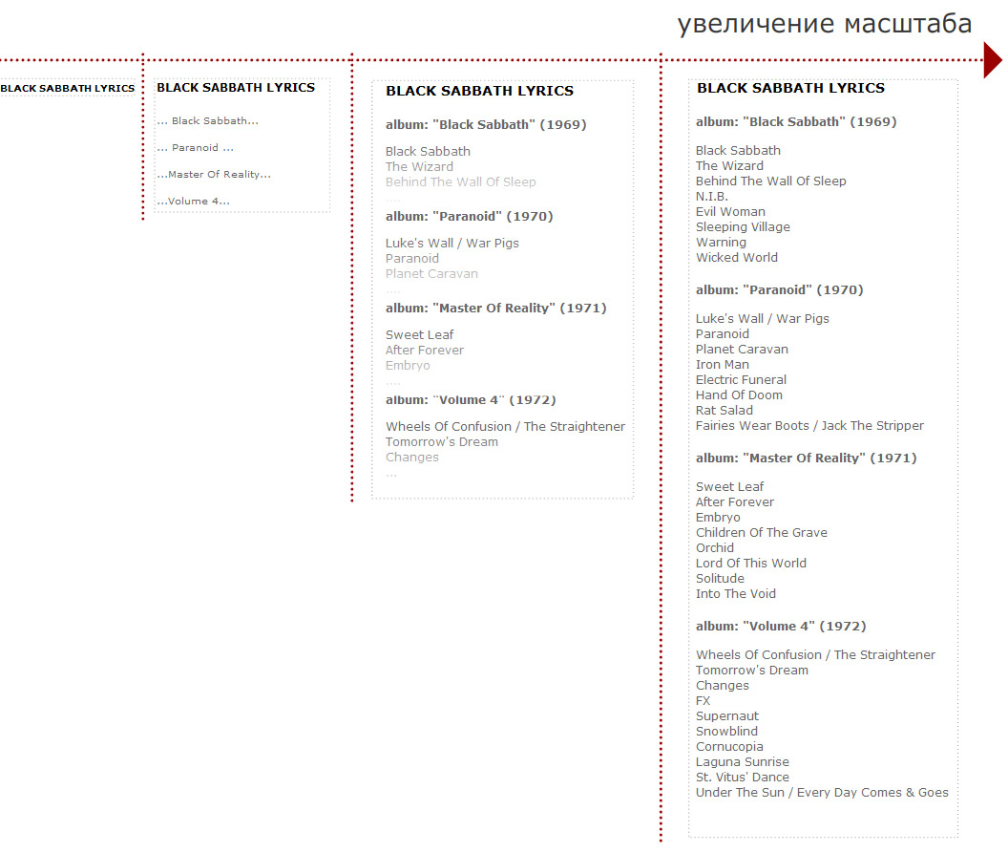
One of ISM’s functions would be the implementation of this process, i.e. a step-by-step generalization of data providing an adequate way to emphasize the primary (reflected) and secondary (concealed) details in every phase of scaling.
Another would be creating a visual perception of data entities based on which it would be easy for the user to assess the individual significance of the elements comprising an entity. ISM should be capable of accentuating primary elements on the screen (those with the maximum contrast for perception) as well as the lesser ones (the contrast of perception should change depending on the assessment of the elements’ degree of significance).

Another purpose of ISM would be visual representation of information entities based on which the user would easily assess the degree of significance of individual elements comprising the entity.

ISM should be capable of functioning based on a complete information object (the description of each of its elements’ value); and of independent analysis as well (calculating the value of the elements on its own).
The most important area of ISM’s functionality would be the processing of text. In a visual society such as ours, text is oftentimes more difficult to grasp than graphic images, which is why the problem of seamless scaling is of vital importance. Here’s an example of possible ISM text processing. A certain text document contains the descriptions of the value of each one of its elements. (Once again, each element would have its own value coefficient. For instance, first-level headings would have the highest value, followed by paragraphs, sentences, and words. Should the document be composed of three parts – the definition of a problem, the analysis, and, finally, the solution, the first and last parts would receive the highest priority, while the analysis would be graded lower). Based on this information, ISM would be able smoothly to alter the presentation of the text. For instance, it would be capable of determining a hundred further steps of particularization. One of the most convenient tools for controlling particularization (altering the scale) is the mouse wheel. Rolling it back and forth, the user would be able to receive information scaled up or down according to his or her purposes without having to peruse the entire text, saving time and mental energy.
Note. Maximum particularization (the upper scaling limit, maximum amount of detail) should not end at the greatest possible elaboration of an information entity. Depending on the context, ISM would be capable of expanding the entity by adding information received from external sources (outside the Information System in question). The most efficient way of performing this process would be through a complete incapsulation of each information system’s meaning, i.e. a complete history of the synthesis of a given IS based on the associative bonds with those CSA junctions that took part in the synthesizing of the Information System earlier.

Maximum particularization (the upper scaling limit, maximum amount of detail) should not end at the greatest possible elaboration of the information entity. ISM should be capable of expanding the entity by augmenting it with information received from external sources (outside the Information System in question).

Controlling the degree of particularization, an ISM user would actually see the essence of the process, the dynamics of induction and deduction. The possibility of illustrating the dynamics of logical conclusions and generalizations would be an additional information channel through which the author of the entity would deliver it to the user. This possibility is truly unprecedented.

Controlling the degree of particularization, an ISM user could actually see the essence of the process, the dynamics of induction and deduction. The possibility of illustrating the dynamics of logical conclusions and generalizations would be an additional information channel through which the author of the entity could deliver it to the user.

The problem of informational integrity in an Information System. Automated control of the relevance factor.

As we have seen, efficient information scaling is related to so-called informational integrity (when each information entity contains the entire database from which it was synthesized). The integrity problem is easily solved with the help of the CCA potential. Mind you – the processing centers (i.e. the hubs of the synthesis) – are specialized based on the assigned tasks, and combine static information with the means of its processing – software. The hubs would be interconnected by conveyor-like information exchange channels.

Informational integrity would bes ensured by utilizing the CCA potential.

The above suggests that information in such a system could be uniformly interrelated, since each hub would be an open, rather than a closed, system. Furthermore, information would evolve inside the hubs as well as in transition along the informational conveyor connecting the hubs. Thus each information entity would be equipped with a special history of its evolution – the history of the chain of inductive and deductive conclusions linked to the database, which would create a foundation for smooth scaling (the basis of ISM)..

The information inside such a system could be uniformly interrelated, since each hub would be an open, rather than a closed, system.

The advantages of CCA, however, are not limited to the ISM functions. Another intriguing possibility would be the automated control of information’s relevance. Since the synthesis of new Information Systems would be effected in specialized (context-dependent) hubs, each time the information base (the set of Information Entities) changes, it could be safely assumed that its relevance has become suspect. At the same time, other information entities that were synthesized using the entity in question would become suspect accordingly. The assessment, within the confines of the proposed CCA, would be a differentiated concept, capable of changing seamlessly from complete relevance to complete irrelevance.

Automated control of information’s relevance. Each time the information base (the set of Information Entities) changes, it could be safely assumed that its relevance has become suspect.

Relevance assessment can be performed based on a simple calculation of the quantitive changes in the hubs as well as via automated analysis and comparison of “old” and “new” versions of the entities constituting the hub’s information base.
The accuracy of the assessment would depend on the degree of specialization of the hubs. The more specialized the hub in which the Information System was originally created, the more accurate the assessment of its current relevance.

The broadened possibilities of data processing.

Obviously, an additional advantage of CSA would be its convenience as a medium, from the completely automated means of information processing viewpoint. Typical examples of automated information processing would be a search (including queries composed in human language), automated cataloguing of data, translation from one language to another during communication, etc. Obviously, since each Information System within the boundaries of CSA would maintain the integrity of the database from which it was synthesized, the information in the database itself would be an invaluable auxiliary material for constructing tools for automated cataloguing, searches, translation, etc. As a whole, global utilization of CSA upon the foundation of the currently available Internet infrastructure opens up new horizons, an entire new level of Artificial Intelligence (AI). The connection between the global version of internet-based CSA and the problematics of Artificial Intelligence will be considered separately later on.

Since each Information System within the boundaries of CSA would maintain the integrity of the database from which it was synthesized, the database itself would be an invaluable auxiliary material for constructing tools for automated data processing with increased precision.

Improved handling of authorship issues.

Another interesting consequence of the projected total integration of data in a global CSA, especially if it is web-based, would be improved control of information system authorship issues, i.e. copyright issues. Since the history of any Information System would be preserved in its entirety, it would always be possible to determine who the author, or authors, were of any given IS. Ergo, control of authorship would become, not merely uniformly possible, but simple and trouble-free as well. Actual authorship problems (and the accompanying profit distribution problems) will be considered in the final section dedicated to the justification of this presentation from the marketing point of view. In the meantime, suffice it to say that the possibilities of authorship control and application of Information Systems whose authorship could be determined quickly and infallibly would be, in and of themselves, an extraordinarily powerful CSA marketing tool.

Since the history of any Information System would be preserved in its entirety, it would always be possible to determine who the author, or authors, were of any given IS. Ergo, control of authorship issues would become, not merely uniformly possible, but simple and trouble-free as well.

Analysis of the dynamic chaos issue. Deduction. Fractioning/identifying information entities.

Getting back to the nature of the human mind, let me reiterate that the thought process is based upon two types of operation, namely, from the concrete to the general (a.k.a. induction, or synthesis of the general conclusion) and from the general to the concrete (deduction, forming a concrete conclusion from a general collection of information). Let us also remember that both synergetics and the idea of information evolution suggest that deduction is in essence the process of synthesizing an information entity with a lesser degree of order than the original information entity.

Deduction is in essence the process of synthesizing an information entity with a lesser degree of order than the original information entity.

In the beginning of this presentation we mentioned that, according to synergetics, the processes of self-organization (order and disorder, i.e. chaos – harmony – chaos, etc) have a cyclical nature. Thus, should we wish to construct a truly life-like system in which information would evolve in accordance with the fundamental laws of the Universe, it would be necessary to implement a special class of tools, a tool kit for fractioning an Information System into building blocks. In synergetics terminology this would be a tool kit for synthesizing Information Systems with a lesser degree of order than the original “raw material,” or a tool kit for supporting the processes of dynamic chaos formation. From psychology’s viewpoint, this would be a tool kit for supporting the synthesis of new Information Entities through deduction. Paradoxically, all of today’s computer software is induction-oriented. Whatever deduction-like processes are used today, none of them go beyond direct copying of information from one entity to another.

Should we wish to construct a truly life-like system in which information would evolve in accordance with the fundamental laws of the Universe, it would be necessary to implement a special class of tools, a tool kit for fractioning an Information System into building blocks, or for supporting the processes of dynamic chaos formation.

While considering the issue of creating “fractioning” tools, it would be necessary to define two types of tasks these tools would perform:
- Fractioning whose purpose would be to form new sets of facts based on which a generalized conclusion could be synthesized.
- Direct deduction in which a selected Information Entity fragment would become an independent Information Entity (still keeping, naturally, its associative bonds in order to maintain system integrity), which would be used either “as is,” or with some corrections from the user (without, however, involving additional entities; the main point here is no secondary generalized conclusion is needed). In essence, this would be a complete deduction operation.

While considering the issue of “fractioning” tools it would be necessary to define two types of tasks::

Fractioning whose purpose is to form new sets of facts.

Direct deduction in which resulting building blocks (fragments) become independent information entities.

In considering “fractioning” functions, we should remember the special factor (which would enhance the idea) of complete informational integrity based on associative bonds with all sources. Another important factor would be the possibility of subtle scaling of information accompanied by subtle control of particularization. In other words, it would be possible to extract information precisely on the level that would subsequently be utilized (by the user).
The following extraction methods could be used:
- Direct selection of blocks slated for extraction. In this case, the extraction tool would mark the boundaries – a fragment that would be extracted from the initial Information Entity. Let us call it the method of direct extraction.
- Intelligent selection of parts of an entity based on a logical condition, or selection through a special menu of the entity in which various possible ways of “fractioning” it are listed. Incidentally, this would suggest that Information Entities should be synthesized with an eye to ensuring efficient intelligent extraction.
- Selection based on the sources’ filter. Since integrity is maintained based on associative bonds with the sources, information could be categorized based on its sources (or, more precisely, the “zones of responsibility” of the sources). In all probability, this tool would come in handy when the issue of relevance control comes up.

The following extraction methods could be used:

1. Direct selection of blocks slated for extraction.

2. Intelligent selection of parts of an entity based on a logical condition, or selection through a special menu of the entity in which various possible ways of “fractioning” it are listed

3. Selection based on the sources’ filter

Дополнение: ККА в действии.

Пирамида узлов синтеза. Схема роста пирамиды узлов синтеза.

Дополнение:
Для лучшего понимания концепции контекстно-конвейерной архитектуры (ККА) будет рассмотрен практический пример организации обработки информации в соответствии с этой концепцией. Поскольку архитектура ККА подобна архитектуре нашего сознания, для начала рассмотрим пример эволюции информационной сущности не в инф. системе, а в нашем сознании. И после этого посмотрим, каким образом эта схема перекладывается на инф. систему.
В качестве примера информационной сущности возьмем эволюцию концепции контекстно-конвейерной архитектуры (ККА). Таким образом, в ходе рассмотрения самого примера также будет фиксироваться и ранее изложенная информация по самой архитектуре.
Архитектура ККА была синтезирована автором на основе представлений автора из двух областей человеческого знания: синергетики и физиологии центральной нервной системы (ЦНС) человека. Однако же эти области человеческого знания не изолированы, и также опираются на другие области. Например, синергетика опирается на физику, на философию, на теологию и пр. В самом крупном обобщении можно построить следующую последовательность эволюции информации.
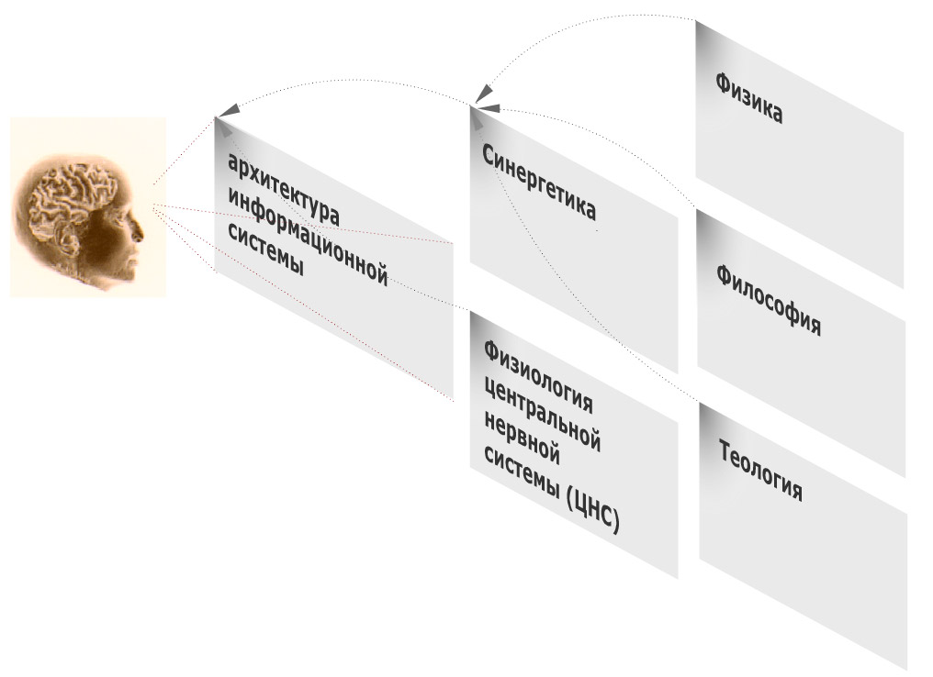
Рисунок 6_ 1.
Если синтез архитектуры ККА произведен автором изолированно от каких либо других лиц, синергетика является продуктом деятельности не одного, а множества специалистов (начиная с метров этой науки – И. Пригожин, Г. Хаген, И. Стенгерс и др). Тем не менее общая схема эволюции информации вполне ясна: от физики, философии, теологии к синергетике, от синергетики и физиологии ЦНС к архитектуре ККА. С другой стороны получаем, что информационная сущность (ИС) «архитектура ККА» имеет ассоциативные связи с сущностями «синергетика» и «физиология ЦНС», при этом опосредовано через ««синергетику», ИС «архитектура ККА» имеет связи с «физика», «теология», «философия» (это в самом крупном обобщении). Предполагается, что если что-то меняется в любой из перечисленных сущностей, сущность «архитектура ККА» начинает терять свою актуальность.
Далее перейдем к реальному примеру организации ККА. ККА – это конвейерная архитектура с контекстной обработкой информации, которая строится на основе унифицированных элементов – узлов синтеза. Узлы синтеза выстраиваются в цепочки обработки информации (в конвейеры) и объединяют в себе как возможности хранения информации, так и ее обработки. То есть в контексте этих узлов запускаются программные приложения, которые специализированы для соответствующих задач. Важно понимать, что конвейер может принадлежать целиком как одному человеку, так и нескольким. Обмен информацией между узлами осуществляется на основе информационных каналов, эти каналы и есть то, что связывает наборы узлов в конвейеры обработки.
Каким образом организуется система узлов и информационных каналов. Операция создания нового узла также должна отражать принцип эволюции информации в самом общем плане. Известно, что информационные сущности в нашем сознании эволюционируют между двумя состояниями - упорядоченности и разобщенности (гармонии и хаоса). Причем состояния упорядоченности на одних уровнях являются состояниями разобщенности на других, то есть образуется многоуровневая система. Каждый логический вывод - то есть синтез инф. сущности в нашем сознании – осуществляется на основе некоторого набора разобщенных фактов ( то есть инф. хаоса, в терминологии синергетики). Таким образом, приходим к выводу, что иерархия узлов синтеза должна отражать иерархию синтеза таким образом, что сущности – узлы одного уровня являются информационным хаосом для узлов более высокого уровня, которые содержат в себе обобщающие выводы. При этом сами обобщающие выводы могут быть информационным хаосом для узлов более высокого уровня иерархии и т.д. Узлы содержат в себе не только лишь информацию, но и средства работы с ней, программные приложения, которые специализированы для работы с этим ПО. В конечном итоге формируется пирамида узлов, причем эта «пирамидальность» хорошо видно на первой иллюстрации (пирамида в три уровня).
Для понимания природы роста этой пирамиды (то есть процесса создания новых узлов) необходимо обратиться к природе формирования хаоса исходных фактов. Если обобщающий вывод – это индукция, то вычленение частного – дедукция. При этом вычленяемый инф. блок как правило имеет меньшую меру упорядоченности, чем исходный. Для этого в ККА предусмотрен особый класс инструментов – инструменты вычленения инф. блоков, то есть инструменты дедукции (по трем направлениям: прямой выбор вычленяемых блоков, выбор на основе логического условия, выбор на основе фильтра источников). Вычленение информации всегда имеет направление – цель, для чего выполняется эта операция, куда этот вычленяемый инф. блок перемещается (один из частных случаев реализации – drag мышкой). Эта цель может быть выбрана явно, то есть может быть один из ранее созданных узлов синтеза. Но если назначения не существует, в этом случае автоматически генерируется новый узел синтеза. Причем этот новый узел синтеза будет находиться на более высоком уровне иерархии, чем узел, из которого инф. блок вычленили.
О создании новых каналов между узлами, а также что такое инф. канал в ККА более подробно. С точки зрения концепции ККА, канал является связующим звеном между отдельными узлами пирамиды. Каналы объединяют узлы в цепочки обработки информации, то есть в конвейеры обработки информации. Информация передается между узлами именно по этим каналам. В целом, с точки зрения архитектуры, канал является воплощением ассоциативной связи между инф. сущностями, которая также используется для автоматизированного решения задач контроля актуальности информации.
А с точки зрения пользователя канал – это способ быстрой адресации к другому узлу. Своего рода ссылка – окно в другой узел синтеза, которая позволяет либо быстро перебросить инф. сущность между узлами, либо этот узел открыть (например, путем масштабирования этой ссылки). Именно к операции перемещения инф. сущностей между узлами и может быть привязана операция создания инф. канала. Новый канал создается в двух случаях:
- Создание нового узла (что происходит в случае вычленения инф. сущности без указания адреса назначения инф. сущности) - в этом случае автоматически создается канал между новым только что созданным узлом и узлом – источником;

- Перемещение инф. сущности в уже существующий узел, но который не имеет с узлом-источником канала обмена информации.
То есть все операции по развитию пирамиды узлов синтеза - как создания узла, так и созданию каналов между узлами - просты, и выполняются параллельно с основой деятельностью без каких-либо для нее осложнений или значительных усилий. Более того, пользовательский интерфейс может быть организован таким образом, что на операции создания узла или канала пользователь вообще не будет тратить никаких усилий – это может выполняться автоматически, в зависимости от контекста выполняемых операций (вычленение инф. блока, перемещение блока между узлами и пр.). Важно понимать принцип, что любое движение информации (выполненное как пользователем, так и самой инф. системой) предполагает наращивание пирамиды узлов/каналов, то есть расширение системы взаимосвязей инф. сущностей. Что повторюсь, может выполняться без дополнительных усилий, просто как фоновые операции для основной деятельности. Иначе говоря, все достоинства архитектуры ККА, такие как:
- Более высокий уровень организации информации, ее упорядоченности. Информация становится более взаимосвязанной.
- Возможность автоматизированного контроля актуальности информации;
- Возможность тонкого масштабирования информации: от состояния с минимумом деталей до полностью развернутой инф. базы по соответствующей инф. сущности
- Возможности наглядной иллюстрации логики синтеза выводов, фактически возможность в динамике увидеть эволюцию инф. сущности, что является доп. инф. каналом в ее понимании и передаче;
- Упрощение пользовательского интерфейса программных приложений (фактически, виджетов) в узлах синтеза – полнофункциональные приложения для выполнения ограниченного набора операций не требуются;
- Более широкие возможности автоматизированной обработки информации за счет возможности анализа по ассоциативным связям инф. сущностей…
… могут быть достигнуты без усилий со стороны пользователя. Пользователь получает лишь эти преимущества в работе с информацией, не затрачивая на то усилий.
Далее следует набор иллюстраций c более детальными примерами эволюции информации. Эти иллюстрации интересны с точки зрения возможных путей организации пользовательского интерфейса – как трехмерное отражение пирамиды узлов, так и их двумерная проекция.
Рисунок 6_ 2. Трехмерная проекция пирамиды узлов:
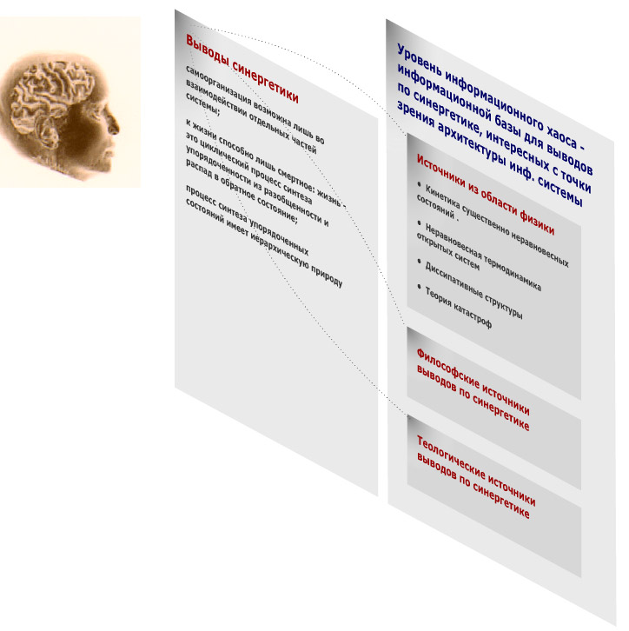
Рисунок 6_ 3. Двумерная проекция пирамиды узлов:
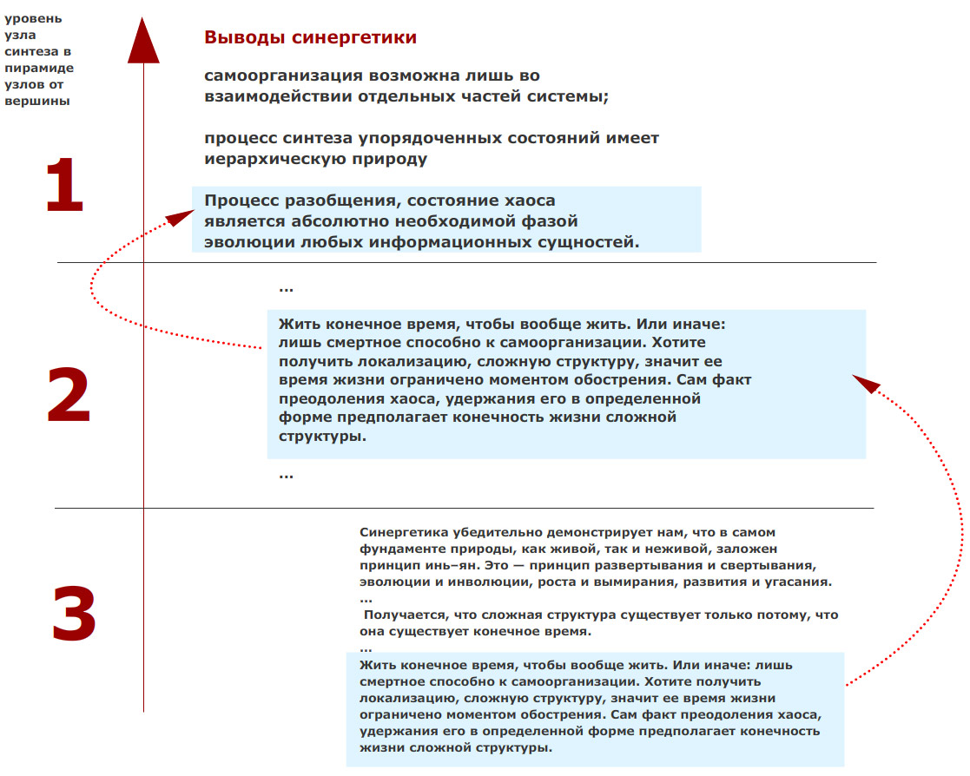
Рисунок 6_ 4. Развернутый пример пирамиды узлов в трехмерной проекции. Вершина – узел синтеза по проблеме дедукции/вычленения инф. блоков в контекстно-конвейерной архитектуре.
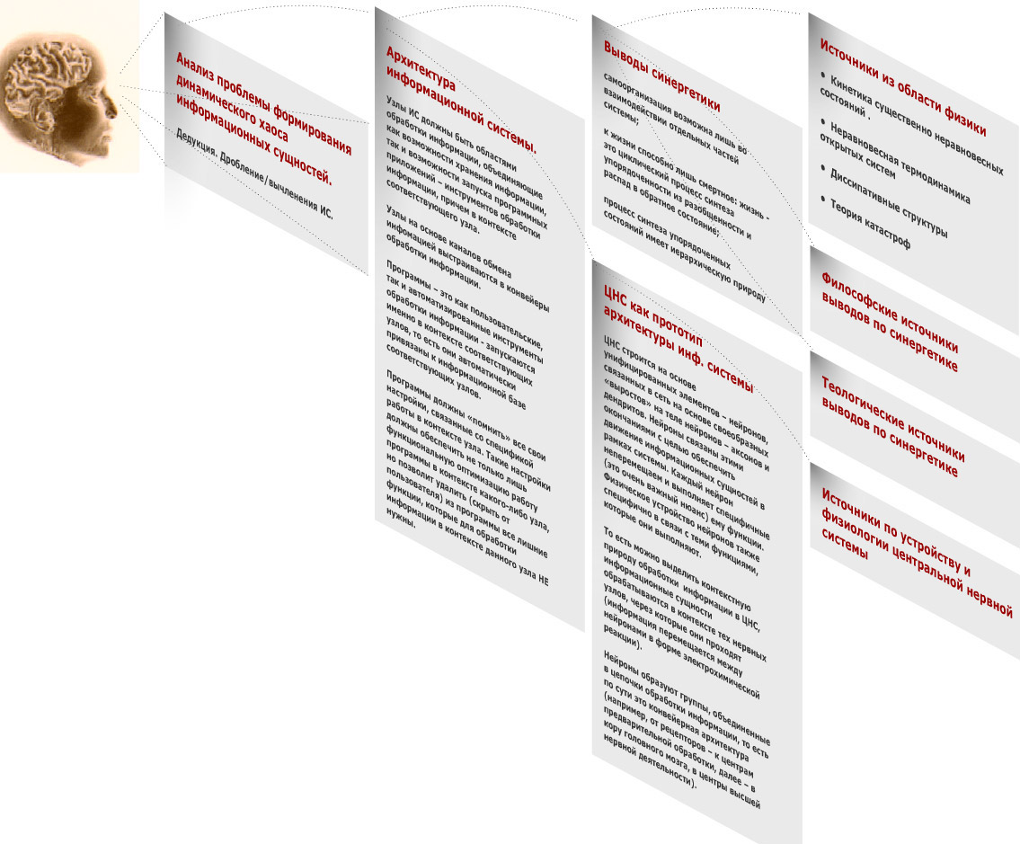

Дополнение: ККА как унифицированная основа сетевого взаимодействия (кооперации).

Предыдущий пример был ориентирован на синтез новых сущностей. С другой стороны системообразующая среда, обладающая качеством глобальной взаимосвязанности информации, открывает новые интереснейшие возможности организации взаимодействия (кооперации) пользователей в общем, а не только лишь с прицелом на синтез. Такие формы сетевого взаимодействия (кооперации) как электронная почта, интернет – форумы, блоги и пр. могут приобрести на основе ККА другую, более эффективную форму.

Association Management.

Defining the task of improving information’s ergonomics.

Getting back to the issue of an information system reflecting the nature of things, let us consider the ergonomics aspect. Let me emphasize, once again, two important moments here. First and foremost, we humans think in composite images derived from sums of associative bonds. Secondly, images in our mind have a hierarchical nature. Taking these concepts a step further, let us see how we could use them for improving the ergonomic factor of information processing. Since we have already considered the hierarchical nature of images and even created a special logical layer for our architecture (Information Scaling Management), the rest will be based on the idea of the composite nature of the mind’s imagery.

We think in composite images derived from sums of associative bonds. The mind’s images have a hierarchical nature.

Introduction of the subsystem (Association Management) to interface processes. Requirements for Association Management.

Let us assume that a special subsystem responsible for the intelligent presentation of ALL information entities (control elements, texts, data – anything) is included in the user interface.

Proposal of a special subsystem responsible for intelligent presentation of an information entity..

Let us give this subsystem a task. Let us ask it to form and control an association system in the user’s mind related to the information entities he or she is using while interacting with an information system. Let us call this subsystem, fittingly, Association Management (AM).
Рисунок 8_1
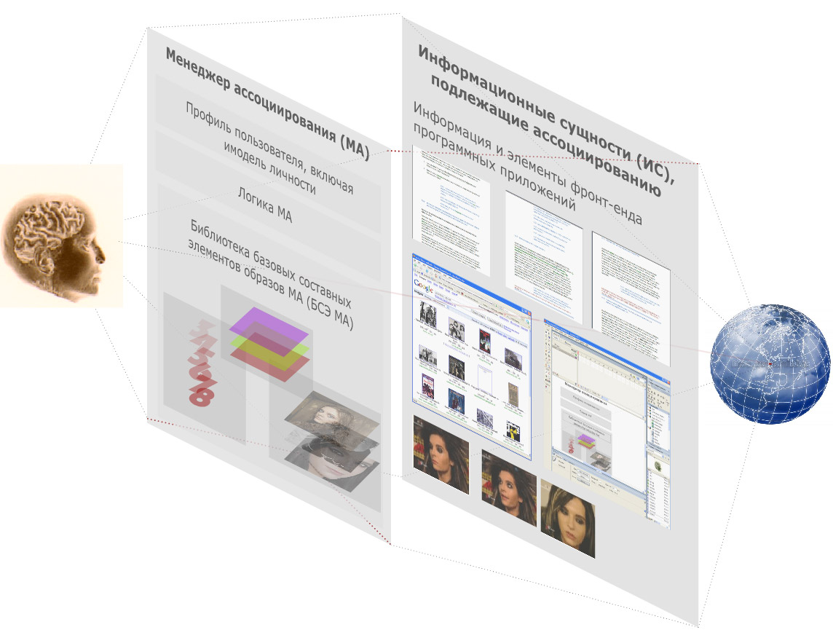
Let us further define the functions for which it would be responsible:
- Making the user’s task easier, sparing him the trouble of identifying information entities;;
- Increasing the informativeness of user interface objects;
- Improving navigation possibilities; more efficient search capability, fully reflecting the organization of human memory;
- Unifying user interfaces of information resources;
- A whole new level of marketing possibilities for information systems.

Giving the subsystem a task – forming and controlling an association system in the user’s mind related to the information entities he or she is using. This subsystem would be called Association Management (AM). Its purposes would be:

1. Sparing the user the trouble of identifying information entities;

2. Increasing the informativeness of user interface objects;;

3. Improving navigation possibilities; more efficient search capability, fully reflecting the organization of human memory;

4. Unifying user interfaces of information resources;

5. New level of the marketing possibilities of information systems.

The main purpose of Association Management, “what it does.”

First, let us figure out what Association Management does, in fact. Roughly, it would be a system of delineating information entities with which the user would interact. As far as its implementation is concerned, AM would be a layer of logic between applications and the user’s mind. The mind is the right word here. If we were to use the word “screen” or “monitor”, it would very crudely narrow down AM’s scope of responsibilities. The scenario of software and AM cooperation can go as follows. The software sends queries to AM in order to identify objects – information entities, with which the user is going to interact; AM delivers the appropriate images using the channels available to it into the user’s mind. Thus AM should be capable of creating a set of appropriate associations for any information entity (whatever it might be – user control element, text, graphics, etc.) and also of presenting the information system in question to the user’s mind utilizing all channels available to it, as a visual image, musical composition, and so forth. In addition to this, AM should be capable of taking into account the required level of particularization of each image, i.e. working closely with ISM.

What AM does. It is a subsystem responsible for delineating of information entities with which the user would interact. AM should cooperate with ISM.

The composite principle of AM image organization. The library of basic components (BC) for AM imaging.

The important issue is how, exactly, AM would create associations (delineate, roughly speaking) among information entities. Let us once again turn to the nature of the thought process and remember that an image in one’s mind is always a composite object derived from sums of associative bonds with other images. There is no such thing as an image in one's mind existing in complete isolation. That said, let us also emphasize the defining quality of AM imaging – the composite nature of each image. An AM image is really a combination of more primitive elements (similar to, say, Korean hieroglyphics). The composite nature of AM images gives us a number of intriguing possibilities in regard to both search and memory capabilities and the marketing possibilities of an Information System.

The defining quality of AM images is their composite nature. Each AM image should consist of several less intricate images.

From now on we will refer to the elements constituting an AM image as basic components (BC). The internal organization of AM would thus have a special subsystem – a library of basic components (BC). The power of the images’ composite nature would lie in the small size of the library. The components would be easy to memorize. At the same time, their combinational possibilities would be enormous. Let us have an example. Suppose an AM image is put together using three components:
- The image’s color
- A favorite number (date of birth, favorite holiday, etc)
- A photograph (depicting a flower, for instance).
Let us further assume that the BC library contains 7 colors, 7 favorite numbers and 7 different photos depicting flowers. As a result, we could have 7 * 7 * 7 = 343 possible combinations of images based on the three basic components (BC’s) plus 7 * 7 * 3 = 147 combinations based on just two of the components, plus 7 *3 = 21 combinations based on one component. The result is 511 possible combinations based on just 21 basic components! Quite clearly, it is far more difficult to remember 511 unique images than 21 (which, we hasten to add, are easy to remember in view of their emotional tint).

The internal organization of AM would have a special subsystem, a library of basic components (BC). The power of the AM images’ composite nature would lie in the small size of the library. The components would be easy to memorize, while their combinational possibilities would be enormous.

Иллюстрация рисунок 8_2: синтез образа инф. сущности на основе библиотеки базовых составных элементов.
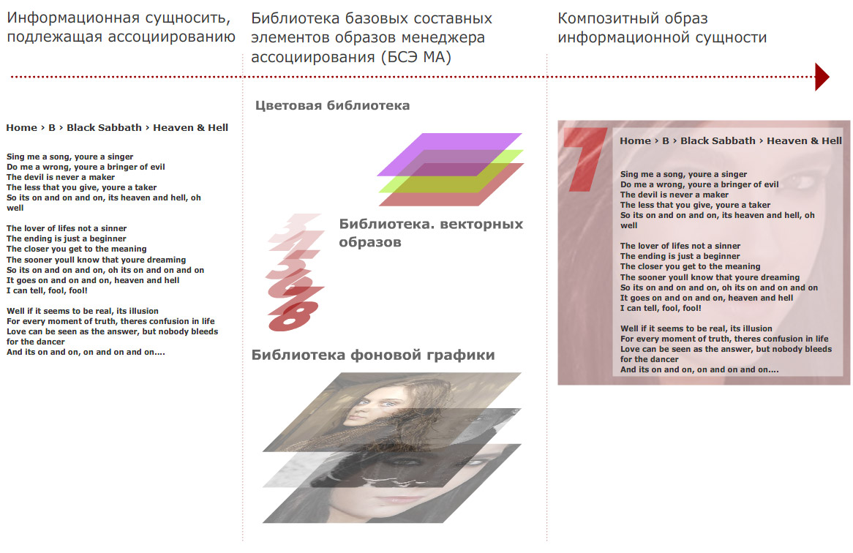

Necessary conditions for AM’s efficiency.

For AM to be efficient, “splicing” of its images with real images in the user’s mind would be necessary. Let me elaborate. An image in the human mind is a composite object. Apart from everything else, it is a sum of feelings, impressions, emotions, etc – all kinds of nervous activity that combines into a certain informational object – a mind image reflecting an Information Entity. Using the fact that such an image is a composite object, we could arrange for such an image to include impressions directly related to an AM image. In other words, AM technology should strive to “splice” its images with the internal images of the human mind responsible for the appropriate entity. While raising the recognition factor, it would also open up new search possibilities. Another aspect of this issue is the vast marketing capability of an Information System based precisely on the aforementioned “splicing.”
In light of the “splicing” issue, the following requirements for AM imaging implementation can be defined:
- The structure of each AM image should closely resemble the structure of an image in the human mind;
- Each AM image should be constructed based on powerful impressions, leaving a perceptible trace in the user’s psyche.

For AM to be efficient, “splicing” AM images with actual images in the human mind would be of vital importance. In order to ensure that this condition is met, the following is necessary:

The structure of each AM image should closely resemble the structure of images in the human mind;

Each AM image should be constructed based on powerful impressions.

How to ensure that the structure of each AM image resembles the actual structure of images in the human mind

An AM image being a combination of basic components, it follows that each individual component could create an association of its own in the user’s mind. Therefore the task lies in combining those elements in such a way as to make the sum of associations more or less mirror the sum of association of an actual image in the user’s mind.
Of vital importance here is the philosophy of CCA itself. The fact that each Information Entity maintains its integrity from its information base’s viewpoint gives us an opportunity to effectively meet the requirement. As it generates an image, AM would rely on the associative bonds of the information entity.

As it generates an image, AM would rely on the associative bonds of the information entity.

For hierarchically dependent entities, one of the consequences would be the following. Images of lower hierarchical order would have to include images of higher hierarchical order. As a rule, the higher the image’s rank, the more primitive it is (compared to images with lower hierarchical positions).

Images of lower hierarchical order would have to include images of higher hierarchical order..

The emotional tint requirement.

The second condition for “splicing” of AM images with the images in the user’s mind would be a powerful emotional coloring of each image. Simply put, each AM image has to “touch the user’s heart” – final compositions and basic components alike. Obviously, plain, bleak images do not lend themselves easily to memorization. A powerful image, especially one that is individually “colored,” would have a better chance of lodging itself in the user’s memory.

Powerful images would have a better chance of lodging themselves in the user’s memory.

AM as a tool for improved text perception.

One of AM’s special features would be an improved perception of text (up till now a fairly difficult object for perception). AM’s task would remain the same – it would still serve as an intermediary between information entities and the user’s mind. AM could assume the responsibility for interpreting (translating, tabulating, particularizing, sectioning) texts into images and definitions easily grasped by the user.

AM would improve the user’s perception by interpreting text, transforming, and subdividing it into images and definitions easily grasped by the user.

AM in improving text perception.

AM’s text processing would be two-fold:
- Constructing AM images consisting of text and recognizable graphic objects;
- Interpretation, i.e. transforming individual words and definitions into images (both textual and graphic) the user could easily grasp.

The composition of AM images that include text.

Let’s begin with the first point. It is necessary to consider the issue of graphic illustrations as such. It is known that a graphic image is more conducive to perception than text. Psychologically, text processing is inherently hindered by its utilization of highest nervous activity (abstract thinking). A graphic image is easier to perceive inasmuch the level of nervous activity is significantly lower. That is why ever since writing was invented, people have been illustrating text with graphics. AM would take advantage of its graphic imaging capability, taking it to an entirely new level. Since AM’s approach is individual, it would select images more recognizable (in each individual user’s case) than the author of the text himself could predict. In addition to that, working together with ISM, AM’s referencing of texts would allow for efficient scaling of information entities consisting exclusively of text (bare-bones text is not easily scaled).

Text perception is hindered by its inherent utilization of the user’s abstract thinking ability. AM would take advantage of the perceptive superiority graphic images have over plain text, taking it to an entirely new level.

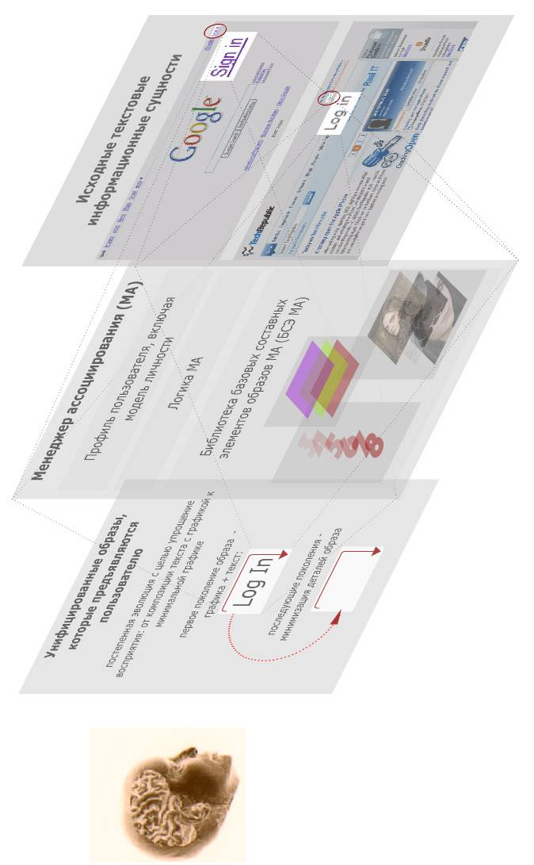
Иллюстрация: рисунок 8_3. Пример построения образа текст + графика, который является унифицированным обозначением для кнопки Log in/Sign In. Являясь по смыслу идентичным объектом, эта кнопка на разных сайтах должна представляться одним и тем же унифицированным образом. Причем образ является композицией как текста, так и графики. Постепенно (по мере фиксации этого образа в памяти) он может упрощаться за счет сокращения текстовых элементов.

Improvement of text perception through interpretation of definitions and individual words.

The second point would be the actual interpretation of words and definitions into forms the user would have an easier time perceiving. The interpretation would serve the following purposes:
- Easier text processing by the user – interpretation of terms and sentences, creation of forms easier for the user to grasp. Case in point: translation of foreign language texts;
- Increased reading speed made possible via abbreviations (short, easily recognizable symbols).
Иллюстрация рисунок 8_4 . Владимир, а можно Вас попросить придумать обратный пример, но со спецификой англ. яз.? Причем от текста с большим количеством символов к тексту с меньшим количеством символов?
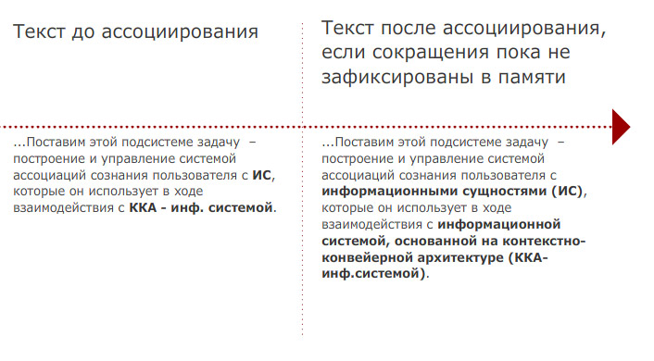

The unification of the elements of the user interface. Increasing the recognition and informativeness factors of user controls.

One of the aspects of the IS recognition issue, as well as the functionality of AM (Association Management) in general is the recognition factor in user interface elements, accompanied by the problem of unification of user interfaces. Concerning the latter, let me note that even though there has been extensive research and somewhat successful developments in that area, Association Management would solve the problem far more effectively.
Let us define the problem first. A user interface is constructed based on a number of control elements. The problem lies in the fact that software providers often use control elements that differ from one another in both appearance and actual application. While in traditional software the problem can be at least coped with, it wrecks chaos in web interfaces.
Let us imagine that AM tackles the problem – this would be possible if AM were used as an intermediary between software (and not just ordinary programs, either, but web interfaces, too) and the user. AM’s part of the job would work like this – a software program sends a query (in human language), AM analyses it and, based on the personality model, transforms the appropriate control element into the final AM image, which would then be presented to the user. Let me emphasize that at that point the user would be offered not just a bare-bones control element, but a composite object combining the control with the AM image. Such a combination would be far more informative than any other in terms of bringing out the work’s context, as well as improved user focusing. Without losing sight of the work’s context, the user would be able to concentrate on the problem’s solution.

AM would serve as an intermediary between software and the user. The user would be presented with a composite object culled from the control object and an AM image.

Implementation of AM mechanisms.

The architecture of the proposed system would require that the visual objects of the user interface be composite images derived and summed up from a number of elementary components. On the other hand, a possibility for subtle control of the particularization of data should be provided (utilizing the mechanism of information scaling described in Section 7.2 (Information Scaling Management)).

The Principle of Composite Image Formation.

Let us imagine that each element of an AM image is a plane – analogous to a layer – containing an image that has its own logic of reflecting information that depends on the scale and size of the overall image. (Note. What is being described is a general method. Let us not get carried away with visual solutions of the scaling problem).
Иллюстрация 9_1 - формирование образа, состоящего из текста и 3-х базовых составных элементов: цвет + векторный образ (число) + фоновое изображение.
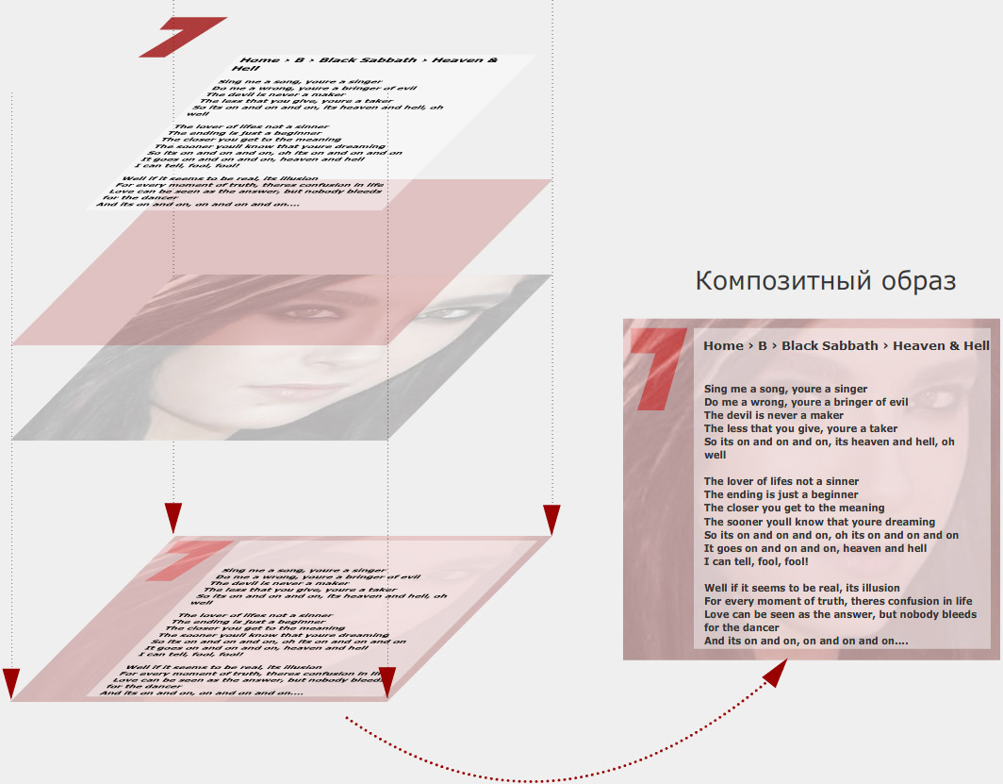
In the process of presenting an AM image to the user, a number of such hypothetical planes would be pasted dynamically together. While this happens, it would be a good idea to make sure that the final AM image is perceived as a whole. One of the most obvious ways of achieving this would be to smooth out the edges of the image. However, a more effective way would be to use a kind of special graphic stylization of the AM image in which all elements would be augmented by a single common property which would make the end result appear as one image. This stylization should not be applied to the text elements of the image, except perhaps to make them more readable.
Иллюстрация 9_3. Реализация требования восприятия образа как единого целого путем включения в составные элементы образа общего признака – единой графической стилизации.
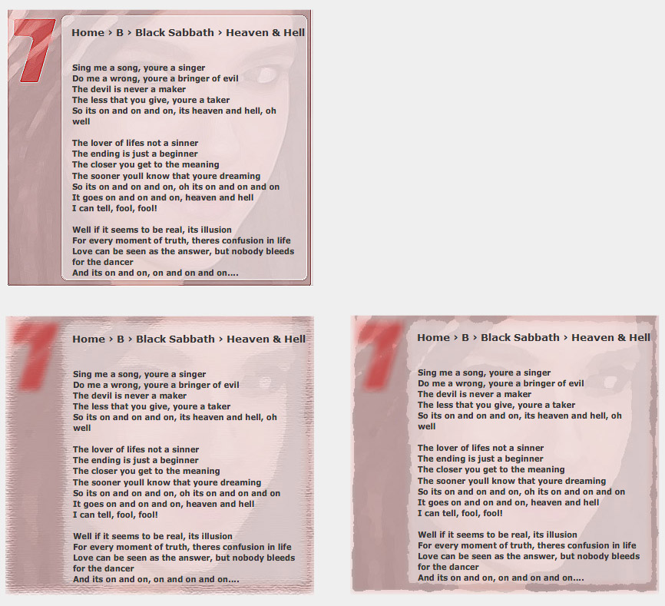

The principles of AM’s scaling mechanism.

- Scaling should be performed based on two groups of parameters:
a. the image’s size;
b. The required informational scale of the object - i.e. the level of particularization.
2. Scaling of the elements of each AM image should be performed following each element’s individual logic.

New layers’ activation – the elements of an AM image.

Both activation and subtraction of an image’s layers representing its components would be performed depending on the image’s scale and size. Increasing the scale or size would add new layers. Decreasing either would result in subtraction of layers.
Иллюстрация 9_2. Пояснение: продемонстрированы пять состояний по ходу процесса масштабирования. При этом следует помнить, что между этими состояния должно быть достаточное количество переходных, чтобы обеспечить плавное, тонкое масштабирование. Продемонстрировано, как по ходу увеличения масштаба активизируются дополнительные слои образа – изначально отображается только слой, отвечающий за цветовое обозначение. При этом каждый слой имеет индивидуальную логику масштабирования. Это заметно по слою, отвечающему за фоновый графический образ – в данном примере он позиционируется таким образом, чтобы отображался наиболее значимый, узнаваемый элемент (глаза).
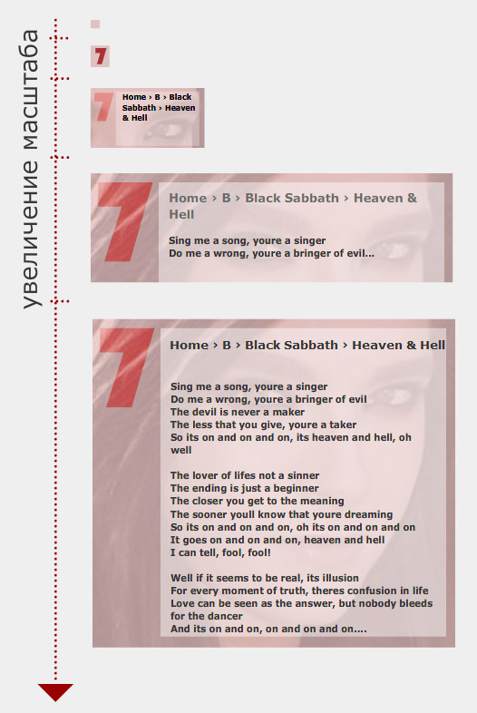

Contrast and visibility control in AM imaging. Significance value.

To make sure it can contend with visual debris while dealing with large volumes of information (as well as to increase the informativeness of visual objects), each AM image should be able to reflect, differentiated, all of its components. The more significant elements should have the most contrast, and vice versa. The least significant information should be just hidden away.
This should be true of AM images (which would be capable of controlling the individual contrast factor and visibility of their components), as well as of each separate element.

Providing continuity (recognition) for AM images, as well as their individual components during scaling.

It is important to avoid AM image “leaps” (that would drastically diminish the recognition factor) in various phases of scaling. The human eye should be able to detect …
- an artificial increase of contrast in objects not slated for change. This would coax the eye towards focusing on the key elements that are not changing. Once the scaling process has ended, the initial contrast levels should be restored.
- temporary introduction of elements (visual marks) serving as beacons for all entities being modified (re-scaled). After the scaling process is finished, these marks would vanish, and yet the user would easily see that the same Information System, only re-scaled, resides where he/she saw the mark a moment earlier. Thus visual continuity would be ensured with an improved recognition factor.
The two methods can be applied separately or simultaneously.
Иллюстрация 9_6 Необходимо обратить внимание, что на фазе масштабирования менее значимые элементы отображаются с меньшим контрастом, а узловые, наиболее важные элементы - наоборот, имеют не только повышенный контраст, но и помечаются особым временным маркером.
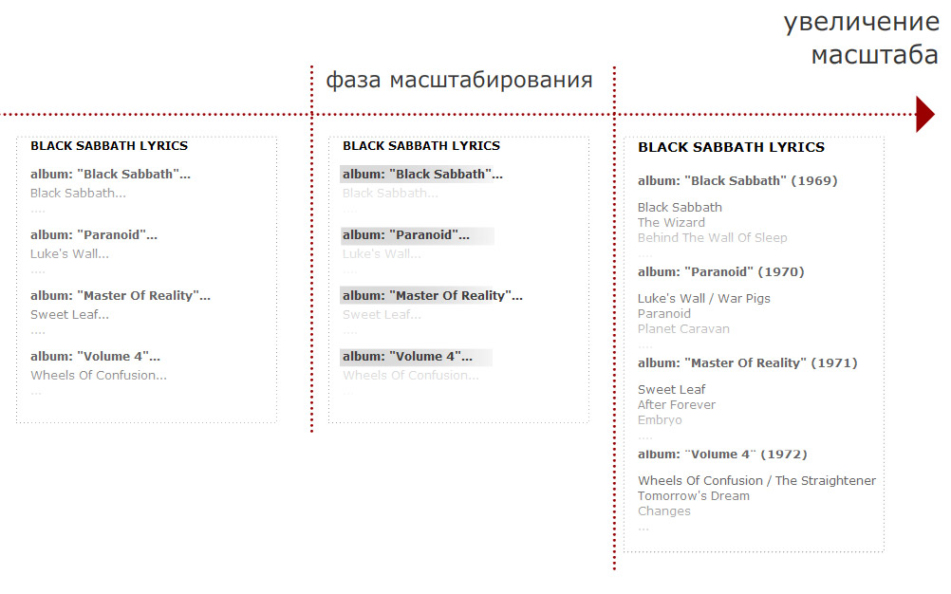

Grouping images with common features. Visualization of image community (не уверен в точности передачи смысла).

Situations could occur in the process of presenting sets of images when a certain part of a set has a common feature (as in, for instance, the images in the set belonging to the same type of information entity, like MS Word documents). Association Manager (AM) would allow to reflect the unity efficiently. The factors that would ensure this are:
- AM images are composite objects, sums of basic image components (BC);
- AM images should be generated based on the actual content of information entities they represent.
It naturally follows that AM images with common features would have common basic components.

The community would be represented based on the composite nature of AM images. AM images with common feature would have common basic components.

The approach would be this:
- Images with common features would be positionally grouped on the screen, adjacent to one another;
- The basic component(s) that constitutes the common feature would be scaled in accordance with the position and size of the element group.
The latter requirement would be realized based on the layer-by-layer visual presentation of images (see the principles of image composition): each layer would be responsible for each basic component; the layers would be summed up (into a stack) similarly to the layers in Adobe Photoshop or Macromedia Flash. Should a certain set of images have a common feature (a common basic component), the layer responsible for that feature would be common for all “stacks” of layers of the image group being allied.

Images that share common features should be positionally grouped on the screen, adjacent to one another.. Should a certain set of images have a common feature (a common basic component), the layer responsible for that feature would be common for all “stacks” of layers of the image group being allied.

Yet another way of bringing out common features in image groups would be to increase the contrast of the layer responsible for the common feature. Such a layer would have more contrast relative of the other components. Besides, the layer would contain additional visual elements which would accentuate the unity – extra frames encasing the group, or lines that would shoot through the images with the common feature.

The layer (hallmark of community) could have more contrast relative of the other components. Besides, the layer could contain additional visual elements which would accentuate the unity – extra frames encasing the group, or lines that would shoot through the images with the common feature.

Иллюстрация 9_5. Пояснение: отображаются три информационные сущности, с одним общим признаком, который представлен фоновым изображением. Слева этот образ для всех трех сущностей отображается индивидуально, справа – фоновый образ отображается единым для всех трех сущностей.
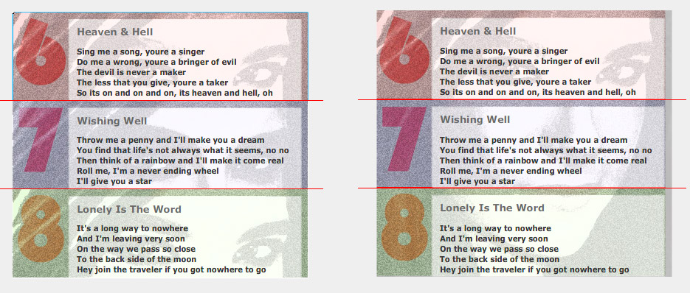
Should the unity of images in a group be of the hierarchical type (as in, images sharing a few features whose quantity in an image depends on the hierarchical level), the hierarchy would be reflected through positional grouping as well as in the organization of the layers responsible for reflecting common features. This process would have the following characteristics:
- The images would be positioned in such a way as to form easily distinguishable visual groups, while the groups themselves would form higher-level super-groups based on their position, which, in turn, would be gathered into super-groups of their own, and so forth. The process of unification of images into group- and super-group hierarchy would be consistent with the basic components’ hierarchical unity;
- For the organization of “stacks” of layers consistent with the set of common visual components, the common elements would be reflected on the planes (layers) common for more than one image, while the images within groups and super-groups could share more than one such plane.

Should the unity of images be of the hierarchical type, the images would be positioned in such a way as to form clearly distinguishable visual groups and super-groups. Common components would be reflected on planes (layers) shared by more than one group, while the images within groups and super-groups could share more than one common plane.

While summarizing the projected methods of image unity visualization, let me note that they would:
- increase the informativeness level of the user interface (effective visualization would serve as an additional channel through which the user would be informed about the appropriate set of entities);
- improve usability (the degree of particularization would be lower; common features would rise from the individual image level to a group or super-group level; images would become simpler and easier to grasp).

Effective visualization of image unity would increase the informativeness of the user interface while lowering the degree of particularization, making images simpler and easier to understand.

AM-powered search and navigation. Adaptive Associative Navigator (AAN).

Specifications.

Splicing AM images with mental images would be the foundation of efficient search (addressing) and navigation features in CCA. Moreover, new search possibilities would open up, based on the composite nature of AM images. In human memory, selection of information is realized by means of association. CCA searches could be similarly organized. The target entity could be addressed using any of its associations (i.e. there would be no need to remember the entire AM image associated with the entity. One detail would suffice).

Splicing AM images with mental images would be the foundation of efficient search (addressing) and navigation. The target entity could be addressed using any of its associations.

The technique of forming composite AM images (with its inherent broad possibilities of uniting, grouping, and scaling them) would open up new possibilities for the navigation and search functions of CCA. Let us take a quick look at the concept of a unified search and navigation tool, which would allow for:
- search and navigation functions in the information entity medium based on association;
- the tool’s inherent capability to adapt itself to both the user’s personal preferences and the requirements of the programming environment.
Based on the said features, the tool would have to be called Adaptive Associative Navigator (AAN). It would be organized in such a way as to be able to realize the entire potential of the combined CCA, AM, and ISM technologies.

Solutions. Examples.

By way of introduction, let us get back to AM’s (and ISM’s) capabilities. Some of AM’s key features are
- its grouping (generalization) capability, in which certain common features of an information entity set could be elevated to the level of group imaging:
- AM images could adjust themselves taking into account scale and size parameters; should this occur, changes of the particularization degree would be possible:
- AM images could control the degree of contrast of their components based on the assessment of their importance value:
Here are the areas in which AM image adaptation would be possible:
- Image size. More important images would have large sizes than others;
- Particularization (the information entity’s scale) of AM images. The degree would be greater for more important images;
- The distance from the attention focus** (the mouse pointer in many instances). More important images would be positioned closer to the pointer*;
- Contrast and brightness. The degree would be greater for more important images.
* The degree of an image’s importance (or significance) would have to be consistent with human assessment methods of information entities. Systems supporting AAN would have to strive towards genuine automated reflection of such grading, based on the coefficients established earlier, as well as on the statistics collected from prior accessing of the appropriate entities.
** The attention focus is the area where the user’s attention is concentrated. The AAN concept does not exclude channels other than visual. Auditory channels would do just as well in certain situations.
Two ways of AM images’ geometrical grouping would be possible – non-angular (circles and spirals) and angular. The former would ensure more precise distribution of information entities based on their importance coefficients. On the other hand, rectangles would be handier in AM’s handling of text elements.
The overall process would look like this:
- ANN would generate an AM image composition consistent with the search criteria*. The composition would then be presented to the user;
- The user selects the navigator’s area responsible for the association group he/she is interested in (for instance, he/she could position the mouse pointer over it). The search parameters would thus become more specific;
- The user increases the scale of the zone responsible for the association group he/she is interested in (say, by rotating the mouse wheel);
- AAN restructures the AM image composition, making it consistent with the more specific search criteria as well as with the new focus area and scale.
*In AAN, search parameters would be a set of associations the target information entity would have to bear. These associations would have to be capable of passing through the AAN filter. Should the associations be visual, they would have to be reflected by visual AM components. (Possibilities for auditory associations will be considered later).
Thus the navigation (search) process within an AM image medium would have to include both the process of association group selection and the process of particularization of selected areas of associations. The reverse would also be possible (Should the user want to decrease the scale instead, for instance, the degree of information entity particularization would then be lowered).
A special requirement would be to maintain the continuity of AAN representation before and after the user’s command. Moving objects should move smoothly and predictably; AM images should remain recognizable despite the changes.

Assessment of the advantages of Adaptive Associative Navigator (as opposed to traditional search and navigation systems).

- AAN would make use of the assets of the combined CCA, AM, and ISM technologies in full measure:
  - genuine reflection of the human mind’s search mechanisms
  - reflection of the hierarchical nature of human memory
  - reflection of the composite nature of associative images in the human mind;
- The broad possibilities for optimization of navigation steps based on random selection of the subsequent association group; one could begin with one type of association, subsequently narrowing down the search criteria based on a different type of association.
- The broad possibilities presented by the adaptive quality of AAN that would take into account both the user’s individual preferences and the requirements of the programming environment;
- The increased informativeness of the user interface, made possible by, among other things, effective visualization of the interconnectedness of information entities;
- The optimization of the user’s efforts expended on shifting focus and perceiving and recognizing new objects;
- The reduction of the impact on the user’s cognitive psychology (especially where tag-driven searches are concerned); improved image recognition. (Graphic image recognition is quicker than reading. Images are intuitively understood; information delivered through text is more strenuous for the mind to process, as well as for the eye to perceive, utilizing as it does resources responsible for abstract reasoning);
- AAN would be a uniform solution for practically any kind of navigation; it could be used for:
  - Command selection (analogous to hierarchical menus);
  - Searching for, and structuring of, information;
  - Implementation of user interfaces capable of genuine dialogue, including step-by-step “wizards”;
….The unification would spare the user time and energy he or she now spends on learning how to handle other tools created for the same tasks; such tools would be rendered unnecessary;
- Efficient handling of peripheral objects consistent with the nature of human perception (vision, in particular);

AAN and dialogue; step-by-step modes of the user interface.

Gradual, step-by-step specification of search criteria (concretization of association sets) would be one of the main functions of AAN. Many dialogue modes of the user interface are equipped for step-by-step specification of parameters. Thus AAN would be useful as a foundation for dialogue modes. Case in point: the various user “wizards.” The utilization of AAN in dialogue mode would have all the advantages of AM and ISM technologies (composition of images and control elements), in addition to the AAN assets.

Dialogue modes of the user interface and the AAN navigation logic are in a sense similar; both concern themselves with step-by-step concretization of parameters. AAN could become the foundation for all dialogue modes.

AAN in further development of keyword and tag searches.

At present, text-based meta-information (tags, keywords, and key phrases) is used for structuring searches in network resources as well as in local applications. Being responsible for forming images consistent with the actual content of an information entity, AM would make good use of such meta-information by raising the level of precision in the association-forming process, which would be the foundation of AAN-driven efficient addressing of the information entity (see the assessment of the advantages of AAN compared to traditional search and navigation systems.

Meta-information could raise the level of associative precision. Which would be the foundation of efficient addressing of the information entity based on AAN.

AAN-based information structuring (object dragging).

Quick natural searches, rapid switching of associations would make AAN a perfect tool for information structuring. A typical task would be moving information entities between categories.

Speeding up navigation by improving the user’s perception of quickly altered images. Improvement of scrolling ergonomics, dynamic animated processes, etc.

While touching upon the ISM and AAN subjects earlier, I mentioned the issue of image recognition at the time of rebuilding information entities on the screen, especially where ISM scaling is concerned. Objects would change, and their coordinates on the screen would, too. In order to make the user’s task easier (by improving the recognition factor), two types of solutions were projected:
- Bringing out constant elements by increasing their contrast;
- Adding temporary visual marks to the image which would serve as symbols signifying elements being modified.
For AAN, a similar task is projected – ensuring the continuity of AAN presentation before and after the user’s command. AAN restructures itself after each modification of navigation parameters, and this restructuring can be very extensive. In order to maintain the recognition factor on the same level, AAN changes would have to be subtle (smoothly executed), in line with the following requirements:
- Objects should be moved in a predictable manner (from the user’s point of view); their movement should not be in any way chaotic
- Recognition of the images before and after AAN modification must not present any problems to the user. Methods used in ISM (bringing out of constants, temporary visual marks) can also apply here.
These issues (concerning AAN and ISM) are similar in that they both have to do with facilitating perception of images being modified. The issue of improving changeable images would be especially relevant for all types of scrolling – such as text scrolling, for instance. On the one hand, scrolling can be very quick, as today’s computers (or PDA’s, or Smartphones) are capable of rapid scrolling. On the other hand, the user is oftentimes obliged to either slow down the process or even stop it altogether in order to get his or her bearings.

The issue of improving changeable images would be especially relevant for all types of scrolling – such as text scrolling, for instance. The user is oftentimes obliged to either slow down the process or even stop it altogether in order to get his or her bearings..

The changeable images in ISM and AM present a number of intriguing possibilities. In considering those, the following factors should be made the starting point:
- Combined with ISM, AM would control all of the user’s attention, i.e. all information entities he or she interacts with
- During the scaling process, ISM relies on the hierarchy of differentiated assessments of the significance of each component of an image
- Recognizing images always takes some time; it is never instant. Needless to say, recognizing more complex images is more time-consuming.
The solution is quite obvious. Temporarily decreasing particularization of information entities (the scale of information, in ISM terminology) could shorten the time it would take the user to recognize changeable images. In other words, whenever the speed of alteration exceeds the user’s ability to recognize information images, the information scale (particularization) could be lowered automatically.

Solution. Whenver the speed of alteration exceeds the user’s ability to recognize information images, the information scale (particularization) could be lowered automatically.

Another way of improving the user’s perception of changeable images could be the inculcation of visual marks into them – along the same lines as in scaling. Such marks could be visually striking objects associated with the images being modified (scrolled). The primary requirement for such marks would be easy recognition, which could be achieved through:
- Their brightness, contrast, or both relative of the information entity being modified;
- Minimization of their visual detail.

Another way of improving the user’s perception of changeable images could be the inculcation of visual marks into them – along the same lines as in scaling. Such marks could be visually striking objects associated with the images being modified (scrolled). The primary requirement for such marks would be easy recognition.

Continuing the ergonomics theme, let us move on to a more general issue – the user’s recognition and perception of complex images in general, as when he or she opens a new document or a webpage, or activates a new application – in fact, whenever the information on the screen changes rapidly and completely. The user always requires noticeably more time to recognize (figure out) an image that has nothing in common with the images he or she saw on the screen a moment earlier. Even in this case, ISM could improve the ergonomics of the process, making it smooth. Gradual particularization of images would take place, in which an image would appear on the screen step-by-step, in groups of image components, based on the degree of significance of each component. The time interval separating the appearance of the next group from the previous one would be calculated based on the user’s individual qualities. First, an image would appear with a minimum amount of detail. After a pause, more details would be added. The pause could vary (again, in keeping with the user’s individual qualities) from tenths of a second to several seconds. During this process, in order to make the user’s visualization of the relations between the essential and the trivial, a temporary artificial change of contrast between two components could be used.

What happens when the user opens a new document or a webpage, or activates a new application – in fact, whenever the information on the screen changes rapidly and completely. Gradual particularization of images would take place, in which an image would appear on the screen step-by-step, in groups of image components, based on the degree of significance of each component. A temporary artificial change of contrast between two components could also be used.

Let me emphasize the …
- successive appearance of components consistent with the assessment of their significance factor, as well as the …
- temporary artificial modification of contrast for the user’s improved distinguishing between the essential and the trivial
… would be an additional information channel the information system would be able to use in communicating with the user. In other words, during the gradual appearance of an information entity on the screen, the system would be able to point out to the user which parts of the entity are more or less important.

Successive appearance of components consistent with the assessment of their significance factor, as well as the temporary artificial modification of contrast for the user’s improved distinguishing between the essential and the trivial would be an additional information channel the information system would be able to use in communicating with the user. In other words, during the gradual appearance of an information entity on the screen, the system would be able to point out to the user which parts of the entity are more or less important.

While on the subject of ergonomics, let us touch upon animation in user interfaces. Briefly, animation allows to realize visual continuity between various states of information entities, which facilitates their recognition by the user. One telling example is Apple iPhone, rich in animation and smooth scrolling in various forms. However, if we compare iPhone’s approach in handling such issues (scrolling, qualitative modification of content, and other such processes) with the projected ISM/AM solutions, the latter have a great deal more possibilities.

Animation allows to realize visual continuity between various information entities, which facilitates their perception by the user.

Marketing possibilities for CCA, AM, ISM, and AAN. AM and ISM-based manipulation of opinions.

Assessment of the marketing possibilities of the proposed architectures should begin by understanding that AM and ISM technologies would serve as intermediaries between information systems and the user’s mind. AM and ISM could control ALL of the user’s attention, the entire user interface as well as images and control elements. In terms of advertising, this would present possibilities far greater and far more versatile than the ones offered by traditional methods.

AM and ISM control the entire scope of the user’s attention. In terms of advertising, this would present possibilities far greater and far more versatile than the ones offered by traditional methods.

Should the three combined technologies be implemented, an analogy would be appropriate with the “sphere” through which a person perceives the world. Those who control this “sphere” could change much in the user’s psyche, subtly controlling his/her internal system of values and priorities. This possibility should be considered, not just from the marketing point of view, but in educational terms as well. Formation of a socially useful system of values in individuals is also a possibility.

An analogy that comes to mind is that of a sphere through which a person perceives the world. Those who control this “sphere” could change much in the user’s psyche, his or her internal system of values and priorities.

Psychological manipulation via scaling tools.

On the one hand, the idea of ISM stems from certain peculiar qualities of the human psyche that are manifested in storage and processing of information. Human memory is hierarchical. The mind manipulates images that are also hierarchical; each image participating in the process relies heavily, as a rule, on a number of images that have a lower status in the hierarchy. On the other hand, one of ISM’s tasks would be the presentation of this hierarchical structure based on control of size, particularization, etc., of objects.
As far as advertising technologies are concerned, an analogy with train tracks comes to mind. What IMS would do, in essence, is provide tracks for the user’s mind, tracks which the train (the mind) would have to follow and which it would find very difficult to deviate from. One of the results, in the final count, could be a reflex developed in the user’s mind to accept whatever hierarchical ratio of the general to the particular ISM happens to be offering. Thus ISM-assisted distribution of psychological weight coefficients could influence the user’s internal system of values.

The user’s mind could develop a reflex of accepting whatever hierarchical ratio of the general to the particular ISM happens to be offering. ISM-assisted distribution of psychological weight coefficients could influence the user’s internal system of values.

The basics of AM-assisted manipulation. Introduction.

AM could be viewed as a layer of logic through which the user perceives entities of any kind. Roughly speaking, it is a system of symbols, or marks, that feeds off the subtle associative nature of the human mind. The most valuable aspect of AM as far as manipulation is concerned is the close resemblance of its information delivery system to that of the human mind itself. That is the one nuance that opens up new possibilities of influencing the user’s consciousness. The analogy would be the user perceiving the world through a layer of logic supplied by AM.

The most valuable aspect of AM as far as manipulation is concerned is the close resemblance of its information delivery system to that of the human mind itself.

Let us consider the following possibilities:
- Direct use of AM imaging in advertising. AM images could be utilized in order to accentuate the more significant information (in the individual context) in advertising campaigns. The significance of AM images in the user’s mind would be thus applied to advertising content, making the advertising information more influential;

- Control of the bonds: the use of images that are interrelated (in a general or individual context) for imposing the required interconnectedness between information entities (for instance, in order for the user to perceive two facts as interrelated). Also, this function crosses paths with the task of reflecting through AM components the actual system of associations the appropriate image bears in the user’s mind;

- Control of the degree of influence exerted by AM images: the distribution of strictly dosed logical stress through the differentiated power of impression. For instance, in advertising as well as education, for entities with higher degree of significance (i.e. more “loaded”) than others, more impressive images could be used. Thus AM could control the user’s subconscious assessment of the relevance and importance of information being presented. That is to say, AM could open up an additional channel through which the degree of significance of information can be controlled.

- Exploiting the emotional tint of AM images: the possibility of transferring the emotional charge of an AM image to the information it represents. That is to say, positively charged AM images would stimulate positive perception of the information. The opposite would also be true. Negatively charged AM images could stimulate a negative reaction from the user.

Creation of the required emotional association based on the composition of emotionally colored elements of AM images.

Manipulation of emotional perception of information would be in a large degree based on the composite nature of AM images. Basic components of AM images would serve as the source of emotional coloring. While combining of emotionally charged elements is in progress, projected emotional responses could be arranged into compositions consistent with the information they represent.

While combining of emotionally charged elements is in progress, projected emotional responses could be arranged into compositions consistent with the information they represent.
The main task of emotion manipulation tools consists of forming and maintaining an active base of emotionally charged components of AM images (the BC library). The following factors would apply here:
- The size of the BC library should not be large. (Its power is in the combinational versatility).
- Image components should have an initial emotional charge – be intriguing in and of themselves, capable of “touching the user’s heart.”
- A small set of emotions (no more than three) should be sufficient to provide the necessary number of associative bonds for any amount of information. For instance:
  - A positive impression;
  - A negative impression;
  - Increased attention, a state of anxiety – in order for the information to draw attention to itself.
And so, the main task is to create a library of elements with high emotional charges. Here’s the solution. Periodically, the elements would be linked, and re-linked, to informational content that has a predetermined emotional charge. Constantly applying a powerful image to varying content whose emotional charge is nevertheless permanent and known beforehand would stimulate an involuntary response in the user’s mind, creating an associative bond with the appropriate kind of emotion.

Constantly applying a powerful image to varying content whose emotional charge is nevertheless permanent and known beforehand would stimulate an involuntary response in the user’s mind, creating an associative bond with the appropriate kind of emotion.

With emotional manipulation in mind, as far as AM images are concerned, all information can be divided into two categories, namely, donor-type content and receptor-type content..

With emotional manipulation in mind, as far as AM images are concerned, all information can be divided into two categories, namely, donor-type content and receptor-type content.

AM would be conducive to accumulating emotional impulses while utilizing a small number of image components. All along, associative bonds for AM images could cover the entire spectrum of feelings consistent with the psychological structure of the appropriate organs.
- Vision:
  - The skeleton; contours of an object
  - Forming an idea about the object’s size and its coordinates in space
  - Dynamics; fluctuations.
...
- Hearing:
  - The range of auditory signals (high-pitched sounds; low-pitched sounds)
  - Patterns within auditory signals, the nature of each sound (melodies or elemental sounds, such as the ocean’s roll, the forest’s rustle, etc). Interestingly, some of the sounds could be combined – a melody could run concurrently with the ocean’s roll, etc).
...
First, there is the possibility of concentrating the donor-type emotional charge within a small number of image components. Secondly, this emotional charge could be spread around the entire sum of components, which would enhance the reliability factor of the emotional influence (summing it up would only increase its potency). In advertising, a combination of these two emotional states might be the most effective – 1. Positive emotional response 2. Close attention.

First, there is the possibility of concentrating the donor-type emotional charge within a small number of image components. Secondly, this emotional charge could be spread around the entire sum of all components, which would enhance the reliability of the emotional influence (summing it up would only increase its potency)..

Accordingly, the financial attraction of the idea is as follows. For the high level of interest they would experience regarding the information presented to them, the receptors of emotional coloring would reward the donors with financing.
Let us emphasize here that the process of transferring the emotional tint of content onto an AM image would be a subconscious operation, effortlessly performed as far as the mind’s resources are concerned. It naturally follows that even traditional advertising could be handled by AM without sacrificing any part of its functionality (and gaining power once AM has processed it, since in any case AM would aim to improve its perception and search factors, and since all of the content would have to be processed by it). For providers of content, “donorship” could become an additional source of income without affecting any other sources.

For the providers of content, “donorship” could become an additional source of income without affecting any other sources.

Special note: In manipulation of emotional coloring, a systematic approach employing strict dosage should be used. It is vital to ensure that no emotional cacophony occurs. Strict dosage of influence should be maintained based on both research data and the individual qualities of users.

Emotionally colored content – donors of emotional coloring – the basis for the library of emotionally colored components of AM images.

The possibility of efficiently accumulating an emotional charge within a relatively small set of components would begin with the proper selection of those components (BC’s). The images themselves should be sufficiently striking, memorable, touching. A human face looking intently at the viewer, a wonderful work of art, etc. A striking image would be one of the necessary requirements for splicing an AM image with the image created in the user’s mind corresponding to the given information entity.

The possibility of efficiently accumulating an emotional charge within a relatively small set of components would begin with the proper selection of those components (BC’s).

BC’s can have an initial emotional charge. However, the idea of transferring this charge from the donor (content) to AM images can enhance it a hundredfold.
Here are three basic types of donor content:
- Text resources with known emotional coloring
- Graphic and video content (art, sex, etc.)
- Games

Here are three basic types of donor content: 1. Text resources with known emotional coloring 2. Graphic and video content 3. Games

In regard to the technique of transferring the emotional charge from donor content to receptor content, the possibility of efficient commercial use of resources that normally present some difficulties in traditional advertising is of a special interest. In today’s advertising, propriety, ethics, context – everything gets in the way of commercial advertising. What kind of context advertising can you place on a resource dedicated to poetry, for instance? Ethical problems arise when one is dealing with sexual or religious content. And so forth. The technique of transferring emotional coloring opens up possibilities for effective commercial exploitation of any content.

The technique of transferring emotional coloring opens up possibilities for effective commercial exploitation of any content.

AAN-based Context Advertising.

Briefly: AAN (Adaptive Associative Navigator) would be an important element of AM technology as well as a excellent tool for context advertising. The efficiency of AAN stems from the advantages of ergonomic scaling and association of data technologies, as well as the advantages of CCA in organization of information processing:
- The possibility of significantly more precise calculations of the advertising content against the IS, AAN-based search context. The reason is the wider scope of information:
  - the current scope of search associations ;
  - the content of filtered Information Systems ;
  - associative bonds of information entities corresponding to search parameters;
  - the context of the user’s work within the confines of a synthesis junction

- AAN-based context ads would be a great deal more ergonomic and processing-friendly than the traditional model; they would have all of the ergonomic advantages of scaling and associating technologies;
- AAN-powered ads would be presented with the help of AM, which would allow for effective manipulation of the user’s emotional perception; thus advertising would become emotionally tinted without unnecessary pressure on the organs of perception; the excitement in the user’s mind would be stimulated exclusively through an internal chain of association.
- with CCA, advertising could have all the advantages of information processing organization characteristic of the technology’s architecture: preservation of associative bonds with the source, exhaustive control of the information’s currency, etc.
- Uniform implementation of AAN as a common tool for accessing information would facilitate effective dosing of advertising impact in accordance with each user’s individual tastes, inclinations, intellectual properties, etc.

Copyright. Advantages. Assets.

The idea of the CCA architecture is based on the principle of global interconnectedness of information, which opens up new levels of copyright control and distribution of profits resulting from commercial exploitation of intellectual property. One of the consequences of global interconnectedness of information is the possibility to generate income from intellectual property wherever and whenever it is used.

One of the consequences of global interconnectedness of information is the possibility to generate income from intellectual property wherever and whenever it is used.

Let’s have an example. A user retrieves (aggregates) a certain information entity from an external network resource into a hub that belongs to him.
Иллюстрация: рисунок 6_3.
Remember that each hub retains its associative bond with the source. Thus each time a new information entity is used, in any manner or form (the user watching a video, for instance), part of the payment would be sent to the original resource owner. The revenue generated by exploiting intellectual property would consist of two parts:
- Traditional advertising methods exploiting aggregated information entities (context advertising, for instance);
- The emotion “donorship” of each aggregated information entity (providing that the said entity has an interesting emotional coloring).
As we see, not only would the sum of the proposed technologies not get in the way of receiving dividends from traditional advertising; but it would establish two additional revenue sources – aggregated information fees and emotion “donorship” fees.

The sum of the proposed technologies opens up two new revenue sources – aggregated information fees and emotion “donorship” fees.

Conclusions. Nominally free software and information resources. “A no-charge world.” Social aspects.

To distinguish between truly good and truly bad, black and white, essential and irrelevant – that is what the system would be capable of. To put it plainly, the powerful (if not downright omnipotent) marketing possibilities of the proposed sum of technologies would be the defining factor of their success.
The following is an analysis of certain common trends that would certainly emerge should a full-scale implementation of the combined CCA, AM, and ISM technologies take place.
A word on IT. The CCA architecture presupposes context processing of information in areas where performance of limited sets of operations prevails. It would therefore be more convenient to work with simple software widgets rather than large applications with powerful functionality and, accordingly, complex control procedures. Developers of these simple widgets would be motivated by the revenue generated by quality solutions of authorship issues and defense of intellectual property.
Easy access to quality information. The broad scope of possibilities for commercial exploitation of information would stimulate online publication of progressively higher quality materials.
Stimulation of Artificial Intelligence problematics. The means of automated information processing, genuine artificial intelligence – could be a great asset for humanity as a whole. The success of combined CCA, AM, and ISM technologies would rapidly result in enormous investments in CCA-based Artificial Intelligence developments.
Pedagogics (child education). AM, combined with means of transferring of emotional coloring, would provide additional opportunities to demonstrate to a child the difference between good and bad. This is especially relevant when it takes into account the inordinate amount of time today’s kids dedicate to electronics (including, but not limited to, video games which could be used as donors of emotional coloring).
Individualized Advertising. Based on the combined CCA, AM, and SM technologies, advertising could become, not just remarkably efficient, but helpful in terms of the user’s personal improvement as well. Once individualized, the main negative side effect of advertisement, the “gray mass” factor, would disappear completely. The current model, based on technologies devised to manipulate the masses’ collective consciousness, is more or less obliged to suppress the customer’s individualism in order to be effective. Today’s advertising paradigm favors unimaginative, shallow, uniform consumers over a society of bright individuals. That is why, thanks to the efforts of the advertising industry, our society is geared towards “mainstream” consumption. The industry as we know it strives to make everyone think alike, targeting millions of people at a time as if they were mere clones of one person with below-average intellectual abilities. Can we blame the industry? Hardly. Under the circumstances, their approach is the one that makes sense in terms of achieving maximum efficiency levels. Naturally, this affects society in the worst possible way. Individualized advertisement, on the contrary, would value the unique qualities of each consumer while enjoying a far greater degree of efficiency than today’s model.

AI problematics. The Aggregate NeuroComputer (ANC).

The architecture of the proposed system would mirror human thought and the principles of existence and development of everything that is. In that light, the project’s scale is very important. In case of a full-scale CCA implementation, with the existing World Wide Web infrastructure, enormous amounts of information would be at the system’s disposal, organized in a manner very similar to the way associative bonds are organized in the human mind. Moreover, the informational capacity of the system might exceed by far the human genome’s capacity. To put it another way, both the informational capacity and architecture of the system would literarily be comparable to the human brain’s potential. It would only be logical therefore to refer to the prospective Internet-based CCA as the Aggregate NeuroComputer (ANC).
The determining factor in developing Artificial Intelligence within the boundaries of the combined CCA, AM, and SM technologies would be its marketing efficiency. It can be safely assumed that investors would be interested in development of the proposed technologies.
Generally speaking, Artificial Intelligence would begin with the automation of information processing tools. Typical applications would be intellectual means of searching and querying, tools for automated structuring (cataloguing), image recognition (as a specific instance of structuring), automated translation, genuine voice recognition, and so forth. The actual architecture of global information interconnectivity would play a great part in the efficiency of the automated processes. The tools would be effective not just within the confines of informational blocks, but also outside those, based on their associative bonds, history of the synthesis, etc.
To resume. The entire scope of applications of the projected ANC could be divided into two categories:
- Functions running within the context of individual user requests (individual-oriented software);
- Functions operating in the global ANC context, a higher level set of programs.
The purpose of the latter category would consist, apart from other things, of generalizing of information received as a result of user interaction of the first category – the customer’s own efforts in structuring information, altering or narrowing down the results of automated processing, etc. Considering the enormous scale of interaction, the ANC would have tremendous possibilities for accumulating and tabulating all kinds of the results.
In the author’s opinion, the function of automated structuring of information has a special significance as it mirrors one of the basic functions of human intellect, i.e. the recognition of the informational category a given entity belongs to (in essence, this is the associative bond function). In that light, the ANC’s learning possibilities would truly be enormous, what with the terabytes of information being arranged under its control. Gradual improvement of this mechanism would allow users to detect associative bonds they never dreamed existed. The ANC would be capable of establishing such bonds on its own as well, limited only by the size of its database which would be a numeric format equivalent of the entire collective knowledge of humanity. It is possible that at some point during the development of -
- the ANC database (sorting out and structuring of the information, interconnectivity based on associative bonds);
- algorithms for automated information processing;
- mechanical resources of the ANC, its calculating efficiency, the capacity of information channels linking various centers of distributed processing -
... a possibility will emerge to model genuine creative processes, or to synthesize new information entities. Should this happen, the next step would be an actual intellect similar to human, an era of symbiosis of human reason with machine intelligence.

Часть III. Выводы по основному содержанию. Формулировка предложений автора на ближайшую перспективу.

Прежде чем перейти к формулировке предложений, в самой краткой форме выделим суть того, что здесь было изложено. Итак,
- в соответствии с выводами синергетики предлагается реализовать системообразующую среду – нейроподобную пирамидальную структуру узлов синтеза, объединенных каналами обмена информации (так называемая контекстно-конвейерная архитектура - ККА). Эта архитектура обеспечивает глобальную взаимосвязанность информации, лучшее ее структурирование, контроль актуальности, возможность естественного масштабирования информации, качественный контроль авторских прав и распределение доходов для правообладателей и др. преимущества – без дополнительных усилий со стороны пользователя.
- взаимодействие пользователя с информационными сущностями осуществляется через особый слой программной логики – Менеджер Ассоциирования (МА). Этот программный объект отвечает за формирование и контроль ассоциаций сознаний пользователя, связанных с теми сущностями, которые он использует в работе. МА выполняет ряд функций для улучшения юзабилити – повышение информативности, узнаваемости и пр. Навигация в среде информационных сущностей осуществляется на основе Адативного Ассоциативного Аавигатора (ААН), основной шаблон действий един для всех случаев навигации: выбор группы ассоциаций – увеличение масштаба (детализации) соответствующей зоны ААН.
- Менеджер ассоциирования позволяет реализовать ряд новых направлений коммерческой эксплуатации контента. Наиболее интересной представляется возможность переноса эмоциональной окраски с одного информационного контента на другой. Иначе говоря, контент, обладающей яркой, заранее известной эмоциональной окраской может выступать донором для контента – акцептора эмоциональной окраски (например, для рекламных предложений). Таким образом можно стимулировать повышенный интерес к рекламным предложениям.
Если сравнивать возможности суммы технологий ККА+МА+ММ в отношении структурирования, обозначения и адресации к информации с тем, что есть сейчас (сейчас это осуществляется на основе текстовой метаинформации и текстовых запросов) следует обратить внмание на

- бОльшую автоматизацию процесса обозначения информации – предполгается, что МА должен генировать образ самостоятельно

- Меньшую нагрузку на сознание, в первую очередь на вторую сигнальную систему и абстрактное мышление, которое отвечает за вербальную информацию.
Для устройств с небольшим экраном большой интерес представляет потенциал суммы МА+ММ в отношении естественного масштабирования информации, то есть естественной и эффективной адаптации информации для представления на небольших экранах. Это решения могут быть эффективны для таких устройств, как PDA, смартфоны и другие подобные устройства.

Если изложенные идеи интересны в принципе, то автор готов построить набор действующих программных прототипов с целью продемонстировать 1. реалистичность и 2. эффективность изложенных здесь идей. Для этого уже есть программные решения в значительной мере готовности. С другой стороны, для того, чтобы качественно выполнить эту задачу, в первую очередь требуется внести ясность в вопрос – интересны ли изложенные здесь идеи для Google или нет. Это необходимо в первую очередь для того, что я мог планировать дальнейшие свои действия – двигать ли мои предложения в другую корпорацию (в первую очередь в Microsoft). Также требуется финансирование, поскольку эта задача плохо согласуется с текущей моей работой и требует полной концентрации.
В конечном итоге меня интересует работа в Гугл, но к этому есть некоторые затруднения - несмотря на то, что в настоящий момент я проживаю в США, я нахожусь здесь по гостевой визе и будучи гражданином России на данный момент могу быть официально трудоустроен только в московском представительстве Google. Тем не менее я могу пользоваться своими банковскими счетами (Citibank Russia) и банковскими карточками в США без ограничений. Кроме этого, для полноценного участия в дискуссиях мне требуется поднять уровень разговорного английского – я не испытываю затруднений с общением в письменной форме, однако все еще есть некоторые затруднения с живым общением.

Приложение. About the author.

контактная информация

My credo.

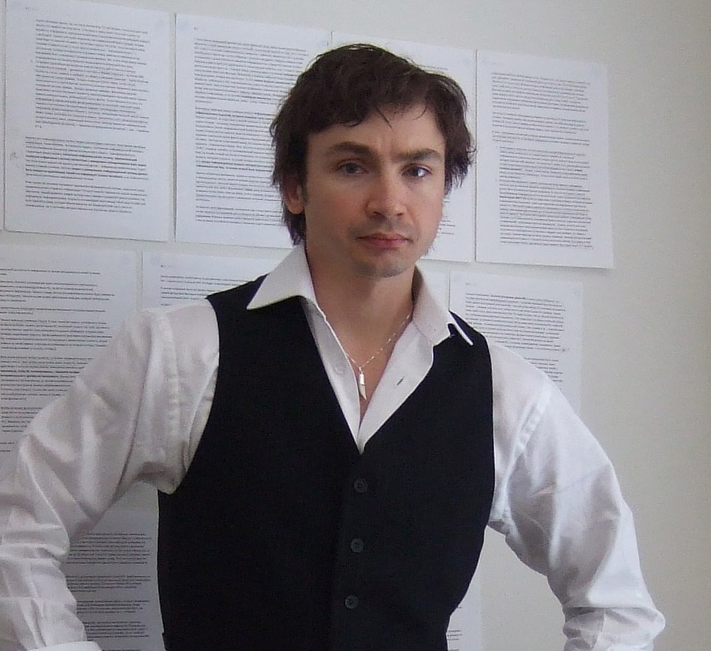
My ideas, some of which are presented here in some measure, are my life. They are a synthesis of a fairly broad scope of interests and pertain to psychology as well as theology, philosophy, and, naturally, information technology.
To a large extent they could be defined as a sum of various technologies, and yet in my opinion it would be more correct to refer to them as a sum of theological teachings, since their ideological aspect contains theological dictums about the oneness of nature as the sum of two causes. The latter have been called many different things over the millennia without changing their essence, which is Yin and Yang, God and Satan, Harmony and Chaos, the deep-rooted duality of the world and development viewed as oscillation between order and disorder.
As the idea of oneness would suggest, he who has grasped the essence has grasped it all. However, even though the law of the Universe is one, it has a great many manifestations, and in certain matters its application is more pronounced than in others.
This is true, first and foremost, in art. The world is two-fold in everything. There is no beauty without ugliness, no happiness without grief, no light without darkness. The abyss separating the two concepts is extremely difficult to comprehend, and to reflect in one’s soul. However, such a reflection (as Friedrich Nitzsche put it, “If you look into the abyss, it looks back into you”) is the one true path for a philosopher or artist. It is each true artist’s duty to allow the abyss to look into his heart, mind, and soul. When that happens, people say about the creator that he speaks with God; and God communicates with people through the artist. Sometimes, it ends badly for the artist. The abyss, and the two opposites it separates, can tear the soul apart. There are many examples of this in the history of art (Van Gogh, Vrubel), as well as in the history of philosophy (Nitzsche himself).

Hobbies.

The ideas I discuss in this presentation are my main passion, of course, taking up ninety percent of my mental resources and time. I will return to them a little later. In this section, I would like to discuss my hobbies.
When all is said and done, the nature of my hobbies is consistent with my conscious leaning towards more vivid manifestations of the world’s duality. I happen to like handguns and flying. In target practice, I like both precision shooting and speed shooting. Periodically I take stunt flying lessons, performing intricate sets of maneuvers on sports airplanes.

Target Practice.

Target practice is, of course, a captivating sport. Apart from that, when it comes to handling weapons, errors can be costly. A handgun is an instrument of death – of Chaos. Thus, target practice is an exercise stimulating self-control, i.e. self-organization. In my personal experience, it is also a good way to relieve stress.
My practice sessions consist of both long-range shooting and speed shooting involving a number of targets. I used to favor the 9mm Glock pistol with the elongated barrel. Recently, however, getting hold of a .38 Smith and Wesson, 686, a seven-shot revolver, I realized I’d found the weapon I’d been waiting for all along. No safety catch nonsense; its only fail-safe feature is the tight trigger when it isn’t cocked, which is hardly a problem for a well-trained hand. The handle is conveniently and thoughtfully designed and fits into one’s palm perfectly. Even though the weapon is on the heavy side, it is peerless in marksmanship.
I feel I have come a long way as a precision shooter. As for speed shooting, there remains plenty of room for improvement.
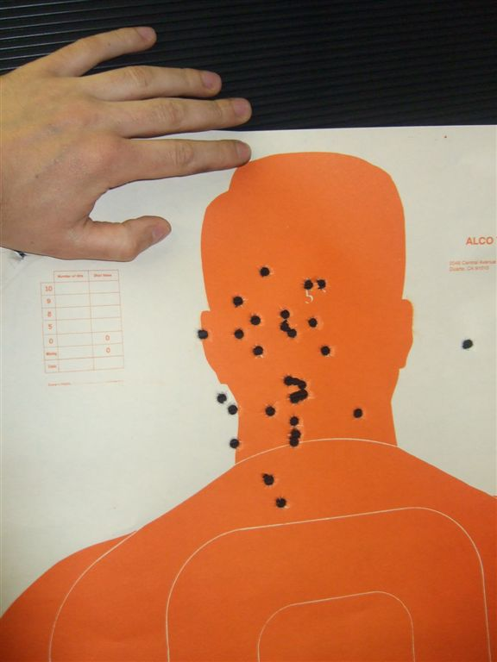  1. Результат на дистанции 20 метров |   2. Глок и его результаты на дистанции 20 метров |   3. Smith and Wesson 686 .38 в моей руке.

Flying.

If I had to make a list of things I feel passionate about, flying would probably come second, right after the ideas I have described earlier in this presentation. Stunt flying, a.k.a. aerobatics, is a thrilling, multifaceted experience. I have been training on a sports plane (Yak-52) for seven years. As I have already mentioned, during my training sessions, I perform programs consisting of sequences of maneuvers, preparing myself for amateur competitions. It may be worth noting here that at the very beginning of my training, immediately following my first participation in the Russian Aerobatics Competition, I was offered to become a candidate to the national team. In other words, with just a few flight hours under my belt, accomplished professionals found my skills promising. A number of personal and professional issues, however, made me turn down their offer.
Part of the thrill of flying is being able to perceive the special, majestic beauty of our planet that can only be truly appreciated when viewed from high altitudes. Indeed, as the poet said, truly great things can only be perceived at a distance. Another part of the thrill is the absolute necessity to be master of all your feelings, exercising maximum self-control. Proper stunt flying requires surgically precise, minutely coordinated, continuous action one is obliged to perform under severe physical and mental stress. The fear factor constitutes a large part of the experience. It is a perilous sport in which the danger element only increases as one’s skills improve – the more complicated the maneuvers, the more pronounced the danger (not to mention the extra G’s).
I will never forget my first solo flight which took place in October, 2000. Getting up there on your own for the first time is really a number-one event in a pilot’s life. It so happened that I was scheduled to take off on Friday, 13. Rescheduling was not an option, I felt. I had to get up there. And so I did.
In addition to flying, I have a number of parachute jumps under my belt, about a dozen, but only as part of pilot training (the idea being that one needs to learn, hands-on, the correct procedure for leaving the aircraft in an emergency). In terms of intensity and the sheer number of powerful impressions, parachute jumping rates well below flying.

  1. Автор в кабине Як-52 | 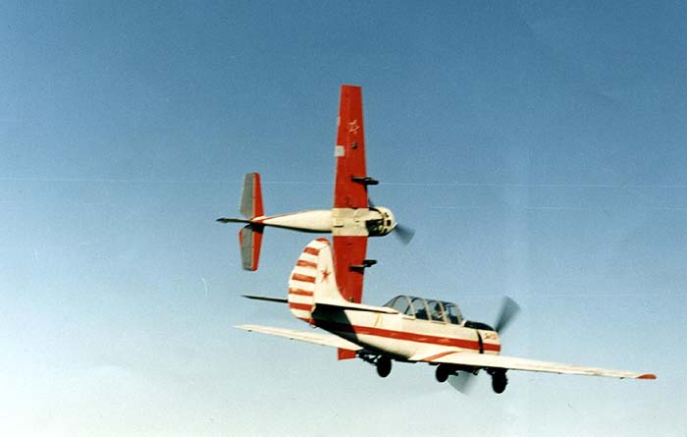  2. Фото автора, групповой пилотаж на Як-52 пилотов из его «родного» аэроклуба.

History. The History of Art. Historical figures.

One of history’s purposes, as we know, is to teach us lessons. I take a vivid interest in important historical figures, social orders and everyday life of various epochs, religion, and art. In addition, I have a soft spot for military history.
When it comes to studying the lives of great people, their psychology, their outlook, their internal equilibrium of “good” and “evil”, are likely to pique this researcher’s interest first. Of primary interest also is the great ones’ supernatural link to reality, their ability to influence events in a way that is quite beyond ordinary people. There are numerous examples of this, both positive and negative.
For instance, there is the now famous Revolutionary War incident in which Thomas Jefferson, after riding to the top of a hill near Monticello to verify the report of a British regiment arriving in Charlottesville (seeing nothing unusual, he decided it was a false alarm), discovered upon his return home that he had lost his sword. Riding back to the hill to retrieve it, he saw British horsemen crowding in the streets of the little town, and some of them already galloping towards Monticello to arrest him. Jefferson managed to escape, saving much of his archive in the process.
One finds it curious how Adolf Hitler was able to escape some forty attempts on his life – as if saved by some kind of Providence, not to mention the numerous close calls he experienced as a soldier in World War One.
Positive and negative, let us note that both men’s activities helped considerably to remap a great deal of the world’s political geography.
In my view, people of great integrity should be capable of both love and hatred. The stronger the personality, the brighter the flame resulting from the two opposing sentiments clashing in one person. People who are only capable of love or hatred can be regarded as spiritual cripples. That is not merely my opinion – denying it is tantamount to discarding disdainfully thousands of years of human experience and wisdom. Unilateral systems are incapable of progress, of development – that is a scientific fact. Creation is only possible through destruction. Truly great personalities were certainly capable of both. (Where great politicians are concerned, the issue of sacrificing human lives comes up more or less automatically. Kill one person, and you are a murderer. Kill a million, and you’re a hero. Cynical? Perhaps. It is nevertheless true).
Let me reiterate that even though I am keenly interested in the psychology of great people in all of history – prophets, generals, artists – their outlooks, formation years, etc. (more so than in in actual events, political plots, and such like), the history of the Twentieth Century specifically piques my interest.
What appeals to me in military history is the set of apparently everlasting principles that has not changed since at least Alexander’s time. The concentration of the attack, the ability to relocate and regroup one’s units rapidly, mobility, intelligence (“The one who owns information, owns the world”), the special importance of ideology and the psychological training of one’s troops – victory is the sum of the triumphant party’s superiority over the vanquished in each of those aspects.

Professional Interests.

IT.

I have been exposed to every technical aspect of IT in the course of my career, in hardware (networking equipment) and software (as a team member in software development), as a programmer as well as a manager. I am an insider intimately familiar with the field. That said, and taking into account my analytical ability, as well as my knowledge and experience of other fields, my ambition is to –
- help develop strategic thinking, the ability to analyze and foresee general trends in IT;
- develop an ability to find solutions at junctions of various different technologies and fields.
My professional characteristics are as follows:
- practical experience in development of software architecture utilizing project tools, including, but not limited to, MS Visio, UML static diagrams, sequence diagrams, component diagrams, etc. I am a certified Microsoft Architect (Architect examination 070-300 Analyzing Requirements and Defining Microsoft .NET Solution Architectures;
- Client web-technologies – my forte; my area of expertise. I have participated in the development of sites for users in the U.S. (formerly the social network tagworld.com – more than two million users; currently I am working on a team creating sites for MTV, Viacom corp., such as pcdmusic.com – the pussycatdolls site) using:
  - Macromedia Flash, object-oriented programming using ActionScript 2.0, development of Flash components; experience in utilizing tools that go along with flash themes (ActionScript editor, tools for editing vector graphics;
  - JavaScript – cross-platform object-oriented programming using JavaScript, including projects where Prototype JavaScript Framework and AJAX interface with the server have to be used;
  - DOM for Internet Explorer and Firefox – cross-platform programming on Document Object Model base for Internet Explorer and Firefox, cross-platform HTML formatting;
  - Designer tools, using Adobe Photoshop as the main tool in working with graphics. Occasionally I use my skills in a kind of art therapy.
  - In 2002, I released my own client Framework, a library of JavaScript and ActionScript types which allows to utilize a Windows-like image interface of web applications; Let me note that the release of my Framework precedes by a considerable time interval the Prototype library and many other versions, and that from the organizational viewpoint my library had significantly greater possibilities of implementation in terms of interactive user interface.
- I have Microsoft Certified Professional (MCP) status, 3427675 MCP in most frequently used server technologies, from Microsoft (C#, .NET, ADO.NET, SQL-queries). I use these skills in my work mostly for organizing the interaction between the front end of web applications and the web services and AJAX queries back end, i.e. in the three-level architecture of applications on presentation and, in part, business, levels. Nevertheless, architectural skills help me understand programming products in general, which allows me to find quality solutions in my current professional activity. After passing the appropriate exams, I have been certified in:
  - 070-300 Analyzing Requirements and Defining Microsoft .NET Solution Architectures
  - 070-315 Developing and Implementing Web Applications with Microsoft Visual C# .NET and Microsoft Visual Studio .NET
  - 070-229 Designing and Implementing Databases with Microsoft SQL Server 2000 Enterprise Edition;
- Network Hardware: initially I worked on projects involving the organization of local networks and network integration for firms using from 150 to 250 computer terminals (for power plants in Moscow, RF). However my skills and understanding of network hardware turned out to be useful in grasping the architecture of Network Hardware of large websites – organization of distributed processing, organization of web farms, server databases, etc.
Special note. In conclusion, I would like to reiterate that I believe my main professional asset to be my ability to analyze and foretell general trends in information technology, as well as the ability to find solutions at junctions of various technologies and areas of human knowledge, such as the junction of IT and psychology, resulting in the idea of combining of AM and ISM, or the junction of IT and philosophy, resulting in the idea of CCA architecture. The idea of information’s evolution cycle (chaos-harmony-chaos) comes from my exposure to synergetics.

Psychology, cognetics, pedagogics.

Psychology plays a significant part in many aspects of my life, most notably in understanding myself and the surrounding environment. Without a doubt, psychology has an enormous practical value. When it comes to psychology, I consider not just concrete instances applicable in IT (such as the usability of user interfaces), but broader areas as well, such as cognetics, perception psychology, memory psychology, pedagogics, as well as the physiological aspect of sentient beings.
My initial education has a great deal to do with my interest in psychology. I am a certified teacher with a good workable background in psychology and a number of other humanitarian disciplines, as well as a natural science instructor (math and informatics). Even though the combination may not be ideal for a technical specialist, it gives me an advantage over those of my colleagues whose education only included purely technical disciplines.

Philosophy and Theology.

Philosophy as we know it, and theology, present a unified outlook on the essence of everything that is. Philosophy is a science of wisdom. My CCA proposal rests upon a philosophical, and in some aspects, theological, foundation, combining as it does the results of ancient religious and philosophical teachings with the contemporary synergetics paradigm. That is why I count philosophy and theology among my professional interests.
In terms of my own ideas’ development, the synthesis (summation, if you will) and comparison of contemporary findings in synergetics with ancient teachings about the structure of the Universe are matters of primary interest to me. My ideas stem from my belief in the essential oneness of everything, and the duality of matter. That is what forces me constantly and quite intentionally to search, in both philosophy and theology, for supporting evidence for my ideas.
The principle of unified understanding of one’s surroundings lies in the very nature of philosophy. Each philosophical teaching proposes a common principle of grasping the structure of the Universe. Theology, being essentially a branch of philosophy, offers ideas that form one’s outlook through one’s perception of God, which I also find interesting, as it seems to be in keeping with the idea of the universal oneness of things. I am also interested in Eastern teachings about the duality of the world, Zoroastrism and Christian mythology and theology. I am especially fond of Thomas Acquinas’ works, Summa Teologica, his proof of the First Cause, etc.
Christianity and Zoroastrism, similar in the essence of their teachings (both prescribing steadfast resistance to internal and external evil), have similar notions of postmortem rewards. This is understandable, since Christianity stems from the monotheism of ancient Hebrews, whose seventy years in Babylon captivity coincided with the epoch of Persian Zoroastrism. There are, however, principal differences between the two. In Zoorastrism the world is born of two sources. In Christianity, God creates the Universe on His own, without the Devil’s assistance. Thus one may conclude that Zoroastrism reflects the duality of the world more precisely than Christianity.
The phenomenon of Christianity’s ubiquitousness and the astonishingly effective inculcation of it in the cultures of so many different countries (in spite of its deep internal contradictions) can easily be explained when one considers its advantages as a tool for mass manipulation. A complete exclusion of the chaotic cause renders the human psyche incapable of independent thinking, forming outlooks fit for enslavement, which are supported by the corresponding mythology about rewards after death. To the powers-that-be, the advantages are clear (the “shepherds” were never themselves “righteous” in the Christian sense of the word). Alas. Science presents evidence that life is only possible while motion is possible, and we are alive only because we are mortal. That is why the commonly accepted historical view holds that the killer of one is a murderer, while the killer of millions is oftentimes a hero. A person familiar with history is jarred by the highest, not immediately apparent, yet special care Providence takes of “heroes”, “good” and “evil,” mass murderers and makers of progress and history alike.
Regarding Christianity, let me note that the concept of “God is love” is, certainly, a pretty-sounding formula, even though it may be fundamentally wrong. If God is the self-realization of the Universe, He must be the sum of two causes, the ones we refer to as “good” and “evil.” Despite the contradiction the formula contains, Jesus defined inclination towards God as a quest for internal purity, light, and love, elevating Moses’ law to a new level. But! Ever since the foundation of the first churches and universal synods, this Christian formula has been used more as bait by those powerful enough to say “God speaks to me … God Himself told me this ... You must follow God’s wishes.”

Art (a professional interest as psychoactive material and embodiment of duality).

I include art in my professional interests for many reasons. The main ones are – the obvious bond between art and human psychological activity; and the philosophical origins of art. True beauty transcends systems – art is a unified view of the essence of things. Thus my practical interest in art is a result, or side effect, if you will, of my practical interest in psychology and philosophy.
In my view, art is a way of communicating with God. It is an echo of the original harmony, of God himself, perpetuated on canvas, in stone, or in a musical composition. It is what brings out the innate resonance in us, a link to the great oneness that the First Cause imparts to us. For we are all likenesses of one original essence.
I find the antique and Renaissance cultural traditions more congenial to me than others, the latter being, in my opinion, merely an extension of the Greek and Roman model applied to Christianity). Also, I am interested in all unique, bright individuals one finds among true artists, those who gazed undaunted into the chasm separating “good” from “evil”, and visited both sides in equal measure – regardless of the epoch they lived in.
Mikhail Vrubel (a turn-of-the 19th Century Russian painter) and his Demon Seated and Demon Downcast (Tretyakovskaya Gallery, Moscow, RF) is a good example. The two paintings are certainly a masterpiece in my view, an embodiment of the world’s duality, a very faithful depiction of one’s gaze directed into the chasm, of the moment when the chasm begins to live inside the artist. (Vrubel’s gazing cost him dearly. Complications following a severe cold resulted in insanity and blindness).
As a form of therapy, I occasionally spend some time trying to restore Vrubel’s original colors (using Adobe Photoshop). It is known, for instance, that in Demon Downcast, the artist used golden hues. The colors have faded considerably, and the overall impression one gets from looking at the painting cannot be what the artist originally intended. Here’s one of my attempts to restore it (I have deliberately scaled it down to leave room for imagination):
In literature, Herman Hesse (1877 – 1962, Nobel Prize winner in 1946 г, http://www.hesse.ru/, list of workds http://www.hesse.ru/books/), with his love and mastery of the genesis of powerful personalities’ internal world, is one of my favorites. I am especially fond of his Demian. The history of the youth of Emile Sinclair. I have read and reared this book a number of times. Now and then I re-read certain fragments of his other works.
About music. Today, we see stunningly interesting possibilities opening up in front of us in the area of music synthesis. At one time I was infatuated with “classical” symphonic music, including opera. However, I did not pursue it in view of the obvious stagnation in that kind of music. It is far more exciting to discover new things, which are a synthesis of both the great composers’ legacy and contemporary music culture (not mass culture, though). I’m especially interested in compositions that concern themselves with the themes of God and Satan, and the duality of the Universe.
My interest in art is related to (and indeed in a large degree responsible for) my love of travel. I go on the road for spiritual joy. Italy is the most plentiful country in that respect, of course, even though there still remain a great many places I have not seen yet that I would like to visit sometime. I am also fond of Germany and Austria (the latter is especially tempting thanks to its music festivals; one day I would be happy to hear live organ playing pieces penned by great German composers).
  1. М. Врубель, «Демон Сидящий» Третьяковская галерея | 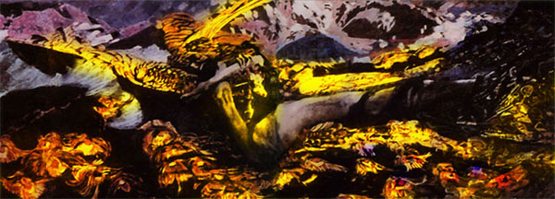  2. Авторская реконструкция картины «Демон Поверженный» М.Врубель

Some Chronological Matters.

Briefly – I spent the last seven years developing the ideas delineated in this presentation, collecting information, studying, training, and choosing places and types of employment that would facilitate my research.
More specifically, for family reasons, I received my education at a regional university, majoring in teaching, which is hardly ideal for a technical specialist. I never really wanted to be a strictly technical person, though.
While still a student, I developed a commercial software product for the field of education. After graduation, I offered this product to a Moscow firm (in 1995). They got interested. After a number of changes, my system turned out to be the best of its kind. However, the second half of the ‘90’s in Russia was a period marked by inadequate education funding, accompanied by overall corruption on all levels of the education system. The company that had purchased my product had to switch (I went along with it) to developing local networks for small and medium-sized firms (mostly power plants). During that period, I coordinated all of the company’s tasks, designed networks, selected equipment from suppliers, handled all interaction with the users, coordinated the activity of my colleagues, supervised the work performed by subcontractors, etc.
In the beginning of 2000, I developed serious health problems. A year was spent trying to obtain a diagnosis (leukemia seemed a strong possibility). Turned out, it was a rare allergic reaction that initiated symptoms similar to leukemia’s. Another six months was spent remedying the problem. During that period, I took a liking to philosophy, and, above all, synergetics. That was when the key moments of the ideas presented here emerged.
After that, I took up aerobatics in order to relieve stress. As I mentioned earlier, I had to turn down the offer from the Russian national team as it did not agree with my objectives.
Along with stunt flying, I perfected my skills in Web applications. Several different jobs followed (I did not spend more than a year at each job back then), in various capacities, including senior developer in Web applications.
I am currently employed as a web-developer, performing tasks related to the development of sites for MTV. The position has allowed me to perfect my ideas to a point where they could be presented in this format (and to look into the copyright issues).
In the beginning of 2007 I received a U.S. guest type visa (B1-B2). I’m currently living in Camarillo, CA, some fifty miles north of Los Angeles. Дополнения + вопрос: More often than not (не понимаю эту фразу) I work with our Moscow’s office from home, “telecommuting,” as we say here.

Приложение. Словарь сокращений

