SERMON NOTES
To The Ends of the Earth
A Sermon Series Through the Book of Acts
“So the Church Throughout all Judea and Galilee and Samaria Had Peace”
Acts 9: 31

___________ is a multilayered concept in the Bible.

One of satan’s oldest and favorite ebbs is to seek to sow conflict, disunity, and strife amongst God’s people. It is perhaps his greatest tool to throw the church off its main mission and _____________ - sharing the good news of the gospel.

At times the disunity that satan seeks to sow is clear sin - like with Ananias and Saphirra in Acts 5 and Simon the sorcerer in Acts 8. Other times it can be simple matters of preference, small disputes, and _________________, perhaps like the widow’s food distribution in Acts 6.

Peace and unity are never _____________ in the Bible – even among God’s people. Instead, it is something that we are called to constantly set before us, work and labor toward, and strive to maintain and keep.

No one is led away into sin against their will. We all go into sin _____________.
We do what we do because we want what we _____________.

All of my wants naturally – way more often than not – are going to center around ______________.

Putting to death the sin of ____________ is one of the constant commands of God to us in Scriptures (2 Cor 5:15; Matthew 22: 35-40; Ephesians 5: 28-29; Ephesians 4:1-3).

Jesus knows and understands that the sin of self is in us all and that it requires the conscious daily _____________ and crucifying of self in our lives (Luke 9:23).

The pursuit of peace is commanded over and over again to believers – as something that is to be prominent and first in our minds – actively worked toward and ____________ for (Eph 4: 1-3; Romans 12:18, 14:19; Hebrews 12:14).

_____________ is a word of labor; a word that carries with it a connotation of work, toil, and sweat toward something. We don’t have to strive toward things that are easy, we strive toward things that are difficult.

We don’t and we won’t stumble and fumble our way into peace with others. The witness of Scripture and the witness of our lives (our marriages, parenting, friendships, and the entire scope of all our relationships) is that peace has to be pursued, sought after, strived for, and _______________ toward.

Peace is not simply the absence of conflict and strife. It is the _______________ of unity, purpose, and goodwill between people.

Peace and unity is not ________________ – that everyone must agree all the time on everything and avoid ever having a different view or opinion than another; it requires attitudes of charity, grace, and forgiveness.

There is nothing sweeter than having the debt of sin forgiven and we are never more like ___________ than when we are relieving others from their debt to us through granting forgiveness.

Peace with God should lead to the pursuit of peace with _________ as the natural overflow of our relationship with God.

How do you seek to make peace when you have wronged someone:

Confession should address _______________ involved.

Confession should be___________ in both the way we apologize and how we acknowledge the specific sin in our request for forgiveness (don’t blame others for why you responded sinfully).

Confession must not ______________ forgiveness from the offended.

Confess with a _______________ to change / alter our behavior by God’s enabling.

When we are sinned against, we are called to two responses biblically: _____________ and ______________ forgiveness.

We are called by God to grant forgiveness the moment it is _____________ (Luke 17:3)

When we forgive, we promise not to remember the sin again, that is not that we forget it but we determine to no longer count it _________ the person (Jeremiah 31:34).

When we forgive, we promise not to bring it up again or tell others (or to __________).

Whenever we forgive, we promise to actively pursue full ____________ (where ever possible).

In Christ, we are all called not to fight and insist on our own ways but rather to lay down our preferences. We are called not to count ourselves - but others as more ____________. (Philippians 2: 1-5; Romans 12:10).

Blanks: Peace; focus; misunderstandings; assumed; voluntarily; want; me; self; denying; strived; Strive; persevered; presence; uniformity; God; others; everyone; sincere; demand; resolution; vertical & horizontal; requested; against; ourself; restoration; significant
Congregational Reading – James 3: 13 – 18

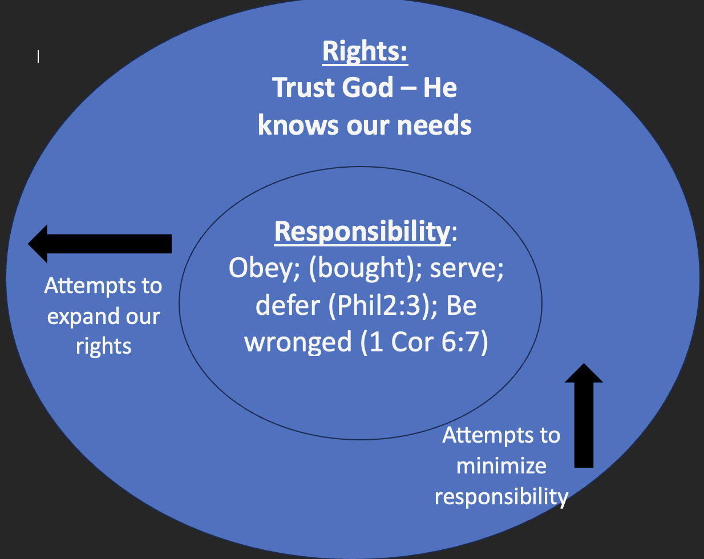
Who is wise and understanding among you? By his good conduct let him show his works in the meekness of wisdom. But if you have bitter jealousy and selfish ambition in your hearts, do not boast and be false to the truth. This is not the wisdom that comes down from above, but is earthly, unspiritual, demonic. For where jealousy and selfish ambition exist, there will be disorder and every vile practice. But the wisdom from above is first pure, then peaceable, gentle, open to reason, full of mercy and good fruits, impartial and sincere. And a harvest of righteousness is sown in peace by those who make peace.

