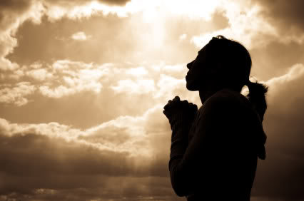
Sermon Title: Prayer Is For Our Benefit, Not God’s
Kim Slowek
Redemption Rock Church of Cape Cod
www.RedemptionRock.net
October 1, 2023

1 Thessalonians 5:17
“pray without ceasing” (KJV & ESV)
“pray continually” (NIV)
“pray all the time” (MSG)

Check out:
- Drawing Near Devotion by Matt Muscatell on YouVersion Bible app
- Prayer Has Its Reasons by Robert Velarde at focusonthefamily.com/faith/prayer-has-its-reasons/

“Child of God” defined:
“But to all who did receive him, who believed in his name, he gave the right to become children of God.”
-John 1:12 (ESV)
My misconceptions:
“Do not be like them [Gentiles heaping up empty phrases], for your Father knows what you need before you ask him.” -Matthew 6:8 (ESV)

“For we do not know what to pray for as we ought but the Spirit himself intercedes for us with groanings too deep for words.” -Romans 8:26 (ESV)

Luke 18:1-5 Parable of the widow and the judge

-we are loved (Luke 18:6-8)
-we are children of God (Romans 8:16)
-we are co-heirs with Christ (Romans 8:17)

Why do we need prayer? Prayer is…

- …how we communicate with God.

2 Chronicles 7:14, Isaiah 40:29-31, Hebrews 4:15-16

- …fulfills emotional needs.

- …grants us the privilege of experiencing God.

“When you are allowed access, you are accepted to come and enter.” -Matt Muscatell (Drawing Near Devotion)

“…in whom we have boldness and access with confidence through our faith in him.” -Ephesians 3:12

- …allows us to participate in God’s works.

“Not everyone who says to me, ‘Lord, Lord’, will enter the kingdom of heaven, but the one who does the will of my Father who is in heaven.” -Mathew 7:21 (ESV)

- Answered prayer is a potential witness.

Matthew 15:30-31, Luke 5:17-26, Mark 7:31-37

- …can succeed where other means have failed.

Genesis 15-17

How do we pray? Luke 11:2-4

- Focus on God
- Worship Him before all else
- Pray that God will reign and rule in each situation you are praying for.
- Make the time AND get ALONE with God
  - “And after he had dismissed the crowds, he went up on the mountain by himself to pray.” Matthew 14:23, “And rising very early in the morning, while it was still dark, he departed and went out to a desolate place, and there he prayed.” Mark 1:35, “And after he had taken leave of them, he went up on the mountain to pray.” Mark 6:46, “But he would withdraw to desolate places and pray.” Luke 5: 16, “In these days he went out to the mountain to pray, and all night he continued in prayer to God.” Luke 6:12, “And he withdrew from them about a stone’s throw, and knelt down and prayed…” Luke 22:41

Questions about today’s message? Contact Pastor Mike at
Pastor@RedemptionRock.net or on his cell phone at 774-209-0182.

Remember to join us next Sunday when Pastor Mike returns to the Bait of Satan sermon series with the next message “Placed in the Body”.

