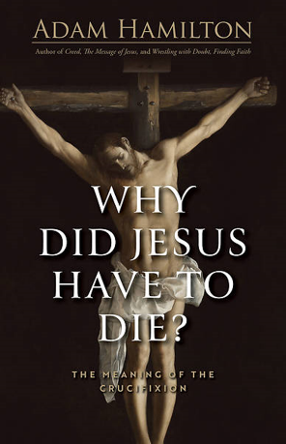
Why Did Jesus Have to Die? New Sermon Series in Lent

January 30, 2026

Dear Brothers and Sisters in Christ Jesus at BRFUMC,
Peace and grace be with you. As we move through the season of Lent, we are taking time to explore the most central moment of the Christian faith: The Crucifixion.
We know Jesus died for us, but have you ever stopped to ask how that works? Or why it had to happen that way? Often, we struggle to make sense of the crucifixion. It can seem confusing, or the explanations we were taught in 20 years ago might not resonate today.
Despite the crucifixion’s central place in Christian faith, the New Testament offers few clear answers about how Jesus’ death saves, or why, exactly, he had to die. The New Testament writers use a host of metaphors—ransom, sacrifice, reconciliation, victory—but never explain exactly how it works or why it had to happen this way.
Join us for a powerful 6-week series as we explore Why Did Jesus Have to Die: The Meaning of the Crucifixion by Pastor Adam Hamilton. Together, we will walk through the New Testament to unpack the different metaphors of the cross—ransom, sacrifice, reconciliation, and victory—to see the profound love of God in a new way.
Whether you are a lifelong Christian or just curious about the meaning of the cross, this series will help deepen your faith and understanding.
0: Preface and Introduction
1: Lift High the Cross: The Crucifixion as God’s Word and Recapitulation
2: O Love Divine, What Hast Thou Done: Penal Substitution and Sacrificial Offering
3: Agnus Dei (Lamb of God): Atonement as New Passover, New Covenant, and Redemption
4: Were You There: The Moral Influence and Moral Example Theories of Atonement
5: What Wondrous Love Is This: Moral Influence Theory, Part II
6: Christ the Lord Is Risen Today: Christus Victor (Christ the Victor) Theory of Atonement

Join us Sunday at 9 am from February 22nd to April 5th, Easter Sunday.
Bring a notebook and pen to take notes!

Blessings,

Pastor, Rev. Inwha Shon

