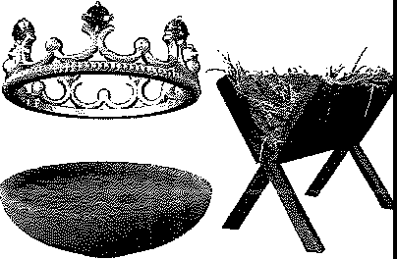

Topic
Gospel of Matthew
Theme
The Gospel of Matthew presents Christ as the Messiah/King and Israel as condemned.
Desired Learner Response
The learner will recog­ nize Christ's authority in his life and submit to Him.

Materials
- Resources 1-3
- Craft supplies for Crown Creations activity

Matthew: Christ Is King

Scripture Focus
Matthew
Summary
This lesson is an overview of Matthew. It will introduce Matthew the writer and will trace his presentation of Christ as the Messiah/l(ing.Special emphasis will be given to our response to Matthew's presentation of Christ.

Outline
- Authorship of Matthew
  - Matthew, the publican
  - Matthew, the disciple
  - Matthew, the writer
- Matthew's Purposes
  - Present Christ as King
  - Present Israel as condemned
Ill. Matthew's Theme Development
- The Messiah presented
  - His lineage
  - His teachings
  - His miracles
  - His formal presentation
- The Messiah rejected
- The Messiah departed
- The Messiah exalted

Memory Verse
"And Simon Peter answered and said, Thou art the Christ, the Son of the living God"
(Matthew 16:16).

18


GETTING STARTED

Expectation Indication
Read the following list of upcoming events one at a time. Have your learners indicate how much they are looking forward to the events by holding up one finger for no anticipation and five fingers for high anticipation. They can use two, three, and four fingers to indicate varying degrees of anticipation. They can refrain from sharing if a particular category doesn't apply to them. Consider adding your own categories personalized to match your class.
- Your next birthday
- Your anniversary
- Retirement
- Dentist appointment
- Birth of a child or grandchild
- Presidential election
- Christmas
- Christ's earthly Kingdom
ASK: What other events are you looking forward to with great anticipation?

ASK: How might anticipating an event affect our lives?
Matthew wrote his Gospel in order to present Christ as the Messiah/King. Christ's rule is yet future, and we have the opportunity to be a part of that time here on earth. This lesson will give us an overview of the Gospel of Matthew. It will challenge us to consider what it means to live under Christ's authority and with anticipation of His future Kingdom.

Crown Creations
Organize the learners in groups of four to six. Provide each group with scis­ sors, construction paper or cardstock, tape, glue, and craft supplies such as the following:
- Beads
- Felt
- Chenille wire
- Plastic jewels
- Markers
- Star stickers
Have the groups make a crown out of the supplies. Give them six or seven minutes to work. Have them suggest who the crown might be for.
ASK: Suppose you were in charge of making a crown for Christ to wear during His future reign on earth. How seriously and urgently would you approach the project? (Ql)
ASK: How seriously and urgently do you take the future, millennial reign of Christ on earth? (Q2)

Matthew wrote his Gospel in order to present Christ as the Messiah/King.
Christ's rule is yet future, but we can anticipate His rule by living insubmission to Him now. This lesson will give us an overview of the Gospel of Matthew. It will challenge us to consider what it means to live under Christ's authority and with anticipation of His future Kingdom.

SEARCHING THE SCRIPTURES

Authorship of Matthew
  - Matthew, the publican
Matthew, also called Levi, was a Jewish tax collector, or publican. He worked for the Roman government collecting taxes from his fellow Jews. The more money he could squeeze out of the Jews, the more money he made. Needless to say, the Jews hated Jewish tax collectors and considered them selfish traitors and thieves. The publicans' love for themselves was so strong that they were willing to be despised outcasts in the Jewish community for the opportunity to indulge themselves.
Jesus was well aware of how the Jews viewed tax collectors. He used this low view to help the Jews understand what true love is (5:43-48) and how serious it is for a believer to refuse to repent of his sin (18:15-17). Yet Jesus did not write off tax collectors as hopeless (21:28-32). Matthew learned this personally.

Matthew, the disciple

See Matthew 12:1-8 for Christ's second used of the quote from Hosea 6:6.
READ: Matthew 9:9, 10. ASK: Describe the transformation that went on in Matthew as he put his faith in Christ and followed Him. (03) Matthew's heart, once filled with selfishness, became filled with love for his fellow Jews.
Matthew's change of heart is obvious right away. He invited his fellow publi­ cans to a meal with Jesus. He wanted them to know what he had discovered about the Teacher. Some of the publicans responded and ate with Jesus and His disci­ ples. The Pharisees, the self-righteous religious leaders of the Jews, asked Jesus' disciples why their Teacher ate with tax collectors and sinners (9:11). Jesus an­ swered the Pharisees byemploying a metaphor. He said those who are whole don't need a physician, but those who are sick (9:12). The Pharisees thought they were whole and acceptable to Go! because they believed they kept the law. In Matthew 9:13 Jesus rained on their parade by quoting Hosea 6:6, I will have mercy, and not sacrifice. This statement gains meaning when we understand that Hosea proph­ esied in Israel during the nation's most troublesome days. Within a few years of his ministry Assyria conquered Israel and took it into captivity. God communicat­ ed through Hosea that the Jews needed to have faithful, loyal hearts rather than outward sacrifices. The ritualistic, self-righteous Pharisees of Jesus' day needed to hear that message too. They were condemned and didn't know it. Matthew, on the other hand, was well aware of hissin and stood righteous before Christ because he had put his faith in Him.

Matthew, the writer
The Scriptures do not name Matthew as the writer of the Gospel that bears his name, but the earliest of the church fathers referred to Matthew as its writer. There is no plausible reason to deny that Matthew authored the Gospel that bears his name.
ASK: How might Matthew's background as a rejected, sinful tax collector influence his Gospel? (Q4) He could write from a personal perspective about the condemned state of theJews as well as the power of the gospel.
The content of Matthew's Gospel points to a Jewish audience, so Matthew probably wrote the Gospel somewhere in or near Israel. Antioch is perhaps the city where Matthew wrote.
As a tax collector, Matthew kept exact records. He did not need to rely on
others for written material for his Gospel because he was thoroughly capable of recording events and conversations. He was, of course, free to use the records that others made of Christ's life.

Matthew's Purposes
  - Present Christ as King
In Matthew Christ is seen as the long-awaited King of Israel. This theme is quite clear as we move through the Gospel. In order to properly appreciate this emphasis, one must remember that godly Israelites for centuries have been long­ ing for the appearance of Messiah the King. Numerous Old Testament prophecies spoke of His coming.
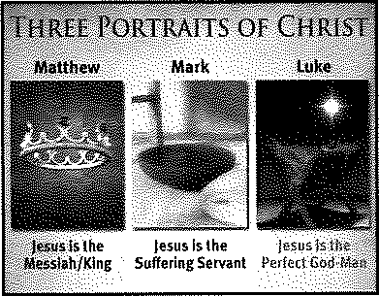
RESOURCE: Display resource 2 to review Matthew's presentation of Christ in comparison to Mark's and Luke's.
It was no small thing when John the Baptist burst on the scene announcing that the way of the Lord should be prepared for the kingdom of Heaven was at hand (Matt. 3:2, 3). This startling message brought to the Jews' minds all the glo­ rious promises found in the Old Testament Scriptures. It immediately connected both John and Jesus with those promises.
ASK: Imagine you are living as a Jew under Roman rule at the time of Christ's arrival onto the scene. How might you expect His arrival to affect your life? (QS) The prospect of being the rulers instead of the ruled was no doubt a thought that captured the many Jews imaginations.

Present Israel as condemned
A major thrust of the book is that of divine judgment on Israel because they rejected the Messiah. This is particularly seen in the latter portion. All of Matthew 23 is taken up with the woes Christ pronounced on the unbelieving nation and its leaders. Israel's accountability for her sin is emphasized in Matthew 23:33-35, and there follows a heartrending pronouncement of divine abandonment until Messi­ ah shall return in glory (23:37-39).

READ: Matthew 23:33. ASK: What did Christ conclude about the destiny of unbelieving Israel and the scribes and Pharisees in particular? {Q6) On their own they were condemned and would not be able to escape the suffering of Hell.

READ: Matthew 23:37. ASK: What does Christ communicate to Israel by describing Himself as a hen and Israel as chicks? {Q7) He communicates His tender love and His true desire to save them from destruction.
A tremendous evangelistic appeal is contained in this Gospel. Christ offered Himself to Israel as He does to men today. They rejected Him. One of the saddest phrases of the Bible is that describing Israel's response to Christ's invitation.
READ: Matthew 23:37-39. ASK: How does Christ describe Israel's response to His invitation? {Q8) Ye would not.
Today also men who refuse the gospel invitation will receive divine punish­ ment, and Christ is also saddened by their unbelief.

Matthew's Theme Development
The word Messiah means the anointed one; and the term refers to the Lord Je­ sus Christ especially as was predicted by the Old Testament prophets. He was to be One Who was especially anointed by God, that is, set apart for a special and holy task. For centuries, the Jews had anticipated the coming of their Messiah. Howev­ er, when He appeared, the nation as whole did not receive Him.

The Messiah presented
The Gospel of Matthew is peculiarly arranged so as to present the credentials of the Christ of God. The Jewish people would naturally be interested in demon­ strable proof that Christ was the Messiah as claimed. Matthew intentionally pres­ ents this proof.

His lineage
Only Matthew and Luke give much information concerning Christ's birth.
Matthew views Christ's birth from the special Jewish vantage point with empha­ sis on His Messianic character. He is the One Who is born King of the Jews (2:2). As mentioned in lesson one, the Savior's genealogy in chapter 1 emphasizes His Davidic origin.

His teachings
Matthew's description of Christ's public teaching sets forth His right to the throne since He is able to formulate kingly proclamations. Christ opened his mouth and taught them (5:2). As a King, He has the authority to set forth what He ex- pects of those who live under His rule. The expectations in Matthew 5 through 7, commonly called the Sermon on the Mount, were certainly compatible with His claim to be a King. They were not intended to be guidelines by which the mass of mankind would live. You will notice that this great message was addressed to his disciples (5:1).

READ: Matthew 5:20. ASK: Summarize the message of this verse, perhaps the central teaching in the Sermon on the Mount. {Q9) No one could ever be good enough to enter into the kingdom of heaven.
True righteousness that is acceptable to God comes through faith in Christ. Jesus set the standard of true righteousness through the Sermon on the Mount. Both His disciples and the reader today must conclude that they cannot achieve true righteousness on their own. That was a truth the scribes and Pharisees were never willing to believe. In fact, they rejected that truth so vehemently that they eventually crucified Christ to try to destroy Him and His message.
Once a person puts his faith in Christ, he has the opportunity to live out the characteristics Jesus spelled out in the Sermon on the Mount because his heart has been changed. The good behavior flows from his heart as evidence of his salvation. There is a growing, inward transformation rather than just an outward conformation.

His miracles
The Gospel of Matthew groups Christ's miracles-for the most part-in chap­ ters 8 through 10. Matthew uses the accounts of Christ's miraculous to support his presentation of Christ as the King of Israel. When John the Baptist heard the report of Christ's works while he was in prison, he sent some of his disciples to ask, Art thou he that should come, or do we loolc for another? (11:3).
READ: Matthew 11:3-5. ASK: What did Jesus tell John's disciples to report to John? (Ql0) Jesus told John's disciples to reporttoJohn about all the miracles they heard about and witnessed.
Jesus declared that John the Baptist could find abundant proof of His Messi­ anic character through His miraculous works. He was definitely the Messiah, the Christ of God, because of those wonderful works He accomplished.

His formal presentation
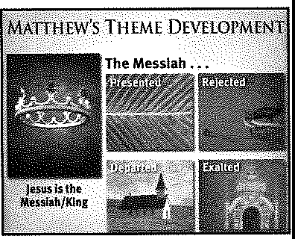
In Christ's last journey to Jerusalem, He formally and publicly offered Him­ self as the promised Messiah (21:1-11). As He approached the city, the nation of Israel could certainly see in His very demeanor that He was the Messiah Whom the prophets had spoken. The crowd responded by shouting hosanna (21:9), which means save now, we pray. The shouts were militaristic in nature. The people expected liberation from Rome. But Christ rode a donkey, a symbol of humility and peace. In doing so He fulfilled Zechariah's prophecy (Zech. 9:9). Eventually Jesus went to the cross and brought liberation from sin rather than liberation from Rome.
Certainly the nation of Israel had no excuse. The Lord Jesus Christ, their
long-awaited Messiah, intentionally presented Himself to the nation. He was declared to be the Son of God from Heaven, the promised Deliverer of Messianic prophecy. He amply demonstrated the fact that He was sent from God. In the face of this evidence, the nation oflsrael turned away.
RESOURCE: Display resource 3 to review the theme: The Messiah Presented.

The Messiah rejected
In his presentation, Matthew intends to demonstrate that the Jewish nation officially rejected Christ. Particularly in chapters 11 and 12 of the Gospel, he pres­ ents the evidence for this indictment. He tells the nation that they rejected John the Baptist, His forerunner; and now they have rejected the Son of God Himself, declaring Him to be a friend of publicans and sinners (11:19). Matthew then states that Christ began to rebuke the cities in which He had done most of His mighty works because the cities did not repent (11:20).
READ: Matthew 11:20-24. ASK: How seriously did Christ take the cities' indifference to His mighty works? (Ql 1) Christ said His judgment on the cities would be worse than the judgment on Tyre, Sidon, and Sodom, three particularly notorious cities.
Treating Christ with indifference was worse than overtly opposing Him. The cities did not do terribly evil deeds. Their main fault lay in their self-righteousness. They believed they had no need for Christ.
In the midst of these chapters in which the Lord pronounces judgment on the nation, He also gives some beautiful invitations to all those who will heed. No more wonderful invitation has ever been given than that in Matthew 11:28. At the end of this section in which His pronouncements of judgment are recorded, He uses for the first time in the Gospel the word whosoever (12:50). The use of this word reveals the fact that He is turning from Israel as an exclusive recipient of
His message to the entire world. He is going to provide salvation for all who will re­ ceive it. The whosoever may come and find rest in the Son of God, Who was clearly rejected by His own people.
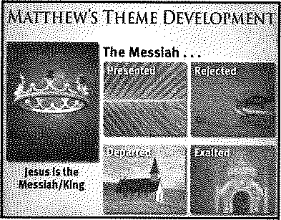
RESOURCE: Display resource 3 to review the theme: The Messiah Rejected.

The Messiah departed
The grouping of parables found in Matthew 13 can be understood only in the light of the fact that Christ would be leaving the world. These parables describe the course of history following Christ's departure into Heaven. They outline the progress of the Church Age and the development of professing Christendom. The fact that the term mysteries of the kingdom of heaven (13:11) is employed of these parables indicated that they unfold truth not found in the Old Testament proph­ ecies. There are things in this chapter about the Kingdom of Heaven that God reserved for the time following Israel's rejection of His Son.
When it becomes apparent within the narrative of the Gospel of Matthew that the Lord Jesus has been rejected by Israel, the author then begins to show how Christ prepared His disciples for His ensuing departure from earth (16:21; 17:12, 22, 23; 20:17-19, 28). They were expecting Him to establish His kingdom by some might or force. However, He began to make it clear to them that this would not be the case.
READ: Matthew 16:21-23; 20:28. ASK: Why did Jesus so adamantly reject Peter's notion that Jesus would not suffer and die? (Ql 2) Christ's death was

God's plan. Christ needed to die in order to save the lost.

READ: Matthew 17:22, 23. ASK: What gives you a clue that the disciples
weren't expecting Jesus to die? (Ql 3) They were exceedingly sorrowful.
As Christ moves farther toward the shadow of the cross, He gives an additional revelation to His disciples. He predicts that in the future He will build an institu­ tion called the church (16:18). This is a completely new revelation, and it is the first time the word is used in the New Testament. The fact that it is coupled with the prediction concerning His death and resurrection (16:21-23) would seem to indi­ cate that the construction of the church would take place in the time following the Lord's departure from the earth.
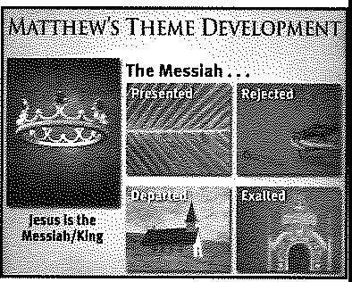
RESOURCE: Display resource 3 to review the theme: The Messiah Departed.

The Messiah exalted
The Gospel of Matthew does not leave the Son of God in utter rejection, but it predicts the time when He will be exalted on this earth. This great truth is emphasized particularly in the Olivet Discourse (24; 25). Like a flash of lightning across the sky, so the coming of the Son of Man would be (24:27). The Christ Who was rejected by Israel will return with power and glory; and the Jewish remnant, their hearts moved by the Holy Spirit, will look up and mourn (Matt. 24:30; Zech. 12:10-14).
Matthew concludes his description of Christ's future exaltation by declaring He shall he sit upon the throne of his glory (Matt. 25:31). He will then be the King over a worldwide kingdom (25:34). Glory will fill the entire earth as the Old Testa­ ment prophets predicted.
The Gospel of Matthew ends with the accounts of Jesus' arrest, trials, crucifix­ ion, resurrection, and ascension (26-28). But the reader is not left wondering what happens next. We have a clear understanding of Christ's future return and reign. We anticipate being part of His Kingdom, but we should respond to Christ with submission and reverence now. He is as much as an authority in our lives now
as He will be during His reign on earth. Our lives ought to show that Christ is our authority. More specifically, we ought to be involved in the church and in carrying out His Great Commission (28:18-20).

RESOURCE: Display resource 3 to review the theme:The Messiah Exalted.

MAKING IT PERSONAL

Recognize Jesus as the King of Kings
Jesus offered Himself to Israel as their king. Their rejection of Him was not a surprise to Christ or God the Father. Christ's suffering and death on the cross were

Christ's return for believers, called the church, will pre­ cede His return to establish His Kingdom. A seven-year tribulation will take place on earth while the church receives rewards for their
service in Heaven. The church
will then come with Christ to earth to be a part of Christ's Kingdom.

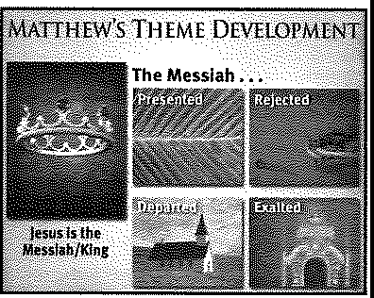

part of God's plan. His future return and reign are parts of God's plan for Israel too. As part of the church that Jesus referred too, we get to participate in Christ's Kingdom and enjoy His reign. Until then, we should anticipate Christ's Kingdom and live with full confidence that one day Christ will rule on earth.
ASK: How much do you consider the future reign of Christ? (Q14)

ASK: How might anticipating the future reign of Christ affect your life? (Ql 5)

Submit to Christ's Authority
ASK: What characterizes the lives of those who live in submission to Christ's authority? (Ql 6) They want to know Christ's will for their lives; they delight in pleasing Christ; they regularly deny themselves in order to serve Christ; they take sin seriously.


Challenge you learners to consider whether they recognize Christ's authority in their lives and to submit to llim in areas of their lives they have withheld from Him. (Q17)

••
••
10,
11,

12.
13.

Summary and Memory Verse
RESOURCE: Display resource 1. Add a summary statement for lesson 2 or use the following: Live in submission to Christ.
Encourage learners to memorize Matthew 16:16. Give them an opportunity to say the verse in class next week.

SPECIAL NOTE FOR NEXT WEEK'S LESSON
For next week's lesson, have your students gather five snapshots that summa­ rize their lives. Ask them to have the pictures ready to show in class next Sunday.
See the first Getting Started activity for lesson three for more information.

