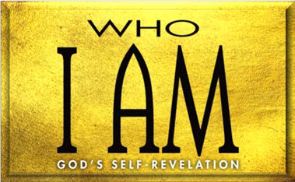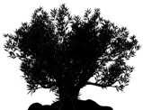

1. Moses’ Song (Deut. 31:28—32:52)

A. Moses’ call to (31:28—32:2)

* 1. Moses’ of God (32:3, 4)
  2. Israel’s response to God’s (32:5, 6)
  3. God’s to Israel (32:7–14)
  4. Israel’s response to God’s (32:15–18)
  5. God’s response to Israel’s (32:19–35)
  6. God’s of Israel (32:36–43)

1. Moses’ Application (32:44–52)
2. Moses’ Blessing (Deut. 33)
3. of the blessing (33:1–5)
4. The blessing of the (33:6–25)

C. (33:26–29)

1. Moses’ Death (Deut. 34)

**LESSON 13 • I AM THE SOLID ROCK**

©2015 Regular Baptist Press ⋅ May be copied for classroom use only.