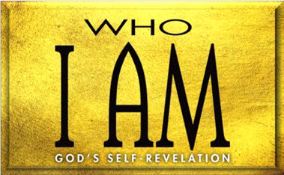

1. Israel’s Rebellions (Num. 14:39—17:13)
   1. Attempting to the Promised Land (14:39—15:31)
   2. Breaking the (15:32–41)
   3. Rebelling against and (16; 17)
2. Moses’ Rebellion (Num. 20)
3. Balaam’s (Num. 22:1––24:25) A. Balak’s (22:1–22)

B. Balaam’s (22:23–40)

C. Balaam’s oracles (22:41—24:25)

1. Balaam’s first oracle (22:41—23:12)
2. Balaam’s second oracle (23:13–26)
3. Balaam’s third oracle (23:27—24:25)

**LESSON 11 • I AM POWERFUL PROCLAIMER**

©2015 Regular Baptist Press ⋅ May be copied for classroom use only.