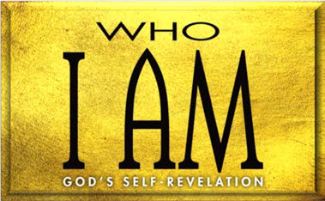

1. God Provided for Israel (Num. 1—11)

A. God’s on Israel (1:1—6:21; 7—11)

B. God’s for Israel (6:22–27)

1. Israel Complained (Num. 11:1–3)
2. Israel Meat (Num. 11:4–35)

A. Israel’s (11:4–9)

B. Moses’ (11:10–15)

C. God’s and (11:16–35)

1. Miriam and Aaron Moses (Num. 12)
2. Israel God (Num. 13; 14)
   1. out the land (13:1–24)

B. the land (13:25—14:38)

**LESSON 10 • I AM GRACIOUS GIVER**

©2015 Regular Baptist Press ⋅ May be copied for classroom use only.