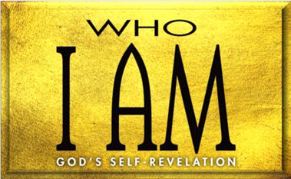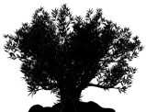

1. God’s Place of Worship (Exod. 35—40)
   1. God provided and (35—39)
   2. Moses constructed the (40:1–33)
   3. God approved of the (40:34–38)
2. God’s Sacrifices (Lev. 1—7; 16)
3. God’s Priesthood (Lev. 8; 9)
4. God’s Demand for Holiness (Lev. 10:1–11)
   1. Nadab and Abihu offered profane (10:1)
   2. God Nadab and Abihu (10:2–5)
   3. God the priests (10:6–20)
5. God’s Laws for and (Lev. 11—15; 17—27)

**LESSON 9 • I AM ATONER**

©2015 Regular Baptist Press ⋅ May be copied for classroom use only.