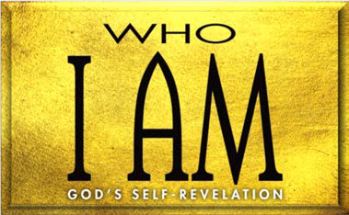

1. Ratification of the Covenant (Exod. 24)
   1. God’s covenant (24:1–8)
   2. God’s presence (24:9–18)
   3. God’s place (25—31)
2. Rejection of the Covenant (Exod. 32:1—33:17)
   1. Israel’s sin (32:1–6)
   2. Moses’ appeal to God’s (32:7–14)
   3. Moses’ execution of God’s (32:15–29)
   4. Moses’ second appeal to God’s (32:30–32)
   5. God’s execution of His (32:33—33:6)
   6. Moses’ appeal to God’s (33:7–17)
3. Revelation of the Covenant Keeper (Exod. 33:18—34:28)
   1. God’s of His glory (33:18—34:9)
   2. God’s of His glory (34:10–28)

**LESSON 8 • I AM GLORIOUS GOD**

©2015 Regular Baptist Press ⋅ May be copied for classroom use only.