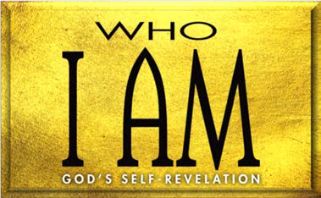

1. God’s Covenant with Israel (Exod. 19:1–8) A. God’s (19:1–4)

B. God’s and (19:5, 6)

C. Israel’s (19:7, 8)

1. God’s Stipulations for Covenant Blessing (Exod. 19:9—20:17) A. Israel’s (19:10–15)

B. God’s and (19:16–25; 20:18–21)

C. God’s law (20:1–17)

* 1. Israel’s relationship with (20:1–11)
  2. Israel’s relationship with (20:12–17)

**LESSON 7 • I AM INSTRUCTOR**

©2015 Regular Baptist Press ⋅ May be copied for classroom use only.