1. God

A. With

Israel (Exod. 13:17—14:31)

(13:17–22)

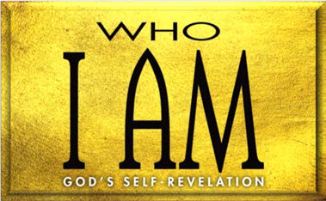

B. With (14:1–18)

C. With power (14:19–31)

1. power (14:19, 20)

2. power (14:21–31)

1. Israel God (Exod. 15:1–21)

A. He is and (15:1–12)

B. He is able to His (15:13–21)

**LESSON 5 • I AM LEADER**

©2015 Regular Baptist Press ⋅ May be copied for classroom use only.