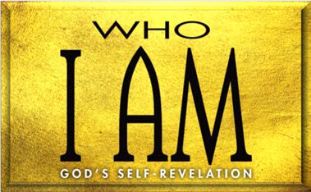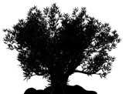

I. God His (Exod. 7:14—8:19)

1. First triplet of plagues (7:14—8:19)
   1. The purpose (7:14–17a)
   2. The plagues (7:17b—8:19)
2. Second triplet of plagues (8:20—9:12)
   1. The purpose (8:22)

2. The plagues (8:20—9:12)

1. Third triplet of plagues (9:13—10:29)
   1. The purpose (9:13–16)

2. The plagues (9:17—10:29)

II. God (Exod. 11:1—12:42)

* + 1. Announcement of the (11:1–10)
    2. Institution of the (12:1–20)

C. The from (12:21–42)

**LESSON 4 • I AM REDEEMER**

©2015 Regular Baptist Press ⋅ May be copied for classroom use only.