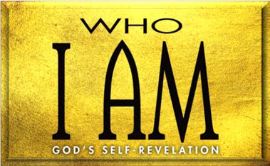

1. God Declared His Plan for Israel and Humanity (Gen. 12:1–3; 49:8–12)
   1. God’s to Abraham (12:1–3)
   2. Jacob’s blessing of (49:8–12)
2. God Worked His Plan (Exod. 1)

A. God His (1:1–7)

B. God Pharaoh’s plans (1:8–22)

1. Pharaoh’s plan A (1:8–12)
2. Pharaoh’s plan B (1:13, 14)
3. Pharaoh’s plan C (1:15–21)
4. Pharaoh’s plan D (1:22)
5. God Prepared His Leader (Exod. 2:1–22)
   1. God’s hand (2:1–4)
   2. God’s hand (2:5–22)
      1. Moses’ training in his house (2:5–9)
      2. Moses’ training in house (2:10)
      3. Moses’ training in the (2:11–22)

**LESSON 1 • I AM SOVEREIGN**

©2015 Regular Baptist Press ⋅ May be copied for classroom use only.