Tests of Faith



**Topic**

Faith

**Theme**

The Lord tests and rewards our faith.

**Desired Learner Response**

The learner will accept tests of his faith and will endeavor to grow through them.

**Materials**

* Resources 1. 7, and 11
* Paper and pencils

**Scripture Focus**

**Genesis 20-23**

**Summary**

Isaac. the promised son, was born when Abraham and Sarah were very old. His birth brought them joy, but it also stirred up conflict between his parents and Hagar and Ishmael. Abraham expelled Hagar and Ishmael from his home. Later the Lord tested Abraham's faith by asking him to sacrifice his son Isaac. Eventually Sarah and Abraham died and were buried in the cave of Machpelah in the Promised Land.

**Outline**

1. **Abraham's Faith Lapses (20)**
2. **God Rewards Abraham's Faith (21:1-7)**

Ill. **God Tests Abraham's Faith (21:8-23:20)**

* 1. The Ishmael test (21:8-21)
  2. The Isaac test (22:1-14)
  3. The land test (22:15-23,20)

**Memory Verse** *'Through faith also Sara herself received strength to conceive seed. and was delivered of a child when she was past age,*

*because sheJudged him faithful who had promised" (Hebrews 11:11).*

***76***



**GETTING STARTED**

**Super Prepared**

Sometimes we joke that some people are so prepared for everything that they even study before getting a blood test.

**ASK:** Are you the type of person who likes to be super prepared for every­ thing? (Ql)

**ASK:** What happens when life throws you a curveball you didn't prepare for? (Q2) Encourage learners t o share their experiences.

**ASK:** How might you prepare for a test of your faith ?

Abraham went through tests of his faith. He didn't pass them all, but the ones he did pass help us learn some important lessons. Those tests are the focus of our lesson today.

**Pop Quiz**

Announce that you will be giving a pop quiz on the lesson you had last week. Give each learner a pencil and a piece of paper for recording their answers to the following questions:

1. What food item(s) did Abraham say he would bring to the three men who visited his camp? *A morsel of bread (18:5).*

2. What was the lowest number Abraham gave in his appeal to the Lord to spare Sodom? *Ten (18:32).*

* + 1. What did the future sons-in-law do when Lot told them to leave Sodom?

*They laughed (19:12- 14).*

* + 1. What was the name of the city to which Lot fled? *Zoar (19:22).*
    2. What were the names of the sons born to Lot by his daughters? *Moab and Ben-ammi (19:37,38).*

Congratulate all those who got all five questions right.

**ASK:** Do you like pop quizzes? Would you rather be prepared?

**ASK:** What kind of pop quiz might God bring our way? *Tests of our faith.*

**ASK:** How might you prepare for a test of your faith?

Abraham went through tests of his faith. He didn't pass them all, but the ones he did pass help us learn some important lessons. Those tests are the focus of our lesson today.

# SEARCHING THE SCRIPTURES

God had made another appearance to Abraham with the purpose of telling him that Sarah would have a son. Sarah heard the conversation and initially laughed at the notion. She then denied she laughed showing her lack of faith. That lack of faith continued to show as she and Abraham made a trip into occu­ pied territory.

### Abraham's Faith Lapses (20)

Abraham decided to leave Mamre and journey to Gerar, the capital city of the Philistines, ten miles south of Gaza. There he repeated the sin of twenty years before: he told Abimelech, the king of Gerar, that Sarah was his sister. As strong as Abraham was, he had a weakness. Cowardice occasionally eclipsed his faith. He had enough faith in God to forsake Ur, enough faith to stay out of Sodom, enough faith to rescue Lot from the kings of the east; but when it came to trust­ ing God with his own personal safety when his wife's beauty attracted pagan kings, he failed.

God appeared to Abimelech in a dream and told him not to touch Sarah be­ cause she was another man's wife. Death would be the consequence if Abimelech disobeyed. Abimelech asked God for mercy since Abraham and Sarah both said they were brother and sister. God told Abimelech that Abraham would pray for him since Abraham was a prophet (Gen. 20:1- 7).

**READ:** Genesis 20:8-11. **ASK:** What did Abraham find out about how much fear of God there was in Gerar? (Q3) *The king and his servants were very much afraid of what God might do because of Sarah.*

The problem was not that there was no fear of God in Gerar but that there was a lack of faith in Abraham. The plan to tell people they were siblings was Abra­ ham's idea, but he tried to excuse himself from the problems he created.

**READ:** Genesis 20:13. **ASK:** Whom did Abraham im plicate? (Q4) *He sa id God caused him to wander from his father's house.*

The word Abraham used for *wander* means to wander around without any hope and without any purpose, like a sheep. Abraham was, perhaps, hoping he could get some sympathy and understanding from Abimelech.

The payments Abimelech gave to Abraham and Sarah were most likely ac­ cording to the customs for such incidents. Abraham then prayed for Abimelech (20:14-18).

**READ:** Genesis 20:17, 18. **ASK:** Why do you suppose God chose barrenness as the judgm ent on the house of Abimelech? (QS) *To make a point to Abraham and Sarahthat they needed toplace their faith in Him when uncertainties and dangers arose.*

Living in a land he didn't own made Abraham afraid. Instead of trusting in God, he made his own plan. God graciously delivered him again.

### God Rewards Abraham's Faith (21:1-7)

Twenty-five years had passed since Abraham first entered Canaan. God's promise of a son who would be his heir was long delayed because God was testing and strengthening Abraham's faith. At last, when Abraham was one hundred years old, the son was born (Gen. 21:1, 2).

**READ:** Genesis 21:1, 2. **ASK:** What word would you use to describe God based on His actions recorded in these verses? (Q6) *Faithful.*

God's promises never fail, no matter how long their fulfillment may take. Because circumcision was the sign of the Abrahamic Covenant, Abraham cir­

cumcised Isaac when he was eight days old (21:4). Abraham's descendants would bear in their bodies the mark of God's promise to Abraham.

Abraham named his son *Isaac,* which simply means *laughter.* He had laughed with holy joy when God promised him a son in his old age (17:1)7. Sarah had laughed in doubt at such a promise (18:12-15); but after Isaac's birth, she laughed in pure ecstasy. She said, God *hath made me to laugh, so that all that hear will laugh with* me (21:6). Her laughter was like the bright shining of the morning sun on a clear day. It had the sound of music in it. Who would have dreamed that Sar­ ah would nurse a child when she was ninety-oneyears of age (21:7)? In the rapture of fulfillment, the happy parents must have forgotten their many years of waiting. God's joy is worth waiting for!

**READ:** Hebrews 11:11. **ASK:** What did Sarah conclud e ab out God after wait­ ing years for a child? (Q7) *That He was faithful.*

**ASK:** When we don't put our faith in God, what are we essentially conclud­ ing about Him? (08) *That He is not faithful and not worthy of our faith.*

Sarah deemed God faithful and put her faith in God. God rewarded her faith with the son He had promised so many years earlier. This account should strength­ en our faith in God and cause us to rejoice in His perfect faithfulness.

### God Tests Abraham's Faith (21:8-23:20)

We might expect God's dealings with Abraham to end with the birth of Isaac. But God wanted to test Abraham's faith. He did so using both of Abraham's sons.

### The Ishmael test (21:8-21)

When Isaac was weaned, Abraham hosted a great feast (21:8). Ishmael by that time was seventeen, fourteen years older than Isaac. He was no longer an only son and no longer Abraham's heir. Ishmael was doing something that involved Isaac. The text is unclear on exactly what the problem was. Perhaps he was making fun oflsaac, abusing him, or trying to steal the show (21:9). The apostle Paul wrote that Ishmael *persecuted* Isaac (Gal. 4:29). Whatever the problem was, Sarah

...., ,

became upset and demanded that Abraham cast out *this bondwoman and her son*

(Gen. 21:10).

Sarah was capable of cruelty, but blinded by her rage, she no doubt felt justi­ fied in her demand. Abraham, on the other hand, was grieved. After all, Ishmael was his boy; he lovedhim. He did not wish to injure him, nor did he want to be separated from him. It is doubtful that he would have yielded to Sarah had not God intervened (21:11).

God did not justify Sarah's attitude or behavior, but it was necessary for the two families to separate; Isaac alone was the son of God's promise. He therefore told Abraham to do as Sarah had bidden (21:12, 13).

**READ:** Genesis 21:11- 13. **ASK:** What was Abraham's test of faith? (09) *He had to believe that God would take care of Hagar and Ishmael.*

Early in the morning Abraham sent Hagar and Ishmael away with only some bread and a skin of water (21:14). That was difficult for Abraham. He released them into God's care. He could no longerensure their safety.

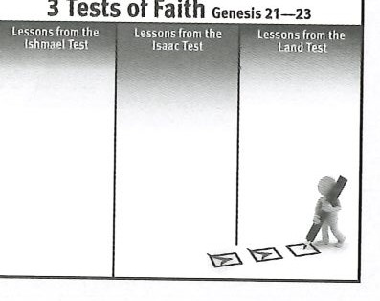

Genesis 21:22- 34 is not covered in this lesson for sake of space. It records a covenant between Abra­ ham and Abimelech. The covenant gave Abraham a defined place to live called Beersheba. Abra­ ham called on the name of the Everlasting God in

Beersheba.

**RESOURCE:** Disp lay resource 11. **ASK:** What aspects of Abraham's test con­ cerning Ishmael are reflective of our tests of faith? (Record or reveal answers.) (Ql 0) *Letting God take control ofour circumstances; trusting God to be faithful to His Word; letting God work out His plan instead of intervening with our own plan.*

Once before, Hagar had been on her way to Egypt and evidently knew the route, but this time she lost her way. She strayed in the wilderness of Beersheba. Eventually the water in the skin was consumed, and Hagar despaired of Ishmael's life. She sat her son under one of the shrubs to shield him from the sun and left him there to die (21:15). She walked about a bowshot away and through her tears agonizingly cried, *Let me not see the death of the child.* In his distress, Ishmael was also crying, and *God heard the voice of the lad.* It was to Hagar, however, that He spoke from Heaven. He asked, *What aileth thee, Hagar?* (21:16, 17).

*Fear not,* God told her.He was not deaf to the pitiful cries of her son. He caused her to see a nearby well. Not only did He spare Ishmael's life, He also promised to *make him a great nation* (21:18-20).

Eventually Ishmae l married an Egyptian (21:21), and his descendants became a source of great grief to Isaac's descendants. Yet his survival and his nation are a testimony to God's faithfulness and to Abraham's victory in his test of faith.

* + - * 1. **The Isaac test (22:1-14)**

After years of tranquility, a tougher test loomed in Abraham's life. The only way to move to a higher level of faith is by pressure to exercise more faith than was ever previously necessary. God called on Abraham to face the supremetest of his life-and thereby to achieve his greatest victory. God was not tempting Abraham

to sin; He never entices anyone to do evil. He was testing Abraham's faith to prove the genuinenessof Abraham's faith and also to strengthen it.

God commanded Abraham to offer Isaac as a burnt offering (a sacrifice first slain and then burned on the altar): *Take now thy son, thine only son Isaac, whom*

*thou lovest* (22:2). God touched Abraham at his most tender spot. Abraham had waited a long time for the birth of Isaac, and he loved him more deeply than words could possibly express. Would he surrender Isaac to the will of God? If he did, what would become of the promise that *in Isaac shall your seed be called?*

We do not read that Abraham either argued with God or hesitated to obey Him.

He knew God too well and believed that He would never do anything wrong or unwise. Abraham got up early in the morning and began his long journey to the land of Moriah. He did not drag his feet or attempt to slow things down. Instead, he hastened to obey. He saddled his donkey, chopped wood, and got everything ready as quickly as possible. His faith was active even when he did not understand why God had commanded him to sacrifice his son.

**READ:** Genesis 15: 1, 4- 6. **ASK:** H ow wo ul d God' s prom ise from years earlier have encouraged Abraham as he slept und er the st ars for t w o night s on his way to sacrifi ce his son ? (Q l 1) *As Abrahamlookedup at the stars,he would have nodoubt been reminded of God's promise to make his descendants as uncountable as the stars. That reminder would have been particularly important to him during the night when his worries and troubles would have been magnified.*

On the third day of the 45-mile journey, Abraham saw the place in the dis­ tance. Abraham instructed his two servants to stay with the donkey. He said, *I and the lad will go yonder and worship, and come again to you* (22:5). Now we know why Abraham obeyed. He did not believe that God would take Isaac from him, be­ cause God had made a promise. Isaac, a teenager, carried the heavy load of wood, even as Christ carried His own cross. The teen's father carried the fire and the knife (22:6). Isaac did not know that he was to be the sacrifice. He asked, *Where* is *the lamb?*

When he learned that he was to be the sacrifice, Isaac seemed to accept his fate. There is no record of a struggle with Abraham. The fact that Abraham

wouldn't have been strong enough to force Isaac onto the altar suggests that Isaac was a willing sacrifice. What a picture this is of Isaac's greater Son! Christ sub­ mitted voluntarily to the Father and endured what Isaac only anticipated. Even the place of the sacrifice is significant; it was Mount Moriah. *Jerusalem in Mount Moriah* (2 Chron. 3:1) is identified with Jesus' crucifixion.

Abraham drew his knife and was ready to plunge it into Isaac. But God re- strained him. Would he have slain Isaac if God had not intervened? Definitely.

**READ:** Hebrews 11:17- 19. **ASK:** What did Abraham believe God could do once he sacrifi ced Isaac? (Ql 2) *Raise him up from the dead.*

Abraham did not waver in his confidence in the Lord's promise that Isaac would beget children and that his descendants would ultimately inherit the land of Canaan.

God stopped Abraham from plunging the knife into Isaac. He called Abraham, saying his name twice, and affirmed, *Now I know that thou fearest God, seeing thou hast not withheld thy son, thine only son from me* (Gen. 22:11, 12). Abraham had fully demonstrated his faith in God. He respected God for Who He is and valued Him

**'I. •**

above all else. Because he respected God, he trusted Him and obeyed Him. God did not require Abraham to sacrifice his son; He had provided His own sacrifice. A ram, caught by its horns in a bush, would become Isaac's substitute (22:13), even as Christ became the sinner's substitute on Calvary.

Abraham called the name of the place of the sacrifice *Jehovah-jireh,* meaning the *Lord Will Provide* (22:14). Abraham believed God would provide, and God did not disappoint.

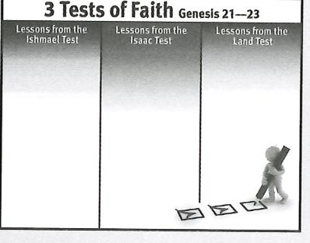**RESOURCE:** Dis play reso urce 11. **ASK:** What aspects of Abraham 's test con­ cerning Is aac are reflect ive of our tests of fait h? (Record or reveal answers.) (Ql 3) *Trusting and obeying God even when wedon't understa nd all He is doing; trusting God's Word no matterwhat our circumsta nces; being willing to give all we are and have to the Lord.*

Abraham passed his test concerning Isaac with flying colors. How his faith had grown! He is a testimony of what God can do in our lives too. He can build in us that same level of faith that trusts Him enough to let go of control and to obey Him no matter our circumstances.

* + - * 1. **The land test (22:15-23:20)**

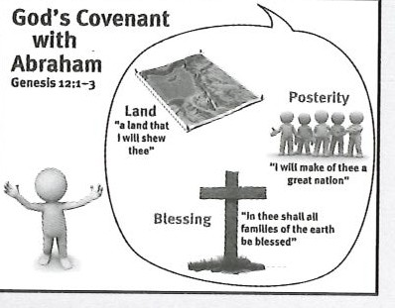**RESOURCE:** Dis pla y reso urce 7 to review the aspects of the Abra ham ic Cove nant.

The Angel of the Lord called to Abraham again. He confirmed His covenant with Abraham. He promised Abraham that He would (1) bless him, (2) multiply his seed, (3) cause his seed to possess the gates of their enemies, and (4) bless all nations through his Seed (Christ), the promised Savior of the world (22:15-18). Nothing can annul the Abrahamic Covenant, but faith is required for individual participation in it.

Adding the promise that Abraham's descendants would possess the gates of their enemies was no doubt encouraging to Abraham. He was still without any land in Canaan. God's specific promise about the enemies' gates surely bolstered Abraham's growing faith. Remember that he blamed God for making him *wander* from his father's house to a land that he did not own (20:13).

Abraham returned from offering Isaac to dwell at Beersheba. There he heard a report of his brother's growing family (22:19-24). But we don't see Abraham travel­ ing back to his homeland. He was in the Promised Land to stay.

When Sarah died at the age of 127, Abraham mourned her death (23:1, 2). He lost a lifelong companion who learned with him to have faith in God. But where would Abraham bury Sarah? Would he return to Paddan Aram just in case his descendants never actually inherited the Promised Land?

**READ:** Genesis 23:3,4. **AS :** Why was bu rying Sarah in the Promise d Land an act of faith for Abraham? (Ql 4) *He owned no land in Canaan.God's promise that one day his descendants would own the land was the only reason Abraham had for burying Sarah in Canaan. He exercised fai t h in God's promise that would be fulfilled hundreds of years in the future.*

Abraham spoke to the sons of Heth (Hittites) to intercede for him with Ephron that he might purchase a portion of ground on which was the cave of Machpelah (23:4-9). Ephron's offer to give him the land was only the empty gesture of o riental custom. In fact, Ephron drove a very hard bargain; he said the land was worth four hundred shekels of silver, which of course was what he expected Abraham to pay (23:10-16). The average cost of a field was only four shekels, and a fertile garden cost only forty shekels of silver.

Abraham became the certified owner of the field and the cave (231:7,18). That was all the land Abrahamever owned in the land of Ca naan. Was he disappointed that he himself never possessedCanaan? No, because he had never expected to.

He knew that the promise of the land would be fulfilled in his descendants some­ time in the future. He needed no guarantees other than the promise of God.

**RESOURCE:** Disp lay resource 11. **ASK:** What aspects of Abraham's test concerning the land are reflective of our tests of faith? (Record or reveal answers.) (015) *Trusting God will do what He has promised to do; acting by faith; resti ng in the Lord.*

Abraham passed all three of his tests of faith. Again, this is a testimony to what God can do in someone rather than how great Abraham was. That fact gives all of us hope that we can be the men and women of faith God wants us to become.

**When Abraham died,** Isaac **and Ishmael laid his body next** to **Sarah's in the Cave of Machpelah (25:8-10).**

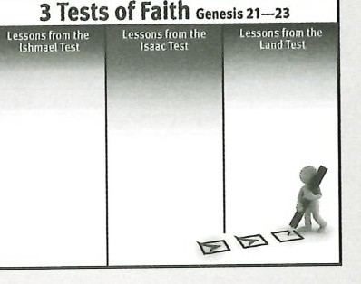

# MAKING IT PERSONAL

## Accept the Tests

**ASK:** When we don't put our faith in God, what are we essentia lly conclud­ ing abo ut Him? (016) *That He is not faithful and thereforenot worthy of our faith. That He is not trustworthy.*

As we go through life and face a varietyof circumstances and decisions, God wants to see our faith. He doesn't want to hear our solutions, excuses, or com­ plaints. He rewards faith because by it we acknowledge that He is faithful both to His promisesand His character.

God sometimes uses situations such as financial difficulties, an illness, a strainedrelationship, a death, or an imporat nt decision to test our faith.

**ASK:** How might God be testing your faith? (0 17)

**ASK:** What will you gain from tests you either resent or try to escape? (018)

*Nothing. We need to accept the test before we will gain from it.*

Have the learners spe nd some time in prayer ac knowledging God's hand in their life and in any tests of their faith He has brought their way. (Q19)

..., ...,

## Pass the Tests

We can wish our faith were stronger, but wishing won't make it any better.

Faith comes through the Word of God. This study on Genesis is a great catalyst to bolster our faith.

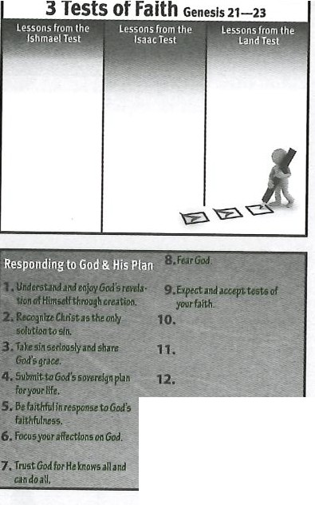

**13.**

?.rN I(!

•

**RESOURCE:** Dis play resource 11 to review the lessons we can learn from Abr aham's tests of fait h. **ASK:** What personal lesson will you take away from Abraham's vic to ries in his tes ts offaith? (020)

Challenge your learners to study passages such as James 1:1- 8 and Romans

5:1- 5 for more helpful insight on facing tests of their faith.

## Summary and Memory Verse

**RESOURCE:** Disp lay reso urce 1. Add a summary statement for lesson 9 or use the follo wing: Expect and accept tests of your faith.

Encourage learners to memorize Hebrews 11:11. Give them an opportunity to say the verse in class next week.